Programme: BA (Hons) Leadership and Management Skills for the Workplace
Module: Leading and implementing workplace change
Module code: BMSW6103
Lecturer: Prof Dennis Pepple
Assignment title: Change management portfolio
Student name: Manjit Kaur Gharu
Student ID: 1814769

Table of contents
Introduction………. p . 3
2. Question 1……….p.4
What is Power………. p.4
What are Politics……….p.5
Data of the Case Study……….p.6-p.9
3. Question 2……….p.10
The Salience Model……….p.10-p.11
Power of interest Matrix Model……….p.12-p.13
4. Question 3……….p.14-p.16
Conclusion……….p.17
Recommendations……….p.18
References……….p.19-p.20
1. Introduction
Post Office have multiple branches across the U.K. each franchise offers crucial services and products which are important to everyone in one way or the other. Most Post Office branches are run by local individuals who have built a good relationship with the community, as this is very important for both the branch staff as well as the public. The local customers will regularly visit the branch for a product or service that is offered. Post office workers from 114 branches have resulted to go on strike for a 24-hour period as they are disputing pay. The portfolio shows how the Post Office consider conducting the strike to minimise the public disruption. As the Members of the Communication Workers Union are involved, all stakeholders are doing their best to come to a resolution to stop any further action such strikes being taken. (Timmins, 2022)

2. Question 1
What is power
Power is when an individual may act or present in such a manner which can highly influence others. This could be for good or bad influence depending on the current situation. The influencer may want an opinion to be heard and managed to influence the majority who too will benefit from what is being voiced.
In any organisation there are agreements and disagreements. An example of this could be to do with the way the management team are treating employees which can cause conflict. From time to time when there is change in the organisation, some employees feel troubled and struggle to adapt.
Power influence can differ depending on the position of an individual in the organisation. In any organisation a manager or senior colleague may have more power to make day to day decisions and this can influence the rest of the team. Generally, these decisions are to meet the targets, motivate staff, etc. On the other hand, the staff have the correct attitude to self-motivate. This could be to aim to receive the financial reward or be top sales staff of the week. This influence can be contagious to other staff members too. As the power influence infects one colleague to another, the whole team would be in sync to achieve. Whereas if there is a disagreement in the workplace, this can affect the organisation accordingly. Any disagreement is not nice but even worse when things can’t settle, and the employees are influenced which can lead to disruption. This could be because the employee or employees are being treated wrongly. An example of this is when the P & O employees were dismissed immediately. For all 800 of the employees there was no notice period, no redundancy offered, just a sudden dismissal. All the employees were affected by the actions of P & O and very disappointed. Knowing this was unfair there was major disruption. Employees began to protest as they knew this was unfair and P & O were breaching the contract. As employees protested there was major disruption for the organisation which led to media coverage. This is something no organisation likes and attempts to settle everything immediately to minimize the impact on the reputation of the organisation. With UK workers rights and in some organisations where there are unions, some disputes can get settled quickly. Others on the other can go to courts to be settled which is jeopardising the organisation’s reputation. (Baynes, 2022)

What are politics
Politics are discussions which are made by a selected number of individuals who can discuss and make agreements to benefit others by influencing them. When we talk about politics this normally involves the government, as politics are discussed, and agreements are made to benefit cities and countries. There are politics in organisations too. This would normally be the directors or CEO’s who make discussions which are implemented to the rest of the organisation, as there is a democracy in politics so the majority would be influenced and follow the guidance given. This is a sense of power which has high influence on others to make a change. In any organisation political decisions are implemented. This could be where all employees must take part in the sustainability policy. This would include using recyclable bottles and avoid using single use plastics, recycling paper, avoid using plastic carrier bags. As the government have announced all organisations must report the sustainability every year, this will help to reduce the organisation waste. (Boswell, 2020)
Data of the case study
The case study shows how power and politics are extremely crucial to any organisation. Both power and politics must be manged accordingly. Post office workers are advised and supported by the Union representatives to stage the strike in attempt to stand for the workers rights and have the pay which the employee thinks is fair. Union representatives are individuals who discuss issues which rise in the workplace and try to resolve the issues between the organisation and the employee. As the Union is the voice for the employee the negotiation is in favour of the employee. The organisation will have a fair chance to resolve most issues but there are times where issues don’t get resolved. This would lead to the employee filing a claim to an employment tribunal. This is when an employee believes they have been treated unlawfully.
As the case study shows that 114 Crown Post Offices will close for 24 hours, this will put a toll on all services. All stakeholders will be impacted by the strike too. Even though the service offered by the Post Office is already put under the regular pressures such as over worked staff due to coronavirus restrictions, the strike leads to staff feeling very exposed by the pay freeze. Post Office staff would appreciate the organisation by having the support of paying the pay expected depending on the role. As the union is supporting the employees who are staging the strike this leads to a very crucial time for the post office reputation. The strike is allowing the organisation to be exposed to the public who naturally have an opinion about staff being paid fairly.

PROS | CONS
- Post Office may compromise with the staff about fair pay  - Post Office will reconsider for the future as the Union is strong and will act  - Giving the employees power to implement fair pay  - Employees can improve working conditions or pay by standing for their rights  - Can get others support eg: some employees are afraid to speak up | - Staff will leave due to personal financial commitments eg: household bills, dependants, grocery, etc  - Reputation of the organisation  - Organisation being exposed in public  - Organisation closure in worst case scenario eg: no agreement and Directors decide to pay out redundancy due to financial loss if they agree with pay increase  - No negotiation which can lead to organisation to close  - Strike can cause disruption and delays in services  - Customers disappointed with organisation as the Post Office is well established

The above table shows some positive and negative impacts which can result from the strike in the Post Office strike. Depending on what the individual views are, there is previous evidence with other organisation strikes showing from time to time there can be no negotiation between employees and employers. This can lead to the organisation closure and employees being made redundant. This is an extreme worse case scenario which can have an incredible effect on both employee and employers.
As discussed previously the organisation P&O was in a very difficult situation where they made 800 employees redundant with immediate effect to protect the remaining employees. This was very drastic action for an organisation to make due to making £100 million financial loss compared to the previous year. The organisation did not give any notice to the employees which caused a lot of upset and confusion. The employees and union representatives started to protest on board and employees refused to leave without any reasonable explanation. The employees have financial commitments of their own e.g.: families, mortgages to pay, household bills to pay. As the employees worked with honesty, they expect to be rewarded with the pay but this was not the case with the sudden announcement. The employees presented power to and caused disruption. The passengers and cargo were removed as the disruption had caused a stand still. The employees were within reason to act in such a way as P&O had breached the contract of employment under the Employment Rights Act 1996. ( GOV.UK, 1996) The disruption led to the Dover port being blocked with lorries waiting to load or unload. Furthermore, the lorries were delayed on the other deliveries which had been scheduled. The disruption put P&O under immense pressure. (Topham, 2022)
An example of the scenario described above is of an organisation named 2 Sisters Food Group Ltd. 2 Sisters Food Group Ltd is a poultry production and packing organisation which provides produce to large supermarkets eg: Aldi, Asda, Co-op, Lidl, Marks and Spenser, Morrisons, Tesco and Waitrose. Prior to 2017 employees of Branch A were feeling uncomfortable about the conditions they worked in and demanded a pay rise. The organisation was in more demand and the senior management had resulted in changing the working shift pattern. Currently there was a shift from 6am to 2pm and the second shift started at 2pm and 10pm. This was 5 days a week Monday to Friday. The new shift that was going to be introduced was 12-hour shifts. This was going to be 4 days on and 4 days off. The change was not going to include any night shift allowance. The days would change as they rotated and didn’t suit the majority due to commitments outside work. Having to work as the union representatives were standing by the employees and being their voice, this led to strikes as no negotiation was made. Union representatives are excellent as they can be the voice for employees and know what employee rights are, whereas not all employees know the details of employee rights. This was the case in 2 Sisters Food Group Ltd Branch A as there was a lot of employees who had resided from abroad and settled in the U.K. These employees were not aware of employee rights as they came from abroad where there were no employee rights. Even when they thought things didn’t seem right, they would silently continue work as they didn’t know how to act. After several discussions between the union representatives and directors of the organisation no negotiation had been reached. Employees decided they would go on strike which led to production delay, loss of poultry orders from several large supermarkets, press reports which led to exposing the organisation and overall immense disruption for everyone involved. As no negotiation concluded, the directors resulted in closing Branch A. All employees at this branch were offered redundancy. (Jones, 2017)
A decision like this can impact everyone differently. Some employees had migrated from abroad and spoke very little English. They struggled to get this job but with the help of the ease of the application, translation offered, interview process they managed to get a job in 2 Sisters Food Group Ltd. These employees would struggle to apply for regular jobs where applications are online or interview stages due to the language barrier and lack of technical knowledge to apply for another job. Other employees who were confident managed to enjoy the redundancy and were able to continue work in another organisation with no trouble.
As the case study explains the 114 branches strike action can impact the Post Office as a whole. The strikes are exposing the organisation. The public will automatically have an opinion on how the organisation is treating the staff in such case under paying staff. The reputation of the Post Office will be affected for other employees from across the organisation.
As the legal battle unveils, previous employees may speak up to sell their story to the press and voice how they were treated when employed by the Post Office. This will continue to make the current situation stronger. Previous employees can risk speaking up if they have left the Post Office as they don’t have any risks attached eg; risk of losing their job.
The employees are using the power they have which is allowing the union to voice what the employees want. With political grounds the employees are using all the useful employment rights to act in an industrial strike. The union would be making negotiations with both the organisation directors and employees. The union would represent the employees as the majority as voted to demand for a fair wage increase.
3. Question 2
The Salience Model
The salience model is a diagram which show the main stakeholder involved in the organisation. It prioritises the stakeholders in the current situation. The diagram below shows the perspective of the Post Office strike scenario. Although there are more stakeholders, the diagram presents the obvious stakeholders who are acting and impacted by the strike action. This model is used for such situations so the correct effort can go to the most important area. With these stakeholders as the priority the whole situation can be calmed down rather than escalating. (Tarhanis, 2018)
The salience model is a 3D model as it monitors the power, legitimacy, and urgency. This is used in larger projects where the stakeholders need to be managed due to the complication involvements. Power is the level of influence this stakeholder must give authority of the results of the strike. Legitimacy is the stakeholder’s involvement suitable for the situation. Urgency is present that this stakeholder needs to be action with immediate effect. This could be because the impact is a key player in the organisation and can jeopardise more than what is being discussed or it could be a time limitation.

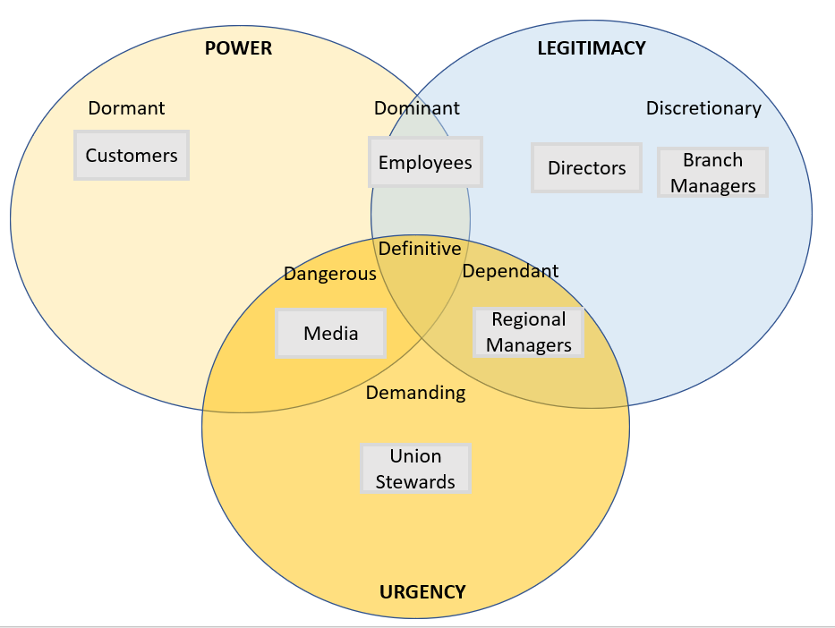

The above Salience model presents the current situation. From time to time as the situation differs the stakeholders involved may be prioritised differently. The customers have power to use other services from any other service providers, but they are put to a stop due to the strikes. Employees have power and dominant influence on other employees, the union representatives, and the public opinion. The media have power but are dangerous so need to be managed with urgency as they are the individuals who can get the message across to the outside world which risks the Post Office reputation. The union representatives are the front line who will make the negotiations on behalf of the employees. The directors and branch managers are the relevant people in the organisation who will make the final resolution. The regional managers are dependant on the outcome as they must manage the other branches which are not taking part in the strike.

Internal stakeholders | Owner  Employees
External stakeholders | Customers, general public  Government agencies  Suppliers  Investors  Media

The Post Office have several stakeholders. Both internal and external stakeholders can be affected by the strikes.

Power of interest matrix model
The power of interest matrix model is used to map out the importance of each stakeholder. This grip can be used from start to finish of any allocated task. The power of interest matrix model shows some stakeholders in the case study. Having the power of interest matrix model each stakeholder can be managed according to the importance for the situation. As the employees have got the union involved who have not been able to make any reasonable negotiation with the senior management of the organisation, the power they have over the employee rights to be vocal about the pay rise the employees expect within reason. As the union and employees go ahead with the strike the public, the customer, the media etc get to have inner knowledge of how the staff are being under paid. This exposes the organisation which influences the Post Office reputation. This can be very embarrassing for the organisation to be exposed in such a way. The remaining branch staff too may get influenced by the strike which risks further strikes in wider regions.

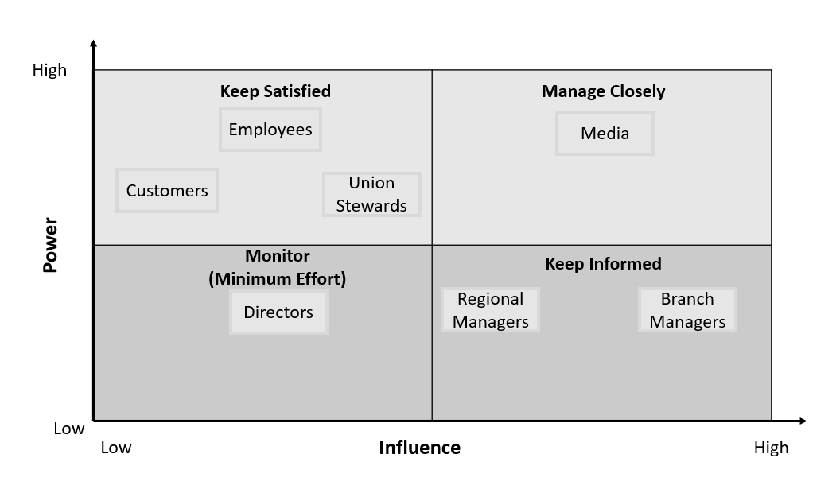
The above power of interest matrix model shows the power and influence of some stakeholders.
Both models present interrelations as they both have interest in prioritising the stakeholders involved. Each model is placing the stakeholder which has the most influence on the current situation so the stakeholder can be informed and monitored closely. Either can be used in the case study.
The power of interest matrix model is a 2D model as it monitors power and influence. This is useful for smaller projects which are not so complicated. The model shows power and influences on the situation which can be actioned according to the importance.
As with any model from time-to-time situations can change suddenly. The models are created by the project manager or anyone who has the authority to manage the project. The model is something they will have an opinion on and place the stakeholders depending on what they decide is important. As the case study is about the strike, the risk of using either model to manage the situation and monitor the stakeholders can miss the bigger picture where other people can get involved and the whole situation can change. An example of this is if the strike was for 24 hours as informed, the employees who are being monitored may take this further by getting other branches involved. The risk of other branches getting involved in strike action will lead to further closures. The service and products being offered will have longer delays due to branch closures. The model was managing the stakeholders, yet the performance has been affected too. Making losses in this way will cause further cutbacks for the overall figure earned by the Post Office.

4. Question 3
The Thomas Kilman’s Conflict model is a resolution model. The model has 5 styles which are considered. This model offers more resolution options which can resolve situations as the case study describes. Having the ability to know what style to use will be useful for the end achievement. (Richard Shell, 2001)
1, Collaborating style – finding a resolution to satisfy all stakeholders involved
2, Competing style – confront the issue to achieve the goal
3, Avoiding style – ignoring the situation, no interest in resolving the situation
4, Accommodating style – where one side would surrender and allow the other party to win the disagreement
5, Compromising style – this is when both decide to have an agreement which they can both move forward from.
Any of the conflict management styles can be used to minimise and control conflict. These styles are used to improve the workplace environment. The management may consider styles from the model above to resolve situations in the organisation before they get out of hand.
In the case study using the Thomas Kilman’s Conflicts model to resolve matters with the employees and union representatives can be considered. The following is described if the Post Office followed the style as described.
Collaboration style – If the Post Office was to collaborate with the 114 branch staff to find a resolution the strike may come to an end. This will result to staff continuing work rather than the branches closing. The local customers would be satisfied as they don’t need to travel to another branch as the local branch has opened. The staff will be pleased as they have been listened to. The union representatives can step away as they will have accepted the collaboration. The public will see the organisation are respecting their employees and meeting their needs which improves the reputation of the organisation.
As the dispute is over pay, the Post Office will need to adjust all employee’s wages not just the employees of those who were on strike. This could result to financial loss. The Post Office will need to consider how they will increase the profit they are making to meet the needs of paying all the employees. This could lead to making redundancies in worse case scenarios or demanding more workload from employees by increasing targets. This could lead to employees feeling under pressure and have an impact on their wellbeing.
Competing style – If the Post Office was to compete with the 114-branch staff and union representatives they may feel threatened that the strike action they are taking is exaggerated and may back down. The employees may agree with the pay freeze and think this is acceptable considering the covid pandemic has had an impact on all organisations and accept the 2% rise the following year. The employees may consider this if the Post Office compete as if the employees leave, they will be left jobless till they find employment which may have its own struggles.
As the Post Office complete the employees and union representatives may get more aggravated and upset with this approach. This may provoke further strikes and other branch employees getting involved. This will give the Post Office further disruption on the services and products being offered. The media will expose the organisation giving it a bad reputation.
Avoiding style – this is something that could be considered by the Post Office. The employees may notice that the Post Office has had no reaction. This may give the employees an option to stop and settle down and continue work as usual.
This could also aggravate the employees, which can lead to situation getting worse. With the strike going ahead and more media exposure.
Accommodating style – this is where the Post Office agree with the employees and union representatives request just to settle everything. The action the employees are taking may come to an end.
The Post Office need to consider the request from the employees may lead the organisation to making a loss. This may lead to cutbacks, job losses or branch closures.
Compromising style – this is the compromising between all parties, so an agreement has been made to manage the situation. This shows both the Post Office and the employees have come to a decision to resolve the situation. This style is a positive outcome for both parties involved as it shows that an agreement has been made to suit everyone involved. The Post Office would value from this as the media can expose the strike action, with compromising style the public can see that the organisation listens to employees to satisfy their needs.
To resolve this situation the Thomas Kilman’s Conflict resolution model is a wonderful tool to consider. Rather than escalating the situation the Post Office could consider making an agreement with the employees and unions representatives. Meeting the dispute halfway could be compromising. Both the Post Office and employees can be pleased, and this will stop any further disruption if agreed. The Post Office can consider suggesting a 1% pay increase in 6 months and this can be reviewed after another 6 months. Compromising with the employment can demonstrate the employees are willing to adjust rather than allowing the situation to worsen which can upset everyone. Even though the Post Office had planned to have a pay freeze for 2021 – 2022, compromising with the employees is important. Rather than have disruption which would have caused financial loss, the 114 branches involved will continue to work and deliver as required.
As previously stated, the employees have power and with their political actions which can result to jeopardising the Post Office reputation. This is something any organisation would void as it puts the remaining branch staff exposed to doing something similar. For the future generations who consider joining the Post Office the reputation is very vital to maintain.
Conclusion
Post Offices are in a very crucial stage where they are under pressure to meet the pay dispute. As the remaining branches are not taking strike action which is a positive thing to know. The 114 branches taking strike action are guided by the members of the communication workers union. As the union is an external organisation from the Post Office, the negotiations have not gone to plan, leading to employees taking strike action for a period of 24 hours. This is going to have a big impact on the organisation. Whereas, if the union was not involved and the employees had discussed this with the HR Department, the outcome may have been different due to the HR Department being an internal source and considering the Post Office’s perspective.
Post Office are to resolve the situation before further action is taken. Meeting the employees request halfway is a great compromise. With the compromise the employees should respect that the Post Office are attempting to negotiate to settle all the disruption. This is causing all stakeholder’s undue stress.
Recommendations
It is recommended that all employees get a wellbeing survey every month. This is to monitor any wellbeing issues that may need managing sooner rather than escalating. The employees are to be reassured of the company policy on who to contact should there be any concerns. As previously the employees got guidance from the union representatives which are a third-party organisation. If the employees had kept this within the Post Office company e.g., the HR department the situation would have been settled sooner. The union representatives have a duty to fulfil which is be the voice for employers. From time-to-time things get out of hand which can be misled by the union.
It is recommended that all employees are updated on the agreement made. This is to reassure the employees that the agreement made is official. Employees like to be informed of any updates.
References
AssistKD (2019) What is Power/ Interest Stakeholder Analysis? Available at: https://www.youtube.com/watch?v=G3R4TO1l6LY (Accessed on 2nd August 2022)
Baynes, M (2022) P&O Ferries makes 800 staff redundant and warns of significant disruption to services over next few days Available at: https://news.sky.com/story/p-o-ferries-makes-800-staff-redundant-and-warns-of-significant-disruption-to-services-over-next-few-days-12568327 (Accessed on 24th July 2022)
Boswell, C (2020) What is Politics? Available at: https://www.thebritishacademy.ac.uk/blog/what-is-politics/ (Assessed on 25th July 2022)
GOV.UK (1996). Employment Rights Act 1996. [online] Legislation.gov.uk. Available at: https://www.legislation.gov.uk/ukpga/1996/18/contents (Accessed on 27th July 2022)
Jones, T (2017) Strike threat at 2 Sisters Food Group Available at: https://www.birminghammail.co.uk/news/business/strike-threat-2-sisters-food-12680737 (Accessed on 28th July 2022)
Kotter, John (1985) Power and Influence Available at: https://books.google.co.uk/books?hl=en&lr=&id=gXkZZnwJA2sC&oi=fnd&pg=PP7&dq=what+is+power&ots=dGOt2GE5yM&sig=QTDyrI0I9xkYHF-Gpjvph7w360M#v=onepage&q=what%20is%20power&f=false (Accessed on 23rd July 2022)
Richard Shell, G (2001) Bargaining Styles and Negotiation: The Thomas-Kilmann Conflict Mode Instrument In Negotiation Training Available at: https://link.springer.com/article/10.1023/A:1013280109471 (Accessed on 1st August 2022)
Staerkle, C (2015) Political Psychology Available at: https://www.sciencedirect.com/topics/social-sciences/political-decision-making (Accessed on 25th July 2022)
Tarhanis, W (2018) Salience Model to Classify Project Stakeholders, Stakeholder Management Available at: https://www.projectcubicle.com/salience-model/ (Accessed on 31st July 2022)
Timmins, B (2022) Post Office strike, Workers to walk out over pay dispute Available at: https://www.bbc.co.uk/news/business-61300417 (Accessed on 23rd July 2022)
Topham, G (2022) P&O Ferries boss admits firm broke law by sacking staff without consultation Available at: https://www.theguardian.com/business/2022/mar/24/po-ferries-boss-says-800-staff-were-sacked-because-no-union-would-accepts-its-plans (Accessed on 27th July 2022)

