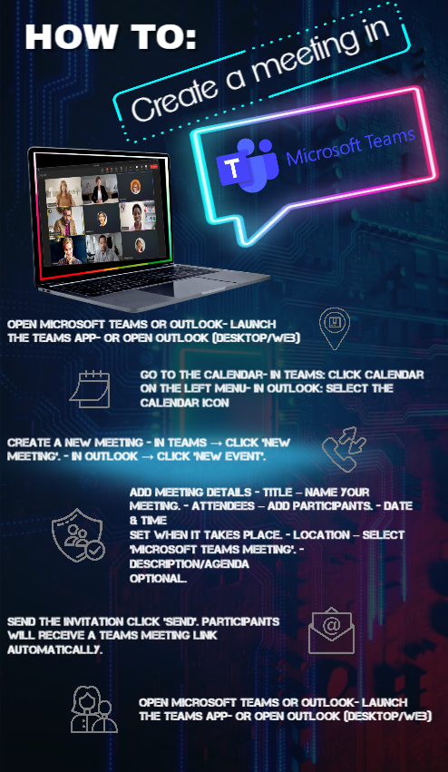

Microsoft Teams is a communication and collaboration platform used in workplaces to support online meetings, chat, file sharing, and teamwork across departments. It allows employees to meet virtually, organise tasks, and stay connected whether they work on-site or remotely.
The poster titled “How to Create a New Microsoft Teams Meeting” provides step-by-step guidance for staff on how to schedule a Teams meeting using either the Teams app or Outlook. It explains how to access the calendar, create a new meeting, add details such as attendees and time, send invitations, and join the meeting. The poster is designed to be clear, visually engaging, and easy to follow, making it suitable for display in a workplace environment to support employees who may be unfamiliar with Teams or need a quick reminder.

