

Student Name: Lois Harris Student ID Number: 1907505

Programme: BEng Engineering Programmes (Part-Time)

Module: Advanced Materials and Processes
Module Code: M6X00414

Lecturer: Graham Howe & Dr Greg Owen

Assignment Title: Advanced Processes Report
Assignment Topic: Electrostatic Powder Coating Process
Submission Deadline: 22/06/20

Table of Contents

ABSTRACT
SECTION 1
  - Introduction

SECTION 2

2.1 Scientific principles of the technology
2.1.1 Chemical pre-treatment
2.1.2 Powder deposition and charging
2.1.3 Curing

2.2 Detailed analysis of the application
2.2.1 Manufacturing – quality
2.2.2 Manufacturing & ethics – efficiency and automation
2.2.3 Environment and health & safety – impact and risk
2.2.4 Environment - recyclability
SECTION 3

3.1 Evaluation of impact technology has on the sector
3.1.1 Smaller production runs – increased collaboration
3.1.2 Improved energy efficiency
3.1.3 Future with Industry 4.0
3.1.4 Changing office furniture industry
3.1.5 Processing different materials

CONCLUSION

REFERENCES

Abstract
The subject of the paper is electrostatic powder coating. Initially, the scientific principles of the technology will be addressed to understand how the process functions. The applications of this process will then be analysed, with regards to key factors including manufacturing, environment, ethics and health safety. Finally, the paper will conclude with an overall evaluation of the impact that the technology has and continues to have on the manufacturing sector – also looking specifically at the office furniture market.
1.1 The term electrostatic can be defined from its prefix electro-; a combining form signifying pertaining to electricity and -static; having gathered on or in an object that cannot conduct a current. The process is fundamentally based on the principle that opposite electrical charges attract (ITW Gema, n.d.). The process consists of three fundamental stages; the chemical pre-treatment, the electrostatic powder spraying and charging, and finally oven curing. Powder coating originated in the 1950s, powders were flame-sprayed onto metallic surfaces to protect them from corrosion and abrasion. This later evolved into lowering a heated part into a bed of fluidized powder. This process resulted in inconsistent film thicknesses. (Utech, 2002). Electrostatic powder coating is a process which has been utilised commercially since the early 1960s. It was initially developed as an alternative to solvent-based liquid coatings containing volatile organic compounds (VOCs) (Stough, 2010). One of the major claims from the industry, including (ITW Gema, n.d.) is that the process is environmentally friendly. (Rainer Hofer, 2019) also agreed that the process is environmentally friendly, easy to control and highly efficient. The manufacturing sector has found many suitable applications within the office furniture, automotive and domestic appliances markets. Powders can deliver cosmetic, protective and longevity characteristics as well as achieving maximum hardness, chemical resistance and gloss retention. (Utech, 2002).
2.1.1 Before any material can be coated using this method, it first must be chemically pre-treated. The first step is to ensure the surface is free of corrosion and grease, which in turn will assure a uniform and permanent adhesion of the coating (Karel Kellens, 2015). What follows will usually depend upon the material that is being processed. In the example of steel sheet, through the phosphating process, a layer of phosphate coating typically including iron, zinc or manganese crystals is added to provide corrosion protection. For most effective results, the surface must be activated with an aqueous solution of alkali salts including titanium salt. Activating the surface increases the number of crystals per unit surface and by which the crystal size, coating weight and reaction time is reduced (Karel Kellens, 2015) (Utech, 2002). For other materials, the pre-treatment will differ. Galvanised steel is pickled, and aluminium sheet is chromatized; both provide corrosion resistance and enhances adhesion. This stage of the process will significantly impact the overall quality of the coating; therefore, it is important that the concentration baths are regularly cleaned and maintained. Likewise, the pre-treatment baths should be designed to suit the geometry of the workpieces to avoid wastes in energy consumption and raw materials. Rinsing is required between each of the chemical treatments to avoid contamination and the final rinse is completed with demineralised water. Before the workpiece can be transported to the powder coating plant, any remaining moisture must be removed. A residual water drier is heated to maximum temperature of 120°C, blowing air at the workpiece. (ITW Gema, n.d.)
2.1.2 After chemical pre-treatment, the workpieces can be automatically transported to the coating plant via the conveyor system. It is here that the powder is deposited onto the workpiece by electrostatic spraying guns. Powder is filled into the hopper, and compressed air is blown through the powder reservoir resulting in fluidized powder movement. (Karel Kellens, 2015). A low voltage is converted in the spraying guns to high voltage, according to the cascade principle. The powder gains a positive electric charge at the gun tip due to the highly negative potential electrodes. The air around the gun tip becomes conductive and a corona field is formed. Powder is charged to between 30-100kV when sprayed. Due to the presence of an electric field created between the powder gun and the workpiece; the particles of powder follow the field lines and become adhered. As soon as the ionized powder particles meet the grounded workpiece, both charges mutually attract one another. As the powder is not electrically conductive, the charge cannot discharge, and the attractive forces remain. (Karel Kellens, 2015), (Utech, 2002).
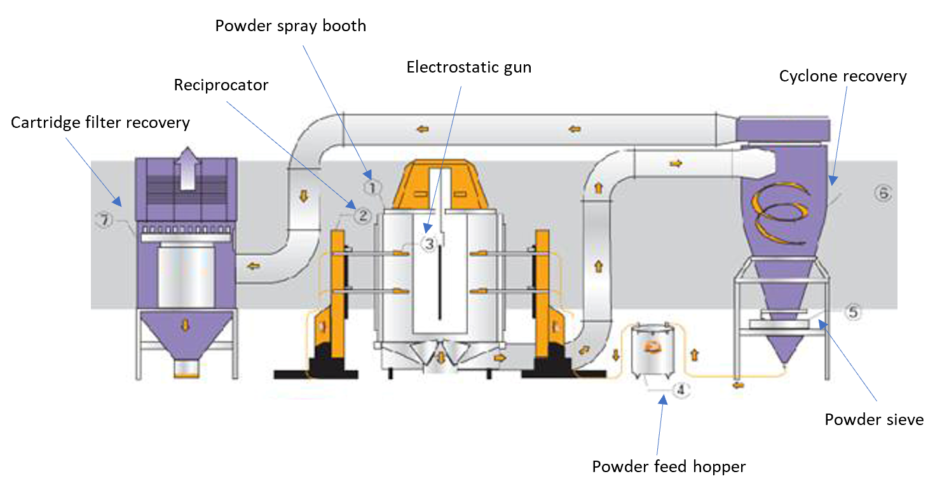
Figure 1.1 - http://www.powder-coating-line.com
2.1.3 The final stage of electrostatic powder coating is curing. Again, via the conveyor system, the workpiece is moved into the curing oven directly from the powder coating booth, with no delay. The curing oven is usually heated to around 200°C (Karel Kellens, 2015) , although this can vary depending on the powder manufacturers specification. (Rainer Hofer, 2019) suggested curing between 180 and 200°C. Similarly, the time taken for the oven to heat up and the time the workpieces stay within the oven will vary. This is due to several contributing factors such as workpiece type, concentration of workpieces, oven insulation and material thickness.
2.2.1 Electrostatic powder coating is becoming increasingly popular, used today within numerous manufacturing industries including the office furniture market. One of the main concerns for a manufacturer is the reliability and consistency of high-quality finishes. The process must achieve the required powder thickness as both under and over-spraying can be a problematic. Under-spraying leads to rework which is inefficient. Likewise, over-spraying creates an uneven surface referred to as ‘orange peel effect’. Larger powder particles have a higher charge, creating a stronger electric field causing a larger electrostatic attraction. This effect is an irregularity in the surface of a coating film resulting from an inability of the film to level out. (Utech, 2002). An advantage is that the process exploits the fact that repelling forces are created due to similarly charged particles. It is used to limit the coating thickness and increase the even distribution of the powder; thus, minimising powder usage and cost saving.
Another risk to output quality is back – ionization, this is where powder is sprayed back creating small craters on the workpiece surface. The voltage at the electrode should be reduced. The voltage here is directly proportional to the charging and space charging, therefore risk is minimised. This must be finely adjusted to maintain enough powder charging. (Utech, 2002).
2.2.2 Manufacturers need to increase the efficiency of any process to maximise output. There are large initial investments needed to introduce this process; although it can provide advantages over other surface coating methods including; fewer rejects; lower energy costs; less material waste and lower waste disposal costs (Utech, 2002). In large volume systems, reciprocators are often used to automate, what once would have been a manual job. They can be programmed to move along three axes, allowing the guns to evenly distribute powder over the workpiece – minimising waste, standardising high-quality finishes. Some would argue that as manufacturers are becoming more reliant on automation to reduce labour cost; jobs are being lost. Conversely, it provides an opportunity to provide increased skilled jobs, to oversee the control of the process. It is common to require one manual coating gun (at the end of the powder booth) to overcome the Faraday Cage Effect. Since the electric field strongly pushes the powder particle field toward the edges of the Faraday cage, fewer particles can intrude the recess. Also, free ions generated by the corona discharge, quickly saturate the coating with extra charge – this can also lead to back ionization. (Utech, 2002).

2.2.3 Two of the perceived benefits of using electrostatic powder coating is its environmental friendliness and safety (Utech, 2002). There are however risks involved arising from the possibilities of dust explosion, fire, electric shock, exposure to hazardous materials and compressed air. These are said to considerably less and more manageable than regular powder coating (Muhammad Kashif Iqbal Khan, 2012). Amongst others, (Stella Papasavva, 2002) and (DSM, 2011) indicated that the transition of solvent-based coatings to powder based coatings leads to a significant improvement of the environmental performance. In support of this (Muhammad Kashif Iqbal Khan, 2012) says, powder coating systems do not require a solvent to provide coverage and flow. Solvent emissions are almost eliminated, making venting to the outside unnecessary. Nevertheless, research from (Karel Kellens, 2015) suggest that this process has a greater environmental impact than fluidized bed sintering. The categories which have the largest impacts on the environment are very concerning and prompts the question, is the process ‘environmentally friendly’, or have only the volatile organic compounds (VOCs) been eliminated?
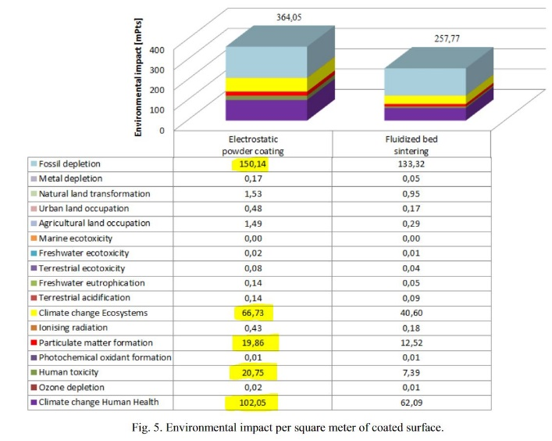
Figure 2.1 – Environmental impact per square meter of coated surface. (Karel Kellens, 2015)

The research (Karel Kellens, 2015) does suggest that the process emissions have the smallest impact on the environment. Although, it is clear that further improvements are needed with regards the impact of both raw material (powder) and energy consumption (gas, electricity and compressed air) for the process to become truly ‘environmentally friendly’.
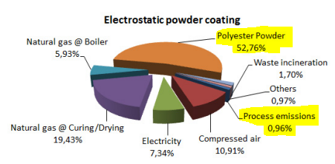
Figure 2.2 – Impact distribution for electrostatic powder coating. (Karel Kellens, 2015)

2.2.4 It is concerning that some particles do not become adhered to the workpiece. (ITW Gema, n.d.), suggest that the process is so economical, because overspray can be recovered, and reused. This is supported by (Utech, 2002), stating that remaining powder falls into a collection hopper where it can be re-sieved and reused. The booth where the powder is deposited from the electrostatic guns is maintained at a lower pressure, achieved by the exhaust suction. Overspray is prevented from escaping from the booth by the intake air flow. This raises the question, how effective is the use of recovered powder? (A. W. Lothongkum, 2007) suggested that using a case study of metal lanterns coated by polyester resin; the loss of powder in the process due to unattached particles to substrates, rework and over spraying was 800kg/month. The case study, amongst other results concluded that the reused polyester resin has a smaller mean particle diameter than fresh resin. It is suggested that small particle sizes less than 25µm should be separated, which can be resolved using the powder sieve/cyclone recovery system (Figure 1.1). It was also found that the suitable weight ratio of fresh and reused powder was achieved at 3:1. Suggesting there is some limitation in the re-usability of the powder. To support this evidence, (Muhammad Kashif Iqbal Khan, 2012) states that particle size determines the maximum charge or saturation charge on particles. Particle size can also be related to the charging efficiency, which is described by the charge to mass ratio. Although contradictory to (A. W. Lothongkum, 2007), it suggests that ultrafine powders may be preferred, and they would mostly adhere better to surfaces.
3.1.1 Electrostatic powder coating has allowed manufacturers to meet market demands for shorter production runs of more varied and customized colours. Although, an unintended consequence is the mounting volume and cost of disposing of the resulting waste powder. Despite the design of powder re-usability in the system, powder is often wasted due to the random mix of colour that accumulates due to colour changeover. Consequently, the process has forced the industry to become more innovative and collaborative to find new ways of reusing wasted powder. In 2010, an industrial consortium was developed, with the aim to reduce the amount of powder waste sent to landfill. They found one common method of re-use was to blend the used powder with a black pigment to create a neutral colour that could be used for non-cosmetic parts. Furniture manufacturers worked with suppliers and found waste powder could also be mixed with other materials to produce counterweights and sound deadening padding. (Stough, 2010)
3.1.2 Due to the energy and resource costs and upcoming regulations on energy and resource efficiency (Karel Kellens, 2015), manufacturers need to find solutions to reduce the environmental impact of their manufacturing processes. Electrostatic powder coating is no different – it has forced powder companies to develop more efficient powder coatings. One such example is Low- E from (Akzo Nobel Powder Coating Ltd, 2019). They suggest that their new product, reduces the curing temperature or curing time, without sacrificing the quality and properties of the coating. Energy consumption will be reduced, and productivity increased, with lower costs and improved ecological footprint. Similarly, (Rainer Hofer, 2019) suggested that curing times could be halved and curing temperatures reduced from 200 to 150 degrees Celsius. Similarly, (ITW Gema, n.d.), claimed that their latest technology provided a client (from the office furniture industry) with improved and more consistent covering with use of less powder. The booth reclaim system has given 50% more reclaim powder and reduced power consumption by 30%.
3.1.3 To maximise efficiency and quality, components need to work in harmony. It is near impossible to make the necessary adjustments and communicate the relevant data to ensure system optimisation. Industry 4.0 can help achieve this – through remote connectivity channel between the system and manufacturer, and a dedicated IoT platform as a user interface. (Teltonika, 2019). Industry 4.0 is the fourth industrial revolution led by intelligent manufacturing. It can combine sensors, control systems and production equipment to form an intelligent network. It is an inevitable trend of the future furniture manufacturing industry – with advantages of high efficiency of resource allocation, quick response to market demand and low labour cost. (Lin Wang, 2017). Industry 4.0 has the potential to allow production of an unimaginable range of products without uneconomically large inventories. The technology is ideally suited to achieve even the most ambitious lean manufacturing objectives, striving towards batch size one. Integrated network interfaces make it possible to monitor the system and would facilitate remote diagnosis – contributing to less downtime. (Nordson, n.d.)
3.1.4 The developments in technology is causing office interiors to change in every sense, as a result the furniture needs to be updated too. The Y generation born between 1981-2000, raised in the 4th Industrial Revolution era has an important effect on workplace designs. (Didem Beduk Tuncel, 2018). Over the last decade, we have seen the decline in the market for steel office furniture. There is a general trend within the industry which has promoted the office having a far more homely feel. Due to the advances in technology, working has become far more flexible, which means team working can occur from various locations. The office is being used in a way different way to how it was previously. Computer aided design and composite materials have allowed office furniture to become more flexible and multifunctional. Customization and personalized is still a key aspect of office furniture, although there is a much greater emphasis on creating a dynamic environment where collaboration, communication and comfort can be achieved. (Didem Beduk Tuncel, 2018). In a similar way to, (Lin Wang, 2017), the paper suggests that the fourth industrial revolution relating to the advancements of artificial intelligence, robotics and 3D printing has now reached a stage where their influence will change the workplace.
3.1.5 As a result, the application of electrostatic powder coating has expanded to non-conductive materials, such as MDF, particleboards and plywood. It is difficult to apply electrostatic coatings using traditional applications because of the low conductivity of the materials. (Memis Akkus, 2019) Preheating was found to increase conductivity in MDF as moisture was brought to the surface. However, this was not practical for uncoated boards as it could deform the adhesives used to manufacture the material, releasing formaldehyde emissions. A study was conducted, (Memis Akkus, 2019), and found that by using the cooling method of curing at moderately low temperatures of 120 degrees Celsius, materials such as MDF, particleboard and plywood were rendered partially conductive; allowing them to be electrostatic powder coated. The experiment used three different types of powder: polyester, epoxy and a hybrid (polyester-epoxy). It is suggested that particleboard and plywood coated with hybrid powder performed best in terms of their abrasion, and plywood coated with epoxy powder and particleboard with hybrid powder best for scratch resistance.
Conclusion
To conclude, the application of electrostatic powder coating has brought various benefits including increased consistency, reliability and efficiency. Although, some of the environmental benefits particularly, can be overvalued by comparing to older similar processes, such as solvent based liquid coatings. It’s clear that considerations in the processes’ development ensure that, harmful VOC’s have been eliminated, powder recyclability is possible, and reciprocators can be utilised to automate the process. Nevertheless, as the use of the technology has expanded, further improvements have been possible. Manufacturers became more resourceful and collaborative to find new ways to minimise waste. Powder manufacturers recognised that the environmental impact of processes is becoming more of a concern for the industry – hence their developed of powders with reduced curing temperatures and times.
The manufacturing sector cannot afford to stand still, and hope current processes meet the requirements of the future. Industry 4.0 is a direct result of technological advancements and must be used to optimise processes such as electrostatic powder coating. It can provide remote connectivity to ensure an intelligent manufacturing system; that will mean relevant data monitoring is communicated instantly to make the necessary modifications to ensure maximum efficiency of the system.
Likewise, the changing needs of the office environment will determine the type of office furniture that there is a demand for. Gone are the days where everyone needed to be in the office, 8 hours a day, 5 days a week to access paperwork, or collaborate with their teams. The industry is driving towards a far more dynamic, fast paced, flexible era – it is essential that processes such as this are modified and utilised to allow these demands to be met. Such examples have been proven by the experimental work to make it possible for different, non-conductive materials to be coated in this way. Another example is shown by (Hee-young MAENG, 2016), experimental work has been carried out to assess if electrostatic powder coating can overcome problems experienced when collecting data using an optical 3D scanning device. Such a problem would never have been considered when electrostatic powder coating was developed. It is proof that there a need to continue with innovation and development of these processes and to strive for continuous improvement.

References

A. W. Lothongkum, R. N. K. S. W. T., 2007. Powder characteristics and coating conditions of fresh and reused polyster resins for electrostatic powder coating: powder recyling and loss prevention. Advanced Powder Technology Vol. 18, No. 2, pp. 175-186.
Akzo Nobel Powder Coating Ltd, 2019. [Online]
Available at: www.interpon.com
Didem Beduk Tuncel, H. Z. K., 2018. The Design of Flexible Furniture for the New Generation Offices. Civil Engineering and Architecture, Volume 6, pp. 78-87.
DSM, 2011. Carbon Footprint Study for Industrial Coatings applied to metal substrate: Focus on powder coatings. [Online]
Available at: www.dsmcoatingresins.com
Hee-young MAENG, M. L., 2016. A Study on the Exploration of Electrostatic Powder Coating Materials Suitable for 3D Scanning. s.l., EDP Sciences.
ITW Gema, n.d. SFEG. [Online]
Available at: http://www.sfeg.co.uk/sites/default/files/What%20is%20powder%20coating.pdf
Karel Kellens, D. P. W. D. J. R. D., 2015. Environmental comparison of metal coating processes. s.l., Elsevier, pp. 420-425.
Lin Wang, J. H. a. S. X., 2017. The Application of Industry 4.0 in Customized Furniture Manufacturing Industry. s.l., GCMM 2016, pp. 1-4.
Memis Akkus, T. A. a. Z. C., 2019. Application of Electrostatic Powder Coating on Wood Composite Panels Using a Cooling Method. Part 1: Investigation. Bioresources, 14(4), pp. 9557-9574.
Muhammad Kashif Iqbal Khan, M. A. S. K. S. R. M., 2012. Electrostatic Powder Coating of Foods - State of the Art and Opportunities. Journal of Food Engineering, 111(1), pp. 1-5.
Nordson, n.d. Trend: Colour on Demand Batch size = 1 Industry 4.0. [Online]
Available at: https://www.nordson.com/
Rainer Hofer, A. S. M. Z. Z., 2019. Green Chemistry for Surface Coatings, Inks and Adhesives. s.l.:Royal Society of Chemistry.
Stella Papasavva, S. K. J. C. &. R. G., 2002. Life cycle environmental assessment of paint processes. Journal of Coatings Technology, pp. 65-76.
Stough, W., 2010. Dispersing the powder coat waste problem on journey to zero landfill, s.l.: s.n.
Teltonika, 2019. [Online]
Available at: https://teltonika-networks.com
Utech, B., 2002. A Guide To High Performance Powder Coating. s.l.:Society of Manufacturing Engineers.

