DS 1 Template
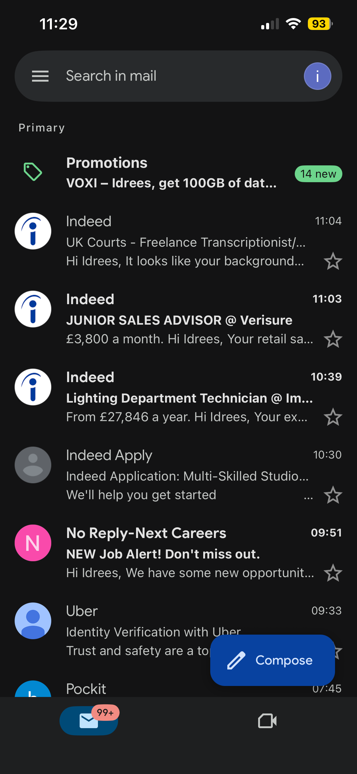
I use Gmail for day-to-day use receiving and sending emails, this screenshot shows my inbox on Gmail receiving emails from various sources. I have always used Gmail as it’s got a good layout which is easy to understand and easy to navigate. Things I could improve using this app is moving important emails to the right place and removing unnecessary emails to the bin as this would clear up a lot of space as you can see I have a lot or emails that I have not read.
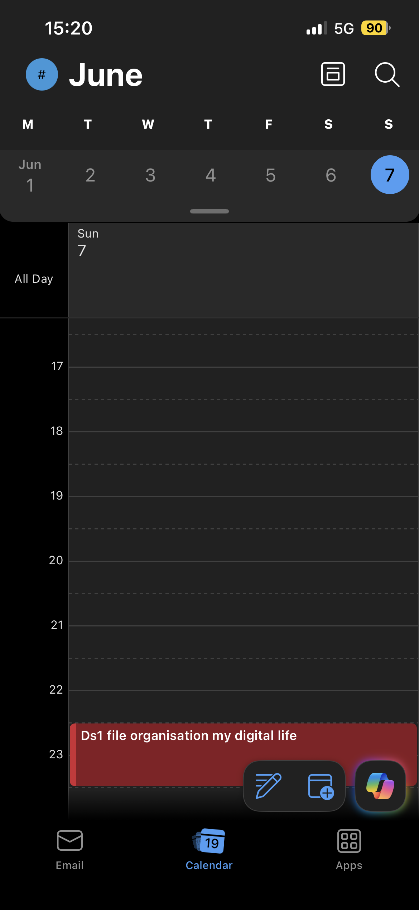
This screenshot shows me using the outlook calendar to remind me of my assignment coming up, this is an exceptionally good way to stay on track of my assignment, as you can set reminders, so you do not forget. As well as this it is remarkably easy and simple to use using this app will certainly make me stay on top of all my work that I have coming up. This is a perfect way for people who are busy in there day to day lives to stay up to date with what they must do it can be used for many things such as businesses, university and much more.
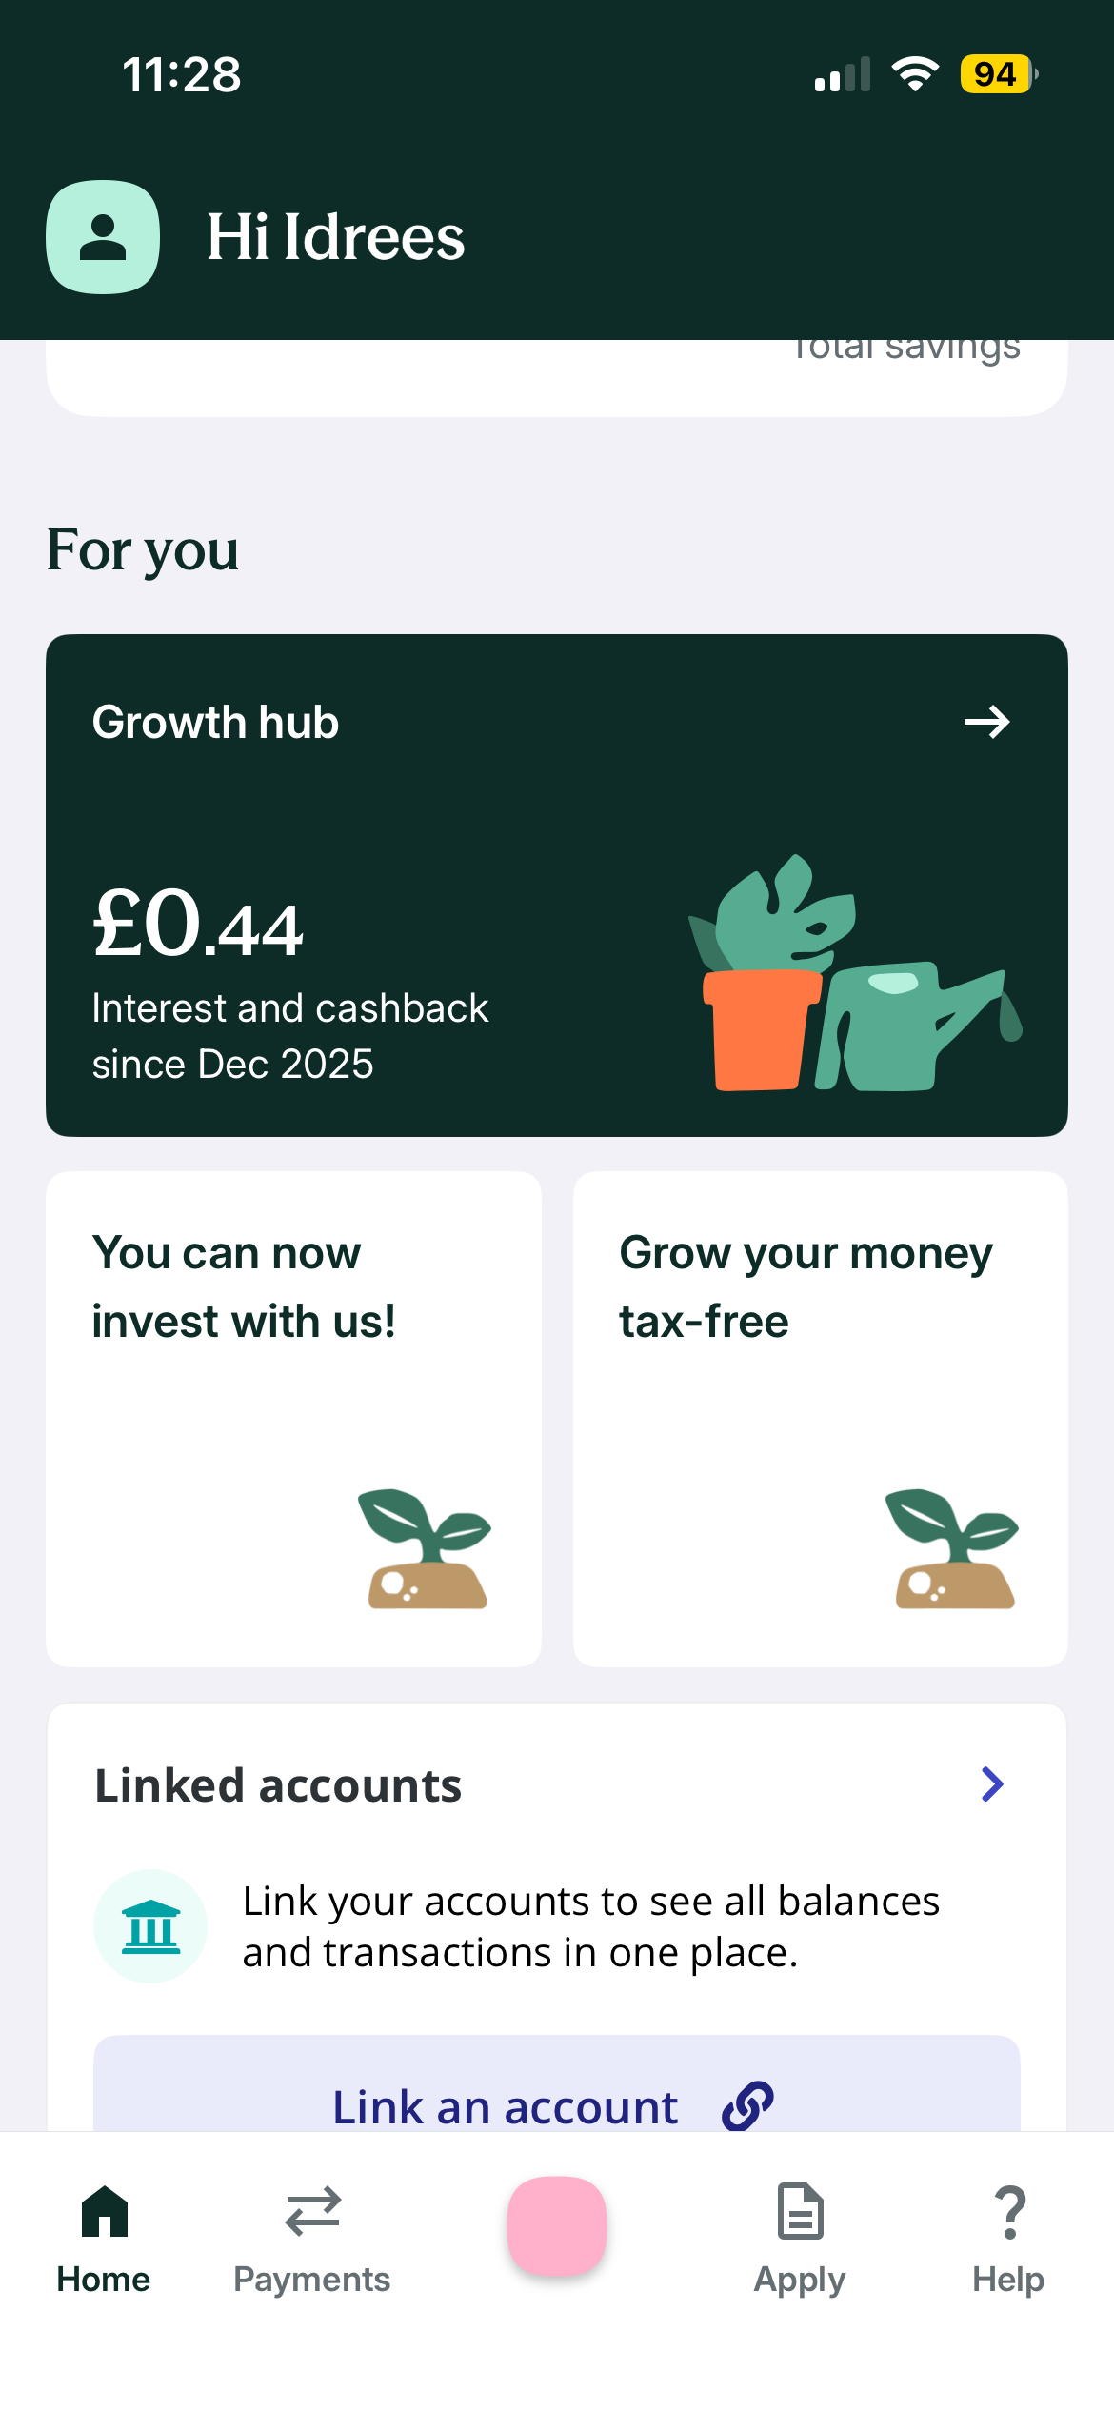
these screenshots of my banking app show the layout of how the app works for example you can see the interest and chargeback I have received you can also see the linked accounts and all the other tabs at the bottom, I use this online bank as it’s easy to navigate and having pots for saving is very useful as you can keeps tabs of how much you have saved and it’s easy to access, I use this for everyday spending as it gives me instant notifications. I enjoy using this app for my digital life as it is easy to use. However, one thing I would improve is the colour as sometimes you can get confused, they should change the colour for each tab which would make it a lot better.

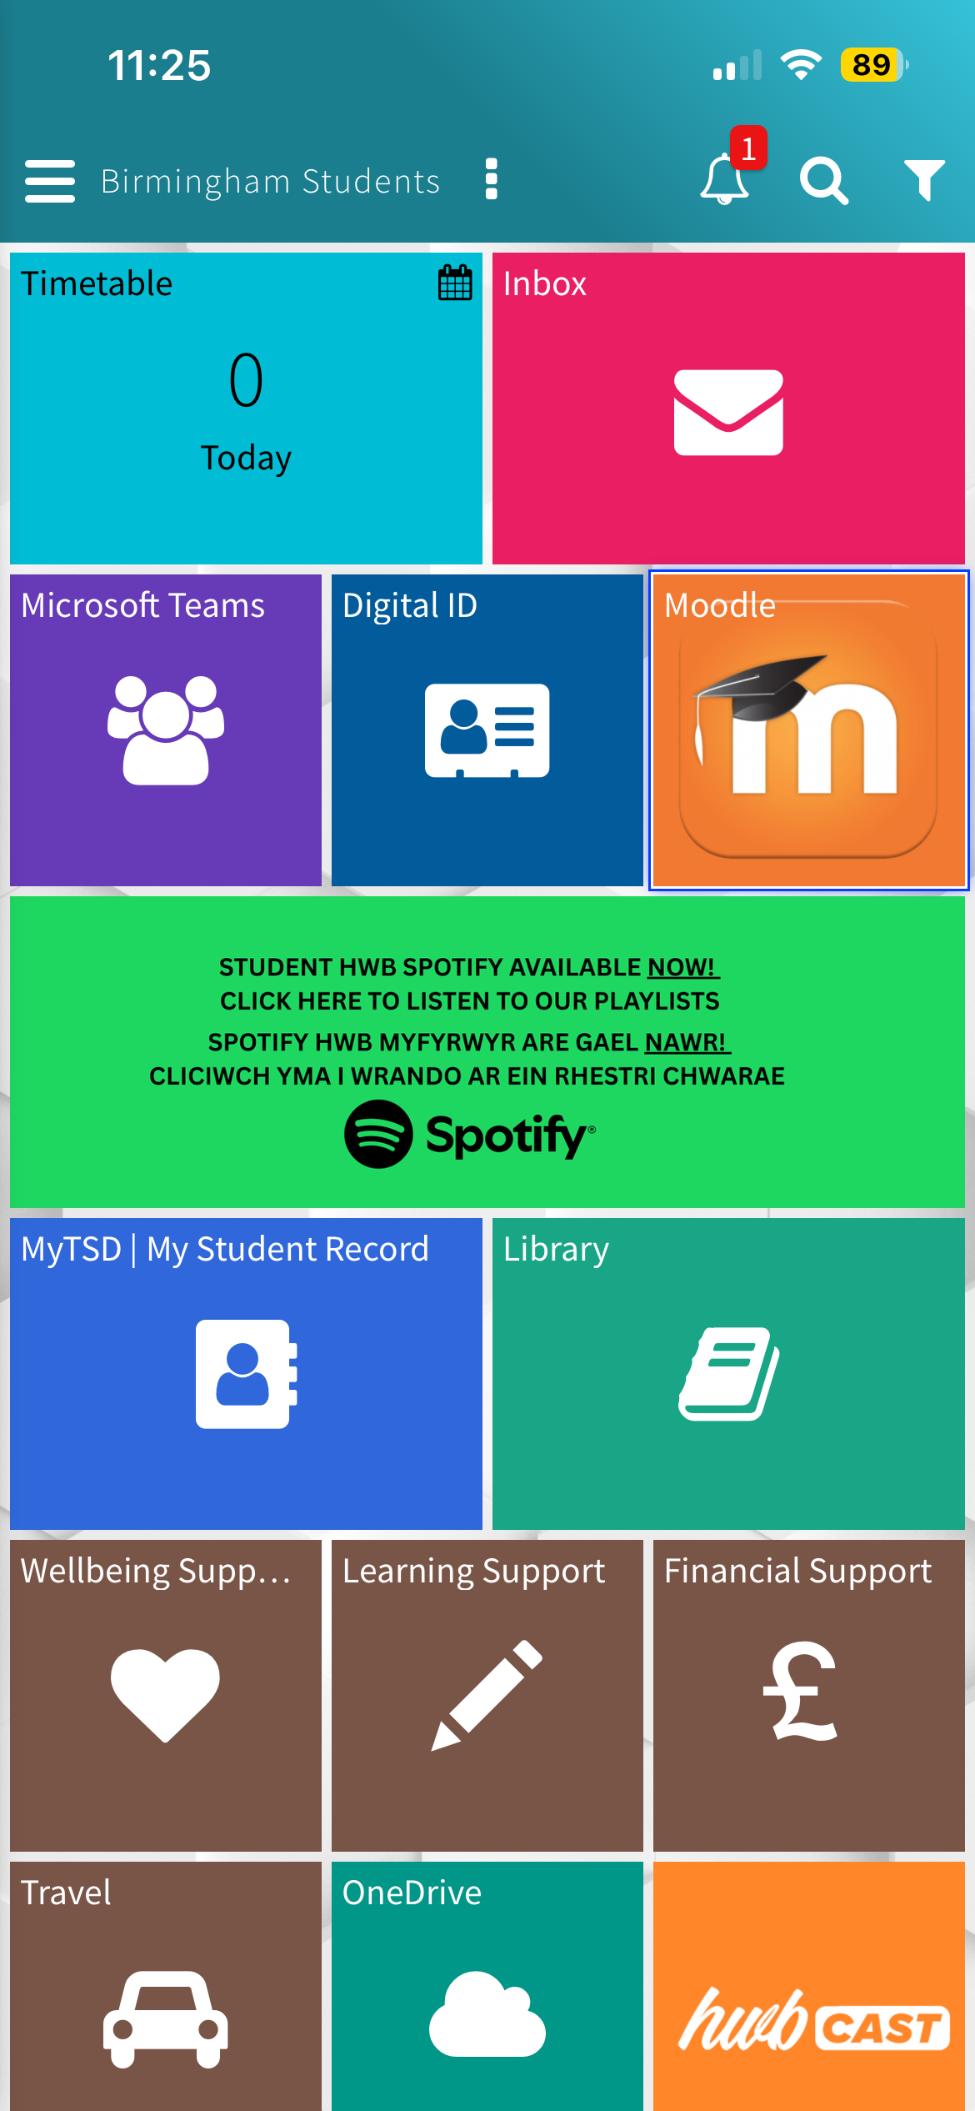

this screenshot shows the student app called Uwtsd Hwb this is the app I use everyday at university. It gives me access to many different things such as my timetable, the moodle app, student support, emails and much more. This app helps me stay on track and organised while being on track of my studies, it shows how digital life is important for me on a daily basis because I use this for learning, catching up on lessons I have missed and managing tasks. One thing I would improve is sometimes some of the tabs do not work when I try open them apart from this the app is perfect for university students such as my self.

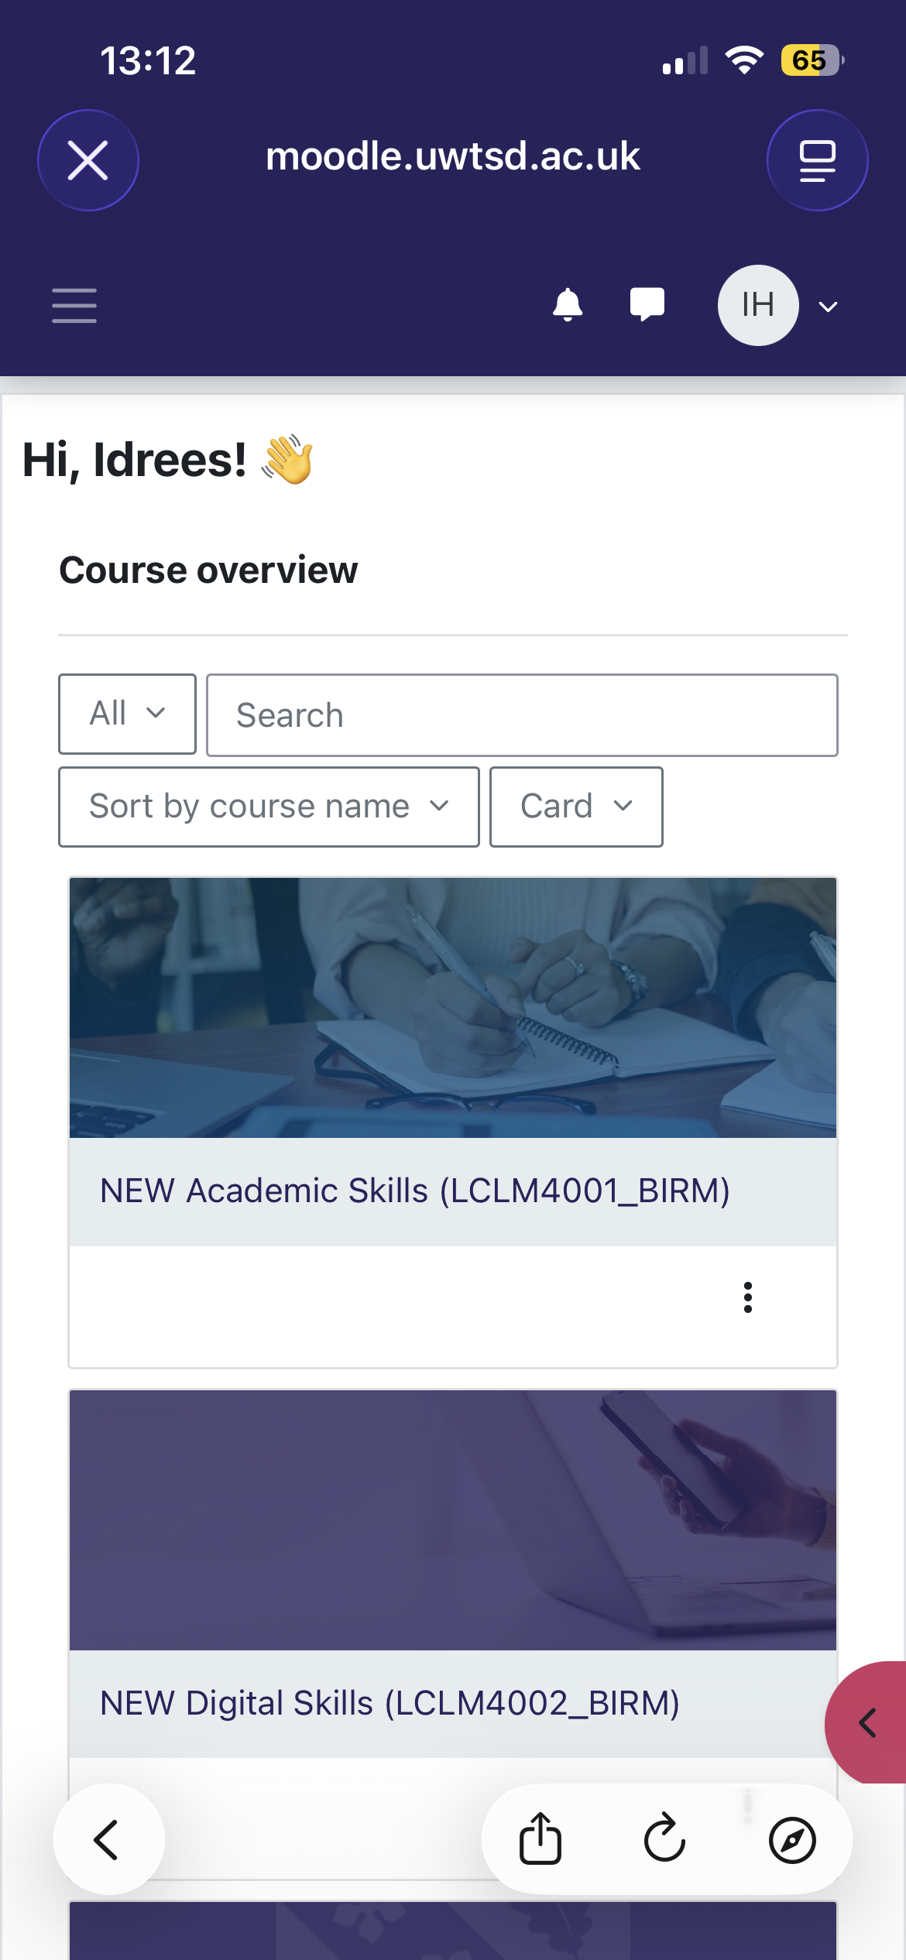
This screenshot shows how university students can access the moodle app, and it shows the home page of the app where you can see the different modules such as academic skills and digital skills. This page allows students like my self to access all the Learning materials that are needed for my course such as the modules, different assignments and other course materials that are key for my studies. One thing that could be improved is allowing students to see all options within that task box for example on the academic skills it could have a drop down box so I can directly click on that instead of opening the whole folder which would save time by scrolling through and looking for it.

My short reflection
I use digital skills for everyday life examples of this are to study, communicate, stay up to date with everything and find essential information. I feel confident when I use digital skills and technology to find out about my assignments and also to find key information about my course that I’m studying, as well as this I’m also confident using multiple digital skills such as email addresses and banking apps to stay up date with everything that way I won’t fall behind.I want to improve my digital skills by Learning about new apps and softwares that can help me while I’m studying and getting my degree. I often use these tools such as a smartphone, laptop banking apps, email, moodle, Uwtsd hwb and outlook calendar I use these on a daily basis however now as I am a university student I want to get more familiar with digital skills known for student as this will make me succeed in my study’s. An example of this is me starting to use the Uwtsd hwb app to get familiar with the layout and it also has key information about university and assignments which is key to me.
I sometimes feel nervous about using new digital tools as I am scared, I will not be able to use the app correctly which could then lead to technical difficulties and losing work, as well as this I am also nervous about my data privacy being leaked. I hope this module will help me become more confident with using new digital skills and trying new things and apps that I would not use before, my goal is to become confident with every app I use and introduce new digital skills to my life that I can use for university and also carry on using them in the future. Digital skills are important for me because they will help me throughout my studies and to succeed by getting my degree, furthermore they will help me learn new things and work more efficiently. As well as these digital skills are important for me as we live in society where everything is based online and through digital apps so by using these I will always be up to date, with me being a university student I need to use digital skills to do well in my course.

