A FITT Framework Analysis on Automatic Text Reminders
Introduction
Within healthcare, patients not attending NHS appointments is a major issue. Estimates in 2015, by then Health Secretary Jeremy Hunt show that missed NHS appointments were costing the NHS £912 million a year (Torjesen, 2015, p. 1). With an estimated £750 million of the £912 million being hospital appointments (Torjesen, 2015, p. 1). Each appointment missed can cost the Cardiff and Vale Health Board (C&VUHB) up to £160.
C&VUHB looked at multiple ways in which they could help in reducing the did not attend (DNA) rate. The strategy agreed was to introduce a reminder system for outpatient appointments. Reminding patients of their appointments can help in reducing patients not attending their appointments (Robotham et al., 2016, p. 1). This developed into an automatic text reminder messaging system in 2016. With studies showing text reminder notifications can reduce the DNA rate (Robotham et al., 2016, p. 13).
Mobile subscriptions worldwide were 7.4 billion in 2016. Which increased to 8.1 billion by 2021. (Ericsson, 2021, p. 5). With the U.K. having 84.5 million active mobile subscriptions at the end of 2021 (Ofcom, 2022, p. 1). C&VUHB believed a text messaging service to remind patients of their appointments was a viable option because of people’s access to a mobile phone within the U.K.
Other health boards have seen the successful introduction of text reminders. The text reminder system has in some areas reduced the DNA rate by half (Kiruparan, Kiruparan, and Debnath, 2020, p. 4). By introducing a text reminder system, C&VUHB predicted there would be a reduction in the DNA rate to a minimum of 10% of clinical activity with a target goal of 5%.
The reasoning behind a new method of contacting patients was because of the drawbacks of the previous booking processes. There were two main methods of booking appointments prior to any text reminder system. The two methods were for patients to be booked by either telephone call or by appointment letter. Both had benefits and drawbacks.
The benefit of booking appointments by telephone is patient input. Patients can agree to the appointment and confirm a date and time that is suitable. However, the drawback to this method is the availability of patients to receive telephone calls during the working day. This increases the time and effort by staff to book through this method and can cause communication errors, leading to the patient receiving the incorrect information.
The method of sending appointment letters to patients is quick and efficient for staff. It reinforces the fact that the information the patient receives about the appointment will be in full, with no misinterpretation. A drawback to this method is that patients do not have input, which can lead to an increase in phone calls for rescheduling and cancellation request (RCR). Another negative is there is no confirmation that the patient receives the letters, and if they are planning to attend the appointment. The patients may never receive an appointment letter sent (Chung et al., 2016, p. S321).
Appointment letters are usually used to book follow-up appointments, with many appointments booked 6-12 months in the future, which patients can forget they have received. Studies have shown that there is a link to higher DNA rates in follow up patients with one of the main reasons for missing the appointment being forgetfulness (Prudden, 2021, p. e151).
C&VUHB could achieve a reduction in the DNA rate by combining methods, but C&VUHB did not see this as beneficial because of the increase in administration demand and was not cost effective. Therefore, a new method, such as the text reminders, was required.
No new IT solution is cheap. Therefore, the benefits of the text reminder messaging system being introduced needed to include multiple items to be considered a cost-effective investment. The first benefit and specific priority was the reduction of the DNA rate. As this was the main cause for introducing a new system. A reduction in the DNA rate will save C&VUHB money. Another factor is reducing administration time spent on the booking of appointments by alleviating the time spent on contacting patients through previous methods like telephone calls. C&VUHB also hoped there would be a reduction in patients’ calls to the appointment booking centre (ABC) enquiring about their next appointment date or to change their appointment at short notice.
After an extensive and due diligent procurement process, C&VUHB chose healthcare communications product envoy messenger (EM) to help facilitate the new communication to patients through text messaging. EM enables text messages to be sent to patients either manually or automatically. The process of automatic text reminder (ATR) was favoured, as it would not increase administration duties and costs.
After careful consideration, C&VUHB decided it would send two texts reminders to patients with upcoming outpatient appointments. C&VUHB selected two text reminders as it could lead to an increase in attendance by almost 20% compared to one text reminder (Robotham et al., 2016, p. 11).
The first ATR allows for two-way communication, with the second ATR being one-way communication. Two-way messaging gives the ability to interact with patients regarding their upcoming appointments (Feldacker et al., 2019, p. 2). However, administration staff is required to manage the responses. One-way messaging is messaging the recipient cannot respond to (Linde et al., 2020, p. 2). The benefit of one-way messaging is that it requires less administration staff, as no outcomes need to be actioned (Linde et al., 2020, p. 2).
Patients receive the first ATR 10 days prior to the appointment. This allows for the patients to confirm, cancel, or reschedule their appointments. This message is a reminder to be received by patients but also sends confirmation of their expected attendance. It enables the patient to cancel or reschedule their appointment if no longer convenient. C&VUHB selected 10 days for the first message to be sent, to give enough time for patients to respond and the responses to be actioned. Unwanted appointment slots are then available to be rescheduled with a replacement patient.
The second text message is a one-way text message being used 2 days prior as a further reminder to the patient of their appointment. This message is to remind the patient of the appointment only, rather than asking the patient to confirm their attendance.
By using the FITT framework retrospectively on implementing the ATR system, it will enable C&VUHB to see if the implementation was a success and where there is a need for improvement. It will also show lessons learned for future IT project implementation.
Method
The FITT Framework
The Fit between Individuals, Task and Technology (FITT) framework is used to help in determining a digital solution’s likelihood of success in businesses. (Tsiknakis and Kouroubali, 2008, p. 40). FITT does this through the idea that the adoption of new technology or systems depends on the fit between individuals, tasks, and technology (Nilsson et al., 2020, p. 2). The FITT framework differs from other approaches as, rather than looking at organisation, it separates the organisation into different facets. With the organisation being split into the individuals or groups and their tasks, such as their defined responsibilities (Ammenwerth, Iller, and Mahler, 2006, p.4).
The FITT framework is a straightforward view to describe and evaluate IT implementation efforts (Tsiknakis and Kouroubali, 2008, p. 50). The FITT framework clearly describes the target and connections affecting the three points (Fig. 1).
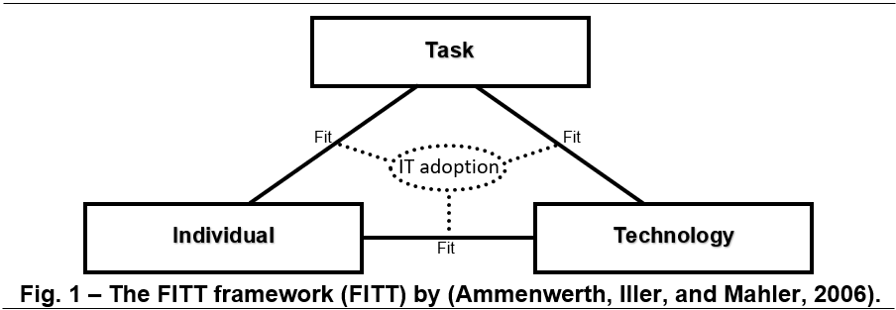
The FITT framework defines the Individual as a singular person or group. The task is the completion of a process. With the technology being the equipment needed to complete said tasks (Ammenwerth, Iller, and Mahler, 2006, p. 4). An example of these parameters is with the introduction of the ATR system. The Patient Administration Support Officers (PASO) represent the individual, reminding patients of their appointments is the task, and the text message is the Technology (Fig. 2).

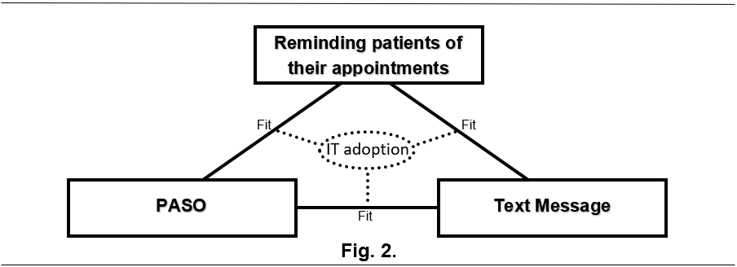
The individual factors could be a user’s computer literacy or motivation, amongst other characteristics. Factors for technology can include the usability of the product, speed of use, and connectivity to other products. Factors for the tasks can comprise of the organisation structure, complexity of the task involved etc (Tsiknakis and Kouroubali, 2008, p. 40). The FITT framework evaluates the different interconnectivity points between each factor that influence the success or failure of adoption of technology products (Cho et al., 2019, p. 3). This means that the interaction between the three attributes is more critical than the attributes separately (Nilsson et al., 2020, p. 2). An example would be IT software requirements and the users’ IT skills matching (Ammenwerth, Iller, and Mahler, 2006, p. 10).
By using the FITT framework, through the interaction of the three elements, it is hopeful the framework will discover issues that will have solutions. Using the FITT framework can predict or retrospectively analyse issues (Honekamp and Ostermann, 2011, p. 47). Any interventions that are made to a system can have further evaluation through the FITT framework (Honekamp and Ostermann, 2011, p. 47).
The object of the FITT framework is to establish the best possible fit between individual, task, and technology. Insufficient fit will lead to an increased chance of failure of projects that are implemented (Ammenwerth, Iller, and Mahler, 2006, p. 11). By understanding the failures of IT projects, it will allow in theory better preparation for the launch of other IT based projects (Ammenwerth, Iller, and Mahler, 2006, p. 12). Furthering the likelihood of future IT based project success through lessons learned.
The FITT framework uses the optimal, sufficient, and insufficient approach using the icons ,, to indicate each in the framework. represents optimal, represents sufficient and is for insufficient.
With the FITT framework being used multiple times throughout. From an overview of the main aim of reducing DNA rate, to how ATR impacted different areas and the project’s objectives.

Work as Done
To establish the success of the IT software introduction through the FITT framework, data will need to be collected. The data will need to cover every aspect of the Individuals, Tasks and Technology within the FITT framework. To do these multiple factors have to be taken into consideration. There is usually a gap between the theory and reality of how things are done (Schubel et al., 2019, p. 767). To improve success of implementation, there needs to be a recognition of the difference between the theory ‘work as imagined’ and the reality ‘work as done’ (Deutsch, 2017, p. 80). The idea is to understand the reality rather than the description (Schubel et al., 2019, p. 767).
To achieve as close to ‘work as done’ as possible, there must be consideration for six views (Deutsch, 2017, p. 81).
These are:
- work as imagined
- work as abstracted
- work as claimed
- work as simulated
- work as observed
- work as documented
Not one perspective of these six views will provide the whole truth, as any new system introduced into a healthcare setting is complex (Deutsch, 2017, p. 81).
Data Collection
To establish current standards and evaluate the ATR system in the FITT framework. A mixed method analysis was required through work observations, data collected, documentation, along with interviews and surveys with all stakeholders of the ATR system.
The stakeholders and users that were interviewed and surveyed for the project, looked at every aspect of how the ATR system can affect users within the outpatient setting. This involved speaking to managers of the PASO team who deal with the booking of outpatient appointments. This is to establish the achievement of the objectives of the ATR system and to gage reaction through the eyes of management. Further to managers, the questioning of the PASO staff took place. To discover not just how they feel the new system works, but to establish their thoughts on technology and the introduction to new ways of working. Clinicians and directorates were also engaged in their views as they are the individuals that see the full benefits realised from the ATR system. As with introducing all healthcare technology that impacts patients directly, it is essential to consider patients’ views.
Work observations of user’s day-to-day activities using the system also took place to gain a greater understanding of the ATR system. While also looking at the previous appointment booking methods used, to gauge the success or failure of the methods along with areas of improvement.
The data viewed included the DNA prior to introduction of the ATR system and post. To see if the system had a quantitative impact on numbers. Quantitative data collected on ATR rollout such as DNA rate only featured the period of 2015-2020. This was because of the suspension of systems such as ATR at the beginning of covid. The reinstating of ATR is currently in a phased approach to incorporate new deliveries of patient care, such as virtual appointments.
Secondary data of patient surveys in 2016 and 2020 from the project team on deployment of the ATR system were also used to see trends on patient’s preferences of communication methods.
Results
DNA rates
C&VUHB piloted the ATR system in June 2016 within the Ear, Nose and Throat (ENT) department. Before the ATR system received a full rollout to all specialities in April 2017. By looking at the second quarters at ENT over a 4-year period starting in the financial year of 2014/2015, which had no reminder system active, it shows a dramatic reduction in the DNA rate (Fig. 3). There was a reduction of 4% from 2014 to 2017. With the DNA rate being reduced in these 3-month quarters from 490 to 312. That is roughly a £30,000 pound saving for the ENT department.

Fig. 3
The project rollout became more successful as time went on with the DNA rate for ATR averaging around the 5% mark between September 2018 and February 2020 for all specialities. (Fig. 4) and (Fig. 5) show that ATR had a considerable impact compared to outpatient appointments that did not receive an ATR. The project manager stated that the non-text reminders DNA rate includes patients with no mobile number recorded and clinics that requested to be excluded for a multitude of reasons.

Fig. 4

Fig. 5
The project manager believed that the increased improvement in the DNA rate for ATR was the awareness campaign they introduced, along with patients becoming more familiar with the ATR service. As a common complaint from patients at the launch, was the belief that ATR was a scam.
Increase in RCR
An issue that became known once the ATR system became operational was the volume of RCR. The Health Board refers to an appointment that patients cannot attend with the slot not reutilised as a CNA (Could Not Attend). From interviews with the directorate and the project manager, they believed that this showed the project was working. ATR was reducing the DNA rate, as it was releasing slots to be backfilled. However, there was no consideration of the increase in work for the PASO team having to backfill these slots. Especially as the slots were only getting released 10 days prior. Meaning that slots would have to be filled by telephone, rather than the quicker method of sending a letter. Creating an extra administration burden that did not previously exist. (Fig. 6) and (Fig. 7) show the number of RCR in Gastroenterology and ENT respectively during the period July to September 2019. This data shows the RCR increase 10 days prior to the appointment, with the highest number of RCR received between 4-7 days prior to their appointment.

Fig. 6

Fig. 7
The average time to fill a short notice slot is 13 minutes. C&VUHB define a short notice slot if it is an appointment filled under 10 days. Table 1 shows the number of slots on average filled by each PASO in the period from February to March 2018. The data shows that the time to fill a slot in this period of 10 days and under has no coloration to the number of days available before the appointment. With only a 0.2 day difference, between the shortest and longest time it takes for appointments to be booked. Table 1 also shows no coloration between the average number of patients called and the number of days prior to the appointment. Therefore, there is no data to suggest there is an optimal time to call patients to book an outpatient appointment.
Table 1 - Statistics on the number of patients called
between February 2018 - March 2018 per PASO.
Time taken | Number of appointment slots filled | Average number of patients called | Average number of days from appointment
16 mins and over | 14.6 | 10.5 | 3.7
11-15 mins | 9.3 | 3.6 | 3.5
6-10 mins | 10.6 | 2 | 4.4
0-5 mins | 8 | 2.4 | 3.5

PASO
Table 2 - Statistics on number of PASO aware of the implementation of ATR.
Using a scale of 1-5 with 5 representing full awareness and
1 representing no awareness at all.
Awareness Scale | PASO Responses | Percentage
5 | 2 | 12.50%
4 | 0 | 0%
3 | 3 | 18.75%
2 | 7 | 43.75%
1 | 4 | 25%

From interviews and surveys done with the PASO team responsible for dealing with the RCR. They expressed there was no consideration for their team regarding the introduction of the ATR software. The PASO team felt managers only made them aware of the new system when it was being deployed. Table 2 shows that roughly 70% of the PASO team surveyed were unaware of the impending implementation of ATR. On the back of the vast majority, being unaware of the deployment of ATR. 75% of the PASO team surveyed believed that if they had been involved in the initial discussions, they would have mentioned the flaw with the extra RCR. However, as these surveys and interviews have taken place after the rise in RCR, it needs to be considered that this might be down to hindsight bias. Hindsight bias is when people believe they knew it all along. In essence, it is the principle that the event is more predictable after the outcome has become known than it was before (Roese and Vohs, 2012, p. 411).
Managers of the PASO team.
During interactions with managers, the biggest issues that have arisen since the ATR system launch were with acceptance from the PASO team. As Table 3 shows, PASO acceptance, along with the increase in administration duties with actioning the RCR, were the biggest issues. The extra administration duties were a new issue not previously seen from the PASO interviews. Managers revealed the ATR system failed to achieve full automation. The managers everyday must action the received RCR from the previous 24 hours. With the RCR only being actioned once a day, it adds a delay for the slots to be reutilised.
Table 3 - What are the biggest issues and benefits
seen since the launch of ATR.
5 biggest issues |  | 5 biggest benefits
1 | PASO acceptance | 1 | Reduction in DNA rate
2 | Extra administration duties (actioning RCR). | 2 | Better communication with patients
3 | Other responses to text messages from patients (more time required to decipher). | 3 | Reduction in calls to ABC (to confirm appointment details).
4 | Increased CNA rate. | 4 | Reduction in time wastage of reception staff (waiting for DNA patients).
5 | Extra calls to the ABC (technology illiterate patients). | 5 | Reduction in paper wastage (DNA letters).

No full integration between healthcare communications and the in-house Patient Management System (PMS) leads to extra administration burden. With only the confirms automatically uploaded to the PMS (Fig. 8). The reports need to be actioned by a manager every day, requiring a higher banded staff member to deal with increased workloads. This reduces the money being saved by using a manager rather than a PASO team member actioning these reports. The extra administration requirement was also a factor for the other responses received from patients. Other responses refer to responses received that were not the designated confirm, cancel, or reschedule. The Other responses need further investigation to decipher the response.

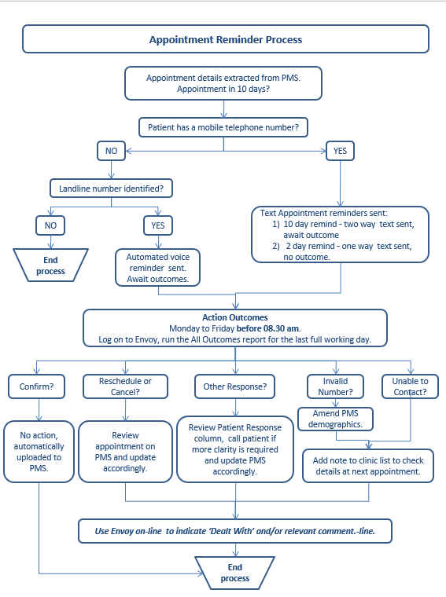
Fig. 8

Clinicians and Directorates
From interviews conducted with clinicians and directorates, the consensus showed that they were extremely happy with ATR as it allowed for more patients to be seen and waiting lists to be reduced (Fig 9). As the slots could be reutilised and the time of the clinicians was not being wasted by waiting for patients who are not attending, improving productivity. This was to be expected, as the clinicians and their teams were not processing the ATR or dealing with the fallout of the RCR and the backfilling of slots. The only negative comment to come out of the process was that the patients on the clinic lists are being replaced at short notice. This is likely to lead to an increase in RCR.

Fig. 9
The Immunology directorate stated that they want the suspended ATR system to be turned back on as soon as possible. The reason for this stance was several issues in recent months with their DNA rate, with one clinic having a DNA rate of 50%. When they audited to find the reason, the consensus was the patient had either forgotten they had an appointment or were unaware. The ATR system solves both issues.
The consensus between clinicians and directorates was there could be improvements to ATR. By using ATR in further ways, such as sending information related to appointments. Such as reminding patients to not eat or drink before an appointment that needs bloods taken.

Patients

Fig. 10

Fig. 11
Patient satisfaction is a key element in introducing any new IT system that involves patient participation. If patients were not happy with introducing the ATR system, it would fail. It was key to the strategy that patient engagement was involved. Through patient engagement in 2016 and 2020 on patient communications preferences, it showed satisfaction in patient communication of outpatient appointments increased by 18% (Fig. 10 and 11). This shows that since C&VUHB introduced text notifications, patients are increasingly happy with the communication they are receiving.
Furthering the link in patients’ satisfaction being improved by ATR is the statistics on patients’ preferred method of reminders for appointments. 2020, which saw a shift to text messages being the preferred method, increasing by almost 18% (Fig. 12 and 13). The reduction in patient preferences towards email and telephone reminders compounds the shift towards text messages. With patients’ preferences for telephone reminders being reduced by 4%, from 2016 to 2020.

Fig. 12

Fig. 13
A factor to come from the patient engagement was that patients’ preferred method of scheduling an appointment had also increased by 18% for text messages (Fig. 14 and 15). With a reduction in the other preferred methods, including a letter in the post, text messages are close to being the joint preferred method. This shows that ATR is working for patients as they see them not only as a method for reminders but as a preferred method of communication with C&VUHB.

Fig. 14

Fig. 15
An interesting note from (Fig 14) and (Fig. 15) is telephone calls are the patient’s preferred method for scheduling appointments. Telephone calls have decreased to 5% in 2020 from 11% in 2016. This bringing to light the issues that were stated by the PASO team regarding the booking of empty slots through RCR because of ATR. With increased appointments being booked at short notice using the method of a telephone call, a service is being provided using a method of fourth choice for patients. Which could be a factor in the increased time to backfill an appointment slot.

Discussion
FITT Framework Analysis
By using the FITT framework for clinicians and the reduction of the DNA rate through ATR, the project’s aim is a success (Fig. 16). With the DNA rate reduced and averaging at just over 5%, the technology and task were achieving at a sufficient level. To achieve optimal adoption, the rate of DNAs needs to be under 5%. ATR did not achieve the DNA rate of 5%, but the ATR did significantly reduce the DNA rate overall, so was accomplishing a sufficient level of adoption. Clinicians along with directorates were happy with ATR as more patients were being seen and reducing waiting list times. The fit between technology and the individual did not achieve optimal integration because of an increase in late changes to the clinician’s clinic.
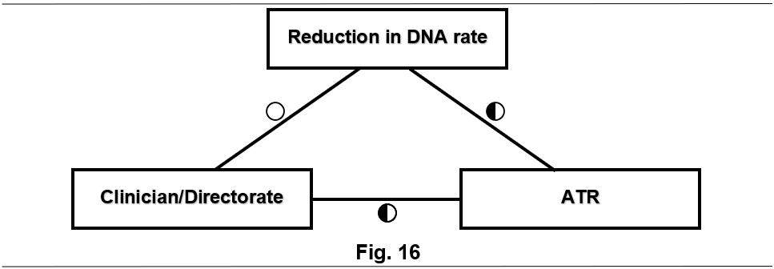
FITT framework achieved optimal adoption when looking at the project from the eyes of patients (Fig. 17). By looking at the objective of improving communication with patients, C&VUHB can see the project as successful. Patients’ preference for reminders is overwhelmingly in favour of ATR. Making optimal levels achieved for the fit between individual to task and individual to technology. However, it is only sufficient levels between the task and technology because staff are only dealing with patient responses once every 24 hours. Leading to a delay in actioning patients’ requests.
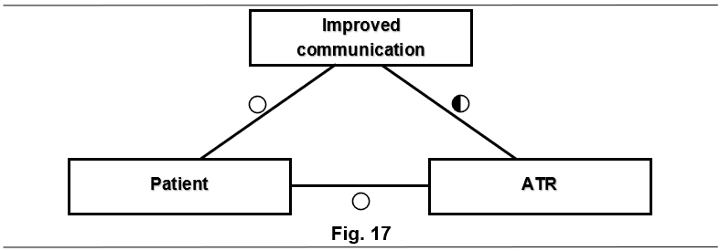

Integrating COM-B
A factor that came out from discussions with managers was the issues with user acceptance from the PASO team with the new technology. From the evidence gathered through interviews with the PASO team, it backed the managers’ assumptions. However, it also showed that staff who had been in post for longer than 5 years thought there was no need for new processes and were less likely to accept change. Staff who had worked in the role for under 5 years were more likely to accept recent technology. By using Capabilities, Opportunities, Motivations, Behaviour (COM-B) model it revealed that there are underlying issues for why acceptance is lower in longer tenured staff and how the FITT framework can help discover these issues.
The COM-B model is an all-encompassing model to capture the aspects that affect behaviour change (Keyworth et al., 2020, p. 475). In the COM-B model, the parts capability, opportunity, and motivation interacted to produce the behaviour which in turn affects the three areas (Michie, van Stralen, and West, 2011, p. 4). COM-B defines capability as having the physical and psychological capability with the task concerned. Opportunity are the factors that lie outside the individual that prompt or make the behaviour possible. Motivation are things that energise an individual, emote responses and address behaviour (Michie, van Stralen, and West, 2011, p. 4). Capability, opportunity, and motivation are all needed to produce behavioural change (Gould et al., 2015, p. 3), with the model not prioritising any factor and all having equal status (Michie, van Stralen, and West, 2011, p. 4). However, even though they are equal, it can identify how changing elements could affect the required resolution (Michie, van Stralen, and West, 2011, p. 4).
By using COM-B with the results of the interviews with the PASO team, it has shown that the reason for the issue is likely to be motivation. The staff’s motivation has dwindled from multiple innovative technology solutions or products being introduced and failing. Therefore, staff that had been in post for a shorter amount of time were less disillusioned as they have been less exposed to previous IT project failures.
By using the FITT framework with COM-B, it is easy to establish an issue with the deployment of the ATR system. As one of the key factors in the individual section of fit is flexibility and openness to new ways of working by the user (Ammenwerth, Iller, and Mahler, 2006, p. 4). Without user openness to new ways of working, it was likely the project would fail. As (Fig. 18) shows, there was a lack of user openness to introducing ATR. The modern technology compounded this, creating an extra administration burden. Where the PASO team viewed ATR as an extra task being added, that has no benefit to them. Rather than seeing how it benefits the trust and patients.
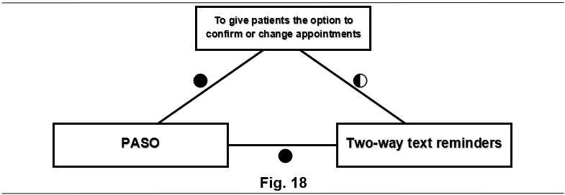
By understanding the complexities of user acceptance, it is easier to put in place mechanisms to negate these issues. These could be investing in training sessions or parting knowledge to the individual users, such as on the key aspects and benefits of the ATR booking system (Ammenwerth, Iller, and Mahler, 2006, p.11). This could include sessions on reducing the DNA rate, leading to the saving of money for the trust. With, discussions also taken place about why ATR will differ from other failed products to garner user support. By investing in training sessions such as webinars and showing the benefits, will allow for users to feel more at ease with the new software. As fear of the unknown is one of the oldest and strongest fears (Carelton, 2016, p. 11).
Limitations of FITT
The FITT framework has its limitations. By trying to be simplistic, it will only show the surface of a product’s implementation if only used for the project’s aim (Fig. 16). By only focusing on one or two of the factors of success, it can overgeneralise the intricate nature of an organisation that the IT solution is being introduced to (Tsiknakis and Kouroubali, 2008, p. 50).
Another limitation of FITT is the lack of consideration for the macroenvironments, unlike the Technology, People, Organisation and Macroenvironmental (TPOM) framework. Like FITT, the TPOM elements do not outrank each other (Cresswell, Williams, and Sheikh, 2020, p 5). The technology and people of TPOM can compare to those of technology and the individual. With organisation and macroenvironmental different elements. The organisation looks at, for example, leadership and management or resources (Cresswell, Williams and Sheikh, 2020, p 4). With macroenvironmental representing elements such as professional groups, vendors or measuring impact (Cresswell, Williams and Sheikh, 2020, p 4).
TPOM, like FITT, does not cover every factor. But it is likely to improve success by encouraging consideration of the key factors that influence outcomes (Cresswell, Williams and Sheikh, 2020, p. 7). However, like many frameworks, TPOM forgets to account for the connection between social and technological dimensions of change (Cresswell, Williams and Sheikh, 2020, p. 7). The evaluation of other frameworks is the building blocks of TPOM. Therefore, TPOM could incorporate the FITT Framework.
The TPOM framework can assist in the decision making in moving from reactive to a proactive strategy. Which helps with quicker decisions. TPOM is likely to be more beneficial when looking at larger projects that affect multiple areas, such as health board wide or national projects.
Conclusion
The FITT framework helped in successfully structuring the retrospective analysis of the ATR system within C&VUHB. Through the evidence gathered using the FITT framework, there was a discovery of issues and barriers to full IT adoption of the ATR system. These included issues with seamless care for the EM.
The biggest barrier discovered was the increase in RCR and the PASO team issue with accepting the new system. The framework highlights the believed reduction in administration duties through introducing the EM. This was incorrect and the duties either shifted to a new task or increased.
Another factor that was not considered in initial implementation was the CNA rate. As the results established that the time to fill slots increases when under 10 days because of patients being called by telephone rather than letter. The new intervention could lead to more slots not being filled. Recording of data on the CNA rate did not take place. So, the benefits of reducing the DNA rate might have not been as effective as shown. The CNA rate could have increased. Therefore, time slots could still have gone unused.
Until C&VUHB look at RCR, seamless care of the automated ATR system will be unlikely. The FITT framework can help improve the success of seamless care as management can directly influence the attributes of task, individual and technology (Ammenwerth, Iller, and Mahler, 2006, p. 4). An example of this is a software update may influence both the fit between task and technology (Ammenwerth, Iller, and Mahler, 2006, p. 5). Which could allow appointments to be booked by PASO staff through manual text messaging, the preferred option behind appointment letters. Or it could schedule the first ATR to be sent with a bigger interval from the appointment, as an example, 14 days prior. Allowing the slots to be backfilled by letter when released through RCR. Training sessions for users may also improve the fit between technology and individuals (Ammenwerth, Iller, and Mahler, 2006, p. 5).
Even with the barriers to seamless care with the ATR System the value to outpatient appointments is clear. There has been a reduction in DNA rate, saving the C&VUHB money and improving the happiness of clinicians, directorates, and patients.
By using FITT framework retrospectively, it is easy to see how C&VUHB can make improvements to future IT projects implementation. By engaging more with the low-level staff likely to be using the software in their daily jobs will help improve staff support and feel a part of the decision process. This will also help in achieving closer results to ‘work is done’ rather than ‘work as imagined.’ It is also essential that training material and tutorials take place. While keeping staff in the loop with the project’s deployments. This will help in reducing staff feeling alienated and help conquer technology illiterate staff.
References:
Ammenwerth, E., Iller, C. and Mahler, C. (2006), ‘IT-adoption and the interaction of task, technology and individuals: a fit framework and a case study’, BMC medical informatics and decision making; BMC Med Inform Decis Mak, 6(1), pp. 3. DOI: 10.1186/1472-6947-6-3
Carleton, R.N. (2016), ‘Fear of the unknown: One fear to rule them all?’, Journal of anxiety disorders; J Anxiety Disord, 41, pp. 5-21. DOI: 10.1016/j.janxdis.2016.03.011
Cho, H., Flynn, G., Saylor, M., Gradilla, M. and Schnall, R. (2019), ‘Use of the FITT framework to understand patients’ experiences using a real-time medication monitoring pill bottle linked to a mobile-based HIV self-management app: A qualitative study’, International journal of medical informatics (Shannon, Ireland); Int J Med Inform, 131, pp. 103949. DOI: 10.1016/j.ijmedinf.2019.08.009
Chung, K., Stobie, P., Travlos, R., Francis, J. and Francisco, J. (2016), ‘Reducing DNA Rates to the Outpatient Cardiology Department: The Challenges Faced at Sir Charles Gairdner Hospital’, Heart, lung & circulation, 25, pp. S320-S321. DOI: 10.1016/j.hlc.2016.06.760
Cresswell, K., Williams, R. and Sheikh, A. (2020), ‘Developing and Applying a Formative Evaluation Framework for Health Information Technology Implementations: Qualitative Investigation’, Journal of medical Internet research; J Med Internet Res, 22(6), pp. e15068. DOI: 10.2196/15068
Deutsch, E.S. (2017), ‘Bridging the Gap between Work-as-Imagined and
Work-as-Done’, Pennsylvania Patient Safety Advisory, 14(2), pp. 80-83. Available at: https://collections.nlm.nih.gov/master/borndig/101711396/201706_80.pdf. (Accessed: 17/02/2022)
Ericsson, (2021), Ericsson Mobility Report, Available at: Ericsson Mobility Report November 2021 (Accessed: 12/02/2022)
Feldacker, C., Murenje, V., Barnhart, S., Xaba, S., Makunike-Chikwinya, B., Holeman, I. and Tshimanga, M. (2019), ‘Reducing provider workload while preserving patient safety via a two-way texting intervention in Zimbabwe's voluntary medical male circumcision program: study protocol for an un-blinded, prospective, non-inferiority, randomized controlled trial’, Trials, 20(1), pp. 451. DOI: 10.1186/s13063-019-3470-9
Gould, G.S., Bar-Zeev, Y., Bovill, M., Atkins, L., Gruppetta, M., Clarke, M.J. and Bonevski, B. (2017), ‘Designing an implementation intervention with the Behaviour Change Wheel for health provider smoking cessation care for Australian Indigenous pregnant women’, Implementation science : IS; Implement Sci, 12(1), pp. 114. DOI: 10.1186/s13012-017-0645-1
Honekamp, W. and Ostermann, H. (2011), ‘Evaluation of a prototype health information system using the FITT framework’, Informatics in primary care; Inform Prim Care, 19(1), pp. 47-49. DOI: 10.14236/jhi.v19i1.793
Keyworth, C., Epton, T., Goldthorpe, J., Calam, R. and Armitage, C.J. (2020), ‘Acceptability, reliability, and validity of a brief measure of capabilities, opportunities, and motivations (‘COM‐B’)’, British journal of health psychology; Br J Health Psychol, 25(3), pp. 474-501. DOI: 10.1111/bjhp.12417
Kiruparan, P., Kiruparan, N. and Debnath, D. (2020), ‘Impact of pre-appointment contact and short message service alerts in reducing 'Did Not Attend' (DNA) rate on rapid access new patient breast clinics: a DGH perspective’, BMC health services research; BMC Health Serv Res, 20(1), pp. 757.DOI: 10.1186/s12913-020-05627-2
Linde, D.S., Andersen, M.S., Mwaiselage, J., Manongi, R., Kjaer, S.K. and Rasch, V. (2020), ‘Effectiveness of One-Way Text Messaging on Attendance to Follow-Up Cervical Cancer Screening Among Human Papillomavirus-Positive Tanzanian Women (Connected2Care): Parallel-Group Randomized Controlled Trial’, Journal of medical Internet research; J Med Internet Res, 22(4), pp. e15863. DOI: 10.2196/15863
Michie, S., van Stralen, M.M. and West, R. (2011), ‘The behaviour change wheel: a new method for characterising and designing behaviour change interventions’, Implementation science : IS, 6. Available at: The behaviour change wheel: A new method for characterising and designing behaviour change interventions - ProQuest (Accessed: 24/02/22)
Nilsson, L., Hellström, A., Wennerberg, C., Ekstedt, M. and Schildmeijer, K. (2020), ‘Patients’ experiences of using an e-Health tool for self-management support after prostate cancer surgery: a deductive interview study explained through the FITT framework’, BMJ open; BMJ Open, 10(6), pp. e035024. DOI: 10.1136/bmjopen-2019-035024
Ofcom, (2022), Telecommunications Market Data Update Q3 2021 Available at: Q3 2021 Telecoms Data Update (ofcom.org.uk) (Accessed: 12/02/2022)
Prudden, G. (2021), ‘Quality improvement project exploring the factors in non-attendance at an NHS musculoskeletal outpatients department’, Physiotherapy, 113, pp. e151-e152. DOI: 10.1016/j.physio.2021.10.149
Robotham, D., Satkunanathan, S., Reynolds, J., Stahl, D. and Wykes, T. (2016), ‘Using digital notifications to improve attendance in clinic: systematic review and meta-analysis’, BMJ open; BMJ Open, 6(10), pp. e012116. DOI: 10.1136/bmjopen-2016-012116
Roese, N.J. and Vohs, K.D. (2012), ‘Hindsight Bias’, Perspectives on psychological science; Perspect Psychol Sci, 7(5), pp. 411-426. DOI: 10.1177/1745691612454303
Schubel, L., Stein, L., Barrientos, R.R., Valdiviezo, C., Townsend, M., Basch, P., Weintraub, W., Hettinger, Z., Laccay, C., Chaney, K. and Miller, K. (2019), ‘Bridging the gap: Workflow analysis evaluating ‘work-as-imagined’ versus ‘work-as-done’ for cardiac risk calculation’, Proceedings of the Human Factors and Ergonomics Society Annual Meeting, 63(1), pp. 767-771. DOI: 10.1177/1071181319631288
Torjesen, I. (2015), ‘Patients will be told cost of missed appointments and may be charged’, BMJ : British Medical Journal; BMJ, 351, pp. h3663.DOI: 10.1136/bmj.h3663
Tsiknakis, M. and Kouroubali, A. (2008), ‘Organizational factors affecting successful adoption of innovative eHealth services: A case study employing the FITT framework’, International journal of medical informatics (Shannon, Ireland); Int J Med Inform, 78(1), pp. 39-52. DOI: 10.1016/j.ijmedinf.2008.07.001

