Christine Shields
Assessment One Image Commentary



Postgraduate/Distance Learning
Assignment coversheet & feedback form

THIS SHEET MUST BE THE FIRST PAGE OF THE ASSIGNMENT YOU ARE SUBMITTING (DO NOT SEND AS A SEPARATE FILE)

For completion by the student:
Student Name:
Christine Shields
Module code:  (HPMS7006)  Module title:  Thomas Becket | Student ID number:  2110921 |  |  | Educational support needs:  Yes/No  No
Module tutor:
Professor Janet Burton

Assignment due date: 17 March 2023
If your module has multiple submissions, please indicate which piece of work this is.
First
1^{st X} 2nd 3rd 4th 5th 6th
I confirm that this is my original work and that I have adhered to the University policy on plagiarism.
Signed …Christine Shields……X……………………………………………………
Email submission: if you are submitting this form via email, please tick this box [X]
(as a substitute for your signature) to confirm that you agree to the above declaration.
Assignment Mark
1st Marker’s Provisional mark
2nd Marker’s/Moderator’s provisional mark
External Examiner’s mark (if relevant)
Final Mark

NB. All marks are provisional until confirmed by the Final Examination Board.

For completion by Marker 1 :
Comments:

Marker’s signature: |  |  | Date:
For completion by Marker 2/Moderator:

Comments:

Marker’s Signature: |  | Date:
External Examiner’s comments (if relevant)

External Examiner’s Signature: |  | Date:

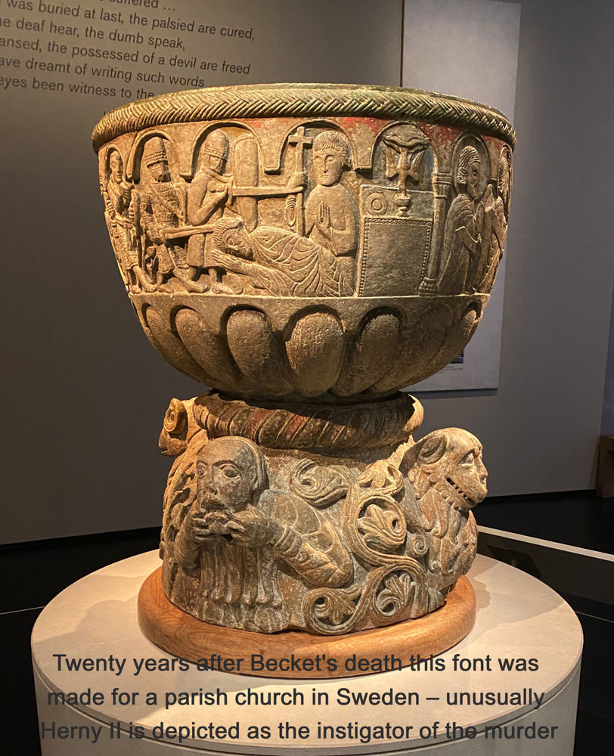
+

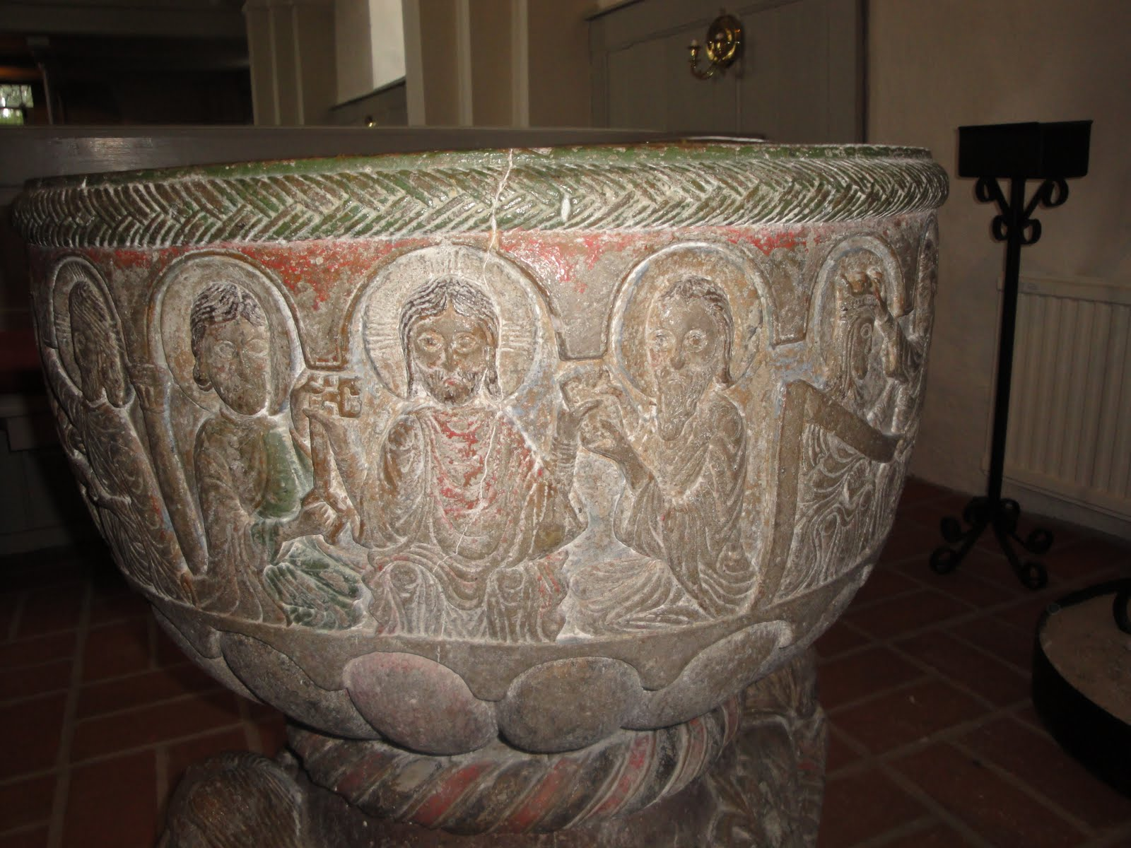

The Baptismal Font at the Parish Church, Lyngsjo

The baptismal font at the parish church, Lyngsjo, Scania in Southern Sweden depicts the martyrdom of Thomas Becket, Archbishop of Canterbury who was murdered in Canterbury Cathedral in 1170. An examination of the font reveals, and this paper maintains that the message conveyed by this object is that the spiritual impact of the martyrdom of Thomas Becket took precedence over earthly concerns and that the impact of his death was on wider Christian Europe and not relegated to England.

The sandstone font dates to the late twelfth century and was most likely carved by a famous stone carver named Tove Stenmastare, who was both a church builder and sculptor. Lyngsjo church itself was built in the twelfth century from local field stone. There are traces of colour on the stone showing it was once painted. In Becket’s time Scania was part of Denmark and part of the wider Scandinavian Becket cult community. Many Scandinavian patron saints were considered “Royal’ Martyrs”, they had lives of great power and then were murdered, Becket’s story perhaps resonating there. Skane remained Danish territory until 1658.

Becket was a well-known saint in Scandinavia prior to the Reformation as relics and elements of church architecture reveal. There are altars dedicated to him and in nearby Trono church in Uppsala diocese a magnificently enameled reliquary made of Limoges exists. Hundreds of missals, paintings and preserved manuscripts and sermons for Thomas’s feast day have been found. A font in the town of Nora that may have some Becket imagery but is considered indistinct and perhaps not related to Thomas. According to art historian Elisabeth Reuterswärd in the nearby Gumlosa church there are several relics; pieces of bone and pieces of horsehair shirt of this undoubtedly very popular saint. Elisabeth Reuterswärd and John H. Lind are two scholars who, in a battle of journal articles, argue about the identity of the donor who commissioned the font. The argument serves to highlight the connections Becket had with a wider Europe. Lind argues that the Danish King Valdemar ordered the font citing as evidence of friendship correspondence with Becket. Reutersward argues that the likely donor is Archbishop Eskil of Lund who was perhaps a kindred spirit as he himself was in conflict with the kings of Denmark. Eskil spent several years in exile (1161–1168) and Becket was in exile in France (1164-1170) until he returned to England and was assassinated. Eskil and King Valdemar, had a reconciliation of a sort but things continued to be uneasy with Eskil tolerating the monarch until the pope granted him the right to retire to Clairvaux in 1177. Becket and Eskil had friends in common and may very well have met. “To the extent that Becket was venerated in late 12th century Denmark, the evidence points to a few select places, primarily located in Eskil’s own backyard, Scania.” The veneration of Thomas was spread by those who knew and liked him on the continent showing again that this was indeed a European and not just an English event and the Church a pan national power. It gives us a picture of Becket invested in the intellectual milieu of the wider church and intellectual community.

The font has traditional images from the life of Jesus, naturally for a font Jesus’s baptism by John the Baptist is portrayed. There are additional images, which show the Archbishop of Canterbury, Thomas Becket, being slain on the high altar of his church by four knights on behalf of King Henry as a result of strife between church and state. Henry is depicted on his throne, his sword marked with the words Rex Hericus. Henry is directing the knights to attack Becket, pointing his right hand in a commanding gesture as the knights move forward, the knight in front striking a blow. Becket is plaintively bent over with a sword upon his head while Ed Grim, a witness to the killing, stands holding a cross. Grim defends Becket and in doing so is injured himself. To the right is a panel with the Holy Spirit depicted as a dove descending into a chalice. On the other side is Christ in center with Saint Peter to his left holding a key and Saint Paul to his right holding a Bible. This is Traditio Legis; Christ handing symbols of authority to Saints Peter and Paul, who stand at his side. Thomas is shown receiving his heavenly reward. Becket was already a saint having been declared so two years after his death.
No part of the font is uncarved. Under the frieze showing the murder there is a lower area separated by a braid that depicts monstrous characters. The lower cup portion or “cupa”, has four carved figures: two horror characters, half animal, and half human one holding his face and one holding serpents and two fantasy animals along with foliage designs. Baptism is the antidote for evil, so this represents what baptism prevents and eradicates. Alternatively, or perhaps in addition the monsters appearing below the line may indicate a “literal demarcation of the boundary of the sacred and profane spaces”, if Henry and the knights’ actions were profane and Thomas’s were sacred, that line that stands between monsters and the profane demands a sacrifice to defend it and Thomas sacrificed himself for the Church. Monstrous bodies violate representational norms, just as ritual violence transgresses taboos.” “Monsters were often used to define boundaries and to express a distinction between morality and sin – or conformity and nonconformity. Those perceived as sinful were often portrayed as physically deformed.” Or perhaps these “monsters” represent unknown parts of ourselves or older, ancient parts no longer recognizable even in the time of Becket causing St. Bernard of Clairvaux to ask in the 12th century: "What are these fantastic monsters doing in the cloisters under the eyes of the brothers as they read? What is the meaning of these unclean monkeys, these savage lions, and monstrous creatures? . . . Surely, if we do not blush for such absurdities, we should at least regret what we have spent on them.” The spiritual aspect is paramount in this image.
The font would be seen by clergy, laity and visitors attending that church. They would first encounter it when they received the first sacrament of life; baptism. “In the Middle Ages, sacramental journeying, and its connection to the cult of saints began at the start of life with baptism. The laity related to the saints in a complicated layering of emulation, supplication, and penitence, with spiritual experiences in the institutional sacraments and in the cultural phenomenon of pilgrimage.” Images of saints, and of Becket in particular where ubiquitous in medieval England and on the continent as well. Throughout life, parishioners would pass by the baptismal font as it stood just inside the door. “The baptismal font stood at the far western end of the church, just inside the door. The unbaptised child was considered impure and therefore should not be carried further inside the church than necessary.” Members of the clergy and laity would see the depiction of Becket’s death hundreds of times as they arrived for Sunday worship and feast days. It was not necessary for the viewer to be literate as the story unfolds in sandstone and tells of Henry, the knights, the crime of the century and the reception of Becket into heaven.

The story illustrates that man plans and God dictates, temporal powers can take the physical body but not the soul over which only God has dominion. As Becket is depicted as a saint the viewer is reminded that the faithful can expect to be persecuted. but rewarded. Becket is portrayed as a holy, humble man and a victim of persecution for his faith. Scriptural lessons are conveyed pictorially and therefore accessible to all. Thousands of people claimed miracles were attributable to Becket with the monks at Canterbury busily recording them. Miracles were recorded in Denmark and the cult of Becket existed in all five Nordic countries. The posthumous miracles circulated widely at home and abroad. The Lyngsjo parishioners were given access to the image of the famous martyr whose miracles inspired hope, indeed there were hundreds if not thousands of stories of people being healed by drinking an admixture of Becket’s blood and water. Henry himself took a flask of the blood “water” after doing penance in 1174.
When the font was presented at the British Museum exhibition on Thomas Becket the curators chose this object, among others, to show the international impact that the murder had. “A key objective of ours was to take what is [often] thought of as an insular British story, and to refocus it and say, actually, this is a European story,” said Lloyd de Beer, the other co-curator. “This murder happens on a European stage. And these objects speak to different elements of how that murder was received in those European countries.”

Henry’s penance is not depicted on the font, only his crime. The object displays the crime against man and God but only shows the consequences for Becket in the afterlife. It does not deal with the temporal issue of the monarch seeking forgiveness, the political fallout, or punishment of the knights; the elements of this story on this plane of existence pale in comparison to what happened in the realm of heaven. The message is conveyed to all who view the font that what is important is not the politics and intrigue behind the story as much as the glorification of God and the reception of the martyr into his reward.

In conclusion the font tells us that the cult of Thomas and his veneration was prevalent in Western Europe, that the impact of his death was impactful upon a wide audience and that the donor and maker of the font wanted to convey the spiritual import of that fateful night in December 1170 and reenforce to the viewer the supremacy of God.

Bibliography

Alston, David. “Gargoyles and Grotesques.” Oxford Art Journal 1, no. 1 (1978): 32–35. http://www.jstor.org/stable/1360085.

Altvater, Frances. "Saintly Bodies, Mortal Bodies: Hagiographic Decoration on English Twelfth Century Baptismal Fonts." Peregrinations: Journal of Medieval Art and Architecture 3, 4 (2012).
Ambrose, Kirk. The Marvellous and the Monstrous in the Sculpture of Twelfth-Century Europe. ((Woodbridge: Boydell & Brewer, 2013).

British Library ‘Medieval Monsters: From the Mystical to the Demonic | The British Library’. [n.d.]. <https://www.bl.uk/the-middle-ages/articles/medieval-monsters-from-the-mystical-to-the-demonic> [accessed 21 February 2023]

‘British Museum to Show How Thomas Becket’s Murder Shook Europe’. 2021. The Guardian <http://www.theguardian.com/culture/2021/may/09/british-museum-show-thomas-becket-murder-shook-europe>
https://www.dandelion.london/post/thomas-becket-murder-and-the-making-of-a-saint-british-museum-review.
Cleaver, Laura. “Pages Covered with as Many Tears as Notes: Herbert of Bosham and the Glossed Manuscripts for Thomas Becket.” In Herbert of Bosham: A Medieval Polymath, edited by Michael Staunton, NED-New edition., 64–86. Boydell & Brewer, 2019.

Crook, John, English Medieval Shrines, (Woodbridge: The Boydell Press, 2011)
Duffy, Eamon, The Stripping of the Altars, Traditional Religion in England, 1400-1580, (New Haven and London: Yale University Press, 2022).
Duggan, Anne, Thomas Becket, (London: Hachette Livre UK, 2004).
Guy, John, Thomas Becket, Warrior, Priest Rebel, (New York: Random House, 2012)
Jorgensen, Ellen, Saint worship in Denmark: Studies of Church Culture and Church Life from the Middle Century to the Reformation, (Copenhagen: H. Hagerup, 1909).

Kinney, Angela M., Editor, The Vulgate Bible, Dumbarton Oaks Medieval Library, Volume VI, The New Testament, Douay-Rheims Translation, (Cambridge, Massachusetts: Harvard University Press, 2013).

Koopmans, Rachel. “To Experience What I Have Heard: Plotlines and Patterning of Oral Miracle Stories.” Wonderful to Relate: Miracle Stories and Miracle Collecting in High Medieval England, University of Pennsylvania Press, 2011, pp. 28–46.

New American Standard Bible, (Anaheim, California: Lockman Foundation, 1998).

Nilsson, Bertil, The cult of Saint Thomas Becket in the Swedish Church province during the Middle Ages, International Journal for the Study of the Christian Church, 2020, VOL. 20, Nos. 3–4.

Orme, Nicholas, Going To Church in Medieval England, (New Haven and London: Yale University Press, 2021).

Staunton, Michael. The Lives of Thomas Becket, (Manchester: Manchester University Press, 2001).

Staunton, Michael, “The View from Canterbury: Benedict of Peterborough and William of Canterbury.” Thomas Becket and His Biographers, vol. 28, (Woodbridge: Boydell & Brewer, 2006).

The Swedish Museum, <https://historiska.se/utstallningar/medieval-art, ‘In Service of the Church | The Swedish History Museum’.

Tomany, Maria-Claudia, “Sacred Non-Violence, Cowardice Profaned: St Magnus of Orkney in Nordic Hagiography and Historiography.” Sanctity in the North: Saints, Lives, and Cults in Medieval Scandinavia, edited by Thomas A. DuBois, (Toronto: University of Toronto Press, 2008).

Urry, William, Thomas Becket, His Last Days, (Thrupp, Stroud, Glouchestershire: Sutton Publishing Ltd 1999).

Warfare, ‘The Murder of Thomas Becket, Archbishop of Canterbury. Font, Lyngsjo Church, Scania, Southern Sweden, Late 12th Century’. [n.d.]. <http://warfare.gq/12/Lyngsjo.htm> .

Warren, W.L., Henry II, (Berkeley and Los Angeles: University of California Press, 1973).

Wilkinson, Louise J. 2020. ‘“Is Still Not the Blood of the Blessed Martyr Thomas Fully Avenged?” Thomas Becket Cult at Canterbury under Henry III and Edward I’, History, 105.367: 673 <https://www.academia.edu/70689687/ [accessed 20 February 2023]

Photo From the British Museum Exhibit at https://www.dandelion.london/post/thomas-becket-murder-and-the-making-of-a-saint-british-museum-review. For a 3-D view of the object please see https://sketchfab.com/3d-models/dopfunt-lyngsjo-kyrka-792bcab325914523bbc2f6fc55a43f22 In 3-D format it can be rotated, enlarged, and viewed in great detail with traces of original red, green and blue paint visible. Credit given on the link. (Hover over the link and hit control and click to follow link or cut and paste into a browser).
‘Medeltida Kyrkor i Skåne: Mordet i Canterbury - På Dopfunten i Lyngsjö Kyrka’. [n.d.]. <http://medeltidakyrkoriskane.blogspot.com/2011/07/mordet-i-canterbury-pa-dopfunten-i.html> [accessed 4 February 2023]
I would like to thank John H. Lind of the University of Southern Denmark, Wes Anders, editor of ALE in Sweden who graciously provided me with pdfs of back issues of ALE (Historical Journal for Skane) and an anonymous peer reviewer of articles in Sweden for their kindness in corresponding with me about the font.
W.L. Warren, Henry II, (Berkeley and Los Angeles: University of California Press, 1973) p. 510.
‘The Murder of Thomas Becket, Archbishop of Canterbury. Font, Lyngsjo Church, Scania, Southern Sweden, Late 12th Century’. [n.d.]. <http://warfarewest.x10host.com/12/Lyngsjo.htm> [accessed 28 January 2023], ‘Lyngsjö kyrka’. 2017. <https://www.svenskakyrkan.se/degeberga-everod/lyngsjo-kyrka> [accessed 4 February 2023]
‘Lyngsjö kyrka’. 2017. <https://www.svenskakyrkan.se/degeberga-everod/lyngsjo-kyrka> [accessed 4 February 2023]
Maria-Claudia Tomany “Sacred Non-Violence, Cowardice Profaned: St Magnus of Orkney in Nordic Hagiography and Historiography.” Sanctity in the North: Saints, Lives, and Cults in Medieval Scandinavia, edited by Thomas A. DuBois, University of Toronto Press, 2008, p 138.
Mathorne, Jon. 2017. ‘How Big Has Denmark Been in the Past?’ <https://sciencenordic.com/denmark-history-society--culture/how-big-has-denmark-been-in-the-past/1444682> [accessed 2 February 2023]
Bertil Nilsson, The cult of Saint Thomas Becket in the Swedish Church province during the Middle Ages, International Journal for the Study of the Christian Church, 2020, VOL. 20, Nos. 3–4, 230–250.
Elisabeth Reuterswärd, Murder, Blood and Miracles. The baptismal font in Lyngsjo, ALE, Historisk tidskrift, For Skane Halland Och Blekinge, 2020. P 1-4, John H. Lind, The Baptismal font in Lyngsjo,Archbishop Eskil and the Thomas-Becket cult in Denmark, Lind, Ale. Historisk tidskrift for Skane, Halland och Blekinge. (2021). In my online conversations, one with a peer reviewer of the journal articles who asked not to be named and the editor of ALE (both of whom were quite cordial and helpful) it seems as if some of the academic community in this area may have found the Lind article perhaps unnecessarily vitriolic. I found Professor Lind to be quite cordial. In any case, either way, it does support my point that Thomas Becket’s influence and relationships were widespread.
William Urry, Thomas Becket, His Last Days, (Thrupp, Stroud, Glouchestershire: Sutton Publishing Ltd 1999) p. 31
Reuterswärd, Murder, Blood and Miracles, p.11-12
Histories, Medieval. 2021. ‘Was Thomas Becket a Controversial Saint in Scandinavia?’, Medieval Histories <https://www.medieval.eu/was-thomas-becket-a-controversial-saint/>
John Guy, Thomas Becket, Warrior, Priest Rebel, (New York: Random House, 2012) p. 313.
Michael Staunton, “Telling the Story: Edward Grim, Guernes and Anonymous I.” Thomas Becket and His Biographers, vol. 28, Boydell & Brewer, 2006), pp. 28.
Nickson, Tom. 2021. ‘Thomas Becket: Murder and the Making of a Saint, British Museum, 20 May–22 August 2021’, Arts, 10.3: 54 <https://doi.org/10.3390/arts10030054>
‘The “Traditio Legis” Image Type: Jesus Deputizes St. Peter and St. Paul’. [n.d.]. <https://www.christianiconography.info/traditio.html> [accessed 9 February 2023]
Anne Duggan, Thomas Becket, (London: Hachette Livre UK, 2004) p. 319.
‘The Murder of Thomas Becket, Archbishop of Canterbury. Font, Lyngsjo Church, Scania, Southern Sweden, Late 12th Century’. [n.d.]. <http://warfare.gq/12/Lyngsjo.htm> [accessed 9 February 2023]
Kirk Ambrose. The Marvellous and the Monstrous in the Sculpture of Twelfth-Century Europe. (Woodbridge: Boydell & Brewer, 2013) p.108.
Kirk Ambrose. The Marvellous and the Monstrous in the Sculpture of Twelfth-Century Europe. (Woodbridge: Boydell & Brewer, 2013) p. 106.
‘Medieval Monsters: From the Mystical to the Demonic | The British Library’. [n.d.]. <https://www.bl.uk/the-middle-ages/articles/medieval-monsters-from-the-mystical-to-the-demonic> [accessed 21 February 2023]
Alston, David. “Gargoyles and Grotesques.” Oxford Art Journal 1, no. 1 (1978): p. 33.
Frances Altvater, "Saintly Bodies, Mortal Bodies: Hagiographic Decoration on English Twelfth Century Baptismal Fonts." Peregrinations: Journal of Medieval Art and Architecture 3, 4 (2012): p. 2 https://digital.kenyon.edu/perejournal/vol3/iss4/2
Eamon, Duffy, The Stripping of the Altars, Traditional Religion in England, 1400-1580, (New Haven and London: Yale University Press, 2022) pp. 155-156.
‘In Service of the Church | The Swedish History Museum’. [n.d.]. <https://historiska.se/utstallningar/medieval-art/> [accessed 28 January 2023].
Proverbs 19:2, Many plans are in a man’s heart, but the counsel of the Lord will stand. New American Standard Bible, (Anaheim, California: Lockman Foundation, 1998).
2 Timothy 3:12 “And all that will live godly in Christ Jesus shall suffer persecution,” Angela M. Kinney, Editor, The Vulgate Bible, Dumbarton Oaks Medieval Library, Volume VI, The New Testament, Douay-Rheims Translation, (Cambridge, Massachusetts: Harvard University Press, 2013).
Matthew 5:12 “Be glad, and rejoice, for your reward is very great in heaven. For your reward is great in heaven, for so they persecuted the prophets who were before you.” Ibid.
Michael Staunton, The Lives of Thomas Becket, (Manchester: Manchester University Press, 2001) p.1
Lind, The Baptismal font in Lyngsjo, Archbishop Eskil and the Thomas-Becket cult in Denmark, p. 5. Citing “Thomas Becket and the Nordics” by Sigvard Skov.
Wilkinson, Louise J. 2020. ‘“Is Still Not the Blood of the Blessed Martyr Thomas Fully Avenged?” Thomas Becket&#39;s Cult at Canterbury under Henry III and Edward I’, History, 105.367: 673 <https://www.academia.edu/70689687/ [accessed 20 February 2023] pp. 1,2
Koopmans, Rachel. “To Experience What I Have Heard: Plotlines and Patterning of Oral Miracle Stories.” Wonderful to Relate: Miracle Stories and Miracle Collecting in High Medieval England, University of Pennsylvania Press, 2011, pp. 34-36, Michael Staunton, “The View from Canterbury: Benedict of Peterborough and William of Canterbury.” Thomas Becket and His Biographers, vol. 28, (Woodbridge: Boydell & Brewer, 2006) p. 49.
John Crook, English Medieval Shrines, (Woodbridge: The Boydell Press, 2011) p. 195.
‘British Museum to Show How Thomas Becket’s Murder Shook Europe’. 2021. The Guardian <http://www.theguardian.com/culture/2021/may/09/british-museum-show-thomas-becket-murder-shook-europe> [accessed 2 February 2023].

