

Therapy Assistant Practitioner
Case Report Notes

Student name: | Debbie Morgan
Student number: | 2413435

Purpose and Aim
This unit will enable the learner to develop scientific knowledge and understanding to allow them to undertake a specific Therapy Assistant Practitioner (TAP) role and apply this knowledge in practice. This scientific knowledge will be defined and described in detail by professional therapy services.

Learning Outcomes: | Assessment Criteria:
  2. | Know how to use research and evidence to develop scientific knowledge within own TAP role.
  2.1 | Collate current evidence from reliable sources to inform and improve profession specific scientific knowledge.
  2.2 | Analyse evidence of profession specific scientific knowledge.
  3. | Understand how to apply the scientific learning to own practice as a TAP in a wide range of clinical situations.
  3.1 | Explain how the scientific knowledge gained informs the care of individuals within own practice.
  4. | Understand the impact of the scientific knowledge on own practice.
  4.1 | Evaluate the impact of their enhanced knowledge on own practice as a TAP.
  4.2 | Explain  .

Assignment 2 explained:

Your health board is tracking the use of science within the Therapy Assistant Practitioner role. You have been tasked to deliver two case reports to the Multidisciplinary Team highlighting how science is used within your role. Please use the case notes to collate information for your verbal report. Your reports will be delivered to the MDT on…… time to be confirmed.

Case Study One
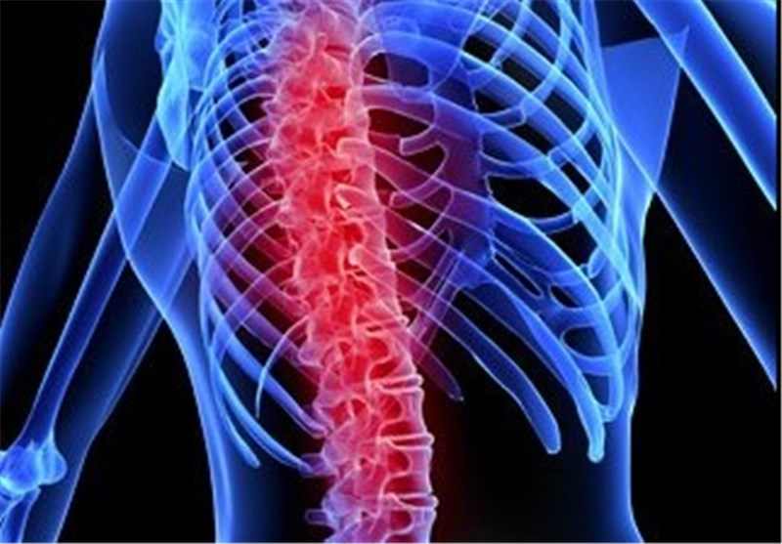
Pen picture one
Using the template below create a detailed pen picture of a case example of someone that you would typically work with, within your clinical setting. Using the biopsychosocial model, distinguish how your case examples health and wellness fits within the various sciences.
Pseudonym Name:
Cruella Trump

Biological details:
Female, 42 years old. Welsh speaking but understands English.
High blood pressure, occasional smoker and drinks 9-10 units of alcohol weekly (Neurohormonal Perturbations – Balance of hormones which regulate appetite and psychological distress)
Height 66inch and weight 92.5kg. BMI 33 (Biomechanical Stress due to excess weight) (Systemic Inflammation is a biological process that contributes to joint pain in OA and Fibromyalgia)
OA in left knee recently diagnosed
Fibromyalgia (shared mechanisms – abnormal stress responses, environmental factors and neuroinflammation)
Pharmacology to manage symptoms with medication
Cardiology would manage high blood pressure
Rheumatology would manage the osteoarthritis

Psychological details:
In shock from fall and diagnosis
Anxious and fearful
Depressed from constant pain (Bidirectional Relationship – when one illness can worsen a chronic illness i.e. depression worsening the Fibromyalgia)
Sleep apnoea
Nutrition and Dietetics to address the BMI which exacerbates the Hypertension and OA symptoms
Physiotherapy – to design low impact exercise programme
Psychology for managing chronic pain, stress, depression and sleep problems

Social details:
Married and has support from husband. 2 children, both in secondary school. Works as a schoolteacher, uses walking stick. Generally active when pain manageable, tries to walk a few miles every day.
Socioeconomic Status (SES) is associated with obesity and hypertension
Occupational Therapy – This can help patient adapt work and home activities to manage her symptoms for example ergonomic adjustments.

Task one: Explain the science behind your assessments or treatment
3.1 Make notes of an assessment or observation you undertook with your case example. Make sure to name what sciences underpinned how the condition impacted the case examples presentation and what sciences informed your choice of assessment or intervention.
The patient was seen on Trauma & Orthopaedic ward. Voice consent gained. Medical notes checked. Patient had a fall at work and has fractured T3 – T5 vertebrae. The fracture is stable and patient can mobilise with TLSO brace.
Biology/orthopaedics was used Anatomy and Physiology to understand the structure of thoracic area and diagnosis.
Pathophysiology – understanding the mechanism of injury and the biological process of bone repair
Biomedical Engineering – imaging tech, CT scan/MRI/ Xray
Pain relief was administered before seeing the patient. (Pharmacology – the use of medication)

While patient lay in bed, strength and movement assessment was given (Biomechanics – understanding of movement and strength in the body) to check for any weakness from the fall. Also, sensation was checked due to the fracture (Neuropathy – nerve damage in spine). NEWS was checked and was scoring 0.
Once completed a TLSO brace was fitted (Orthotics and Biomechanics, as its uses principles of force and pressure and patient was assisted to sit on edge of bed. BP taken as patient was feeling faint (Biomedical Engineering – development of the Blood pressure machine and cuff)
Physiotherapy was used to assist patient to stand and mobilise using a Wheeled Zimmer Frame to start to gain confidence. (Biomechanics - strength, balance and movement) (Rehabilitation engineering and Ergonomics – the science of designing equipment to assist mobility). A study by C. Cunningham, H. Mc Laughlin, G. O Donoghue (2022) highlights the pressing need for more research, especially high-quality clinical trials that include diverse populations. It also emphasises the importance of exploring physiotherapy practices and understanding the experiences of patients with vertebral fragility fractures, to better inform and improve care.
Patient was left sat in a chair by bedside with TLSO brace worn and a discussion about their goals and prognosis and ways to help improve their medical history. (Psychology – study into behaviour and how they think and feel and act also Psychodynamic therapy to assist with issues like anxiety and depression

Case Study Two
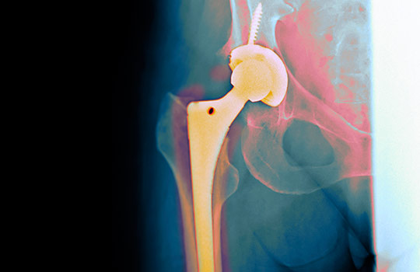
Pen picture one
Using the template below create a detailed pen picture of a case example of someone that you would typically work with, within your clinical setting. Using the biopsychosocial model, distinguish how your case examples health and wellness fits within the various sciences.
Pseudonym Name:
Bill Baggins

Biological details:
68-year-old Male
History of primary osteoarthritis
High blood pressure
Height 70inch Weight 99kg.
Geriatric Medicine would focus on the care of older adults and physical decline and patient’s hypertension and arthritis. Cardiology may be involved due to blood pressure.
Orthopaedic Surgery for performing the total hip replacement.
Physiotherapy for postoperative rehabilitation and Occupational therapy for adaptions at home to reduce risk of dislocation.

Psychological details:
Chronic persistent pain in right hip, unrelieved by non-surgical management
Very depressed and anxious about post op surgery
Struggliong with daily tasks
Sleep deprivation
Frustrated and powerless
Nutritional Science/Dietetics could provide guidance for healthy weight management and a diet that would support general health, wound healing and blood pressure management.
Pain Management to provide medication to treat osteoarthritis and postoperative pain.
Mental Health/Psychology will support and provide guidance to improve coping mechanism, self-efficacy and overall quality of life.

Social details:
Married, retired postman, lives in a house, stairs, still drives.
Social Work – help coordinate care and ensure patient has the necessary social support for a successful recovery

Task Two: Explain the science behind your assessments or treatment

3.1 Make notes of an assessment or observation you undertook with your case example. Make sure to name what sciences underpinned how the condition impacted the case examples presentation and what sciences informed your choice of assessment or intervention.
Patient seen on elective ward post-surgery. Voice consent gained and medical records checked. Patient had a full total hip replacement, cemented due to bone quality. Surgery went well and patient was stable. Xray was taken after surgery.
Anatomy - a understanding of the musculoskeletal system including the configuration of hip joint, surrounding muscles, ligaments and nerves.
Biomechanics – guide implant design and positioning to reduce stress and wear.
Material Engineering – development of the durable biocompatible materials used in the hip replacement.
Physiology – an understanding of bone biology.
Biomedical Engineering – Xray of hip and blood pressure monitoring
Patient NEWS score was 3, blood pressure high and SATs 93%. Hb level was 97. Blood transfusion was not indicated in notes.
Patient was assessed while lying in bed for strength and movement and sensation Biomechanics – understanding of movement and strength in the body) to check for any weakness from operation. Also, sensation was checked on lower limbs and feet. (Neuropathy – nerve damage in hip)
Patient was also asked about home life and access to property and stairs and family support and patients’ goals and expectations (Psychology – helps support coping skills, manage pain and increase motivation). Driver et al., (2017) confirmed that while physiotherapists are aware of psychological interventions, they face barriers including “lack of knowledge, time constraints, and role clarity.” And in a later article, Driver et al., (2020) revealed that physiotherapists wanted training in “assessment and management of psychosocial issues.”
Patient was able to move both legs and able to sit on edge of bed independently. Blood pressure was checked with a reading of 98/63 (Biomedical Engineering – BP monitor and cuff) patient felt lightheaded and needed time to recover. Patient went back onto bed and lay for a while.
Returned to patient after 15 minutes and patient feeling better and blood pressure improved. Patient sat on edge of bed independently and then stood to a wheeled Zimmer Frame. (Rehabilitation engineering and Ergonomics – the science of designing equipment to assist mobility) Patient managed to transfer to chair with assistance of frame.
Neuroplasticity and balance – the brain needs to adapt to the new joint’s mechanics. Balance training proprioception exercise are crucial during rehabilitation.
Physiotherapy – According to research it is critical, early mobilisation promotes faster recovery and prevent complications such as pneumonia, deep vein thrombosis and pressure injuries. (Paes et al., 2025).
Patient left comfortable in chair. Discussed with patient what the plan for the following day and what they could do with the assistance of staff on the ward. Physiological recovery - coping with pain relief, improved walking and due to patients age, they may have a fear of movement, falling or damaging the new joint which can limit a patient’s willingness to be active.

Task Three: Evaluate the impact of using science to understand the case study performance and your decision making.
4.1 and 4.2: Using the Gibbs reflective cycle, reflect on how your enhanced knowledge of science influenced the assessment or intervention described in task one.
Description: How did you learn about the sciences? Where did you gain the knowledge?
Most of my research has been conducted online and informed by previous study sessions with my tutor. Using AI, I have been able to ask questions and then continue my research using the citations that appear in the answers. On occasion, I have asked consultants on the ward and my supervisor about their knowledge of the sciences behind orthopaedic rehabilitation.

Feelings: How does having an enhanced knowledge of science make you feel when assessing or carrying out an intervention? How does it make others feel?
Knowing the science now gives me a deeper understanding of my role as a Physiotherapy Assistant Practitioner. I also have broader knowledge of the different roles within the NHS and am amazed at how many roles play a part in a patient's recovery. I feel that these sciences should be taught more in schools to give pupils a better understanding of medical research and the NHS.

Evaluation: What are the positive and negative aspects of gaining and understanding knowledge of science and applying to practice.
Understanding the science, such as pain neuroscience, helps me better explain conditions to patients, promoting collaborative decision-making and enabling patients to make informed treatment choices. An ever-growing evidence base supports the development and adoption of new techniques and technologies, advancing the profession and enhancing care quality. However, scientific knowledge can often be quite different from its application in a busy clinical setting, making practical implementation challenging.
Analysis: What sense can you make of having enhanced knowledge of science when assessing or treating someone? What impact does it have on your overall performance?
Science offers a helpful framework for understanding the complex biological, psychological, and social factors (biopsychosocial model) that influence health and behaviour. This approach allows us to see the bigger picture and assess the root causes rather than just the symptoms.
Knowing about psychometrics and research methods helps practitioners choose trustworthy assessment tools and interpret results confidently within scientific standards.
It also enables a deeper understanding of individual differences in treatment responses, which are shaped by genetics, neurobiology, and environment- leading to more personalized and effective care.
Using a scientific approach means collecting and analysing data systematically to track patient progress objectively, making it easier to adjust treatment plans based on real evidence of what works best.
Embracing science enhances a practitioner's credibility with patients, colleagues, and other healthcare professionals by showcasing their expertise and dedication to best practices.
Since science is always evolving, a solid scientific background fosters curiosity and critical thinking, encouraging continuous learning and the integration of the latest research into everyday practice.

Conclusion: What did you learn about yourself when gaining an enhanced level of knowledge of science? What did you learn about your application of scientific knowledge in your practice?

I realised that I do incorporate science into my role but was unaware of the specific sciences involved. Now, I have a better understanding of the various sciences relevant to my work and, with time, I believe I will be able to apply them more effectively in my daily assessments. I hope this knowledge will boost my confidence when discussing patients with consultants and doctors, enabling me to communicate more clearly about the scientific principles behind their decisions.

Article Title | Author(s) | Year of publication | Journal name | Abstract  (y or n) | Methods/  instruments used | Reliable  (y or n) | Validity  (y or n) | Ethical Considerations  (y or n) | Reference list  (y or n)
Physiotherapy Post Vertebral Fragility Fracture | Cunningham, C., Mc Laughlin, H. and O Donoghue, G | 2022 | Physiotherapy | y | Mixed method | y | y | y | y
Knowledge, behaviors, attitudes and beliefs of physiotherapists towards the use of psychological interventions in physiotherapy practice | Driver, C., Kean, B., Oprescu, F. and Lovell, G.P | 2016 | Disability and Rehabilitation | y | Mixed Method | y | y | y | y
A systematic review of evidence regarding the association between time to mobilization following hip fracture surgery and patient outcomes | Paes, V.M., Ting, A., Masters, J., Mahalia, Graham, S.M. and Costa, M. | 2025 | Bone & Joint Open | y | Mixed Method | y | y | y | y
Psychosocial strategies for physiotherapy: A qualitative examination of physiotherapists’ reported training preferences | Driver, C., Lovell, G.P. and Oprescu, F | 2020 | Nursing & Health Sciences | y | Qualitative | y | y | y | y
Critique check list

Reference list
Cunningham, C., Mc Laughlin, H. and O Donoghue, G. (2022). Physiotherapy Post Vertebral Fragility Fracture: a Scoping Review. Physiotherapy, 119, pp.100–116. doi:https://doi.org/10.1016/j.physio.2022.11.001.
Driver, C., Kean, B., Oprescu, F. and Lovell, G.P. (2016). Knowledge, behaviours, attitudes and beliefs of physiotherapists towards the use of psychological interventions in physiotherapy practice: a systematic review. Disability and Rehabilitation, [online] 39(22), pp.2237–2249. doi:https://doi.org/10.1080/09638288.2016.1223176.
Driver, C., Lovell, G.P. and Oprescu, F. (2020). Psychosocial strategies for physiotherapy: A qualitative examination of physiotherapists’ reported training preferences. Nursing & Health Sciences, 23(1). doi:https://doi.org/10.1111/nhs.12771.
Paes, V.M., Ting, A., Masters, J., Mahalia, Graham, S.M. and Costa, M.L. (2025). A systematic review of evidence regarding the association between time to mobilization following hip fracture surgery and patient outcomes. Bone & Joint Open, 6(7), pp.741–747. doi:https://doi.org/10.1302/2633-1462.67.bjo-2024-0243.r1.

