Robert McIntyre
Advanced Web Development
Part 2
M6X01086
Mike Dacey

Table of Contents
Model View Controller 3
Page Controller 3
Front Controller 3
Page or Front Controller 3
Template Pattern 4
MVC Practical Application 5
Screen shots 5
Login page 5
_{Main page when logged in} 6

Model View Controller
A Model View Controller (MVC) framework approach splits the web design architecture into three components; model, view and controller. The Model part handles retrieving the data and performs rules on the data. It is independent of the View and the Controller. The View covers how the interface with the user is displayed. It shows the model data given to it by the controller. The Controller deals with the requests and interacts with both the Model and the View. It gets the data from the Model and passes it to the View. The user interface is considered to be a combination of the View and Controller. It is very important for there to be a separation between the model and the view/controller. Depending on what is required the users may require the same model information but it may need to be displayed in a variety of ways. If the model is separated from the view/controller then the same model code can be used for many applications. The user interface is dependent on the model but the model is not dependent on the user interface in good designs. It is also easier to test if the code is separate and changes can be made to the user interface without changing the model. Separating the View and Controller are less necessary. It is quite commonly done in Web front ends but only used when it is helpful to do. Page and Front Controllers fit into the controller part of MVC.

Page Controller
A page controller is an object that deals with requests for a specific page on a web site. Usually there is one input controller for each page but if there are more actions on a page there may be more. Page controller is often combined with Template View in a single file but this does have some compromises in the structure if the page is not simple. Page controller can be a server page or structured either as a script or as a helper object that can be used for the logic needed. The responsibilities of the page controller are to decode the URL and work out the data needed for the action. Then to action any model objects needed and determine which view is needed to display the results returned from the model objects. Using a helper class can prevent duplication of code. Model objects can be used as helpers if all the helper has to do is act as a forwarder to the model object. However there must not be any servlet dependent code.

Front Controller
A front controller has a single handler object that deals with all requests. This object is then modified with decorators when being used. It is usually structured with a web handler and a command hierarchy. The web handler object receives requests and decides on the action that is then passed to the command to deliver. Both the web handler and command are classes rather than server pages. The web handler is mostly a simple program as it only decides which command is carried out. The commands can be static or dynamic. This may depend on the use as static commands have the advantage of having explicit logic and error checking whereas the dynamic ones allow adding new commands without having to change the web handler. One of the decorators that is used with Front controller is Intercepting Filter which can deal with issues of authentication and identification.

Page or Front Controller
Page controller is much simpler than Front controller and works well when actions are carried out by server pages or scripts. If the controller logic is simple then Page controller works well using a combination of server pages and helper objects. Front controller is more complex and so has a greater overhead but works well when there is a more complex navigational path in the web site. It is also possible in a MVC framework to use both Page and Front controllers for different parts of the web site. Only one Front controller is configured on a web server with the web handler providing the dispatch function. It has the ability to be dynamic and is easy to port and as new command objects can be created it does not need to be made thread safe. Sharing of other objects has to be avoided. One of the main advantages over Page controller is that code that could be duplicated is avoided.

Template Pattern
Template Pattern fits into the View part of MVC. It takes the information from the model objects and renders it into HTML. Markers are embedded into the HTML page. If the page is static a WYSIWYG editor can be used but in dynamic web pages like those that handle database queries each time the page will look different so markers are used. There will still be static parts to the page and these act as a template with markers embedded into it when it is written. These markers are then replaced with the results of the actions requested by the controller. A lot of tools use the template pattern in different ways.
Markers can be embedded into the HTML in the form of tags. This is quite easy for editors to recognise because they are in angled brackets. They can either ignore them or treat them differently as they are easy to identify and they are also in a standard format. If they are not embedded as tags they can be embedded in the body text as special text markers. This is sometimes easier for syntax. Some platforms allow custom tags and markers to be defined to fit in with particular needs. One form of template pattern is a server page which can also have logic programming in it. The disadvantage of this is that only programmers can alter the page which may be a problem when working with graphic designers on a web site. Having this code on the page also removes some of the structural features of the page that allow it to be a modular design. Layers can also become mixed up and duplication occurs. In order to prevent some of the problems having a helper object on the page where the logic code can reside can make it simpler. This also enables the graphic designers to alter the page design easily. Conditional display is another type of marker that can be used but where possible should be moved into the helper where possible as quite often they require logic code.
The first function of the template pattern is to be the View in MVC but in some instances where the system is simple it may also be the controller. If this is the case it is important that the helper is used to handle the logic programming. The template will need to be compiled by the web server either when it is used or when it is created. Sometimes strange outputs can occur if exceptions happen and therefore these should by caught to prevent this.
In the MCV framework the main choice for View is between Template and Transform patterns. Template has the advantage that the content of the page can be designed by looking at the page structure and is easier to learn. The disadvantage is that it is harder to test and maintain as it is easy to include complicated code in it.

Symfony
Symfony is a framework that uses model view controller concepts to design websites. It works in PHP and provides a series of prefabricated tools and methodologies to guide the developer through the process of designing a website with best practice. The tools allow code to be written quickly and efficiently with less errors and the structured methods enable the applications designed to be stable, maintainable and upgradeable. Symfony is an open source code so that developers can add modules to the framework to improve it for others to use.
Databases are relational and Symfony is object oriented therefore there needs to be an interface between them which is called Object Relational Mapping(ORM). One advantage in using an ORM is that using a layer like this avoids the need to use syntax specific to a database. It will translate model objects into SQL Queries particular to the database being used. This means that changing from one database to another is easy with just the alteration of one line of code. Using objects instead of records and classes instead of tables means that additional methods can be added easily. By using objects and classes different attributes can be added that a not always in the table columns but this is addressed by the classes which determine which attributes are displayed in the columns. The main benefit of the ORM is that it is reusable and methods of a data object can be used in different parts of the application and also in different applications. Symfony uses Propel as the ORM and Creole as its database abstraction layer. A relational schema for the database needs to be created in YAML before producing the model classes.[1]
Symfony has a large number tools for automated testing of the designed web site. Automated tests require developers to develop tests in a structured framework which may also be able to reduce the documentation needed as the automated tests show how the application is meant to work. Symphony provides both unit and functional tests. Unit tests check a single case whereas functional tests look at a complete feature. The unit testing framework used by Symfony is called lime which is a lighter version than some PHP frameworks but does have some advantages. It is based on Test::More Perl library, and is TAP compliant. It puts the test files in a sandbox so it has a clean environment for each test. Functional tests validate a process and require a scenario to work. Symphony provides a special object called sfBrowsesr to carry out these tests without the need to use a server. It also has an extension sfTestBrowser to do functional tests with smart assert methods that are capable of testing GET and POST requests. Symfony provides several other testing tools for testing things such as CSS selector and DOM. There is also a method for testing for errors.[2]
Symfony is one of the best frameworks for developing REST web services. There are several bundles that need to be installed to create REST api’s including FOSRestBundle. The bundle provides several tools to help in creating a REST api including a view layer, listener support and an automatic route generator.[3]
NoSQL is supported in Symfony using the DoctrineMongoDBBundle. The MongoDB Object Document Mapper works with the PHP objects and then passes them to and from the MongoDB without changing them.
Symfony is completely customisable but also provides some built-in tools to help with the debugging process. It has code generating tools that enable easy prototyping and testing. It has the ability for both client-side templates and server-side templates. On the server side it can call a function to check the correctness compared to that stored in the database. All errors are reported and events logged so that developers can quickly and easily develop better code.[4]

MVC Practical Application
The MVC application is a light version of a virtual learning environment. This is where students can get their information from university resources.

Screen shots

Login page
The user is greeted with a login page where the students will have to enter their details to view the website
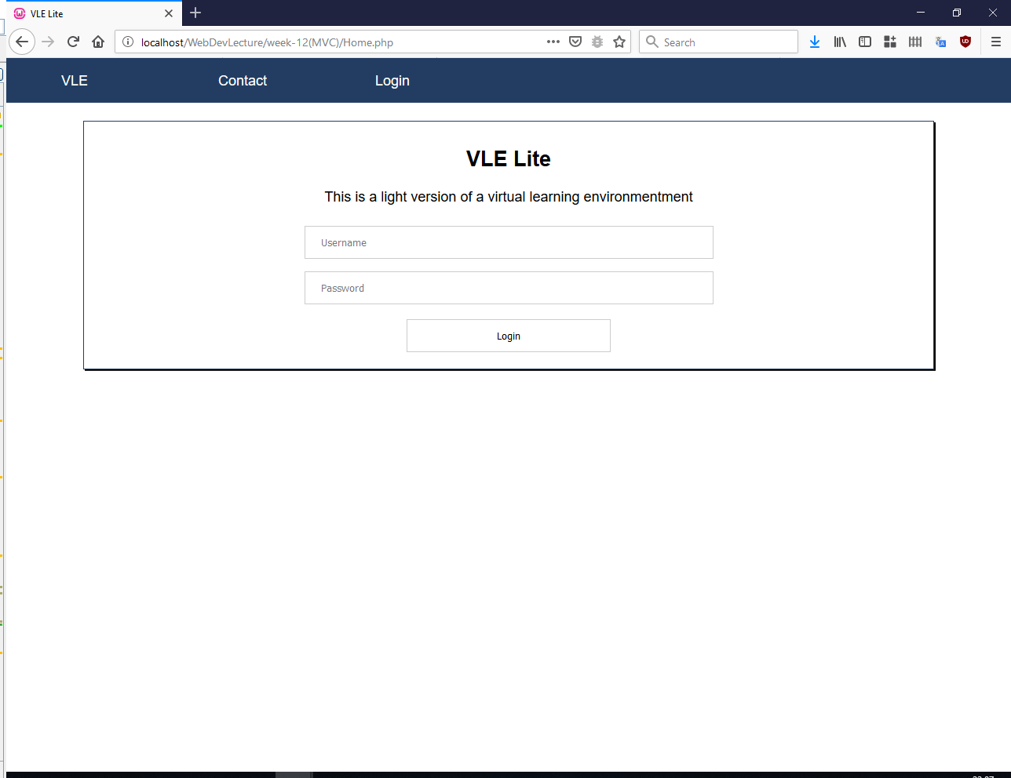

_{Main page when logged in}
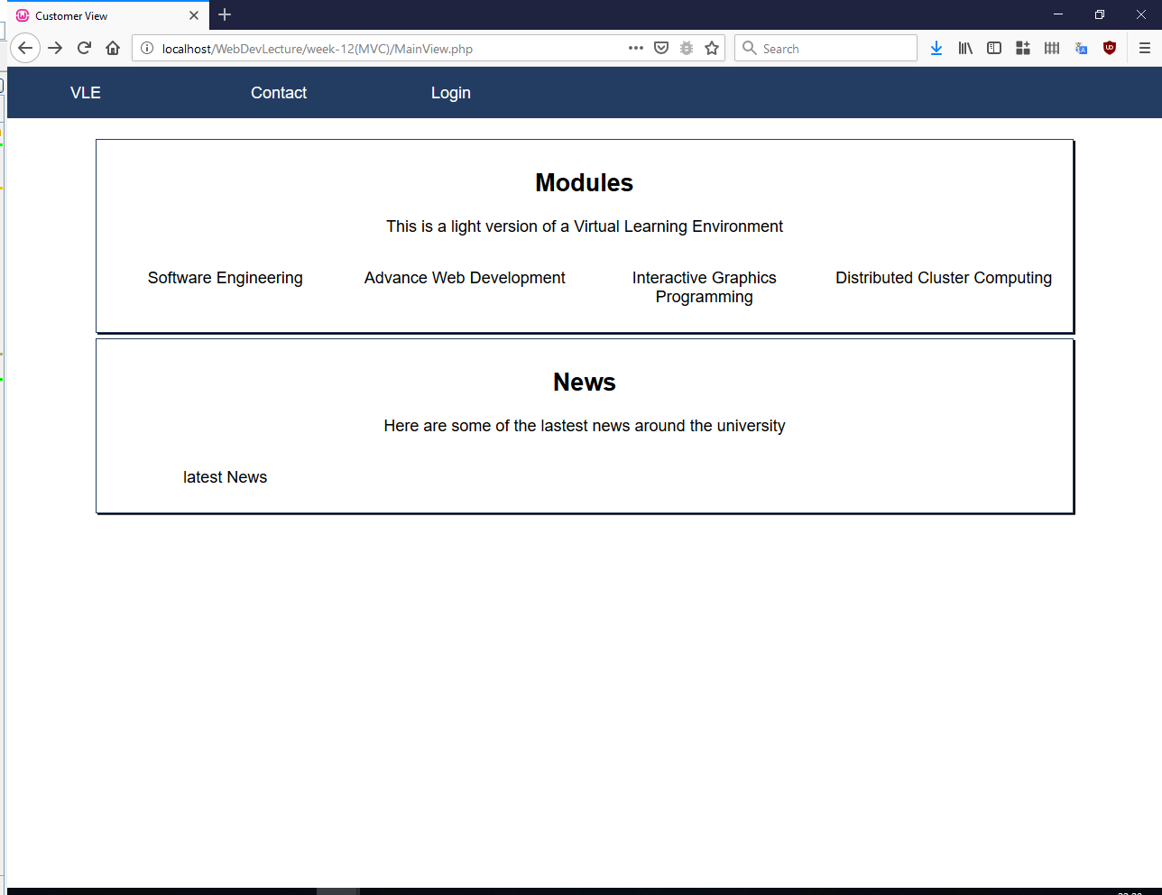

Testing of the database
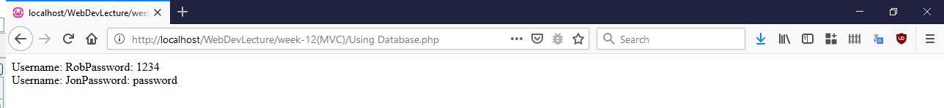
This is a database using a singleton pattern where there are two students in the database.

References
[1] “Chapter 1 - Introducing Symfony (1_1).” [Online]. Available: https://symfony.com/app.php/legacy/doc/book/1_1/en/01-introducing-symfony. [Accessed: 01-Apr-2019].
[2] “Chapter 15 - Unit And Functional Testing (1_1).” [Online]. Available: https://symfony.com/app.php/legacy/doc/book/1_1/en/15-Unit-and-Functional-Testing. [Accessed: 02-Apr-2019].
[3] “Getting Started With FOSRestBundle (Symfony Bundles Docs).” [Online]. Available: https://symfony.com/doc/master/bundles/FOSRestBundle/index.html. [Accessed: 02-Apr-2019].
[4] J. Jarmoowicz, W. Zabierowski, and a. Napieralski, “Presentation of improvements for PHP programmers, based on Symfony framework. Creation of example portal and description of used technology,” Mod. Probl. Radio Eng. Telecommun. Comput. Sci. 2008 Proc. Int. Conf., pp. 595–597, 2008.

