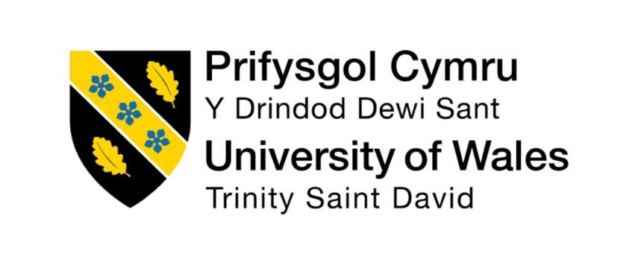

Programme: Master of Business Administration
Module: Human Capital Management
Module code: LCMB7023
Word count:2432
Lecturer: Ejike Udeogu
Student Name: Samit Chanda
Student ID: 2504511
Submission Date- 17th Oct 2025

Table of Contents

- Introduction .............................................................................................................. 3
- Technological Advancements Reshaping Labour Markets .............................…………..4-6
- Demographic and Geopolitical Factors on the Labour Markets .................................. 6-8
- Bridging the Competency and Talent Gap: The Role of Strategic HRM in Skills and Talent Development .......................................................................................................... 8-9
- Reflection: My Skills in an International Work Placement Setting .............................. 9-11
- Conclusion ............................................................................................................... 12
- References ........................................................................................................... 13-14
INTRODUCTION

The modern organization is teetering on the cusp of two overlapping trends: the Fourth Industrial Revolution, and a long overdue re-examination about what it even means to be part of an organization’s workforce in times when employees are as empowered as they have ever been — largely if not entirely due to their desire for meaningful and purposeful work. This global movement is sweeping the HRM to a strategic shaper of organisational resilience and human capability rather than an administrative process. While filling up at the closest petrol station to my university, a convoy of Cuman na MBantaha + Republican Socialist stalls on campus and posters everywhere heralding various other sectarian conflicts I realise that perhaps yesterday’s experiences are not far removed from today’ for me as a “modern” human being in the middle of modern liberal democracy. What follows is a look at three forces reshaping the work world: automation and the gig economy; the need for a new skilling and learning model; and why purpose, ethics, leadership matter. Based on and beyond literature and organizational examples, this paper explores new challenges for HRM/IHRM, as a context to reflect on my own possibilities to cope with, and contribute to, such a new professional global world in the making.
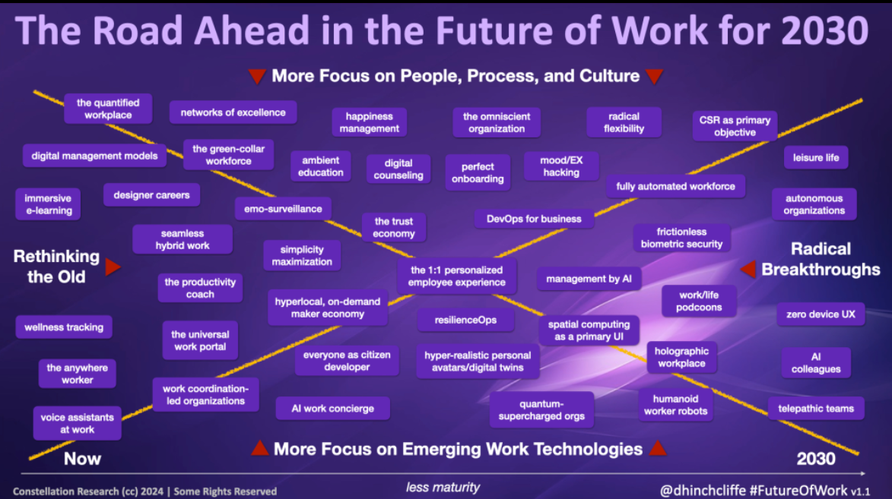
Source: Future of Work Trends 2030

1. DIGITALISATION, AUTOMATION AND THE FUTURE OF WORK
Computerized and more than AI are permanently penetrating our world - revising the paradigms of labor, the nature of workforce. It is not only that technology is pushing aside employees but rather that it is radically reshaping the decision of who does what, how and who needs to be heard. According to the World Economic Forum (2020), it is projected that in the man and machine scenario, the division of labor will have evened out by 2025 - substituting millions of jobs but also creating numerous ones that need uniquely human qualities and capabilities. The displacement of the workforce in traditional sectors and the necessity of the industries to successfully introduce a digitally enhanced workforce challenges HRM in two aspects.
And to a great extent it manifests itself in the growing gig, or contingent, economy whereby independent contractors and freelancers find employment via online solutions. The world today offers the best talent pool in the history of companies - they now have more options than ever before. It also entails difficulties in HRM. To avoid this, and/or to remain in control, however, rather than aiming to achieve onboarding, performance management and knowledge transfer/dissemination practices that could be front of the pack, they will require them not only of employees but also of gig workers (Ashford et a l., 2018). Joint study In November 2018, scholars of the Sussex University and Oxford Internet Institute discovered that algorithmic management of the gig-workers by the firm, including Uber and Deliveroo (where algorithms distribute tasks, control them and adapt pay scales), presents basic ethical challenges of worker autonomy, fairness in decision-making processes and transparency (Wood et al., 2019). The challenge now lies with HRM to develop systems that cut across technology to business effectiveness and at the same time based on the principles of decent work.
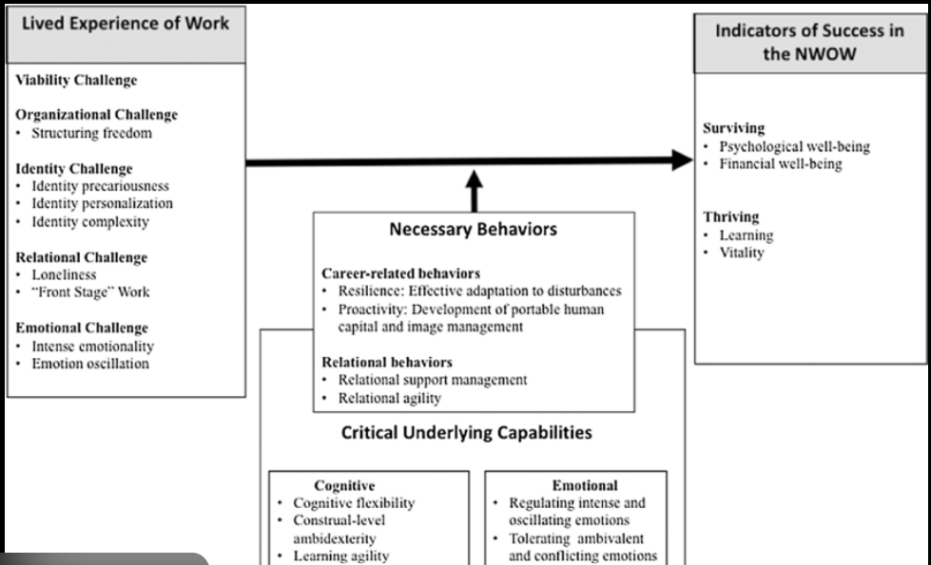

Source: Capabilities of the Gig Economy

The change poses a special challenge to international human resource management (IHRM). Those companies that employ remote workers via global talent agencies must navigate a complex tangle of employment, tax and social security regulations. Assuming a German company intends to hire an Irsih programmer as freelance worker, then the expectations and legal/cultural context of the respective job (worker rights, benefits) would be utterly different to that of Germany where it is highly regulated. Professions as they have been experienced are being disaggregated into tasks according to Susskind and Susskind (2015) so that IHRM needs to develop new models to manage a workforce that is disaggregated, global, digitally-mediated.
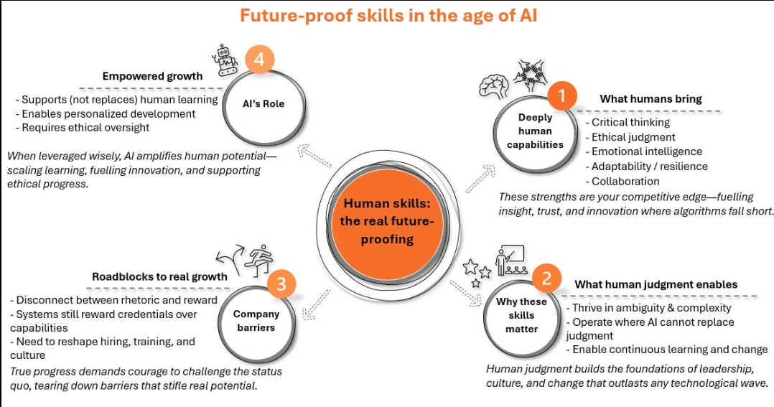
Source: Global Digital Jobs Framework

2. THE SKILLS REVOLUTION AND THE NEED FOR LIFELONG LEARNING
The above technological incursion has rendered ridiculous the entire concept of front-loaded education that is not dynamic. Half-life of professional skills has been shrinking very fast which leads to a persistent shortage in skills that threatens individual employability and the competitiveness of the enterprise. This has even transformed serious lifelong learning as a personal development virtue to a corporate strategic requirement. HRM, however, is experiencing what is new because the core activity of filling gaps due to the existing skills has been complemented by the necessity to establish an organisational learning culture in which upskilling/reskilling can take place on a large scale (Garavan et al., 2021).

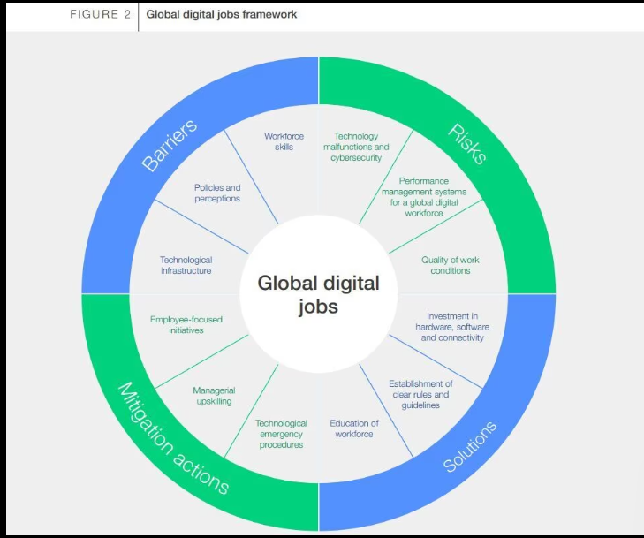

Source: Hidden Skills / Future-proof Skills in the Age of AI

Business organizations are reacting by re-aligning their Learning and Development (L&D) groups. The company is willing to demystify emerging technologies to all its employees by having an internal AI Business School to train employees who have developed a background in various fields other than technology to appreciate and utilize the potential of AI in their workplace. Even more so, an announcement by Amazon to invest $7 billion in advancing its staff by enrolling them in re-skilling programs known as Upskilling 2025, which is an investment to re-train its employees in future proof skills (data science and machine learning) was a clear indication that the company is strategically no longer buying talent but developing it internally (Daugherty and Wilson, 2018). The functions of HRM include individualizing the learning process, applying technology to on-demand micro-learning and make learning a regular part of everyday job.
The main challenge in the case of IHRM is to develop global, but culture aware learning strategies. The necessary skills in one market might not be needed in another. To take the example, the engineering skills that are highly valued in Germany and its developed manufacturing sector have to be combined with other skills, such as project management and user- experiences, that will be required in the same company division in Ireland in digital services. And, the attitudes to learning of the cultures - are they the students who like to be led by an instructor and follow the certain lessons or the students who are independent learners is very different. According to Boxall and Purcell (2016), MNCs need to pay attention to maintain a balance between the efficiency of centralised learning platforms, on the one hand, and localised content and delivery mechanisms, on the other, to attain actual skills-acquisition and utilisation in various cultural environments.

3. PURPOSEFUL WORK AND THE EMERGENCE OF ETHICAL LEADERSHIP
In addition to the change in technology and skills, another major change is the one that is occurring in employee expectations. Workers in a world of increased automation and uncertainty Workers, particularly the representatives of the millennial and Gen Z generations, are seeking more than a cheque. They gravitate towards businesses that market a sense of mission, good in society, and lack of a culture of psychological safety and ethical leadership (Gartenberg et al., 2018). This has transformed the purpose of corporations, as a marketing pitch, to a core component of the Employee Value Proposition (EVP) and a basic magnet / keeper of talent.
The purpose needs to be embedded in an organisation and HRM has a very major role to play in that. And it is not only about the writing of good mission statement. It is More Like Making certain that all of the contact points of the staff experience, including the method they are recruited and on-boarded, performance management and rewards, demonstrate proclaimed principles of a company. In the case of Patagonia, purpose is giving its employees paid time off to participate in activism or bail money in case they are arrested due to a peacefully organized protest - these business values are real, strong and true. The result of this strong alignment is unmatched employee engagement and brand loyalty (Sinek, 2009). This quest of accountability sort of yardsticks in business with a purpose is acted out with the rise of the B Corp movement that certifies businesses that demonstrate that they have achieved the best of social and environmental performance.
At the international level, IHRM is faced with a challenging challenge of balancing the need to have a universal corporate purpose and the need to uphold multiplicities of cultural values. Indicatively, a purpose statement on individual empowerment may be conceivably included in the mission but may be rephrased in collectivist societies where the society and harmony within groups have dominance. Moreover, ethical leadership is most interrogated in relation to the case of international business operations with MNCs that must address the aspects of labour standards in supply chains, corruption and environmental activities in various regulatory authorities. One of the most urgent and challenging challenges that modern IHRM has to face is the creation of the global set of leaders, capable of negotiating such ethical grey areas in a fully authentic way (Northouse, 2018).

4. REFLECTIONS:MY SKILLS FOR GLOBAL WORKFORCE
4.1 Analytical and Technical Aptitude
Being a trained industrial engineer in Germany, I am well prepared in terms of analysing and thinking systematically. MAD SCIENCE I like to tear apart complex processes, find broken processes and convert vanilla js to poorly written code. I have done so with one of my university projects where I made a better model of a production line, which theoretically increased the output by 15 percent. But the recent migration to Ireland has made me aware of how far this loss of touch between these old-fashioned technical abilities and digit-al fluency has gone. Thus, I am a master at this process modelling software and a terrible programmer (Python and R) who has no knowledge about cloud computing or integration of APIs. To respond to this, I am getting myself to speed through researching a foundational certificate in Data Science and beginning a new personal project into which I can invest so much of my conscious energy, one that will bring me out of thinking about physical models of systems into actualizing digital versions.
4.2 Intercultural Adaptability
I have been brought up and schooled in Germany, which preconditioned a low-context, direct, task-oriented approach to communication. One should not be long-winded when communicating on professional matters. I have spent my time in Ireland as a cultural code-switching course. Irish professional culture is also highly relational and high context that implies that humor, indirect communication, small talk and common history are tactics of becoming familiar with people before getting down to business. This was one of my earliest group projects, and my critique of one of the ideas was very blunt and was perceived as dismissive and damaging to the group relationship. This feedback was crucial. During the intervening years I have improved with the deliberate effort of softening my words, devising little talk to establish relationships, and putting feedback in the most constructive way to initially find common ground. This constant adjustment has been challenging yet it has taught me a lot in playing an effective role in multi-cultural teams.
4.3 Risk Tolerance and Thriving in Ambiguity

My German engineering culture, which brought me up, is that of careful preparation, accuracy and risk-aversion. The idea is to have an ideal plan prior to implementation. The Dublin tech ecosystem is founded on an alternative principle: the agile ideology of rapid iteration, failure and lessons learned. During my internship experience in a tech start-up, I struggled to make sense of the fact that two weeks sprints project objectives might change with minimal warning. I was ready to push my heels in and continue the way it was intended. My mentor coached me to see this as a change that has been adopted due to new information and not because of failure to plan. This was a shift in viewpoint. Based on the growth mindset, Dweck (2006) argues that I am attempting to build a growth mindset, which perceives ambiguity and uncertainty as a possible source of creativity and learning instead of a threat.

4.4 Self-Directed Learning
I studied in Germany where the study program was properly structured. It was good but it raised the demand to acquire formal education. Learners should also be more responsible and proactive in their pursuit of knowledge in the fast-evolving digital economy. I have somehow arrived at the conclusion that waiting to have a class is not a very good way in my life of learning anything new. I should possess my life-long learning. To bring this to fruition, I have implemented my own form of learning process - five hours a week on unstructured learning (reading industry blogs, watching tutorials of the new technology or holding an informational interview with the people in jobs I would love to do). You are now a lifelong learner and not a student anymore.

4.5 Development Strategy and Integration
This reflection raises the requirement of me combining my root analytic advantages with other more flowing, digital and interpersonal dimensions that will play a crucial role in our future of work. My planned professionally developed plan includes:
Short-Term (In 3 months): Complete Data Science certificate. To work part-time or volunteer in a digital-first organisation, to see first hand an agile environment. Attend three technology networking events in Dublin.
Short-Term (Next 4-12 months): Secure myself an internship on People Analytics or HR Transformation.
Introduction to ambiguity and agile Leadership: Leadership to manage a large project in your student society. Find an advisor of the world tech ecosystem who is not an academic.
Long-term goal: To bridge the gap between the old and the new work place by integrating my experience in industrial systems with the new digital and human resources knowledge to take up a position that facilitates the traditional industries to be digitized.
CONCLUSION
Each of the forces of skill shift, digitalization, and purpose-seeking has been addressed in this analysis, as it is how they mix together to create the next era of work. The essence of this transition is HRM/IHRM, which reacts and regulates an ever more temporary and mix envirment through the creation of a culture of constant learning that makes this embedded in our DNA corporate the natural leadership style that utilizes the ethos / purpose. My own experience between the industrial heartland of Germany to the digital frontier of Ireland is a microcosm of such a trend, which has led to increased analytical capabilities and posed more critical questions regarding the new requirements of skills (adaptability, digital fluency and intercultural communication skill sets). Through this self-criticism meditations on these lacks, I want to painstakingly create the professional out of mage who can become aware of and take action on these global developments to organizations and people.
REFERENCES
Ashford, S.J., Caza, B., & Reid, E. (2018) ‘From Surviving to Thriving in the Gig Economy: Capabilities of the Gig Economy’, Research Agenda for Individuals in the New World of Work, ResearchGate. Available at: https://www.researchgate.net/figure/Capabilities-of-the-gig-economy_fig1-329350813 (Accessed: 17 October 2025)
Ashford, S.J., George, E. and Blatt, R. (2018) 'Old assumptions, new work: The opportunities and challenges of the "gig economy"', Annual Review of Organizational Psychology and Organizational Behavior, 5, pp. 579-609.
Boxall, P. and Purcell, J. (2016) Strategy and human resource management. 4th edn. Basingstoke: Palgrave Macmillan.
Daugherty, P.R. and Wilson, H.J. (2018) Human + machine: Reimagining work in the age of AI. Boston: Harvard Business Review Press.
Dweck, C.S. (2006) Mindset: The new psychology of success. New York: Random House.
Garavan, T., McCarthy, A. and Carbery, R. (2021) 'The role of the learning and development professional in organisational change', in The Routledge Companion to Organizational Change. London: Routledge, pp. 367-386.
Gartenberg, C., Prat, A. and Serafeim, G. (2018) 'Corporate purpose and financial performance', Organization Science, 30(1), pp. 1-18.
Hinchcliffe, D. (2024) ‘A Comprehensive Guide to the Future of Work in 2030’, On Digital Strategy. Available at: https://dionhinchcliffe.com/2024/01/18/a-comprehensive-guide-to-the-future-of-work-in-2030/ (Accessed: 17 October 2025).
McKinsey Global Institute (2021) The future of work after COVID-19. Available at: https://www.mckinsey.com/featured-insights/future-of-work/the-future-of-work-after-covid-19 (Accessed: 10 May 2024).
Northouse, P.G. (2018) Leadership: Theory and practice. 8th edn. Thousand Oaks, CA: SAGE Publications.
Pink, D.H. (2011) Drive: The surprising truth about what motivates us. New York: Riverhead Books.
Sinek, S. (2009) Start with why: How great leaders inspire everyone to take action. London: Penguin UK.
Susskind, R. and Susskind, D. (2015) The future of the professions: How technology will transform the work of human experts. Oxford: Oxford University Press.
The Workforce Lens (2024) ‘Hidden skills in the age of AI’. Available at: https://theworkforcelens.substack.com/p/hidden-skills-future-proof-ai-era (Accessed: 17 October 2025).
Upwork (2021) Freelance Forward 2021: The U.S. Independent Workforce Report. Available at: https://www.upwork.com/research/freelance-forward-2021 (Accessed: 10 May 2024).
Wood, A.J., Graham, M., Lehdonvirta, V. and Hjorth, I. (2019) 'Good gig, bad gig: Autonomy and algorithmic control in the global gig economy', Work, Employment and Society, 33(1), pp. 56-75.
World Economic Forum (2020) The Future of Jobs Report 2020. Geneva: World Economic Forum.
World Economic Forum. Realizing the Potential of Global Digital Jobs 2024, Global Digital Jobs Framework. In: World Economic Forum. Available at: https://www3.weforum.org/docs/WEF_Realizing_the_Potential_of_Global_Digital_Jobs_2024.pdf (Accessed: 17 October 2025)
Zuboff, S. (2019) The age of surveillance capitalism: The fight for a human future at the new frontier of power. London: Profile Books.

