

Module Information
Module Code: BMHP5015
Module Title: Changemakers: Building Your Personal Brand for Sustainable Employment

Student Information
Student Name: Rabia Ahmed
Student Number: 2321114
Assignment Details
Assignment Title: Component 1: Online Portfolio of Set Exercises

Task 1 – Personal Brand
Compassion, effective communication and teamwork are my personal characteristics. After two years working in a care home, I have learnt how to care for people with dignity, respect and empathy. I think these are key attributes to develop good working relationships with service users and provide person centered care.
I'm a really useful person because I'm compassionate. I recognise the emotional and physical needs of people and support their wellbeing. I'm also an excellent listener, which means that I can be sensitive to my service consumers' concerns and respond appropriately. I also effectively collaborate with other members of a team to provide highly effective and consistent care.
My career aspirations are to become a Support Worker working in health and social care in the future. In order to do this, I must persist in building my professional expertise and skillset. This is about strengthening my leadership skills, developing my confidence in decision making, as well as taking advantage of relevant training opportunities. Creating a professional network and having a positive online profile, like LinkedIn, can also help build my personal brand and help enhance my employability.
The definition of personal branding, according to Tom Peters (1997), is the process of distinguishing and promoting personal strengths and values. In addition, Rampersad (2008) emphasizes authenticity as a key component in the process of creating a personal brand. I will continue to enhance my skills, knowledge and professional reputation to progress towards my career ambitions and to positively contribute to the health and social care sector.
References
- Peters, T. (1997) The Brand Called You. Fast Company.
- Rampersad, H.K. (2008) Authentic Personal Branding. Information Age Publishing.

Task 2 - Network Map and Rationale
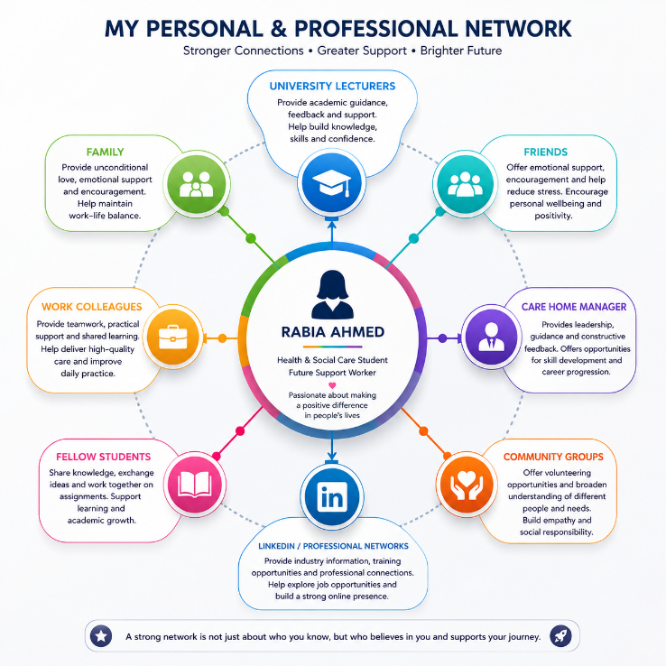
My personal and professional network is a key part of supporting my career development and wellbeing. As a student studying Health and Social Care and working in a care home I have a number of relationships that help me develop, learn and progress for the future.
Emotional support and encouragement from my family and friends helps to keep my work and life life balanced. In my place of employment, colleagues and managers provide professional guidance and provide me with opportunities to acquire new skills and knowledge and give me practical skills. The support they provide has enabled me to become confident in caring for others to a good standard and to understand the role of working within the health and social care service.
Reference: AI
The education network is important and consists of lecture and university friends. They offer academic assistance, exchange information and foster critical thinking. These relationships enable me to practice and gain knowledge of skills and understanding that I would need for future employment as a Support Worker. Social media sites like LinkedIn can offer industry information, training and potential employers as well.
Granovetter (1973) found that opportunities can be generated through professional and social networks by linking people into new avenues of information and job opportunities. Likewise Forret and Dougherty (2004) propose networking has a positive effect on career success and career development. But networks can only be useful if they are maintained and kept in good communication.
I have a supportive network, both personally and professionally. Through maintaining and building upon these links and networks I can develop my employability and further my career ambitions within health and social care.
References
- Granovetter, M.S. (1973) ‘The Strength of Weak Ties’, American Journal of Sociology, 78(6), pp. 1360–1380.
- Forret, M.L. and Dougherty, T.W. (2004) ‘Networking Behaviors and Career Outcomes’, Journal of Organizational Behavior, 25(3), pp. 419–437.

Task 3- Blog
Presented by: Sainsbury's UK and the FCA
Course Code: Core Skills for Health and Social Care Students (HSC 101) and for New Care Workers (HSC 102).
Recognise the challenges for the workforce in the UK for social care.To be aware of the challenges that face care workers in the UK.
The social care sector is important for the care of older people, people with disabilities and people with complex care needs. But there are major staffing issues at present for both care providers and users. As a student of health and social care and care worker, I feel it important to be aware of these issues and how it affects the quality of care.
Staff shortage is one of the greatest issues in social care. Few care providers have a shortage of staff, but rather a shortage of qualified staff, which results in staff becoming overworked. Lack of staffing can put strain on staff, and make it challenging to deliver person centred care. Low pay, lack of career advancement and the workload of caring work are frequently cited as causes of staff shortages (Skills for Care, 2024)..
The problem of employee burnout is a big one. Long working hours, emotional demands/staffing pressures can impact wellbeing and job satisfaction. These can cause staff attrition and recruitment problems if they are not addressed (Care Quality Commission, 2024).
Continuous professional development and training is also a continuing issue in the sector. Caring workers are trained on an ongoing basis to ensure the quality of care and the ability to meet the needs of service users and the changing regulations. For employers, investing in staff development pays, offering them a better chance of retaining skilled employees and providing high quality services.
There is growing pressure on the demand for social care services. The UK is an ageing society, with the number of people who need care increasing, but the number of care workers not keeping up (Department of Health and Social Care, 2024).. This imbalance poses a big problem for the future of this sector.
There is potential for improvement, even with some problems. Employers should strive to improve working conditions, provide better pay, support employees' wellbeing and offer opportunities for progression to gain a higher foothold in social care. Also, it is important to give greater recognition to the contributions of care workers.
The workforces are enduring great difficulties in UK social care. It is important to speak to them to provide care that is safe, effective and compassionate, as well as supporting staff wellbeing and professional development.

Task 4- NHS Equality, Diversity and Inclusion
- What is the primary goal of the NHS Equality, Diversity, and Inclusion Improvement Plan?
To foster equality and equity in a workplace where all employees have the chance to thrive

- How does the NHS EDI Improvement Plan propose to tackle the gender pay gap?
Promote equal opportunities for promotion, leadership roles and fair pay practices.

- What is meant by the term ‘intersectionality’ as used in the NHS EDI Improvement Plan?
Recognizes that individuals can be impacted by multiple types of disadvantage, around various dimensions of their identity

- Why is it important for the NHS to create a psychologically safe work environment?
It promotes staff to raise concerns, learn from errors and errors without fear.

- How does the NHS EDI Improvement Plan suggest improving the experience of internationally recruited staff?
By providing improved induction, support, mentoring and equal career development opportunities.

- What role does leadership play in advancing EDI objectives according to the NHS Improvement Plan?
Leaders foster inclusion, challenge discrimination and hold leaders to account for EDI targets.

- Identify one way the NHS EDI Improvement Plan aims to reduce health inequalities within the workforce.
By enhancing access to training and career advancement opportunities for under-represented populations.

- Why does the NHS EDI Improvement Plan emphasise the importance of collecting and analysing data on protected characteristics?
It is useful in determining inequalities and measuring progress toward increased inclusion.

- Explain how flexible working policies can contribute to equality and inclusion in the NHS workforce.
They offer assistance to employees who have caring responsibilities, health issues or personal obligations.

- What is one strategy mentioned in the NHS EDI Improvement Plan to combat bullying and harassment in the workplace?
Clear systems for reporting inappropriate behaviour and responding swiftly.

Task 5- A Letter to Yourself
Dear Younger Me,

I remember there were periods when you were facing financial problems and didn't know what tomorrow would bring. The stresses and strains of daily life were often very severe when trying to balance personal responsibilities, education and financial requirements. In hindsight, I would like to pass on some of my lessons learned on emotional intelligence and resilience to help you during those hard times.
Firstly, emotional intelligence is the ability to recognise, understand and manage emotions effectively. When money was tight, you tend to think about your problems and weren't able to boost your own confidence. You would have been able to better handle stress and stay calm and make rational decisions instead of reacting emotionally to issues if you had gained more emotional awareness.

Resilience is another quality that is important. Resilience is not about not having problems, it's about having problems and facing them in a positive way. Resilience can help to keep people positive and motivated in the face of financial challenges, which can lead to frustration and anxiety. All the challenges that you went through have helped develop determination and perseverance.

I would also remind you that seeking help is not a weakness, it's a strength. At times, family, friends and mentors can offer guidance and support. You don't have to solve all of the problems by yourself.

Remember that setbacks are temporary, most of all! Financial challenges may slow you down, but they don't stop you from achieving your goals. Continue focusing on your education, personal development and career goals. All progress is progress!

I can see how those challenges have contributed to building a stronger and more resilient person. Things that were once too much for you were now valuable learning experiences that helped build your confidence and resilience to future challenges.

Yours sincerely,
Rabia Ahmed
Task 6- GANTT Chart (200 words equivalent)
Gantt Chart: Future Employment Goal (Support Worker)
Activities | Jul 2026 | Aug 2026 | Sep 2026 | Oct 2026 | Nov 2026 | Dec 2026
Complete University Assignments | 🟩 | 🟩 | 🟩 | 🟩 | ⬜ | ⬜
Continue Care Home Work Experience | 🟩 | 🟩 | 🟩 | 🟩 | 🟩 | 🟩
Update CV and Cover Letter | ⬜ | 🟩 | 🟩 | ⬜ | ⬜ | ⬜
Attend Training and CPD Courses | ⬜ | 🟩 | 🟩 | 🟩 | 🟩 | ⬜
Improve Communication Skills | 🟩 | 🟩 | 🟩 | 🟩 | 🟩 | 🟩
Build Professional Network | ⬜ | 🟩 | 🟩 | 🟩 | 🟩 | 🟩
Search for Support Worker Jobs | ⬜ | ⬜ | ⬜ | 🟩 | 🟩 | 🟩
Prepare for Interviews | ⬜ | ⬜ | ⬜ | ⬜ | 🟩 | 🟩
Secure Support Worker Position | ⬜ | ⬜ | ⬜ | ⬜ | ⬜ | 🟩
Key:
🟩 = Task in Progress
⬜ = Not Scheduled

My future career aim is to be a Support Worker in health & social care. The Gantt chart details the main activities I will have to execute in the next six months in order to reach this goal. Firstly, completing my BSc Health and Social Care successfully with the continued experience of working in a care home. This will enable me to gain theoretical knowledge and the practical skills needed for the job.
Writing a new CV and cover letter to make sure that they are up to date and reflect my qualifications, work experience and transferable skills correctly is another important responsibility. I also aim to complete further training and ongoing training and development (CPD) to further develop my understanding of person centred care, safeguarding and communication. Networking and future working relationships with colleagues, lecturers and other professionals will be supported by building relationships with them.
I will be seeking out and applying for Support Worker jobs during the latter part of my plan. My employment will be enhanced as I prepare for interviews and show my knowledge, caring and team working attributes. This is an organised plan with each of the identified tasks to be completed within the set time and I would like to get a role of Support Worker and progress in my career in health and social care.

Task 7- Making Changes- Report
Medication Management in a Care home – how to do it better.
Introduction
I am looking to optimize the current medication management system that is in place at a care home facility, to make it safer for residents, with a lower risk of medication errors, and compliant with regulatory requirements. In health and social care it is important that medication is managed effectively as it can have a negative impact on residents health, wellbeing and quality of life if it is not managed effectively.
Proposed Change
The proposed change will include introducing a new medication management system which will include electronic medication records, regular medication audits and additional training for staff. This new system would have the ability to record, administer and monitor medications accurately, and minimize human errors.
Skills Required
There are multiple skills to successfully make this change. The ability to inspire employees and assist in the change process requires leadership skills. Good communication helps staff to grasp the need for change. The training and coaching sessions build staff confidence and competence, and problem-solving skills can help staff cope with challenges when implementing.
Change Model
Lewin's Change Management Model can be used to aid the process. The first phase "Unfreeze" is related to preparing the staff for change; communicating the value of better medication management. The second phase is "Change" which involves implementation of the new system, training and supporting staff during the transition phase. The final stage is “Refreeze” as the new practices are anchored into the everyday work (Lewin, 1951).
Potential Barriers
There are some challenges that could inhibit the change from taking place. Others staff members might be reluctant to change because they are frightened about technology or think that they will have to do more work. There are also resource constraints, time and training demands that may be a challenge. These obstacles can be overcome by communication, involvement of staff, constant support and frequent feedback moments.
Conclusion
Implementing a better medication management process can help to improve resident safety, enhance quality of care and reduce medication errors. The care home now has a robust leadership, communication and change management system in place which will enable it to implement and sustain this key improvement.

Reference List
- Burnes, B. (2020) Managing Change. 8th edn. Harlow: Pearson.
- Care Quality Commission (2024) The state of health care and adult social care in England 2023/24. Newcastle upon Tyne: Care Quality Commission.
- Department of Health and Social Care (2024) Adult social care reform and workforce development. London: Department of Health and Social Care.
- Forret, M.L. and Dougherty, T.W. (2004) ‘Networking behaviors and career outcomes’, Journal of Organizational Behavior, 25(3), pp. 419–437.
- Granovetter, M.S. (1973) ‘The strength of weak ties’, American Journal of Sociology, 78(6), pp. 1360–1380.
- Health and Social Care Act 2008 (Regulated Activities) Regulations 2014. Available through UK legislation.
- Lewin, K. (1951) Field Theory in Social Science. New York: Harper & Row.
- Peters, T. (1997) ‘The Brand Called You’, Fast Company, 10, pp. 83–90.
- Rampersad, H.K. (2008) Authentic Personal Branding. Charlotte, NC: Information Age Publishing.
- Skills for Care (2024) The state of the adult social care sector and workforce in England. Leeds: Skills for Care.

