BA (Hons) Leadership and Management Skills for the Workplace
Developing Emotional Intelligence Skills for the Workplace

BMSW6106

Assessment Task 1 –Individual Report

Student Name: Ivaylo Georgiev
Student Id: 2128090
Lecturer Name: Masoud Keimasi

Executive Summary

The report here deals with the discussion of emotional intelligence within an individual and its impact on the personal and professional life of an individual. The three models of emotional intelligence that have been used for the explanation of the models are The Goleman model, The Mayer-Salovey Model, and the Bar-On Model of Emotional-Social Intelligence. The organisation that has been considered for the report is Rhug Estate Organic Farm Shop (Corwen) an organic farm, cafe and online shop known for its 100% organic beef to customers. It has also shed light on the importance of developing emotional intelligence in an individual and the issues that are being faced. The identified issues are a lack of management of emotions and opportunities. The ‘models of emotional intelligence’ have been applied to understand the perspectives of the employees and improve their productivity rate. It can be recommended to Rhug Estate focus on team collaboration and confidence through team meetings and collaborative platforms, offering stress management opportunities by incorporating workshops and feedback systems and training related to emotional intelligence.

Table of Contents
Task 1: Individual Report 4
Introduction 4
a) Introduce the organisation …………………………………………………………….. 4
b) Key models of emotional intelligence 5
c) Applying the key models of emotional intelligence 7
d) Critical evaluation of The ‘models of emotional intelligence’ applied to The chosen organisation 10
e) Recommendations 14
Conclusion 18
References 19
Appendix 22

Task 1: Individual Report

Introduction
The report here deals with the discussion of emotional intelligence in an individual while working within an organisation. The organisation that is being discussed in the report is Rhug Estate Organic Farm Shop which is an organic farm that provides facilities for online shopping and a cafeteria for its customers in the role of farm assistant. The emotional intelligence models that are being addressed in the discussion of the various aspects of the report are The Goleman model, The Mayer-Salovey Model, and the Bar-On Model of Emotional-Social Intelligence. The report shed light on the importance of the development of emotional intelligence in an individual based on the application of the models. Lastly, it aligns the emotional intelligence with that of the requirements of an organisation for its success in the market.

a) Briefly Introduce the organisation you have chosen to write about
Rhug Estate Organic Farm shop (Corwen) is an organic farm, cafe and online shop known for their 100% organic beef to customers (The Rhug Estate, 2025a). The farm is self-contained field to plate operations, following the highest of animal welfare standards (The Rhug Estate, 2025a). The company runs their own farm where animals are provided access to rich organic pasture which improves the health of the animals in their farm. The Animals within their farms are allowed to live freely with minimal stress and are constantly monitored by the governing body of the company which is The Soil Association (The Rhug Estate, 2025a). The company has also won an award for its commitment to sustainability and their ability to generate heat and power. The company has made extensive installation of solar energy on their estate which helps them in producing 1,235KW of solar energy on the estate (The Rhug Estate, 2025b). The Rhug Wild Beauty utilises ingredients from the estate itself which helps in using own farm produce and is considered an ideal model for sustainable practices. In this company, I worked in the role of Framhand which is basically a farm assistant and this allowed me an opportunity to work with the farm teams and develop my emotional intelligence ability.

b) Briefly introduce the key models of emotional intelligence that you will underpin in your report
Goleman model: This model has been introduced by Goleman with the question regarding what makes a good leader in the concept of emotional intelligence based on five aspects like self-awareness, self-regulation, motivation, empathy and social skills. In this aspect the prophet of the model mentioned that this framework helps an individual in the identification of their ability and the methods that can be accessed so that they can control their own emotions and others emotions as well (Medium, 2023a). The use of this model in the report is that it will help in the identification of the methods which will help in controlling emotion while working in a professional field.
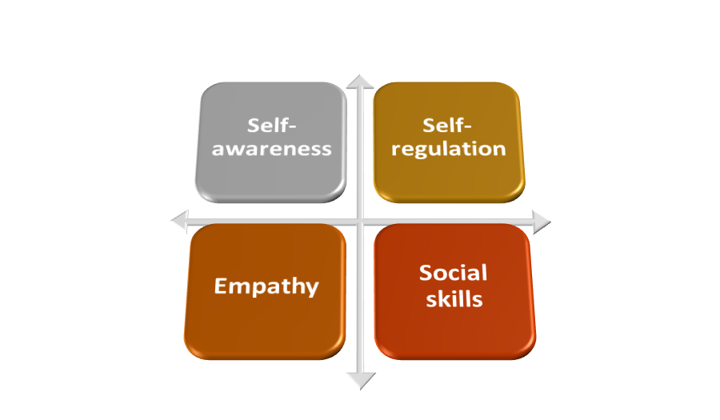
Figure 1: Goleman model
(Source: Created by the learner)
Mayer-Salovey Model: This model can be referred to as the framework of emotional intelligence as the ability of an individual in using emotions so that it can enhance their thinking and behaviour (Medium, 2024). This is a four branch model that describes emotional intelligence based on the ability of an individual to perceive emotions, use emotion for facilitation, understand emotions and manage emotions. In the context of the report this will help the learner in amending its ability based on the four branches of the model. This helps an individual in using emotional intelligence to facilitate cognitive tasks and understand complexities in the workplace.

Figure 2: Mayer-Salovey Model
(Source: Created by the learner)
Bar-On Model of Emotional-Social Intelligence: This is considered to be a theoretical framework that defines the emotional intelligence of an individual as a collection of certain interrelated emotional and social competencies which allows and individual to understand so that they can express themselves in relation to others so that they can cope with the required demands (Medium, 2023b). The implementation of the mode in the report here will helps in understand and identify the emotional intelligence skill sets that are possessed by an individual while they are working in a professional environment.
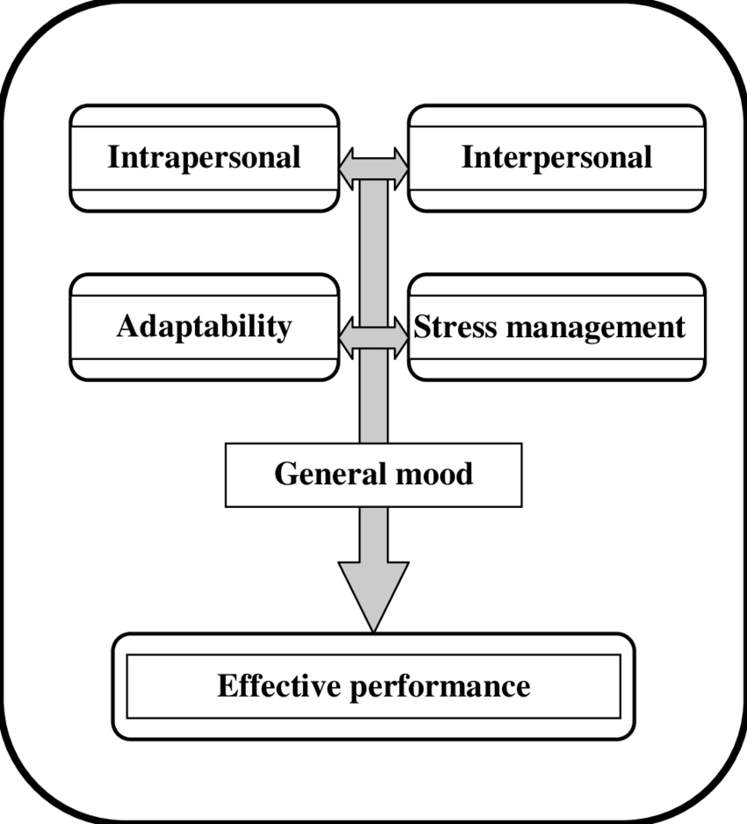
Figure 3: Bar-On Model of Emotional-Social Intelligence
(Source: Zoromba et al. 2015)

c) Answer the question by applying the key models of emotional intelligence to your chosen organisation, i.e. Explain the importance of developing emotional intelligence in the workplace and the relationship between emotional intelligence, effective management communication and business advantage.
The importance of developing emotional intelligence in the workplace and the relationship between emotional intelligence, effective management communication and business advantage
In today's dynamic environments, emotional intelligence plays an important role in ensuring that employees within a workplace are able to navigate through day-to-day challenges and this is achieved by fostering collaborative workplace environments, and incorporating strategies which allows a business to achieve competitive advantage. With the help of emotional intelligence, a person is able to develop a better understanding regarding the emotional needs of others and this helps employees in understanding each other's perspectives, engaging in effective communication and reducing the risk of conflict (TSW Training, 2023). According to Kotsou et al. (2019), emotional intelligence is defined as the ability of a person to identify, express, manage, understand and use emotions. Additionally, employees with high emotional intelligence tend to experience a higher job satisfaction as emotional intelligence boosts their ability to manage relationships and communicate effectively with others thus leading to a positive overall workplace experience (Manage Magazine, 2024).
Goleman model of Emotional intelligence:
The Goleman model of Emotional intelligence was discovered by Daniel Goleman which comprises areas regarding how to control oneself, understanding others and interacting effectively (Singh, Prabhakar and Kiran, 2022). Each of the five key components of the Goleman model plays an important role in the development of emotional intelligence of employees and leaders within companies like The Rhug Estate.
Self-awareness in the case of Rhug Estate is vital for ensuring that employees are able to reflect on their action, and the impact of their action on the environment which allows them to make better decisions regarding sustainable farming practices. For instance, I have seen that employees working on a firm team feel closely associated with the team members and in this team people work together, help each other and even celebrate birthdays together which is really encouraging and helps me to connect with others. Self-regulation is practised within the Rhug Estate through resilience where employees are motivated to stay calm and engage in group discussion to regulate their emotions and ensure the delivery of top-quality services. In my case I used to talk with my coworkers, and this used to reduce my stress and help me stay calm.
Motivation of employees at Rhug estate comes from their sustainable practices and focus on ethical sourcing which encourages employers to contribute towards organisational goals rather than just focusing on monetary rewards. With the help of EI the goals of employees are aligned with the sustainability goals of the organisation, Rhug Estate also emphasizes personal satisfaction of employees by offering competitive salaries and benefits packages which keep them motivated and engaged with their work (The Rhug Estate, 2025c). This enhanced job satisfaction, reduced employee turnover and increased the loyalty of employees. In terms of showing Empathy, Rhug Estate focuses on offering equal rights to men and women at work which promotes fair treatment of employee artworks and employees are allowed to freely express their emotions. While working there I have seen more than half of the employees there are women, and they actively do farm work whereas men are assorted with hospitality roles. This boosted my confidence in the fact that irrespective of their roles and designation equal respect and consideration is provided to each of the employees. Social Skills are developed within Rhug Estate due to their team-oriented introverts where everyone is provided with equal work opportunities and the scope to improve their performance. This allows the opportunity to openly communicate with others and develop trust and understanding with each other.
Mayer-Salovey Model:
The four stages of the Mayer-Salovey Model of Emotional Intelligence applied to the Rhug State in the following manner.
In the context of Rhug Estate, perceiving emotions involves the process of recognizing emotional cues from others, especially colleagues. While working on forms everyone uses to be attentive towards others and welcoming when any one of us wants to share something. This helps in understanding that a team-based environment actually helps with perceiving the emotions of others and improves the satisfaction levels at work. The use of emotion in employees is often used as part of decision making within a team so that there is mutual problem solving and decisions could be mutually beneficial for all. However, in case new team member is added it used to be challenging in beginning to understand their emotions because sometimes employees lack confidence to open up or share their concerns within a workplace. Thus, to help manage emotions of new employees in this situation group meetings and one on one conversations are helpful which helps influencing the actions of others in a constructive manner. Moreover, workforce training is also provided to staff to help them not only be aware of workplace practices but also related to needs and demand of customers and show empathy in resolving their issues.
Bar-On Model of Emotional-Social Intelligence:
Emotional and social intelligence is one of the key areas of focus of Rhug Estate and the five areas of The Bar-on model are vital in maintaining a productive, positive and resilient workforce. For instance the Intrapersonal Skills allows employees, especially the farm role and hospitality role, to be self-aware, and motivates them to work for long hours and in changing weather conditions in firms whereas Interpersonal skills such as empathy and effective communication allows employees to foster better relationships with customers and colleagues. This helps in ensuring smooth operations and clear communication while allowing employees to respect each other’s emotions. Adaptability is an essential skill for employees at Rhug estate as the weather condition can constantly change so does the farm condition and adaptability skills helps employees to be efficient under any conditions. As farming and offering high quality customer service is physical as well as emotionally demanding, therefore there is scope for the company to offer stress management opportunities to their employees. This will help in improving the general mood of employees and enhance their job satisfaction.

d) Critically evaluate ‘models of emotional intelligence’ you have applied to your chosen organisation and explain the extent to which you think they are appropriate in meeting the development needs of the individual.
Emotional intelligence can be referred to as a person’s ability to manage their emotions and recognise the feelings of others (Lauren, 2025). It is a useful aspect for navigating the work life and relationships. Being a farm assistant, it is necessary to have high emotional intelligence to manage the relationship with animals and colleagues. This is because understanding the needs of the animals and feeding them properly and behaving with them in the proper way is necessary to take great care of them. Great emotional intelligence is likely to have a positive impact on workplace behaviour (Loi et al. 2021). It can be done by listening to the query of the employees and helping them to complete the task in a given time frame. In this respect, critical evaluation of models of emotional intelligence is required and their applicability to Rhug Estate Organic Farm shop (Corwen) is the focus area. Three different models have been desiccated below which are ‘models of intelligence’ namely Goleman model, Mayer Salovey model and bar-on model of emotional-social intelligence. It is important to analyse the models for contributing to the development and needs of an individual. Moreover, making the organisation gain a sustainable market position can also be attained in this respect.
Goleman model: The model of Goleman focuses on five major elements such as self-awareness, self-regulation, motivation, empathy and social skills. Emotion for cognitive thinking can be guided with the help of the Goleman model (Heather, 2019). The aspect of self-awareness has been applied by me in the organisation to understand the emotions of customers to purchase the products. It has also been applied in case of understanding the training needed of the employees to improve productivity. Self-regulation has been applied in Rhug Estate in the context to manage the disruptive emotion by enhancing social skills and ensuring customer satisfaction. Motivating the employees by giving technological training and monitoring their performance has been done. This is because it makes the employees feel motivated and comfortable and helps to improve the productivity rate in this global marketplace. Empathy helps in understanding the feelings of the people (Heather, 2019). Maintaining the enthusiasm of organic farming has been done to improve the work culture. Social skills such as communication skills and customer relationship have also been applied to resolve the queries of the customers by the employees related to the product details and satisfy their needs. It is also done to resolve the team conflict within the different departments of Rhug Estate.
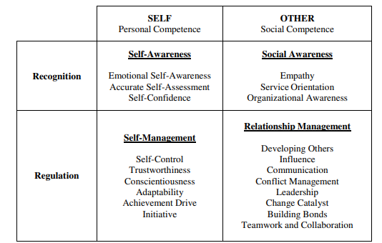
Figure 4: Major elements of Goleman model
(Source: Delgoda and Weerasinghe, 2021)
The model is appropriate for balancing the emotional intelligence with respect to practical skills to improve the performance of Rhug Estate.
Mayer-Salovey Model: The Mayer-Salovey Model consists of four major key branches which are perceiving emotion, using emotion to facilitate thought, understanding emotions and managing emotions (Heather, 2019). Perceiving emotion has been applied to recognize the emotions of the employees. The postural expression of the employees develops a strong instinct related to their way of understanding of the respective job role. On the other hand, the expression of customers is also considered to understand their purchasing intention. Facilitating thought is applied in context to have a problem-solving approach. The issue related to the shipping system of the organic product has been considered (BBC, 2021). Problem-solving approaches such as improving operational efficiency by usage of AI are regarded as profitable outcomes. Understanding the emotion of the employees and allowing flexible working hours to reduce stress is acknowledged. Managing the emotions of the employees' work stress has been resolved by reducing the stress of the employees by giving them training and reducing their workload.
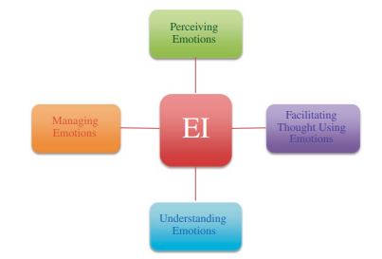
Figure 5: Mayer-Salovey Model
(Source: Fiori and Vesely-Maillefer, 2018)
I believe that The model Mayer-Salovey is considered to be of high value in context to regulation and emotional awareness, however, it might need effective training support to improve the company’s performance.
Bar-On Model of Emotional-Social Intelligence: I believe that the Bar-On Model of Emotional-Social Intelligence is a comprehensive framework which focuses on social and emotional competencies. It is seen that the model is a cross-cutting section of emotional competence (ZAMFIRESCU-MAREȘ, 2024). It has five major elements such as interpersonal skills, intrapersonal skills, stress management, adaptability and general mood. Interpersonal skills, such as teamwork and communication have been applied to make effective communication with other departments. Based on intrapersonal skills, active listening and adaptability has been applied by myself to make the team handle the situation of crisis and huge number of sales rates. Stress management has been applied by making the employees feel valued and giving them flexible working hours. Adaptability, in terms of a positive work environment, has been considered. General mood with respect to motivating the employees by giving them technical training has been done.
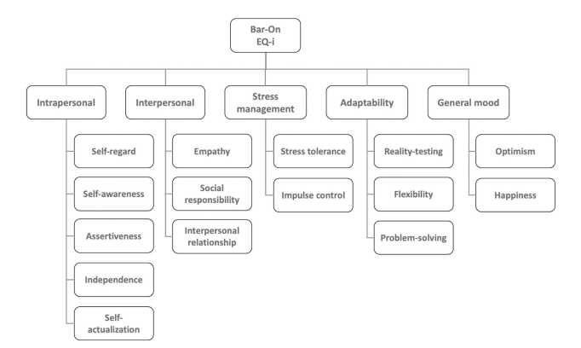
Figure 6: Bar-On Model of Emotional-Social Intelligence
(Source: Rosenberg et al. 2024)
It is thus suitable for individual development in terms of generating skills and leading the work in an effective way.

e) Provide recommendations with a plan for the systems and processes that may enable better collaboration and connectedness between people and implement company values to high EQ behaviours among existing staff during this current volatile economic environment.
Recommendation 1: Team collaboration and confidence through team meetings and collaborative platforms
Specific | Measurable | Achievable | Relevant | Timebound
To develop team collaboration and confidence among the team through team meetings and collaborative platforms. | It can be measured by 50% of rise in confidence and understanding the emotions of the team members. | It can be achieved through team meetings and incorporating collaborative platforms such as Zoom and Google meet. Moreover, taking online courses related to boosting up confidence can also be considered. | It is relevant because interaction and collaboration among the human workers is of utmost importance (Arslan et al. 2022). This is because it can help in reducing team conflict and enhance productivity. | 4 Months
Table 1: SMART
(Source: Created by the learner)
Justification
The recommendation of team collaboration and confidence through team meetings and collaborative platforms is justified because it might enable better collaboration and connectedness between people. This can be done in terms of using the collaborative platform of Zoom and Google Meet. Implementation of high EQ behaviours is necessary among the existing staff in this current volatile economic environment to attain a sustainable market position. This is because it improves the work-life balance and maintains knowledge-sharing behaviour (Soliman et al. 2023). In this respect, goal-setting theory can be used to measure the success of the employees and lead to better performance.
Implementation plan
Step 1: Scheduling the weekly meetings and making the employees understand about the goal of the meeting and the project as well.
Step 2: Encouraging dialogue among the team members to understand their perspectives. It will be done to improve the communication among the team numbers related to customer feedback or any meeting agenda. It can be done through online meetings by accessing Zoom.
Step 3: Usage of collaborative platforms such as Zoom and Google Meet to keep the conversation ongoing without any disturbance.
Step 4: Empower the managers to schedule the meeting in a given period. The manager needs to become an active listener and discuss the issues faced by the employees to boost up their confidence.
Recommendation 2: Offering stress management opportunities by incorporating workshops and feedback system
Specific | Measurable | Achievable | Relevant | Timebound
To offer stress management opportunities through conducting workshops and enhancing their job satisfaction by incorporating feedback systems. | It can be measured by having 70% of employees participants in the workshops and improving the wellbeing of 20% employees. | It can be achieved through hiring local wellness coaches for running the workshops. Moreover, a feedback system can be initiated to understand the requirements of the employees. | It is relevant because it might help Rhug Estate to pay more attention to the well-being of the employees and enhance the employee satisfaction rate which are needed in some unavoidable circumstances.. | 4 Months
Table 2: SMART
(Source: Created by the learner)
Justification
Stress management provides a range of tools to improve the physical and mental well-being of an individual (Mayo Clinic, 2025). In this respect, Offering stress management opportunities might improve the general mood of the employees. It can further help in enhancing the job satisfaction of the employees. It is justified because collaboration and connectedness between people can be done with the help of conducting workshops and making the employees come under one roof and gain experience by showcasing their problems and understanding the ways to feel less burdened. Incorporation of feedback system might be beneficial to understand the needs of the employees and make them feel valued. The goal-setting theory can be applied in terms of focusing on the emotional adaptability and wellbeing of the employees. The company's value can be implemented with respect to the performance evaluation of the employees. The current volatile economic environment needs effective consideration of the feedback system to manage the performance of the employees and the organisation itself.
Implementation plan
Step 1: Identifying the emotional challenges faced by employees through the survey. Feedback systems can also be used to understand the needs of the employees.
Step 2: The development of tailored workshops and focusing on building resilience can be considered.
Step 3: Ensuring the attendance of the employees during the workshops is a part of their development plan.
Step 4: Doing the follow-up of the feedback to understand the impact of resilience on the working patterns of the employees.
Recommendation 3: Training related to emotional intelligence
Specific | Measurable | Achievable | Relevant | Timebound
To give proper training to the employees in the context of emotional intelligence. | It can be measured by 75% of improvement in the post training and positive behaviour of the employees. | It can be achieved with the help of in-house trainers and Emotional intelligence experts to align the goal of the company and the employees simultaneously. | It is relevant because through better emotional intelligence training effective operational efficiency can be achieved by recognising and managing the emotions of others. | 3 Months
Table 3: SMART
(Source: Created by the learner)
Justification
It is justified because the cultivation and development of emotional skills might offer the element of contemporary research (Papoutsi et al. 2021). It can also be said that a better training program might enhance the capability of the employees to improve the shipment process and enhance operational efficiency. It shows the collaboration and connectedness between people and the company value in context to improve the business performance and dancing the sales rate. Goal setting theory is applicable by focusing on improving the emotional intelligence of the existing staff in a volatile environment. Training efforts within the organisation indeed to improve the business performance (Kirkpatrick and Kirkpatrick, 2022). Thus resulting in effective growth in this contemporary business environment.
Implementation plan
Step 1: Conducting assessment related to the skills of the employees through the observation by the manager
Step 2: Develop the curriculum based on social skills, empathy and self-regulation.
Step 3: Giving training in terms of workshops and online modules.
Step 4: Measuring the progress rate through real-time application of emotional intelligence and 360-degree feedback.

Conclusion
Based on the above discussion it can be concluded that the development of emotional intelligence within an individual helps in identifying the skill sets that help in managing a successful professional status while working. The three models that have been considered for the study are the Goleman model, the Mayer-Salovey Model, and the Bar-On Model of Emotional-Social Intelligence. Along with that, the use of these models has been used for the identification of the issues including perceiving emotion and understanding the emotions of the team members based on lack of communication. The suggestions that have been highlighted for the development of the skills are active communication along with collaboration with the members of the team.

References
Arslan, A., Cooper, C., Khan, Z., Golgeci, I. and Ali, I., (2022). ‘Artificial intelligence and human workers interaction at team level: a conceptual assessment of the challenges and potential HRM strategies’. International Journal of Manpower, 43(1), pp.75-88.
BBC, (2021). Organic food shipping system is a 'nightmare' post-Brexit. Available at: https://www.bbc.com/news/world-europe-55725205 (Accessed: 18 February 2025)
Delgoda, L. and Weerasinghe, T.D., (2021). ‘Gender differences in emotional Intelligence: moderating role of organizational culture’. Journal of Human Resource Management Perspectives, 6(1), pp.59-82.
Fiori, M. and Vesely-Maillefer, A.K., (2018). ‘Emotional intelligence as an ability: Theory, challenges, and new directions’. Emotional intelligence in education: Integrating research with practice, pp.23-47.
Heather, (2019). Emotional Intelligence Theories & Components Explained. Available at: https://positivepsychology.com/emotional-intelligence-theories/ (Accessed: 18 February 2025)
Kirkpatrick, J.D. and Kirkpatrick, W.K., (2022). ‘Training on trial: How workplace learning must reinvent itself to remain relevant’. HarperChristian+ ORM.
Kotsou, I., Mikolajczak, M., Heeren, A., Grégoire, J. and Leys, C., (2019). ‘Improving emotional intelligence: A systematic review of existing work and future challenges’. Emotion Review, 11(2), pp.151-165.
Lauren, (2025). What to know about emotional intelligence. Available at: https://www.medicalnewstoday.com/articles/components-of-emotional-intelligence (Accessed: 17 February 2025)
Loi, N., Golledge, C. and Schutte, N., (2021). ‘Negative affect as a mediator of the relationship between emotional intelligence and uncivil workplace behaviour among managers’. Journal of Management Development, 40(1), pp.94-103.
Manage Magazine, (2024). The 10 Benefits of Emotional Intelligence in the Workplace. Available at: https://managemagazine.com/article-bank/emotions-emotional-intelligence/the-10-benefits-of-emotional-intelligence-in-the-workplace/ (Accessed: 18 February 2025)
Mayo Clinic, (2025). Stress basics. Available at: https://www.mayoclinic.org/healthy-lifestyle/stress-management/basics/stress-basics/hlv-20049495 (Accessed: 17 February 2025)
Medium, (2023a). Daniel Goleman’s Bestseller -“The Emotionally Intelligent Leader”: Book Review & Key takeaways for all Available at: https://medium.com/lean-in-women-in-tech-india/daniel-golemans-bestseller-the-emotionally-intelligent-leader-book-review-key-takeaways-for-e1d5c88b6240 (Accessed: 20 February 2025)
Medium, (2023b). What is social intelligence? Available at: https://medium.com/@dr.victor.bodo/what-is-social-intelligence-7ee1499ab6ea#:~:text=According%20to%20the%20Bar%2DOn,daily%20demands%2C%20challenges%20and%20pressures (Accessed: 20 February 2025)
Medium, (2024). Emotional Intelligence 101: Identifying, Understanding, and Managing Emotions Available at: https://medium.com/psych-pstuff/emotional-intelligence-101-identifying-understanding-and-managing-emotions-b836a6b90a54#:~:text=Salovey%20and%20Mayer%20(1990)%20proposed,of%20emotional%20dynamics%2C%20and%20effectively (Accessed: 20 February 2025)
Papoutsi, C., Drigas, A. and Skianis, C., (2021). ‘Virtual and augmented reality for developing emotional intelligence skill’s. Int. J. Recent Contrib. Eng. Sci. IT (IJES), 9(3), pp.35-53.
Rosenberg, C., Caballero, C.L., Hayley, A. and Walker, A., (2024). ‘The success elements of humor use in workplace leadership: A proposed framework with cognitive and emotional competencies’. Plos one, 19(5), p.e0304650.
Singh, A., Prabhakar, R. and Kiran, J.S., (2022). ‘Emotional intelligence: A literature review of its Concept, models, and measures’. Journal of Positive School Psychology, 6(10), pp.2254-2275.
Soliman, M., Sinha, R., Di Virgilio, F., Sousa, M.J. and Figueiredo, R., (2023). ‘Emotional intelligence outcomes in higher education institutions: Empirical evidence from a Western context’. Psychological reports, p.00332941231197165.
The Rhug Estate, (2025a). Our Story. Available at: https://rhug.co.uk/our-story (Accessed: 18 February 2025)
The Rhug Estate, (2025b). Rhug Estate: A Model of Sustainable Farming in North Wales. Available at: https://rhug.co.uk/our-sustainability (Accessed: 18 February 2025)
The Rhug Estate, (2025c). Join Our Team: Rhug Estate Careers. Available at: https://rhug.co.uk/careers?srsltid=AfmBOor2dBdMjct-0VRpyD1Tr-mh7UI2IH--qwWPTln-SjoOQYcnIlhL (Accessed: 18 February 2025)
TSW Training, (2023). The Benefits of Emotional Intelligence in the Workplace. Available at: https://www.tsw.co.uk/leadership-and-management/the-benefits-of-developing-emotional-intelligence-in-the-workplace/(Accessed: 18 February 2025)
ZAMFIRESCU-MAREȘ, D., (2024). ‘Social and Emotional Development in University: Educational Training Activity for Social Work Program Students’. Educația Plus, 35(1), pp.186-203.
Zoromba, M.A.A., Abdellatif, S.A., Hussien, E.S. and Hamed, W.E.S., (2015). ‘Relationship between Emotional Intelligence and levels of Depression among Patients with Depressive Disorders’. Mansoura Nursing Journal, 2(1), pp.45-54.

Appendix


