University of Wales Trinty Saint David
Module: Material Science / Structural Appreciation, Science and Materials
Module Code: M4X01314 / M4X01349
Lecturer: Allan Nantel
Assignment Title: Construction Materials
Assignment Date: 08th January 2019
Student Name: Phillip Abdullah
Student Number: 1708489

Concrete Frame
A skeleton frame of vertical concrete columns and horizontal beams. This grid supports the building’s floors, roof, walls and is typically constructed on a concrete foundation. Columns are the primary load carrying element of the building and are therefore considered most important. A damaged floor slab/beam would result in only one floor being affected but a damaged column could result in the collapse of a building. Although concrete frame structures remain the most commonly used structures worldwide, steel structures are often used for high-rise buildings.
Central Plaza is one of the most famous concrete frame skyscrapers in the world:
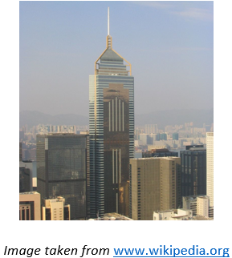
Overview
Completed in 1992 and taking 44 months to complete, Central Plaza stood as the tallest building in Asia until Shun Hing Square, China was built in 1996. The site of construction was reclaimed land from Hong Kong’s Victoria Harbour. The exact construction cost of Central Plaza has not been well documented.
Joint developers Ryoden Development, Sino Land and Sun Hung Kai Properties employed Architect Dennis Lau & Ng Chun Man(HK) Ltd to design the 374m, 78-storey building(Wikipedia, 2001)
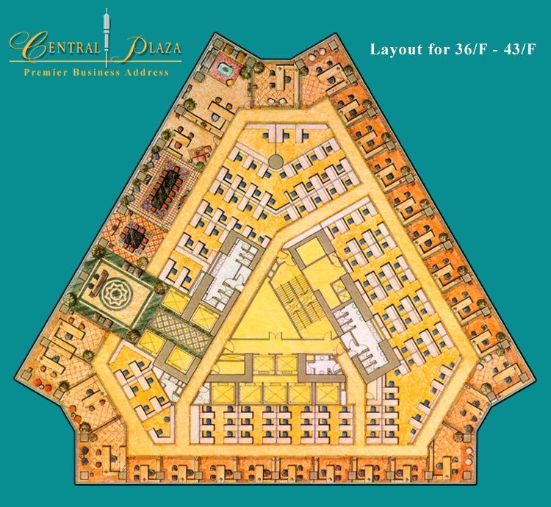
Design Planning
Central Plaza was designed triangular in shape to increase views of Victoria Harbour and allow for better utilisation of floor space; offering internal column-free office areas. However, the shape of the building meant bespoke Air Handling Units(AHU) were required.

The Central Plaza houses Sky City Church, the world’s highest church inside a skyscraper(Skyscrapper.com). The building is also crowned with a unique “Lightime” feature which displays time with the use of neon lights. The tip of the building's mast is equipped with an anemometer which measures wind speed.
To optimise views Central Plaza had to be built taller than neighbouring high-rise buildings. Difficulties experienced in structural and building services design of enormous buildings can potentially weaken safety operation – precautions must be taken which can increase capital costs. Due to high windload in high-rise buildings in Hong Kong, every increase in building height by a metre would increase structural cost. A final floor height of 3.6m(12 ft) was adopted allowing substantial cost savings over the 58 office floors.
“Not only is Central Plaza the grandest skyscraper in Hong Kong, it also offers some of the best views in Hong Kong” Engineer Nushma Juwaheer
Construction
When construction began, significant changes were made by engineers to increase the project’s speed of development. At the peak of construction each floor took approximately 4days to complete.
During early design stages, it was decided a steel frame structure would be used. However due to time constraints and concerns that steel may not be readily available an alternative reinforced concrete frame was considered. To accommodate the concrete frame structure, management decided to reduce the height of the building and increase the floor plate size. A 60N/sq mm concrete was used for the first time in Hong Kong, resulting in the tallest concrete building in the world.
Adoption of a climbing formwork construction method ensured construction took no longer than if a steel frame had been used. This enabled lower floors to be completed and occupied whilst upper floors were still under construction, maximising revenue.
Hong Kong is an area effected by typhoons and strong winds which presented key challenges for engineers. A detailed study from experts at the University of Ontario’s wind tunnel laboratory ensured the structure would withstand predicted wind speeds and provide acceptable comfort levels for occupants.
As the building is situated on reclaimed land from the harbour, the water table rises to about 2m below ground level. A diaphragm wall design was therefore required to accommodate the 6-story basement specified in the original brief.
Central Plaza was a key addition to Hong Kong’s business area by expanding local businesses, creating construction jobs and bringing income to the local economy(Ice.org.uk).

Steel frame
A skeleton frame of vertical steel columns and horizontal I-beams, constructed in a rectangular grid to support the floors, roof and walls of a building which are all attached to the frame. The development of this technique made the construction of the skyscraper possible(Wikipedia, 2005)
Empire State Building is one of the most renowned steel frame skyscrapers in the world:
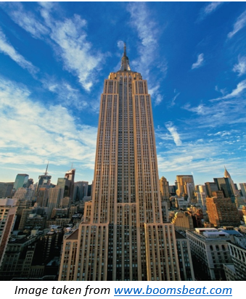
Overview
Since completion in 1931 the Empire State Building(ESB) has been internationally famous. The iconic structure known as The Heart of New York City stood as the tallest building in the world for over 40 years until World Trade Centre was built in 1972. Taking just 13 months to complete, ESB holds the record for the fastest erection of a world’s tallest Skyscraper. Construction of ESB cost just $24.7 million against the estimated $43 million.
Developer John Raskob’s ambition of building the tallest building in the world was the main driver throughout early design stages and construction. Raskob allegedly asked architect William Lamb:“How high can you make it so that it won't fall down?”(Douglas, cited in Jacobsson and Wilson(2018)
Design Planning
Architects Shreve, Lamb, and Harmon were contracted to design the distinctive ‘pencil like’ building.
The original design of ESB was a 50story office building. After fifteen revisions, the final design was an 86story building with an airship mast which ensured it would be the world's tallest building(Wikipedia)
The top floors needed to be set back because of fluctuating air currents over Manhattan and projected wind pressure on the extension. The 1916 Zoning Act imposed further restrictions stopping enormous buildings from preventing light and air reaching adjoining buildings and streets below.
Everything was planned for speed. Design plans were thoroughly analysed by building experts and adjusted to overcome foreseen delays. Art deco style was chosen to utilise machine made and ready-to-use supplies. Choice of materials was limited to those which could be obtained in time to be fabricated and set.
Project manager Paul Starrett stated “never before in the history of building had there been an architectural design so magnificently adapted to speed in construction”(Tauranac,cited in Jacobsson and Wilson(2018)
The modular nature of design, identical floor plans and repetition of processes aided speed of construction. Methods resembling an assembly line were employed maximising construction to 4.5stories per week. Individual elements such as windows were standardised to reduce installation time.

Construction
The gruelling demolition of the existing Waldorf-Astoria Hotel presented issues with disposal as there was no demand for the hotel’s recyclable waste material. Consequently, debris was dumped into the Atlantic Ocean and wood burned in nearby swamps.
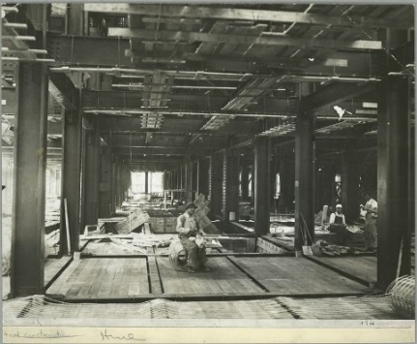
Groundworkers dug the 55-foot foundation to reach solid bedrock and concrete footings were used to support steelwork. Four colossal columns installed at the centre supported a combined 10,000,000 pounds when the building was completed. 210 closely spaced steel columns produced a robust frame but equally restricted flexibility in layout and ease of adaptation in future.
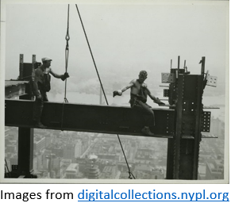
2500 workers meant logistics was problematic. Use of bespoke equipment such as rail tracks/specially designed hoists allowed efficient material transportation reducing movement on-site.
Off-site depots were used to buffer supply and Just in Time deliveries eliminated need for storage and double handling; saving time and money. Large pieces of pre-cut limestone and prefabricated metal arrived ready to install. “All the workers had to do was put them in place and attach them to the framework"(Mann,cited in Jacobsson and Wilson(2018).

Nearly 60,000 tons of steel used for framework was manufactured in Pittsburgh and transported 400miles to Manhattan. This was the largest ever single order of steel at the time.
Management understood the importance good relationships with those living and working in the area would have on its progress. The “Empire State Building Club” and the “Fifth Avenue Association” were established to provide open forums for key stakeholders.
In 2013, Time magazine hailed ESB as a feat of American engineering stating “It’s story, since then, has become interwoven with New York’s history”. At the peak of construction 3500 workers were employed on site boosting the local economy during the ‘Great Depression’
Joint developer Al smith stated ESB had been built for generations to come. With Over 3.5 million visitors per year, ESB has since been declared a landmark and so by law it must be preserved to appear just as it always has.

Comparison of Concrete vs Steel Frame buildings:
Concrete is a conventionally used material for construction while steel is now gaining momentum for its flexibility and reduced construction time (Designingbuildings.co.uk)
Durability and Climatic Resistance
Steel buildings are extremely durable and can last for generations with minimal maintenance, resisting extreme weather conditions including heavy rain/snow loads and strong winds. Steels capability to expand keeps the I beam from buckling, cracking or failing. It’s also unlikely to rot, rust and warp.
Concrete is also considered a durable, practical solution for environmentally responsible design and requires little maintenance over the lifetime of the building (except when subjected to highly aggressive environments such as sea water and frost). Concrete does not rust, rot or burn and as a result, concrete buildings have low environmental impacts associated with maintenance and repair.
Corrosion of steel embedded in concrete structures limits durability and performance of reinforced concrete structures in harsh environments(Bentur et al, cited in Bediwy 2016) Sacrificial anodes are used to provide early stage strength and protect embedded concrete reinforcement from corrosion. Concrete exhibits cracking tendencies due to increased thermal/drying shrinkage with high early strength concretes more prone to cracking than moderate/low strength concrete.

Although compressive strength is a measure of durability it is not entirely true that strong concrete is always durable concrete(Cegyan.com). However, modern technology has led to high performance concrete with super-tensile load qualities.
Prefabricated steel components enhance safety by allowing better quality control of manufacturing. Steel requires fire protection whereas this is characteristic of concrete. Pouring concrete frames in-situ whilst exposed to weather elements and labour intensive construction processes can affect quality and construction time.

Production Process and The Environment
Both concrete and steel framed structures have environmental issues associated with embodied energy.
Cement production results in high levels of CO2 output through burning of fossil fuels/coal and thermal decomposition of calcium carbonate. 4-5% of CO2 emissions is caused by cement production. Production of one tonne of cement results in 780kg of CO2(Greenspec.co.uk)
Steel production also has many environmental impacts, including air emissions, wastewater contaminants and hazardous/solid wastes. The major impacts from integrated steel mills are from coking and iron-making. Approximately 7-9% of CO2 emissions derive from iron and steel production. The average CO2 intensity for the steel industry is 1.9 tons of CO2 per tonne of steel produced(Worldsteel.org)
Heavy based concrete construction has the recognised advantage of providing thermal mass helping reduce the energy consumption on buildings. However, as the floors of steel and concrete framed buildings are often constructed mainly from concrete, both structures can be designed for maximum energy and thermal efficiency offering future sustainability.
Research carried out by Guggemos and Horvath(2005) compared environmental effects of steel and concrete framed buildings. The results suggest that steel frame structures are more environmentally friendly during construction stage than concrete:
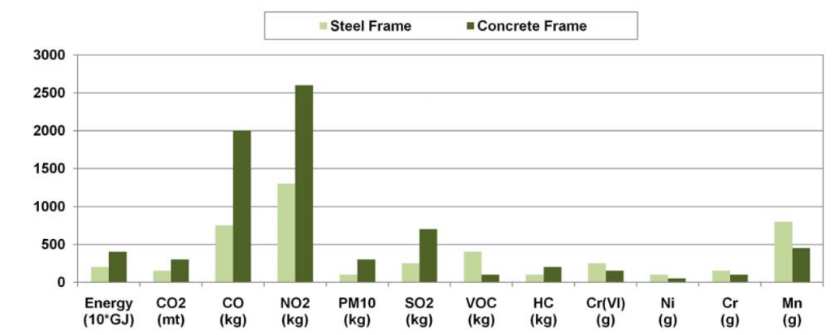

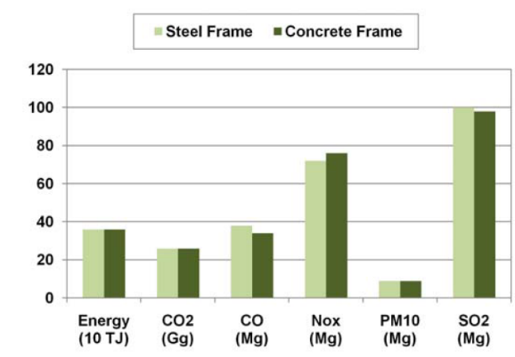
However, when considering the total life cycle energy use and emissions of steel and concrete framed buildings, the overall results are comparable and therefore more research is needed(NRMCA.org)

Concrete also provides the benefit of being a locally produced material whereas steel is often sourced nationally or even imported. The use of locally manufactured materials reduces environmental impact of transportation. Using concrete that is produced and manufactured in the same community supports the local economy.
Low/zero carbon buildings with high BREEAM ratings are achievable using steel construction. Steel buildings can be made from 100% recyclable materials without any loss of quality. In the UK, approximately 86% of steel frame sections of redundant buildings are recycled to create more steel products and 13% are reused in their existing form(Scribd.Com)
Research shows issues with moisture content and material variability means the potential of using recycled concrete is economically unviable. However waste materials such as GGBS(Ground Granulated Blast-Furnace Slag) and PFA(Pulverised Fuel Ash), that would typically be sent to landfill can be included within concrete mix to add strength and durability. The use of such substitutes has the added benefit of reducing CO2 emissions during production of concrete.

Ease of Assembly and Adaptation within Life Cycle
Steel buildings are economical to build and can be prefabricated and constructed to individual specifications. Steel framework is as much as 60% lighter than a comparable reinforced concrete frame which allows for less expensive foundation systems.
Prefabrication of steel increases overall speed of construction on site, significantly reducing building time and labour costs. The time gain of using a steel frame can be substantial on multi storey buildings. Although greater production costs may be evident initially for high rise steel frame buildings, this is usually offset by substantial reduction in erection time compared to concrete frame high rise buildings (Scribd.com)
Hybrid solutions and innovations in formwork have improved the efficiency of concrete construction. The use of precast concrete can also help to significantly reduce waste and build time while improving quality and strength of concrete.
Design flexibility
The use of longer spanning frames in steel structures offer greater flexibility and functionality of layout making completed buildings more attractive to potential occupants.
Sustainable buildings should be flexible to change of use and adaptable to future needs and regulatory or market driven requirements. Adaptation of steel buildings can be facilitated by easy removal/addition of structural steel members. In-situ concrete frames are more difficult to modify after construction limiting life cycle building use and leading to premature redundancy and subsequent demolition.
Ducts and services can run easily through steel members allowing ease of access for future maintenance/inspection, no such flexibility exists with concrete members.
Conclusion
The comparisons above highlight the fact that use of either a concrete or steel frame does not completely outweigh the other. The decision as to whether a concrete or steel frame is preferred will often be based on cost and time constraints and the nature of each project.
References and Sources:
Arco Steel (2016) Steel and The Empire State Building [Online] Available at: http://www.arcosteel.com/steel-empire-state-building/ [Accessed 10 Dec. 2018]
Bediwy A G (2016) Resilient Infrastructure. Improving The Efficiency Of Zinc Sacrificial Anodes In Repaired Concrete [Online] Available at: https://ir.lib.uwo.ca/cgi/viewcontent.cgi?referer=https://www.google.com/&httpsredir=1&article=1004&context=csce2016 [Accessed 28 Dec. 2018]
Building.co.uk Whole-life costs: Concrete vs steel [Online] Available at https://www.building.co.uk/data/whole-life-costs-concrete-vs-steel/3069406.article [Accessed 28 Dec. 2018]
Cegyan.com (2016) Factors Affecting Durability Of Concrete [Online] Available at: http://www.cegyan.com/blog/factors-affecting-durability-of-concrete [Accessed 15 Dec. 2018]
Concrete Sustainability Report. Life Cycle Assessment of Concrete Buildings 2011 [Online] Available at: https://www.nrmca.org/sustainability/CSR04%20-%20Life%20Cycle%20Assessment%20of%20Concrete%20Buildings.pdf [Accessed 8 Dec. 2018]
Designing Buildings Wiki. Concrete v Steel. [Online] Available at https://www.designingbuildings.co.uk/wiki/Concrete_vs._steel [Accessed 28 Dec. 2018]
Douglas, G. H. (2004). Skyscrapers: A social history of the very tall building in America. Jefferson, NC: McFarland & Company Inc. [Online] Available at: https://books.google.co.uk/books?hl=en&lr=&id=IxDUUqut-XkC&oi=fnd&pg=PR7&ots=j6WTXkVcsL&sig=1Hy0sKzrXHpqjgeJLExilG4eK-Y&redir_esc=y#v=onepage&q&f=false [Accessed 12 Dec. 2018]
Empire State Realty Trust. Empire State Building. [Online] Available at http://www.esbnyc.com [Accessed 10 Dec. 2018]
Greenspec. Cement: Materials and manufacturing process [Online] Available at: http://www.greenspec.co.uk/building-design/cement-materials-and-manufacturing-process/ [Accessed 8 Dec. 2018]
Greenspec. Steel production & environmental impact [Online] Available at: http://www.greenspec.co.uk/building-design/steel-products-and-environmental-impact/ [Accessed 8 Dec. 2018]
ICE.org. Central Plaza Hong Kong. Build the tallest skyscraper in Asia [Online] Available at: https://www.ice.org.uk/what-is-civil-engineering/what-do-civil-engineers-do/central-plaza-hong-kong [Accessed 27 Dec. 2018]
Jacobsson, M and Wilson, T L (2018) Revisiting the construction of the Empire State Building: Have we forgotten something? [Online] Sweden. Vol 61, Issue 1, Jan–Feb 2018, P 47-57. Available at: https://www.sciencedirect.com/science/article/pii/S0007681317301258 [Accessed 7 Dec. 2018]
Langmead, D (2009) Icons of American Architecture: From the Alamo to the World Trade Center. Volume 1. Empire State Building, New York City [Online] Available at: https://books.google.co.uk/books?id=OTh8b2cyGBcC&pg=PA72&redir_esc=y#v=onepage&q&f=false [Accessed 27 Dec. 2018]
Luk, J (2005) CTBUH. Three Mega Buildings in Hong Kong [Online] Available at: http://global.ctbuh.org/resources/papers/download/1757-three-mega-tall-buildings-in-hong-kong-central-plaza-two-international-finance-centre-and-international-commerce-centre.pdf [Accessed 28 Dec. 2018]
Sacks, R and Partouche , R (2010). Empire State Building Project: Archetype of “Mass Construction”. Journal of Construction Engineering and Management [Online] Available at: https://www.researchgate.net/publication/245284136_Empire_State_Building_Project_Archetype_of_Mass_Construction [Accessed 10 Dec. 2018]
Scribd.com. Acumen (2010) Steel Frame vs Concrete Frame for High Rise Buildings. [Online] Available at:https://www.scribd.com/document/81665674/Steel-Frame-vs-Concrete-Frame-for-High-Rise-Buildings [Accessed 28 Dec. 2018]
SteelConstruction.info. Sustainability [Online] Available at: https://www.steelconstruction.info/Sustainability [Accessed 7 Dec. 2018]
SteelConstruction.info. Thermal mass [Online] Available at: https://www.steelconstruction.info/Thermal_mass [Accessed 7 Dec. 2018]
Skyscraper Centre. Central Plaza [Online] Available at: http://www.skyscrapercenter.com/building/central-plaza/277 [Accessed 8 Dec. 2018]
Tauranac, J. (2014a). The Empire State Building: The making of a landmark. Ithaca, NY: Cornell University Press. [Online] Available at: https://www.worldcat.org/title/empire-state-building-the-making-of-a-landmark/oclc/876592009/viewport [Accessed 14 Dec. 2018]
Time magazine (2013) The Empire State Building: A City Icon Turns 82 Amid Battle to Go Public [Online] Available at: http://newsfeed.time.com/2013/05/01/the-empire-state-building-an-icon-in-the-city/
Understand Building Construction. Concrete Frame Structures [Online] Available at: http://www.understandconstruction.com/concrete-frame-structures.html [Accessed 7 Dec. 2018]
Wikipedia.org (2001). Empire State Building [Online] Available at: https://en.wikipedia.org/wiki/Empire_State_Building [Accessed 7 Dec. 2018]
Wikipedia.org (2005) Steel Frame [Online] Available at: https://en.wikipedia.org/wiki/Steel_frame [Accessed 10 Dec. 2018]
World Steel Association. Steel's Contribution To A Low Carbon Future [Online] Available at: https://www.worldsteel.org/publications/position-papers/steel-s-contribution-to-a-low-carbon-future.html [Accessed 7 Dec. 2018]

