5CO02 - Evidence-based practice Briefing paper
Claire Smith (0852214)
CIPD Membership Number: 88340471

Table of Contents
1. Section One 2
1.1. Evaluation of the concept of Evidence Based Practice (EBP) in decision making and application to people practice and organisational issues. 2
1.2 Evaluation of analysis tools and methods and their application to diagnose organisational issues, challenges and opportunities. 3
1.3 The principles of Critical Thinking and application to ideas. 4
1.5 Assess how different ethical perspectives can influence decision making. 6
3.1 Appraise ways an organisation can measure financial and non-financial performance. 7
3.2 Explain how to measure the impact and value of people practice using a variety of methods. 8
2. Section Two 10
2.1 Interpretation of analytical data in reference to people practice. 10
2.2 Key findings from stakeholder people practice initiatives 14
2.3 Recommendations based on evaluation of the benefits, risks and financial implications of potential solutions. 15

Section One

Evaluation of the concept of Evidence Based Practice (EBP) in decision making and application to people practice and organisational issues.
Practitioners CIPD (2023) argue that the key concept of EBP is to make good quality informed decisions through critical appraisal of information available. This is supported by academics such as Barends, Rousseau and Briner (2014) who state that this can be achieved, by applying critical thinking (see 1.3), to the best available evidence, from a variety of sources within the four key areas of experiential knowledge, scientific data, organisational data and stakeholder views. However, as stated by Briner (2019), although everyone uses some form of evidence to inform everyday decisions, when applying this to EBP it is key to apply conscientious, explicit, and judicious use, to quality and reputable sources.
Evidence shows that EBP has been utilised effectively within various industries including Healthcare, Aviation and Education throughout the past 40 years (The Oxford Review, 2023). However, it is only in more recent years that EBP have been applied within people practice and management. Gifford, Young and Barends (2023) state that one of the benefits of applying EBP to people practice, is to assist people management professionals overcome the outdated insights, potential bias, such as conformity bias (herd mentality) and augment the potential for effective solutions. Professional Body CIPD (2023) attest that the approach to EBP throughout time and different industry has remained primarily the same and applying the six steps of EBP, which are Asking, Acquiring, Appraising, Aggregating, Applying and Assessing, to various sources of evidence from the four key areas as detailed above, (see Figure 1) will assist people professionals make effective and strategic decisions.
Figure 1.
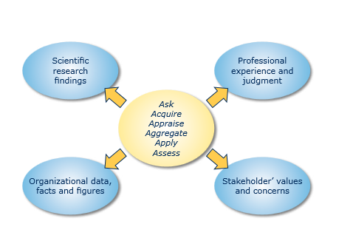
(Barends, Rousseau and Briner, 2014)
Moore Interiors, an SME based in Swansea and specialise in the internal design and refit of commercial premises, documented that the organisation had recently experienced difficulty in recruiting suitably qualified and experienced employees to key roles. After a discussion between the directors present, it was agreed to increase the salary offered to attract the right candidate (Moore Interiors, 2024). From the limited evidence available, it could be argued that this decision was based solely on experiential knowledge and consequently, as claimed by Gifford, Young and Barends (2023) could therefore be subject to outdated insights and bias. By applying the six steps of EBP to the remaining three key areas of issue the directors may have identified other factors contributing to the issue, for example stakeholders and organisational data may have provided a better insight, providing a more strategic and effective decision and outcome.
Like all theories and processes EBP and the six steps are not without limitations as documented by CIPD (2023) although it is not always feasible to follow all six steps, they recommend that people professionals should try to cover as many of the steps as possible. Furthermore, Barends et al (2017) identified that despite there being a positive attitude towards EBP within people professionals, their limited time and understanding of scientific research is one of the major factors for limited widespread implementation within the field.

1.2 Evaluation of analysis tools and methods and their application to diagnose organisational issues, challenges and opportunities.
To assist organisations to identify and overcome potential challenges, there are numerous tried and tested analytic tools that could be implemented to the daily business. These include but are not limited to SWOT, PESTLE, Porter’s Five Forces and the Boston Matrix. Beevers, Rea and Hayden (2019) attest that the method of analysis chosen by an organisation must consider all factors that may impact on the organisation achieving its objectives.
Battisa (2023) state that PESTLE analysis is an integral tool within core knowledge for enabling change and the CIPD Profession Map. PESTLE can assist an organisation to categorise the macroeconomic factors of the business, with into six key areas, which are, Political, Economic, Social, Technological, Legal & Environmental (Taylor and Woodhams, 2022). Some examples of potential factors that may be considered under each area when applying PESTLE to people management are:
Political – Government Changes, Industry Regulation
Economic – Inflation, Cost of Living Crisis
Social – Hybrid Working, Employee Demographic
Technology – Social Networking, Working Practices
Legal – Labour Laws, Working Practices
Environmental – Transport Policy, Environmental Values
As with all tools there are limitations and many academics and practitioners note that although PESTLE is a simple tool that can provide strategic oversight to an organisation, due to the fast pace of development in fields such as technology, the information gathered can quickly become irrelevant and therefore it needs to be repeated on a regular basis. Furthermore, Marmol and Feys (2015) argue that using PESTLE alone is not sufficient and using it in partnership with a microenvironment tool such as Porter’s five forces or SWOT can prove to be more beneficial.
There are a number of potential methods organisations could employ to gather information and data required to identify issues a few of these are: Surveys, Interviews and Focus Groups.
Surveys are a popular choice, and when conducted effectively, can provide researchers with reliable, usable, primary data that can aid an organisation to inform business decisions. Furthermore, with the use of technology they can supply a cost and time effective option, in addition to reaching a lager sample than traditionally conducted surveys (Wright, 2005). Barends and Rousseau (2018) proclaim that most surveys produce quantitative data (numerical / statistical) with closed questions where respondents have a set of predetermined responses. However, Beevers, Rea and Hayden (2019 pg. 81) state that they can be designed to capture quantitative and qualitative data.
It is suggested that there are three common types of survey that can be beneficial for people managers to engage with employees within their organisation, which are Employee Satisfaction, Employee Culture and Employee Engagement (SHRM, undated). There is also evidence to suggest that when employees feel engaged this also has other benefits of for the origination including, staff retention, customer satisfaction and productivity (CIPD, 2023a).
However as argued by Taylor and Woodman (2022) to ensure a good response rate it is important that they are not too bulky. Furthermore, it is important that any outcomes from the surveys are actioned to ensure employees do not feel that the survey is just a box ticking exercise (Taylor and Woodman ed., 2022). Some other potential issues when using surveys are whether they are effectively designed, implemented and evaluated to avoid bias (Barends and Rousseau, 2018 and Wright, 2005).

1.3 The principles of Critical Thinking and application to ideas.
Critical thinking can be defined as the process of evaluating and breaking down the validity of theories and concepts, without personal bias, to make decisions and find well-reasoned solutions to issues (Armstrong and Taylor, 2023 and Coleman 2022). As attested by CIPD (2019) critical thinking is a key skill for people professionals and can bring clarity to confusion and increase the potential to succeed. In addition, Biech (2008) argues that scrutinising evidence, exploring alternative viewpoints and navigating complexities can ensure choices that benefit employees and the organisation.
When applying this to ideas whether they be your own or ideas of others Chatfield, (2022) states that it is important to be able to identify and see through faulty reasoning and understand potential cognitive bias, which is, a process where the human brain can oversimplify information, based on experience and preference. It is also important that people management professionals are on a level playing field and they can identify individuals that may be using critical thinking techniques to distract or control the conversation (CIPD, 2019). Quarry and Ash (2021) state that it is important to evaluate an idea logically, not impulsively. So, to assess any proposal it is important to examine it in detail and then weigh up the advantages and disadvantages rather than just reacting.
To apply critical thinking and become an evidence based professional, with the ability to formulate a strong well balanced and defined plan, Gifford, Young and Barends, (2023) argue that people professionals should, apply critical thinking to all five steps of the CIPD maturity model. (see Figure 2).
Figure 2.
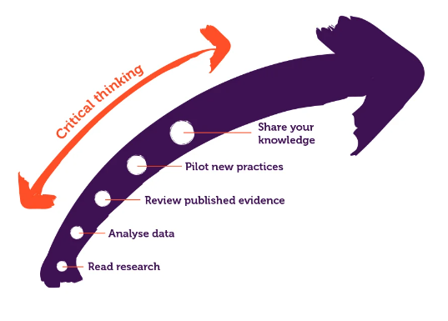
(Gifford, Young, and Barends, 2023)
For people professionals CIPD (2023b) state following the maturity model can assist them in their journey. It recommends starting with reading textbooks or journals within a chosen area of interest, then collecting and analysing relevant organisation data. Follow by reviewing published documents, as there is a high volume of high-quality studies to assist in decisions, this information can then be applied to piloting new practices and finally sharing knowledge. By repeating these steps people professionals can develop their individual performance and the overall efficiency of the organisation.
1.4 Decision- making processes for achieving effective outcomes.
The are various processes that can be applied depending on what the problem is. A selection of these are De Bono and his six hats, The Demming Wheel and Stakeholder Analysis. A brief overview of two of these three processes is are outlined below.
De Bono’s Six Hats – This is a technique that can be utilised within a group or as individual as part of the thinking / decision making process. The principal idea is that there are six imaginary, different coloured hats which each signify a different style of thinking (Sheth, 2012). When a participant is wearing a particular colour hat, they must only focus on the style of thinking that the hat signifies as follows:
White - Information and the Facts Yellow - Positives
Black - Risks Blue - Actions
Red - Emotions Green - Ideas
It is important that each person wears each of the coloured hats and when within a group situation, each person wears the same- colour hat as everyone else at the same time. This prevents four people looking at four sides of the same problem and allows more organised well-balanced thinking that covers all angles (De Bono, 2009).
The Deming Wheel – This technique sometimes referred to as the Deming or PDSA Cycle can be used to identify sources of variations that may affect the end goal. It proposes that organisational processes, products or services are analysed in a continuous feedback loop allowing managers to identify problems and make improvements where required (Scherkenbach, 2001). The cycle is made up of four key steps within a continuous improvement cycle which are:
Plan - Design or revise organisational process to improve result.
Do - Implement the plan and measure it performance.
Study - What did we learn what problems where identified.
Act - Adopt or discard the change then repeat the cycle.
The above steps can be repeated as part of a constant cycle, promoting continual learning and improvement (The Deming Institute, 2023)

1.5 Assess how different ethical perspectives can influence decision making.
Bosley (2023) argues that ethical practice is as important to an organisation’s reputation as the quality of the products and services they provide. It is important that People professionals lead by example, when it comes to ensuring that ethical practice is incorporated into all aspects of the organisation (Waite et al, 2021). Some ethical perspectives that may be used to inform decision making are detailed below.
Utilitarianism – Academics argue that key principle of this perspective consideration that an action is morally good, if it maximises the happiness of a given situation (Armstrong and Taylor, 2023). This theory incorporates ethical values such as honesty and fairness and informs moral decision making. One of the benefits of this perspective is that is simple to understand that we should all act to increase general contentment. However, on the opposite side one disadvantage with this theory is a person's perception of happiness may differ significantly to another.
A hypothetical scenario for utilitarianism is as follows: Directors of an organisation, with 50 employees have the idea to change the breakdown of the working week from the current 8.30am to 4.30pm Monday to Friday, to 7.30am to 4.30pm Monday to Thursday and 7.30am to 1.30pm pm on Fridays. This makes no change to the total hours worked per week just the way they are distributed throughout the week. The Directors intention of the change is to provide employees with increased quality time at weekends. Therefore, it could be argued that this is for the greater good and is therefore influenced by Utilitarianism.
Altruism – This ethical perspective has similarity to Utilitarianism. As argued by Seglow (2005) altruism, focuses being selfless and helping others without expecting anything in return, contributing to a friendlier, happier work environment. One of the benefits of this theory as argued by academics and practitioners is that altruism can positively impact on an individual’s wellbeing (Singer, 2023). However, one disadvantage is that there may be some that would take advantage of another person’s selflessness.
A hypothetical scenario for Altruism is as follows: during a project management meeting tasks are assigned to individuals and departments. The contract department has been assigned the highest percentage of tasks. At this time one of the key employees from the contracts department is on leave, which leave the remaining team member overladed. Despite having a number of tasks assigned to the accounts department the manager of the department offers to assist the contracts team member. Therefore, it could be argued that the decision of the accounts manager to assist the contracts team, without expecting anything in return is influenced by Altruism.

3.1 Appraise ways an organisation can measure financial and non-financial performance.
Measurement of performance within business can help to identify where your business is strong or where it may need some additional assessment and work. There are two key areas of performance management financial or non-financial.
One of the many ways to measure financial performance is by assessing the Gross Profit Margin. This is a measurement ratio that considers the percentage of revenue (sales) remaining after the direct cost of those sales, such as materials and production costs are deducted (Stobierski, 2020). For example, Moore Interiors (2024a) gross profit (GP) target is 35%, this target is calculated using historical company financial data, which shows that direct costs on average are made up of average materials costs, of 31% and average labour costs of 34%, leaving a balance of 35% GP.
The main issue with measuring organisational financial performance solely with GP is that it does not consider operating expenses, such as overheads and other operational costs such as marketing. Therefore, despite providing a good indication of production efficiencies it offers a limited view of the organisation’s overall profitability.
The non-financial performance measurement method may vary depending on the type of industry that the organisation operates within. However, customer feedback and retention are one measurement that is considered vital across industry (Ranaweera and Prabhu, 2003). For example, Moore Interiors operate within the UK construction industry, and primarily deal with large construction firms on commercial developments. These large construction firms are key to Moore Interiors success, therefore, as part of standard processes customer satisfaction is monitored throughout every contract in the form of meetings and end of contract questionnaire. The data compiled is essential for Moore Interiors to identify any areas that may be improved upon to ensure that it retains the custom for future developments.
One disadvantage of customer satisfaction purely in the form of questionnaire is that they may not have the time to inclination to complete the questionnaire.

3.2 Explain how to measure the impact and value of people practice using a variety of methods. adds value to an organisation and two methods that measure their impact.
People practice professionals can add value to an organisation in various ways. at every stage of employee lifecycle (see figure 3), by utilising the data to identify trends or issues. Every organisation has some form of data for their workforce including age, job title and pay scale. As argued stated by Taylor and Woodhamans (2022 pg.9), people professionals are the ‘nuts & bolts’ of an organisation, and can utilise analysis of the data to assist managers in streamlining procedures and processes and may include working at a more at a strategic level. They can such as adviseing on recruitment strategies and. People managers provide the a link between the employees and organisational management, and assist with the day to day with implementation ing of training and staff development initiatives, and to build the strength of the workforce, ensuring that the people strategy aligns with the organisational goals.
Figure 3.
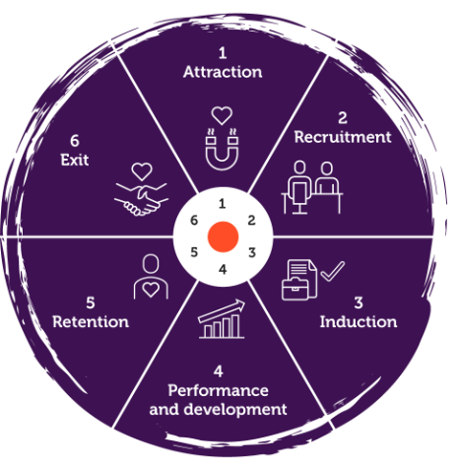CIPD (2024b)
Two methods that can measure the impact and value of people practices are performance management and employee attendance.
Performance management Appraisals – by effectively managing staff performance people managers can maximise the value that employees create. CIPD (2022) detail that defining and measuring performance falls into three areas of performance, which are Task, Contextual and Adaptive. Regular performance management with detailed feedback and a clear ratings system, can help to motivate employees and help them improve, which in turn improves the organisation. Armstrong (2022) argues that successful performance management requires developed skills in defining roles and setting objectives, conducting performance and development discussions, providing feedback in additional to handling challenging conversations, which is not a skill shared by all managers.
Employee Absence – There are various reasons why employees may be absent from work. General data on number of days and duration should be available within organisational payroll data. Suff (2023) attests that accurate monitoring and identifying trends and any underlying reasons for absence are key. There are three measurement methods, Loss Time rate, which identifies the percentage of total time lost. Frequency rate, which identifies average number of absences per employee and The Bradford Factor, measures the number of spells and frequency of absences.
Implementing effective methods to identify trends within the organisation can that allow the organisation to adapt and overall attain return on investment (ROI) through efficient people practice resulting in employee retention and welfare.

2. Section Two

2.1 Interpretation of analytical data in reference to people practice.
There are two key forms of data that can be analytically interpreted. These are Quantitative and Qualitative. Quantitative is numbers based and countable and measurable, whereas Qualitative data is descriptive, and interpretation based.
As touch upon within section one of this report most organisations already hold vast amounts of quantitative data in relation to their employees within payroll records, which can be analysed using purpose-built software or applications such as Microsoft excel to identify potential areas for improvement within any organisation. Organisations that regularly engage with their employees may also hold qualitive data, gathered from employee satisfaction surveys as detailed in 1.2 or as part of performance review data (CIPD, 2024).
Young (2023) argues that drivers for commitment and motivation can differ significantly from one organisation from another. So, employees should have effective channels. Therefore, a mixed method approach may be best as different methods have different strengths and provide a more rounded picture and understanding of people resource.
The following charts A to D provide details of findings of performance reviews by department over two quarters from the quantitative data provided in Table 1. Table A provides details of value of bonus to be award to each employee in line with the organisations policy in addition to the overall cost to the organisation and Chart E illustrates the cost per quarter and overall cost to the organisation. This is after analysis of the data provided using Microsoft excel formulas and tables and charts.
Chart A.
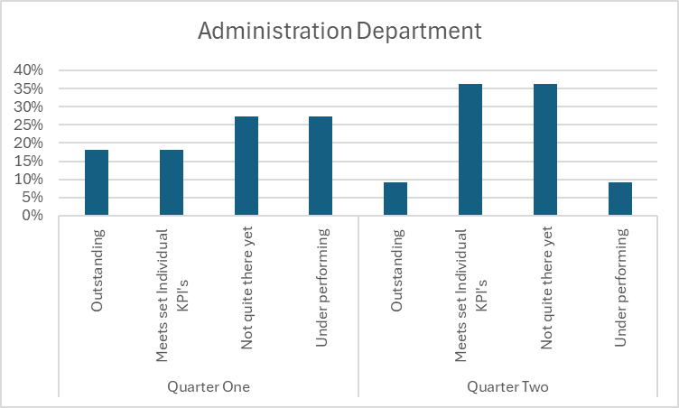
Chart A provides a breakdown of the employees of the administration department into the four criteria over the two-quarter period. Of the data provided, this department data shows the only reduction within the outstanding category over the four departments which reduced by 9% from18% in quarter one to just 9% in quarter 2. This is also the only department that has any employees in the Under Performing category in quarter 2.
Chart B
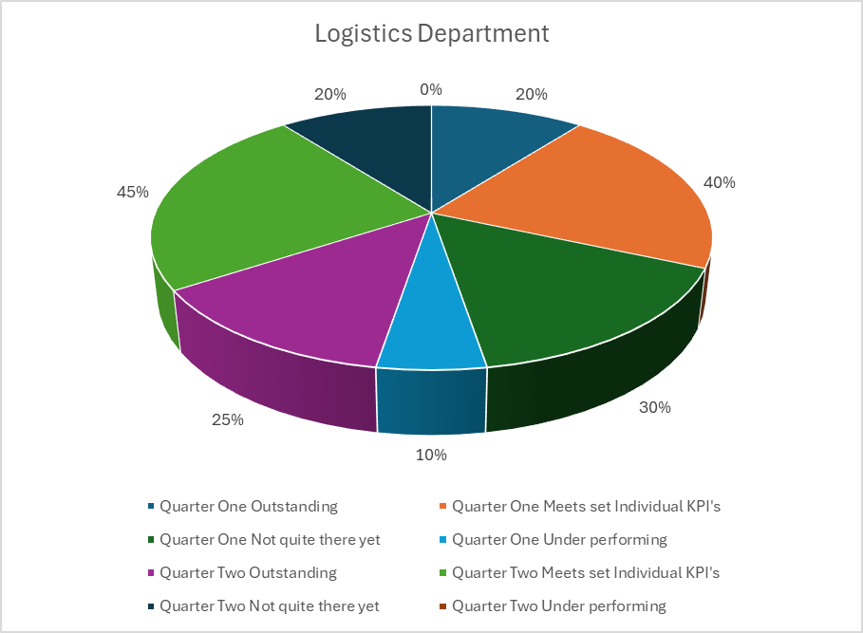
Chart B provides a breakdown of the employees of the logistics department into the four criteria over the two-quarter period. Of the data provided this department shows that over the two quarters there was a slight improvement over all categories. However, it is important to note that there were two employees absent in the second quarter data.

Chart C
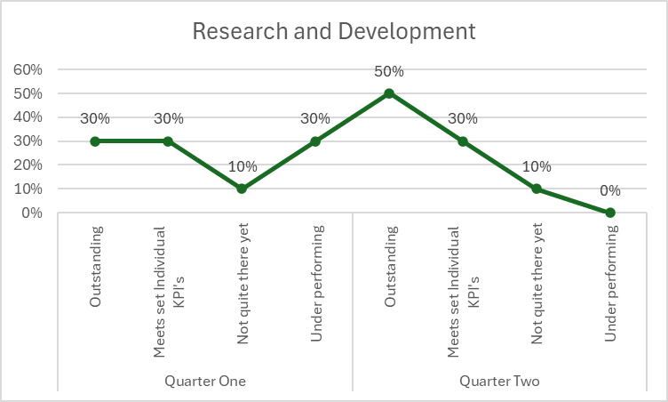
Chart C provides a breakdown of the employees of the research and development department into the four criteria over the two-quarter period. From the data provided this department overall showed the largest improvement with the outstanding category increasing from 30% to 50% and the underperforming category reducing from 30% to zero from quarter one to quarter two.
Chart D
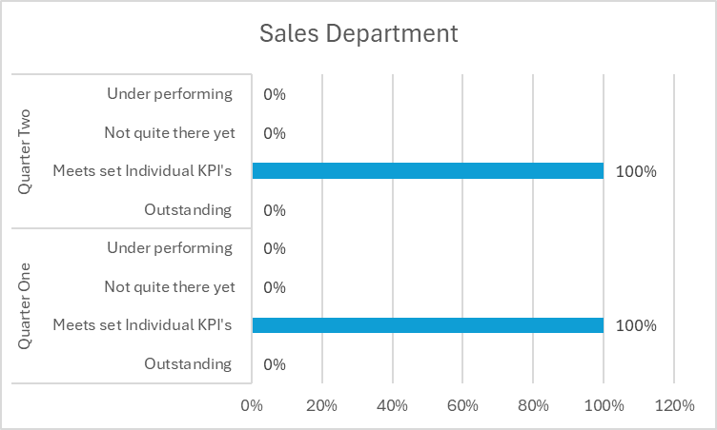
Chart D provides a breakdown of the employees of the sales department into four criteria over the two-quarter period. From the data provided this department is the only department to not show any change over the two periods with all employees showing that they are meeting the set KPI’s.
Table A
Chart E
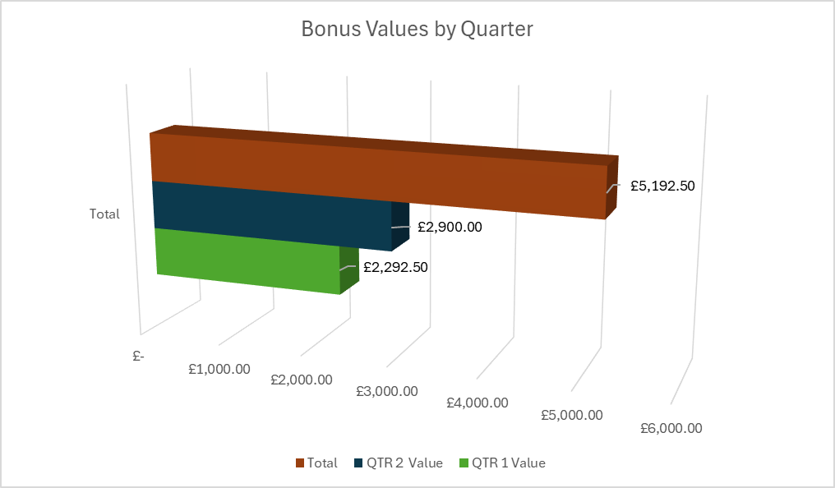
From the evidence available the data analysis indicates that there is a significant variance between the four departments and how the respective managers set, record and measure performance targets. Furthermore, the figures in Table A suggest that the bonus incentive may not be the most effective with only a 2 person increase between quarter one and quarter two.

2.2 Key findings from stakeholder people practice initiatives
The following charts F and G display the results of the qualitative data analysis from the survey data provided in table 2.
Chart F

Chart F provides data from Manager feedback. The data identifies that although the majority of managers agree that they are given time to prepare for appraisals and they are confident when applying ratings, all managers have stated that they disagree or strongly disagree that they have had training to complete this task. Furthermore, the majority of the responses across all questions are within the disagree or strongly disagree columns.

Chart G

Chart F provides data from employee feedback. The data identifies that although the majority of employees agree that their manager has time to listen to them, 80% disagree that their manager listen to the ideas they put forward.

2.3 Recommendations based on evaluation of the benefits, risks and financial implications of potential solutions.
On review and analysis of the data evidence available it is recommended that
1: Training and development of management staff in effective performance review:
From the data available within Tables 1 and 2 the analysis identifies that there are inconsistencies within performance management targets and reviews across different departments and managers. As stated by CIPD (2022a) it is important to ensure that the process is fair with clearly defined and consistent criteria. Therefore, it is important; train evaluators on how to avoid biases; and ensure the process is open to input from employees. The benefits of engaging in a fair and open performance review can increase employee motivation, engagement and overall performance (Armstrong and Brown, 2019).

The potential financial implications of accepting and acting on this recommendation are as follows:
Detail | Cost
1 Day Training Course (external provider) | £3, 600.00
1 Day Management team away from Daily duties (approx. based on 50 managers @ avg £200/day) | £10,000.00
Room hire & Refreshments | £ 680.00
Total Cost | £14,280.00
2: Review the Manager and Employee feedback survey questions to ensure they are clear, follow up surveys with sample focus groups.
As detailed in 1.2 of this report the design of a survey and the style of the questions asked can have a negative impact on the information returned. As there appears to be some conflict in relation to the responses, a review of the questions to ensure they are clear and concise. As the information provided is quantitative, but the questions relate to feelings and emotions, follow up of the survey with a random sample of respondents for focus groups where qualitative data can be obtained to provide further insight. As argued by Young (2023) the mixed method approach does provide more detailed information than just one method alone
Detail | Cost
Staff time focus group (based on 5 groups 10) | £6,730.7
Room hire & Refreshments x 5 | £ 3,350.00
Total Cost | £10,080.70

Bibliography
ACAS (2024) ACAS working for everyone. Available at: https://obs.acas.org.uk/. (Accessed 20 November 2024)
Alder, G.S. (1998) Ethical Issues in Electronic Performance Monitoring: A Consideration of Deontological and Teleological Perspectives. Journal of Business Ethics 17, 729–743 . https://doi.org/10.1023/A:1005776615072
Ali, L. (2022) Equality, diversity and inclusion (EDI) in the workplace. Available at: https://www.cipd.org/uk/knowledge/factsheets/diversity-factsheet/#Equality. (Accessed on: 15 November 2023)
Armstrong, M. (2022). Armstrong’s handbook of learning and development: a guide to the theory and practice of L&D. Kogan Page.
Armstrong, M., & Brown, D. (2019). Armstrong’s handbook of reward management practice improving performance through reward (6th ed.). Kogan Page.
Armstrong, M., & Taylor, S. (2023) Armstrong’s handbook of human resource management practice: a guide to the theory and practice of people management. 16th ed. Kogan Page.
Barends, E., Rousseau, D.M., & Briner, R.B. (2014). Evidence Based Practice: The Basic Principles. Amsterdam: The Centre for Evidence-Based Management.
Barends, E., Rousseau, D.M. (2018) Evidence-Based Management: How to Use Evidence to Make Better Organisational Decisions. New York. Kogan Page.
Battista, M. (2023) PESTLE analysis. Available at: https://www.cipd.org/uk/knowledge/factsheets/pestle-analysis-factsheet (Accessed: 28 October 2024)
Barends, E., Villanueva, J., Rousseau, D. M., Briner, R. B., Jepsen, D. M., Houghton, E., & Ten Have, S. (2017). ‘Managerial attitudes and perceived barriers regarding evidence-based practice: An international survey’. PloS One, 12(10), e0184594–e0184594. Available at: https://doi.org/10.1371/journal.pone.0184594.
Beevers, K., Rea, A., & Hayden, D. (2019). Learning and development practice in the workplace. 4th ed. Kogan Page.
Biech, Elaine. (2008). The Pfeiffer book of successful team-building tools best of the annuals (2nd ed.). Pfeiffer.
Bosley, A. (2023) Ethical practice and the role of people professionals. Available at: https://www.cipd.org/uk/knowledge/factsheets/ethics-role-hr-factsheet/#what-is-ethical-practice-in-organisations. (Accessed on: 7 November 2024)
Briner, R. (2019). ‘The Basics of Evidence-Based Practice’. People & strategy: journal of the Human Resource Planning Society, Vol. 42, Issue 1, pp. 16–20. Available at: https://www.shrm.org/executive/resources/people-strategy-journal/winter2019/pages/ebp-briner.aspx (Accessed: 26 October 2024).
Chatfield, T. (2022). Critical thinking: your essential guide (2nd edition.). SAGE.
CIPD (2019) Critical thinking. Available at: https://www.cipd.org/uk/knowledge/podcasts/critical-thinking/ (Accessed: 30 October 2024).
CIPD (2022) Performance Management: an Introduction. Available at: https://www.cipd.org/uk/knowledge/factsheets/performance-factsheet/#two. (Accessed on: 5 November 2024)
CIPD (2022a) Performance feedback: An evidence review. Available at: https://www.cipd.org/uk/knowledge/evidence-reviews/performance-feedback/. (Accessed on: 5 November 2024)
CIPD (2023) Evidence-based HR: Make better decisions and step up your influence: A step-by-step approach to using evidence-based practice in your decision-making. Available at: https://www.cipd.org/en/knowledge/guides/evidence-based-profession/ (Accessed on: 5 November 2024).
CIPD (2023a) Employee engagement and motivation. Available at: https://www.cipd.org/uk/knowledge/factsheets/engagement-factsheet/. (Accessed: 5 November 2024)
CIPD (2023b) Building an evidence-based people profession. Available at: https://www.cipd.org/uk/views-and-insights/thought-leadership/insight/evidence-based-profession/. (Accessed 31 October 2024)
CIPD (2024) Performance management: an introduction Available at: https://www.cipd.org/uk/knowledge/factsheets/performance-factsheet/#two. (Accessed 10 November 2024)
CIPD (2024b) People analytics: Guide for people professionals. Available at: https://www.cipd.org/uk/knowledge/guides/analytics-practitioner-guide/#what-is-people-analytics. (Accessed 25 January 2025)
Clark, S. (2015) Ethical decision-making: Eight perspectives on workplace dilemmas. Research report. CIPD. Available at: https://www.cipd.org/globalassets/media/comms/the-people-profession/profession-map-pdfs/ethical-decision-making-2015-eight-perspectives-on-workplace-dilemmas_tcm29-9564.pdf. (Accessed on: 1 November 2024)
CMI (2014) Stakeholder Analysis and Management. Available at: https://www.managers.org.uk/wp-content/uploads/2020/03/CHK-234-Stakeholder-analysis-and-management-1.pdf. (Accessed on: 14 November 2024)
CMI (2020) Decision Making. Available at: https://www.managers.org.uk/knowledge-and-insights/resource/decision-making/. (Accessed on: 4 November 2024)
Coleman, J. (2022) Critical Thinking Is About Asking Better Questions. Available at: https://hbr.org/2022/04/critical-thinking-is-about-asking-better-questions (Accessed on: 5 November 2024)
De Beer, J., & Whitlock, E. (2009). Indigenous Knowledge in the Life Sciences Classroom: Put on Your de Bono Hats. The American Biology Teacher, 71(4), 209–216. https://doi.org/10.1662/005.071.0407
De Bono, E. (2009). Six thinking hats (Rev. and updated ed.). Penguin.
Fixsen, A., Seers, H., Polley, M., & Robins, J. (2020). Applying critical systems thinking to social prescribing: a relational model of stakeholder “buy-in.” BMC Health Services Research, 20(1), 580–580. Available at: https://doi.org/10.1186/s12913-020-05443-8
Giermindl, L. M., Strich, F., Christ, O., Leicht-Deobald, U., & Redzepi, A. (2022). ‘The dark sides of people analytics: reviewing the perils for organisations and employees. European Journal of Information Systems, 31(3), 410–435. Available at: https://doi.org/10.1080/0960085X.2021.1927213.
Gifford, J., Young, J., & Barends, E. (2023) Building an evidence-based people profession. Available at: https://www.cipd.org/uk/views-and-insights/thought-leadership/insight/evidence-based-profession/ (Accessed 24 October 2024).
Hulpke, & Fronmueller, M. P. (2020). ‘Review of Evidence-Based Management: How to Make Better Organizational Decisions by Eric Barends and Denise Rousseau’. Journal of Business Ethics, 164(2), 417–419. Springer Nature B.V. Available at: https://doi.org/10.1007/s10551-020-04488-3.
Jepsen, A. L., & Eskerod, P. (2009). Stakeholder analysis in projects: Challenges in using current guidelines in the real world. International Journal of Project Management, 27(4), 335–343. https://doi.org/10.1016/j.ijproman.2008.04.002
Jepsen, D. M., & Rousseau, D. M. (2022). ‘Perceived evidence use: Measurement and construct validation of managerial evidence use as perceived by subordinates’. PloS One, 17(4), e0266894–e0266894. Available at: https://doi.org/10.1371/journal.pone.0266894
Marmol, T. del, & Feys, B. (2015). PESTLE analysis (C. Probert, Trans.). Lemaitre Publishing.
Moore Interiors (2024) ‘Minutes of Management Meeting 17 July 2024’. Moore Interiors, Swansea, Unpublished.
Moore Interiors (2024a) ‘Financial Forecasts 2024-5’. Moore Interiors, Swansea, Unpublished.
Payette, P., & Barnes, B. (2017). Teaching for Critical Thinking: Edward de Bono’s Six Thinking Hats. The National Teaching & Learning Forum, 26(3), 8–10. https://doi.org/10.1002/ntlf.30110
Platje, A., & Wadman, S. (1998). From Plan-Do-Check-Action to PIDCAM: the further evolution of the Deming-wheel. International Journal of Project Management, 16(4), 201–208. https://doi.org/10.1016/S0263-7863(97)00031-8

Rawling, P. (2023). Deontology. Cambridge University Press. https://doi.org/10.1017/9781108581196
Quarry, P. and Ash, E. (2021) Insights and strategies. 4 ways to develop your critical thinking. Melbourne, Victoria: Seven Dimensions.
Ranaweera, C. & Prabhu, J. (2003) On the relative importance of customer satisfaction and trust as determinants of customer retention and positive word of mouth. Available at: https://link.springer.com/content/pdf/10.1057/palgrave.jt.5740100.pdf. (Accessed on: 9 November 2024)
Rousseau, D.M. (ed.) (2012). Envisioning Evidence-Based Management. The Oxford Handbook of Evidence-Based Management, Oxford Library of Psychology 2012; online ed., Oxford Academic, 18 Sept. 2012. Available at: https://doi.org/10.1093/oxfordhb/9780199763986.013.0001.
Rousseau, D. M. (2020). ‘The Realist Rationality of Evidence-Based Management’. Academy of Management Learning & Education, 19(3), 415–424. Available at: https://doi.org/10.5465/amle.2020.0050.
Scherkenbach, w. w. (2001). The Deming route to quality: a practical guide to quality management. Management Books 2000.
Seglow, J. (ed.) (2005) The Ethics of Altruism. Available at: https://www.researchgate.net/profile/Jonathan-Seglow/publication/233233349_The_ethics_of_altruism_Introduction/links/5436e9550cf2bf1f1f2d4356/The-ethics-of-altruism-Introduction.pdf#page=10. (Accessed on 8 November 2024)
Seven Dimensions (Producer), & . (2021). 4 Ways to Develop Your Critical Thinking. [Video/DVD] Seven Dimensions. Retrieved from https://video.alexanderstreet.com/watch/4-ways-to-develop-your-critical-thinking-2
SHETH, M. (2012). THE AMAZING CONCEPT OF SIX THINKING HATS. International Journal of Management Research and Reviews, 2(3), pp. 449-452.
SHRM (undated). Managing Employee Surveys. Available at: https://www.shrm.org/resourcesandtools/tools-and-samples/toolkits/pages/managingemployeesurveys.aspx. (Accessed 4 November 2024)
Singer, P. (2023). How and why business should embrace effective altruism. In The Business & Management Collection, Henry Stewart Talks. Available at: from https://doi-org.ezproxy.uwtsd.ac.uk/10.69645/OXYI7416. (Accessed on 30 October 2024)
Stobierski, T. (2020) 13 Financial Performance Measures that Manager should monitor. Available at: https://online.hbs.edu/blog/post/financial-performance-measures. (Accessed on: 9 November 2024)
Suff, R. (2023) Absence measurement and management. Available at: https://www.cipd.org/uk/knowledge/factsheets/absence-factsheet/. (Accessed on: 9 November 2024)
Taylor, S., Woodman, C. (2022). Studying Human Resource Management: A Guide to the Study, Context and Practice of HR (3rd ed.). London. Kogan Page.
Taylor, S., Woodman, C. Ed. (2022). Human Resource Management: People and Organisations (3rd ed.). London. Kogan Page.
Thornhill, J. (2023) Average UK Salary By Age. Available at: https://www.forbes.com/uk/advisor/business/average-uk-salary-by-age/#:~:text=The%20latest%20government%20data%2C%20published,of%206.2%25%20compared%20to%202022. (Accessed on 12 November 2024)
The Deming Institute, (2023) The PDSA Cycle. Available at: https://deming.org/explore/pdsa/ (Accessed 5 November 2024)
The Oxford Review (2023) The Essential Guide to Evidence-Based Practice. The Oxford Review Briefings. Available at: https://oxford-review.com/evidence-based-practice-essential-guide/ (Accessed 28 October 2024)
Waite, K., Beevers, K., Small, N., Tomlinson, K., & Hussain, S. (2021). People practice : a complete guide. KoganPage.
Wild, S. (2023) Gender pay gap reporting guide. Available at: https://www.cipd.org/uk/knowledge/guides/gender-pay-gap-reporting-guide/. (Accessed on: 8 November 2024)
Wright, K. B. (2005) ‘Researching Internet-Based Populations: Advantages and Disadvantages of Online Survey Research, Online Questionnaire Authoring Software Packages, and Web Survey Services’. Journal of Computer-Mediated Communication, Volume 10, Issue 3, 1 April 2005, JCMC1034. Available at: https://doi.org/10.1111/j.1083-6101.2005.tb00259.x
Young, J. (2003), Employee engagement and motivation. Available at: https://www.cipd.org/uk/knowledge/factsheets/engagement-factsheet/. (Accessed on: 8 November 2024)

