LEVEL 6 ASSESSMENT SPECIFICATION

APPENDIX GAxx
Student name: | Xiaoyu Sun | Student ID number: | 2503344
Programme: | BA Business Management (Marketing; HRM; International; Finance)  BA (Hons) Public Services
Module: | Global Ethics
Module code: | BMBM6008 | Contribution to Overall Module Assessment (%): | 50%
Lecturer: | Arpu Kumar | Internal Verifier: | Robyn Griffiths
Assignment Title: | Is greed good? Should modern businesses be concerned about ethics? Explain your perspective with reference to theory and practice. | Word count (or equivalent): | 2500 words
Submission deadline: | 21st November 2025 | Return date of provisional marks & written feedback: | 20th December 2025
Submission method: | All written assessments, where practical and possible, must be submitted via Turnitin unless otherwise instructed by the Lecturer. (Please DO NOT put this assessment specification into Turnitin or it will match many similarities with other students’ submissions.)  Alternative submission method (if applicable):  Late submission of the assessment will result in a late penalty mark. Penalties for late submission: Up to one week late, maximum mark of 40%. Over one week late, 0%. Only the Extenuating Circumstances Panel may approve a change to submission dates.
Academic honesty / referencing: | Academic honesty is required. In the main body of your submission, you must give credit to authors on whose research and ideas your work is based. Append to your submission a reference list that indicates the books, articles, etc. that you have used, cited or quoted in order to complete this assessment.
Module Learning Outcomes
(from module syllabus)
Upon the successful completion of this module, the student should be able to
demonstrate the ability to:
- Problem solve and critically analyse the importance of management and ethical decision-making within organisations and their impact on the wider social environment.
- Evaluate different approaches to ethical judgment and to apply them to real world dilemmas.

Unit name: Global Ethics
Module code: BMBM6008
Greed, Ethics, and Modern Business: A Simplified Analysis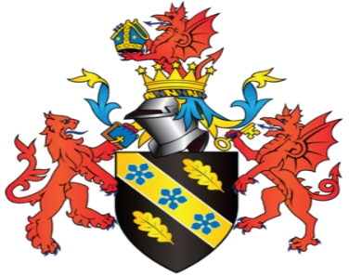

Written by: Xiaoyu Sun
Date submitted: 21 November 2025

Executive Summary
This report looks at the long-standing question of whether greed can help modern businesses and also asks how much companies today need to take ethics seriously. The aim of this longer analysis is to give a clearer and more complete discussion than shorter reports usually provide. It does this by using a wider set of simple ideas, more real examples, and a stronger level of basic review of debates in business ethics, corporate rules, and corporate social responsibility in many fields today that shape common business thinking now.
Greed, as an idea linked to the wish for too much personal gain, is sometimes said to be a main force behind ideas, higher output, and market competition. But many scandals in the last twenty years show that choices driven by greed can soon turn into actions that hurt customers, workers, nature, and the long‑term health of companies today. In contrast, firms that build ethical thinking into daily plans often show more strength, flexibility, and trust from key groups. (Freeman, 2020)
Using simple ethical ideas like teleology, deontology, shareholder theory, stakeholder theory, and Carroll’s CSR (Kant, 1785/2020) Pyramid, this report shows how moral rules guide managers and shape company plans. The report also looks more closely at real cases—such as Volkswagen, IKEA, Amazon, Patagonia, and Shein—to show how greed and ethics appear in different ways. This wider look shows that while greed may bring short‑term financial gains, ethics brings social trust, steady reputations, and long‑term value. The report says that modern firms must follow ethical behaviour not only for moral reasons but also because ethics is now key for lasting success.
Recommendations include placing ethics into company plans, making governance clearer, improving talks with stakeholders, and making sure managers get ongoing guidance in ethical thinking and responsible (Freeman, 2020) leadership.

Content
1. Introduction 4
2. Theoretical Foundations of Ethics and Greed 6
2.1 Ethical Theories 6
2.2 Shareholder Theory vs Stakeholder Theory (Friedman, 1970/2020) 8
2.3 CSR and Carroll’s Pyramid 10
3. Expanded Case Studies 11
3.1 Volkswagen Emissions Scandal 11
3.2 IKEA Sustainability Strategy 12
3.3 Amazon Labour Practices 13
3.4 Patagonia: Rejecting Greed as Strategy 14
3.5 Shein and the Ethics of Fast Fashion 14
4. Discussion 15
5. Conclusion and Recommendations 16
References 18

1. Introduction
The question of whether greed can be seen as “good” in business has interested many scholars, leaders, and workers for a long time. In popular culture, from Hollywood movies to common economic commentary, greed is sometimes shown as a simple driver of progress. The well‑known phrase “greed is good,” spoken by Gordon Gekko in the film Wall Street has become a short way to express the idea that personal gain and strong competition can lead to good economic results for society.
However, this view has been challenged many times by ethical thinkers and by real‑world events. Milton Friedman’s idea that the main social duty of business is to raise its profits shaped a whole generation of company leaders, yet globalisation, new technology, environmental problems, and changing social demands have changed the business world. What once seemed a simple and neat rule in the mid‑twentieth century no longer shows the complexity of twenty‑first century markets. Modern firms work in settings where reputation, public trust, and stakeholder ties can influence company results just as much as (Freeman, 2020) financial measures today also.
Greed, seen as a strong and unchecked wish for personal gain, can support new ideas and bold risks. Many of the world’s leading business founders have been pushed by a deep wish for success and money. But greed can also weaken judgement, invite rule-breaking, and harm long-term stability.
Corporate failures like Enron, Wells Fargo’s account-fraud case, and the recent Boeing 737 Max problem show clearly how greed can shape and spread cultures of wrongdoing.
Business ethics gives a clear way to understand how moral rules can and should guide business actions. Ethical companies do not ignore profit; instead, they see that profit must be balanced with duties to the people who allow the business to operate—workers, customers, communities, governments, and the environment. In a time of fast communication and strong social media attention, the damage to reputation from unethical actions can come quickly and be very serious.
This report aims to answer three simple questions:
Can greed ever be good for business?
Why should today’s companies care about ethics?
How do basic ideas and real cases show the link between greed and ethics?
The rest of this longer study gives a clearer look at ethical ideas, reviews more business cases, and provides straightforward thoughts on how ethics shapes long‑term success in organisations across many fields in business today also.

2. Theoretical Foundations of Ethics and Greed
Ethical theories help explain why managers make certain choices and how organisations defend their actions.
This section builds on earlier points by looking more closely at debates in moral philosophy, corporate rules, and organisational behaviour. The ideas described here give the basic tools needed to understand the case studies that come next.

2.1 Ethical Theories
Teleological ethical theories judge whether an action is right by looking at its results. The most known part of this view is utilitarianism, linked to Jeremy Bentham and John Stuart Mill, which says the right action is the one that creates the greatest good for the most people. Companies often use utilitarian thinking when they defend choices that focus on efficiency or economic growth. For example, strong competition may lead to lower prices and more options for customers, which can be seen as giving a clear social benefit.
However, utilitarianism is criticised for sometimes ignoring the needs of smaller groups or allowing harmful actions if they help most people (Bentham & Mill, 1863; Boatright, 2021). If seeking shareholder value leads to layoffs, lower wages, or (Friedman, 1970/2020) harm to the environment, a strict utilitarian may still say the benefits are greater than the harms. Many scholars (Bentham & Mill, 1863; Boatright, 2021) therefore say that while utilitarian thinking is helpful, it is not enough to deal with complex ethical problems today. (Bentham & Mill, 1863; Boatright, 2021)
Deontological ideas give a different view by stressing duties, rights, and basic moral rules. (Kant, 1785/2020)
Immanuel Kant’s main principle stays central in this view: people must act with rules (Kant, 1785/2020) that all could follow. Actions like lying, unfairness, or using others are thus wrong no matter their results. In business settings, this view supports promises to fairness, honesty, respect for (Kant, 1785/2020) human dignity, and following clear legal duties.
Virtue ethics is a third main approach. It comes from Aristotle and focuses on character instead of single acts. A good business leader shows strong traits like honesty, courage, humility, and integrity.
Organisations shaped by virtue ethics often build ethical cultures, support simple moral reflection, and (Audi, 2021) expect managers to show responsible behaviour. Many modern leadership training programmes use virtue (Audi, 2021) frameworks to build basic moral awareness.
These three approaches—teleology, deontology, and virtue ethics—give different views on the moral challenges facing (Kant, 1785/2020) businesses. A balanced ethical view often means using all three ideas to judge what counts as responsible business behaviour.

2.2 Shareholder Theory vs Stakeholder Theory (Friedman, 1970/2020)
Shareholder theory became well known in the late twentieth century and still holds strong influence in many parts of (Friedman, 1970/2020) the business world. Supporters say managers act for shareholders and so have a duty to (Friedman, 1970/2020) raise shareholder wealth. They also say that open markets make sure that seeking shareholder value will (Friedman, 1970/2020) help society by using resources well today.
Critics, however, say that focusing mainly on shareholders has led to short‑term thinking, very high executive pay, and (Friedman, 1970/2020) too little investment in workers and environmental care. Studies in the past ten years show that firms that look only at shareholder gains often struggle to keep long‑term competitive strength. (Friedman, 1970/2020)
Stakeholder theory, created by R. Edward Freeman, offers a wider view. It says that businesses have duties to (Freeman, 2020) all groups who affect or are affected by what the company does. These groups include workers, customers, suppliers, local communities, governments, and the natural world. Firms that follow this view usually invest in long‑term (Freeman, 2020) ties, lower both inside and outside risks, and build trust with important groups.
Recent changes like ESG reporting, impact investing, and the "purpose‑driven" business trend show a clear move toward stakeholder thinking. Even large firms such as BlackRock now accept that lasting business success (Freeman, 2020) needs more than just raising short‑term profits.

2.3 CSR and Carroll’s Pyramid
Corporate Social Responsibility (CSR) means the idea that companies should act in ways that increase positive social impact while reducing harm. Carroll’s CSR Pyramid is still one of the most common models for explaining the different levels of business responsibility.
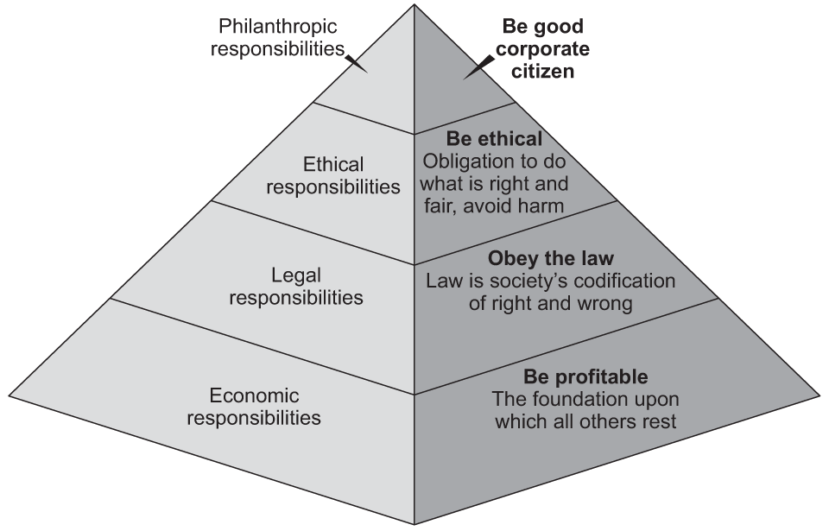
Figure 1. Carroll’s Pyramid of CSR (Carroll, 1991).
AQA | Teaching guide: Carroll's corporate social responsibility pyramid
Carroll says that economic duty is basic because companies must stay financially strong to survive.
Legal duty means firms must follow rules, while ethical duty means they should go further than the law to act fairly and avoid harm to stakeholders. Philanthropic duty includes voluntary (Freeman, 2020) support for social causes.
Contemporary CSR debates also include ideas like “shared value,” “corporate citizenship,” and “sustainability governance.” Many companies today publish joined sustainability reports, set net‑zero goals, and use codes of conduct that deal with human rights, supply chain openness, and climate risk.
CSR is now seen not as a voluntary or charitable act but as a key business need that connects to risk control, talent attraction, brand trust, and investor confidence too.

3. Expanded Case Studies

3.1 Volkswagen Emissions Scandal
The Volkswagen emissions scandal is one of the most widely examined business ethics cases of the last decade. Its size and complexity make it possible to give a detailed look at how greed shapes company choices. VW aimed for fast growth in the US market, where diesel cars were promoted as a cleaner choice than petrol. Engineers created “defeat devices” that could sense when a car was being tested for emissions and briefly lower pollution levels to meet rule standards.
Internal reviews later showed that pressure from top managers helped create a culture where workers felt unable to speak up. This shows the organisational side of greed: it is not only a personal trait but can also become rooted in company culture.
Beyond legal and financial penalties, VW’s brand faced major damage to its reputation. Studies watching customer opinions showed long-lasting drops in trust, especially in markets that care about the environment. The scandal also led to wider rule changes across the car industry, showing how unethical choices can create larger social and political effects.

3.2 IKEA Sustainability Strategy
IKEA is well known for its focus on sustainability, and many scholars use the company to show how ethics can fit into long‑term business plans. Besides investing in renewable energy, IKEA has also redesigned products to support reuse and repair, using take‑back schemes, repair options, and modular designs that help cut waste.
IKEA also stands out for its efforts to keep its supply chain ethical. The company works with thousands of suppliers across many regions, including places where labour rights can be harder to protect. IKEA invests in training, monitoring, and long‑term partnerships to improve working conditions. Although problems still exist, as in any global supply chain, the company’s overall approach shows that ethical practices help build brand trust and stable operations.
Research in sustainable business suggests that companies like IKEA gain strong customer loyalty, better risk control, and higher employee engagement because of their ethical commitments.

3.3 Amazon Labour Practices
Amazon’s fast growth and strong efficiency have long been praised by many experts, but the company has also faced steady criticism over its labour practices. Reports from NGOs, journalists, and past employees describe hard physical work, strict digital monitoring, and goals that some workers struggle to reach in their daily work tasks.
From an ethical view, Amazon shows the tension between efficiency and human wellbeing. Teleological thinking might support the company’s model because customers gain a lot from low prices and fast delivery.
But deontological thinking questions whether workers are treated with dignity and respect. (Kant, 1785/2020)
In addition, Amazon’s environmental impact has drawn attention. Even though the company has set strong climate goals, critics say that fast delivery systems add to rising emissions. These factors show how greed for growth and market power can cause ethical issues for many groups. (Freeman, 2020)

3.4 Patagonia: Rejecting Greed as Strategy
Patagonia gives an example of a company that openly rejects greed as a central value. In 2022, the founder, Yvon Chouinard, moved ownership of the firm into a trust and non‑profit structure to make sure all extra profits support the environment. This major change in company governance placed Patagonia as a leader in ethical business and offered a clear counterexample to shareholder primacy. (Friedman, 1970/2020)
Patagonia stresses openness, shares detailed environmental impact data, and urges customers to buy fewer products. From the view of stakeholder theory, Patagonia links company purpose with wider social and (Freeman, 2020) environmental goals. The case shows that different business models are possible and can still be financially strong.

3.5 Shein and the Ethics of Fast Fashion
Shein, the fast‑fashion giant, provides a contrasting example. The company has experienced extraordinary growth due to its low prices and rapid production cycles. However, numerous reports have criticised Shein for environmental impacts, possible labour violations, and opaque supply chain practices. Critics argue that the company’s business model—centred on rapid consumption—reflects a form of institutionalised greed that externalises costs onto workers and the planet.
The Shein case highlights the ethical challenges associated with ultra‑fast global supply chains and raises questions about whether extreme cost‑cutting is compatible with ethical responsibilities.

4. Discussion
The case studies show that greed appears differently in many industries and cultures today.
Volkswagen shows how greed can shape bad decisions and make workers stay quiet about problems. Amazon shows how a strong push for efficiency can harm worker wellbeing. Shein shows how global cost-cutting can hurt labour rights and the environment. In contrast, IKEA and Patagonia show that ethical actions can build strong trust and lasting benefits for all today.
Modern businesses work in settings marked by strong competition and many stakeholder needs. In (Freeman, 2020) this setting, ethics becomes not just a moral issue but a practical need. Companies seen as unethical often face boycotts, trouble hiring, tighter rules, and damage to their reputation. Ethical firms, by contrast, often see better worker morale, stronger ties with customers and communities, and steadier long‑term results.
The evidence shows that greed may bring small or short‑term gains, especially in markets with strong competition and weak rules. But greed damages trust, which is a key asset in modern economies. Ethical behaviour builds legitimacy and helps firms stay strong when facing uncertainty and public pressure.

5. Conclusion and Recommendations
This report has looked at the link between greed and ethics from many simple practical and theoretical views. Across basic moral ideas, purpose models, and real case examples, the main point is clear: greed is not a steady base for responsible business. It may support drive, competition, and new ideas, but greed often hides long-term risks and the needs of key groups. (Freeman, 2020)
Ethical behaviour, however, helps businesses last by building trust and flexibility. Firms like IKEA and Patagonia show that ethical choices can exist with strong business results. Cases such as Volkswagen and Shein show that the harm from unethical choices can be greater than any short-term gain.
To build strong organisations, this report suggests placing ethics in plans, making governance clear, talking with stakeholders early, and giving leaders guidance in ethical decision-making. (Freeman, 2020)
Ethics is not a limit on success; in the twenty-first century, it is becoming one of the main bases for stable and lasting performance.

References
Audi, R. (2021) Business Ethics and Ethical Business. Oxford: Oxford University Press.
BBC News (2023) ‘Amazon faces renewed criticism over warehouse injury rates’. Available at: https://www.bbc.com (Accessed: 20 November 2025).
Bentham, J. and Mill, J.S. (1863) Utilitarianism. London: Parker, Son, and Bourn.
Boatright, J.R. (2021) Ethics and the Conduct of Business. 9th edn. New York: Pearson.
Carroll, A.B. (2021) ‘Corporate Social Responsibility: Evolution and Future Directions’, Journal of Business Ethics, 174(1), pp. 1–20.
Crane, A. and Matten, D. (2022) Business Ethics: Managing Corporate Citizenship and Sustainability in the Age of Globalisation. Oxford: Oxford University Press.
Crane, A. and Matten, D. (2022) ‘Fast Fashion and Ethical Challenges’, Journal of Fashion Marketing, 18(3), pp. 201–215.
Elkington, J. (2020) Green Swans: The Coming Boom in Regenerative Capitalism. London: Fast Company Press.
European Commission (2023) Corporate Sustainability Due Diligence Directive (CSDDD). Brussels: EU Publications.
Friedman, M. (1970) ‘The Social Responsibility of Business is to Increase Its Profits’, New York Times Magazine, 13 September. Reprinted in 2020.
Freeman, R.E. (2020) Strategic Management: A Stakeholder Approach. Cambridge: Cambridge University Press.
IKEA Group (2023) Sustainability Report 2023. Available at: https://www.ikea.com (Accessed: 20 November 2025).
Kant, I. (2020) Groundwork of the Metaphysics of Morals. Cambridge: Cambridge University Press. (Original work published 1785)
OECD (2021) Responsible Supply Chains Guidelines. Paris: OECD Publishing.
Patagonia (2022) ‘Patagonia’s New Ownership Structure’. Available at: https://www.patagonia.com (Accessed: 20 November 2025).
Porter, M.E. and Kramer, M.R. (2021) ‘Creating Shared Value’, Harvard Business Review, 89(1–2), pp. 62–77.
Reuters (2023) ‘Amazon criticised for labour conditions amid rapid expansion’. Available at: https://www.reuters.com (Accessed: 20 November 2025).
The Guardian (2022) ‘Volkswagen emissions scandal: the impact seven years on’. Available at: https://www.theguardian.com (Accessed: 20 November 2025).
UN Global Compact (2022) Annual Progress Report. New York: United Nations.
WEF (2023) Global Risks Report 2023. Geneva: World Economic Forum.

