

Evaluating and Comparing the Performance of Routing Protocols (OSPF, RIP, EIGRP) on Network Devices

by
ZEYU XIE
Supervisor: MUNYARADZI NICHOLAS MURIRA

Project submitted as part of the requirements for the award of
BSc Computing (Computer Networks and Cybersecurity)

November 2025

CONTENT
CHAPTER1 3
1.1 INTRODUCTION 3
1.2 AIM 4
1.3 OBJECTIVES 4
1.4 CONCLUSION 5
CHAPTER 2 6
2.1 INTRODUCTION 6
2.2 A Critical Analysis of Existing Research 9
2.3 CONCLUSION 10
CHAPTER 3 11
3.1 INTRODUCTION 12
3.2 Research Onion 12
3.3 Research Philosophy - Positivism 13
3.4 Research Approach - Deductive Approach 13
3.5 Research Strategy - Experiment 14
3.6 Research Choice - Quantitative Method 14
3.7 Time Horizon - Cross-Sectional 15
3.8 Techniques and Procedures - Data Collection Methods 15
3.9 Evaluation Criteria 16
3.10 CONCLUSION 17
CHAPTER 4 17
4.1 INTRODUCTION 17
4.2 Experimental Requirements 18
4.3 Network Topology Design 19
4.4 Implementation and Experimental Procedure 22
4.5 Specific implementation and testing 23
4.6 CONCLUSION 45
CHAPTER 5 46
5.1 INTRODUCTION 46
5.2 Analyses the testing digital data 46
5.4 Verification of Research Hypotheses 48
5.4 Analysis of the Rationality of Experimental Results 49
5.5 Experimental Reflection and Improvement Plan 49
5. CONCLUSION 49
CHAPTER 6 50
CONCLUSIONS AND RECOMMENDATIONS 50
6.1 Introduction 50
6.2 Implement Suggestions 50
6.3 LIMITATIONS OF RESEARCH 51
6.4 Further work 51
6.6 FINAL CONCLUSION 51
CHAPTER 7 52
REFLECTION 52
CHAPTER 8 54
REFERENCE 54
APPENDICES 56

CHAPTER1

1.1 INTRODUCTION

In modern internet architecture, the Transmission Control Protocol (TCP/IP) serves as the core engine driving the operation of global internet and enterprise networks. Its primary goal is to achieve seamless interconnection between heterogeneous networks, thereby providing universal and reliable communication capabilities for diverse network architectures. Undeniably, the value of network interconnection lies in transcending geographical boundaries, enabling hosts in different networks to establish communication connections [1]. Most networks employ a layered protocol architecture, where each layer serves the upper layers while abstracting the implementation details of underlying protocols. To ensure accurate and efficient data packet forwarding across the network, the routing function at the network layer is essential. This layer plays a central role in both datagram transmission and path selection.[1]

In the network architecture, the Internet consists of interconnected subnets (Autonomous Systems, AS) linked by backbone links. The IP protocol ensures data packet forwarding between these autonomous systems. Regardless of network location, devices rely on various routing protocols to guarantee reliable data transmission from source nodes to destination nodes [2]. The router acquires network topology data via routing protocols, evaluates multiple potential paths, and selects the optimal route based on optimization principles (routing protocols are customizable, with path priorities adjustable through configuration commands). Significant differences among routing protocols in path calculation mechanisms, convergence speed, and scalability may lead to varying impacts on overall network performance.

For large enterprise networks[4], selecting appropriate dynamic routing protocols (such as OSPF, EIGRP, or RIP) is critical for enhancing performance, improving reliability, and supporting future scalability. As organizations expand or network environments evolve (e.g., changes in link configurations, department consolidations, or growing service demands), network topologies often require continuous adjustments. In such scenarios, optimizing routing mechanisms, reducing network latency, increasing throughput, minimizing packet loss, and preventing bottlenecks and single points of failure have become core requirements in enterprise network design and maintenance. For instance, adopting more efficient routing protocols or implementing rational topologies (such as mesh architectures[5]) can maintain communication through backup paths during link failures, ensuring the continuity of critical business services. [3].

This experiment is a test and analysis experiment for network routing protocol.

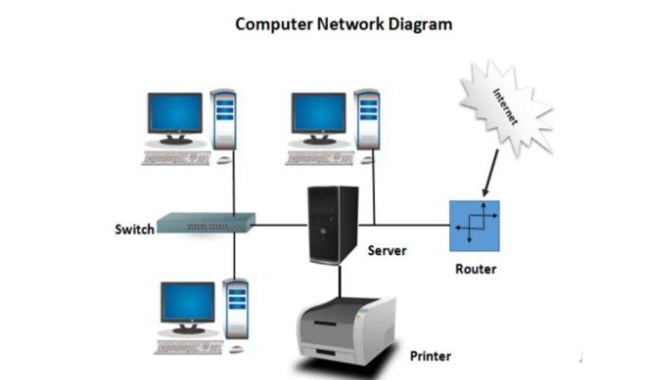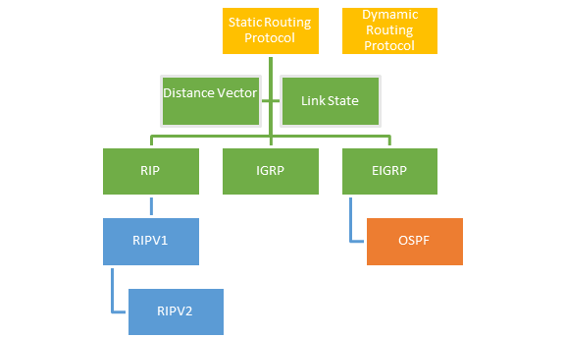
Figure1: What’s networking[4] Figure2: Routing protocol[5]

1.2 AIM
This project aims to simulate the enterprise network environment, evaluate, and compare the performance of different routing protocols under different platforms, analyze their efficiency, time performance and cost impact, to support the design of enterprise networks and the optimization of routing strategies.

1.3 OBJECTIVES
The five objectives for this report are:
1. Conduct a structured literature review of routing protocols and network simulation tools (including GNS3 and Huawei eNSP) to identify key performance metrics, comparison criteria, and existing research gaps relevant to enterprise network environments.
2. Identify and justify an appropriate research methodology for the project, selecting suitable experimental and analytical approaches to ensure reliable comparison of routing protocols within a simulated enterprise network environment.
3. Design and implement a representative enterprise network simulation using tools such as GNS3 and/or Huawei eNSP, configuring and testing at least two routing protocols based on defined performance criteria.
4. Capturing and analyses network performance data using tools such as Wireshark, evaluating measurable metrics including latency, throughput, and convergence time to enable objective comparison of routing protocols.
5. Evaluate and interpret the findings by comparing protocol performance alongside estimated deployment and operational costs and produce justified recommendations for enterprise network architecture and routing strategy optimisation.

1.4 CONCLUSION

This chapter introduces the background of the experiment, its purpose, and the research subjects.

In Chapter 2, "Research and Literature Review", I will study relevant literature on routing protocols, network simulation tools, and the indicators used.

The 3rd chapter will be the "Methodology section", where the experiment will be designed using the "Research Onion" method to ensure the reproducibility and reliability of the experiment.

In the Chapter 4,"design and implementation section", I will present the network topology and device configurations on the two simulation platforms, including correct network address allocation and routing protocols, etc. After the topology can operate normally, I will use network protocol analyser (Wireshark and Npcap) for caught, testing and data collection.

Chapter 5 is the "Evaluation" section, where I will compare the experimental results of Chapter 4, compare the device data under different platforms, and draw conclusions.

Chapter 6 will combine the results of the previous two chapters and the actual equipment costs to provide some reference suggestions for the company to choose brands and equipment.

Chapter 7 will be personal "Reflection". I will review all the efforts related to the project throughout the year, summarize the new knowledge I have learned and the points that are helpful for personal improvement.

Chapters 8 and 9 will present reference resources, Gantt charts, and some tools I used to help me learn in IEEE format.

CHAPTER 2
RESEARCH & REVIEW OF LITERATURE

2.1 INTRODUCTION
This chapter will validate the research rationale and theoretical framework of the study within computer network disciplines through systematic analysis of literature on network topology. The literature review begins with fundamental theories of network topology and routing, then examines the characteristics of RIP, OSPF, and EIGRP. It compares existing performance evaluations of these protocols and extends to emerging intelligent technologies in network performance optimization. Finally, the chapter critically assesses limitations in prior research to highlight the necessity and contributions of this study.

2.1.1 Overview of Interior Gateway Protocol

Before analyzing the references, the author will briefly explain the concepts of RIP, OSPF, and EIGRP routing protocols to help readers better understand the research. Understanding the principles and characteristics of these protocols enables a fair evaluation of their performance.

RIP (Routing Information Protocol)

The Routing Information Protocol (RIP) is designed to assist routers in determining the optimal path for transmitting data packets within a network. It uses the number of hops as its routing metric, and due to its limited scalability, it is mainly used in small to medium-sized networks. [8]

The “packet count” indicator refers to the number of routers that a data packet must pass through before reaching its destination. [8]

OSPF (Open Shortest Path First)

Open Shortest Path First (OSPF) is a link-state Interior Gateway Protocol (IGP) developed by the Internet Engineering Task Force (IETF) to provide efficient routing within an Autonomous System (AS). OSPF uses the Shortest Path First (SPF) algorithm, developed by Dijkstra, to determine the best route to each destination.[9]

EIGRP (Enhanced Interior Gateway Routing Protocol)

Enhanced Interior Gateway Routing Protocol (EIGRP) is an advanced distance-vector routing protocol that uses characteristics of both distance-vector and link-state protocols, making it a hybrid routing protocol.[10]

2.1.2 Network Topology and Its Influence on Routing

Network topology serves as the foundational infrastructure for routing protocols. As demonstrated by Liu and Liu (2014) [6], it not only governs the physical and logical interconnections among network nodes but also directly impacts routing efficiency, reliability, and congestion behaviour.[6]

The paper divides the common network topology into eight categories: point-to-point, bus, star, ring, mesh, tree, hybrid, and daisy chain.[6]

Liu's literature analysis reveals that the redundant path feature in mesh architectures enables dynamic routing protocols like OSPF and EIGRP to fully leverage multipath advantages, achieving faster convergence and higher path selection efficiency.[9][10] In contrast, RIP 's reliance on hop count and periodic updates makes it unsuitable for complex topologies or large-scale networks.[10]

2.1.3 Performance Research and Comparison of RIP, OSPF and EIGRP

Ioan & Gavril [2], in their research paper “Network Performance Evaluation for RIP, OSPF and EIGRP Routing Protocols”. Using “Opnet” Simulator (Figure 3) conducted a systematic evaluation of the performance of these three protocols under different network scales, traffic pressures, and topological conditions.

The literature indicates that in terms of convergence speed, due to the different principles of various routing protocols, it is manifested as follows: EIGRP > OSPF > RIP (speed from fast to slow)[2][11]
EIGRP achieved peak throughput across all test scenarios due to its precise comprehensive metrics and superior path selection, while OSPF demonstrated stable performance and RIP recorded the lowest throughput. EIGRP's rapid fault detection capability also resulted in the lowest packet loss rate, whereas RIP's high packet loss rate stemmed from frequent routing inconsistencies during convergence[2][11]. In latency performance, OSPF outperformed all protocols by enabling rapid adaptation to network changes, achieving optimal load balancing and bandwidth utilization with minimal latency[2]; EIGRP follows closely behind, while RIP experiences the highest latency due to sub-optimal path selection and slow convergence.

In conclusion, the study conclusively demonstrates that EIGRP is optimal for enterprise networks requiring high performance and rapid response, OSPF is better suited for large-scale and complex scenarios, while RIP is more appropriate for smaller networks.
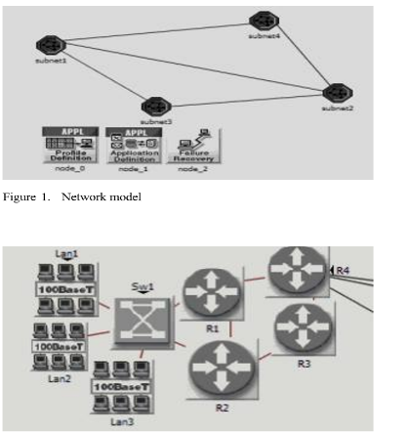
Figure3: Opnet Simulator[2]

2.1.4 Comparison of Routing Protocol Performance

In their paper “RIP vs. OSPF Routing Protocols: Which One Is the Best for a Real-Time Computer Network”, Majid & Fuada[7] conducted a systematic study of two common internal gateway routing protocols—RIP and OSPF. The research aimed to compare their performance across various network scales and real-time environments, while further exploring how protocol design mechanisms influence actual network performance.[7]

The author constructed a testing environment using the GNS3 and ENSP simulation platforms to evaluate protocol performance from multiple perspectives, including convergence time, end-to-end latency, throughput, packet loss rate, real-time application performance (such as VoIP and video transmission), and shortest path selection efficiency. The research findings clearly demonstrate significant differences between OSPF and RIP in path selection mechanisms and overall network performance. [7][13] OSPF calculates path costs based on link bandwidth, enabling it to more accurately identify optimal paths in complex topologies. In contrast, RIP, which relies solely on hop count as a routing metric, tends to select logically shortest but sub-optimal paths in practice, making it more prone to sub-optimal routing. Performance data further supports this: OSPF's average end-to-end latency is significantly lower than RIP's (83ms vs. 177ms)[7]，and it can update the routing table quickly when the link state changes, while RIP's periodic update mechanism causes the response lag in dynamic environment.[7][12]

Furthermore, a key finding of this study is that implementation variations across different emulation platforms affect protocol performance. For instance, ENSP demonstrates significantly lower average latency than GNS3 (94ms versus 329ms)[5]，The results show that the internal mechanism of the simulation tool and the equipment model have a non-negligible effect on the experimental results. In the shortest path test, OSPF consistently chooses the better path in ‘traceroute’ experiment, while RIP often has the phenomenon of detouring due to the hop limit.[13]

Overall, this study not only demonstrates OSPF's significant superiority over RIP in real-time scenarios, but also highlights how the simulation platform itself can influence experimental outcomes. This provides a theoretical basis for the project to adopt multi-platform or more precise simulation methods. Furthermore, it emphasizes that RIP's performance is unsuitable for large-scale or high-real-time-network environments due to better alternatives. Additionally, the implementation differences of experimental platforms (such as GNS3 and ENSP) can significantly affect test data, suggesting that researchers should carefully select tools and account for platform biases when conducting network simulation tests.

2.2 A Critical Analysis of Existing Research

Although the performance of RIP, OSPF and EIGRP are analysed in the existing literature, there are still some limitations and superficiality.

First, the study “RIP vs. OSPF: Which One Is the Best for a Real-Time Computer Network?” primarily compares the two protocols, RIP and OSPF, and draws conclusions about their performance differences across various simulation platforms. However, the research scope is limited, with test data mainly obtained through basic network tests and ‘traceroute’ commands like ‘Ping’ and ‘traceroute’, without in-depth analysis of metrics such as throughput and packet loss rate. Additionally, while the study highlights significant latency differences between ENSP and GNS3, [7]it fails to explain the underlying causes of platform variations, such as differences in device models, configuration methods, or internal implementation mechanisms. This, to some extent, affects the rigor of the conclusions.

Secondly，While the paper “Network Performance Evaluation for RIP, OSPF and EIGRP” provides a comprehensive comparison of the three protocols, its experimental topology is limited to small and medium-sized networks. It fails to address the complex hierarchical structures, multi-region OSPF designs, and traffic pattern variations in large enterprise networks. [9][10] Furthermore, the references highlight the advantages of EIGRP. They do not assess its applicability in a cross-vendor environment, although this is because the eNSP device does not support the EIGRP routing protocol. However, the purpose of the article is merely to compare the differences between the protocols. If the eNSP does not support the configuration of EIGRP, this will result in the lack of comparability of EIGRP data between different manufacturers' devices. Therefore, the article should not only compare the numerical differences between the routing protocols, but also discuss them separately. If this is not done, it will affect the credibility of the conclusion and make it difficult to provide actionable recommendations for enterprises. [2]

Finally, “A Study on Topology in Computer Network” underscores the critical role of topology in network performance. However, its analysis primarily focuses on classifying and describing topological structures, without establishing connections between topological complexity and the performance of specific routing protocols. [6]Moreover, some of the examples analysed, such as the bus topology, are no longer relevant to current applications.

2.3 CONCLUSION

This chapter provides a comprehensive review of research in three mainstream routing protocols—RIP, OSPF, and EIGRP—while examining how network topology impacts protocol performance. Studies indicate that RIP, despite its simplicity and ease of configuration, is better suited for small or simple networks due to its basic metric mechanism, slow convergence, and limited path selection capabilities.[7] OSPF, on the other hand, excels in path selection accuracy, convergence speed, and network scalability, making it the preferred choice for large enterprise networks.[9] EIGRP, while offering the best performance in convergence time and throughput, faces practical deployment challenges due to its limitations in cross-vendor environments and significant dependence on device types.[10]

Furthermore, literature comparisons reveal that different simulation platforms (e.g., GNS3 and ENSP) exhibit protocol implementation differences, which significantly affect experimental outcomes. Therefore, when conducting network protocol performance research, the selection of simulation tools and consistency of experimental environments are critical to ensuring result reliability. Additionally, existing studies still fall short in experimental scale, metric scope, and depth of cross-protocol comparisons, particularly lacking experimental designs for real-world enterprise network architectures and multi-perspective analytical recommendations.

CHAPTER 3
RESARCH METHODOLOGY

3.1 INTRODUCTION

This chapter explains the research methodology adopted to investigate and compare the performance of RIP, OSPF, and EIGRP routing protocols within a simulated network environment. To ensure a structured and academically justified research design, the methodology is developed using the Research Onion (Figure 4) framework proposed by Saunders et al., which provides a clear step-by-step approach to selecting appropriate research methods.

Using this framework, the chapter examines each relevant layer of the research process, including research philosophy, research approach, strategy, methodological choice, time horizon, and data collection techniques. Since the project focuses on measurable network performance indicators such as latency, convergence time, packet loss, and route efficiency, a quantitative experimental methodology is considered the most appropriate.

The chapter also discusses how the selected methods contribute to the validity, reliability, and overall credibility of the study, providing a strong foundation for the implementation and testing stages presented in the following chapter.

3.2 Research Onion
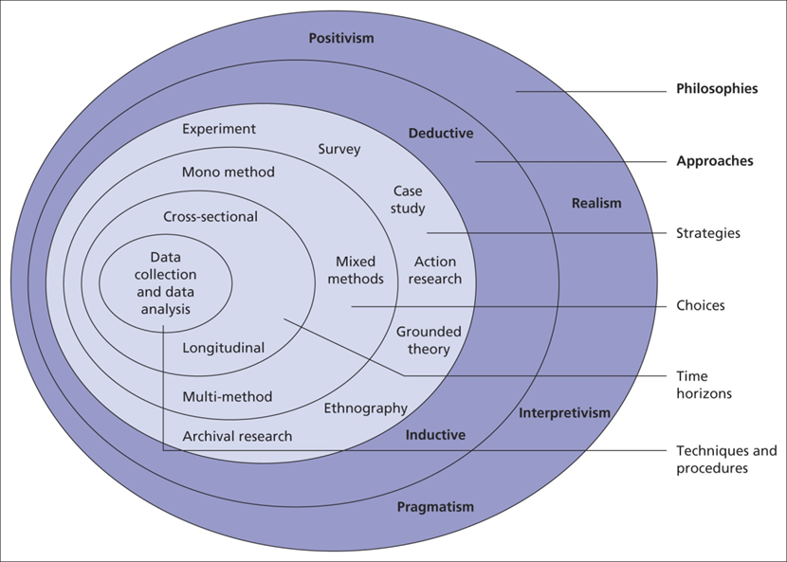

Introduction
As this research is an experimental project, it focuses on constructing controlled topologies through network simulation environments to collect quantitative performance metrics under different routing protocols. The chapter concludes by introducing how data collection and analysis are conducted using the Research Onion model, ensuring the reproducibility of the research process, the verifiability and authenticity of experimental results, and the scientific and rational nature of the experimental methods. It also explains the tools (GNS3, HUAWEI eNSP) and hardware selected for this project.
Figure 4: research onion[14]

3.3 Research Philosophy - Positivism

Concept and Reasons
This study will adopt positivism as the research philosophy, which means that the author will design hypotheses and test them and understand the behaviour of network protocol through measurable and verifiable data.

The philosophical approach was adopted because routing protocol performance metrics—such as latency, throughput, and convergence time—are objective and quantifiable, making them ideal for empirical analysis, even in a virtual network environment. Moreover, the positivist methodological framework permits leveraging established experimental findings.

The limitation is that experiment ignores real-world affecting network deployment. Project will happen with simulator. Not considering the actual physical elements. For example, deployment spaces and lab room’s temperature.

It will be expected that the experiment acknowledges this limitation by restricting conclusions to controlled environments while recommending real-world validation in future work.

3.4 Research Approach - Deductive Approach

Concept and Reasons
This research will employ the deductive method, which involves deriving testable hypotheses from known theories and verifying them through experiments. In essence, it begins with the given experimental hypotheses and then tests their validity through specific experiments. This approach not only provides a reference for designing experiments to achieve the research goals, but also directly links theory with empirical verification. If the hypothesis is proven correct, it is regarded as a success; otherwise, the experimental results will be presented along with the actual findings.

Based on the literature review, the following hypotheses are formulated
- Hypothesis 1: The average delay of OSPF will be significantly lower than that of RIP.
- Hypothesis 2: EIGRP achieves convergence faster than OSPF and RIP.
- Hypothesis 3: OSPF and EIGRP are more likely to select optimal paths, whereas RIP tends to produce suboptimal paths.

All experiments were designed to test or refute these hypotheses.

3.5 Research Strategy - Experiment

Concept and Reasons
This study mainly adopts the experimental research method as the core quantitative analysis tool, and conducts quantitative exploration based on standardized experimental procedures.
During the implementation of the experiment, this research will actively manipulate and regulate the core independent variables, systematically observing the actual effects and changing patterns of variable changes on the dependent variables; at the same time, through random allocation, the experimental group and the control group are reasonably divided to effectively eliminate the influence of irrelevant interfering factors, thereby accurately clarifying the internal logic between variables and establishing the causal relationship between different routing protocols and network performance indicators. This study takes three main dynamic routing protocols, namely RIP, OSPF, and EIGRP, as the core independent variables, and focuses on data monitoring and analysis of key performance indicators in network operation, including network transmission delay, data throughput, network convergence time, and data packet loss rate as the four core dependent variables.
Compared with other research methods, the experimental research method has significant application advantages. On the one hand, it can achieve a high degree of control over various experimental variables, minimizing experimental errors caused by external environments; on the other hand, it can complete precise horizontal comparisons of the performance of different routing protocols under a unified experimental environment and configuration standards, clearly and intuitively presenting the differences in the operation of each protocol; in addition, standardized experimental steps and parameter settings can ensure the standardization and uniformity of the overall experimental operation, effectively improving the reproducibility of the research experiment, and further enhancing the scientific, objectivity, and reference value of the current research results.

3.6 Research Choice - Quantitative Method

Concept and Reasons
This research adopts a quantitative research method, as it focuses on collecting and analysing numerical data derived from network performance tests.
Quantitative data is essential in this context because routing protocol performance must be evaluated using measurable indicators rather than subjective judgment. The use of numerical metrics enables precise comparison and statistical analysis. Because data sources are more abundant. The results which are more credible because they can be cross-platform validated.

3.7 Time Horizon - Cross-Sectional

Concept and Reasons
This study will adopt a cross-sectional design, as it aims to compare protocol differences without requiring long-term dynamic monitoring. Performance metrics such as latency, convergence, and packet loss can be obtained and replicated within a short timeframe.

The specific project schedule will be presented via Gantt Chart in the Appendix.

3.8 Techniques and Procedures - Data Collection Methods

This research will rely on professional network command and simulation tools to complete the collection and recording of all experimental data. The research will use a test tool based on the ICMP protocol to accurately measure network transmission delay, thereby capturing the data round-trip transmission delay under different routing protocol environments. At the same time, professional traffic generation tools will be used to continuously monitor the network data transmission process, and real-time statistics and recording of throughput-related data will be conducted to objectively reflect the data carrying and transmission capacity of the link.

Regarding the measurement of network convergence time, this research will simulate fault scenarios such as link interruption and link recovery artificially, observe the route updates and the stability speed of the entire network after the network topology changes of RIP, OSPF, and EIGRP, and thereby complete the quantitative evaluation of convergence performance. The overall data collection scheme has significant advantages. The test commands and analysis tools used throughout the experiment are all industry-standard tools in the network field, with standardized and unified operation procedures, which can effectively ensure the replicability and reproducibility of the experimental process and research results.

Simultaneously, the experimental data output by various tools are presented in quantitative numerical form, the results are clear and intuitive, and are convenient for subsequent horizontal comparison, data analysis, and result discussion. It should be noted that this research still has certain limitations.
Due to the constraints of the performance parameters and operation mechanism of the tools, there may be minor errors in the measurement process, which will have a certain impact on the measurement accuracy.

3.9 Evaluation Criteria

The comprehensive performance of the routing protocol will be comprehensively and systematically evaluated based on four core quantitative indicators, to objectively compare the operational performance and adaptation differences of RIP, OSPF and EIGRP, three dynamic routing protocols, under the same network environment.

Firstly, the latency[15] is measured in milliseconds It can illustrate the transmission time during the data forwarding process and the network response efficiency and is a key indicator for evaluating the smoothness of network communication.

Secondly, the throughput[16] is measured in megabits per second (Mbps), which display the total amount of data transmitted over the network link within a given period. It effectively demonstrates the overall network operation efficiency and the actual utilization level of link bandwidth resources, and directly reflects the data forwarding capability of the routing protocol in high-load scenarios.

Furthermore, the routing convergence[17] is uniformly measured in seconds. It specifically refers to the duration required for all network routing devices to complete the update of routing information, synchronization of routing tables, and restoration of stable operation after a network topology change, link failure, or device status alteration. This fully demonstrates the adaptive adjustment capability and fault-tolerant ability of the network architecture in the face of sudden changes.

Finally, the packet loss rate[18] is presented in percentage form, representing the proportion of lost packets during the transmission process out of the total sent packets. It shows the integrity and stability of the data transmission process and is an important reference for evaluating the data forwarding quality of the routing protocol and the reliability of network communication.
By conducting a comprehensive analysis based on the above four multi-dimensional performance criteria, it is possible to conduct a comprehensive, objective, and three-dimensional assessment of the overall operational performance of different routing protocols, clearly compare the advantages and disadvantages of each protocol, and thereby provide solid and comprehensive quantitative support for the experimental analysis and research conclusions of this study.

3.10 CONCLUSION

Based on the objectives of this experimental test, combined with the regulations of "Research Onion" on the experimental process, predictions and risk assessments were made.

The methodology provides a solid foundation for the design and implementation phase presented in the next chapter, where the experimental setup and procedures will be described in detail.

CHAPTER 4
DESIGN & IMPLEMENTATION

4.1 INTRODUCTION

This chapter will elaborate on the implementation process and experimental setup used to evaluate the performance of the RIP, OSPF and EIGRP routing protocols. I will design and configure a network topology that meets the experimental requirements in GNS3 and eNSP and provide a controllable testing environment.

At the same time, this chapter will describe the network architecture, device configuration, protocol deployment, and the testing process used to generate comparable performance data. Protocol traffic is captured using Wireshark and the routing behavior during normal operation as well as under simulated network failure conditions is analyzed.

It should be noted that since Huawei eNSP does not support the deployment of EIGRP, the experimental screenshots of EIGRP in eNSP will not be presented in the fifth chapter's experiment section. During the result analysis, a comparison was made between the data of OSPF and RIP on the two platforms. EIGRP will only compare with other routing protocols that have been deployed on the GNS3 platform. The relevant content will also be covered in the suggestions of Chapter 6.

The purpose of this chapter is to demonstrate how the experimental framework was constructed, to prepare for the results and evaluations presented in the subsequent chapters.

4.2 Experimental Requirements

4.2.1 Hardware Equipment

To ensure stable virtual network simulation and the simultaneous execution of multiple routers, a laptop/PC with a minimum of 16GB RAM was used. Sufficient memory allocation was necessary because several virtual routers and network appliances needed to run concurrently within GNS3 VM and Huawei eNSP environments. In addition, the processor was required to support hardware virtualisation technologies to enable efficient VM performance.

4.2.2 Software System

For this experiment, multiple professional network simulation and analysis software were selected to jointly establish a complete experimental environment and complete the performance evaluation. GNS3 and its accompanying virtual machines were mainly used to build a highly realistic Cisco routing simulation environment, accurately simulating the protocol operation mechanism of Cisco devices; Huawei eNSP, combined with the virtual machine deployment method, can achieve comparative tests across multiple vendor platforms, facilitating horizontal comparison of the running characteristics and behavioural differences of routing protocols under different brand devices.

Wireshark, as a professional packet capture tool, is responsible for capturing network data packets throughout the process and deeply analysing the protocol interaction process and traffic characteristics; Npcap provides underlying packet capture driver support for the Windows system, which is a necessary component to ensure the normal implementation of data capture by Wireshark.

The software which be installed in experiment, generally has the advantages of flexible deployment, and high degree of customization, enabling the free construction of diverse network topologies, adjustment of experimental parameters, support for multiple repeated tests and variable control, and effectively ensuring the operability, repeatability, and overall rigor of this network experiment.

4.3 Network Topology Design

A consistent and controlled experimental topology was designed and implemented in both GNS3 and Huawei eNSP to ensure a fair comparison between RIP, OSPF, and EIGRP routing protocols. The use of two simulation environments was beneficial in reducing platform-specific bias and improving the credibility of the results.

The topology consists of five routers (R1–R5) and four end devices (PC1–PC4). Each edge router provides connectivity to one or more end hosts, while the internal routers form the routing backbone of the network. This structure reflects a simplified enterprise network containing access nodes, distribution paths, and core routing functions.

Multiple redundant links were intentionally included between routers to support dynamic rerouting and convergence testing. In particular, alternative paths were established between R1, R4, and R5, allowing traffic to be redirected when the primary route failed. This was an important design decision, as routing protocols cannot be effectively evaluated without topology changes or failure scenarios.

A structured IPv4 addressing scheme was adopted to simplify management and analysis. Separate subnets were assigned to each point-to-point router link and each LAN segment, enabling routing updates and path selection to be clearly identified during testing.

Following screenshot was taken from GNS3:
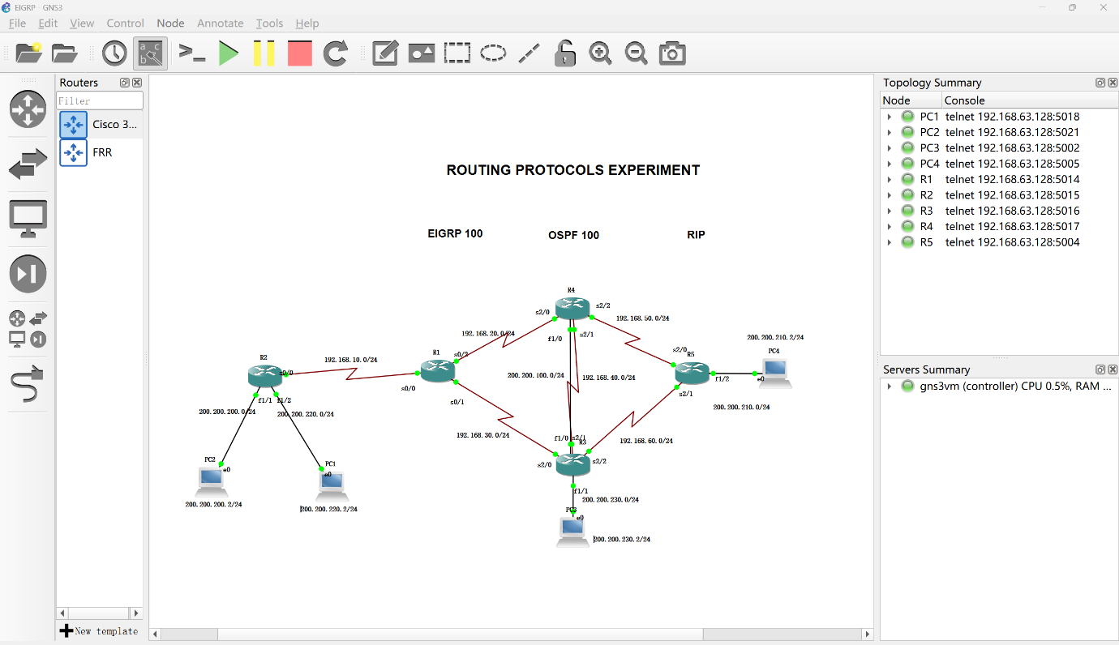
Figure 5

The experimental topology (Figure 5) employs Cisco 3640 (C3640) series routers, which are simulated and run in GNS3. These are used as 5 core routing devices, R1-R5, to support the deployment and testing of dynamic routing protocols such as EIGRP, OSPF, and RIP.

The topology uses serial links to connect the routers, and the PCs are directly connected to the routers via links.

To test the convergence performance of the routing protocol under network failure scenarios, this topology has designed multiple redundant links and backup paths. Among them, multi-path redundancy is configured between R1 and R5, including two main paths: R1→R4→R5 and R1→R3→R5. At the same time, a multi-hop backup path R1→R4→R3→R5 is reserved. Between R4 and R5, a direct connection main link and a backup link via R3 are set up. In case of failure of the direct connection link between R4 and R5, the routing switch can be triggered to measure the protocol convergence time. In addition, R1 simultaneously establishes connections with R3 and R4, forming a dual-exit structure. When one of the links fails, the traffic can continue to be forwarded through the other link, thereby verifying the path switching efficiency and fault recovery capability of different routing protocols.

Following screenshot was taken from eNSP:
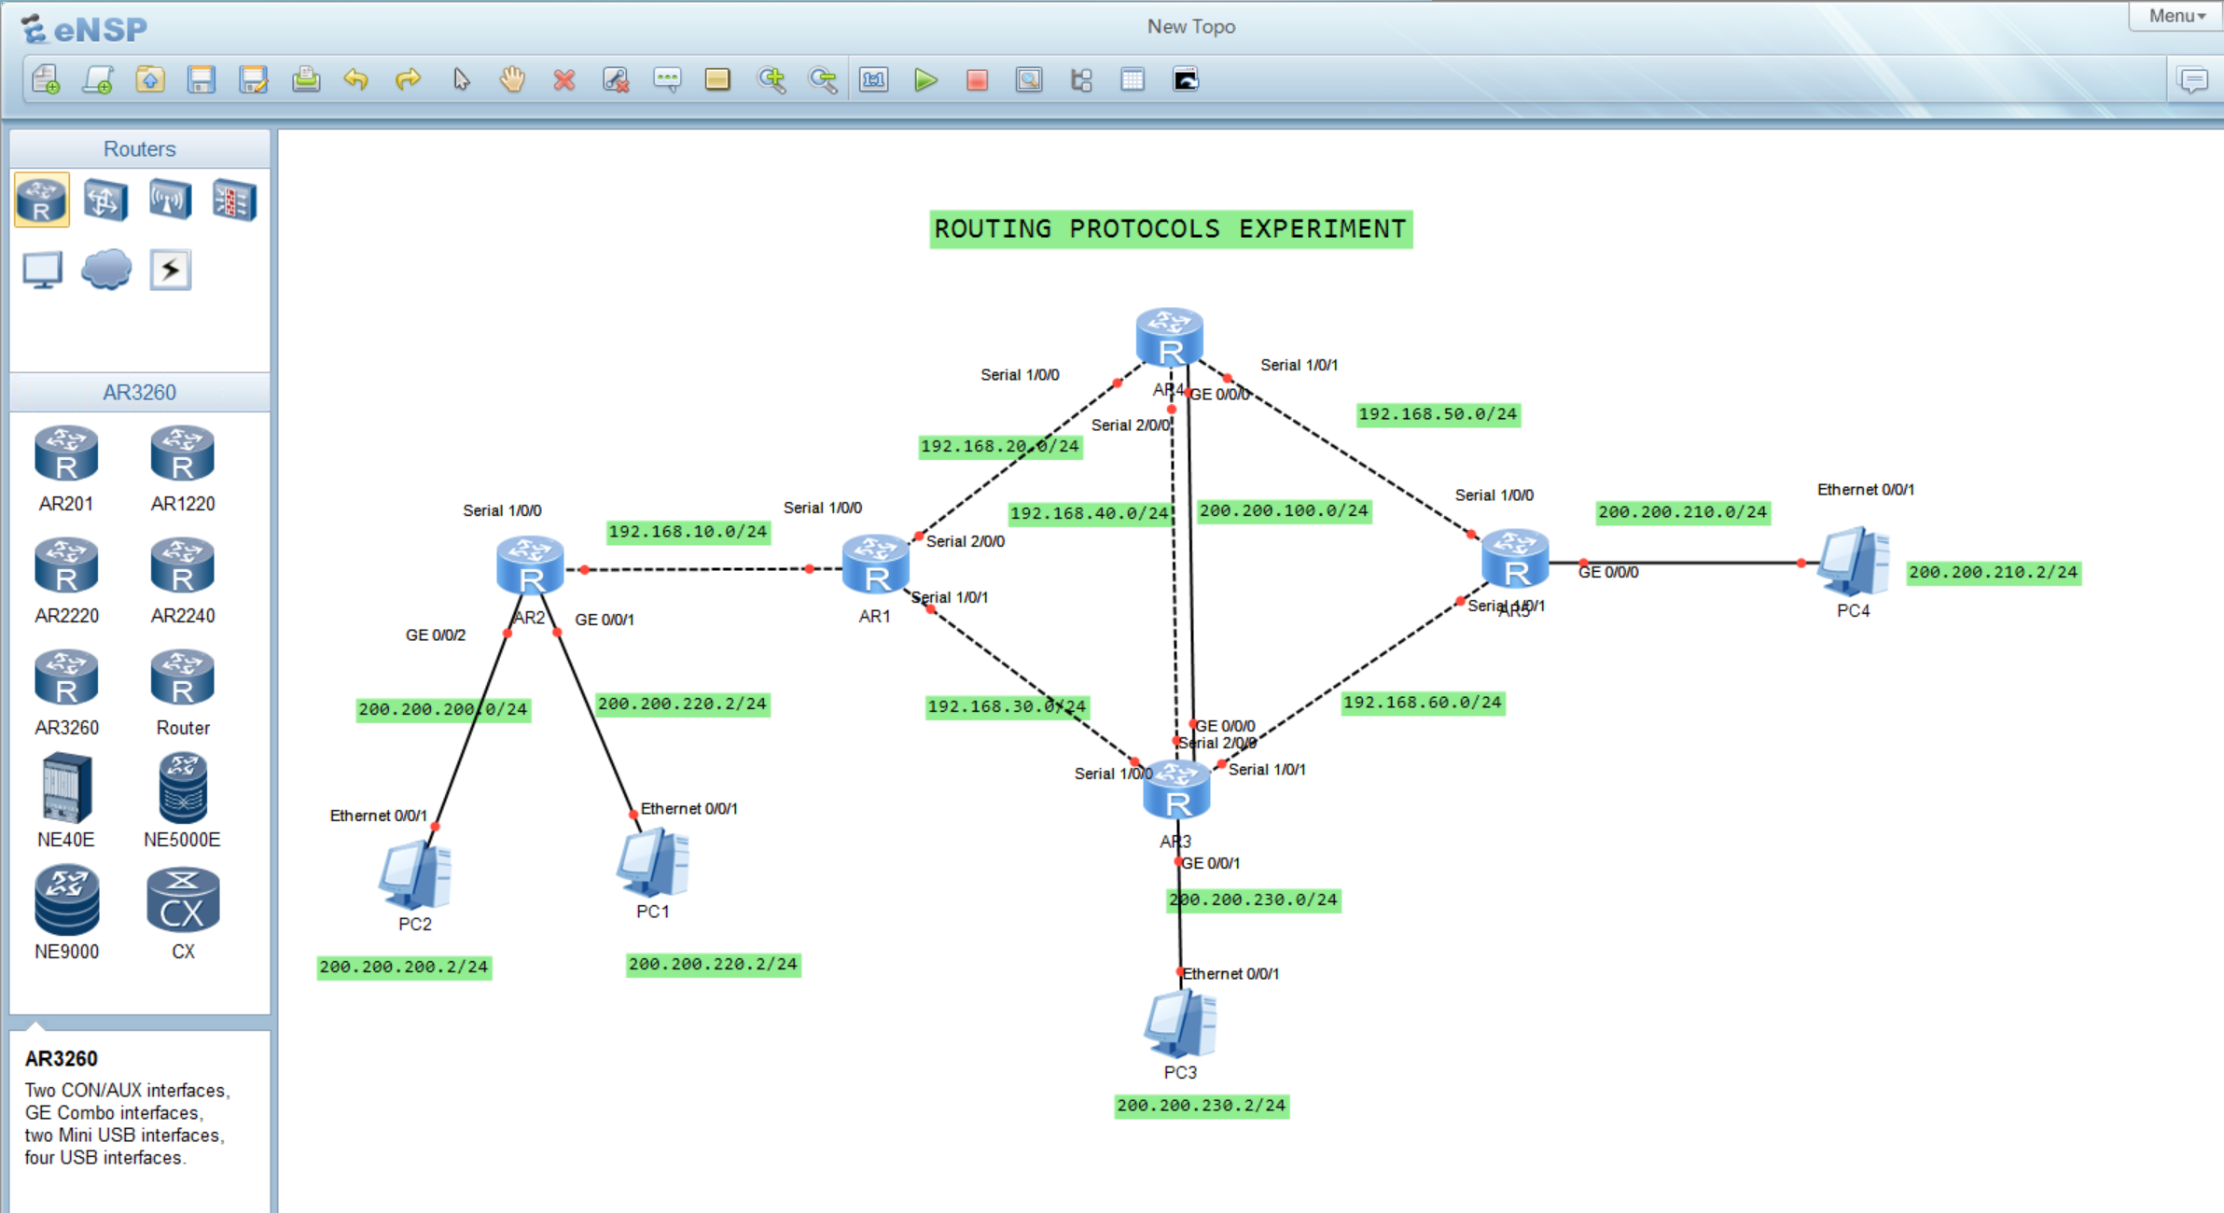
Figure 6

The Figure 6 demonstrated the Huawei AR3260 series routers, which are simulated and operated in the eNSP platform. These devices are used as five core routing devices AR1-AR5, supporting the deployment and testing of dynamic routing protocols such as OSPF and RIP.
The topology structure connects the routers through serial links, and the PC is directly connected to the routers via Ethernet links.

To test the convergence performance of routing protocols in network failure scenarios, this topology designs multiple redundant links and backup paths. Among them, a multipath redundancy is configured between AR1 and AR5, including two main paths: AR1→AR4→AR5 and AR1→AR3→AR5. Between AR4 and AR5, there is a direct main link and a backup link via AR3. If the direct connection link between AR4 and AR5 fails, a routing switch can be triggered to measure the protocol convergence time. Additionally, AR1 simultaneously establishes connections with AR3 and AR4, forming a bidirectional exit structure. When one of the links fails, the traffic can continue to be forwarded through the other link, thereby verifying the path switching efficiency and fault recovery capability of different routing protocols.

When deploying the topology diagram, apart from the interface changes, ensure that the device quantity structure of the two platforms is consistent.

A case in point of Subnetting

GNS3
Device | Interface | IP Address | Mask
R1 | S0/0 | 192.168.10.2 | /24

eNSP
Device | Interface | IP Address | Mask
R1 | S1/0/0 | 192.168.10.2 | /24
The complete addressing table is provided in Appendix.

A case in point is that R1 routing’s eigrp neighbour.

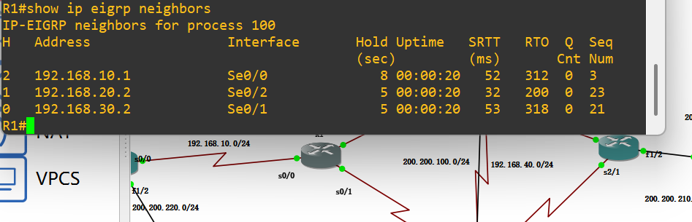
Figure 7

From figure 7, the "show ip eigrp neighbors" command, the three neighbors (R2, R4, R3) of R1 have normal session states, and parameters such as Hold Time and SRTT are within reasonable ranges. This indicates that the neighbor relationship is stable and EIGRP has completed full network convergence.

4.4 Implementation and Experimental Procedure

Following completion of the design stage, the topology was implemented within GNS3 and replicated in Huawei eNSP. All virtual routers were instantiated and interconnected according to the planned structure. Interfaces were manually configured with IPv4 addresses, subnet masks, and activated using administrative commands.

Initial connectivity was verified through direct ping tests between adjacent devices to ensure correct Layer 3 communication before routing protocols were enabled.

Three routing protocols were then deployed separately under identical conditions.

For RIP testing, RIPv2 was configured to support classless routing, and automatic summarization was disabled where necessary. For OSPF, a single backbone area (Area 0) was adopted to reduce unnecessary complexity while maintaining realistic link-state operation. For EIGRP, a common autonomous system number was configured across all routers to establish neighbour adjacencies and exchange routing information. During the link failure test, the disconnection time for all links was 10 seconds.

After protocol deployment, verification commands were used to confirm successful operation. These included routing table inspection, neighbour relationship checks, and route advertisement confirmation.

Wireshark was integrated through the GNS3 packet capture function to allow real-time monitoring of protocol traffic. This enabled observation of hello packets, routing updates, neighbour establishment, and route recalculation during failure scenarios.

Several implementation challenges were encountered during setup, including packet capture integration issues and interface addressing inconsistencies. These were resolved through manual path configuration, software reinstallation, and repeated connectivity verification.

4.5 Specific implementation and testing

4.5.1 Baseline Connectivity and Latency Results

GNS3:
EIGRP: PC1 and PC2 ping to PC4, respectively.
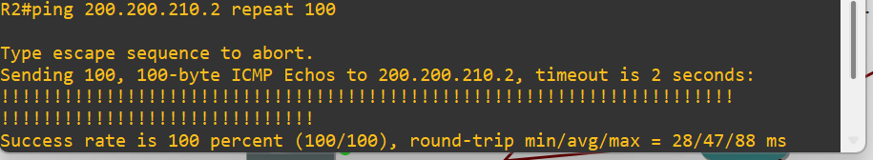
Figure 8

OSPF: PC1 and PC2 ping to PC4, respectively.
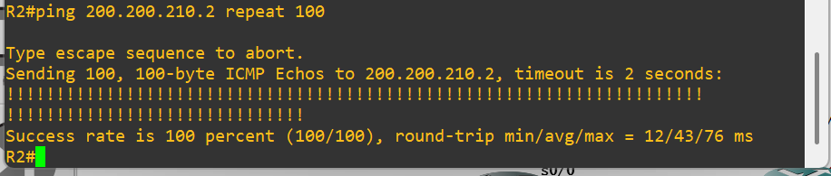
Figure 9

RIP: PC1 and PC2 ping to PC4, respectively.
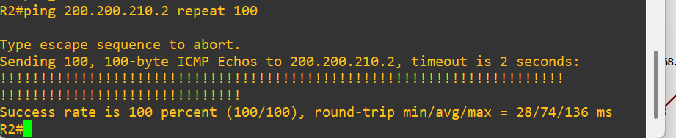
Figure 10

The figure 8-10 respectively illustrates that Network can be running in EIGRP, OSPF and RIP environment with each different delay time. The result of testing was recorded in table.

Protocol | Avg Latency (ms) | Packet Loss (%)
RIP | 74 | 0%
OSPF | 43 | 0%
EIGRP | 47 | 0%

eNSP:
OSPF: PC1 and PC2 ping to PC4, respectively.
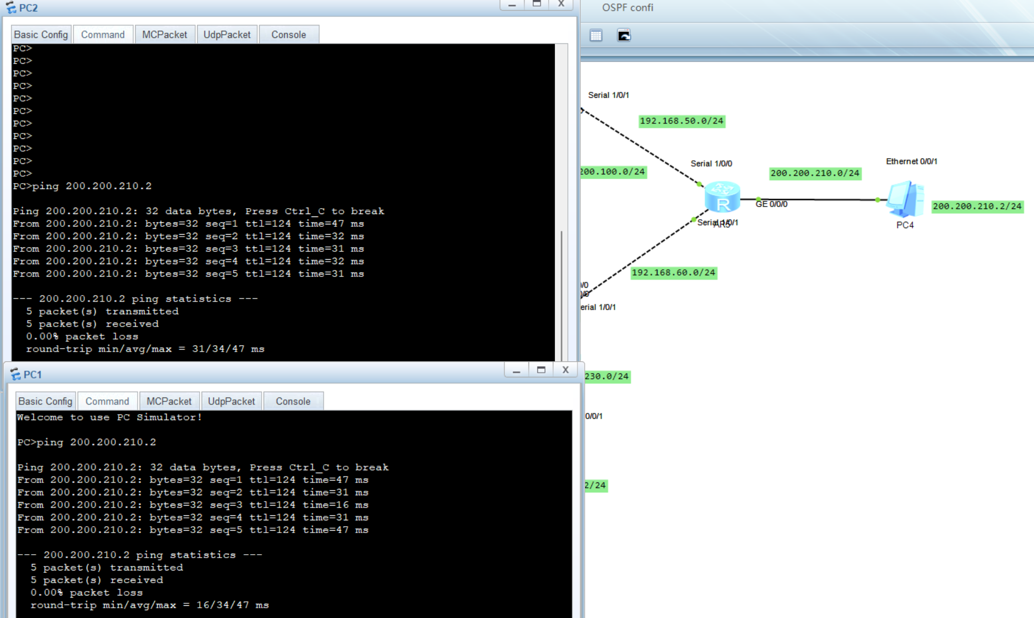
Figure 11

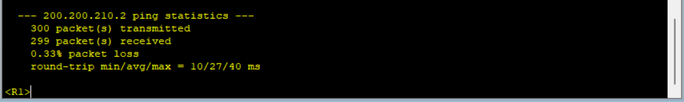
Figure 12
Under a fault-free baseline condition, a long ping test (in figure 12 can be observed that R1 sent 300 ICMP packets to PC4) was conducted on the forwarding stability of the RIP protocol. The results showed that there was a slight packet loss during the test, with a packet loss rate of 0.33%, and the average round-trip delay was 27ms, with the maximum delay being 40ms.

RIP: PC1 and PC2 ping to PC4, respectively.
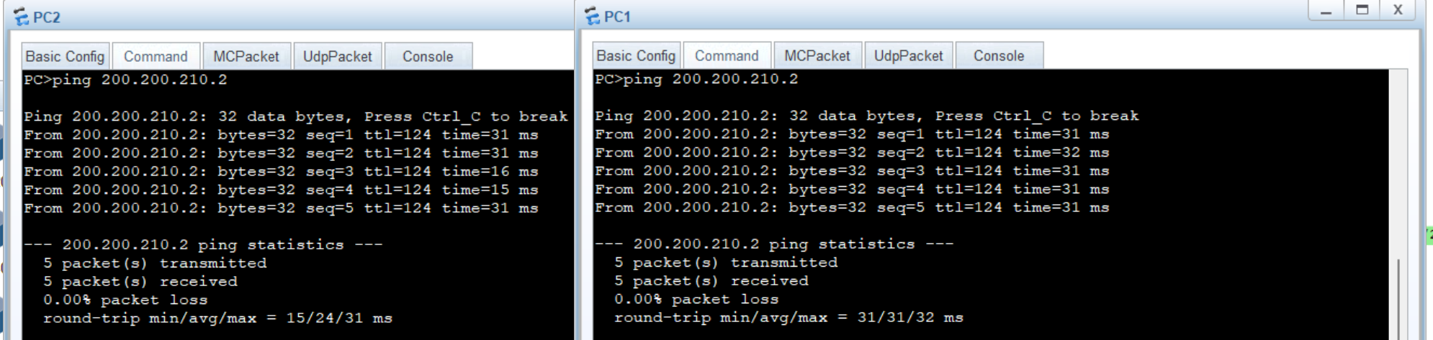
Figure 13

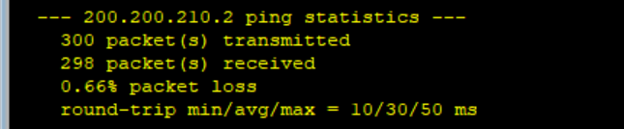
Figure 14

Under a fault-free baseline condition, a long ping test (Figure 14 shows that R1 sent 300 ICMP packets to PC4) was conducted on the forwarding stability of the RIP protocol. The results showed that there was a slight packet loss during the test, with a packet loss rate of 0.66%, and the average round-trip delay was 30ms, with the maximum delay being 50ms.

Protocol | Avg Latency (ms) | Packet Loss (%)
RIP | 30 | 0%
OSPF | 27 | 0%

4.5.2 Path Selection Results

GNS3:
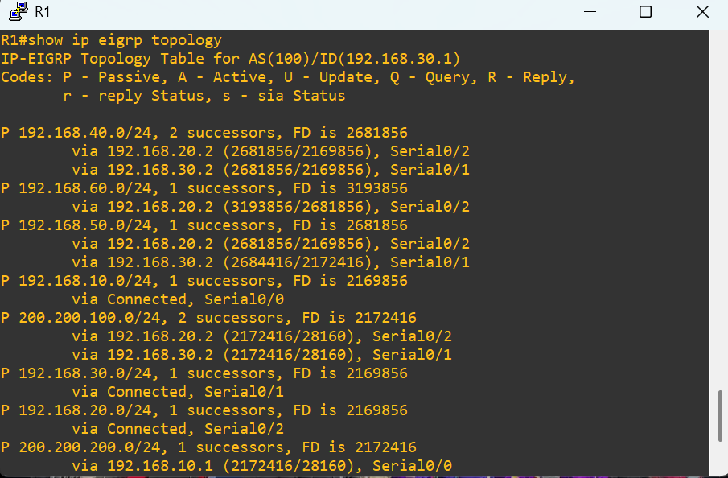
EIGRP
Figure 15

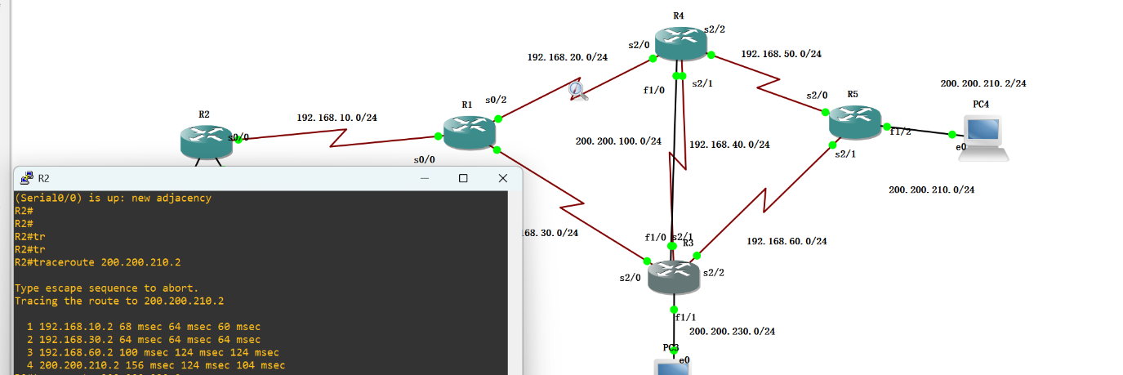
Figure 16

The traceroute test conducted when all interfaces were in an open state clearly demonstrated the network path (Figure 15) selected by EIGRP under normal operating conditions.

Figure 16 shows that route from R2 to PC4 (200.200.210.2) passed through R1, R3 and R5, which confirmed that EIGRP chose the path through R3 as the preferred path based on its comprehensive indicators.

All traceroute attempts successfully reached the destination, proving that the network is fully connected in a normal state.

OSPF
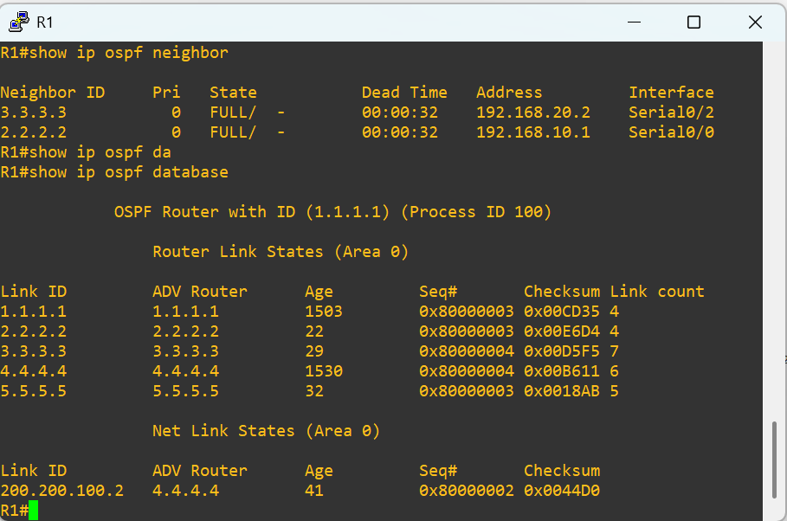
Figure 17

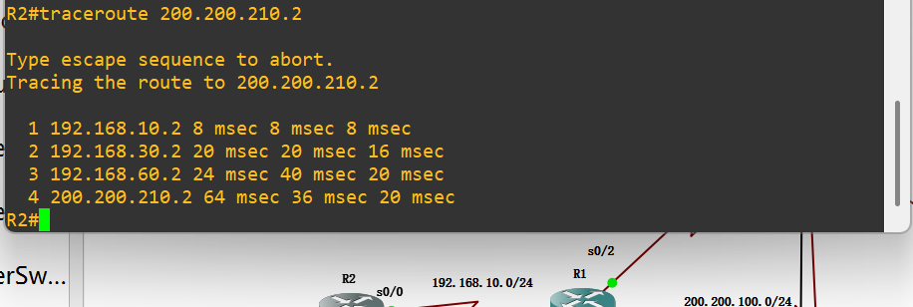
Figure 18

The traceroute test conducted when all interfaces were enabled clearly shows in Figure 17 the network path selected by OSPF under normal operating conditions. OSPF choses R4 as the preferred path. Figure 18 was found that the path from R2 to PC4 would pass through R1, R4 and R5. All the routing trace attempts successfully reached the destination, indicating that the network was fully connected under normal conditions. The round-trip time to the destination was approximately 20 to 64 milliseconds.
RIP

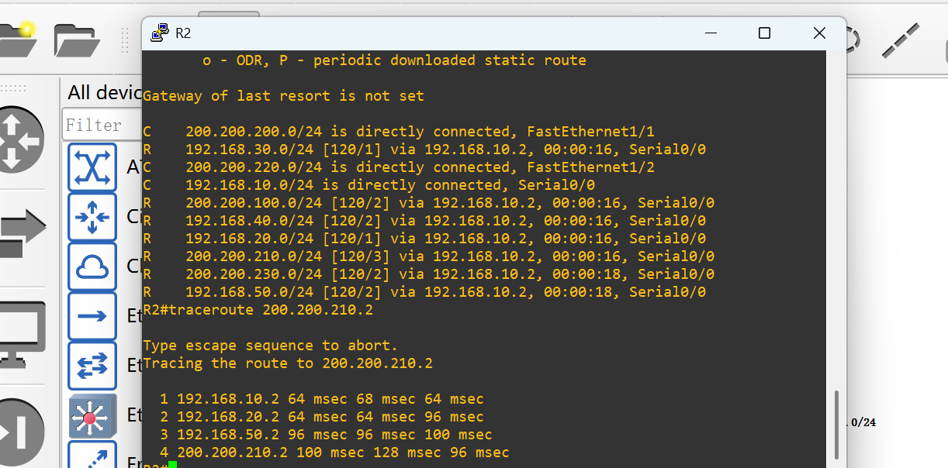
Figure 19

The traceroute test conducted when all interfaces were enabled clearly shows in Figure 19 the network path selected by RIP under normal operating conditions. RIP chose R4 as the preferred path. It was found that the path from R2 to PC4 would pass through R1, R4 and R5. All the routing trace attempts successfully reached the destination, indicating that the network was fully connected under normal conditions. The round-trip time to the destination was approximately 96 to 100 milliseconds.

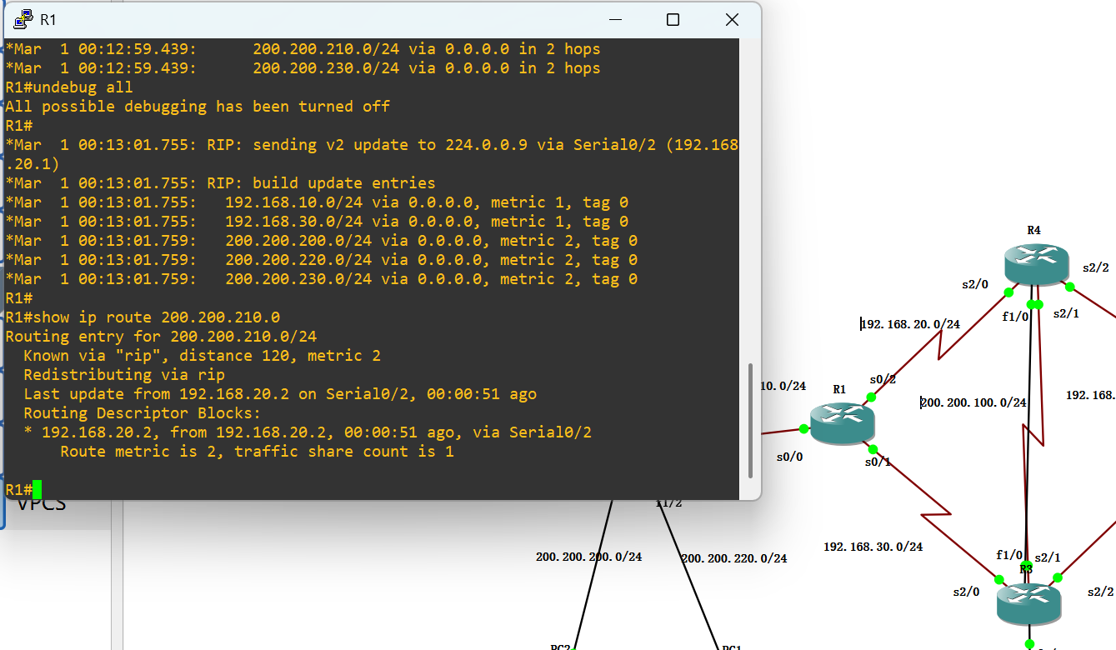
Figure 20

The RIP only installs a single path in the routing table. Even if multiple paths have the same hop count metric value (figure 20), RIP will only retain the first learned routing entry and ignore subsequent routing updates.

eNSP:

OSPF
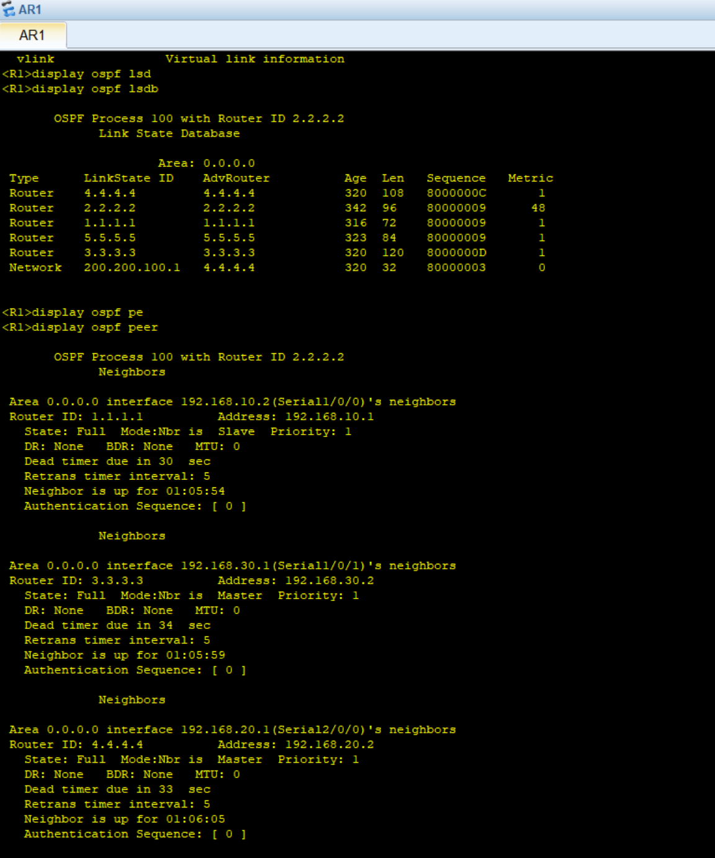
Figure 21
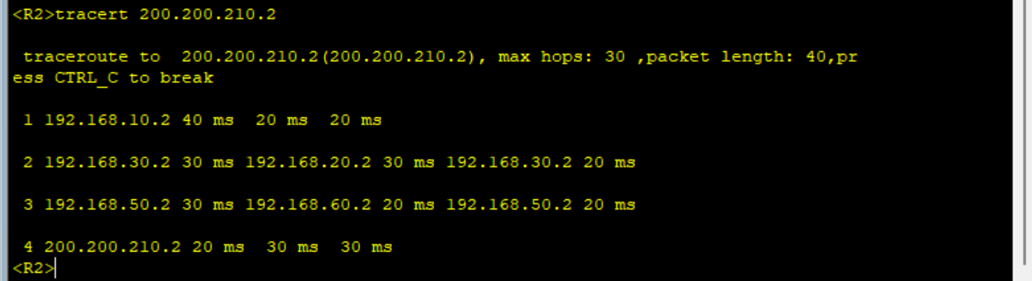
Figure 22

Figure 21 illustrates that all neighbours of R1 (Router ID: 2.2.2.2) were in Full adjacency, and the link-state database was fully synchronized. Figure 18 was found that the path from R2 to PC4 would pass through R1, R4 and R5. All the routing trace attempts successfully reached the destination, indicating that the network was fully connected under normal conditions. The round-trip time to the destination was approximately 20 to 64 milliseconds.

RIP

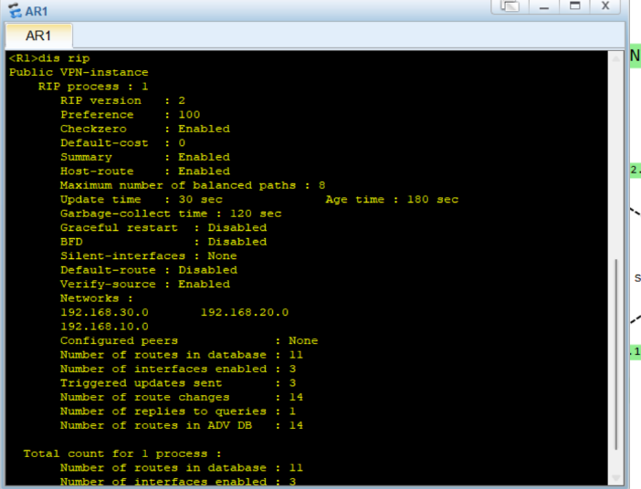
Figure 23

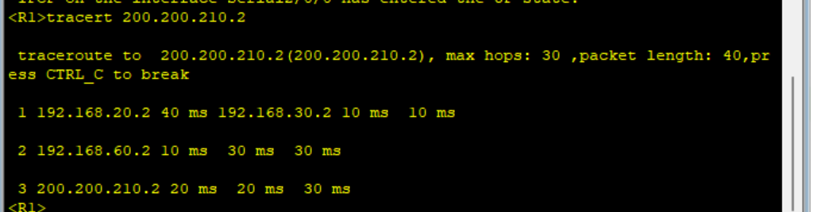
Figure 24
Under normal conditions, figure 24 shows RIP selected the path “R1 → R4 → R5” to reach PC4 (200.200.210.2), with a round-trip time of 20–30 ms. When the link failed at 07:52:28, RIP did not update the routing table immediately. Instead, it waited for its default 30-second periodic update cycle to receive new routes from neighbours, remove the failed path, and switch to the backup path. ( As shown in Figure 23.)

4.5.3 Link Failure and Convergence Results

GNS3:
EIGRP
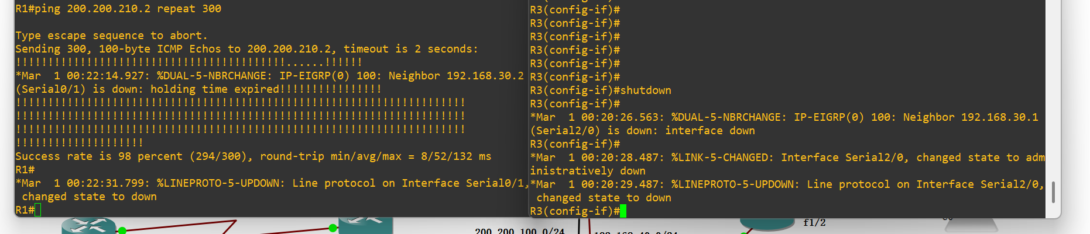

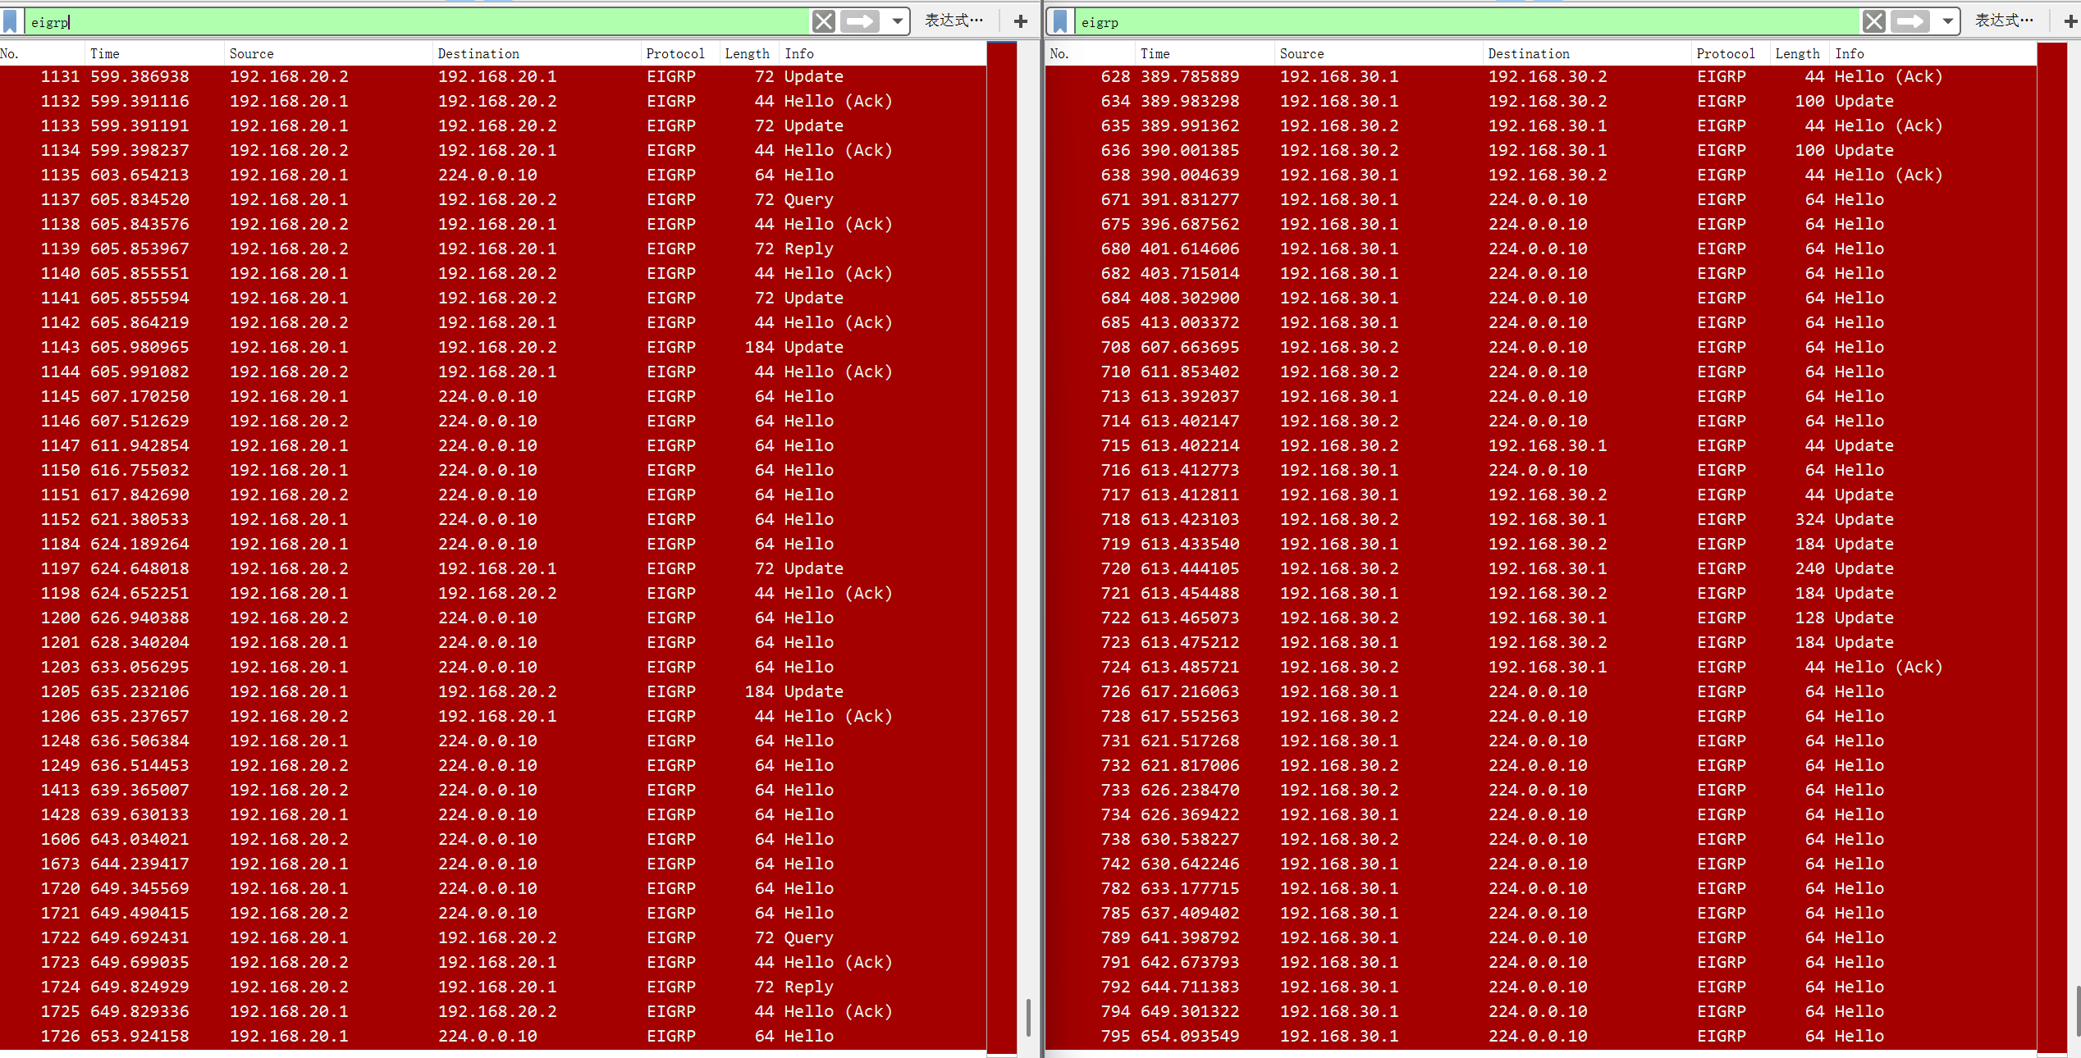
Figure 25

Based on the corresponding analysis of the packet capture data in Figure 25 and the experimental scenario, the routing switching and convergence process of the EIGRP protocol after the failure of the primary link can be completely restored. After the primary link interface is disconnected, the regular Hello messages exchanged between the two ends of the link immediately stop being transmitted. The EIGRP neighbor relationship is declared invalid after the Hold time expires. The router then triggers the routing update process and announces the failure of the primary link's direct network segment to the entire network. At the same time, the neighbor relationship of the backup link remains stable. The router sends path queries to the backup link neighbors through the Query-Reply mechanism. After receiving the Reply message confirming the existence of the feasible successor route, the router immediately completes the routing table update through the Update message and guides the business traffic to the backup link.

OSPF
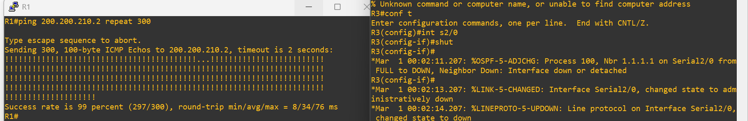
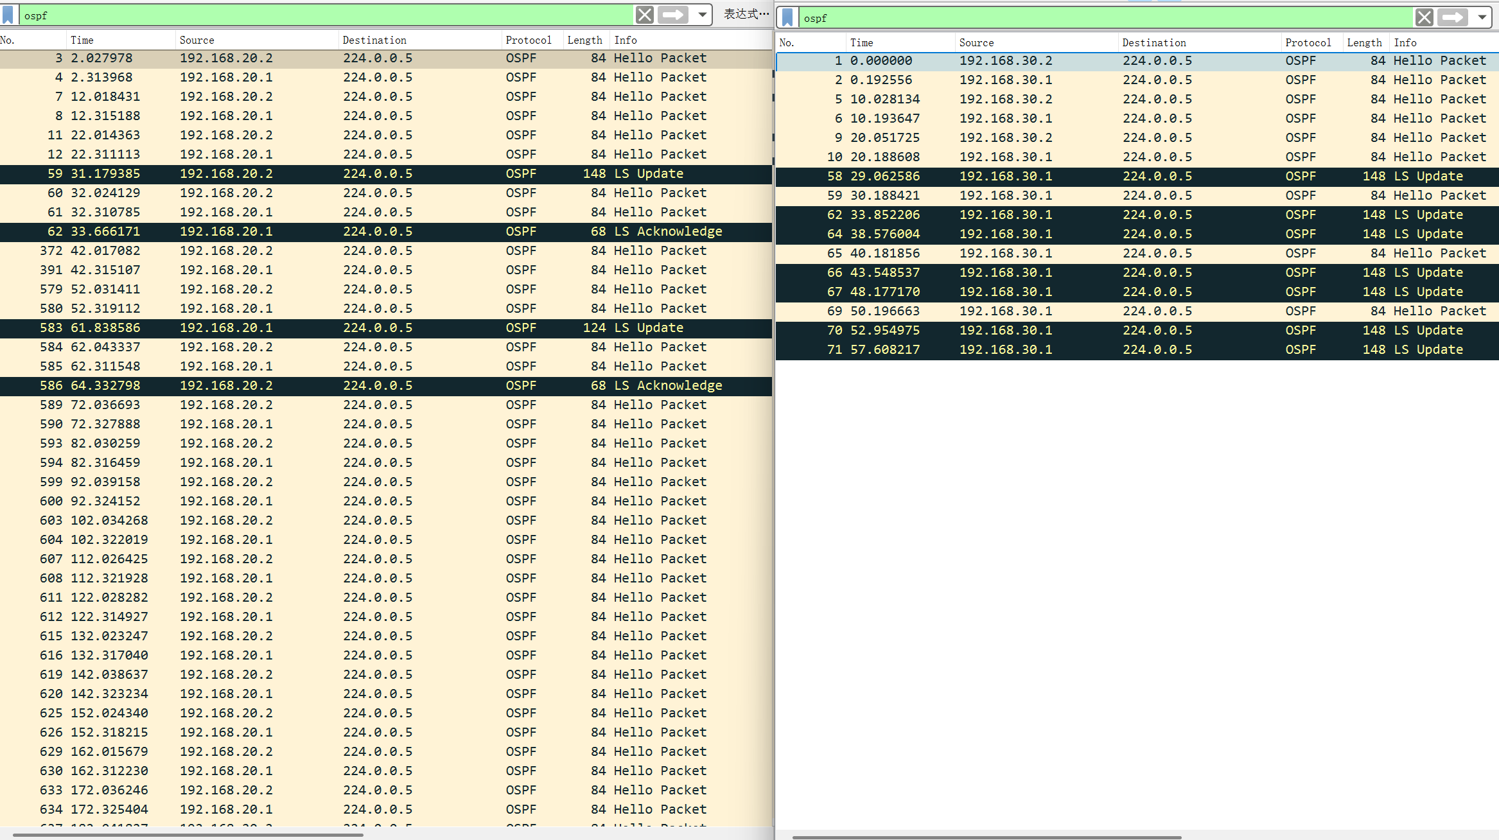
Figure 26

In the output of figure 26, the routing convergence process following primary link failure is fully observable. Prior to failure, the primary link exchanged 84-byte Hello packets every 10 seconds with multicast address 224.0.0.5 to maintain adjacency; upon failure, these packets stopped immediately, and the neighbour relationship expired after Dead time. At 29.06s, the router began sending 148-byte LS Updates to flood the link failure, while the backup link remained stable with uninterrupted 84-byte Hello transmissions. Two LSA synchronization cycles occurred: the first LS Update sent at 31.32s received a 68-byte LS Acknowledge at 33.66s, and the second sent at 61.83s was acknowledged at 64.33s. From failure trigger to completion of LSA sync, LSDB update, and SPF calculation, the full convergence took approximately 4–5 seconds.

RIP
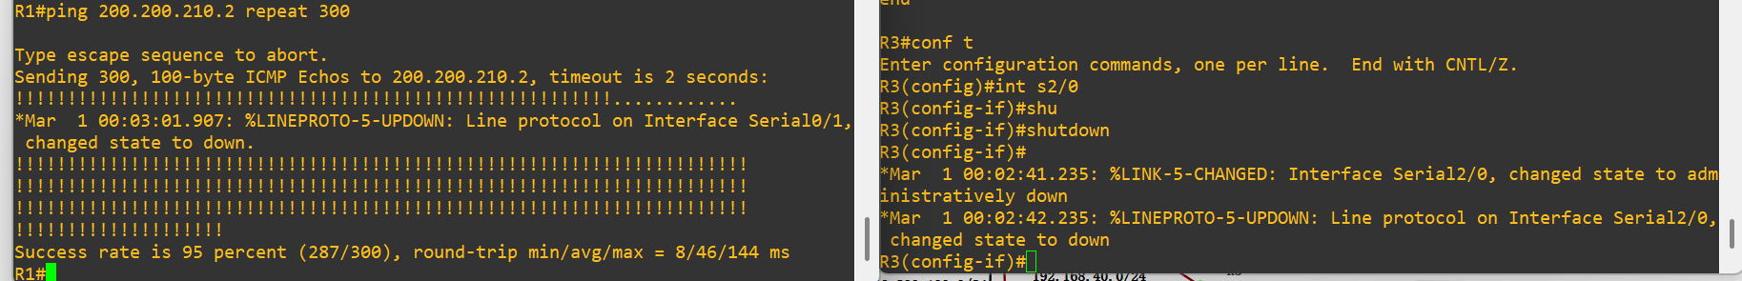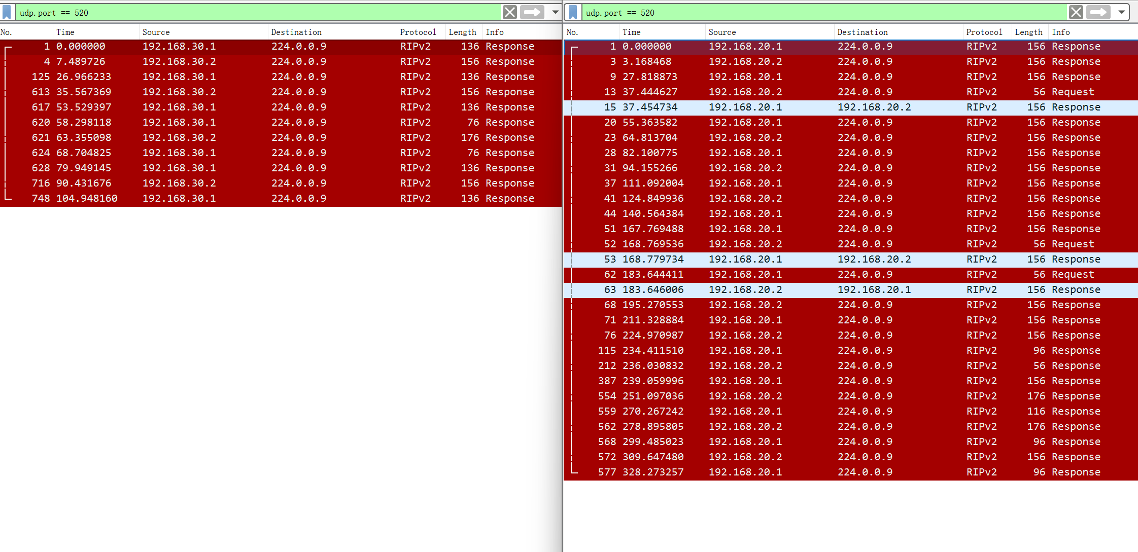
Figure 27

Based on the results of figure 27, by using UDP port 520, successful observation of RIP version 2's route update information was made in both the primary and backup links. This confirmed that normal neighbour communication had been established before the failure event occurred. During the continuous Ping tests, the closure of the primary link triggered obvious routing activities on the backup path, exchanging multiple response and request data packets within a short period of time. This behaviour indicates that RIP detected topological changes and initiated route recalculation to restore reachability through the backup route. The presence of additional request messages indicates that the router was actively querying updated route information, rather than merely relying on the normal 30-second timer cycle. Meanwhile, the routing traffic on the backup interface continued, indicating that the neighbour relationship was still available and that the backup path could assume the forwarding responsibility after the link failure.

eNSP

OSPF

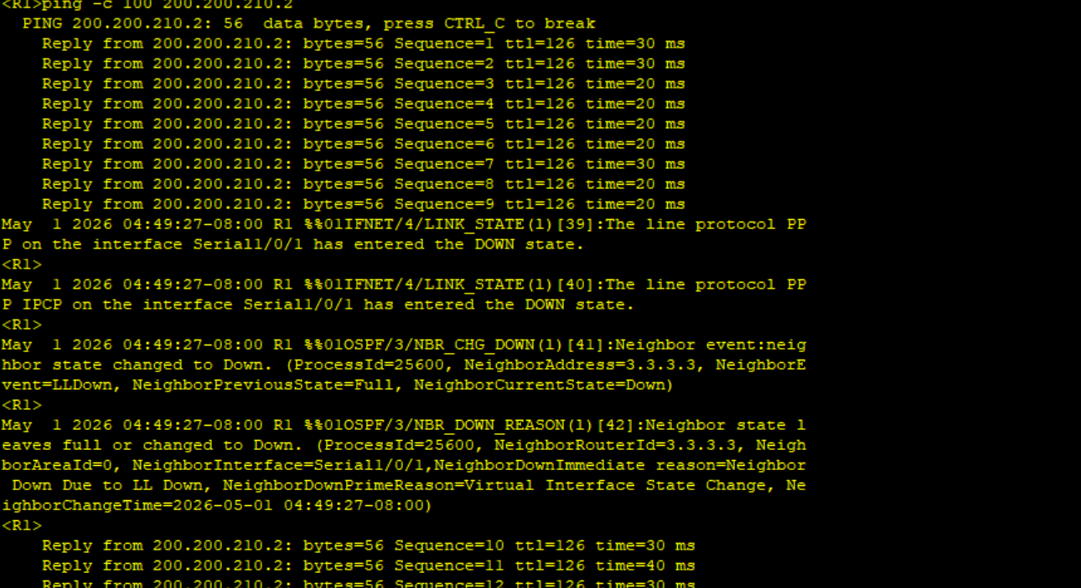
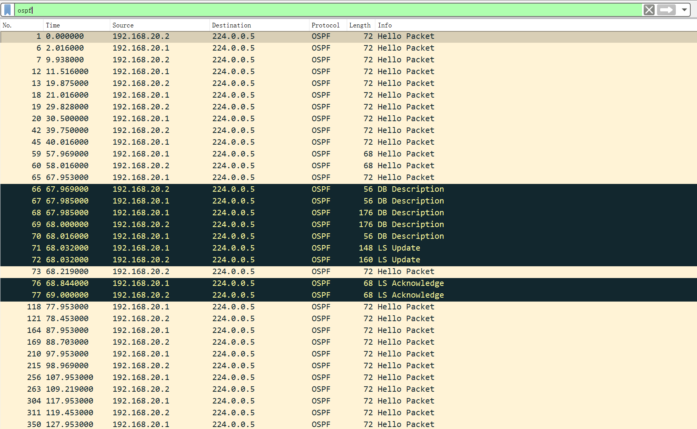
Figure 28

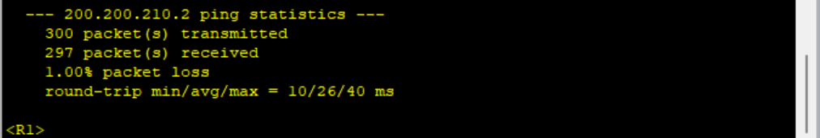
Figure 29

After the interface was disconnected, the neighbor relationship of the main link became invalid, and OSPF immediately triggered the neighbor establishment process on the backup link (figure 28). Meanwhile, in the packet capture, the DB Description, LS Update, and LS Acknowledge messages starting around 67.9 seconds were visible, completing the synchronization and update of the link state database. The changes in message length also reflected the differences in LSA synchronization content at different stages. The ping test results showed that out of 300 ICMP message transmissions, 293 were successfully received, with a packet loss rate of only 1%, indicating that the OSPF protocol successfully identified the main link failure and completed the neighbor establishment and routing calculation on the backup link.

RIP
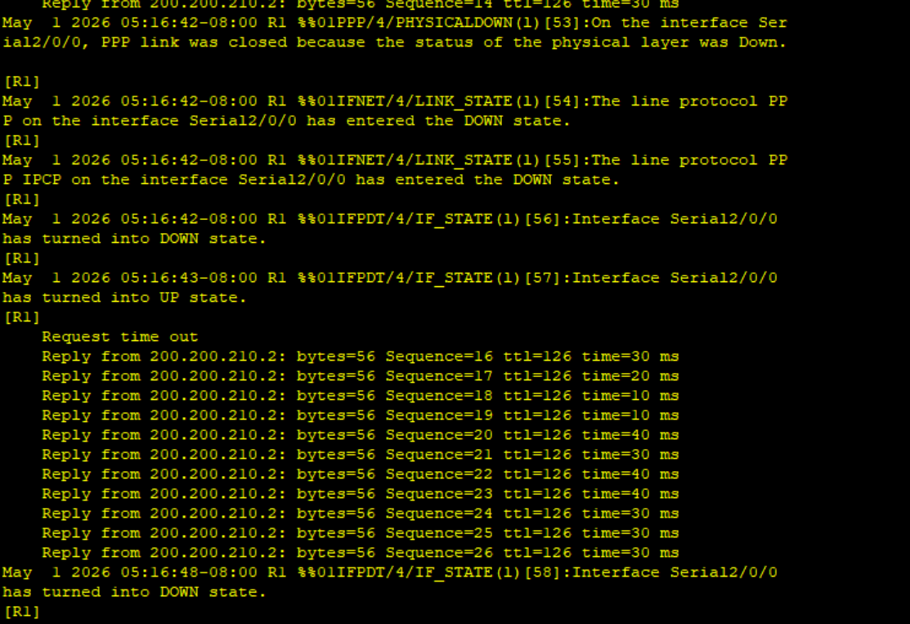
Figure 30

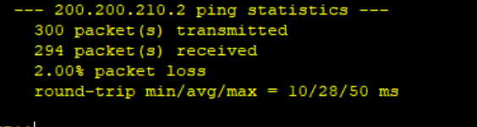
Figure 31

From the packet capture data and ping test results shown in Figure 30, it is possible to fully restore the process of traffic switching and route synchronization after the main link failure. In the packet capture data, RIPv2 messages continuously interact with the multicast address 224.0.0.9, with message types including Request and Response. After the failure occurred, the frequency of Request message interaction significantly increased, and the number of long Response messages carrying more routing information also significantly increased, reflecting the process of routing information synchronization between devices.

The ping test results show that out of 300 ICMP message transmissions (figure 31), 298 were successfully received, with a packet loss rate of 2%. This indicates that after the main link failure, the traffic path successfully switched to the backup link, with only a small amount of packet loss during the switching process, and the overall connectivity was not significantly affected. This fully presents the actual effect of the route switching in this test.

4.5.4 Internal Protocol Behaviour

EIGRP
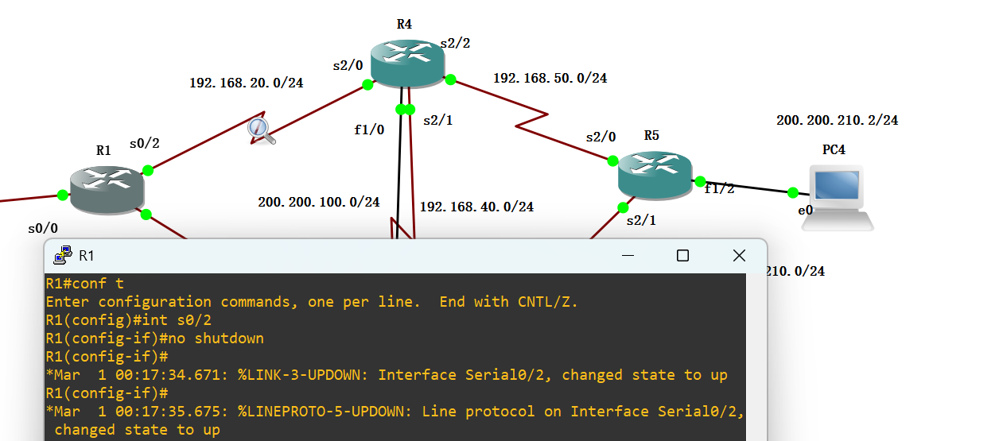
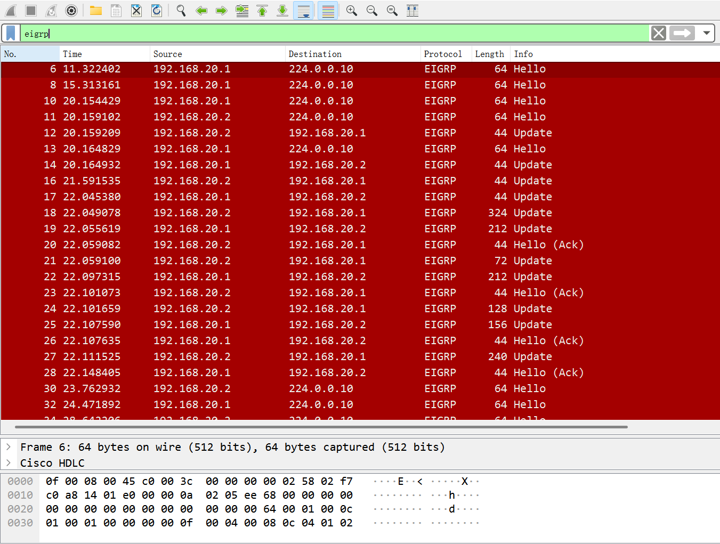
Figure 32

Figure 32 demonstrates the neighbor discovery and route synchronization behavior of EIGRP: After the interface is restored, the device first sends a 64-byte Hello message, and then immediately sends Update messages of different lengths, corresponding to the synchronization process of the routing entries.

At the same time, it can be observed that Update messages and Hello (Ack) messages appear in pairs, indicating that Update messages require explicit confirmation, verifying the internal behavior of EIGRP that it is ensuring reliable transmission of route updates through the Ack mechanism.

The dynamic changes in the length of the messages directly reflect the differences in the composition of Update messages under different numbers of routing entries, thereby demonstrating the scalability of EIGRP routing update messages.

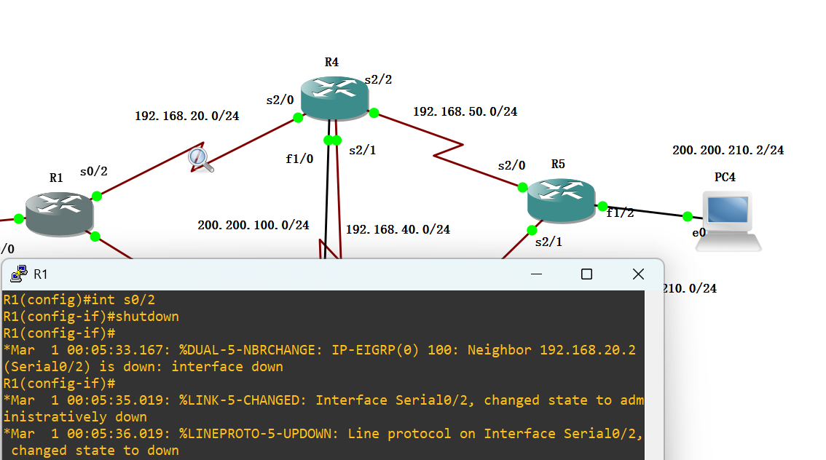
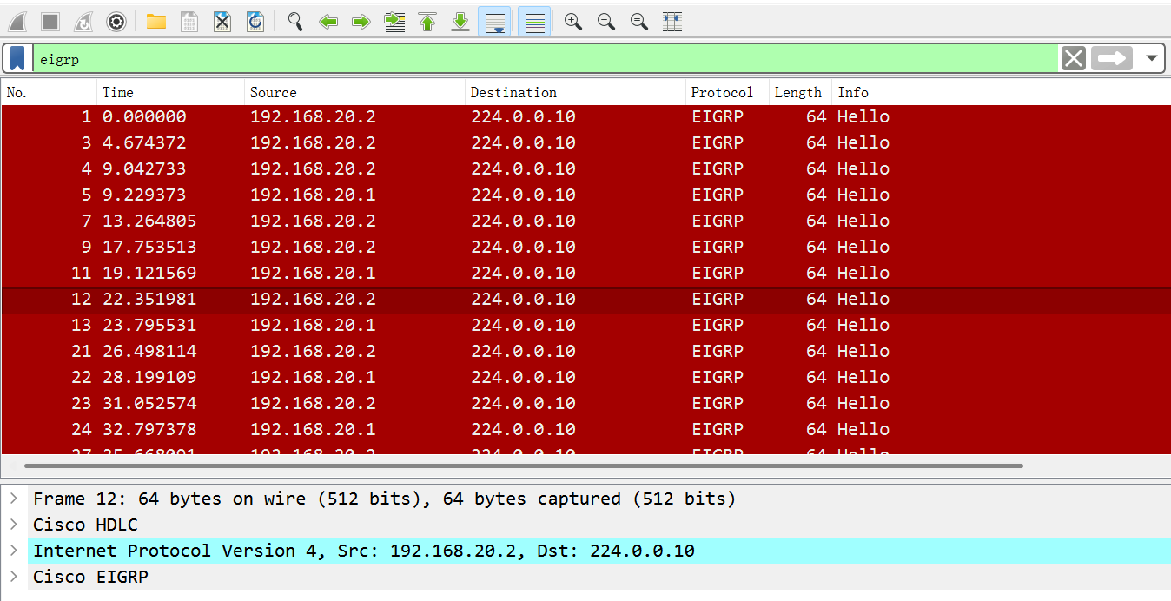
Figure 33

Figure 33 demonstrates the neighbor maintenance mechanism of EIGRP. During the normal link stage, the device sends 64-byte Hello messages to 224.0.0.10 at a fixed interval, maintaining continuous interaction and verifying the core role of the Hello message as the neighbor activation signal.
Meanwhile, the matching of the source/destination IP and protocol fields in the message (192.168.20.1/2 → 224.0.0.10, with the protocol being EIGRP) demonstrates that the Hello message is the standard interaction method for EIGRP neighbor discovery and maintenance.

During the stable phase without Update messages, in contrast to the packet capture during the link recovery phase, this verified the behavioral characteristic of EIGRP, which only sends Hello messages and does not send route updates when the topology is stable.

OSPF
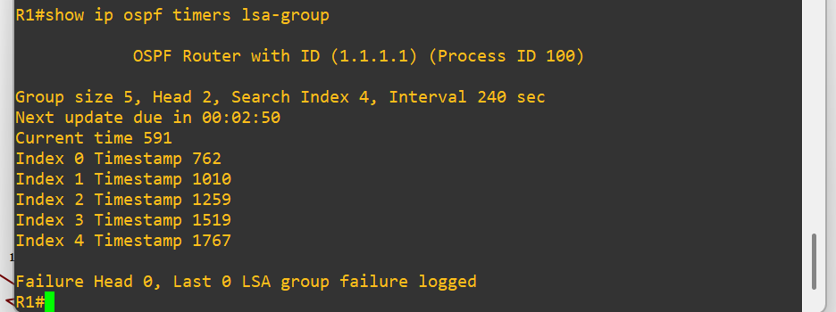
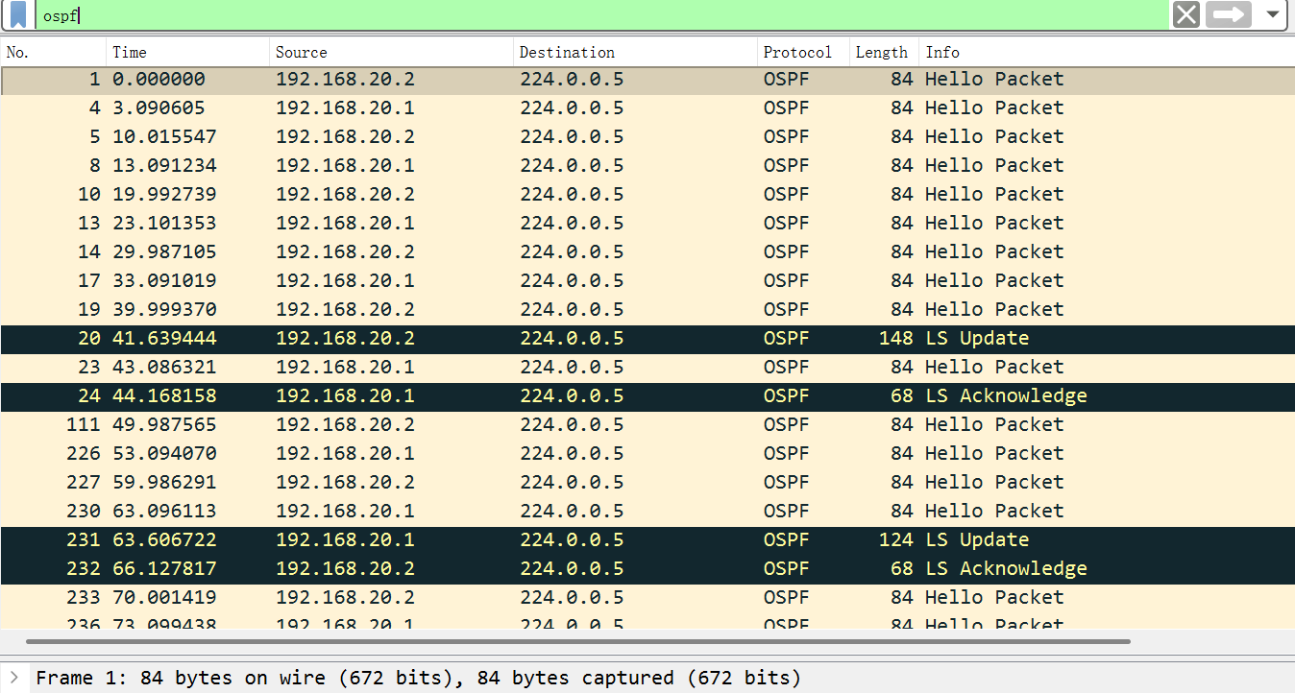
Figure 34

When the R1-R3 link failed, the affected router immediately sent an LS Update packet to the OSPF multicast address 224.0.0.5 to advertise the topology change. The neighboring router responded with an LS Acknowledge packet to confirm receipt. (Figure 35)

After the link was restored, another LS Update was sent to update the network with the new topology, followed by a corresponding acknowledgment. This process confirms that OSPF relies on full topology synchronization and SPF recalculation, rather than precomputed backup paths. The total time from LSA transmission to ping recovery was approximately 7–8 seconds, which aligns with the previously measured recovery time from router logs.

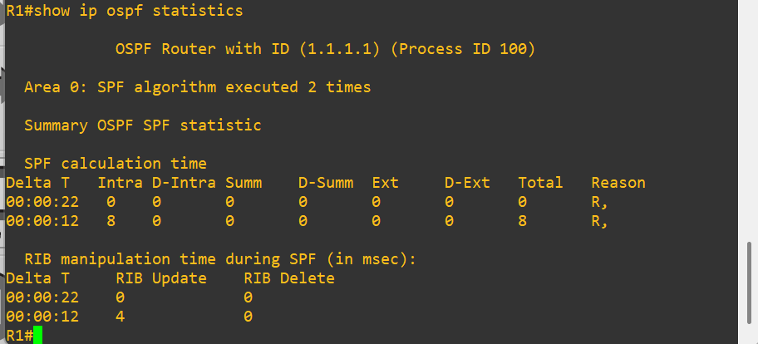
Figure 35

The execution of the SPF algorithm on R1 was recorded through the command "show ip ospf statistics". The results of figure 35 showed that OSPF process 100 (Router ID: 1.1.1.1) performed a total of 2 SPF calculations within area 0. The second execution took 12 seconds, corresponding to the topology change triggered by a link failure. This SPF calculation updated 8 intra-domain route entries and completed 4 RIB route update operations, with no route entries deleted. This verified the convergence capability of OSPF in a redundant topology to quickly identify faults, recalculate the shortest path, and update the routing table.

RIP
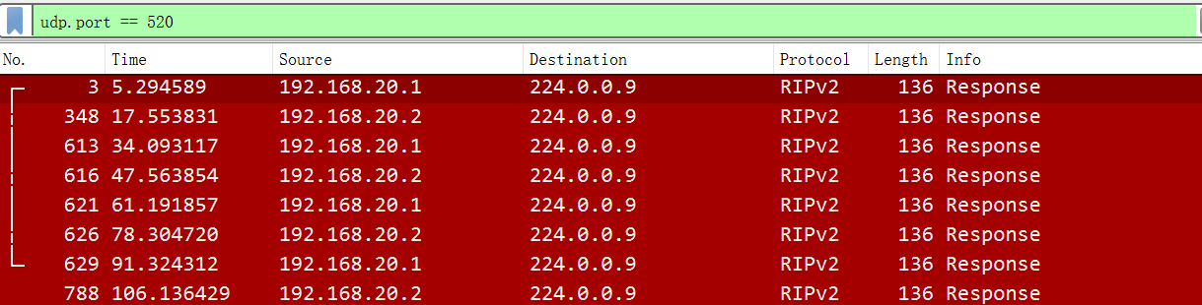
Figure 36

Wireshark captures from R1 showed that RIP version 2 exchanged routing information using UDP port 520 and multicast address 224.0.0.9. Update packets were observed at intervals of approximately 30 seconds in figure 36. Consequently, it matches the default RIP timer behaviour.

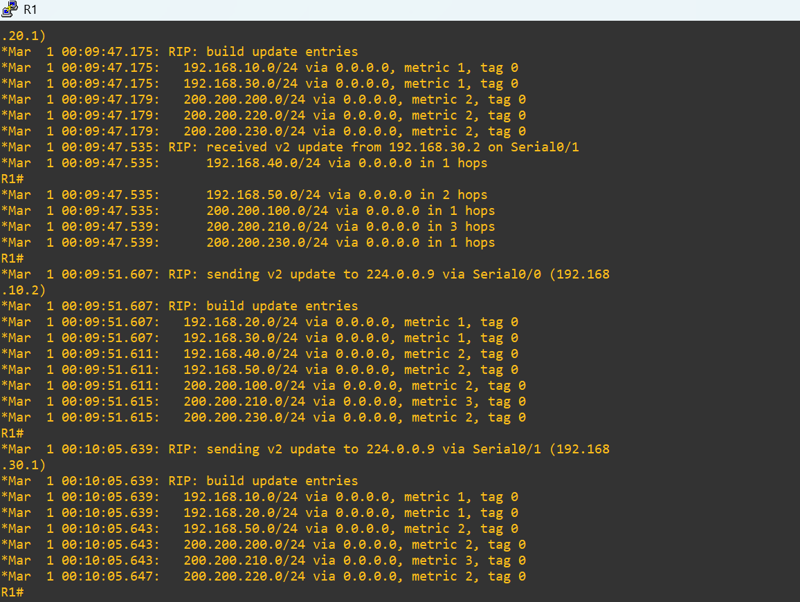
Figure 37
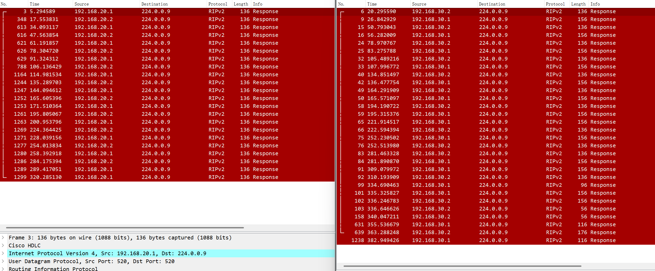
Figure 38

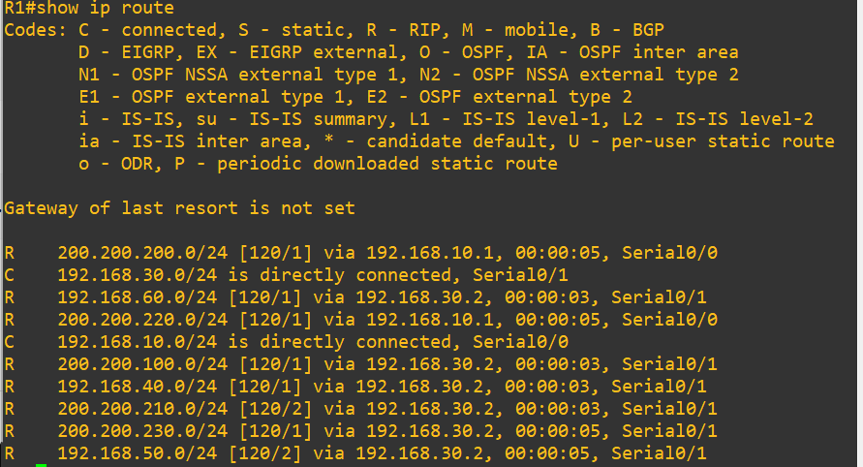
Figure 39

Comparing with figure 37-39, the result of packet capture was demonstrated. The periodic interaction of RIPv2 Response messages, and the message length dynamically changes according to the number of routing entries; the entries marked as `R` in the final routing table prove that RIP has successfully written the update to the routing table and completed the path decision. The three elements mutually confirm each other, fully presenting the core behavior of RIP in the process of route synchronization and path decision-making.

eNSP:

OSPF

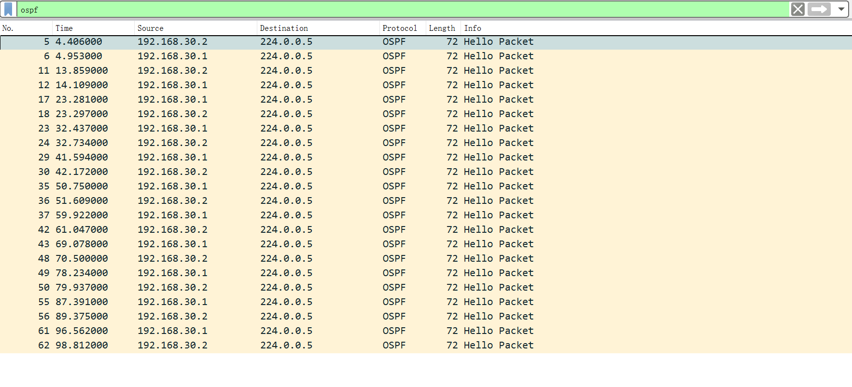
Figure 40

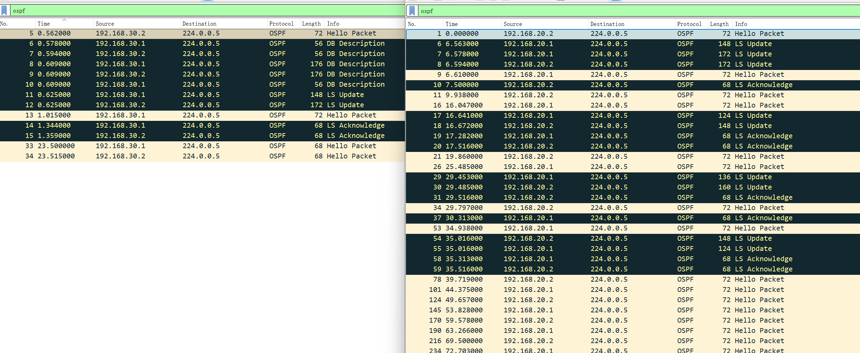
Figure 41

From figure 40 to figure 41, discover the complete adjacency establishment and LSA synchronization process after OSPF topology change. Complete database summary exchange is accomplished through DB Description message, followed by sending LS Update messages of different lengths to synchronize the complete LSA, and achieving reliable flooding with LS Acknowledge. Finally, periodic Hello message exchanges are restored, demonstrating the adjacency reconstruction and link state synchronization mechanism of OSPF during link switching.

RIP

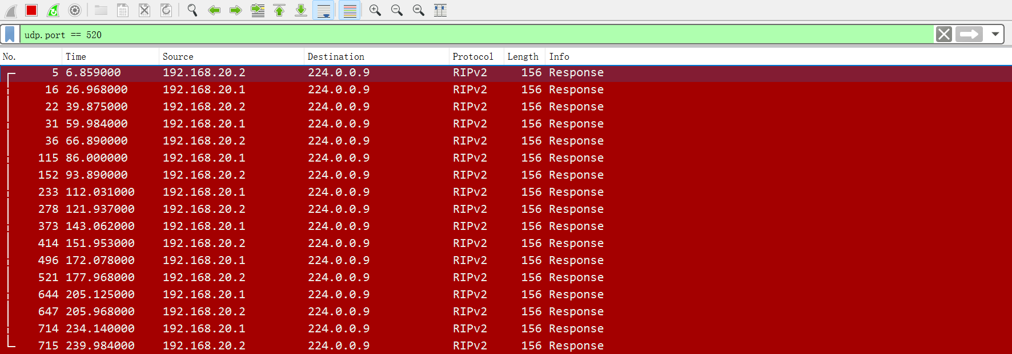
Figure 42

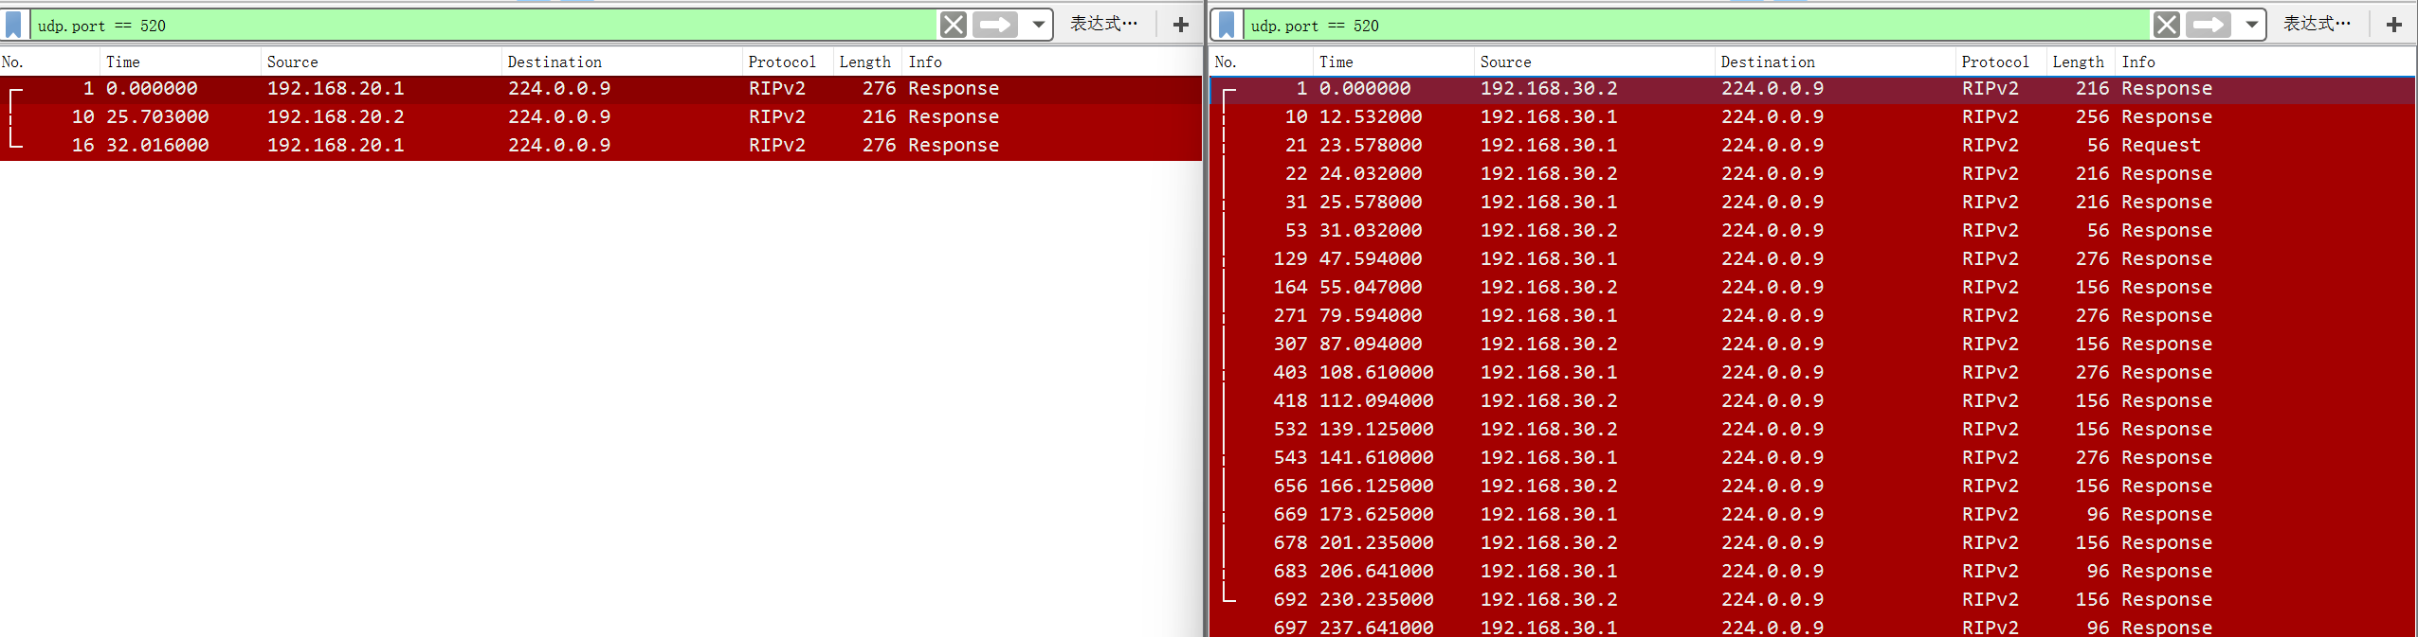
Figure 43

By comparing Figures 41 and 42, it can be observed that during the link stability phase, RIP sends equal-length RIPv2 Response messages to 224.0.0.9 at a fixed interval, performing periodic route updates.

During link switching, the message length changes dynamically according to the number of routing entries, and there is an interaction of Request query messages, which demonstrates its routing synchronization mechanism that combines "periodic update + triggered update".

4.6 CONCLUSION

In Chapter 4, through the preliminary planning of the experimental project, such as the design of the topology diagram, the setting of various invariants like subnets and interfaces. Then, through conducting experiments and obtaining results, the experimental screenshots show the performance differences of different routing protocols under the same topology diagram in GNS3 and Huawei eNSP. Moreover, not only when the equipment is operating normally, but also during each test, I deliberately created a link failure to compare the data under normal circumstances. This will be more persuasive and more realistic. At the same time, the addition of Wireshark can reveal more data beyond the virtual machine function, and more powerfully demonstrate the scientific nature of the entire experiment.

CHAPTER 5
EVALUATION

5.1 INTRODUCTION

This chapter will conduct a systematic evaluation and analysis of the experimental test results from the previous sections, review the three research hypotheses proposed earlier, and discuss the core experimental data related to delay, packet loss rate, convergence time, and path selection mechanism. At the same time, by comparing with the existing theoretical achievements in the literature review, it will verify whether the experimental results are consistent with the existing studies and test whether this experiment has fully achieved the research goals and overall research purpose preset by the project.

Furthermore, this chapter will objectively analyze the rationality of the experimental data and the discrepancies from expectations, summarize the limitations and shortcomings of this experiment, and propose optimized improvement plans that can be implemented when repeating the experiment. This will enable a comprehensive evaluation of the overall performance comparison experiment of the routing protocol.

5.2 Analyses the testing digital data

Comparing with OSPF protocol and RIP protocol between the GNS and eNSP
In normal situation.
Platform | Protocol | Avg Latency (ms) | Packet Loss | Convergence Time (s)
eNSP | RIP | 30 | 0%
eNSP | OSPF | 27 | 0%
GNS3 | RIP | 74 | 0%
GNS3 | OSPF | 43 | 0%

In Link-state is failure
Platform | Protocol | Avg Latency (ms) | Packet Loss | Convergence Time (s)
eNSP | RIP | 28 | 2% | 6
eNSP | OSPF | 26 | 1% | 3
GNS3 | RIP | 40 | 5% | 43
GNS3 | OSPF | 34 | 1% | 5

The comparative tests of RIP and OSPF protocols on the eNSP and GNS3 platforms show that, regardless of normal links or link failure scenarios, OSPF consistently outperforms RIP in terms of delay, packet loss rate, and convergence time. Moreover, the overall performance of the eNSP platform is superior to that of GNS3, especially in the link failure scenarios. On the eNSP platform, the convergence time of RIP (6 seconds) is significantly faster than 43 seconds on GNS3, demonstrating the significant impact of platform differences on protocol performance. Overall, OSPF exhibits greater stability and fault recovery capabilities.

Comparing three different routing protocols in GNS3
In normal situation.
Protocol | Avg Latency (ms) | Packet Loss | Convergence Time (s)
RIP | 74 | 0%
OSPF | 43 | 0%
EIGRP | 47 | 0%

In Link-state is failure
Protocol | Avg Latency (ms) | Packet Loss | Convergence Time (s)
RIP | 46 | 5% | 19
OSPF | 34 | 1% | 5
EIGRP | 40 | 2% | 6

In the comparative test of RIP, OSPF and EIGRP routing protocols on the GNS3 platform, regardless of normal links or link failure scenarios, the performance of OSPF and EIGRP is comprehensively superior to that of RIP: in normal scenarios, all three have no packet loss, with OSPF having the lowest average delay (43ms), followed by EIGRP (47ms), and RIP having the highest delay (74ms); in the case of link failure, the packet loss rate (5%) and convergence time (19 seconds) of RIP are much higher than those of OSPF (1%, 5 seconds) and EIGRP (2%, 6 seconds), while OSPF still maintains the lowest delay (34ms), overall, OSPF has the best performance, followed by EIGRP, and RIP shows a significant difference in stability and convergence speed in the failure scenario.

5.3 Comparison of Experimental Results with Literature Review

The measured data in this experiment is highly consistent with the theoretical research content in the previous literature review, with no obvious contradictions. The literature generally indicates that OSPF has a triggering LSA flooding mechanism, which can quickly detect topological changes and shorten the convergence time.

EIGRP achieves fast path calculation through the DUAL algorithm. While RIP relies on periodic updates and timer mechanisms, it inherently has the defects of slow convergence and the potential for generating routing loops.

Meanwhile, the experimental data from this simulation test, including the convergence time, packet loss fluctuations, and delay differences, fully confirm the existing theoretical research viewpoints, effectively verifying the authenticity and reference value of the literature content.

5.4 Verification of Research Hypotheses

Hypothesis 1: The average delay of OSPF will be significantly lower than that of RIP.

This hypothesis is valid. In both the Huawei and Cisco simulation environments, OSPF maintains lower transmission delays during stable operation and fault recovery phases. RIP, due to its outdated algorithm and long routing update cycle, has lower forwarding efficiency and significantly higher delay values. The experimental data fully supports this hypothesis.

Hypothesis 2: EIGRP achieves convergence faster than OSPF and RIP.

This assumption is not entirely valid. In actual tests, OSPF has the fastest convergence speed, taking only 3-5 seconds. EIGRP converges slightly slower than OSPF, and both are far superior to RIP. EIGRP, with its DUAL algorithm, could converge quickly. However, in this link switching test, the link state trigger update mechanism of OSPF reacts more quickly, so the original assumption does not fully match the actual results.

Hypothesis 3: OSPF and EIGRP are more likely to select the optimal path, while RIP tends to generate suboptimal paths.

This assumption is completely valid. OSPF calculates the cost value based on interface bandwidth, while EIGRP selects routes by combining factors such as bandwidth and delay. It can precisely choose the optimal transmission path. In contrast, RIP only uses the number of hops as the sole metric and cannot consider the bandwidth and quality of the links. In heterogeneous networks, it is prone to choosing low-speed long links, resulting in suboptimal path issues.

5.4 Analysis of the Rationality of Experimental Results

The overall experimental results are in line with theoretical expectations and are consistent with the technical principles of the routing protocol. The rapid convergence and low packet loss performance of OSPF, the limitations of EIGRP when applied to Cisco devices, as well as the high latency and slow convergence issues of RIP, all conform to the common understanding in the industry.

There are only a few minor deviations, such as significant differences in the RIP convergence time under different simulation platforms. This phenomenon is a normal and reasonable deviation, mainly caused by the virtualization scheduling mechanisms of eNSP and GNS3, as well as the differences in device system versions. It does not affect the overall experimental conclusion and the validity of the comparison.

5.5 Experimental Reflection and Improvement Plan

If this research is conducted again, I will make the following two optimizations. First, expand the network topology scale, add multiple regions, multiple branches, and redundant links, which will better match the real enterprise network environment and fully leverage the protocol advantages of EIGRP and OSPF. Second, unify the operation and resource configuration of eNSP and GNS3, reduce the data errors caused by differences in the simulation platform, and make the cross-vendor comparison results more objective and fairer.

5. CONCLUSION

This chapter conducted a comprehensive performance evaluation of the three routing protocols, RIP, OSPF, and EIGRP, by analyzing various test data. It also verified each of the three hypotheses proposed in this study. At the same time, the experimental data closely matched the existing literature theories, and both the research goals and the experimental purposes were successfully achieved. Finally, based on the experimental process, the limitations of the simulation environment were pointed out, and corresponding improvement ideas were proposed, providing a reference basis for possible future research.

CHAPTER 6

CONCLUSIONS AND RECOMMENDATIONS

6.1 Introduction

This chapter summarizes the final conclusions of the research based on the experimental results and provides practical suggestions for the selection of routing protocols in the enterprise network environment. At the same time, it will point out the limitations of this study and propose the direction for future research.

6.2 Implement Suggestions

I will combine the research results and discuss the deployment matters for several different equipment combinations:

Mixed networking across different vendors: OSPF protocol should be preferred as it offers low latency, rapid fault recovery, and low packet loss in both Huawei and Cisco simulation environments. Leveraging common open attributes can avoid vendor lock-in, allowing for flexible selection of cost-effective equipment while considering the operational performance and procurement costs of multi-brand mixed networks.

Pure Cisco equipment networking: OSPF remains the primary deployment option, facilitating network expansion and cross-vendor integration in the future; EIGRP can be an alternative for closed pure Cisco networks, with excellent convergence efficiency, but the equipment procurement cost is high, and the private protocol attribute increases operational risks and expansion limitations.

Pure Huawei equipment networking: OSPF is the only high-performance and highly reliable routing solution. Pairing it with cost-effective Huawei AR series routers can effectively reduce networking costs; since Huawei equipment does not support Cisco's private protocol EIGRP and RIP has weak comprehensive performance, it is not recommended for use in enterprise-level networks.

Small and low-demand scenarios: RIP is simple to configure and has lower hardware investment, but it converges slowly and has severe packet loss when there is a link failure, which can cause long-term service interruptions. This protocol is only suitable for extremely small office networks without redundant links and with low stability requirements and should not be applied to enterprise-level or large network architectures.

6.3 LIMITATIONS OF RESEARCH

This research was conducted within simulated environments rather than physical production networks. As a result, factors such as hardware forwarding performance, real cable latency, CPU resource constraints, and enterprise traffic diversity were not fully represented.

In addition, throughput testing, and large-scale area based OSPF designs were outside the scope of the project.

6.4 Further work

First, all the experiments in this study were conducted based on the eNSP and GNS3 virtual simulation environment. In the future, real networks can be built using Huawei and Cisco physical hardware devices to eliminate the performance deviations caused by the virtualization of the simulators and obtain more accurate and realistic protocol operation data that closely match the actual situation.

Second, expand and establish multi-node redundant networking, wide-area network long-distance transmission, and scenarios with high traffic congestion, and test the performance of various routing protocols under high-load conditions.
Meanwhile, the current evaluation indicators are rather monotonous. In the future, additional dimensions such as equipment resource occupation, protocol security protection capability, and bandwidth utilization can be added to build a more comprehensive evaluation system.

Finally, a quantitative analysis is conducted based on the equipment's entire life cycle consumption, long-term operation and maintenance costs, and technical training costs, providing both technical and economic references for the selection of enterprise network solutions.

6.6 FINAL CONCLUSION

In conclusion, routing protocols play a critical role in network efficiency and resilience. Through controlled experimentation, this study demonstrated that protocol design directly affects path optimisation, failure recovery, and scalability. The findings provide useful practical guidance for selecting suitable routing technologies in modern enterprise networks.

CHAPTER 7

REFLECTION

Looking back on this nearly one-year experimental project, in this section, I will summarize the experiences and skills I have gained by combining the practical operation skills of my major with project management aspects.

From a professional perspective, the simulation software used in this experiment is not just the Cisco Packet Tracer used in the course learning. This means it is necessary to learn the usage methods of new test simulation software, such as setting up the experimental environment and configuring commands. Although the underlying topology logic is the same. But the first problem to be solved is to determine the legality of downloading the test software, that is, whether the official version can be obtained from the official software and whether the functions in the resource can meet the expectations of the tester. Secondly, the command languages of different software are different. I not only need to clearly understand the configuration commands of different routing devices, but also need to know how to select the correct physical device before starting the configuration, such as in GNS3, how to select the correct interface model for router devices and switch devices to achieve routing functions, and which port should be selected as the correct routing port when connecting the devices. At the same time, during the experiment, troubleshooting situations occurred frequently. Sometimes the link selection of the equipment may be incorrect. I need to recheck my routing table and routing table database. However, interesting problems are often discovered. When my routing table and routing neighbor relationships are correct and normal, but my ICMP requests always fail. After a thorough investigation, it was found that simply restarting the machine can solve the problem.

Through this experiment, objectively analyzing the extracurricular gains is a rehearsal for future employment. Because in actual work, engineers will face different system or software devices. Early contact with devices closer to reality can help me adapt to learning and operation in various working environments in advance and learn more solidly. Because I can get timely help from my supervisor.
The successful completion of the project greatly exercised my self-discipline ability. Since this is an independent project completed by me, with a longer coverage, in addition to the specific experimental direction and content, in the initial design stage, it is also necessary to divide the overall time and assign weights, that is, to formulate a planning table. As an undergraduate, how to manage one's free learning and creative time requires in-depth thinking. To find a balance between life and study and complete the specified tasks according to the set plan steps. At the same time, during this period, regular communication with the supervisor or the guiding teacher can also help students better learn how to report work progress to department managers or supervisors, to better carry out work in the future.

CHAPTER 8

REFERENCE

- Lydia Parziale, David T. Britt, Chuck Davis “TCP/IP Tutorial and Technical Overview”, ibm.com/redbooks, December 2006.

- I. Fiţigău and G. Toderean, “Network performance evaluation for RIP, OSPF and EIGRP routing protocols,” IEEE Xplore, Jun. 01, 2013. https://ieeexplore.ieee.org/document/6636217 (accessed Nov. 01, 2020).

- Andrew S. Tanenbaum, “Computer Networks 4Th Ed.”, Prentice Hall, 2003.

- https://www.facebook.com/momena.khalil, “What Are Computer Networks? Why Are Computer Networks Necessary? | Techironed,” Techironed, Dec. 12, 2023. https://techironed.com/what-are-computer-networks-why-are-computer-networks-necessary/

- “Routing Protocols Types: Static, Dynamic, IP, CISCO,” www.guru99.com. https://www.guru99.com/routing-protocol-types.html

- Q. Liu and Q. Liu, “A Study on Topology in Computer Network,” IEEE Xplore, Oct. 01, 2014. https://ieeexplore.ieee.org/document/7003481?arnumber=7003481
- Nuur Wachid Abdul Majid and S. Fuada, “RIP VS. OSPF ROUTING PROTOCOLS: WHICH ONE IS THE BEST FOR A REAL-TIME COMPUTER NETWORK?,” Jurnal SIMETRIS, vol. 11, No.1 P-ISSN 2252–4983, pp. 249–256, Apr. 2020. http://download.garuda.kemdikbud.go.id/article.php?article=1589220&val=5218&title=RIP%20VS%20OSPF%20ROUTING%20PROTOCOLS%20WHICH%20ONE%20IS%20THE%20BEST%20FOR%20A%20REAL-TIME%20COMPUTER%20NETWORK

- GeeksforGeeks, “Routing Information Protocol (RIP),” GeeksforGeeks, May 17, 2018. https://www.geeksforgeeks.org/computer-networks/routing-information-protocol-rip/
‌
- GeeksforGeeks, “Open Shortest Path First (OSPF) Protocol Fundamentals,” GeeksforGeeks, Apr. 20, 2018. https://www.geeksforgeeks.org/computer-networks/open-shortest-path-first-ospf-protocol-fundamentals/

- GeeksforGeeks, “EIGRP fundamentals,” GeeksforGeeks, Apr. 19, 2018. https://www.geeksforgeeks.org/computer-networks/eigrp-fundamentals

- GeeksforGeeks, “Difference between Star topology and Bus topology,” GeeksforGeeks, May 04, 2020. https://www.geeksforgeeks.org/computer-networks/difference-between-star-topology-and-bus-topology/

- GeeksforGeeks, “Difference between RIP and EIGRP,” GeeksforGeeks, Jun. 05, 2020. https://www.geeksforgeeks.org/computer-networks/difference-between-rip-and-eigrp/

- “RIP V/s OSPF | Differences between RIP and OSPF,” ComputerNetworkingNotes. https://www.computernetworkingnotes.com/ccna-study-guide/rip-v-s-ospf-differences-between-rip-and-ospf.html

- getitdoneex, “The Research Onion Explained: Layers, Methodology, and Application - Academic Writing Solutions,” Academic Writing Solutions, Apr. 16, 2025. https://getitdoneex.com/the-research-onion-explained-layers-methodology-and-application/

- GeeksforGeeks, “What is Latency?,” GeeksforGeeks, Sep. 2021. https://www.geeksforgeeks.org/computer-networks/what-is-latency/

- “Network throughput,” Wikipedia, Jun. 23, 2022. https://en.wikipedia.org/wiki/Network_throughput

- Wikipedia Contributors, “Convergence (routing),” Wikipedia, May 14, 2018. https://en.wikipedia.org/wiki/Convergence_(routing)

- “Packet loss,” Wikipedia, Jan. 28, 2020. https://en.wikipedia.org/wiki/Packet_loss

- “groundcover,” Groundcover.com, 2026. https://www.groundcover.com/learn/networking/packet-loss-troubleshooting (accessed Apr. 29, 2026).

- ‌

‌
‌

APPENDICES

GANTT CHART

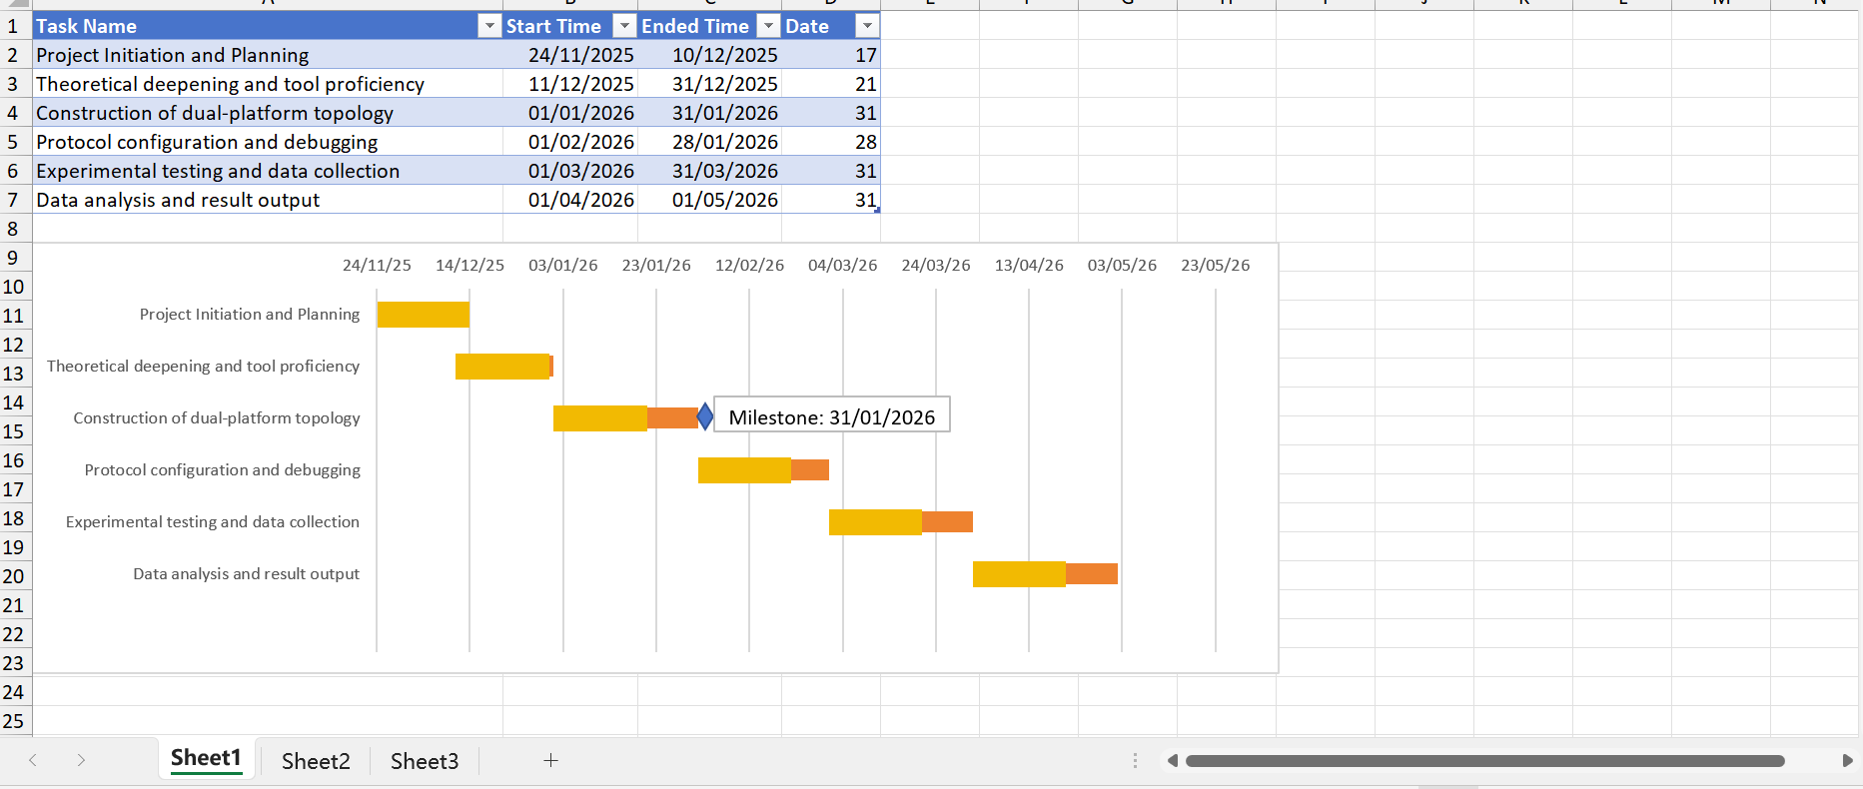

Subnetting of Devices

GNS3
R1 | S0/0 |  | 192.168.10.2 | 255.255.255.0
R1 | S0/1 |  | 192.168.30.1 | 255.255.255.0
R1 | S0/2 |  | 192.168.20.1 | 255.255.255.0
R2 | S0/0 |  | 192.168.10.1 | 255.255.255.0
R2 | F1/1 |  | 200.200.200.1 | 255.255.255.0
R2 | F1/2 |  | 200.200.220.1 | 255.255.255.0
R3 | S2/0 |  | 192.168.30.2 | 255.255.255.0
R3 | S2/1 |  | 192.168.40.2 | 255.255.255.0
R3 | S2/2 |  | 192.168.60.1 | 255.255.255.0
R3 | F1/0 |  | 200.200.100.2 | 255.255.255.0
R3 | F1/1 |  | 200.200.230.1 | 255.255.255.0
R4 | S2/0 |  | 192.168.20.2 | 255.255.255.0
R4 | S2/1 |  | 192.168.40.1 | 255.255.255.0
R4 | S2/2 |  | 192.168.50.1 | 255.255.255.0
R4 | F1/0 |  | 200.200.100.1 | 255.255.255.0
R5 | S2/0 |  | 192.168.50.2 | 255.255.255.0
R5 | S2/1 |  | 192.168.60.2 | 255.255.255.0
R5 | F1/2 |  | 200.200.210.1 | 255.255.255.0
PC1 | E0/0 |  | 200.200.220.2 | 255.255.255.0
PC2 | E0/0 |  | 200.200.200.2 | 255.255.255.0
PC3 | E0/0 |  | 200.200.230.2 | 255.255.255.0
PC4 | E0/0 |  | 200.200.210.2 | 255.255.255.0

eNSP
R1 | S1/0/0 |  | 192.168.10.2 | 255.255.255.0
R1 | S1/0/1 |  | 192.168.30.1 | 255.255.255.0
R1 | S2/0/0 |  | 192.168.20.1 | 255.255.255.0
R2 | S1/0/0 |  | 192.168.10.1 | 255.255.255.0
R2 | G0/0/1 |  | 200.200.200.1 | 255.255.255.0
R2 | G0/0/2 |  | 200.200.220.1 | 255.255.255.0
R3 | S1/0/0 |  | 192.168.30.2 | 255.255.255.0
R3 | S2/0/0 |  | 192.168.40.2 | 255.255.255.0
R3 | S1/0/1 |  | 192.168.60.1 | 255.255.255.0
R3 | G0/0/0 |  | 200.200.100.2 | 255.255.255.0
R3 | G0/0/1 |  | 200.200.230.1 | 255.255.255.0
R4 | S1/0/0 |  | 192.168.20.2 | 255.255.255.0
R4 | S2/0/0 |  | 192.168.40.1 | 255.255.255.0
R4 | S1/0/1 |  | 192.168.50.1 | 255.255.255.0
R4 | G0/0/0 |  | 200.200.100.1 | 255.255.255.0
R5 | S1/0/0 |  | 192.168.50.2 | 255.255.255.0
R5 | S1/0/1 |  | 192.168.60.2 | 255.255.255.0
R5 | G0/0/0 |  | 200.200.210.1 | 255.255.255.0
PC1 | E0/0/1 |  | 200.200.220.2 | 255.255.255.0
PC2 | E0/0/1 |  | 200.200.200.2 | 255.255.255.0
PC3 | E0/0/1 |  | 200.200.230.2 | 255.255.255.0
PC4 | E0/0/1 |  | 200.200.210.2 | 255.255.255.0

