Design, Build & Test of a 555 Timer Circuit.

Ben Palmer-Drury - 2212937

Fundamentals of Electronics ACDA4018
OME Level 4 Year 2

Contents
Section 1 – Assignment Purpose p3
Section 2 – Circuit Description and Operation p3
Section 3 – Proteus p5
Section 4 – Calculations p7
Section 5 – Breadboard p8
Section 6 – Conclusions p9
Section 7 – References p10

Figures & Tables
Figure 1 – Required Circuit p3
Table 1 – Component Details p3
Figure 2 – Resistance explained p4
Figure 3 – Virtual Breadboard p5
Figure 4 – Working simulation p6
Figure 5 – Breadboard 1 p8
Figures 5& 6 – Breadboard operational p8
Figure 7 – Oscilloscope p9
Figure 8 – Oscilloscope p9

Section 1 – Assignment Purpose
To design a circuit, using an astable 555 timer, capable of flashing 2 different coloured LED’s alternately. Firstly, it will be designed using Proteus software to simulate the operation, then built, physically, using a breadboard and the required components. A common example of this type of circuit would be a simple emergency vehicle beacon. Therefore, this example will be referred to throughout this report.
Section 2 – Circuit Description and Operation
Figure 1 is a schematic of the required circuit as given in the brief;
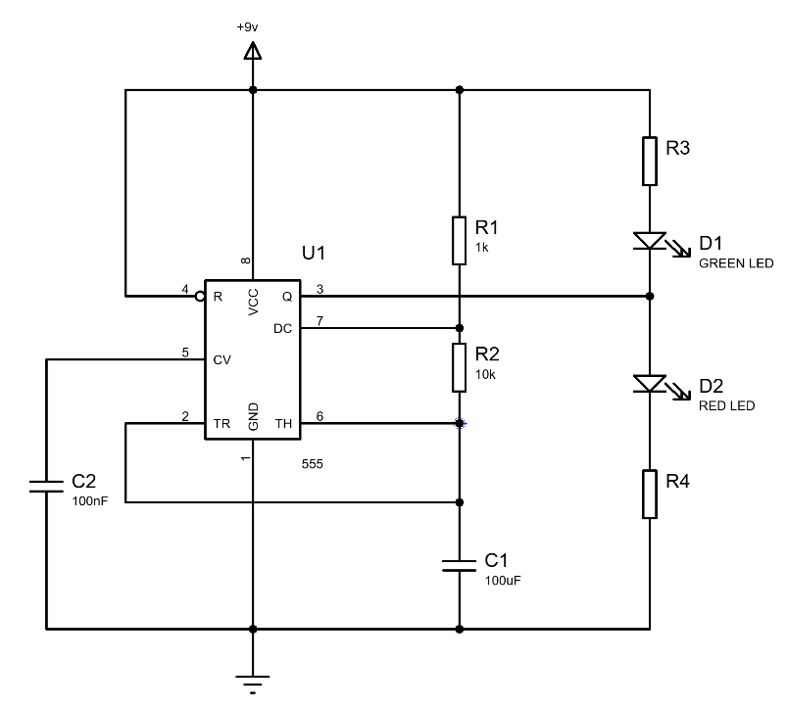

Figure 1
The following table details the required components;
Component | Details
R1 – Resistor 1 | 1 kiloohm (kOhm)
R2 – Resistor 2 | 10 kiloohm (KOhm)
R3 – Resistor 3 | To calculate
R4 – Resistor 4 | To calculate
D1 – Green LED | Coloured Light Emitting Diode
D2 – Red LED | Coloured Light Emitting Diode
U1 - 555 | Integrated Circuit, programmable chip
C1 – Capacitor | 100 microfarad (uF)
C2 – Capacitor | 100 nanofarad (nF)
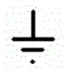 | Ground – In this instance the frame of the lamp, where it is earthed to the vehicle frame
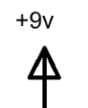 | Electrical Power Supply – In this instance the vehicle power supply, a DC battery supply.
Table 1 – Component details
NB - Most emergency vehicles use a 12v electrical system, unless on an HGV, which uses a 24v system. For safety the light bars can be stepped down in voltage, particularly for smaller applications like motorcycles.
To appreciate the operation of this circuit, a few underlying principles must be understood.
2.1 – Electricity. In context, this is the flow of negatively charged particles, from the negative terminal of a battery to the positive. These particles are called electrons and orbit the nucleus of all atoms. The nucleus contains Protons and Neutrons. Protons being positively charged, neutrons having no charge/neutral charge. Normally, the number of electrons is equal to the number of protons, however, when this balance is upset by an external force, atoms may lose or gain electrons. This movement or loss of electrons is considered to be electric current [1]. Each electron carries a small negative charge (1.602x10⁻¹⁹ coulombs) [2]. When millions flow, this is measurable using various tools.
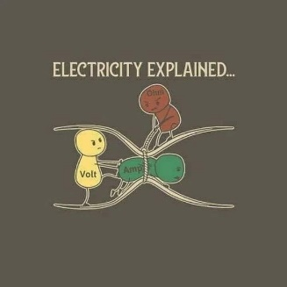
2.2 – Resistance. This property is the measure of opposition to the flow of current-carrying charged particles. This is observed as the emission of heat from a wire or component, however it is a characteristic of all electrical parts [3]. It is summed up in figure 2, a humorous cartoon;
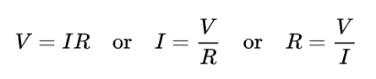
2.3 – Ohms Law. Ohm is the unit of resistance. It is intrinsically linked to voltage and current. Voltage being the difference of potential across a circuit, or electromotive force [4]. Current, measured in amperes (amps), being the flow of electrons [5]. Ohms Law is expressed as;
Figure 2 [8].

This means that resistance is the ratio or applied voltage to current does not vary with the current strength, at a constant temperature [2].
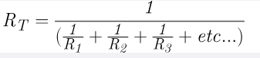
2.4 – Resistors. Materials vary in their ability to allow conductivity of electricity. Copper is highly conductive, often used in wiring for this purpose. Mica, quartz, polythene and porcelain have very little (to no) conductivity, therefore are considered to be non-conductive, or, an insulator. There is an intermediate layer of materials called semi-conductors. Elements such as germanium and silicon are considered so. Generic, or fixed (where the value cannot change), resistors are generally of a carbon composition. Should the resistors rating be exceeded it will over heat and become useless. The resistor is in operation when heat is being generated. Resistors are identified by coloured bands, but, should a user be unfamiliar with this system, then a more practical means of identification would be to use a multimeter [2]. There are two methods for calculating total equivalent resistance, shown below;
Parallel

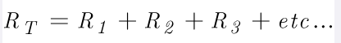
Series
2.5 – Capacitor. These are electrical components that have the ability to temporarily store and release charge. When voltage is established across the insulator component, called the dielectric, connecting the two conductors, a charge is stored. This stored charge is proportional to the voltage; double the voltage, double the charge. If the voltage is tripled, the charge is also, and so on. From this we see that the ratio of voltage to charge is constant. This constant is called capacitance and is measured in farad [2].
2.6 – 555 Integrated Circuit. “The invention of integrated circuits is perhaps the most important advance ever made in electronics.” [2]. And it is plain to see why. IC ‘chips’ have miniaturised circuits enabling devices to become smaller and more complex, not only in their construction but the tasks they are capable of. They have moved a lot of individual components to within the chip for extra functionality. In the astable mode, they are widely used in a variety of timer delay, pulse generation and oscillator applications. They are also capable of generating sounds when connected to speakers. In the context for this report, they are used as an oscillator that generates a square waveform. The wave’s frequency is adjustable by varying resistor and capacitor values, that are connected to the IC. The following equations shows LED on/off cycles when resistor and capacitor values are altered;
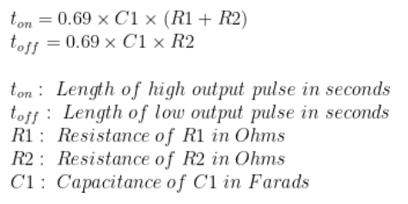

If the values of C1 or R2 are increased, both the output on and off times also increase. If R1 is the only variable that is increased, then only on time is increased [6].
Section 3 – Proteus
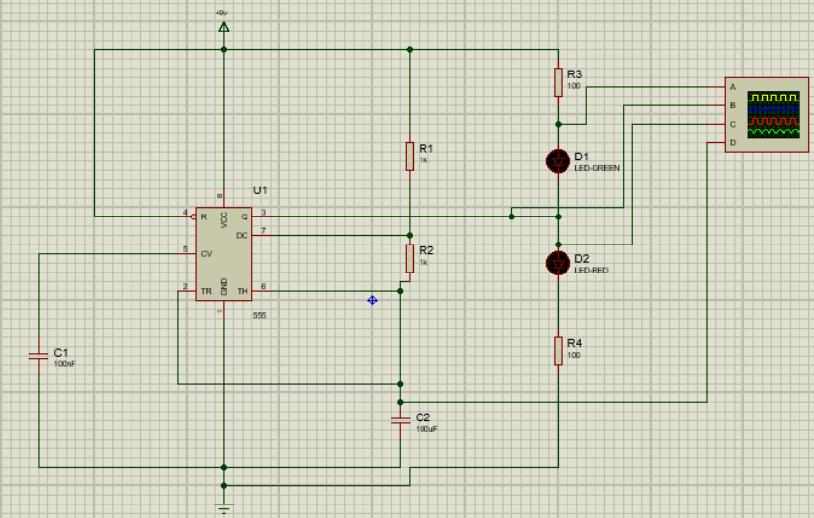
Proteus is a design suite to enable the design, test and layout of printed circuit boards. Using the brief, the author lad out the virtual breadboard after finding and labelling the required components. The virtual breadboard is shown below;

Figure 3 – Virtual Breadboard
For reasons that were unfathomable at the time of writing, the simulation does not run as intended. Resistor values have been adjusted ad nauseam, to no avail. Both LED’s illuminate, but do not flash. This is the second iteration. On the first, it failed to simulate at all. The second iteration was started from scratch.
As of 12/01/2024 the simulation now runs! The author missed an errant wire that ran under a capacitor, which was not connecting as it should. For a fresh perspective, he enlisted the help of a Proteus user at FHD on the same team, GH. GH and the author took a systematic approach to checking each component and each wire, eventually discovering the issue.
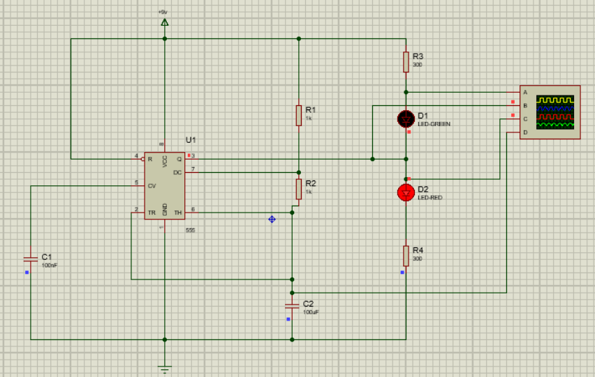

Figure 4 – Working simulation.

Section 4 – Calculations
Calculating resistances for R3 and R4.
Given that R1 and R2 are known, as well as voltage, we can calculate R3 & R4. Using the data gathered from the Proteus components, it was first necessary to know the forward volt drop for the LEDs (V_{f}). Looking at the max recommended current, about 20mA, it’s generally accepted to run at 50-75% of the maximum rating. The simulation was run at 10mA. Next, it is required to work out what voltage is across the current limiting resistors (R3 & R4). The circuit power supply is 9v (V_{s}).
Voltage across the resistor would be; V_{s} - V_{f} = Resistor voltage
9v – 2.2v = 6.8v
Next calculate the resistor using Ohms Law; R = Voltage / Current (I)
= 6.8v / 0.01A
= 680 ohm
This results in the complete equation; R = (Vs –Vf) / I
Therefore, the resistances for R3&4 will both be 680 ohms.
To revisit the following equation from Section 2, we can work out the LED on/off times;
t_{on} = 0.69 x 0.0001 F x (R3 + R4)
t_{on} = 0.09s

t_{off} =0.69 x 0.0001 F x R4
t_{off = 0.05s}

R3 & 4 substituted as they are the direct load limiting resistors. The 100uF capacitor is used for this calculation.
These results would apply to both LEDs as they are of comparable spec.

Section 5 – Breadboard

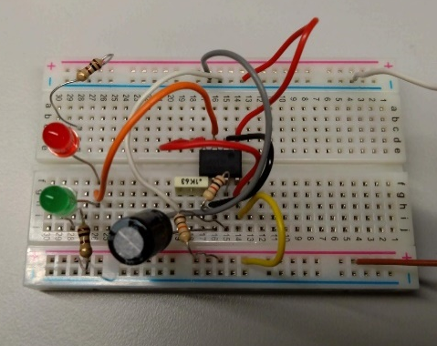
Iteration 1 – The circuit initially failed to operate. The author carried out some basic troubleshooting diagnostics ruling out the resistors and power supply, using a multi meter. Initially, there was a case of operator error on the part of the author being unfamiliar with the voltage generator. Through like-for-like replacement it was discovered that both the IC and the breadboard were defective.

Figure 5 – Breadboard 1
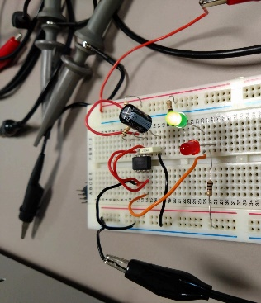
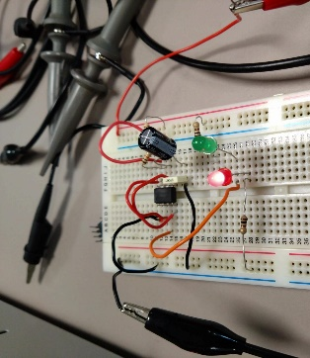
Iteration 2 – Once the IC and breadboard were changed the system operated as intended. Although, at first the green LED failed to function, but it was quickly realised that it was in backwards. This iteration was also much Figures 6&7 - Breadboard 2
operationally simpler, eliminating excess wiring, using the board to facilitate this. The author was initially thinking like a (former) mechanic rather than with an electronics mind-set. Once these issues were resolved, the system fully functioned as per the brief, enabling gathering the following data.
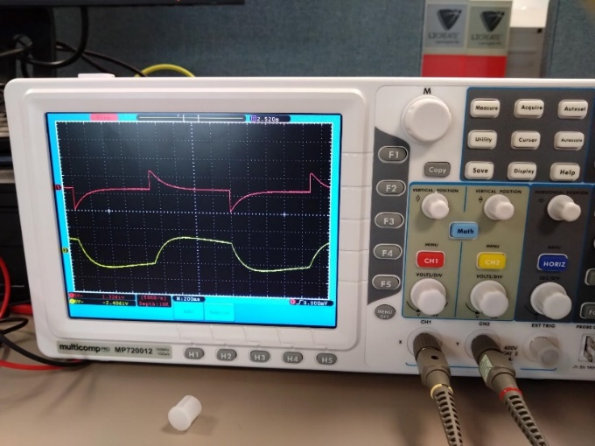
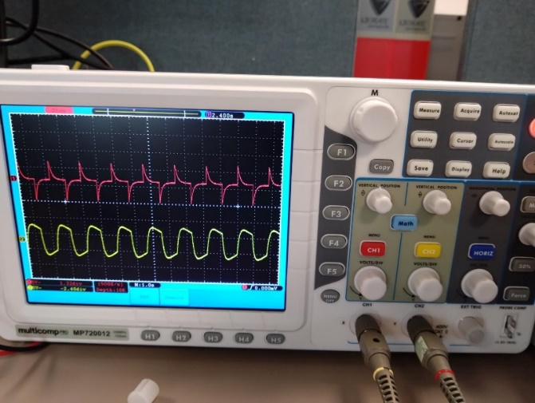
Figure 8 – Oscilloscope data Figure 9 – Oscilloscope data
From these readings the author was able to calculate that the on/off time was 0.8 seconds. The frequency being derived from the formula;
Frequency = 1/Time
Using an appropriate calculator [7], using the extracted data, it was possible to calculate that the frequency of our LEDs was 1.25Hz.

Section 6 – Conclusions
From what started as a complete disaster with faulty simulations, and then faulty components in making the physical circuit the author has learnt (and remembered) a lot, with regard to electronic circuits.
Learnings included more in-depth theory to integrated circuit design and build, whilst building on 17 years as a professional mechanic.
Lessons learned include, testing of all equipment and components, before commencing a build. Historically the author would have done this, but took it at face value that the equipment provided was viable.

Section 7 References

[1] | C. Platt, Make: Electronics, Canada: Maker Media, 2009.
[2] | G. H. Olsen, Electronics, Bungay: Heineman, 1986.
[3] | Britannica, “Resistance,” 21 11 2023. [Online]. Available: https://www.britannica.com/technology/resistance-electronics. [Accessed 15 12 2023].
[4] | E. Hughes, Electrical Technology, vol. 4th, Bungay: Longman, 1969.
[5] | J. C. Morris, Applied Electronics, Loddon: Preston Press, 1997.
[6] | S. Campbell, “555 Timer Basics - Astable Mode,” Circuit Basics, [Online]. Available: https://www.circuitbasics.com/555-timer-basics-astable-mode/. [Accessed 15 12 2023].
[7] | R. Rain, “Frequency Calculator,” [Online]. Available: https://www.omnicalculator.com/physics/frequency. [Accessed 12 01 2024].
[8] | Facebook, Electricity Explained.

