Module name: Component 1 -E-Portfolio
Student name: Kasim Abu Bana
Student ID: 2509667

learning in the digital era assigment

Table of Contents
Task 1 (a): Report on Essential Academic and Employment Skills 2
Task 1 (b): Evaluation of Task 1 (a) based on Similarity report 4
Task 2: Collaborative Mind Map and Individual Poster A3 Poster): 4
Task 3: Virtual Collaboration and RefWorks 5
Task 4: E-Portfolio Creation and Evaluation 5
Task 4 (a): E-Portfolio Creation Error! Bookmark not defined.

E e-Portfolio.

View my online portfolio here
https://sites.google.com/view/kasimbana/task-1-written-summary

TASK 1 IN E-PORTFOLIO

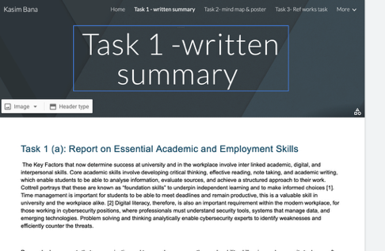

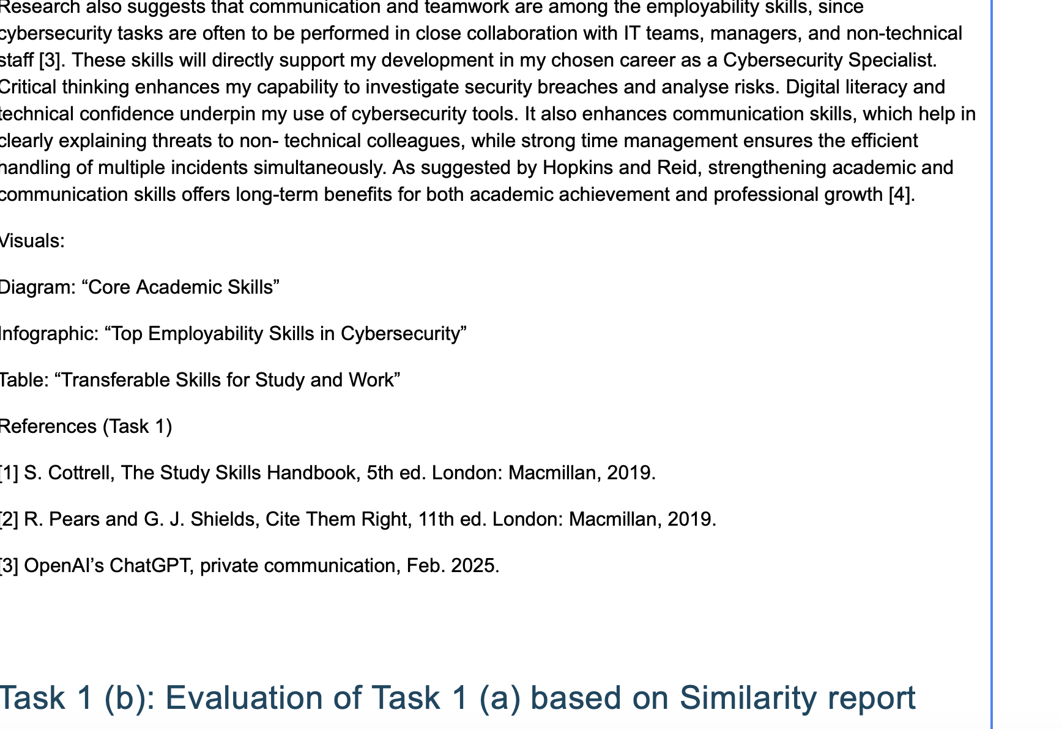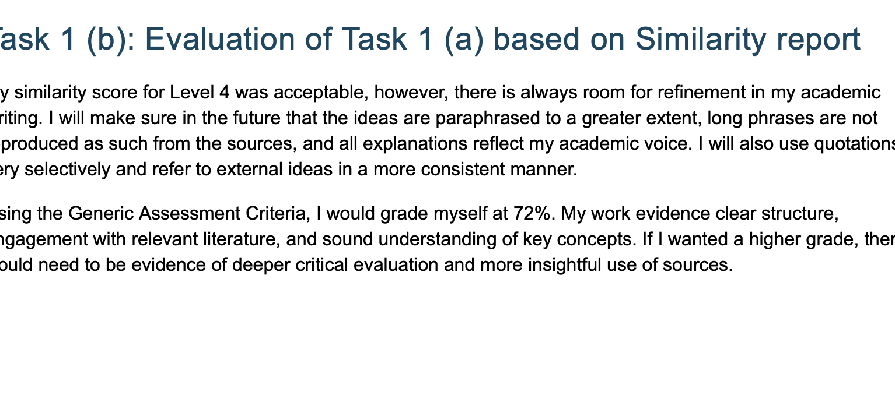
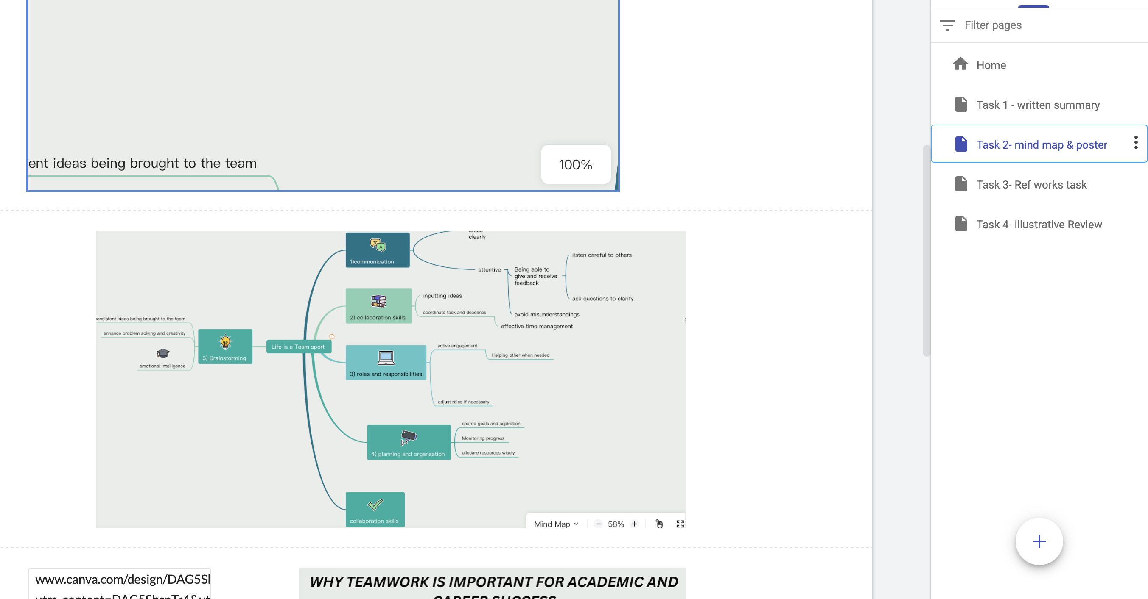

Task 1 (a): Report on Essential Academic and Employment Skills

The main factors that are highly contributed to determine success at university including the work environment, involve the combination of academic, digital and lastly interpersonal skills. These significant academic skills require developing critical thinking skills which are needed, Aswell as effective reading, note taking and academic writing, which allow students to have the ability to analyse information, evaluate sources, and lastly achieve a clear structure to their work. Cottrell highlights that these are known as “foundation skills” to determine independent learning and to make informed choices [1]. Time management is also significantly important for students to be able to meet deadlines and remain productive, this is a valuable skill in university and the workplace alike. [2] Digital literacy, therefore, is also an important requirement within the modern workplace, for those working in cybersecurity positions, where professionals must understand security tools, systems that manage data, and emerging technologies. Problem solving and thinking analytically enable cybersecurity experts to identify weaknesses and efficiently counter the threats.

Research also suggests that communication and teamwork are among the employability skills, since cybersecurity tasks are often to be performed in close collaboration with IT teams, managers, and non technical staff [3]. These skills will directly support my development in my chosen career as a Cybersecurity Specialist. Critical thinking enhances my capability to investigate security breaches and analyse risks. Digital literacy and technical confidence underpin my use of cybersecurity tools. It also enhances communication skills, which help in clearly explaining threats to non- technical colleagues, while strong time management ensures the efficient handling of multiple incidents simultaneously. As suggested by Hopkins and Reid, strengthening academic and communication skills offers long-term benefits for both academic achievement and professional growth [4].
[1] S. Cottrell, The Study Skills Handbook, 5th ed. London: Macmillan, 2019.
[2] R. Pears and G. J. Shields, Cite Them Right, 11th ed. London: Macmillan, 2019.
[3] OpenAI’s ChatGPT, private communication, Feb. 2025.

Task 1 (b): Evaluation of Task 1 (a) based on Similarity report
My similarity score for Level 4 was acceptable, however, there is always room for refinement in my academic writing. I will make ensure in the future that the ideas are paraphrased to a greater extent, long phrases are not reproduced as such from the sources, and all explanations reflect my academic voice. I will also use quotations very selectively and refer to external ideas in a more consistent manner.
Using the Generic Assessment Criteria, I would grade myself at 72%. My work evidence clear structure, engagement with relevant literature, and sound understanding of key concepts. If I wanted a higher grade, there would need to be evidence of deeper critical evaluation and more insightful use of sources.

