
Module Name: Academic Skills in the Digital Era
Module Code: BMSW4013
Assessment 1: E-Portfolio
Student Name: Abdulhafid Ben-saoud
Student Number:1501879
Lecturer: Scott James
Deadline: Friday 21st November 23:59PM

Contents
Component 1 – Research and Planning Template 3
Source Exploration 3
Key Challenge for Students 3
Key Opportunity for Students 4
Timeline for Component 2 5
Component 2 – Answering the Question 5
Introduction 5
Component 3 – Reflective Presentation 7
Slide 1 (Overview) 7
Slide 2 (Research) 8
Slide 3 (Planning & Writing) 8
Slide 4 (Challenges) 9
Slide 5 (Successes) 9
Reference list………………………………………………………………………………………………10

AI Acknowledgement
An AI tool was used only to identify strengths, weaknesses, and possible areas for improvement in this report. All writing, revisions, and final decisions were completed by me.

Component 1 – Research and Planning Template

Source Exploration
The source that I chose is a peer reviewed article written by Aivaz, Kamer-Ainur; Teodorescu, Daniel, called “Advantages and Disadvantages of Using Devices During In-Person Courses”. “Case Study at a University in Romania”, and it was published in August/2023.
The main point or finding that’s related to digital tools in the article is that it’s a study looks at how digital devices affect learning in university classes, showing both the good and bad sides, and trying to figure out the best way to use them so every student benefits
I chose this source because it gives a balanced view of both the advantages and disadvantages of using digital devices in university classes. It helped me understand how technology affects learning and why it’s important to think carefully about how devices are used in the classroom.
This source helps me answer the main question because it shows how digital devices can both help and distract students. It gives me information I can use to understand the overall impact of using devices in class.

Key Challenge for Students
According to the study they did on students from different situations, some were students but also worked full time, students that worked part time and just full time students, the study found that the main challenges of using digital devices in class are that students can miss important information, distract others, or use the devices just to pass the time instead of focusing on learning. Full-time workers worry most about missing content, while non-working students are more concerned about disturbing classmates. As a first-year full-time student, I sometimes get distracted by my phone in class and miss certain parts of the lecture. I try not to bother other students. Phones can be helpful, but they can also make it hard to pay attention.
This challenge is important because missing parts of the lecture can affect understanding of the subject and lower academic performance. Staying focused helps make the most of class time and learn effectively.

Key Opportunity for Students
Digital devices like phones, tablets, and laptops help students access information and learning materials quickly and easily. They can be used to record lectures, take as well as organise notes, work on group projects, and complete assignments. Devices also make it easier for students to communicate with teachers and classmates, which supports collaboration and understanding, so the most important benefit of using digital tools make learning more convenient, connected, and efficient.
In my experience I found that Phones, tablets and laptops, make it easier for students to access information and stay organised. In my first-year classes, I often used my phone to take notes and quickly check ideas or words I didn’t understand during lectures. I also used it to work with classmates to help each other with lectures and assignments, through chat apps. This shows that digital devices can help students learn more efficiently, keep track of important details, as well as communicate better with others.
This is important to me because using my phone effectively in class helps me understand the material better, stay organised and work well with classmates. It makes learning easier and helps me get the most out of my time at university
Planning Your Report
I will focus on both challenges and opportunities. Digital tools have many benefits, like helping students find information, take notes, and work together, but they can also cause problems, such as distractions or missing important parts of lectures. Looking at both sides gives a clear and balanced picture of how these tools affect students.
I will include phones, tablets, and laptops, as examples because they are the most used by students. I will give examples like using a phone to take notes, quickly check information during class, and work with classmates on group projects, as well as the downsides like getting distracted or missing key information. I might also mention apps for notetaking or messaging that help with learning.
My report will follow this structure:
Introduction → Challenge (Distractions) → Opportunity (Access to Tools) → How Students Can Adapt → Conclusion.

Timeline for Component 2
Task | Date/ Deadline
Finish research | 09/11/2025-17/11/2025
Draft first section | 12/11/2025
Complete first draft | 12/11/2025
Final editing | 17/11/2025

Component 2 – Answering the Question

Introduction
Today, many students use phones, tablets, and laptops as part of their everyday learning. They allow students to access information quickly, take notes digitally, record lectures, and collaborate on group projects (Pérez-Juárez et al., 2023). While these tools offer clear advantages, they can also create challenges, such as distractions and over-reliance on technology (Martin et al., 2025). Understanding both the benefits and potential downsides is important for students who want to make the most of their learning experience. This report will explore the main challenges students face, highlight the opportunities digital tools offer, and suggest practical strategies for using them effectively. By examining recent research, the report aims to provide a balanced view of how students can benefit from digital learning while managing its drawbacks.
Challenges Students Face
One key challenge students face is distraction. Smartphones and laptops can tempt students to check social media, watch videos, or browse unrelated content during lectures, which can disrupt focus and reduce learning outcomes (Pérez-Juárez et al., 2023). Research by Martin et al. (2025) found that multitasking with digital devices is a common problem among students, often leading to missed information and lower grades.
Another major challenge is superficial learning, where students rely on easily accessible information instead of deeply engaging with the material (Chan & Hu, 2023). For example, using AI tools to quickly answer questions may save time but can limit critical thinking and the ability to understand concepts thoroughly (Wecks et al., 2024). These challenges are significant because they can affect exam performance, long-term retention, and overall academic success. Students must therefore learn how to balance the use of digital tools, so they enhance, rather than hinder, their learning experience.

Opportunities Digital Tools Provide
Digital tools also offer many benefits when used effectively. One major advantage is quick access to information. Students can instantly look up concepts, review lecture materials, and clarify doubts during class (Pang & Wei, 2025). For instance, as a first-year student, I often use my phone to search for definitions or explanations while taking notes, which helps me follow along more confidently.
Another benefit is improved collaboration. Tools like Google Docs, Microsoft Teams, or messaging apps make it easier to work with classmates on group projects, even if everyone is in different locations (Chan & Hu, 2023). These tools allow students to share ideas, give feedback, and stay organised, helping projects run smoothly.
A third benefit is personalised learning support. AI-powered tools and educational apps can offer tailored practice exercises, summaries, or study plans (Sajja et al., 2025). For example, I can use an app to generate practice questions for topics I find difficult, which allows me to study more efficiently. These opportunities show that, when managed well, digital tools can significantly improve learning outcomes and engagement.
How Students Can Adapt
Students can take several steps to succeed in a digital learning environment.
1. Reduce distractions with management tools, Apps like Forest or Focus Me can block access to social media or notifications during study sessions (Pérez-Juárez et al., 2023). For example, setting my phone to “focus mode” during lectures prevents me from checking unrelated apps, helping me stay attentive.
2. Use AI thoughtfully alongside active learning, rather than fully relying on AI, students can combine AI-generated summaries with manual notetaking and discussions (Wecks et al., 2024). For example, after generating a summary, I highlight key points and rewrite them in my own words to improve understanding.
3. Organise digital collaboration effectively, Platforms like Google Workspace or Microsoft Teams can structure group work and make communication smoother (Chan & Hu, 2023). For example, in a recent project, our team used shared documents to assign tasks and track progress, ensuring everyone contributed on time.
These strategies help students get the most out of digital tools while avoiding distractions and superficial learning. Research shows that students who manage technology intentionally experience higher engagement, better comprehension, and improved academic performance (Sajja et al., 2025; Pang & Wei, 2025).

Conclusion
Digital tools offer both challenges and benefits for university students. Key challenges include distraction and superficial learning, which can hinder focus, comprehension, and exam performance (Martin et al., 2025; Chan & Hu, 2023). On the other hand, benefits such as quick access to information, improved collaboration, and personalised learning support can enhance understanding and engagement when used effectively (Pang & Wei, 2025; Sajja et al., 2025). Students can adapt by limiting distractions, using AI tools thoughtfully, and organising collaborative spaces efficiently. Successfully managing these tools is essential for academic success and developing skills for future careers. Overall, digital tools can transform learning positively, but only when students use them intentionally and responsibly.

Component 3 – Reflective Presentation

Slide 1 (Overview)
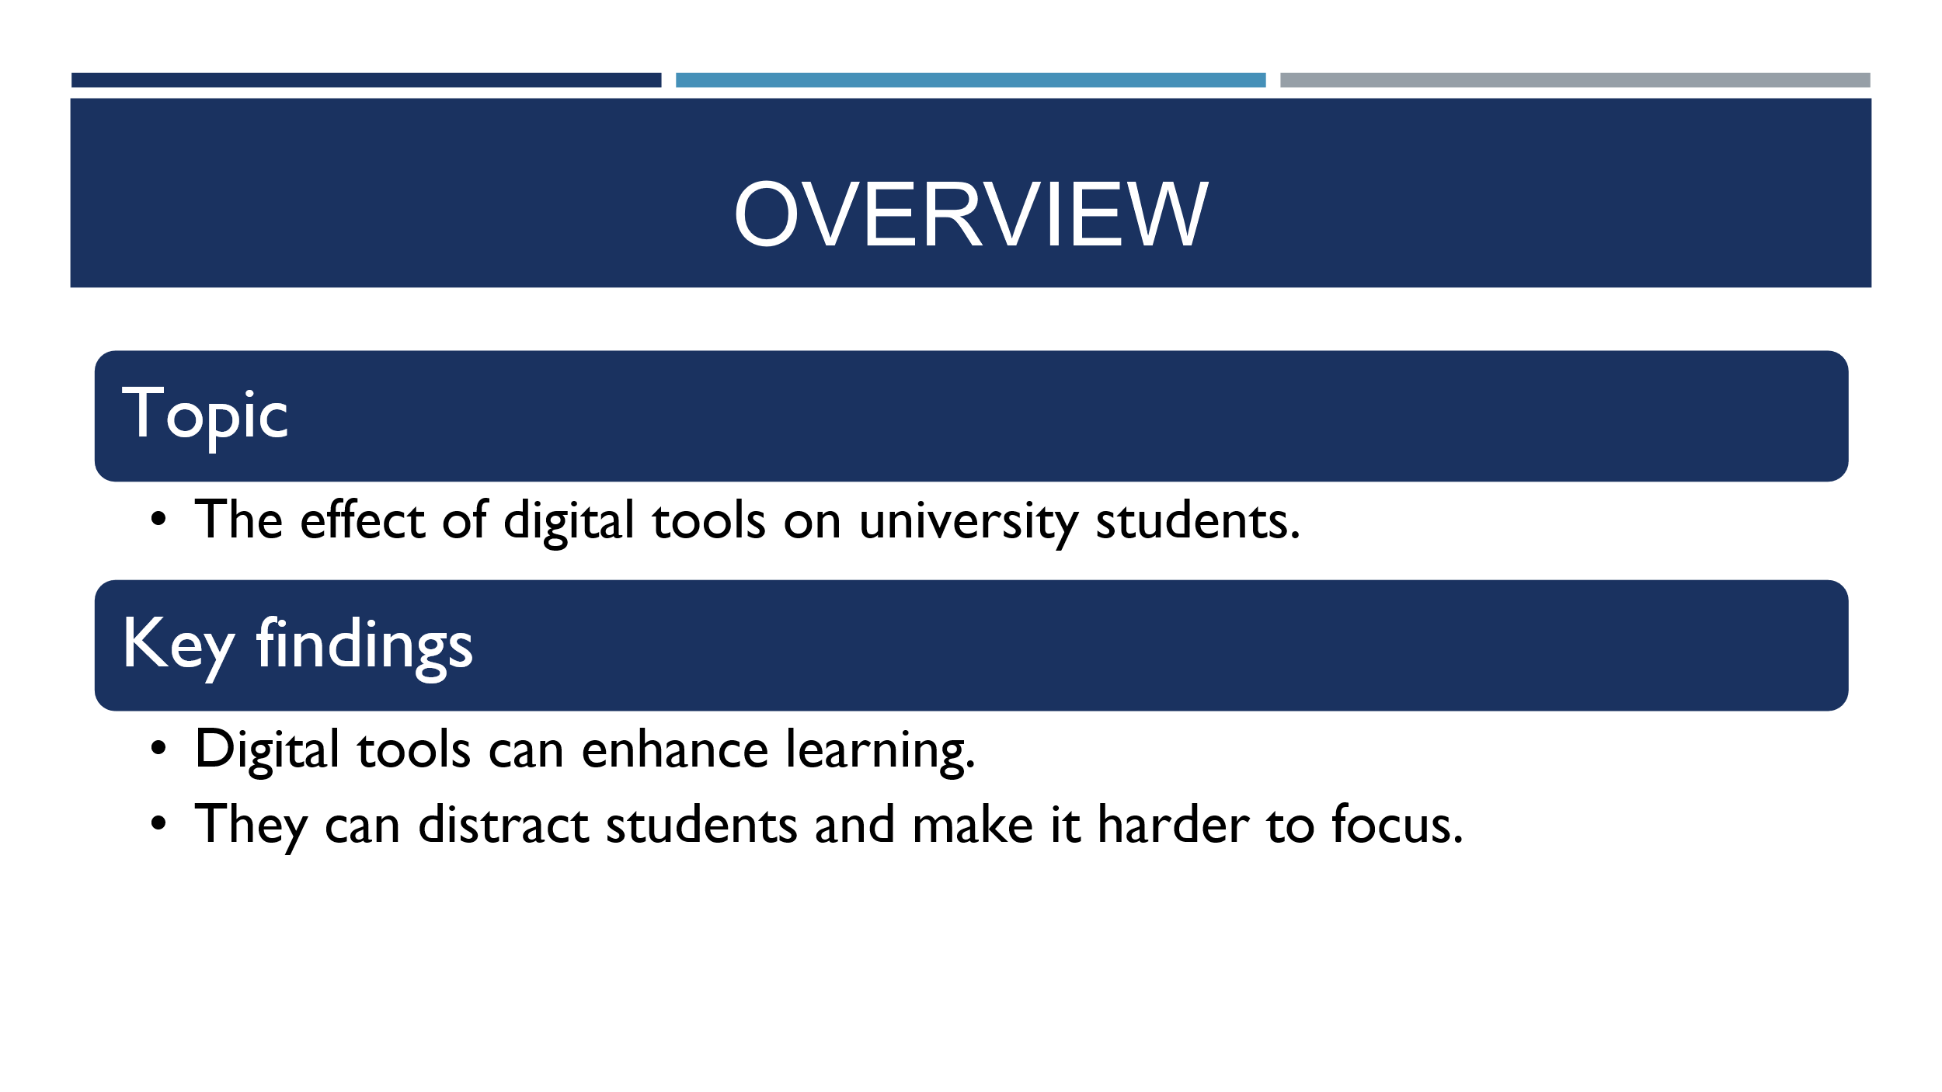

Slide 2 (Research)
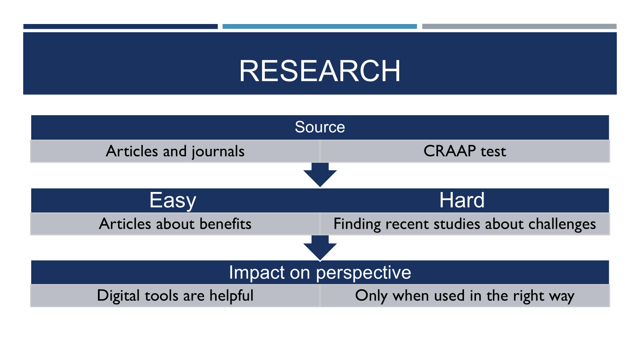

Slide 3 (Planning & Writing)
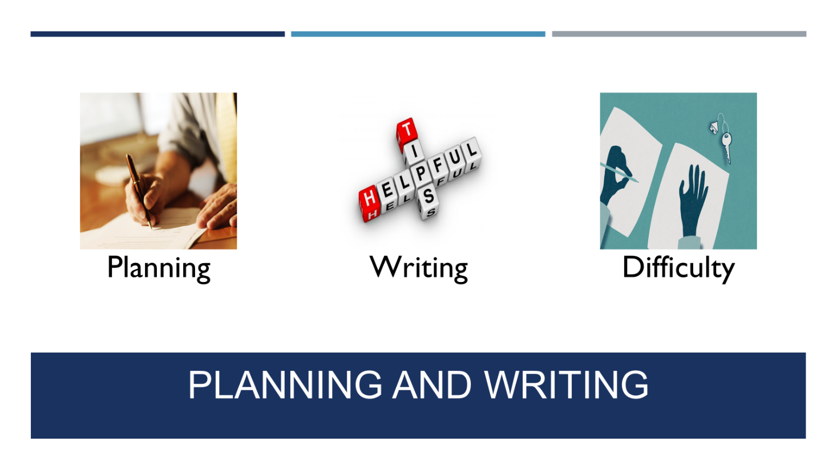

Slide 4 (Challenges)
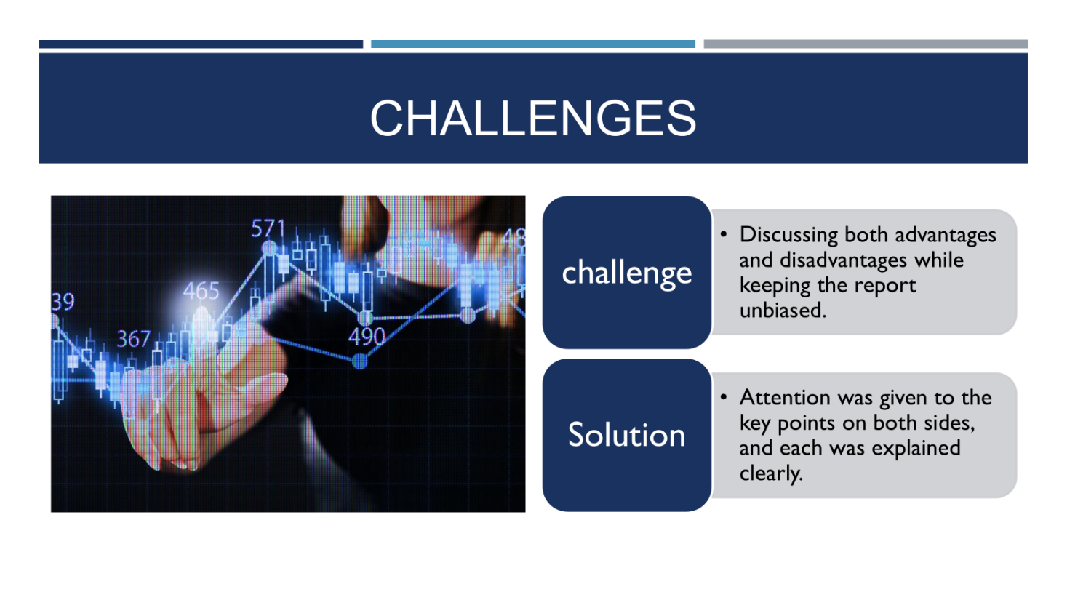

Slide 5 (Successes)

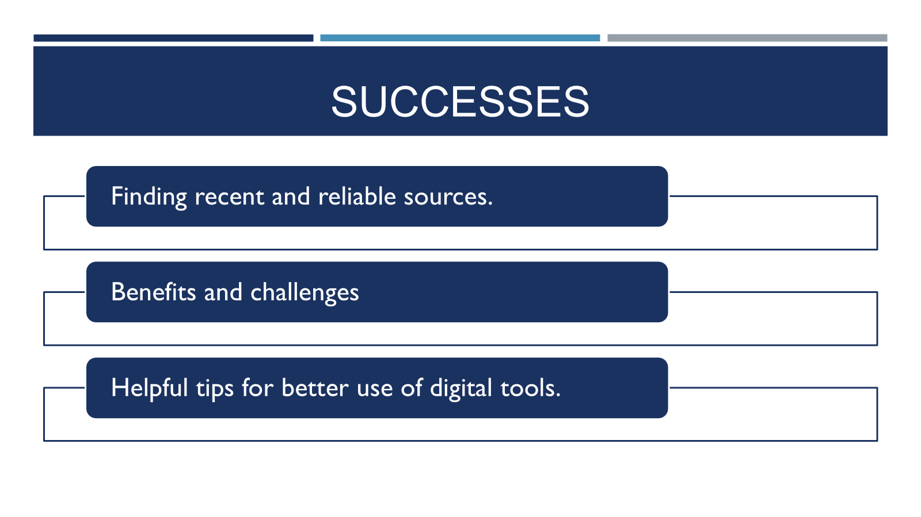

References
∙Chan, C.K.Y. & Hu, W., 2023. Students’ voices on generative AI: perceptions, benefits, and challenges in higher education. International Journal of Educational Technology in Higher Education, 20(43). doi:10.1186/s41239-023-00411-8.
∙Martin, F., Long, S., Haywood, K. et al., 2025. Digital distractions in education: a systematic review of research on causes, consequences and prevention strategies. Educational Technology Research and Development. doi:10.1007/s11423-025-10550-6.
∙Pang, W. & Wei, Z., 2025. Shaping the Future of Higher Education: A Technology Usage Study on Generative AI Innovations. Information, 16(2), p.95. doi:10.3390/info16020095.
∙Pérez-Juárez, M.Á., González-Ortega, D. & Aguiar-Pérez, J.M., 2023. Digital Distractions from the Point of View of Higher Education Students. Sustainability, 15(7), p.6044. doi:10.3390/su15076044.
∙Sajja, R., Sermet, Y., Fodale, B. & Demir, I., 2025. Evaluating AI-Powered Learning Assistants in Engineering Higher Education: Student Engagement, Ethical Challenges, and Policy Implications. arXiv preprint. Available at: https://arxiv.org/abs/2506.05699.
∙Wecks, J.O., Voshaar, J., Plate, B.J. & Zimmermann, J., 2024. Generative AI Usage and Exam Performance. arXiv preprint. Available at: https://arxiv.org/abs/2404.19699.
∙Beckingham, S. & Hartley, P., 2025. One year on – Using Generative AI Effectively in Higher Education. DigitalEd Report. Available at: https://www.digitaled.ie/wp-content/uploads/2025/05/One-year-on-Using-Generative-AI-Effectively-in-Higher-Education.pdf.
∙Freeman, J., 2025. Student Generative AI Survey 2025. HEPI Policy Note 61. Available at: https://www.hepi.ac.uk/wp-content/uploads/2025/02/HEPI-Kortext-Student-Generative-AI-Survey-2025.pdf.
∙Ijaz Baig, M. & Yadegaridehkordi, E., 2025. Factors influencing academic staff satisfaction and continuous usage of generative artificial intelligence (GenAI) in higher education. International Journal of Educational Technology in Higher Education, 22(5). doi:10.1186/s41239-025-00506-4.
∙University Teachers’ Views on the Adoption and Integration of Generative AI Tools for Student Assessment in Higher Education, 2024. Education Sciences, 14(10), p.1090. doi:10.3390/educsci14101090.

