
Diversity of the LPR Construction
HUMAN RESOURCE PROFFESION
Ruby Khatun (1702871)


Executive Summary

This report will give the reader an insight on the diversity problems in construction. This report will talk 3 subjects these will be gender, ethnicity and disability. The first topic is about how many construction companies do not hire women. The second topic is about how construction companies do not has a wide variety of ethnicity’s. Finally the last topic is about how companies do not hire many individuals who may suffer with a disability. This report concludes by the writer recommending what their company could do to over come these obstacles.

Contents Page
- Introduction……………………………………………………………………4
  - Report Remit
  - Background of LPR
  - Rationale
- Literature Review……………..……………………………………………….4-11
  - What is diversity and inclusion in the workplace?
  - Gender diversity in the construction industry
  - Employment by ethnicity
  - Construction industry improving employment for disabled people
- Conclusion…………………………………………………………………………12
- Recommendations…………………………..…………………………..……12
- Biblography…………………………………………………………………………13-14

Figures

Figure 2.1.1 shows Men and Women in construction…6

Figure 2.1.2 Wage gap……………………………7

Figures 2.3.4 employment of ethnicity…..9

Figure2.3.4 construction………………………..10

Introduction

1.1 Report Remit

This report will provide a critical review on diversity for the LPR construction co, LPR construction is based in the United States they provide premier steel erector. The writer will provide an expressive conclusion from the review of the various information sources. This report will include acceptable recommendations to stakeholders to sustain and improve many practices. The writer will be using secondary information when providing evidence for example online data bases.

Main Body

2.1 Background of LPR

Three entrepreneurs discovered LPR CONSTRUCTION CO in 1979. The company was chiefly as a local steel erector in the Rocky Mountains region. LPR goal was to deliver a quality merchandise and service to their clienteles at a reasonable price. LPR recognised itself as a leading steel erector through the United States. Since 2005 LPR Construction Co has widened their assistances to provide Industrial Construction Services and Plant Services to meet their clients’ needs nationally (LPR Construction, n.d.)

2.2 Diversity and Inclusions

Diversity means more than just race or ethnicity. Diverse companies are made of employees with different features including, spiritual and political beliefs, gender, culture, education, socioeconomic background, sensual orientation and geographic location (Smallbusiness.chron.com, n.d.).

Diversity in the workplace is essential for staff because it establishes itself in constructing an outstanding reputation for the business, proceeding to improved profitability and prospects for employees. Workplace diversity is vital inside the company as well as externally (Smallbusiness.chron.com, n.d.).

Companies find ways to include diversity into their organisations without producing major modifications to the way their companies’ function. Integrating diversity practices in a company can involve employing various talent to make the organisation open to employees from numerous circumstances (Smallbusiness.chron.com, n.d.).

Diversity is good within an organisation because working beside individuals of diverse upbringings, experiences and working styles, imaginative ideas can happen when working with other individuals because you may get some feedback and recommendations. One individual may be good at thinking of innovate ideas and the other one may have some basic experiences to perform it; so it is important to play on each person’s strong point and co-operate with others in the group (Undercover Recruiter, n.d.).

Linguistic barriers and ethnic differences can frequently act as an obstacle for a business who may want to develop their organisation overseas; though, by employing staff who communicate in different languages it can make it possible for a business to work on an international basis and setup with a wider customer base. On behalf of a quantity of ethnic groups within a business, it can also support to make it more relevant (Undercover Recruiter, n.d.).

By being diverse in the workplace it will increase the companies’ status and brand. Businesses who are enthusiastic to constructing and indorsing diversity in the place of work are viewed as respectable and socially responsible in a business (Martic, n.d.).

Inclusion means making sure that no one excluded because of their age, disability, race, religion ,sexual orientation, marriage, pregnancy and maternity, or other features for example social background (Inclusiveemployers.co.uk, n.d.). Finally an inclusive working setting lets individuals be their own person at work. Equality and diversity can bring challenges, so to indorse workplace inclusion, companies need to contemplate how their employees will work together on a day-to-day basis (Murphy, 2018).

Diversity and inclusion work together because bosses decide staff choices founded on equality. For example, if you have an employee who may not be fluent in English, you will need to find a way to communicate with them so they are up to date with company decisions, and also policy updates and events that may be coming (Grissom,2018).

Culture discusses the views and behaviours that regulate how an organisations employees and management co-operate outside corporate dealings. Usually, culture is indirect, not specifically distinct, and grows gradually over time from the growing qualities of the individuals the business hires (Yourerc.com, 2019).

If LPR construction do not provide diversity and inclusion people may not want to be hired by the company, as they do not like how they do not have a diverse work force. If LPR construction co does not provide a good work force they may get a bad reputation. This means they may find it difficult to gain employees and to stay open, as they have made a bad name for themselves.

2.2 Gender diversity in the construction industry

Gender diversity is reasonable or rational demonstration of individuals of diverse genders. It most frequently refers to a reasonable proportion of men and women, but may also contain individuals of non-binary genders (Sytsma, 2006).

Over the past years in the news you will listen to stories about gender diversity in company boardrooms and other parts that may usually be dominated by men. Most of the corporate industries may have more dominance of men over women for example construction, medicine and science (Skills 4 Ltd, n.d.).

It is agreed fair and creative working atmosphere, an identical balance of men and women is required. However this is not the circumstance even though the modern day and age that we live in. Gender diversity in a place of work means that men and women are employed at a comparable and dependable rate, are paid likewise and are given equal working chances with the same promotional prospects (Skills 4 Ltd, n.d.).

Gender diversity is helpful for women and the company. Gender diversity confirms a gender- balanced and improved staff. But the other side, gender diversity delivers female’s economic independence. Gender diversity supports companies to appeal and recall a gifted workforce. Diverse talent workforce improves the problem solving skill of the company, helping the company to tolerate itself in the competitive times. Helping various client base, this also is easier for gender diversity. Gender diversity promotes healthy work culture (Medium, 2018).

The disadvantage of gender diversity is women all around the world are still being being underpaid. Studies have shown that woman will need to work more than 70 more days each year to catch up to what men are earning (Catalyst, n.d.).
Recent research has said that on in five UK construction businesses have no women in senior positions. Some industry’s professionals believe that there is a prejudice against women in the construction industry (Constructionglobal.com, 2018).
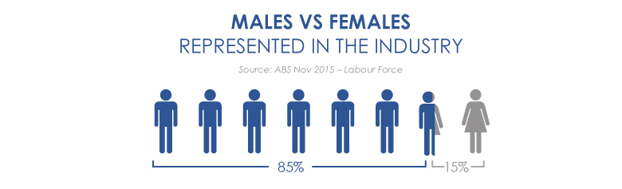
Figure 2.1.1 shows Men and Women in construction

According to construction news they have stated that half of all their construction firms have never had a female manager within the business. Research shows that 48% of women who have worked in the construction industry have experienced gender discrimination in their workplace. 28% of women have experienced inappropriate comments and also behaviour from male co-workers. These figures clearly show that the construction industry needs to implement more guidelines to alter attitudes concerning women in the industry and urge equality (Constructionglobal.com, 2018).
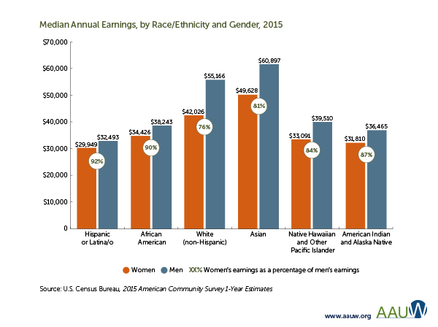
Figure 2.1.2 Wage gap

Gender pay gap seems to be a huge problem still mixing within the construction industry. Near enough half (42%) of the construction companies do not observe identical pay among gender in the industry and 68% were not alert of any enterprises to help women transition into senior roles (Newton, n.d.).

According to Randstad, 79% of males think they receive the same amount of money as their female colleagues in the same position. Though 41% of women disagree, women working in the industry believe that the construction companies need better pay transparency within the industry to dismiss insights that men are receiving more (Constructionglobal.com, 2018).
When it comes to construction workers, statics show that men fill 99% of the roles.

This statistics demonstrates that the lack of diversity within the construction industry. 93% of people who work in construction believe if they had female bosses it would not affect their job, they believe it wouldn’t have a positive effect in improving the work environment.
According Randstad in 2020 women are likely to be over a quarter of the UK’s construction workforce. If the trade aims on terminating the skills gap, women could possibly have a chance (Constructionglobal.com, 2018).

With the business raising worries that it is suffering a deficiency of capable workers, 82% of individuals employed by construction think that there is a significant of amount of skills shortage. There may be a demand expected that may require an additional million workers in 2020. Woman may account for an important percentage of that, particularly in senior positions, which have previously been prejudice concerning their male co-workers (Newton, n.d.).
There is still a substantial difference in the quantity of women in senior roles associated with their male co-workers. There is some development over a few years (Newton, n.d.).
In 2005, there was only 6% of females in senior roles in the UK’s construction industry. But in 2015 it had risen by 16% and studies show that it is still expect tom rise as we approach 2020 (Constructionglobal.com, 2018).

Even though all the discrimination women have received through this industry they would still recommend the job to many other women. Gender diversity had progressed during the years within construction buy there is still a long way to go.

2.3 Employment by Ethnicity

The construction business the whole thing works well with ethnically diverse workforces. Equality regulation not only outlaws judgement but allows public bodies to inspire diversity and make chances for people (Go Construct, 2018).
In the UK the black and minority ethnicities BME selecting jobs in construction and succeeding.

This is beneficial news not just for staff, but also for the business as an entire. Better diversity makes a good loop in motion, creating businesses to become more striking to a wider variety of gifted people (Go Construct, 2018).

The same businesses become more eye-catching to customers and extra competitive too, because their clients are well represented (Go Construct, 2018).
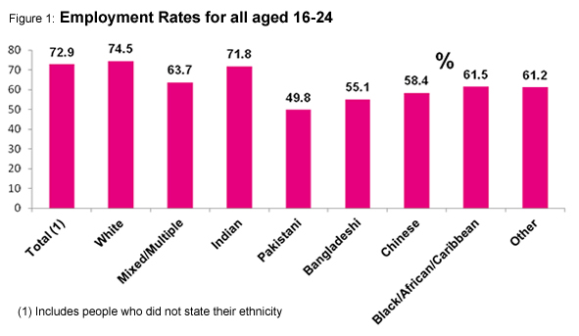
Figures 2.3.4 employment of ethnicity

Their employees can attract additional involvements and broader perceptions, to produce improved concepts and development more rapidly (Go Construct, 2018).

There could be more done to improve black and minority ethnicities (BME) construction for many ethnicities. This includes changing observations about what the business includes (Go Construct, 2018).

Many businesses are now taking constructive actions, and have healthy equality and diversity guidelines, and outlines in position to help BME staff. Others have faster training courses, and offer committed management and leadership programs to people who demonstrate ability (Go Construct, 2018).

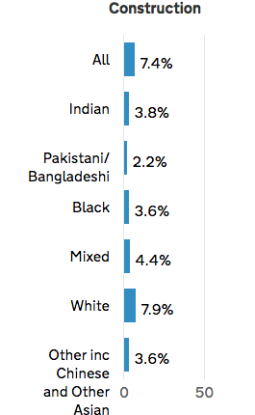

Figure 2.3.4 shows The GOV website brought out statistics in 2017 to show how many different ethnicities work in constructions. The statistics show that only 3.8% of Indian people work in construction. Only 2.2% of Pakistani’s and Bangladeshis , 3.6% of black people, mixed race only 4.4%, white people 7.9% and other ethnicity or example Chinese was only 3.6% (Ethnicity-facts-figures.service.gov.uk, 2017).

It shows that white people are employed more in construction and this could be seen as ethnic diversity which may be a problem in the future as many people may question it as racism.

It would be helpful if LPR hired different ethnicity’s as it shows they are open to diversity. If they employee different ethnicities they are able to learn about different backgrounds and they may gain more ideas as people from different backgrounds, they may also broaden their knowledge on different background. If LPR do not hire people from different backgrounds this may come across as racist as they are not willing to hire different ethnic minorities. By not hiring different ethnicities LPR may make a bad name for the company

2.4 Construction industry with disabled people

In the UK, a substantial amount of disabled individuals are jobless and earlier inquiries has recommended details for this contain the distance of workplace surroundings that have not been designed, or modified, to accommodate the necessities of disabled individuals, and the nature of effort being assumed in the workplace setting (Taylor & Francis, n.d.)
.

A survey was carried out with the UK’s top 100 construction sights. They gave their views on disabled people in this industry. The survey showed that

Construction sites are unlikely to have suitable guidelines and practices in position to help disabled job candidates through the employment process. Contractors are likely to make ‘practical alterations’ as it is compulsory by the UK Disability Discrimination Act if the alteration is comparatively reasonable, and if negligible changes are essential in command to familiarise workplaces such that they deliver a comprehensive method to the employment of disabled individuals (Taylor & Francis, n.d.).

Contractors work hard to make sure that if a worker becomes disabled they are suitably aided to continue their job. During the survey only a small amount of construction sites believed that disabled people did not have a place in the industry (Taylor & Francis, n.d.)
.

It can be decided that construction sites are not likely to employee disabled individuals, they are more likely to resume to hire individuals once they become disabled, but they are unlikely to monitor and evaluate this procedure by contractors and it is possible that contractors are not achieving their duties under the Disability Discrimination Act as a result (Taylor & Francis, n.d.)
.

The LPR company needs to know that everyone is capable to work, even if they may have a disability or not. Most construction companies never hire people with disabilities only recently they have promoted individuals with disabilities working in construction. There is now a law called the UK Disability Discrimination Act this is an act where people cannot discriminate against people who have a disability. If LPR construction did not hire people with disability they would look like they are discriminating which may give them a bad reputation, many people may feel uncomfortable working for the company so they may resign, therefor LPR will lose out on hard working employees.

3.0 Conclusion

To conclude this report it shows that many construction companies need to improve on many things for example diversity. Many companies do not follow diversity very well as many companies do not hire women or they may hire them but they will not get senior roles in construction. If LPR construction co undertake these problems and fix them they are more likely to succeed as a company.

4.0 Recommendations

For LPR construction co to improve I would recommend the company to improve diversity amongst its workforce. They would do this by broadening their knowledge about different ethnicities and being more open to employee someone with a disability. They would also have the knowledge of the Disability Discrimination Act so they would gain knowledge about the act and they would know not to discriminate anyone with a disability.

I would also recommend that LPR construction co hire more women because then the company will not look sexist. By employing more women the company would look open to any gender joining their team this will therefore urge many other young women to join LPR as they would think it was a good company and open to many opportunities.

These are the recommendation I would say LPR should undertake to be a better company.

5.0 Bibliography

Catalyst. (n.d.). 10 Big Issues Women Face at Work and What Leaders Can Do to Help - Catalyst. [online] Available at: https://www.catalyst.org/2017/01/19/10-big-issues-women-face-at-work-and-what-leaders-can-do-to-help/ [Accessed 7 May 2019].

Constructionglobal.com. (2018). Gender diversity in the construction industry. [online] Available at: https://www.constructionglobal.com/mission-critical/gender-diversity-construction-industry [Accessed 7 May 2019].

Ethnicity-facts-figures.service.gov.uk. (2017). Employment by sector. [online] Available at: https://www.ethnicity-facts-figures.service.gov.uk/work-pay-and-benefits/employment/employment-by-sector/latest [Accessed 7 May 2019].

Go Construct. (2018). Ethnic diversity in construction. [online] Available at: https://www.goconstruct.org/construction-today/blog-events/ethnic-diversity-in-construction/ [Accessed 7 May 2019].

Grissom, Andrew R., 2018. Workplace Diversity and Inclusion. Reference & User Services Quarterly, 57(4), pp.242–248.

Inclusiveemployers.co.uk. (n.d.). Inclusion, Diversity and Equality | Inclusive Employers. [online]
Available at: https://www.inclusiveemployers.co.uk/about-us/inclusion-diversity-and-equality [Accessed 7 May 2019].

Inclusiveemployers.co.uk. (n.d.). Inclusion, Diversity and Equality | Inclusive Employers. [online] Available at: https://www.inclusiveemployers.co.uk/about-us/inclusion-diversity-and-equality [Accessed 7 May 2019].

LPR Construction. (n.d.). Who We Are - LPR Construction. [online] Available at: http://www.lprconstruction.com/who-we-are/ [Accessed 7 May 2019].

Martic, K. (n.d.). Top 10 Benefits of Diversity in the Workplace [INFOGRAPHIC INCLUDED].
[online] Blog. Available at: https://www.talentlyft.com/en/blog/article/244/top-10-benefits-of-diversity-in-the-workplace-infographic-included [Accessed 7 May 2019].

Murphy, William, 2018. Distinguishing Diversity from Inclusion in the Workplace: Legal Necessity or Common Sense Conclusion? Journal of Business Diversity, 18(4), pp.65–84.

Newton, H. (n.d.). Women In Construction Gender Equality Report 2018 | Randstad.co.uk. [online] Randstad.co.uk. Available at: https://www.randstad.co.uk/employers/areas-of-expertise/construction-and-property/women-in-construction/ [Accessed 7 May 2019].

Skills 4 Ltd. (n.d.). What is gender diversity and why is it important in the workplace. [online] Available at: https://genderdiversity.co.uk/what-is-gender-diversity/ [Accessed 7 May 2019].

Smallbusiness.chron.com. (n.d.). Define Diversity in the Workplace. [online] Available at: https://smallbusiness.chron.com/define-diversity-workplace-4926.html [Accessed 6 May 2019].

Smallbusiness.chron.com. (n.d.). Why Is Diversity in the Workplace Important to Employees?. [online] Available at: https://smallbusiness.chron.com/diversity-workplace-important-employees-10812.html [Accessed 7 May 2019].

Sytsma, S. (2006). Ethics and intersex. 1st ed. Dordrecht: Springer, p.38.
Undercover Recruiter. (n.d.). What Are the Benefits of Diversity in the Workplace?. [online] Available at: https://theundercoverrecruiter.com/benefits-diversity-workplace/ [Accessed 7 May 2019].

Taylor & Francis. (n.d.). Do disabled people have a place in the UK construction industry?. [online] Available at: https://www.tandfonline.com/doi/abs/10.1080/01446190500372510 [Accessed 7 May 2019].

Yourerc.com. (2019). Workplace Culture: What It Is, Why It Matters, and How to Define It. [online] Available at: https://www.yourerc.com/blog/post/workplace-culture-what-it-is-why-it-matters-how-to-define-it [Accessed 6 May 2019].

