Week one - Talking about what game we are making and researching similar styles
During our first week, the group discussion was about the game we were going to make and researching ideas. These ideas were put onto a mindmap so it was a very collaborative session. We performed lots of research into the colour, themes, style and characters for our mood board. The chosen idea for our game will be based within a natural forest environment.
It is hoped that all the characters and backgrounds will complement this environment and give it a more realistic feel.

Week two- Talking about our role in the group-
We had a discussion about each of our roles in the group and we decided that my role will be to make a game on the platform - Unreal engine. The other members of my group will give their narrative and artistic design work to me and I will use their work and put it on Unreal Engine. This platform shall be used to create the characters, colours and maps.
I feel happy at this choice as I know that game development via online tools and software is where I feel more comfortable.

Week three - Learning about Unreal engines
Today I have researched how to programme the different movements and camera angles needed for my characters and backgrounds. I used YouTube to help with this as well as using trial and error on the basic program of Unreal Engine.

Week four to six - doing 2D game to practice (how to add an attack and damage on game and how to change movement control )

Weeks 4-6 I made a demo game to learn how to make a basic game and made a 2D game like Mario but in my own style. I used starter pack to help me learn the basic 2D game and I changed the characters and map with my design. As you see that image that shows the 2D I practice with
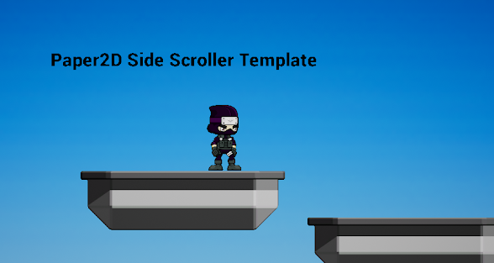
I learnt how to add movement on my demo game with the camera staying on my characters while we were walking around the map. Also, I added controller mode on it to test that our game can be played on different platforms. I also learned how to add an attacking mode and damage being shown on the map or enemies. I developed some advanced moves, such as being able to jump and attack whilst I added more sprites so that the idle animation can also run and jump when attacking. As you see on image that character attacking with sword out
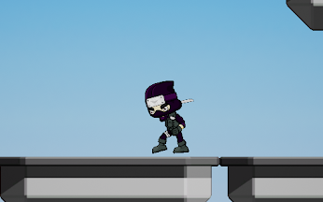

Week seven - researching which name of on style similar to Pokemon top down
After I had finished my 2D demo game, I was researching a game called Pokemon and some other games with a similar style. I did this so that I could use some of their work and try and replicate similar work into my groups game. After doing the research of these styles I found out that it is difficult to replicate with Unreal engine so after going on to research which is the best opinion for our game, I found out some could work well with Top-down style.

Week eight - learning the basic of Top-down style on unreal
I watched lots of YouTube videos and found out that their lots of different variations of the Top-down style and I have a discussion about which type is better for our game. After our discussion, we decided to use 3D because we can use a starter pack for our template.
I learned how to use material our game, as you see on the floor I wanted to make grass on this map.

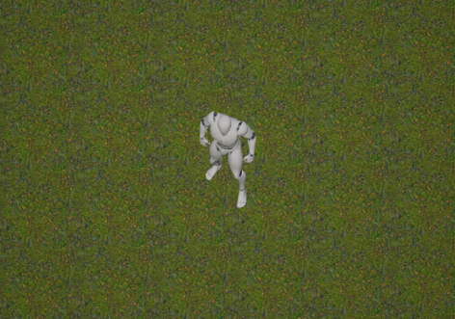

Mechanics: In our game there will be 4 items in the game which consist of things that belonged to the main characters mother (hair pin, wedding rings, shoe and pearl necklace) these items are required to complete the level. I don’t want to make the game more difficult by adding a trap as it's more like a child’s game so I want it kept simple.

Controls: in our game’s control system will be WASD with other keybind that can used to attack enemies. We don't have a camera that rotates so we don't need a mouse for that. I can add more control systems like PS4 or Xbox controllers on this game which could make it easy for people to control the character movement.

Challenges of importance: The challenge of this game will be the quest with multiple small puzzles inside each section of the level, to unlock each level the player is required to collect all 4 items to complete the level and kill the enemies which is called The mother ghost that will complete the game.

Characters: The main character in this game is a little girl with short black hair and a bright yellow jacket. The yellow jacket makes it easy to locate her wherever she is on the screen and also to stand out against the dark shadows of the greenish-blue forest she’ll go through.
Some enemies are from myths - monsters like the Welsh christmas spirit which is called Mari Llwyd. Some simple enemies look like faceless ghosts that crawl across the floor making them very slow. The second type of enemy looks similar to Mari Llwyd but is blind and can’t see anything so players will need to distract it with the sling shot. The last enemy is the main character which is mother that only appears once to scare the player and can catch the player off guard.

Weapons: In the game the player will attack with a slingshot that has a limit of 5 shots and you can get more ammo by picking up small stones on the floor and attack at enemies with it. Also, the player can pick up the acorns and pine cones that they can use for destruction and damage on enemies.

