St. Peter’s Church Lampeter

Graveyard Survey 2018

Headstone uniformity- an indicator of changing attitudes to death?

Contents
Photographs, 1-7 St Peter’s Graveyard.
Appendix-Map, St Peter’s.
Appendix-Raw data section 1,2 and 3.
Appendix-Bar charts, table 1,2 and 3.

Introduction
Lampeter is a small market town in the rural heart of south west Wales, within the county of Ceredigion. According to the 2011 census figures has a population of just under three thousand people, with a third of that belonging to the University. Lampeter is quite small, isolated and with limited transport options. Small winding and twisting roads must be travelled some distance to get to the larger urban centres of Aberystwyth and Carmarthen. This may have had an impact on the burial makeup of St Peter’s graveyard. It contains some very ostentatious memorials, expensive material to buy and transport such as Balmoral granite and White marble. These could skew the findings if compared to another similarly sized rural graveyard if you did not consider the impact of the college to local status. St Peter’s church, Lampeter; in its present form was built between 1867 and 1870; this replaced the 1821-2 building which replaced an earlier one first mentioned in 1291(Coflein). The present church replaced a poorly built one of 1836-38(Coflein); which had been demanded by the town’s people after the building of St Davids College within Lampeter.
The large churchyard has been used extensively as a cemetery (Coflein). Upon first entering the main gate to St Peter’s graveyard, there is located on your left an extensive number of pauper’s graves. These are shielded or hidden by a quantity of tall gravestones. The quantity of pauper’s gravestones that can be seen (people from the local Workhouse) may be considered unusual by the sheer number of gravestones and their location within the graveyard, according to University of Wales Trinity Saint David lecturer in Archaeology Quentin Drew. Quentin mentioned spoke of this when we toured the churchyard but was also explained as parish politics over land acquisition and usage. I do not have sufficient experience or knowledge of the local Graveyards or further afield yet to verify or refute what would be usual or otherwise in the quantity and location of pauper’s graves. St Peter’s may be less than typical as it has the graves for the nearby Catholic Church, Our Lady of Mount Carmel, buried within it. Our Lady of Mount Carmel was not allocated sufficient land to build a Church and have a graveyard as well.
St Peter’s graveyard looks like a boot or a large woolly sock from an aerial view (see map); the church fits across the instep of this boot. All the graves within the foot shaped area of the boot, date from the middle of the eighteenth up to the beginning of the twentieth century. There are exceptions to this rule; a variety of graves from later in the twentieth century are seeded within these areas, but still sympathetic to their immediate neighbours in style. Within the graveyard it has interestingly delineated footpaths; this can be seen in my wonderfully hand drawn map of the graveyard in the appendix. Footpaths are highlighted in orange, section 1 is the most recent section of the graveyard to have burials. Included within the paper are various photographs of the formations and patterns of the headstones upon observation.
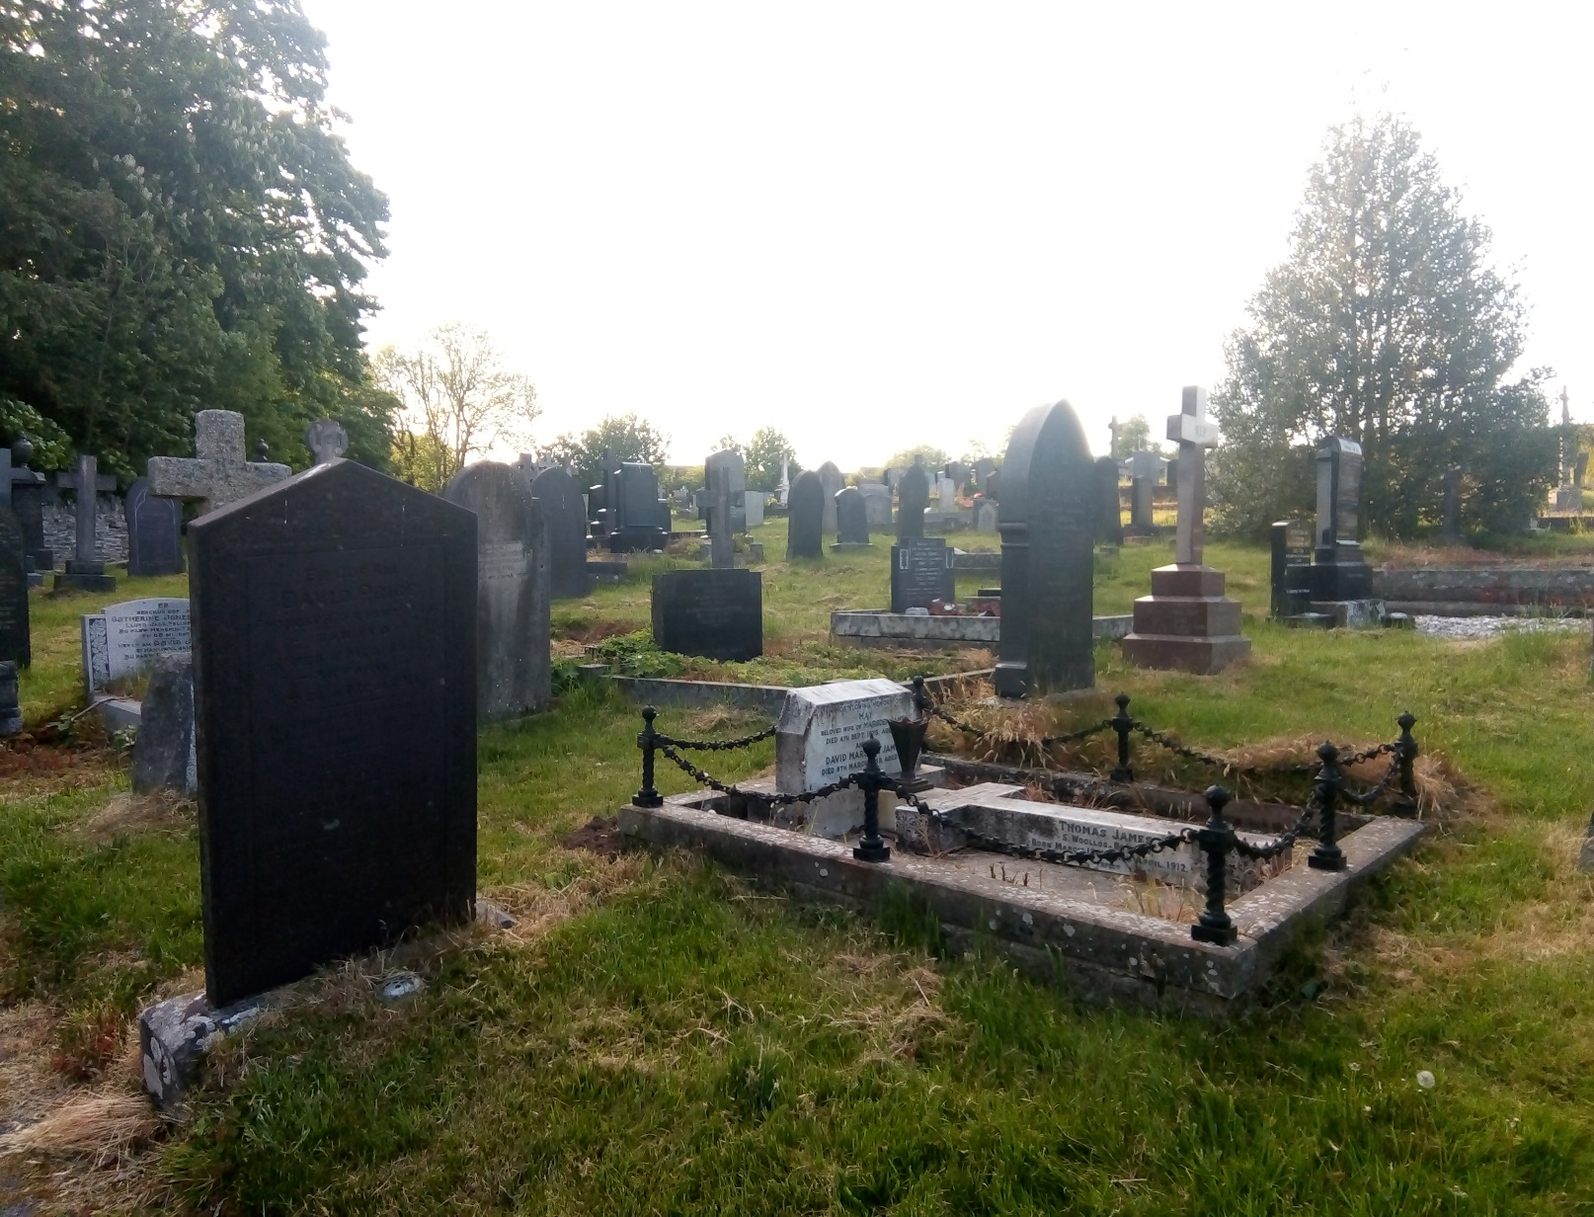
The question on headstone uniformity as an indicator of the changing attitudes to death; arose on first looking at the formation of gravestones in Section 1; how on observing section1 from the footpath separating them from the Catholic and Polish section, highlighted their almost soldierly uniformity. Not just in rows and columns; but their heights, widths and even depths of the headstones. Why did the headstones in this section of the graveyard appear so uniform? Pearson (1982: 110) argues that the decrease in memorialising with ostentatious, lavish and elaborate headstones on the grand scale is due to the rise in cremations and the rise in secularism. Pearson (1982: 110) goes further and describes the changes in mortuary rituals which could be explained by acknowledging the change in social control from religion to rationalism, science and medicine. He adds that the view of the body has changed from it being a corpse, to becoming an undesirable object that needed to be disposed of as hygienically and swiftly as possible. Pearson (1982) questions the views on cremation as being more hygienic than burial, and the use or loss of space to burials, as there were still plenty of space available for leisure activities. Pearson (1982) speaks of the remoteness of death to present day people. Not so the Victorians, whose conspicuous consumption included their burial rituals. Due to the reduction in infant mortality and childhood deaths; and the rise in care homes, more deaths potentially occur in hospitals and care facilities and away from the home. The home before had been the location for many of these deaths; now they had become more remote and removed from people’s everyday existence Pearson (1982). Death to the Victorians was the natural process of transition (Pearson 1982), and now the end of a person’s life is viewed differently; fewer people since the Victorians consider the after-death aspect of life. The changes that have occurred since the Victorians and their conspicuous consumption; social class delineation and more overt religious connection in the realm of death and burials has been extensive. The Victorian expression of wealth and class manifested itself in many ways not least in their mortuary practices. The monumentalism was not limited to their bridges, homes and public buildings but also to their memorials for the dead; the headstone.
Photograph 1 St Peter's Graveyard. Patrick Sweeney. 15 May 2018, Lampeter.

Jones (1979) writes about the neglect that churchyards face, talking about declining church attendance and how graves can become untidy through there being no family in the parish to attend to the graves’ maintenance. This has left some churches in the position of paying someone to uses shears to tidy up the grass between graves; which is more time and costly than paying someone to use a lawnmower to move between graves more conveniently and less costly. The photograph above is an example of Victorian ostentatious memorialisation, conspicuous class and wealth markers.
Methodology
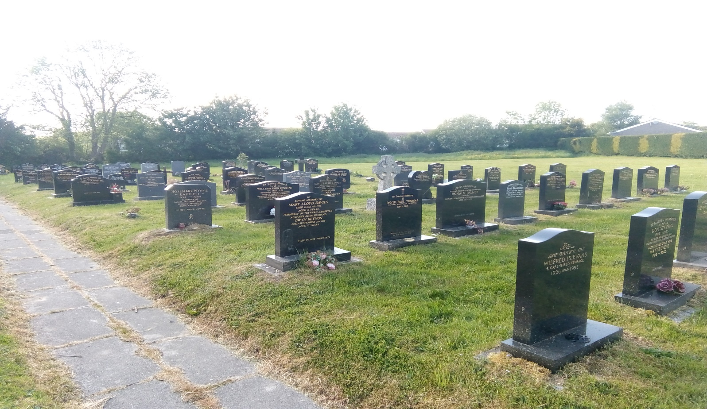Photograph 2, Section 1. St Peter's Graveyard. Patrick Sweeney. 15 May 2018, Lampeter.
There are a few headstones that standout in photograph 2 and 3 as not fitting the visual uniform pattern. The crucifixes being the most obvious ones; many of the headstones upon first appearance seemed so alike as to beg the question; were they? Starting with Section 1, as the area that first stood out as most anomalous to its neighbours. Details recorded were name (the grave could be located later should it prove necessary, see appendix A, B and C for raw data), date of birth if given, date of death, age of death if given, repeat this if the grave contained more than one occupant. Then measurements were taken of the height of the stone, its width (across the face of the stone) and the depth of the headstone. The measurements were taken in millimetres for accuracy. Twenty headstones were chosen, accepting the effect of bias upon those chosen, this number was chosen as the smallest number that may be representative as well as obtaining enough data to work with.
Data was collected from section 2, where again twenty headstones were chosen. And then finally twenty more from section 3. True randomness may not be possible, but the intention was to pick a sizable enough selection from each section as to get sufficient data to compare and attempt to draw a conclusion from. All measurements were recorded as a table (see appendix A, B and C). Then plotted as bar charts of height (appendix D) width (appendix E) and depth (appendix F).

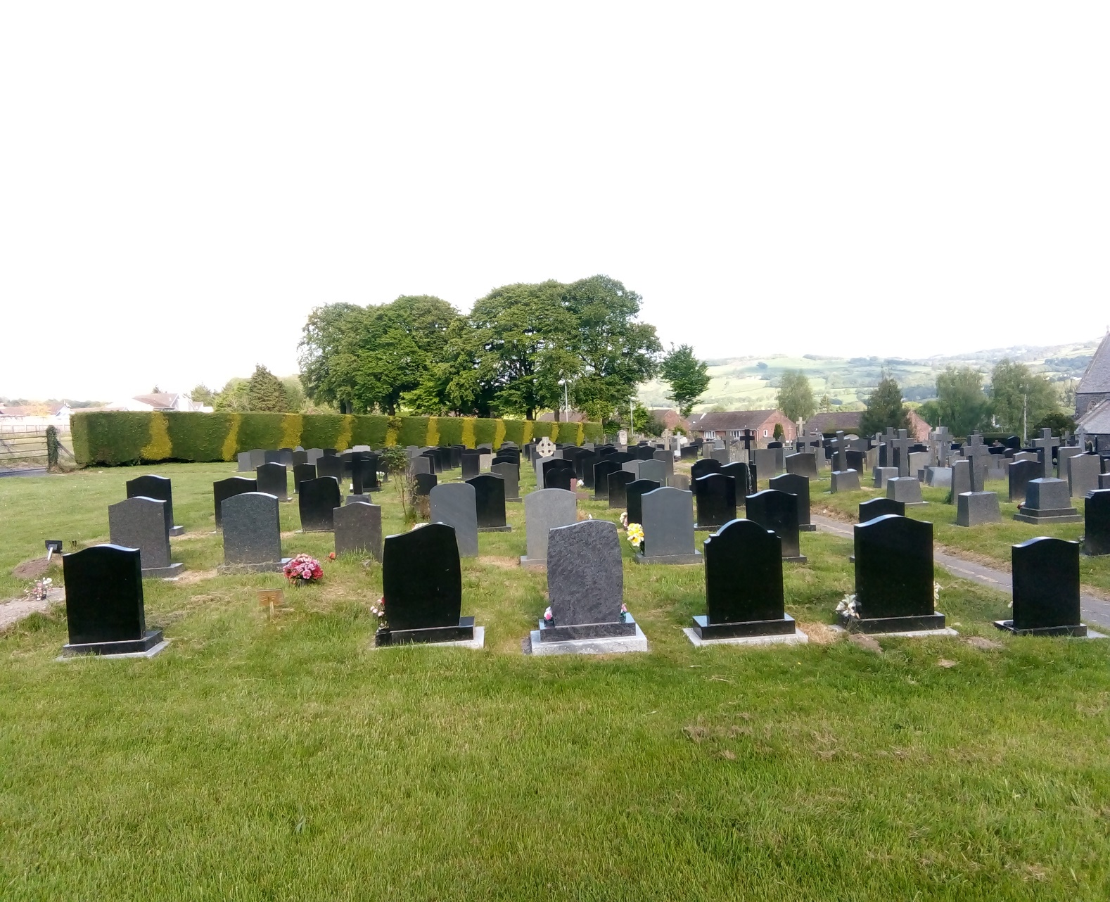
Photograph 3, Section 1. St Peter's Graveyard. Patrick Sweeney. 15 May 2018, Lampeter.
The headstone was the only part that was measured so, the comparison of data would only be on the headstones in Section 1, 2 and 3. Graveyard table 1(appendix D) shows the heights of the headstones measured in millimetres. Table 2 shows the width of the same headstones and table 3 shows the depths of these same headstones (Appendix E and F). I chose a ten-centimetre scale to be able to fit the breadth of height and width measurements on the bar charts and make them still readable. Looking at table1; is that from twenty headstones sampled in section 1(table-series 1) 13 of them are within ten centimetres of each other in height (765-764mm). The next nearest cluster (755-764mm) is of five; from section 1. There is a cluster of five (685-684mm) from section 2. This the largest group of headstone heights outside of section1. When you look at table 2, depth of headstones; section 1 again has the largest cluster of headstones. There are ten in the 95-104mm group and nine in 105-114 group. Only section 3 has a larger cluster in the same 95-104mm group as section 1, with 14 in this group. The rest are scattered in considerably smaller groups or individuals. Table 3 width of headstones; shows five relatively large clusters; with three of them from section 1 and two from section 2.
Why does section 1 look the way it does; why are so many of the headstones so like each other? The geology of the headstones selected has not been described yet. Several them were polished black granite. There were differences in the shapes of these headstones; some had curved sides or tops, were more angled than others. This can be seen in photos 2 and 3. To reduce the impact on the data, all measurements were taken from the highest, widest and deepest point on the headstone to reduce variations as much as possible.
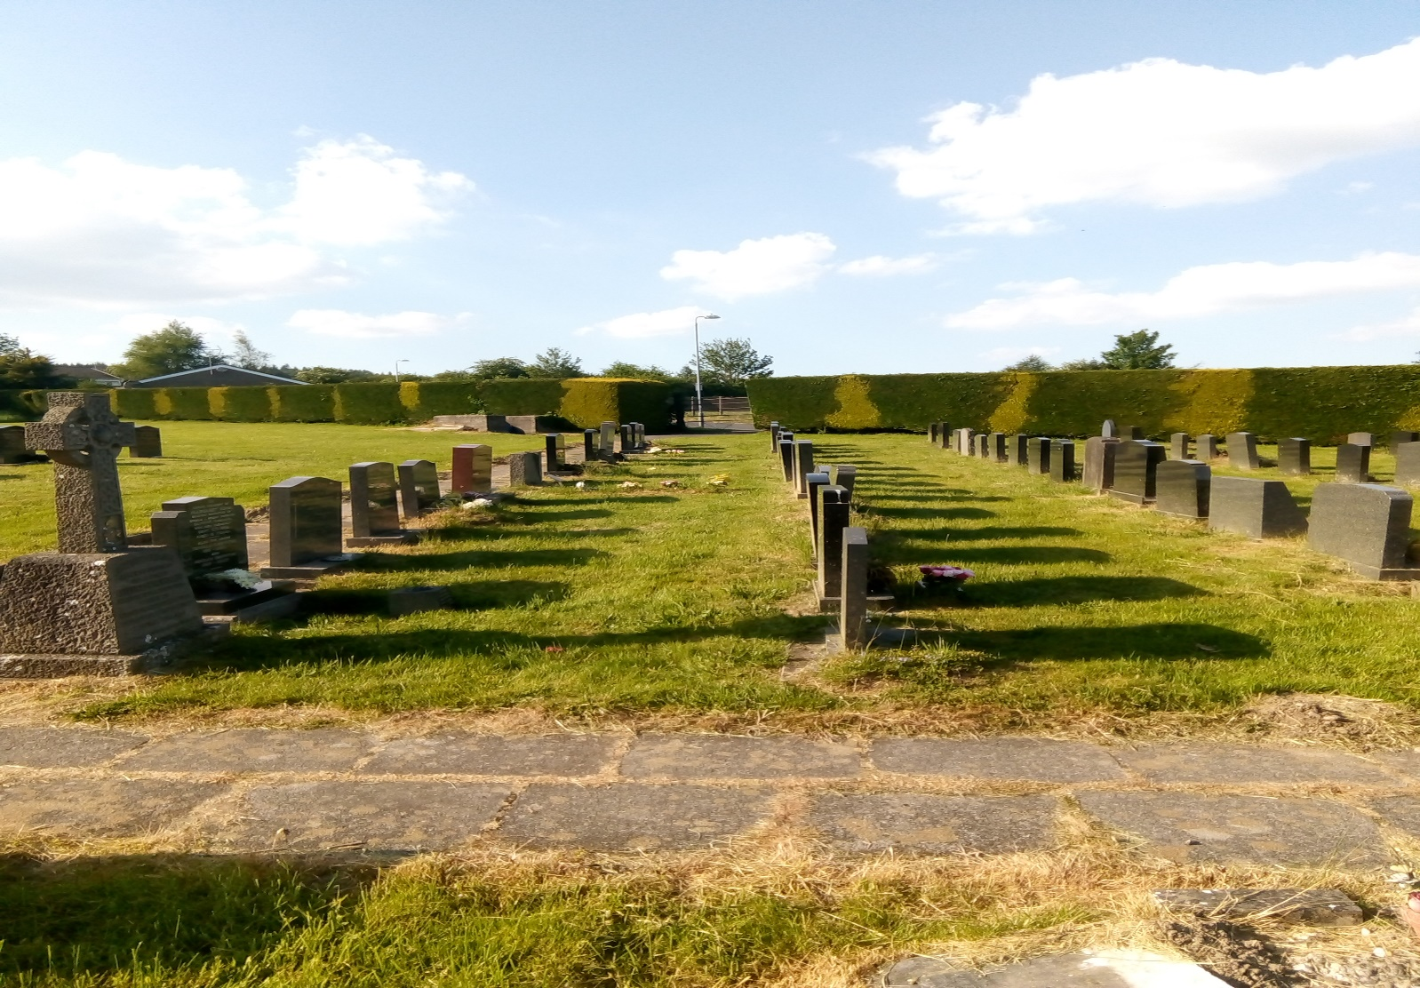
Photograph 4, Section 2. St Peter's Graveyard. Patrick Sweeney. 15 May 2018, Lampeter.

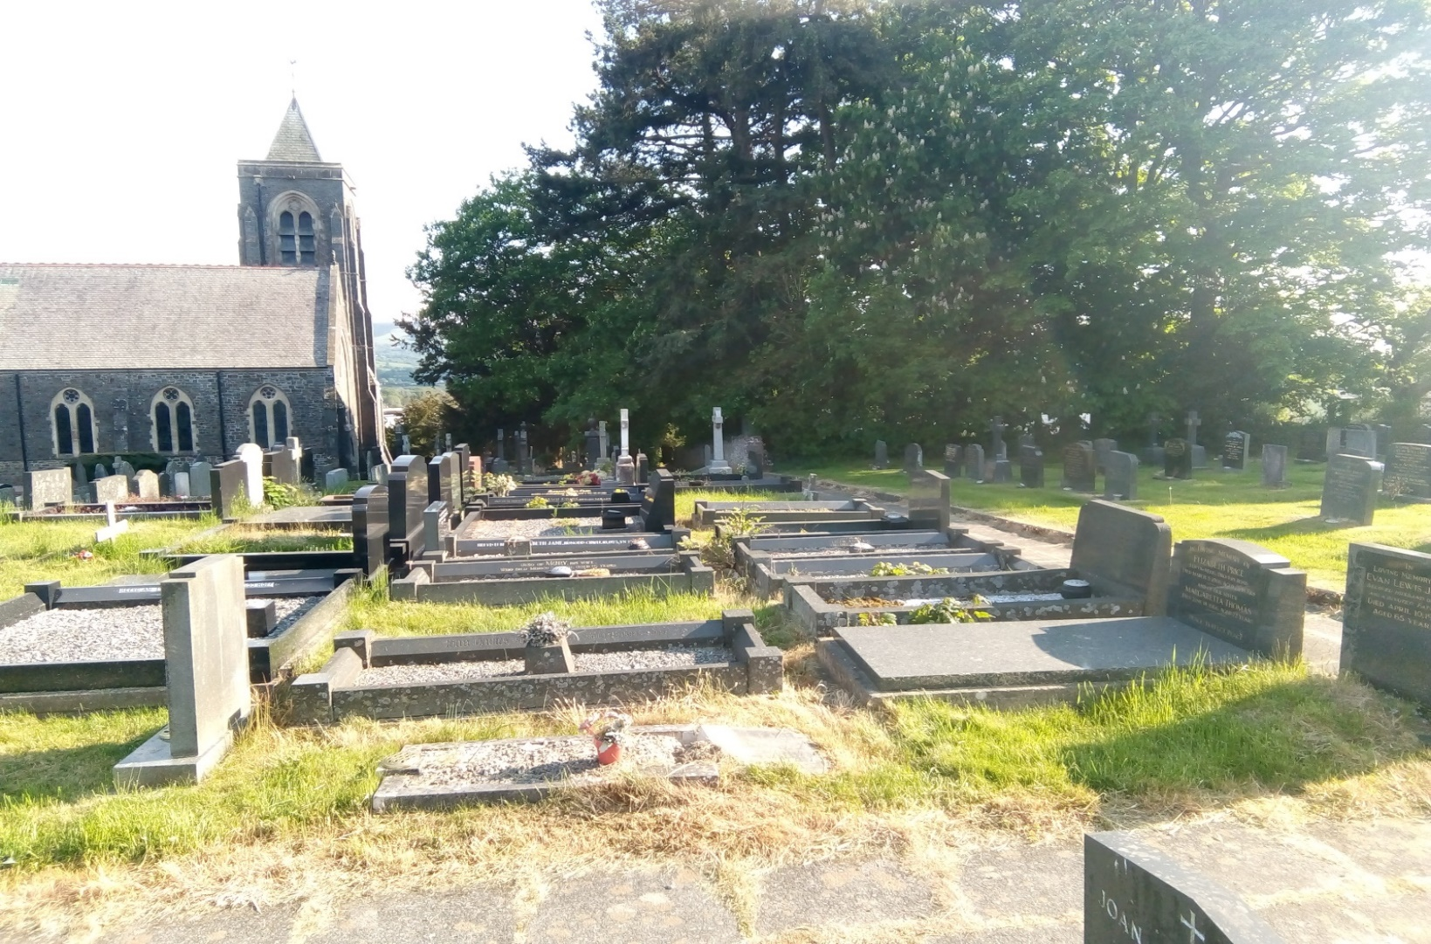
Photograph 5, Section 3. St Peter's Graveyard. Patrick Sweeney. 15 May 2018, Lampeter.
Discussion

Jones (1979) argued that between family no longer being present in the parish to help maintain the grave of their loved one; and parishes struggling with the cost of maintenance; led to the shift in the style of graves to more maintenance friendly ones. This would be hard to argue against if you compare Section 3 graves to 1 or even Section 2 graves. Economics and migration are strong reasons, but are enough? You can go online and search out headstones and find there are still quite a large variety. Economics, in that same search you will find that polished black granite headstones range in price from eight hundred to twelve hundred pounds. This is not an inconsiderable sum of money. Britain has been through several recessions since the late nineteen eighties. Conspicuous consumption may longer be an option or tolerated in community. Tarlow (1999) speaks about changing commemorative practices; Jones (1979) speaks of maintenance and upkeep. On walking through the graveyard from the front gate; through to the most recent burials on the far side of the graveyard; it is hard not to see the changes in commemorative practices; the diminishing ways of memorialising the dead. Tarlow (1999:150) describes the headstone as an observable declaration of emotion for the Victorian’s. Tarlow (1999: 184) concludes that as archaeologists and as archaeologists of death we must look beyond the material. Tarlow goes on to paraphrase Andrews and Barrett (1998) that archaeology is the study of people and not things. Commemorative monuments are more than granite, marble or sandstone; they are filled with the emotions and aspirations of the loved ones left behind.

Conclusion

The data shows the headstones are uniform; what mixture of social expectations, conformity, parish pressure for maintenance and cost have shaped this uniformity I am not yet able to specify. That our attitudes to death have changed is observable; you might argue what is observable is our commemorative mortuary practices. Is that not in itself an indicator of our changing attitude to death. It is difficult to represent an 3D object in bar charts, what would demonstrate the uniformity better would be to use a 3D modelling system, uniformity is still apparent without the 3D modelling by looking at the three tables in the appendix. To reduce error, choose a larger representative sample and from all sections of the graveyard. Is Lampeter alike or anomalous to other rural graveyards? How does rural compare to Town or City graveyards? Do larger populations increase or decrease the similarity to Lampeter? It is interesting the similarity of the uniform rows of small anonymous headstones in the pauper’s section to the rows of uniform headstones in the newest section of the graveyard. From here it would be necessary to do further research; to be able to eliminate some factors and include others yet not considered; before being able to conclusively say which factor or factors have led to the uniformity of headstones at our present time.

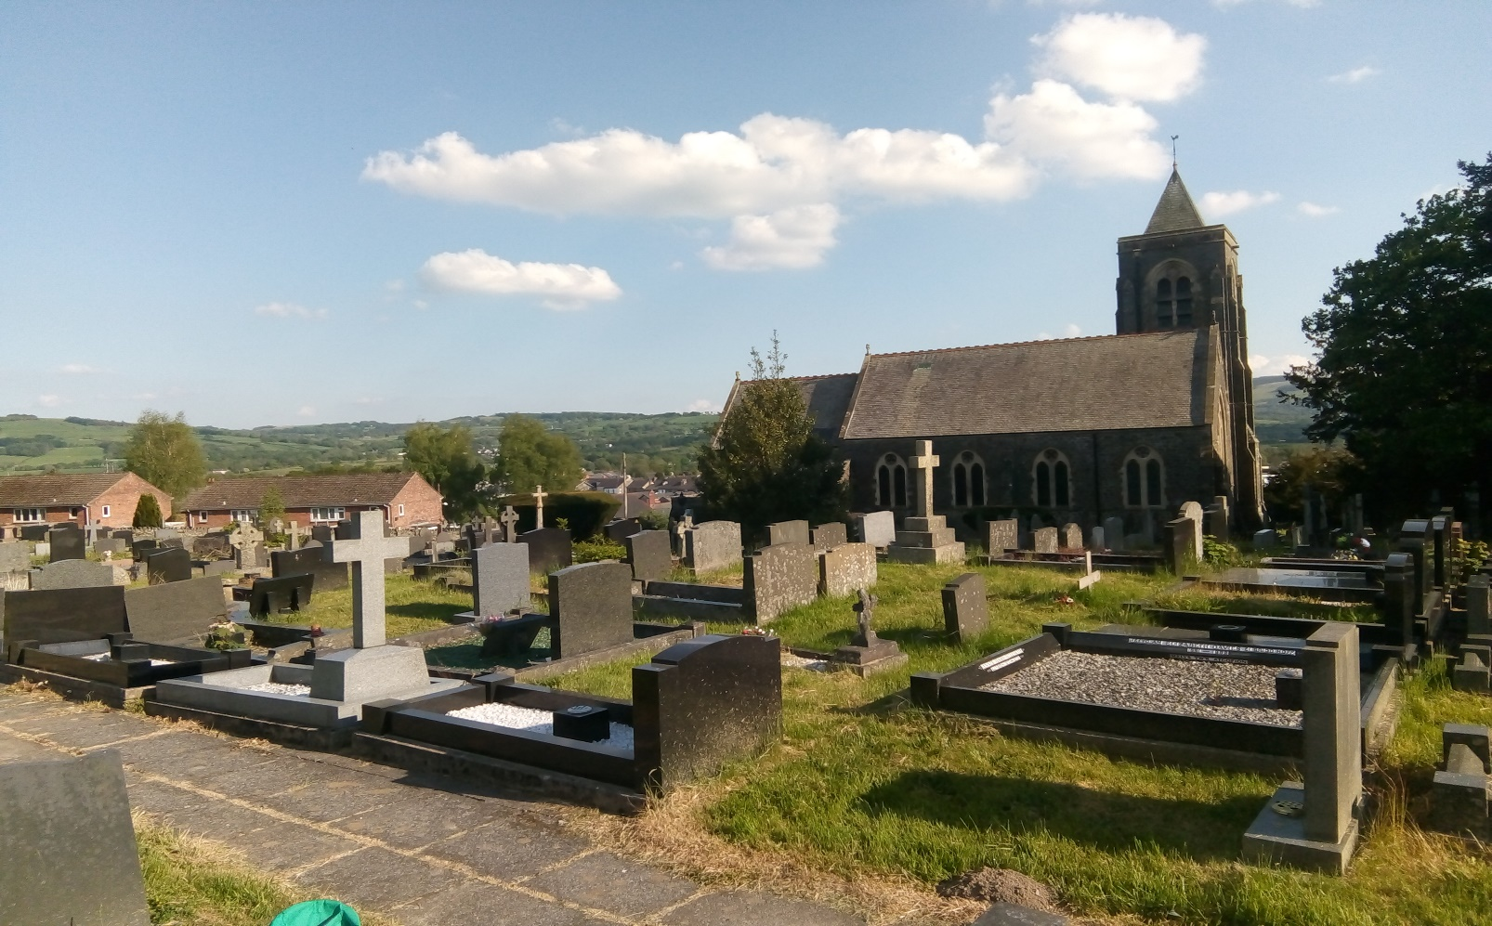
Photograph 6, Section 3. St Peter's Graveyard. Patrick Sweeney. 15 May 2018, Lampeter.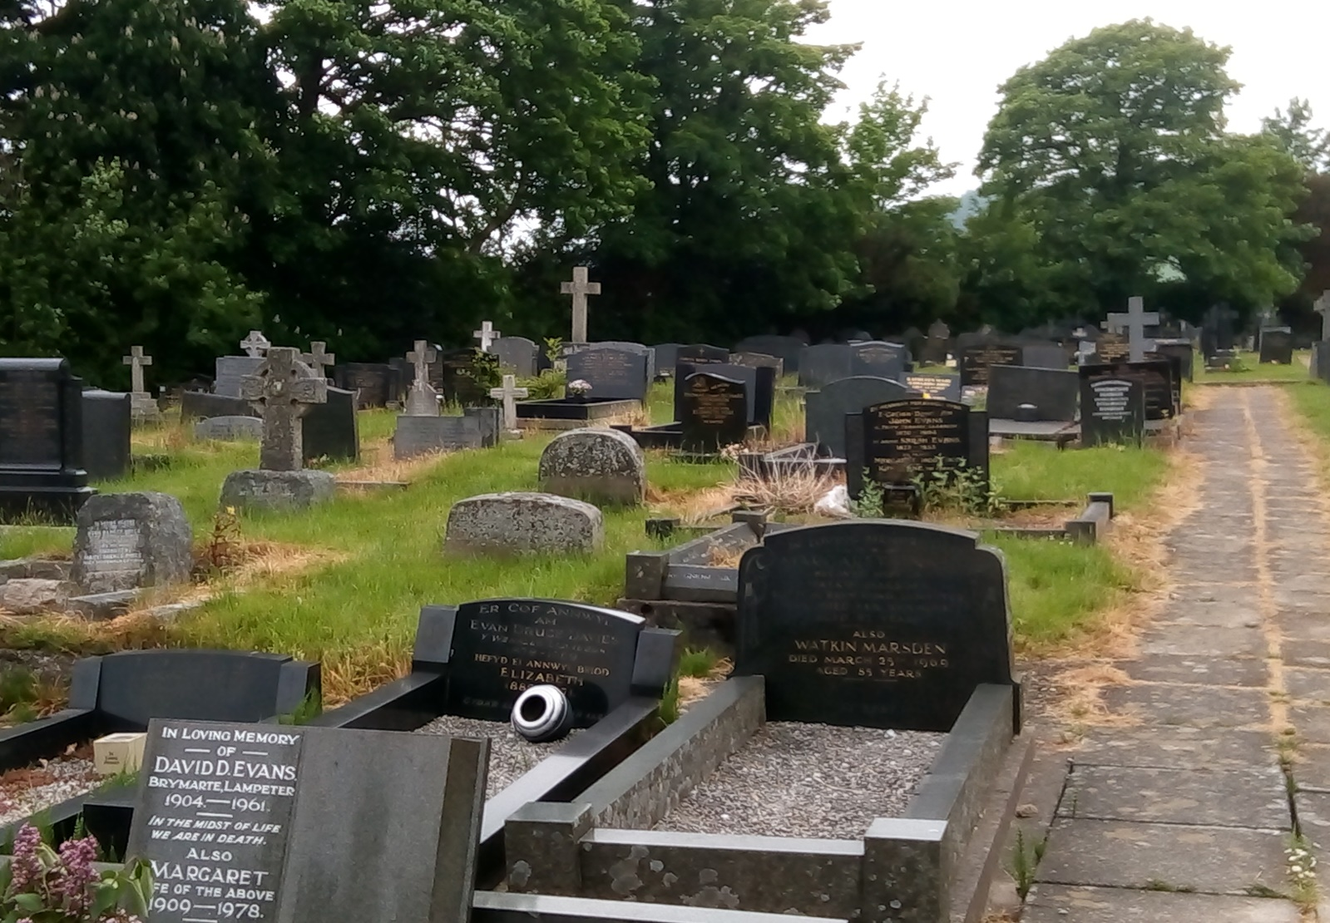Photograph 7, Section 3. St Peter's Graveyard. Patrick Sweeney. 15 May 2018, Lampeter.

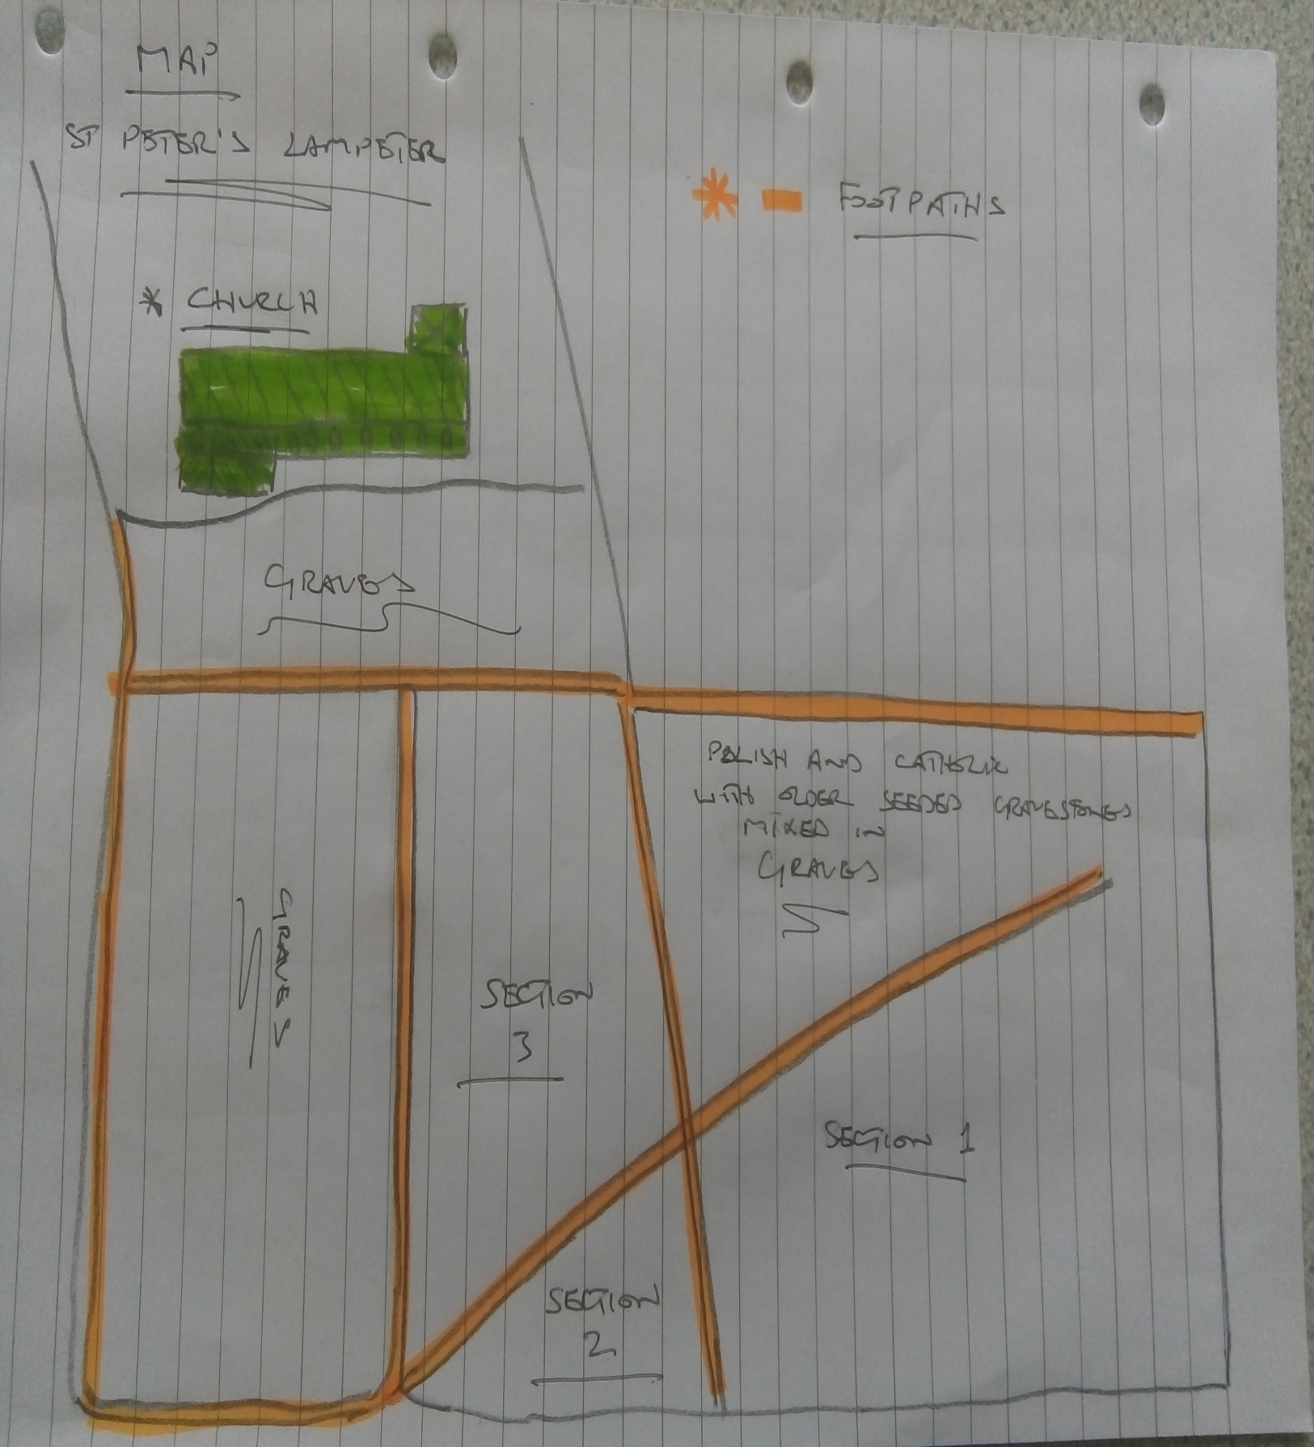
Map 1, St Peter's Graveyard. Patrick Sweeney. 15 May 2018, Lampeter.

Appendix A. Raw data section 1.

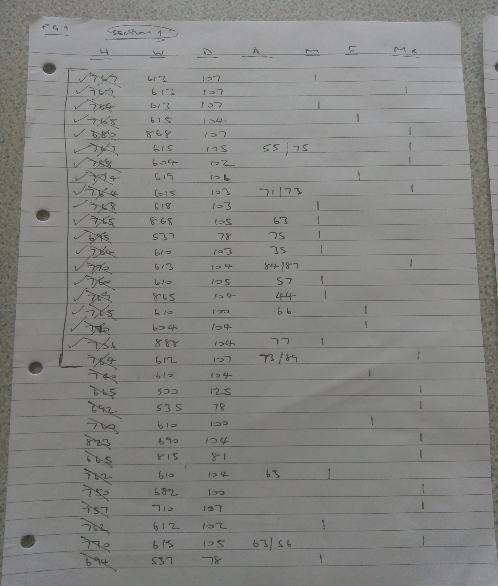
Raw data from Section 1, St Peter’s. Patrick Sweeney. 15 May 2018, Lampeter.

Appendix B and C. Raw data. Section 2 and 3.

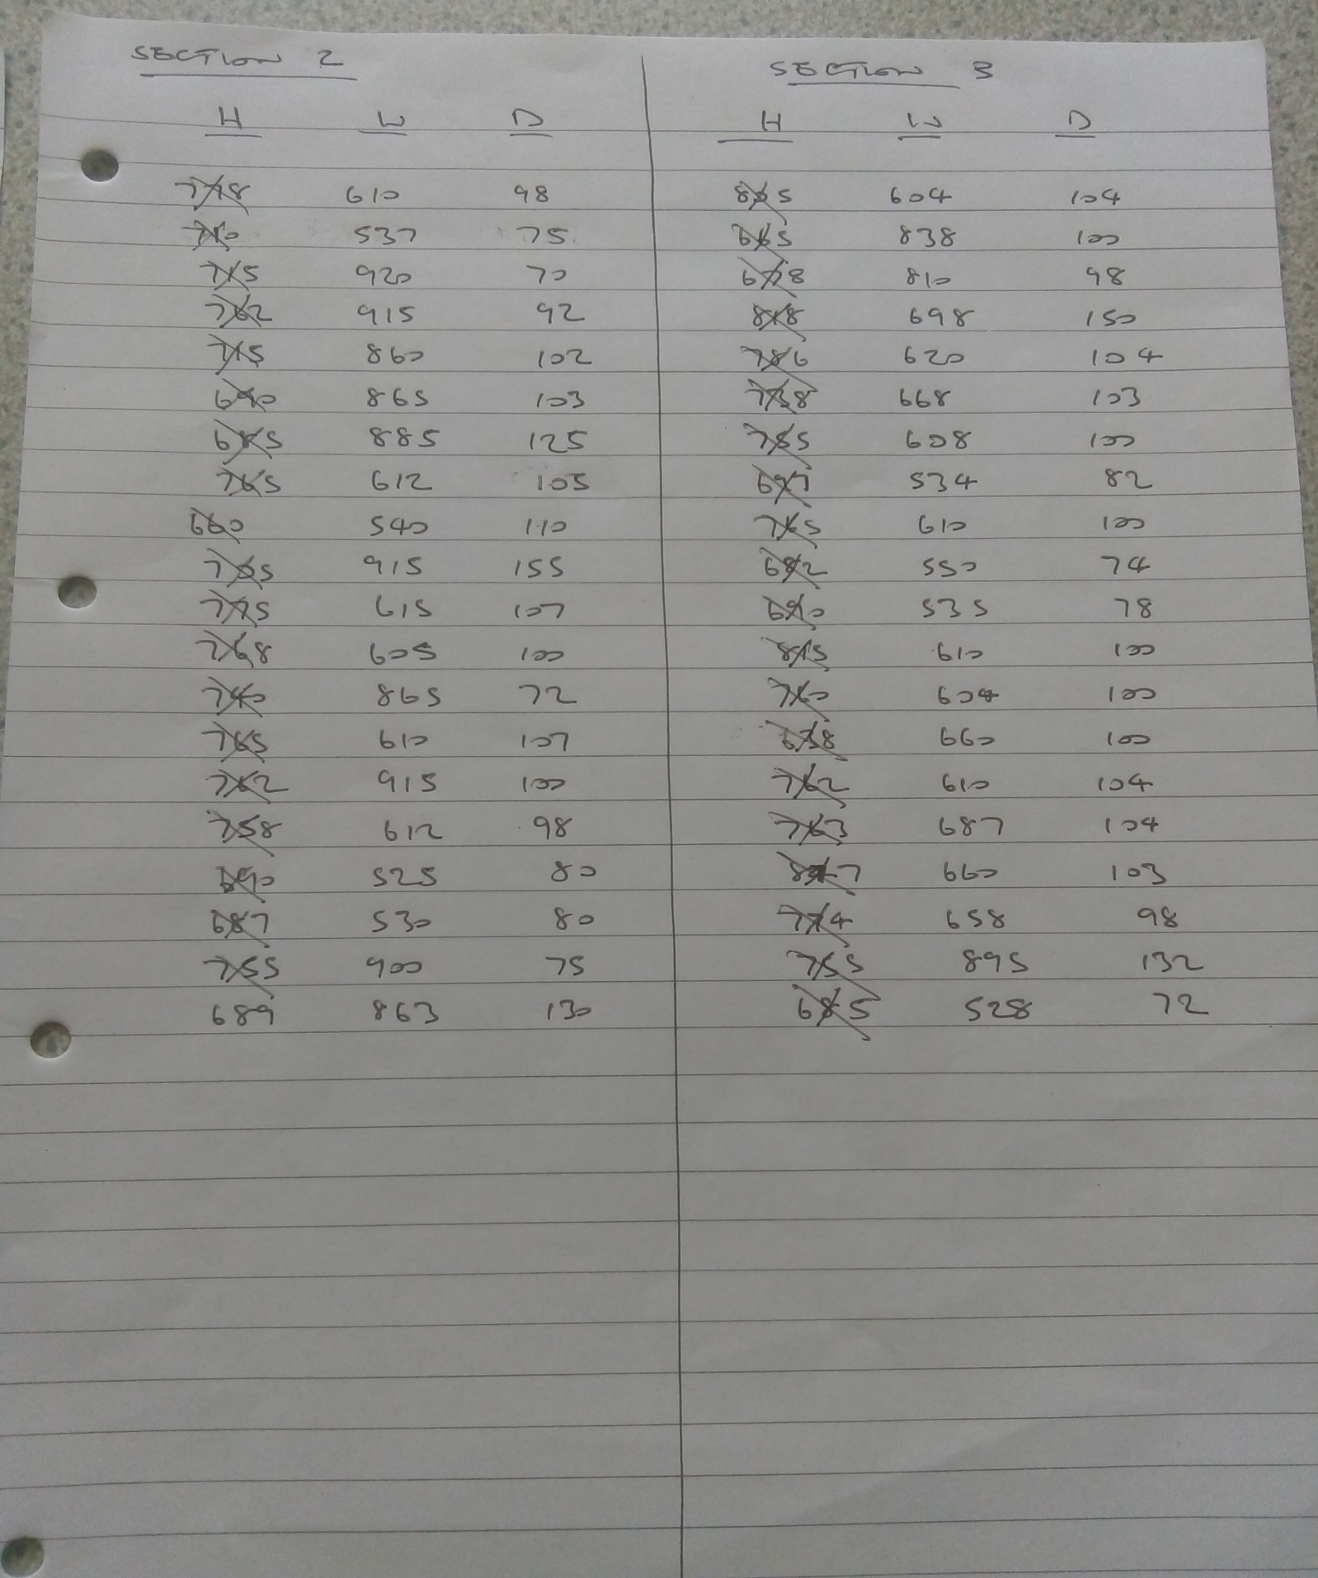
Raw data from Section 2 and, St Peter’s. Patrick Sweeney. 15 May 2018.

Appendix D. Bar chart of headstone height in mm.

Table 1, St Peter’s graveyard. Patrick Sweeney. 18 May 2018, Lampeter.

Appendix E. Bar chart of headstone depth in mm.

Table 2, St Peter’s graveyard. Patrick Sweeney. 18 May 2018, Lampeter.

Appendix F. Graph of headstone width in mm.

Table 3, St Peter’s graveyard. Patrick Sweeney. 18 May 2018, Lampeter.

Reference

Jones, J.A. 1979. How to Record Graveyards. London: Council for British Archaeology.
Pearson, M.P. 1982. Mortuary practices, society and ideology: an ethnoarchaeological study, in
Hodder, I (ed.) Symbolic and structural archaeology. 99-113... Cambridge: Cambridge University Press.
Tarlow, S .1999. Bereavement and Commemoration an Archaeology of Mortality. Cornwall: Blackwell Publishers.

