
Power electronics & drivers
Assignment 1

November 16, 2019
BEng in electrical & electronic engineering
University of Wales Trinity Saint David

Contents
Abstract 2
Introduction 3
Power Factor 3
Power Faction Correction 3
PWM (Pulse Width Modulation) Motors & Drivers 4
Three-phase inverters 4
Over-Current Protection 5
Method 6
Results 8
Exercise One 8
Exercise Two 8
Discussion 9
Conclusion 9
Bibliography 10

Abstract

In this report exercises will be carried out on a circuit board that will have various readings shown by the computer programs on the pc. These programs allow detailed monitorisation of the circuit board as changes occur, such as adding capacitors, faults and other elements to the board. Each experiment will be slightly different in the results they produce and will be documented within the method and results section of the report.
The report includes a detailed examination of each exercise carried out on a circuit board, that is connected to a computer and monitored using its various specialised programs. The programs, allow the user to use an Oscilloscope, multi-meters and visual graphs to monitor and experiment with the circuit board. Adding capacitors, faults and then visualising the effects on the computer. Calculations can then be used to calculate the phase angle and current amplitude.
A section of research is dedicated to the functionality of Power Factor, Power Factor Correction, Pulse Width Modulation and Three-phase inverters. Briefly describing how each element is used and what for.
Followed by the method section, giving the reader a description of each task, the objectives and finally the results of the experiments carried out. Each result is calculated by various calculations and images provided to demonstrate the results in a form of waveforms.
The conclusion thus ends the report, discussing all that was learnt from carrying out the experiments, possible improvements and the limitations of the experiments. References for the report will be found in the Bibliography, seen after the conclusion of the report.

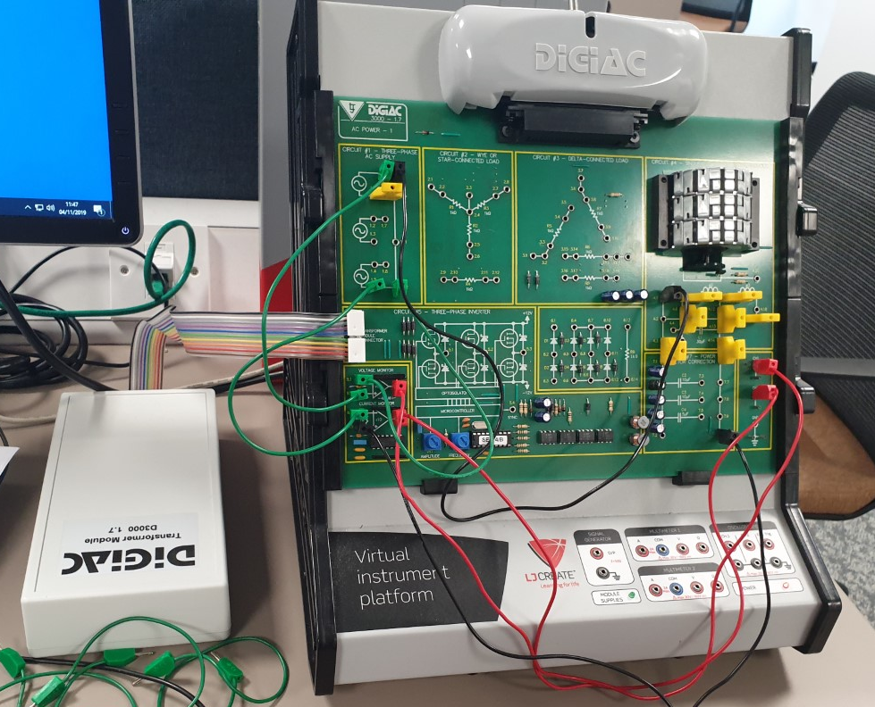

Introduction

Power Factor
Power Factor is the ratio of real power (kW) and the measurement of apparent power (kVA) within a circuit. It is used as an indicator work site energy used and its efficiency. The apparent power is the total of both reactive and real power, the real power identifying as the electricity used by the equipment and the reactive power can be viewed as a side-effect, that is, electricity used but has no real purpose. [1]
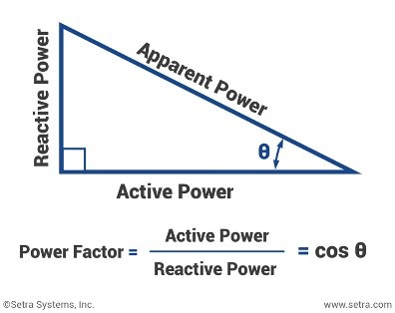 [2]

Power Faction Correction
Power Factor Correction is a technological term that is used to describe the functionality of achieving power factor to be as close to unity as possible. To achieve this within the electrical network, capacitors are added to compensate for the reactive power demand of the inductive load, this reduces losses within the distribution system and in turn reducing the electricity bill. The operation of the capacitors is too, neutralise as much of the magnetizing current as possible, this acts as nominal lagging power factor.
Power Factor is typically around 0.92 – 0.95. This is to prevent wasted energy within the distribution system, also encouraging the consumer to apply the correct Power Factor or be penalised for going above the regulated limit. 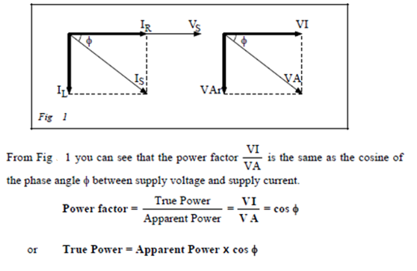

PWM (Pulse Width Modulation) Motors & Drivers
PWM (pulse width modulation), is effectively chopping up the signal into discrete parts which reduces the average power delivered by the electrical signal generated. This “chopping” is created by a controlled switch turning the supply on and off and a quick rate, creating that signature square wave symbol. By placing the switch on the on period for a greater amount of time that the off period, will generate a higher total power that will be supplied into the load. This makes PWM especially suited for running inertial (high-speed centrifuges), loads such as motors, which usually are not affected by discrete switching, mainly due to the inertial reacting slowly.
Ideally the switching frequency of the PWM will need to be high enough as to not affect the load and the resultant waveform by the load must be as smooth as possible to generate and the frequency rate at which the switch occurs can vary greatly depending on the application and load. [3]

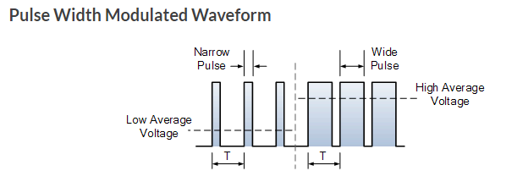 [3]

Three-phase inverters
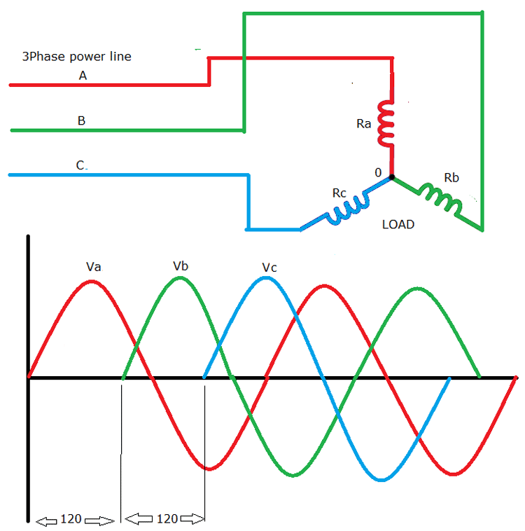
The three-phase inverter is a device that converts the DC input, into a three-phase AC output. It does this through generating output pulses spaced apart by 120$°$ from one and other at 60 pulses in one-half cycle that are connected to three separate loads. [4]
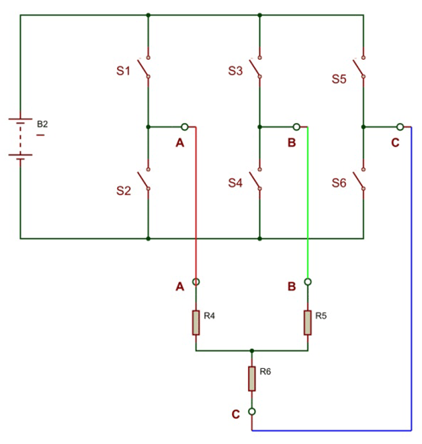

Over-Current Protection
Overcurrent protection for the three-phase supply is critical to both personal and equipment safety and from various other hazardous conditions that may occur from faulty overload protection within the circuit. Overcurrent protective devices or (OCPD’s), are used to protect against ignition/flash hazards from faulty voltage related or interruptive overcurrent’s in a circuit, or other faults such as; over-load currents and short-circuits within the system. These faults can result in various hazardous incidents such as injury, damage of equipment or even death, if not properly maintained and regulated.
Standard circuit protective devices would fall ineffective against a three-phase supply, as they could easily explode or rupture from inadequate voltage ratings, therefore there are a separate form of protection required. [5]

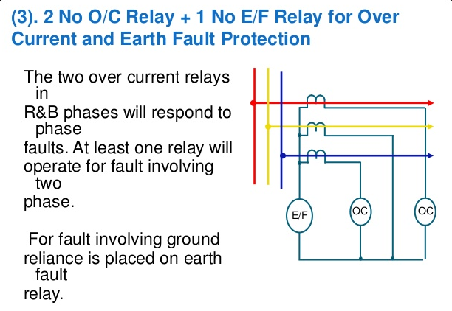
[6]

Method
The objectives for this experiment were to, connect the circuit board as seen in the figures below and measure the effects of having no correction capacitor added to the circuits and then adding various types of capacitors to the circuit. The examine how these changes would affect the phase angle and current amplitude of the circuit board. This was achieved by connecting the circuit board to a computer and analysing the readings using the Oscilloscope program on the pc, multi-meters and power supply module, which allows the experimenter to view the sign waves on the computer.
The first exercise was to measure the phase angle between the voltage supply and the current, which would be lagging with no capacitors added to the circuit because it’s an inductive load. Secondly the experimenter would measure the current amplitude in mA peak – peak and then use the equations seen in example one, to convert the reading into results. The results would then be displayed in a table within the results section of the report and discussed in the discussion section.
After this, a fault will be added to the circuit and following the principles above the results would be obtained, documented, discussed and compared to first set of results.
The second exercise would consist of the observation of three-phase inverters being placed into the circuit, over current protection and finally another fault added. Once again, the same procedures as the first exercise would be carried out to monitor the changes using the computer programs, the equations to calculate the results and those then being placed into a table and discussed I detail.
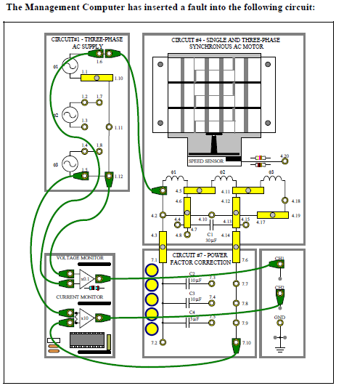
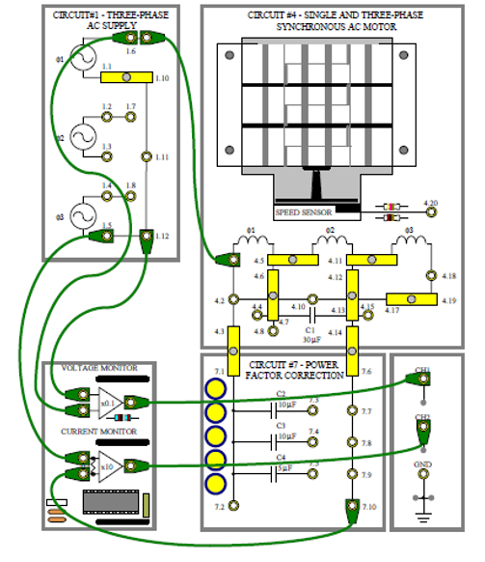
Figure.1 Figure. 2

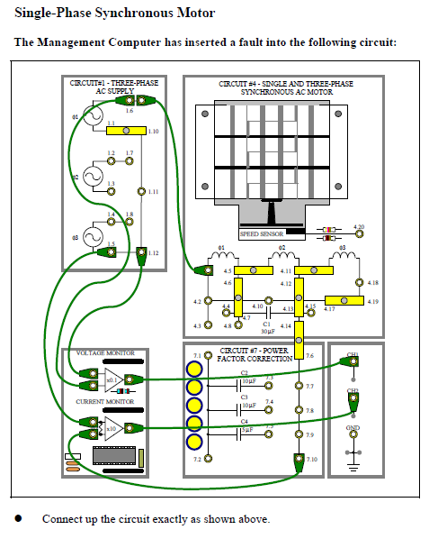
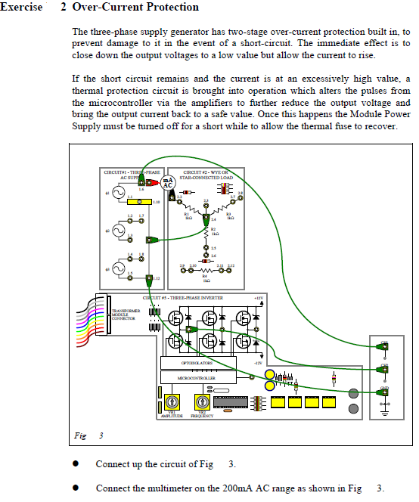
Figure 3. Figure 4.

The equations used to calculate the phase angle and current amplitude can been seen below, along with screenshots of the computer program used to monitor the results and discover the figures needed to calculate the results;
Phase Angle = $\frac{time}{period }=x 360=Degrees(°)$
Current Amplitude = $\frac{Peak-Peak x 1000}{10}=$ mA
Example one;
Connection capacitor: None
Time period: 13.943ms
- Phase angle (lead/lag) = Lagging

DX: 1.343ms

$$\frac{time}{period }= \frac{1.343}{13.843}x 360=34.67°$$

- Current amplitude (mA peak – peak)
DY: 5.299V
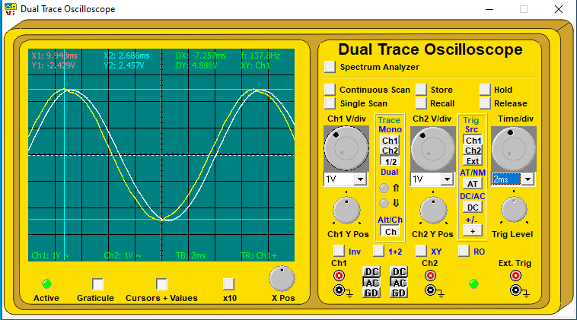
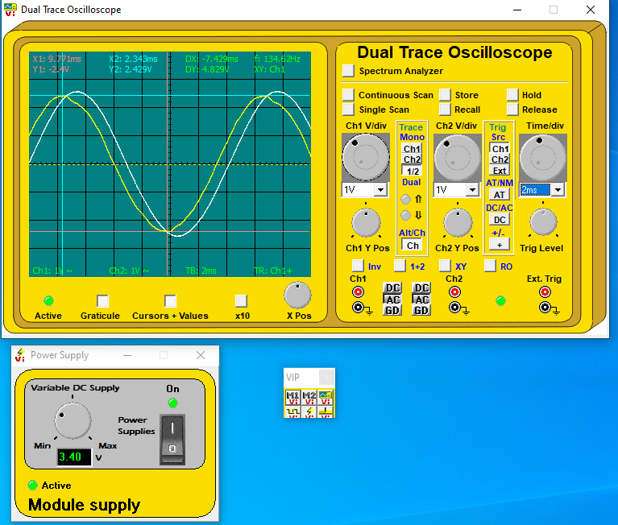
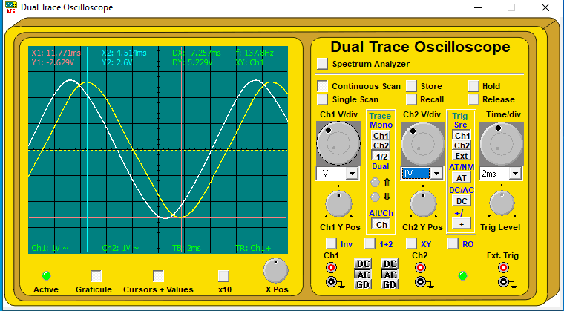
$$\frac{P-P x 1000}{10}= \frac{5.299 x 1000}{10}=522.9mA$$
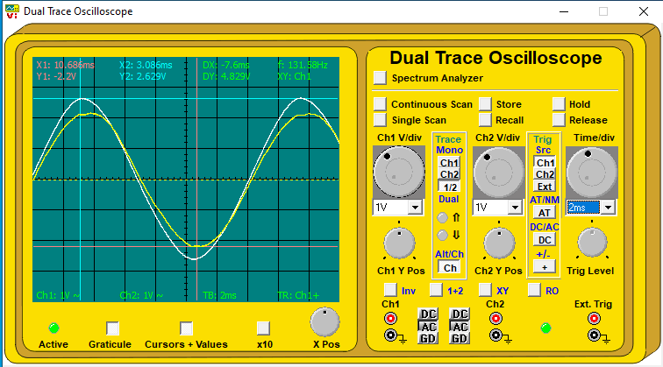

Results

Exercise One
Time Period: 13.943ms
Correction Capacitor | None | C2 + 10µF | C2 + C3 - 20µF | C2 + C4 - 15µF
DX | 1.343ms | 200µs | 914.286µs | 571.429µs
Phase Angle | 34.67$°$ | 5.163$°$ | 23.61$°$ | 14.75$°$
Lead/Lag | Current Lagging | Current Lagging | Current Leading | Current Leading
DY (P-P) | 5.229V | 4.371V | 4.829V | 4.886V
Current Amplitude | 522.9mA | 489.2mA | 489.2mA | 488.6mA

The yellow section is highlighting the best functioning capacitor correction.
- Power Factor (cos ɸ), with no correction capacitor: cos (34.67$°$) = 0.822
- Power Factor (cos ɸ), with the best correction capacitor: (5.163$°$) = 0.995
- Supply voltage (V p-p): 5.029V x 10 = 50.29V (p-p)
- Power supply in watts: V x I x cos = $\frac{V}{2 √2 }x \frac{I}{2 √2 }$
None = $\frac{50.29}{2 √2 }x \frac{.5992}{2 √2 }=3.77W$
C2 = $\frac{50.29}{2 √2 }x \frac{.4371}{2 √2 }=2.97W$

Exercise Two
Time Period: 15.682ms
Correction Capacitor | None | C2 + 10µF | C2 + C3 - 20µF | C2 + C4 - 15µF
DX | 1.729ms | 1.754ms | 2.214ms | 1.928ms
Phase Angle | 39.69$°$ | 40.26$°$ | 50.82$°$ | 44.25$°$
Lead/Lag | Current Lagging | Current Leading | Current Leading | Current Leading
DY (P-P) | 5.37V | 5.283V | 6.284V | 5.177V
Current Amplitude | 537mA | 528.3mA | 628.4mA | 517.7mA

The yellow section is highlighting the faulty capacitor correction.
- Power Factor (cos ɸ), with no correction capacitor: cos (39.69$°$) = 0.77
- Power Factor (cos ɸ), with the faulty correction capacitor: (50.82) = 0.63
- Load current = 27.6mA AC

Discussion
The results gathered from exercise one demonstrates only a slight difference, in performance from each correction capacitor installed into the circuit. This may seem insignificant or pointless, but by reducing the overall power factor an industry that demands a high-power supply could save greatly on their current consumption, simply by generating a greater power output from using the same current or less amps.
The second exercise shoes similar results to the first one, minus the faulty capacitor.
The final excursive sees a current out of 0.172A and a voltage of 16.75V before any capacitors are added. Adding a capacitor to the circuit causes the motor to react within the circuit, causing the voltage to reduce and thus brining it down to a minimum of 1.49V. The current then rises to an astonishing 398mA before reducing to 38mA after 10 seconds and the voltage also reduces to 0.17V.

Conclusion
From these exercises it demonstrates how adding a capacitor to the circuit, greatly improves the overall phase angle and current amplitude. These exercises also show how choosing the right capacitor is crucial and how a faulty capacitor can have negative affects o the circuit and overall power factor, especially when dealing with high amounts of voltage and current.

Bibliography

[1] | B. O'Neill, “Power Factor Explained,” Canstar Blue, 15 December 2017. [Online]. Available: https://www.canstarblue.com.au/electricity/power-factor-explained/. [Accessed 12 December 2019].
[2] | D. Banshir, “What do you mean by power factor (pf)?,” 5 April 2018. [Online]. Available: https://www.quora.com/What-do-you-mean-by-power-factor-pf. [Accessed 12 December 2019].
[3] | E. Tutorials, “Pulse Width Modulation,” Electronics Tutorials, 1 October 2019. [Online]. Available: https://www.electronics-tutorials.ws/blog/pulse-width-modulation.html. [Accessed 12 December 2019].
[4] | D. Raja, “Three Phase Inverter Circuit - 120 Degree and 180 Degree Conduction Mode,” 29 November 2019. [Online]. Available: https://circuitdigest.com/tutorial/three-phase-inverter-circuit-diagram-120-degree-and-180-degree-conduction-mode. [Accessed 02 December 2019].
[5] | K. Kelle, “Overcurrent Protection,” N/A N/A 2010. [Online]. Available: https://www.sciencedirect.com/topics/engineering/overcurrent-protection. [Accessed 02 December 2019].
[6] | S. S. Palayi, “Basics of overcurrent protection,” 01 September 2015. [Online]. Available: https://www.slideshare.net/sspalayi/basics-of-overcurrent-protection. [Accessed 05 December 2019].

