Student Name: Adam Dean
Student ID Number: 2304834
Module: Construction materials
Module Code: ACBA40

A Comparative Analysis of Concrete and Steel Framing: Case Studies of the Angel Building and Gatwick Airport.

( External Areas Gatwick March 2019 - J (106).jpg )

Contents page
3. Introduction
4. Angel Building
6. Gatwick Airport
10. Summative Comparison
12. Conclusion
13. References

Introduction
This report looks at the framing materials used in two buildings. The Angel Building, which has a concrete frame, and Gatwick Airport, a steel frame. It looks at the benefits and drawbacks of concrete and steel, focusing on strength, durability, performance, how they impact the environment and local communities. It also considers how easy they are to assemble and how flexible they are over time. The outcome is to understand what influences the choice of framing materials in construction.
The Angel Building and Gatwick Airport were designed with different priorities. The Angel Building focuses on sustainability and energy efficiency, utilising reinforced concrete while Gatwick Airport required open space and flexibility and used steel framework.

The Angel Building.
The Angel Building, a six-storey office space in London, was redeveloped with a reinforced concrete frame for strength and energy efficiency. Concrete’s thermal mass helps keep the building cool, reducing the need for air conditioning (Allen & Iano, 2019). It has compressive strength, making the structure solid, and since it’s durable and weather-resistant, maintenance requirements are reduced (CivilConcept, 2023).
The exposed concrete works with a displacement ventilation system allowing temperature control and improved energy efficiency. However, concrete is a major source of CO₂ emissions. Producing it requires significant water and raw materials, which isn’t environmentally sustainable (CivilConcept, 2023; Soutsos & Domone, 2017). Advancements in cement production could lower its environmental impact.
Framing Material Choice: Strength, Durability & Climatic Resistance
The Angel Building uses a reinforced concrete frame. Its strength, durability, and ability to store and release heat, suits London’s moderate climate and meets the building’s sustainability goals (Allen & Iano, 2019).
Concrete is resistant to wind, moisture, and fire, contributing to the building's durability (Soutsos & Domone, 2017). Exposed concrete surfaces are fire resistant, making it a safe choice for office spaces (Soutsos & Domone, 2017). Its thermal mass helps regulate indoor temperatures by absorbing and slowly releasing heat, reducing requirements for heating and cooling. Concrete can crack due to thermal expansion and shrinkage, so proper reinforcement and maintenance is required (Allen & Iano, 2019). Concrete takes time to cure on-site, which increases labour costs and has budgetary considerations. Its rigidity makes future modifications harder.
While reinforced concrete makes the Angel Building durable and energy-efficient, it’s not as flexible as steel and is prone to cracking. The building is built to last, but modifying or expanding it later would be difficult (Allen & Iano, 2019), reducing its adaptability.
Impact of the Framing Material’s Production Process
Cement, the main component of concrete, has one of the highest environmental impacts in construction, accounting for 8% of global CO₂ emissions (Soutsos & Domone, 2017). A large proportion of these emissions originates from limestone calcination, producing carbon dioxide during cement production. Beyond carbon output, the quarrying of raw material can damage ecosystems. Cement plants produce dust and particles that lower air quality, increasing health risks (Allen & Iano, 2019).
Concrete production requires large amounts of water, adding extra tension on local supplies, which can be problematic in low water regions. While concrete’s durability reduces the need for frequent repairs or replacements, providing some mitigation, its initial carbon footprint remains high (Soutsos & Domone, 2017). Recycling crushed concrete as aggregate helps mitigate some environmental harm, but it does not fully counteract the material’s overall impact.
To improve sustainability, low-carbon cement alternatives and carbon capture technologies are needed to lower concrete’s high embodied carbon emissions (Allen & Iano, 2019).
Ease of Assembly & Adaptability.
Concrete construction is slow, making modifications and expansions expensive, leading to increased costs (Soutsos & Domone, 2017). Any structural changes to a reinforced concrete frame require extra reinforcement to maintain stability.
Concrete frames limit flexibility, making adaptations challenging (Allen & Iano, 2019). Unlike steel structures, which can be modified with ease, concrete’s rigidity creates challenges in fast-changing urban environments. Future projects may need more solutions that combine its resilience with materials that allow for easier modifications (Allen & Iano, 2019).

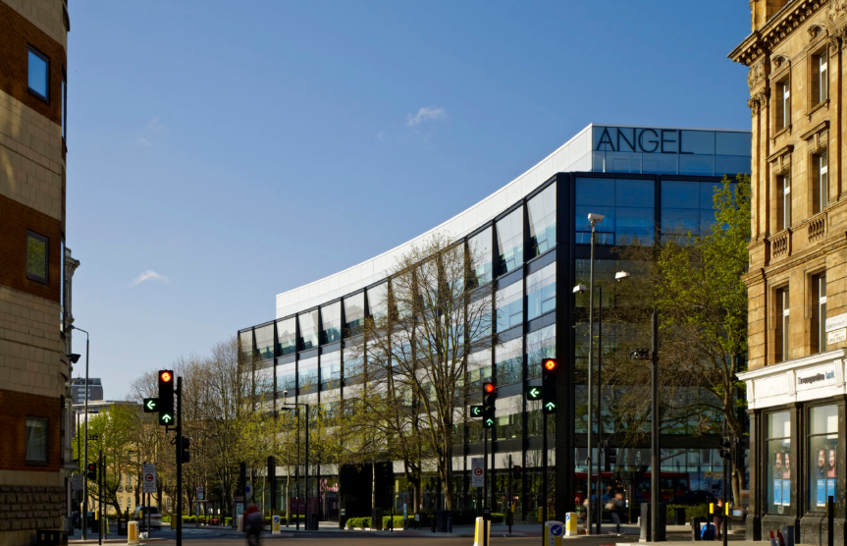
(Angel Building - Properties - Derwent London)
To summarise, The Angel Building demonstrates the benefits of concrete when creating modern office spaces. Its solid concrete frame provides strength and durability while thermal mass improves energy efficiency (Allen & Iano, 2019).
Concrete’s durability makes it a good choice for urban office buildings, resisting weather and fire hazards.
Architectural considerations may also play a factor in considering materials to sustain the aesthetic of a location. The building’s industrial aesthetic fits the architectural style of many locations which may have concrete framed structures, combining visual appeal with long-term sustainability (Allen & Iano, 2019).

Gatwick Airport
Gatwick Airport uses a steel-framed structure ensuring expansive spaces considered essential for efficient passenger movement. Steel was chosen for its high strength to weight ratio, allowing for bigger spans with fewer support columns, which optimises space (Soutsos & Domone, 2017). Steel is resistant to corrosion and fire, ensuring durability over time (Allen & Iano, 2019).
Steel is considered sustainable due to its high recyclability. Many parts of the airport’s framework are made from recycled materials, which reduces the environmental impact (CivilConcept, 2023). The use of prefabricated steel sections reduces construction time, minimising disruption (Allen & Iano, 2019).
Steel production is high energy, releasing high carbon emissions during iron ore extraction (Soutsos & Domone, 20). While, steel is adaptable and efficient for large scale projects, addressing its environmental impact is a challenge.
Framing Material Choice: Strength, Durability & Climatic Resistance
Selecting a steel framed structure for Gatwick Airport demonstrates this material's suitability for environments that have significant construction and pedestrian traffic. Steel is well known for its high tensile strength and adaptability, essential for creating expansive spaces. Its strength-to-weight ratio permits long spans with minimal internal columns, ensuring accessible spaces which are flow-friendly.
Steel is highly rated for its flexibility, allowing structures to absorb seismic activity and counteract fatigue. The National Academy of Sciences cites this as an important safety aspect for environments such as airports (The National Academies of Sciences, Engineering, and Medicine, 1994). Steel’s resistance to environmental factors, such as corrosion and temperature is beneficial. Although in humid environments, where moisture and salt exposure lead to rust, protective coatings and regular maintenance are needed. Not using steel appropriately makes it prone to corrosion. While fire resistant coatings and galvanization can help lower these risks, they do not remove the need for remedial actions and necessary repairs (Harris & Watson, 2020).
Steel can be made quickly, by prefabrication, which is advantageous, especially in reducing disruption during construction. This speed of assembly reduced the impact, ensuring continuity of operation. However, while prefabrication accelerates initial construction, the long-term need for maintenance to prevent corrosion is a consideration, especially in an environment subject to high humidity. However, as it's located in the UK this may not be a significant concern (Bryant, 2020).
Despite its higher maintenance requirements, steel is the best choice for large infrastructure like Gatwick Airport because of its structural efficiency and adaptability. Steel can create expansive spaces which is advantageous with flexibility for future changes and expansion or improvements. While maintenance is a consideration, the advantages that steel brings outweighs the disadvantages for such projects as Gatwick Airport, ensuring future demands will be met (Harris & Watson, 2020; Crocker, 2021).
Impact of the Framing Material’s Production Process
Steel production is energy-intensive, but its high recyclability reduces long-term environmental impact compared to concrete (Crocker, 2021). There are also benefits to communities with job creation and subsequently economic growth.
Steel manufacturing contributes to approximately 7–9% of global CO₂ emissions, primarily from iron ore extraction and smelting. However, using steel scrap in the production process can reduce CO₂ emissions by 58%. Over 90% of structural steel is recycled, significantly lowering its lifetime carbon footprint.
The initial energy demands of steel production are high, but its ability to be recycled infinitely ensures sustainability. Communities near steel mills often experience air pollution and heavy metal contamination because of emissions from steel production. Industrial pollutants released by steel plants can hinder air and water quality in nearby areas, leading to environmental and health concerns (Crocker, 2021). Advancements in electric arc furnace (EAF) technology improves energy efficiency, reducing steel’s carbon footprint (Bryant, 2020).
Steel offers significant long-term benefits due to its recyclability and efficiency. However, the initial production process remains energy-intensive, with ongoing efforts needed to reduce emissions (Bryant, 2020).

Ease of Assembly & Adaptability
The flexibility and adaptability of steel has advantages over concrete for large scale infrastructure projects like Gatwick Airport (Harris & Watson, 2020). Steel frames are made off site, reducing on site construction time and minimizing disruptions to airport operations. The buildings design also allows for easy expansion and redesign, which is important for changing environments like airports (Harris & Watson, 2020). Gatwick’s steel frame enables quick construction and future modifications with low structural impact. Steel can also adapt to changing needs ensuring value long term (Harris & Watson, 2020).

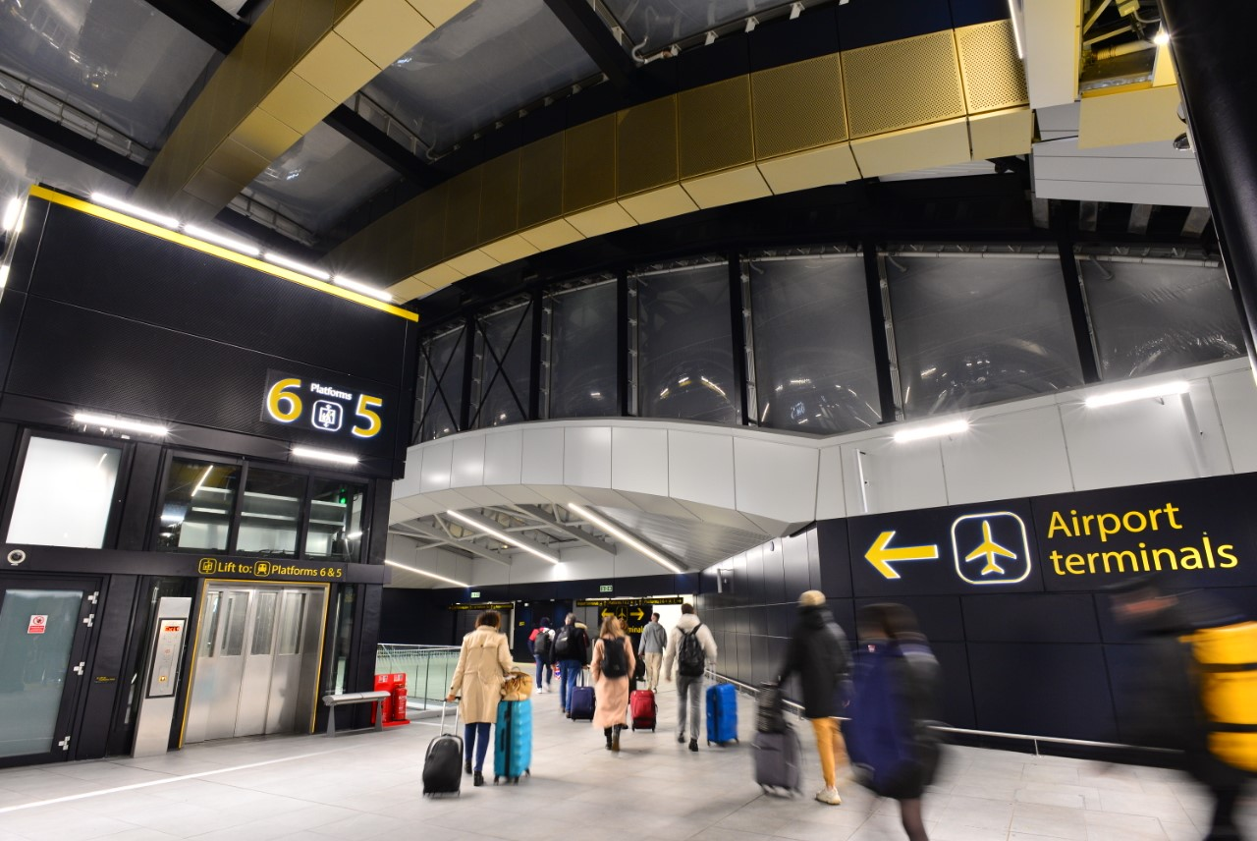
( Wayfinding strategy for Network Rail & Gatwick Airport Limited | Mima)
This image of Gatwick Airport highlights its steel-framed structure, which provides large, open spaces with minimal internal columns, allowing for easy passenger flow, accommodating high traffic. Steel’s ability to withstand environmental stresses, such as seismic activity and heavy foot traffic, is crucial for the airport’s expansive terminals and concourses (Harris & Watson, 2020 and Crocker, 2021). Additionally, the steel frame enhances the airport's modern look, with its clean, minimalist design that blends practicality with visual appeal (Bryant, 2020).
Comparative Analysis of Structural Approaches.
These two structures are compared to show how structural materials affect long-term efficiency, sustainability, and functionality.
The Angel Building, with its concrete construction is perfect for workplace spaces that value energy efficiency, guarantees durability, fire resistance, and passive cooling. The steel frame of Gatwick Airport, on the other hand, offers modular adaptability, quick assembly, and spatial flexibility, satisfying the requirements of heavy traffic infrastructure that is necessary for changing transportation hubs (CivilConcept, 2023; Allen & Iano, 2019).
Fire resistance is a critical factor in material selection, especially in large scale structures. According to British Standards (BS EN 1992), reinforced concrete offers enhanced fire resistance compared to steel, making it a preferred choice in high rise construction (Chudley & Greeno, 2019). Its non-combustible nature allows it to maintain structural integrity under high temperatures, unlike steel, which requires additional fireproofing measures such as coatings. While concrete’s thermal performance enhances fire resistance, its slow production time and environmental impact pose sustainability and financial challenges. steel on the other hand offers faster construction and greater flexibility, but its production emissions show the need for better recycling efforts.
While both materials serve their roles, future construction must incorporate low-carbon alternatives to mitigate environmental concerns (Soutsos & Domone, 2017; Allen & Iano, 2019).
Advancements in low-carbon cement alternatives and sustainable steel production will be critical for the future of eco-friendly construction (Allen & Iano, 2019; CivilConcept, 2023).

Factor | Concrete | Steel
Strength | Good compressive strength but can be weak to tension (Allen & Iano, 2019). | Very high tensile and compressive strength, good for load bearing structures (Soutsos & Domone, 2017).
Durability | Resistant to fire, water, and weathering, but may crack over time if not maintained properly (CivilConcept, 2023). | Corrosion concern, maintenance or additional coatings required (Harris & Watson, 2020).
Sustainability | High CO₂ emissions from cement production but can use recycled aggregates (Crocker, 2021). | Recyclable with lower CO₂ footprint per reuse (Bryant, 2020).
Time to make | Longer production time, impacting costs (Allen & Iano, 2019). | Quicker production time reduces on-site work (Soutsos & Domone, 2017).
Price | Initially cheaper but may require maintenance/ repairs (CivilConcept, 2023). | Higher initial cost, lower maintenance costs (Harris & Watson, 2020).
Thermal Performance | High thermal mass, natural temperature regulation (Allen & Iano, 2019). | Low thermal mass, requiring more insulation (Soutsos & Domone, 2017).

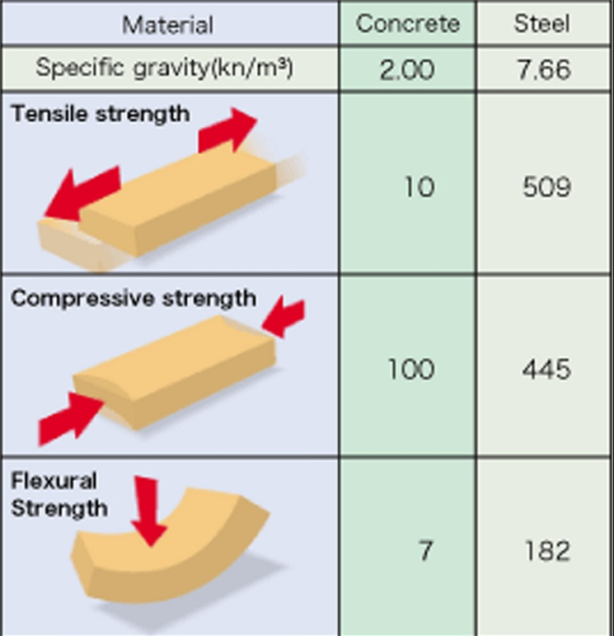

(Skoutaris Steel – Structural Steel)
This graph shows that steel can handle higher levels of tension without breaking, whereas concrete can crack or break under stress. Steel has a normal reaction to loads, making it easier to design. Different to concrete, which takes time to make and can be prone to brittle failure, steel can take heavy loads and bend rather than snap, making it good for large buildings and large structures. Even though concrete is still good, especially for handling compression loads, this comparison demonstrates why steel is often the material for projects requiring durability and resilience.

Conclusion
The framing choices of the Angel Building and Gatwick Airport show the benefits and drawbacks of concrete and steel. Concrete, used in the Angel Building, provides durability, thermal, and energy efficiency but faces challenges with strength and a carbon footprint. On the other hand, Gatwick Airport’s steel frame allows for fast construction, flexibility, and expansive spaces, though it requires plenty of energy for production and maintenance.Concrete improves energy efficiency and structural integrity in office buildings, while steel suits dynamic environments like transport centres. However, both production processes have environmental challenges, concrete’s high CO2 emissions and steel’s energy demands.
Ultimately, while concrete remains the most used material for compressive load bearing, the increasing focus on sustainability and structural efficiency has led to improvements in high performance steel and hybrid construction techniques. In conclusion, the choice depends on project-specific requirements, durability and environmental impact outweigh strength considerations

References
Allen, E., & Iano, J. (2019). Fundamentals of Building Construction: Materials and Methods. John Wiley & Sons.
CivilConcept. (2023). "Concrete as a Building Material: Advantages and Disadvantages."
Soutsos, M. N., & Domone, P. L. (2017). Construction Materials: Their Nature and Behaviour. CRC Press.
The National Academies of Sciences, Engineering, and Medicine (1994) Fatigue and Fracture of Steel Structures. Washington, D.C.: National Academies Press.
Bryant, S. (2020). Britain is playing catch-up inside the race for clean steel. The Times. Retrieved from https://www.thetimes.co.uk/article/britain-is-playing-catch-up-inside-the-race-for-clean-steel-times-earth-95frrm50c
Crocker, K. (2021). Recycling in the steel industry. Circular Economy. Retrieved from https://circulareconomy.europa.eu/platform/sites/default/files/euric_metal_recycling_factsheet.pdf
Harris, T., & Watson, G. (2020). Comparison of construction materials: Steel vs. concrete. AISC Architecture Center. Retrieved from https://www.aisc.org/architecture-center/design-principles/comparison-to-other-materials/
Skoutaris Steel. (n.d.). Structural Steel – Technical Information. Retrieved from https://skoutarissteel.com/en/technical/structuralsteel/
Chudley, R., & Greeno, R. (2019). Building Construction Handbook (11th ed.). Routledge.
Riley, M., & Cotgrave, A. (2017). Construction Technology 3: The Technology of Refurbishment and Maintenance (2nd ed.). Palgrave Macmillan.

