Health, wellbeing and sustainable development

Halema begum 1816637

Written assessment

Lecturer Jonathan wyatt

Contents
introduction 2
introduction to concepts 2
Goal a 3
What are the factors that determine why one uses a food bank 4
working poverty 4
Cost of living 4
Goal A Plan 2 5
Marcus Rashford 5
Challenges in implementing the goal and reccomendations 6
Goal B– Plan 1 6
What effects does a period have on a female 7
What may prevent a person from purchasing menstrual products 7
Goal B plan 2 8
Types of contraception 8
Purpose of contraception 9
Sexually transmitted disease 9
References 10
Appendices 18

introduction
The purpose of this report is to Examine critically how prevalent good health, happiness, and sustainable development are in the current health and care industries. Improve current municipal and governmental health, well-being, and sustainable development policies and initiatives through the analysis of secondary data and formulation of suggestions. An in-depth look at two of the Sustainable development goals implemented by the United Nations will be explored to suggest any areas of improvement. Following that, the UK government's progress will be critically evaluated, with each goal emphasizing the importance of identifying challenges in how they structure the implementation of the goals and finishing with recommendations for the achievement of the goals based on credible sources and conclusions.

introduction to concepts
More than 178 nations endorsed Agenda 21 in June 1992 in Rio de Janeiro, Brazil, at the Earth Summit, a comprehensive plan of action to create a worldwide partnership for sustainable development to enhance human well-being and safeguard the environment as stated in the (United Nations, 2015).
The aim of the United Nations is well-being, but what is well-being? According to the oxford dictionary wellbeing is “the state of being comfortable, healthy, or happy .” but it is more comprehensive than the definition in the dictionary according to the World Health Organization [WHO] (2022) wellbeing is governed by social, economic, and environmental factors. The quality of life is a component of wellbeing. Wellbeing is very important as it impacts every aspect of one’s being as it combines one’s mental, physical and emotional security as well as financial and environmental factors. According to Mind, (2020) there is not one definitive definition of mental health. We may use it to discuss how we're feeling, how well we're handling day-to-day living, or what currently seems feasible. Subjective well being is a perception of one’s opinion on their own life (Albuquerque, 2017). Objective well being has a strong emphasis on quality-of-life factors that determine this are money, food, shelter, and social characteristics like relationships, education, and health (Alatartseva and Barysheva, 2015).

Sustainable development is the growth of the economy that doesn't deplete natural resources. Sustainable development is a guiding philosophy that attempts to achieve human development objectives while allowing natural systems to support humans with essential natural resources and ecosystem services. According to environment and nature (2022) Sustainable development is a method of growth that seeks to balance multiple demands while keeping in mind the social, political, and economic restrictions that our society is subject to and according to” (‌Federal Office for Spatial Development (1987) development that satisfies current demands while not jeopardizing the ability of future generations to satisfy their own needs.
Sustainable development is important because it is an approach of development that looks to balance different needs against an awareness of the environmental, social and economic limitations we face as a society
(environment, 2022), sustainable development goals are intertwined and the main purpose is to serve the people and the planet in the present and future as it serves as a consensus on a strategy for world peace and financial prosperity (education.nationalgeographic.org, n.d.).

Goal a
The United Nations goal two is zero hunger by 2030, Goal 2 aims to eradicate hunger worldwide (united nations, 2023). To achieve zero hunger in that timescale actions, need to be implemented. Food banks are charitable organizations that can assist you if you are unable to buy the food you require (Citizens Advice, 2023). These organizations either need a referral from certain agencies or criteria need to meet to access a food bank. Professionals in the care sector can identify who are in dire need to use a food bank and issue a referral (The Trussell Trust, 2019). Many foods provided adhere to many diets to accommodate to various service users. Some food banks have restrictions on the number of times they can actually be accessed (www.theukrules.co.uk, 2022) which may have a detrimental impact on someones mental health having to keep asking for the same help repeatedly, it may cause the service uses to feel inadequate (The Big issues, 2022). According to (Politics.co.uk, n.d.) “In 2022, the Trussell Trust operated 1,400 food banks in the UK. It has been estimated that there are a further 1,172 independent food banks in the UK. This takes the number of food banks operating in the UK to around 2,500.” In (appendices, image 1) a clear translation can be extracted from the graph that a major increase in the use of food banks has soared consecutively from 2008 through to 2021.

What are the factors that determine why one uses a food bank
A person experiences different changes in a lifetime and this also applies in one’s personal situation that could impact the day-to-day responsibilities this can be a new illness or disability, losing a job or a change in one’s marital status that can have a detrimental impact on finances. The reason people use food banks can be a for the reasons stated but there are also other factors that can contribute.

working poverty

The working person may be employed but may not exceed the threshold of the poverty line due to the combined income in the household (unglobalcompact.org, n.d.). Poverty affects 14.5 million individuals. According to (The Green Party, n.d.) One out of every 10 full-time employees are on the poverty line, and this number rises to one-third of working-age persons in families with only part-time. A person’s geographic place of residence will impact how much they get paid according to a study conducted by (Koopmans and Beckmann, 1957). This can also be interpreted as cost of living.

Cost of living
The cost of living is the amount of money needed to cover basic expenses such as housing, food, taxes, and healthcare in a certain place and time period (Banton, 2021). Prices are under pressure as the world recovers from the coronavirus (COVID-19) epidemic (Office for National Statistics, 2022). The economy took a massive hit worldwide and it is stated in an article by BBC News (2020) that the economy may not recover to what its standing was before Covid-19 until 2024. The Bank of England has raised its interest rate 13 times consecutively. Which has been the highest in the last 15 years as reported in The Guardian (Wearden, 2023). This will cause mortgage borrowers to be in an uncertain financial state. With the interest rate rising so will mortgages but this will not stop at homeowners rent will also rise (Politics.co.uk, n.d.). But due to the interest rising this will have a domino effect on the economy. For one to maintain costs they may increase prices of trade/ produce or even services which will have a knock-on effect to an already struggling economy.

Goal A Plan 2
Children are the future of tomorrow, but they are also very demanding in so many ways, one is financial. Children grow at a rapid rate which is complemented by a varied healthy diet. During covid-19 food vouchers were distributed to families who were entitled to free school meals or were on low income. But what prompted such a move?

Marcus Rashford
Marcus Rashford is a premier league footballer, during Covid-19 he started campaigning for school aged children to get meals as this was something he had struggled with as his mother was working numerous jobs as a single parent (Olusoga and Olusoga, 2020). He was awarded an MBE by the prince of Wales. This allowed families eligible for free school meals to get vouchers to help with the strain of being in a lockdown and meet the needs of their children. But one criticism would be that the government knew a lockdown was approaching but this was not factored into any budget or was not as important to make this a priority (Mckie, 2022).

The school vouchers scheme started in spring 2020 and stopped before the summer holidays 2022. A voucher used to be issued per child of £15 for a week this was continuous through lockdown and continued during school holidays.
However, some local authorities opted to provide instead of vouchers as a cost saving measure. This proved to be troublesome as it did not factor in dietary requirements for children with varying dietary needs. The voucher scheme empowered parents to buy food suitable for their children and to be able to budget this into their finances, which due to the climate were already stretched. The voucher scheme proved to be effective and continues in many local authorities after the covid 19 pandemic.

Challenges in implementing the goal and reccomendations
The UK government is under scrutiny, they may start a *scheme” but it is not usually long term and usually has an expiration date on it. On a yearly basis the budget needs to factor in an actual set of budgets, so this is a long-term goal that needs to be adequately addressed.
With everything costing so much having a balanced well-nourished diet is proving impossible as fresh produce is very expensive, whereas fast food is easily accessible and equates to less in price to get yourself a meal. The public are not just factoring the cost of the actual food items but also the cost of making the items as gas and electricity is at an all-time high, with that in mind everyone is trying to live whatever way possible to be cost efficient.
Supermarket chain Morrisons have started a new initiative to provide free hot meals in a decreet way. Ask for henry and get a free jacket potato with beans no questions asked (Neal, 2023)

Goal B– Plan 1
Good health and well being is the third goal in the United Nations sustainable development goal. Whilst we know that cancer will not have an overnight cure and obesity is on the rise one of the main factors of this goal is to promote good health and one’s wellbeing. According to (United Nations, 2022) “By 2030, ensure universal access to sexual and reproductive health-care services, including for family planning, information and education, and the integration of reproductive health into national strategies and programs”. Period poverty and contraception will be discussed as part of Plan B.

Period poverty is a global issue affecting individuals that lack access to safe, hygienic menstruation products and/or have no means to manage their periods with dignity, often because of community shame and consequence (action aid,2021). Period poverty does not only affect those in third world countries here in the UK we have a lot of homeless women, and they lack the means to feed themselves let alone source sanitary products (periodpoverty.uk, n.d.). according to (bodyform, n.d.) a leading provider of Period products a staggering 137,700 children in the UK miss school due to period poverty. According to research a female will have a period for 40 years of their lives (Anon, 2022). It is stated on the (NHS Choices, 2019) “Between the ages of 12 and 52, a woman will have around 480 periods, or fewer if she has any pregnancies” and this is usually every 28 days.

What changes does a female go through in a lifetime
A woman experiences so many changes to her body in her lifetime, first comes puberty which usually starts before any physical changes start. The significant changes are breast developing, getting bodily hair and having virginal discharge, but alongside this they start their period which usually begins between 8 years and 13 years of age (NHS, 2018).

Another major life change and body change for a women can be getting pregnant. As beautiful as it may be growing a being internally your body is morphing into a body you do not recognize due to the growth of the baby. A women’s weight will increase breasts will get bigger and hormones will be at an imbalance (the Healthline Editorial Team, 2012).
Menopause is said to have 34 symptoms the main ones are hot flushes, excessive sweating and mood swings to name a few (www.ukmeds.co.uk, n.d.).

Whilst a lot of changes happen to a female, there are so many organizations trying to promote menstrual health and the importance of it (appendices image 2) but so many are still affected by period poverty (mhhub.org, n.d.). one would think the UK is classed as a first world country that is developed and such necessities would be easily available.

What effect does a period have on a female?
Females go through a monthly cycle known as a period or menstruation. Cramping, bloating, acne breakouts, painful breasts, lethargy, and mood changes are all possible symptoms (www.medicalnewstoday.com, n.d.). Over 90% of people who have a period suffer symptoms throughout their menstrual cycle, according to estimates. A week or two before their period, many women have premenstrual syndrome (PMS) according to (Broster, n.d.). Hormonal variations occur naturally during your period. Nonetheless, they can influence other hormones in your body, as well as the brain chemicals dopamine and serotonin. Both hormones are recognized to play a role in depression (Healthline, 2021).

What may prevent a person from purchasing menstrual products
The cost of the products itself has a significant impact as no one really classes it as an essential item even though it should be due to the frequency of use.
Tampons although very necessary tampon tax was applied to sanitary products, the date this had started is unclear but a lot of movements to stop any tax on sanitary products were started and in January 2021 was abolished in the UK (HM Treasury, 2021).

Tampons are considered a taboo, Tampon usage, like masturbation, became disapproved upon or considered sinful in cultural groups across the world, and it is still frowned upon among particular Christian denominations, as well as many severely observant Jewish and Muslim homes (www.vice.com, n.d.). The use of tampons on virgin girls is considered in certain cultural households is seen to be immoral due to the fact they believe it tampers with the female’s virginity (Silvers, 2020).

Goal B plan 2
Sex or sexual intercourse is a part of human nature, the wants, the desires and the pleasures. But as with anything pleasurable it always comes with risks. Contraception is used to prevent pregnancy and sexually transmitted diseases when you have intercourse. Different kinds of function in different ways (www.bupa.co.uk, n.d.). Contraception (birth control) prevents conception by interfering with the biological processes of ovulation, fertilization, and implantation (The Free Dictionary, n.d.).

Types of contraception
There are different forms of contraception, it is not a case of one fit all. there are different forms of hormonal pills, The combination oral contraceptive pill is frequently referred to as "the pill." It includes synthetic copies of the female hormone’s estrogen and progesterone, which are generated naturally in the ovaries (NHS, 2020). The progestogen-only pill is classed as the “mini pill” this works by making it more difficult for sperm to enter the uterus and fertilize an egg. All progesterone-only tablets stiffen the mucus from the cervical cavity, making sperm movement difficult (onlinedoctor.lloydspharmacy.com, n.d.). Aside from pills there are coils that are known as IUD or IUS. The IUD and IUS are both little plastic t-shaped implants that are measured and put into the uterus (womb) to avert conception. They are long-acting reversible contraceptives, unlike alternative forms of contraception such as combination pills or patches. This means they may be kept in for up to five to ten years before needing to be replaced, but they can be removed at any time before then if you wish to change techniques or become pregnant (www.healthexpress.co.uk, n.d.). There are many other options such as the implant that is implanted into the arm, the patch which can be placed anywhere on the body, and it lets hormones in to prevent pregnancy through the skin. The most noninvasive method would be the use of male and female condoms.

Purpose of contraception
When someone is coming of age they like to experiment sexually with different partners but do not want the lingering thought of becoming pregnant or contracting a sexually transmitted infection. HIV/aids is one of the most infectious diseases globally “HIV remains a major global public health issue, having claimed 40.1 million [33.6–48.6 million] lives so far with ongoing transmission in all countries globally” as reported by (WHO, 2023) Whilst some may use contraception to avoid pregnancy altogether some may use it as a vice to plan when they would like to start a family or have a baby, what the age gap may be between children and when they want to stop or prevent having more children (Familyplanning.org.nz, 2013).

Sexually transmitted disease
Public Health England (PHE) launched the Use a Condom sexual health campaign in 2017 to urge young adults aged 16 to 24 to use condoms to lower the prevalence of STIs. Its goal is to promote awareness about the devastating repercussions of STIs, as well as to normalize and encourage condom usage (Public Health England, 2019). In the 1980s aids was reported as gay cancer (Weston, 2021) but the true reality was it was something new that the world was not prepared for and due to lack of education and knowledge. 37 million people are living with HIV/AIDS (ONE, 2018).
According to an article by (Kingston, 2019) “one person is diagnosed with a sexually transmitted disease every 4 minutes in the UK”. Testing if you have a sexually transmitted disease has become easier as there are many methods that can be done, visiting ones GP or sexual health clinic. A home testing kit can also be sent to one’s home for those who may not otherwise seek medical attention due to the embarrassing nature of the infection, thus preventing them from spreading it to others. Once samples are sent off results are usually received within a week (SH:24, 2020). Sexually transmitted disease statistics in the England alone are very alarming according to PHE in 2018 new diagnosis of sexually transmitted disease were at 447,694 (Appendices image 3)

Abortion
Unplanned Pregnancy can be hard for someone to fathom, this may be for so many different factors, a result of a one-night stand, pregnancy out of wedlock or a result even after using contraception. Whatever the reason maybe it is a personal one to the individual but irrespective of that statistics on abortions are recorded. There were 214,256 abortions carried out on women in England and Wales in 2021, the most ever performed since the Abortion Act was passed (GOV UK, 2022) as shown (appendices image 4). The abortion act was passed in 1967 (Legislation.gov.uk, 2019). The Abortion Act empowers doctors to decide whether a woman can terminate a pregnancy on various grounds (BPAS, 2012)

Teenage pregnancy
Teenagers are essentially the adults of tomorrow. So, depending on how they are educated will form the foundations or their lives, schools educate the pupils about sex education. The guidelines from (Department for Education, 2019) “Knowledge about safer sex and sexual health remains important to ensure that young people are equipped to make safe, informed and healthy choices as they progress through adult life. This should be delivered in a non-judgmental, factual way and allow scope for young people to ask questions in a safe environment.”.

According to (Office for National Statistics , 2018) “In 2018, conception rates for under 18-year-olds in England and Wales declined by 6.1% to 16.8 conceptions per 1,000 women aged 15 to 17 years. Since 1999, conception rates for women aged under 18 years have decreased by 62.7%.” this may be an indication that sex education in schools play a prominent role in teenagers lives to enable them to make better informed decisions.
School nurses can now provide emergency contraception to pupils in a safe and confidential environment which eliminates the risk of teenage pregnancy (The Royal College of Nursing, 2021).

Children born to adolescent moms have a 63% higher probability of being born into poverty than children born to mothers in their twenties (Child Poverty Needs Assessment Toolkit, n.d.),

Challenges in implementing the goal and reccomendations
Whilst schools are educating children on periods and contraception it may need to be addressed more widely as some children do not attend school and are educated at home. The basics may not be addressed especially if the child is from a background were talking about periods or sex is considered a taboo. It may be beneficial for religious leaders to talk about periods and contraception to allow it to be normalized as “The research revealed that a worrying gap in knowledge still exists for men, as one in 10 men (14%) have never had a conversation with a woman about periods” as reported by (happiful.com, n.d.).the government have introduced a new scheme which allows places of education to offer Free sanitary products like sanitary towels and tampons
Stigmas relating to period poverty and sexual health need to be removed and spoken about more to eliminate future decline in the lack of knowledge, but with the knowledge would come understanding (BBC, 2021)
Contraception is free in the UK from GP and sexual health clinics. Some schools have nurses that give out condoms and morning after pills to prevent teenage pregnancies. Brook is the only national charity that provides clinical sexual health care, education and welfare programs for youth, as well as professional training and support (Brook, 2019).
Period poverty is such a prevalent problem in the UK that a petition was raised in parliament to make all sanitary products free to all women that have periods, but the motion was denied (Petitions - UK Government and Parliament, n.d.)
Spermicide is a substance that prevents pregnancy by destroying sperm before they can fertilize an egg (WebMD, n.d.). Spermicide is used in condoms and lubricants. whilst its not widely known to the sexually active population it is an effective supplement alongside other birth control. Unfortunately, spermicide is not available on the NHS.

Conclusion
Whilst it is admirable that the 17 sustainable development goals are to maintain the people and the world around them, the goals listed above have an estimated year of 2030 to reach the target but that is only 7 years away. Due to on going crisis across the world due to not having enough money to provide a comfortable life for oneself, be it due to not having means to buy essentials like food and having to use food banks and essentially ask for handouts, individuals subjective views one themselves will be very low. It is very alarming when a footballer has to speak up and recommend free school meal vouchers, this does not put any faith in the government for the United kingdom to have the needs of the people at the focal point.

References
Action Aid (2021). Period poverty. [online] ActionAid UK. Available at: https://www.actionaid.org.uk/our-work/womens-rights/period-poverty.
‌ Alatartseva, E. and Barysheva, G. (2015). Well-being: Subjective and Objective Aspects. Procedia - Social and Behavioral Sciences, 166, pp.36–42. doi:https://doi.org/10.1016/j.sbspro.2014.12.479

Albuquerque, B. (2017). What is Subjective Well-Being? Understanding and Measuring Subjective Well-Being. [online] PositivePsychology.org.uk. Available at: http://positivepsychology.org.uk/subjective-well-being/.

Banton, C. (2021). Why the Cost of Living Is Different for Various Cities and Regions. [online] Investopedia. Available at: https://www.investopedia.com/terms/c/cost-of-living.asp.

www.bodyform.co.uk. (n.d.). What is Period Poverty? [online] Available at: https://www.bodyform.co.uk/break-taboos/our-world/period-poverty/.

BPAS (2012). Britain’s Abortion Law | Briefings | Advocacy | BPAS. [online] Bpas.org. Available at: https://www.bpas.org/get-involved/campaigns/briefings/abortion-law/.

Brook (2019). Brook. [online] Brook. Available at: https://www.brook.org.uk/.

Broster, A. (n.d.). How Your Mental Health & Menstrual Cycle Are Linked. [online] Forbes. Available at: https://www.forbes.com/sites/alicebroster/2020/07/09/how-your-mental-health--menstrual-cycle-are-linked/?sh=59c6b03e6370 [Accessed 10 Jul. 2023].
‌

‌ www.bupa.co.uk. (n.d.). Contraception | Health Information | Bupa UK. [online] Available at: https://www.bupa.co.uk/health-information/sexual-reproductive-health/contraceptives.
‌
Child Poverty Needs Assessment Toolkit. (n.d.). Available at: https://www.local.gov.uk/sites/default/files/documents/child-poverty-fact-sheet--221.pdf.
‌

‌
Citizens Advice (2023). Using a food bank. [online] www.citizensadvice.org.uk. Available at: https://www.citizensadvice.org.uk/debt-and-money/using-a-food-bank/.
‌
Department For Education (2019). Relationships Education, Relationships and Sex Education (RSE) and Health Education. [online] GOV.UK. Available at: https://assets.publishing.service.gov.uk/government/uploads/system/uploads/attachment_data/file/1090195/Relationships_E

Environment, I.W. and Nature (2022). What Is Sustainable Development and Why Is It Necessary? [online] Utopia. Available at: https://utopia.org/guide/what-is-sustainable-development-and-why-is-it-necessary/#Why%20Is%20Sustainable%20Development%20Important? [Accessed 17 Jun. 2023].

Environment, I.W. categories: (2022). What is Sustainable Development and Why Is It Necessary? [online] Utopia. Available at: https://utopia.org/guide/what-is-sustainable-development-and-why-is-it-necessary/.
‌
Familyplanning.org.nz. (2013). Benefits Of Contraception Use - Family Planning. [online] Available at: https://www.familyplanning.org.nz/news/2013/benefits-of-contraception-use.
‌

‌Federal Office for Spatial Development (1987). 1987: Brundtland Report. [online] www.are.admin.ch. Available at: https://www.are.admin.ch/are/en/home/media/publications/sustainable-development/brundtland-report.html.
‌
education.nationalgeographic.org. (n.d.). Sustainable Development Goals | National Geographic Society. [online] Available at: https://education.nationalgeographic.org/resource/sustainable-development-goals/.

GOV UK (2022). Abortion statistics, England and Wales: 2021. [online] GOV.UK. Available at: https://www.gov.uk/government/statistics/abortion-statistics-for-england-and-wales-2021/abortion-statistics-england-and-wales-2021.

GOV.UK. (n.d.). Free period products for all schools and colleges. [online] Available at: https://www.gov.uk/government/news/free-period-products-for-all-schools-and-colleges
‌
happiful.com. (n.d.). Men’s gap in period knowledge fuels stigma, reveals data. [online] Available at: https://happiful.com/data-reveals-worrying-knowledge-gap-for-men-in-menstruation-education.

Healthline. (2021). Menstrual Depression: Why It Happens and How to Cope. [online] Available at: https://www.healthline.com/health/depression/menstrual-depression#hormones-and-mood [Accessed 10 Jul. 2023].

HM Treasury (2021). Tampon Tax Abolished from Today. [online] GOV.UK. Available at: https://www.gov.uk/government/news/tampon-tax-abolished-from-today
‌Koopmans, T.C. and Beckmann, M. (1957). Assignment Problems and the Location of Economic Activities. Econometrica, 25(1), p.53. doi:https://doi.org/10.2307/1907742.

Kingston, H. (2019). London has the highest rate of STIs in the UK. [online] LetsGetChecked. Available at: https://www.letsgetchecked.com/articles/highest-rate-of-stis-in-the-uk/.

Legislation.gov.uk (2019). Abortion Act 1967. [online] Legislation.gov.uk. Available at: https://www.legislation.gov.uk/ukpga/1967/87/contents.

mhhub.org. (n.d.). MH Hub - Strengthening the global female health ecosystem. [online] Available at: https://mhhub.org/about.

www.medicalnewstoday.com. (n.d.). Periods: Menstrual symptoms, problems, and premenstrual symptoms. [online] Available at: https://www.medicalnewstoday.com/articles/312661.

‌ Mckie, R. (2022). Britain got it wrong on Covid: long lockdown did more harm than good, says scientist. [online] the Guardian. Available at: https://www.theguardian.com/world/2022/jan/02/britain-got-it-wrong-on-covid-long-lockdown-did-more-harm-than-good-says-scientist.
‌
MIND (2020). Wellbeing. [online] Mind.org.uk. Available at: https://www.mind.org.uk/information-support/tips-for-everyday-living/wellbeing/wellbeing/.

Office for National Statistics (2022). Cost of living latest insights - Office for National Statistics. [online] www.ons.gov.uk. Available at: https://www.ons.gov.uk/economy/inflationandpriceindices/articles/costofliving/latestinsights.

Olusoga, D. and Olusoga, P. (2020). What Marcus Rashford’s campaign for hungry children tells us about the footballer – and Britain. [online] the Guardian. Available at: https://www.theguardian.com/lifeandstyle/2020/dec/22/what-marcus-rashfords-campaign-for-hungry-children-tells-us-about-the-footballer-and-britain.

Neal, W. (2023). ‘Ask for Henry’ discreet free meals returns to Morrisons for coronation. [online] Metro. Available at: https://metro.co.uk/2023/04/21/ask-for-henry-free-meals-returns-to-morrisons-for-coronation-18651343/ [Accessed 12 Jul. 2023]

‌ NHS (2020). Combined pill. [online] NHS. Available at: https://www.nhs.uk/conditions/contraception/combined-contraceptive-pill/.
‌

NHS Choices (2019). Periods and fertility in the menstrual cycle - Periods. [online] NHS. Available at: https://www.nhs.uk/conditions/periods/fertility-in-the-menstrual-cycle/.
‌
NHS (2018). Early or Delayed Puberty. [online] nhs.uk. Available at: https://www.nhs.uk/conditions/early-or-delayed-puberty/.
‌ ONE. (2018). 14 facts about the AIDS epidemic you need to know. [online] Available at: https://www.one.org/international/blog/aids-facts-epidemic/.

onlinedoctor.lloydspharmacy.com. (n.d.). Progestogen Only Pill | LloydsPharmacy Online Doctor UK. [online] Available at: https://onlinedoctor.lloydspharmacy.com/uk/contraception/progestogen-only-pill.
‌

periodpoverty.uk. (n.d.). Home. [online] Available at: https://periodpoverty.uk/.

Petitions - UK Government and Parliament. (n.d.). Petition: Make all sanitary products free for women. [online] Available at: https://petition.parliament.uk/petitions/576852 [Accessed 12 Jul. 2023]

Anon, (2022). How Many Years Does A Woman Have Her Period - PeriodProHelp.com. [online] Available at: https://www.periodprohelp.com/how-many-years-does-a-woman-have-her-period/#:~:text=On%20average%2C%20women%20get%20a%20period%20for%20about.
‌
Periods ‘should be talked about more often’ in NI schools. (2021). BBC News. [online] 17 Dec. Available at: https://www.bbc.co.uk/news/uk-northern-ireland-59689693 [Accessed 12 Jul. 2023]
‌

Politics.co.uk. (n.d.). Latest interest rate rise ‘piling more pressure’ onto struggling households. [online] Available at: https://www.politics.co.uk/opinion-former/press-release/2023/06/23/latest-interest-rate-rise-piling-more-pressure-onto-struggling-households/ [Accessed 27 Jun. 2023].
‌

Politics.co.uk. (n.d.). Food Banks - All you need to know. [online] Available at: https://www.politics.co.uk/reference/food-banks/.
‌
Public Health England (2019). Health matters: preventing STIs. [online] GOV.UK. Available at: https://www.gov.uk/government/publications/health-matters-preventing-stis/health-matters-preventing-stis.
‌
SH:24 (2020). SH:24 Free Home STI STD Test | Sexual & Reproductive Health. [online] Sh24.org.uk. Available at: https://sh24.org.uk/.
‌ Silvers, I. (2020). Why Are Tampons Taboo in Some Communities of Colour? [online] Women’s Health. Available at: https://www.womenshealthmag.com/uk/health/a33403057/tampons-bame-communities/.

The Big Issue. (2022). ‘Heartbreaking’ reports from food bank users show mental health impact of poverty. [online] Available at: https://www.bigissue.com/news/social-justice/heartbreaking-reports-from-food-bank-users-show-mental-health-impact-of-poverty/.
‌
The Free Dictionary. (n.d.). contraception. [online] Available at: https://medical-dictionary.thefreedictionary.com/contraception.
‌

The Green Party. (n.d.). Greens back £15 an hour Minimum Wage and declare support for trade union campaigns on pay. [online] Available at: https://www.greenparty.org.uk/news/2022/10/02/greens-back-%C2%A315-an-hour-minimum-wage-and-declare-support-for-trade-union-campaigns-on-pay/ [Accessed 25 Jun. 2023].
‌
www.healthexpress.co.uk. (n.d.). ᐅ IUS vs IUD • Which Is The Best Contraceptive? [online] Available at: https://www.healthexpress.co.uk/contraception/iud-vs-ius.
‌

the Healthline Editorial Team (2012). What Bodily Changes Can You Expect During Pregnancy? [online] Healthline. Available at: https://www.healthline.com/health/pregnancy/bodily-changes-during#senses.
‌
The Royal College of Nursing. (2021). School nurses providing emergency contraception | Publications | Royal College of Nursing. [online] Available at: https://www.rcn.org.uk/professional-development/publications/role-of-school-nurses-in-providing-emergency-contraception-uk-pub-009-629.
‌
The Trussell Trust (2019). How food banks work - The Trussell Trust. [online] The Trussell Trust. Available at: https://www.trusselltrust.org/what-we-do/how-foodbanks-work/.
‌
www.ukmeds.co.uk. (n.d.). What are the 34 symptoms of menopause? - UK Meds. [online] Available at: https://www.ukmeds.co.uk/blog/what-are-the-34-symptoms-of-menopause.
‌

www.theukrules.co.uk. (2022). Rules for Using a Food Bank | How Food Banks Work in UK. [online] Available at: https://www.theukrules.co.uk/rules/employment/benefits/entitlement/using-a-food-bank.html.
‌
unglobalcompact.org. (n.d.). Living Wage | UN Global Compact. [online] Available at: https://unglobalcompact.org/what-is-gc/our-work/livingwages/.
‌

United Nations (2015). The 17 sustainable development goals. [online] United Nations. Available at: https://sdgs.un.org/goals.
United Nations (2023). Goal 2: Zero Hunger - United Nations Sustainable Development. [online] United Nations Sustainable Development. Available at: https://www.un.org/sustainabledevelopment/hunger/.

United Nations (2022). Goal 3: Ensure healthy lives and promote well-being for all at all ages. [online] United Nations. Available at: https://sdgs.un.org/goals/goal3.
‌
UK economy ‘might not recover until 2024’. (2020). BBC News. [online] 27 Jul. Available at: https://www.bbc.co.uk/news/business-53552494.
‌
www.vice.com. (n.d.). What It’s Like Growing Up with the Belief that Tampons Take Virginity. [online] Available at: https://www.vice.com/en/article/594ybb/pm-tampons-virginity-periods-menstruation-hymen.
‌

Wearden, G. (2023). Bank of England governor denies trying to trigger recession after hiking interest rates to 5% – as it happened. the Guardian. [online] 22 Jun. Available at: https://www.theguardian.com/business/live/2023/jun/22/bank-of-england-interest-rates-inflation-mortgage-timebomb-andrew-bailey-business-live?page=with:block-64941f618f08657ec73207ed [Accessed 26 Jun. 2023].

WebMD. (n.d.). Male Birth Control Options. [online] Available at: https://www.webmd.com/sex/birth-control/male-contraceptives.

Weston, J. (2021). Aids: the epidemic that changed Britain. [online] HistoryExtra. Available at: https://www.historyextra.com/period/20th-century/aids-hiv-epidemic-changed-britain-how/.
‌

World Health Organization (2022). Promoting well-being. [online] www.who.int. Available at: https://www.who.int/activities/promoting-well-being.

WHO (2023). HIV/AIDS. [online] World Health Organization. Available at: https://www.who.int/news-room/fact-sheets/detail/hiv-aids

Appendices
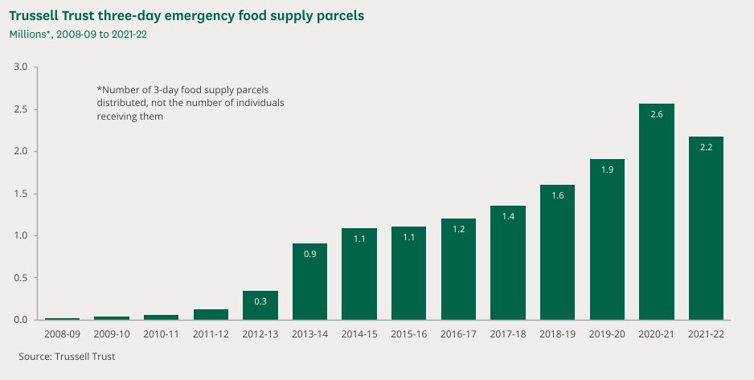
Image 1

Image 2
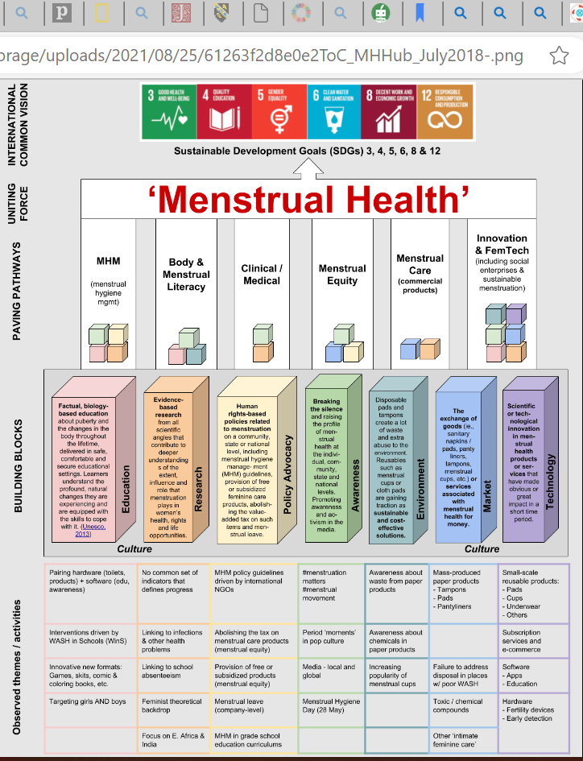

Image 3
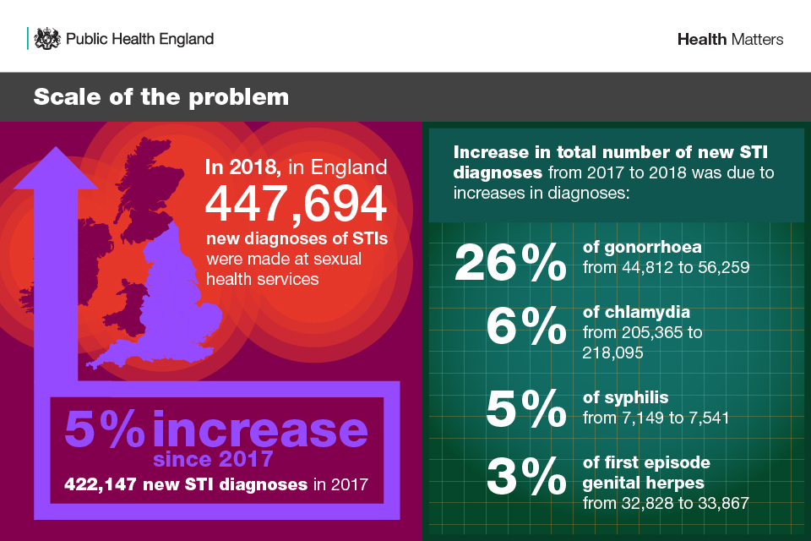

Image 4
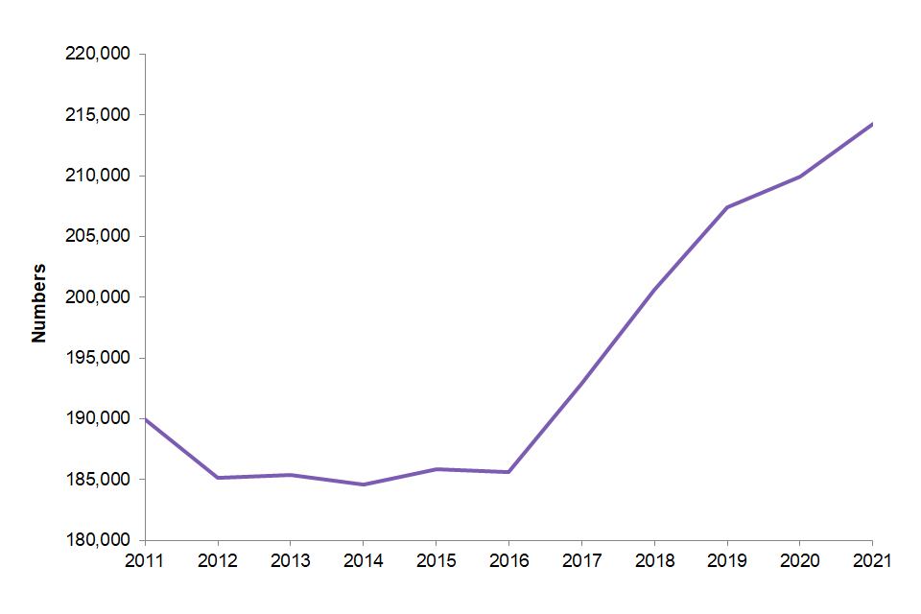 (GOV UK, 2022)

