Monnow Monmouth Medieval Bone Assemblage

Emily Hughes 2003400

Acknowledgments
Cleo Harris
David Hinsull
Dave Lewis
Kayne Thomas
Julia Jones
Nikki Griffiths
Josh Rankin
Sing Lee (Phoenix)

Contents
Medieval Period 2
Butchery 3
Tanneries and Fellmongers 6
Wool Industry 8
Conclusion 9
References 10
Appendix 11

Medieval Period

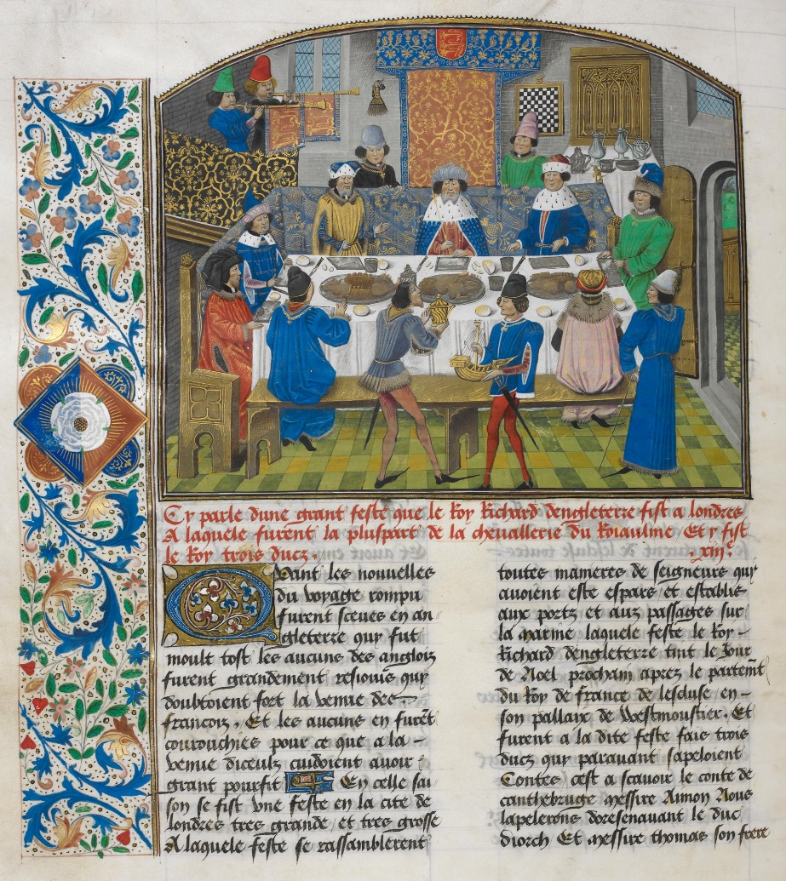
During the Medieval Period, Christianity was the main religion, and the Church was very influential and because of this authority they had over people, not only did the Church affect their daily lives but also controlled what they ate to an extent. In 1336 the Papal Decree declared that meat was only to be eaten twice a week and they had big taboos on what animals can be eaten, furthermore horses could not be eaten because the church saw it as Pagan food. On certain days people would have to fast on for example such as Sundays was a fasting day and when Saint Days came along, they would fast on that day too, and this is because of the church driving ideology and their beliefs, so this means they can decide on what days is ‘appropriate’ to be fasting. Cereal would make up most of a medieval person’s diet along with dairy products as peasants tend to keep cows which would be able to roam in a certain area. What we know about the medieval diet is from cookery books such as “A Boke of Kokery”, and preserved foods was important to a peasant’s diet, peasants would make salted, pickled, dried and many other ways of food to keep food preserved. Furthermore, bread was a staple for all classes and what was also a staple for all classes was a dish called pottage, a thick soup which has meat, vegetables, or bran (A. Bovey).
Jean de Wavrin, Recueil des chroniques d'Angleterre (Volume III) c.1470-80 Illustration of Richard II dining with the Dukes of York, Gloucester, and Ireland, in Jean de Wavrin's Anciennes et nouvelles chroniques d'Angleterre (Royal MS 14 E IV, f. 265v)

Another way we can see what people ate during the Medieval period is through manuscript such as the Feast of Richard II by Jean De Wavrin. This is a feast for a king which means the food would be very different from what peasants, and what lords would eat. There would be many roasted birds, and just an excess of lavish food that displayed wealth and power.
Knowing what the average medieval person ate is important in understanding the assemblage from Monmouth. It helps to understand why they would be slaughtering certain animals, such as cows. Cows and sheep have multiple uses to them, so it is understandable why they are the most slaughtered in the assemblage. We know that the average medieval person would only eat meat twice a week, so to constantly be butchering a lot of animals just for their meat is not smart, but finding other useful means from the animal but keeping it alive is far more important than the meat itself.

Butchery

Butchery is one of the oldest official trades to form a guild, the first official guild dates to 1272, however in the 970s we see guild activity of payments for support and protection. Guilds required butchers to maintain high levels of cleanliness to prevent the outbreak of disease as during the medieval period the plague was rampant, so cleanliness was a must to be considered a reputable butchers. Only a butcher is allowed to butcher an animal as they needed to divide the meat up as some of the meat would go towards the rich and then a bit of the meat would also go towards the butcher. Furthermore, disposing left over animal carcasses would be important as diseases can come from dead animals, and they cared a lot to dispose of carcasses the best they can. It was illegal for the peasant class to hunt on land that belonged to the aristocracy and because of this it would lead to frequent poaching.
Butchers that mislabelled or sold poor quality meat in medieval times were frequently punished. People would be fined for a dead cow which has not been inspected or butchered. This is because the meat could be tainted and could cause illness to spread, and this is what guilds and people were trying to stop. If an animal was going to enter a city, it must be on foot this is to ensure the health of the animal when it is being butchered. This really shows how highly regulated meat was during the Medieval period as it has shown that animals can spread disease by Hippocrates and Galen, who for their time was advanced in understanding illness and disease. However, the law was not always enforced as we can see with Butcher’s Bridge which was where butchers threw whatever scraps of a carcass they had into the river, in 1369 this was illegal however the practice continued (Sabine 1993).

The bone collection from Monnow Street in Monmouth has evidence of butchery, from chopping marks and cutting marks on bones. Looking at Graph 1, we can see from the data collected that in the bone assemblage many of the bones have butchery marks on them, and that lots of the bones have slice marks on which would indicate that they were fileting the meat off the bones, and this would indicate that a butchery was here. Not only are there slicing, chopping and cutting marks on the bones, there’s teeth marks from a carnivore, and in the assemblage there one Canis molar which shows that there was a dog present and most likely chewing on bones that were scrap and not needed. But because of the presence of the dog’s tooth confirms that there was a carnivore present when bones were being butchered because far too many bones have these carnivorous teeth marks on. Within the assemblage there was a NISP of one for the dog, which means the MNI is one. The one species we do not have evidence of butchery is the horse, the NISP of the horse that was found is 4, and the MNI 1, which suggests that the horse did not die for food reasons, as obviously eating horse during the medieval period was seen as taboo, because of links to Paganism. Most likely this horse was used for work, or as a warhorse or used for hunting, and because of its value and importance would not have been butchered and eaten. When the horse died it was most likely old or ill or killed in fighting (depending on what the use of the horse would have been) which caused its death, because of the lack of butchery marks on the bones present they obviously did not butcher it.
Another species that does not appear as commonly as Bos, Ovis and Sus, which is shown on the NISP and MNI graph (Graph 2 and 3) is the Cervus (Deer) which has a NISP of 9 and an MNI 4 or potentially 5. The activity of deer hunting became an activity reserved for the aristocracy and the deer became protected under Royal Parks as venison was considered a high-status meat. However, with protected animals and high value meat, antlers, and skin available come the poachers which was a very common problem during this period. What their goal would be is to poach game off the Royal Forests, and not only are they hunting the animals reserved for aristocracy hunting, they also take materials such as wood from the Royal Forests (Birrell 1992). So, for there to be most likely 5 Cervus found in this assemblage could suggest there was a high-status person living in the area and most likely a royal park would be nearby which could explain why we have Cervus appearing in the assemblage. However, there might have been a group of poachers who used to live in the area who tried to profit off the Royal Parks. The majority of the assemblage’s species are adults, and in Graph 5 tells the fusion of bones in different species. Although there are juveniles in the collection with butchery marks, it is most likely they were slaughtering animals when they have matured but it does show that they were killing young animals as many juvenile bones have butchery marks. Majority of the unfused Ovis bones have clear signs of butchery, which means they could be slaughtering the young ones for lamb, as lamb is very young sheep. The way the cuts present themselves on many on the bones, are evidence of filleting and this is shown because of how the slice cut marks appear. The butcher was trying to get the flesh from the surface of the bone which causes the thin straight slice marks on the bones, that many of them appear to have.
There is clear evidence of a butchery being present in Monnow Street in Monmouth although it may not be one of the main trades present in the collection, we do see a lot of butchery happening. This is seen by the number of butchery marks that are present on the bones in the collection and from Graph 1 we see that over 82% of the bones have butchery marks on. However, some of the butchery marks present on the bones does not necessarily mean it came from a butcher, for example butchery marks on the feet of animals could suggest the work of a tannery. This would indicate there are lots of different forms of trade happening. Not only is there a butchery, but there is also evidence of tanneries and even perhaps Wool trade even happening. This is because of the amount of Bos and Ovis that have been slaughtered and that are present in the assemblage, it would make sense that there would be more tradesmen present on Monnow Street and not just the one.

Tanneries and Fellmongers

Tanning is a process of turning animal skin into leather. With treated animal skin you can create Vellum, which is parchment that those in the Medieval Period used to write and with the leather you can make clothes and shoes. Tanneries would have exclusive rights to buy cow hides from the butchers to make leather, and Fellmongers would have access to sheep, pigs, and other lighter and smaller skinned animals. Horns and hooves was no use to butchers so they would leave them attached to the skins, so tanners would discard of them in a pit and the horns would be an indicator that the pit was associated to a tannery. These pits would also be dominated by metapodials and would have marks of butchery on them.

In the assemblage we see lots of bones from the feet of animals and this suggests that there was a tannery present, not only is there bones from the feet of animals there is horns which means this site could have been a tannery. The assemblage has more Bos feet bones than any other species and lots of butchery marks, which shows that the animal’s skin is still attached to the animals hooves and horns, which the tanner would have to remove in order to treat the skin of the animal to make it into leather. The skin of the cow is very valuable as it is able to made into products such as clothing, shoe and vellum, all of which everyone during the medieval period would need. The vellum would obviously go towards aristocracy and people of the church, as they were the main people in society who could read and write. In the Monmouth bone assemblage, there was a good number of horns found, which can suggest that this pit was a tannery. Furthermore, the bone assemblage has a NISP of 136 Cattle bones found, which suggests that the cattle was being butchered and its skin being sold to tanneries to make leather. In Graph 4 you can see that Bos dominates the Butchered feet of animals, with Ovis coming next and surprisingly one bone of a Cervus, all which have been butchered to most likely remove the skin of the animal. The bones have a majority of multiple cutmarks being on the bones which suggests that they were butchered for their meat, but when the skin is given to the tanner, they have chopped at the bone to separate bone from skin. However, the bones from animal feet are not the only way to tell that an animal has been skinned for their skin, “skinning cutmarks are only visible on parts devoid of flesh or tendinous masses” (The reference collection of cutmarks 2019). This means other bones would be affected in the skinning of the animal, in “The reference collection of cutmarks”, the authors talk about the metacarpal, phalanxes and rarely tibias and tarsals being affected by skinning, this means skinning is most likely happening and is being shown in the bones that can be affected which can explain further butchery marks on these parts of the bones. We see horizontal cutmarks on the bones that make up the feet, which shows that horizontal cutmarks are best to remove the skin from the feet or probably the easiest way to separate skin from the bone here. But the butchery marks on the feet of the animals are clear indications of a tanner’s work because a butcher would just leave the feet and horns still attached to the skin, so it’s clear that someone has made use of the skin and made leather, to either make into clothes, shoes, saddles, or anything that needed to make because of demand.

Wool Industry

Wool in the Medieval era drove the economy, it was considered “the jewel in the realm”, however John Davies writes, in his History of Wales, in regards to the newly formed chain of Cistercian monasteries in Wales ”for the monks were granted thousands of hectares of grazing land, where they pioneered the Welsh woollen industry; there is very little evidence that sheep were important to the Welsh economy before the coming of the Cistercians” (Davies 2007). Which suggests that the wool industry started to pick up in Wales when the Cistercians came, and the Grace Dieu Abbey, was established in 1226 near the town of Monmouth. The Abbey also had large areas of land which could have possibly held sheep. Also, not far from Monmouth is Tintern Abbey one of the first Cistercian foundations in Wales, which has mill houses ruins which could suggest an industry is happening here, which could be wool. The Abbeys presence in the area of Monmouth does suggest that the wool industry was present here, also the River Wye runs through Monmouth which is the source of water mills to process wool. Furthermore, Pliny the Elder, in his Natural History talks about sheep and wool, and how useful they are, “Many thanks, too, do we owe to the sheep, both for appeasing the gods, and for giving us the use of its fleece.” . This shows that sheep were mainly kept for their wool and then secondarily their milk there was no point in killing the sheep for its meat as sheep produced secondary products that were of value and use.
By the site where the assemblage was found there is the River Wye going through the town near the site which could indicate a water wheel there for a wool industry. In Table 1 we see a that 43% of species found at the site are Ovis, with NISP of 134, and MNI of 12 this could indicate there was an industry of wool in Monmouth. Although wool might have not been produced in Monmouth itself, it is highly likely it was being produce somewhere not too far away from the town. The presence of sheep in the assemblage show that these animals were present during this period, and that is important as it can tell a lot about the area. Ovis bones does suggest they are slaughtering these sheep, but most likely a few at a time once they are getting too old, or they slaughter the young for lamb as older sheep would give you mutton. But the sheep fleece coat is what’s more valuable as the weather in Wales is not the best so it would help you to survive the winter’s nights. The meat off the sheep is not that important as the medieval person would only eat meat twice a week, and it would most likely be offal as that is cheapest meat a poorer person could buy. We have a NISP of 12 Ovis in our assemblage which suggests that there were a lot more living and they would have been used for their secondary products. They would have been kept in the land all around Monmouth roaming freely in a certain space.

Conclusion
We can conclude that on the site there was a tannery and a butchery. The wool from sheep were most likely made outside of Monmouth and brought in to trade, as the Abbey’s did a lot with wool, but unsure whether the Abbey’s by Monmouth had any sort of wool industry. It would make sense with the river, and how Tintern Abbey did have water mills there. The tannery being at the site of the dig would make the most sense, simply because there was a lot of metapodials and horns, which does suggest that this was a tanners. This would mean a butchery was not too far from this site as tanners, and fellmongers would have to get their animal skins from somewhere. Furthermore, many of the animal bones apart of this assemblage does have clear signs of butchery, and this would mean a butcher’s being somewhere in the area. The evidence from the bone assemblage suggests that this was a bustling town because of the many tradesmen in the area, and the number of bones found. Monmouth being a town full of trade is important in the Medieval period, as you would need all these different trades just to survive. Looking at the geography of the area there is lots of fields and space to keep many different animals, it is also on the river which is very important to a town during the Medieval period. However, the pit this assemblage most likely came from is a tanners, simply because of the metapodials and horns found in the assemblage it is a big indicator of a tannery as these parts of an animal would not appear in a butchers.

References

Sabine, Ernest L. “Butchering in Mediaeval London.” Speculum, vol. 8, no. 3, 1933, pp. 335–53. JSTOR, https://doi.org/10.2307/2848862. Accessed 14 Mar. 2023.

Bovey, A “the Medieval diet.” 2015 https://www.bl.uk/the-middle-ages/articles/the-medieval-diet#:~:text=Peasants%20tended%20to%20keep%20cows,meat%2C%20vegetables%2C%20or%20bran. Accessed 17 Mar. 2023

Birrell J, “Deer and Deer Farming in Medieval England” Agricultural History Review, Vol.40:2 (1992) https://www.bahs.org.uk/AGHR/ARTICLES/40n2a2.pdf Accessed 17 Mar. 2023

Sandrine Costamagno, Marie-Cécile Soulier, Aurore Val and Sébastian Chong, “The reference collection of cutmarks”, Palethnologie [Online], 10 | 2019, Online since 01 November 2019,. URL: http://journals.openedition.org/palethnologie/4089 ; DOI: https://doi.org/10.4000/palethnologie.4089 Accessed 18 Mar. 2023

Davies, J. “A History of Wales.” (2007). Penguin Books Limited.

Grace Dieu Cistercian Abbey - https://coflein.gov.uk/en/site/306498/ Accessed 18 Mar. 2023

Tintern Abbey - https://coflein.gov.uk/en/site/359/ Accessed 18 Mar. 2023

Foster, H.J “A Zooarchaeological Study of Changing Meat Supply and Butchery Practices at Medieval Castles in England” 2016. file:///C:/Users/User/Downloads/Foster%20H%20no%20copyright%20images.pdf – Accessed 19 Mar. 2023

Appendix

Graph 1

Graph 2

Graph 3

Graph 4

Table 1 NISP, %NISP, MNI and
Fusion of Animal Bones
Graph 5
Species | NISP | %NISP | MNI | %MNI
Pig | 31 | 9.8 | 5 | 15.6
Dog | 1 | 0.3 | 1 | 3.1
Horse | 4 | 1.3 | 1 | 3.1
Sheep | 134 | 42.5 | 12(13) | 37.5(37.1)
Deer | 9 | 2.9 | 4(5) | 12.5(35.7)
Cattle | 136 | 43.2 | 9(10) | 28.1(10.6)
Total | 315 |  | 32(35)
Table 1 NISP, %NISP, MNI and %MNI for all species
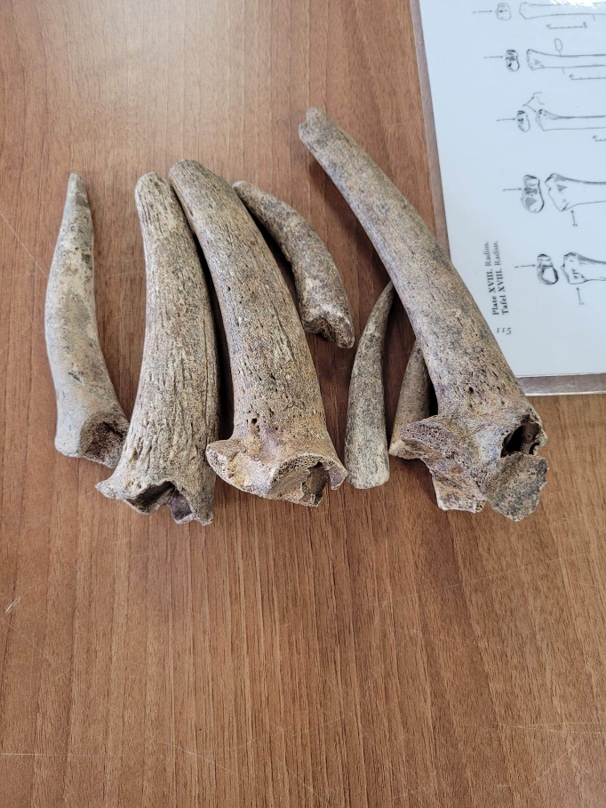
Horns in the Monnow Monmouth Assemblage
Photo By David Hinsull
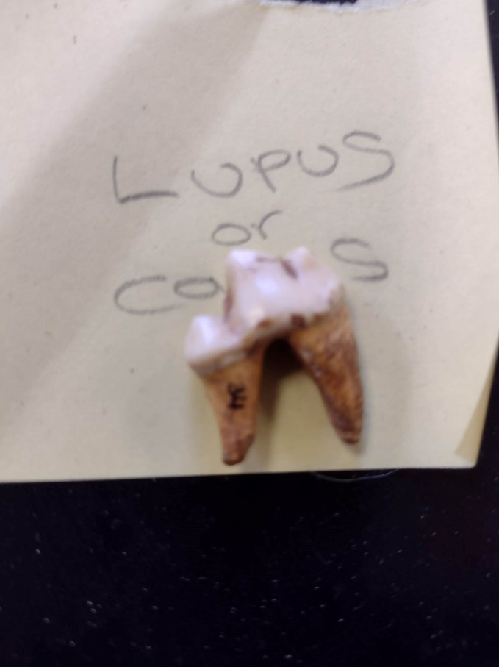
Dog Tooth, only evidence of a dog in the assemblage.
Photo by David Hinsull

