Consultancy Report
By
Name of the consultancy: Helping Hand
Client Name: Premier Inn
Date of delivery: 07/ 12/ 2022
Student: Sorin Ionut Boata, 2014248
Module: Organisational Consultancy, BMIH6005
Lecture: Gayathri Nadeeshani Senanayake Mudiyanselange
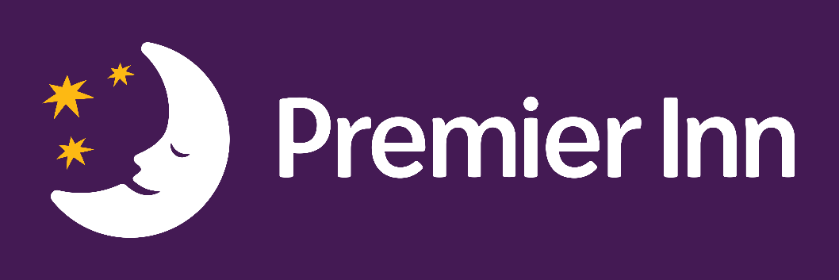
Executive summary
  - The problem /issue at the venture
The specialists of Helping Hand research focused on challenges that Premier Inn may face at its hotels in the United Kingdom, particularly in London, but also as a brand in general. Due to this, the research has raised concerns about its lack of trained workers, decreased income as a result of eco-political instability, and poor hiring as well as retention rate (BBC, 2021). The employee retention rate is becoming lower due to the increased work pressure that affects the business operations of Premier Inn. moreover, the inferior quality of hygiene maintenance, policy breaching, slower service as well as a higher rate of accommodation during the lockdown period reduced the brand value of Premier Inn. Furthermore, deficient performance in emerging markets and growing labour costs in developed markets weighed heavily on Premier Inn. Manufacturing costs have risen as a result of economic issues such as price increases and higher interest rates. As a result, both the internal and external business environments have a considerable influence on the management of Premier Inn. The report has conducted a SWOT and PESTLE analysis and examined all projected positive and negative aspects to better understand the Premier Inn challenges that need to be addressed (Chen et al., 2022).
Findings (including figures)
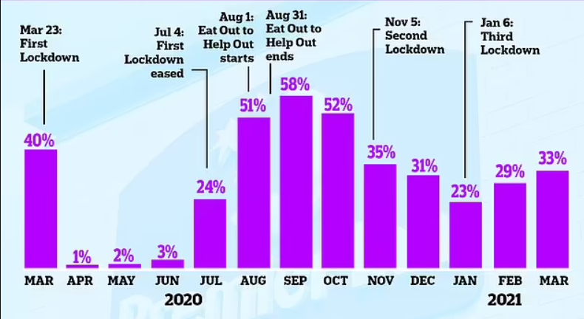
Level of occupancy in Premier Inn
Source: (Pyman, 2021)
From the discussion that follows, the hotel provides its guests with stunning, opulent accommodations where operates more than eight hundred hotels across the world and has more than 77,000 rooms. The hotel's beneficial aspect is that it offers reasonably priced rooms for one hundred pounds, as well as discounts on both their rooms and food with a basic discount of 20%, therefore the guests can purchase their buffet meal for 9.45 pounds. Customers can choose from family rooms, premium rooms, twin rooms, and accessible accommodations. However, they offer poor service and few amenities additionally, it is estimated that the hotel's booking rates dropped to 3% during the lockdown time and by 25% during the second lockdown. Furthermore, it had a limited worldwide presence, but during the third lockdown, it increased to 23%. Additionally, the corporation suffered a significant loss of 725 million pounds during the epidemic (Donnelly, 2022).
  - Analysis of these findings
Based on the data, it can be established that Premier Inn, the largest hotel chain in the United Kingdom, has had financial and customer satisfaction issues. The challenge of customers to reserve rooms in the Premier Rooms has fallen, due to issues with room service, however, they offer significant benefits in terms of room quantity, hotel affordability, and the variety of food choices available, the Premier Inn also provide unique deals and happy hours on buffets and drink packages (Uk, 2022).
  - Recommendations to the client
This consultancy report has suggested appropriate ways for promoting Premier Inn's ongoing development and improving brand value to extend its market further. The context has created an action plan to potentially tackle the challenges, and the recommendations have been made with those in consideration (hoteltechreport, 2022). Premier Inn needs to hire a skilled staff to coordinate the maintenance work and as a consequence, to comply with all of the preparation requirements, the hotel chain must improve its room service quality and grow its portfolio. In addition to these requirements, the Premier Inn be required to ensure adequate hygiene to provide a safe stay for the customers. An issue that could affect the brand, is the fact that has encountered privacy and security difficulties with its websites and as a result, it is suggested that they develop its web services and make them beyond straightforward (Gonzales, 2022).

  - Conclusion
This executive summary outlines the results from the hotel Premier Inn assessment. The section has described the company's issues with client satisfaction, a website issue, inadequate comfort, but also poor service. In addition, relevant data and graphs relating to the company that shows the decrease throughout the Covid-19 period have been displayed. Furthermore, recommendations for reducing the problems based on the problems have been made to the company.
Table of Contents
Introduction 6
Purpose of report 6
Problems/issues to be addressed 6
Scope and analysis 7
Company background 7
SWOT Analysis of Premier Inn 8
PESTLE Analysis of Premier Inn 9
Main Body 12
Positive aspects of Premier Inn 12
Negative aspects of Premier Inn 13
Issues faced by Premier Inn 14
Analysis of the issues faced by Premier Inn 19
Findings and results 20
Action plan 22
Recommendations 24
Conclusion 26
References 27

Introduction
The following context will seek to discuss the Premier Inn hotel's current state and generate a potential consultancy report based on the observations. A detailed corporate background will be discussed to facilitate future research. As an outcome, the goal of this report is to identify and analyse concerns with the operations of the Premier Inn hotel and provide with the recommendations that can drive the business to success and to achieve customer positive feedback, therefore, to implement new strategies regarding the hotel’s improvements.

Purpose of report
The study will use a SWOT and PESTLE analysis to analyse and evaluate the key issues, which will aid in recognising the scale and negative implications that affect business operations. This consultancy report will discuss its recent reviews, news, and problems at the Premier Inn hotel. As a result, the main body of this study will discuss the need of maintaining a balance between positive and negative consequences for Premier Inn hotel to succeed. The next study will therefore summarise the findings and conclusions that have been identified, as well as produce an action plan for future development by minimising all potential issues. The study will then offer a suitable strategy in which the Premier Inn hotel could achieve its business objectives efficiently and effectively.

Problems/issues to be addressed
This background will be used to address the potential Premier Inn hotel challenges where the concerns will be detected using current news reports, journals, and the company's official websites. The hotel's pricing strategy, room maintenance, workforce challenges, and Premier Inn hotel booking policy issues will be highlighted. The challenges that arise as a consequence of the external corporate environment will be reflected in the following consultant report along with the rising inflation rate, the consequences of Brexit, and the Covid-19 epidemic will be thoroughly examined in this context. The PESTLE analysis will concentrate on the external business influencers, whilst the SWOT analysis will convey the view of internal elements that impact the business operation of the Premier Inn hotel.

Scope and analysis

Company background
Premier Inn, formerly known as Travel Inn, was founded in 1987 to combat against Travelodge. Later, Travel Inn joined Premier Lodge and reopened as the Premier Inn hotel in 2007. Whitbread plc is the parent firm of this hotel chain, and they effectively service throughout the United Kingdom. They have a limited global footprint, and the nations they serve include the UAE, Ireland, the Isle of Man, Germany, Jersey, Qatar, and Guernsey. This is a prominent British hotel chain with over 800 locations and almost 77000 comfortable rooms (premier inn, 2022). The hotels are located in upscale sections of the city, which include city centres, airports, and prominent tourist attractions. The Premier Inn hotel features family-friendly accommodations as well as high-quality cuisine and drinks. To keep guests entertained, the Premier Inn hotel provides a selection of activities at a affordable costs. According to 2022 statistics, the hotel has around 30000 efficient staff, and the company's net income is worth £ 906.5 million according to 2021 financial data. This public limited company was established on a vertically integrated structure, with specialised departmental managers. The top-down organisational route improves laud passing and promotes work development (Premier Inn, 2022).

SWOT Analysis of Premier Inn

Strengths | Weaknesses
- Standard and affordable rates of accommodation are one of the biggest strengths of the hotel chain Premier Inn.  - This is the largest hotel chain that operates across the UK and has a few global presences that can be expanded.  - 3. Premier Inn is a highly advertised hotel, and they frequently provide lucrative deals and offers to attract potential customers (BBC, 2021). | - Premier Inn has a lot of competitors that reduce their revenue margin significantly.  - This hospitality business has a limited international presence to its competitors.  - The issues and negative feedback regarding refunding policies that occurred during the period of lockdown made their customers unhappy (Wood, 2022). The hygiene issue has been reported against Premier Inn which adversary influences their brand awareness.

Opportunities | Threats
- Premier Inn has a strong online presence, and they are awarded as the finest hotel chain in the UK.  - Premier Inn planned to establish new decor in some international areas and refurbish the existing hotels to gain a competitive advantage.  - Therefore, this hospitality business has 28 hotels in Germany and Premier Inn planned to expand its markets in this country as well as try to keep up its functions (Bobyliev, 2022). | - The negative feedback from potential customers regarding booking money and the refund policy has become a major concern that affects their brand awareness.  - The unstable economical condition of the UK has affected their business operations significantly.  - 3. some legal threats are enforced against the operation of Premier Inn which affects their revenue margin (Ambrose, 2021).

Evaluation of the SWOT analysis
According to the SWOT analysis, there are opportunities for Premier Inn to increase its revenue margin and operate smoothly over the long term. However, the brand is now dealing with a few problems that seriously harm the awareness of its image. Due to complaints, the organisation has previously received about policy violations, they have had to go through various legal processes. Additionally, the negative reviews about the lack of service and poor hygiene decreased their customer demand. The organisation should thus take a look at those internal aspects that they have influence over. The Premier Inn hotel chain firm needs to build a useful strategy to tackle the nation's economic outlook (Madsen and Stenheim, 2022).

PESTLE Analysis of Premier Inn

Factors | Impact on the organisation
Political | The political aspects have become a major concern of Premier Inn. The combined effects of the Coronavirus epidemic, Brexit and the ongoing Ukraine war influence the political condition of the UK. the changing government regulations impacted the operation of the Premier Inn. Moreover, in some other European countries, Premier Inn operates successfully. The political condition of those countries affected their business as well. Due to the pandemic, the government created restrictions that affect the smooth running of Premier Inn (BBC, 2019).
Economic | The emerging rate of inflation within the UK has increased the price of essential commodities. Accordingly, the operational cost of Premier Inn has eventually upsurged. The rising cost of essential resources, such as foods, electricity, and fuel lower the cost-effective production that in turn, reduces the revenue margin of Premier Inn. on the other hand, the labour cost in these developed countries is higher rather than in developing economies which also influences their cost of business. Due to the lockdown situation, sales have fallen, and they have faced a huge loss which is near about £1bn annually (Kollewe, 2021). As per the 2020 data covid caused the forced closure of some hotels, as it hits Premier Inn with £ 725m loss (Kollewe, 2020).
Social | Tourists and consumers are the main keys that help the business run. Premier Inn must serve its customers as per their needs and has to modify its facilities as well. Customer satisfaction depends on the better-quality service provided by the Premier Inn. that is why hotels should offer some additional facilities at a lower price to their customers to attract them more. Moreover, Premier Inn should serve the tourists in diverse ways as they are serving international customers irrespective of age, ethnicity, race, and caste (countyhealthrankings, 2022).
Technological | This is a dynamic era of advanced technology, and this hotel chain has a strong presence on online websites. They provide prior booking facilities to their customers as well as offer lucrative discounts through their online portals. However, Premier Inn have to improve its website privacy as they are facing issues regarding its online booking and refund policies. Otherwise, the other competitors will reduce their competitive advantage and revenue margin. Moreover, the organisation's details should be regularly updated on their websites to build more trust among customers (cvent, 2019). The need for future investigations is the driving factor behind the use of innovative technologies and the introduction of innovative products within the business. Trends focus on improving consumer information through their questionnaires, which can influence the need for change and adaptation to new requirements (ANTHONISZ, 2014).
Legal | This factor is related to the legislation and government policies to run a transparent business. Therefore, Premier Inn has faced legal threats for breaching some of its customers. Moreover, Premier Inn has to pay the wages to their labourers as per the government rules and create their business policies according to the laws of the UK government, no matter whether they can make more revenue or not. The behaviour of the employees should be maintained, otherwise, Premier Inn will face lawsuits for breaching the regulations. Further, Premier Inn must follow the guidelines to establish the hotels and safety rules that often cause a lower revenue margin (Foskett et al., 2021).
Environmental | Generating waste, cleanliness, and carbon emission rate are accounted for by environmental factors. Therefore, promoting green stays and sustainability will enhance their brand popularity though the cost of operation can be compromised. Moreover, Premier Inn has committed that they will contribute to the less carbon emission mission and aimed to cut the emission in half by 2025 (George, 2021).

Evaluation of the PESTLE analysis
According to the PESTLE analysis, it has been seen that the economic factors of the business environment have been affected Premier Inn on a long-term. The Covid-19 pandemic's impacts and lockdown affected this business organisation, and the effects of the ongoing Russian war were badly reflected on Premier Inn (Wallace and Angell, 2022). Though, this hotel can be able to hold its position in the UK and run successfully with its unique business strategies. They always look after their customer’s preferences and serve accordingly. It also gets reliable performance because of the modern technologies they have included. They are unable to influence political and economic issues, including changes in governmental regulations, the rate of inflation, and price increases, due to this, they are making it difficult to accomplish the business's aims (Carlo, 2021).

Main Body

Positive aspects of Premier Inn
The rooms at the hotel
Although the hotel company is unable to provide boutique rooms, it does offer attractive and pleasant overnight accommodations. To make the visitors' stay more pleasant, the rooms offer luxury double beds, a television, an internet connection, and coffee-making facilities.
Affordable pricing
In central London, Premier Inn offers affordable quality accommodations offered for one hundred pounds, which is significantly lower than the prices of comparable luxury hotels in London. One of the primary reasons for their popularity is their low cost, besides, clients can select from buffet breakfast and continental dining options (premier inn, 2021).
Regular discounts
Premier Inn reduces its accommodations regularly, providing them with an edge over its competitors. The hotel's competitive pricing differentiates it from other central London hotels and the deals aim to attract people from other locations.
Good family experience
Premier Inn is well-known throughout families because it provides facilities for both children and adults to enjoy at their UK locations. The families are choosing to book with Premier Inn because of the rooms' price and capability to accommodate two adults and two children (medium, 2020).

Money back policy
The hotel chain has an additional money-back guarantee scheme in case any customer is not satisfied with their stay, thus this option is unique to any other hotels in London.
Active community participation
Members of the hotel are actively involved in community ascension efforts. The company provide their workers with the opportunity to select a noble cause and volunteer in the community for three hours each week, allowing them to learn about the communities they serve.
Training programs
The hotel's innovative training plans assist in the training of both new and existing members. It offers a high-quality working environment for their employees and gives possibilities for advancement; therefore, the development of hotels has been linked to a range of advantages, including increased employee satisfaction, enhanced customer fulfilment, and cost benefits (Chen, 2017)
Adhering to safety norms
The hotel provides a smooth check-in process and social distancing, and the employees and management at Premier Inn adhere to health and safety rules that guarantee guests are safe and protected. Additionally, staff are given protective equipment and mandatory training (operations, 2022).

Negative aspects of Premier Inn
Poor housekeeping
The Premier Inn’s guests have recently complained about the poor housekeeping and unsanitary rooms and have also expressed dissatisfaction with the levels of noise in several areas, which has had a substantial impact on the hotel's revenue.

Booking issues
Premier Inn have faced consumers that have complained about the hotel making and charging for false reservations. Their website has privacy difficulties, and clients are occasionally charged extra for services they have not requested.
Low quality of amenities
There have been complaints about the air conditioning and room heating systems in different hotels of the company where the customers have expressed disappointment about this. The hotel's goal is to give guests a restful night's sleep, but they are falling short of that promise.
Not enough food options and missing items
Customers have complained about missing items on the menu, even though the hotel provides a diversity of cuisines. Their breakfast selections are restricted, which gives clients a negative impression and therefore makes them complain about the inadequate quality of the meal.
Slow service
Customers have complained to the Premier Inn hotels for their poor service, in addition to slower room service, guests had to wait to check into their rooms at the reception and this promotes a poor perception of the company's brand. The visitors had to travel to the reception to obtain another key card when the key entrance cards occasionally failed to function.

Issues faced by Premier Inn
Lack of skilled employees
Premier Inn is having difficulty finding competent personnel for its hotels due to inflation and rising workforce prices. Employment from EU countries is limited due to Brexit, and the reduction in employment wage margins in the UK is failing to attract new personnel to the market. Furthermore, because of the pandemic, it has been difficult for the organisation to acquire new personnel due to safety regulations and cleanliness standards. Moreover, because of the poor income production during the epidemic, graduates were hesitant to participate in the hotel business (Davies, 2018). Although the hotel's revenues are improving, the company's lack of a competent crew has been a significant barrier (Hunt, 2022).

Decrease in revenue
The hotel industry was the most hit by the pandemic, therefore Premier Inn's income was severely impacted by the Covid 19, and it performed poorly at that time. The brand has a 1% market share, and its share price is currently declining. In the budget year 2020-2021, the company's annual revenue dropped by 71.5%, resulting in a loss of 635 million pounds. The company's profitability continued to fall until the end of 2021, however, the corporation had 1200 million pounds in cash equivalents at the end of the year to maintain the operation. Whitbread PLC's owner claimed to have recovered from the pandemic, however, they have yet to match pre-covid standards (Whitbread, 2021).
Figure 1: Level of occupancy in Premier Inn
Source: (Pyman, 2021)
The above graph graphic illustrates that accommodation bookings were fewer than usual during the epidemic. Bookings dipped as low as 3% during the first shutdown. By the end of 2020, it had returned to 58% but had dropped by 25% by the second shutdown. The hotel's company has taken a blow because of the consecutive lockdowns, and the damage can be seen in their income (Barlow and Vodenska, 2021).
Lack of global presence
Premier Inn, unlike other multinational hotel companies, has yet to enter the international market. Although they are existent in industrialised economies such as Germany and developing nations have yet to create them, in contrast to its competitors, Marriott.
Increased labour wages
Because of inflation, the cost of labour increased, forcing the hotel chain to raise employee wages. In 2021, the CEO promised that the compensation will be increased to meet up with growing inflation. However, the rise remains below EU norms and has failed to attract workers from other nations.
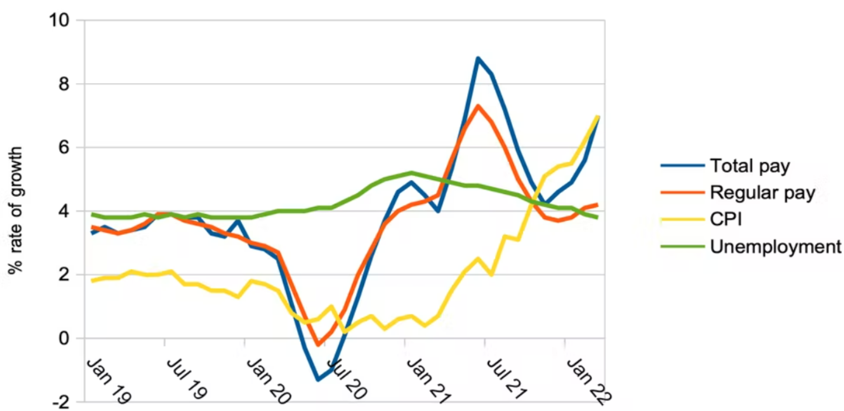
Figure 2: Wage inflation and price inflation
Source: (Spencer, 2022)
The line graph above depicts a link between price inflation and sewage inflation. It has been discovered that salary inflation and price inflation are inextricably linked. As the cost of goods rises owing to inflation and Covid 19, so does the cost of labour. The work costs are expected to rise by 8% by 2021 and as a result, Premier Inn announces compensation increases for their staff. When deciding on the increase, the hotel had to consider the increases in the cost of living.
Increased workload
Due to a labour shortage, the existing workforce has been under immense pressure this year. The hotel's HR department has raised concerns from staff about their workload and lack of
resting.

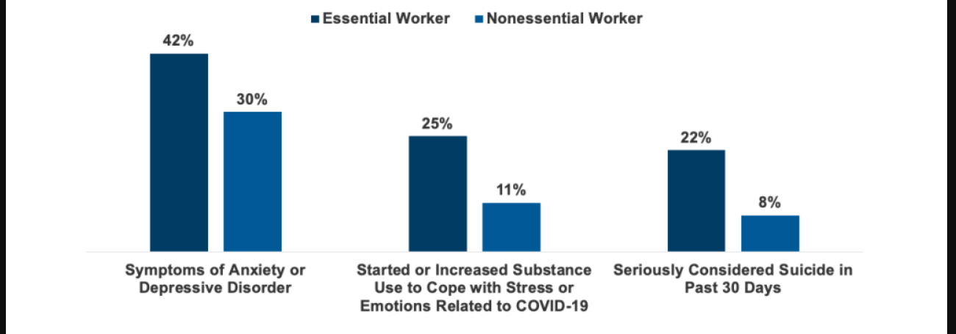
Figure 3: mental health distress among workers due to workload during covid 19
Source: (Garfield, 2020)
According to the graph above, overburdened employees suffer from anxiety and depression. The pandemic has resulted in a new set of company regulations. Specifically in the hotel business, where cleanliness and safety rules must be followed, workers have worked overtime to provide better service to their guests. Employees at Premier Inn have been pressured because of excessive workload and a lack of holiday leave, which has resulted in employee disengagement (Juckes et al., 2021)
Hiring and retention
The hotel company has struggled to retain personnel and recruit talented workers. The hotel has a shortage of administrative, housekeeping, front desk, and maintenance personnel. As a result, the service has been hindered, leading to complaints from guests (Pekerşen and Tugay, 2020). Furthermore, Premier Inn has had difficulties due to a dearth of qualified millennials in the hospitality industry. As a result, the hotel giant's service has become less competitive. On booking websites, customer reactions have varied. Most negative comments have been focused on delayed service and a lack of qualified workers. Furthermore, the hotel's recruiting drive has been slow in comparison to other hotels in the country. As been observed that Premier Inn has not kept its obligations to its workers, because of its lack of an efficient compensation system for motivating and encouraging staff. The results can be seen in their dissatisfied and disengaged employees that are unable to provide quality service (Grimshaw et al., 2019).
Operational issues
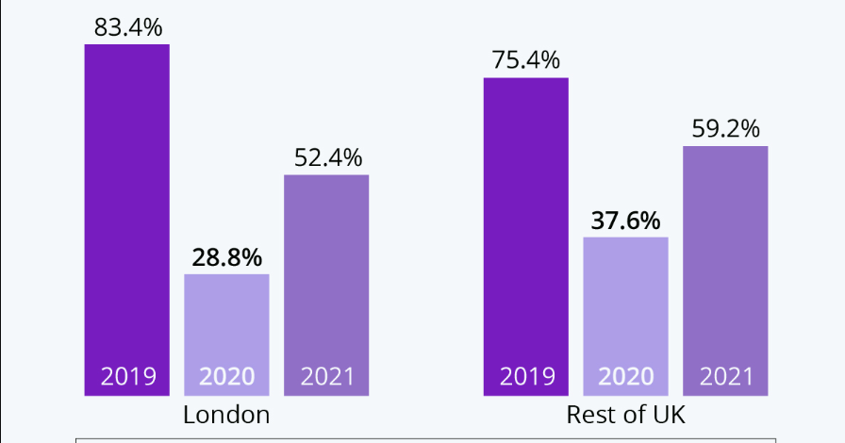
Figure 4: Occupancy forecast of the UK hotels
Source: (Armstrong, 2020)
The graph above demonstrates the hotel occupancy rate in London and the United Kingdom for the years 2020 and 2021. The booking rate fell as low as 28% in the first wave and increased to 52% in 2021, which is still insufficient compared to 2019. (Jones and Comfort., 2020). The epidemic has impacted the hotel business throughout the nation, including the Premier Inn hotel. All the hotel departments are unable to operate together. According to PwC, it might take another four years for the hotel sector to recover from the pandemic's consequences (Sillas, 2022).
The rising cost of services
Inflation has raised the cost of transportation, which has increased the price of goods and services, therefore the cost of necessities has soared across the country. As a result, the cost of meals and services at Premier Inn has risen. A surge in supply chain costs has resulted in poor-quality service at several of the company's hotels. Furthermore, job losses have resulted in unemployment in the country, affecting people's affordability. As a result, Premier Inn is struggling to maintain its food and beverage quality (Dominique-Ferreira and Antunes, 2019).

Analysis of the issues faced by Premier Inn
In the UK, the hotel industry has suffered as a result of Brexit and COVID 19, hence hotels across the country have had difficulty keeping the quality of their businesses, consequently Premier Inn's major challenges over this time have been operations, workforce , costs, and guest expectations (Anabila et al., 2022). The pandemic, as well as other global crises such as terrorism, have caused economic challenges such as inflation and recession. Inflationary pressures have resulted in higher employment pay, higher transportation expenses, and higher commodity price. As a result, the hotel's service charge has risen significantly. Premier Inn is trying to stay up with the market's competitive price. Their market share has decreased. The hotel chain is unable to hire people and results also in a poor employee retention rate. Furthermore, their lack of ability to meet guest expectations has a negative influence on their brand image. To alleviate operational challenges, an integrated hotel PMS system can be installed. To efficiently manage the hotel's budget, cost-cutting techniques might be devised. Furthermore, cleaning and maintenance personnel should be made aware of hotel standards to maintain the quality of the hotel's visitor experience (Casado et al., 2019).

Findings and results
Food and beverage
Premier Inn Hotels have affordable restaurants across the UK, and they serve a wide variety of delightful foods to their customers. The menu changes depending on the season, for example, autumn dinners are particularly common and may be delivered to the guest's accommodation. The menu includes everything from chewy and meaty burgers to flavorful curries. On the other hand, a variety of salads, pizzas, and sweet desserts are featured on the menu. Travellers staying in Premier Inn hotel rooms may enjoy delectable snacks and beverages in their rooms. Furthermore, they provide their customers with a breakfast buffet with a variety of food selections for 9.50 pounds. The main bargain they give with their meal menus is that when adult eats at their hotel's buffet, they get complimentary breakfast menus for two children (premier inn, 2022). They mostly serve English breakfasts, although there are a variety of additional culinary alternatives on the menu some of the options are: bacon, ham, freshly cooked sausages, hash potatoes, and eggs, where kids may have vegetables of their choice. While they also serve continental breakfast, popular products include various fruits, milk, cereal, and baked pastries. On their menu, they also offer varieties of yoghurts, jams, honey, cornflakes, and Weetabix, as well as beverage alternatives such as coffee, cranberry juice, apple juice, and orange juice. In addition, the meal menus, which are available Monday through Friday from 12-5 p.m., provide two dishes for 9.45 pounds and three courses for 11.45 pounds, the hotel also provides a children's menu that includes cheese sausages and brownies (premier inn, 2022).
Rooms
Premier Inn has over eight hundred hotels worldwide, totalling around 77,000 rooms. The rooms contain various outstanding characteristics for the guests' comfortable sleep. Luxury king-size baked, soft, and wonderfully designed pillows, and soft and lightweight blankets can be found in every room at the hotel. Furthermore, there is the option of a power shower, and all rooms include a hair dryer and flat TV. Customers may also use the hotel's Wi-Fi 24 hours a day and make their tea and coffee. There are several accommodations kinds available, including premier plus rooms, twin rooms, family rooms, and accessible rooms (Kensbock et al, 2019). Premier rooms are better for business trips, on the other hand, the brand also offers family rooms which are designed for parents with their kids. However, accessible rooms are designed for disabled people as the rooms are spacious and people can easily move their wheelchairs, the beds are low heights for disabled people and can be also adjusted.
Staff members and roles
More than 35,000 people are employed by 1600 Premier Inn hotels worldwide. The Premier Inn hotel employs a variety of employee categories, each performing a single purpose. The general manager of each Premier Inn oversees overseeing all employees, handling finances, and interacting with guests to ensure that the hotel runs properly (Revfine, 2022). Front desk representatives and receptionists are the team members in charge of ensuring that guests have a positive check-in experience and are satisfied. They also respond to guests' questions and make accommodations for them (Im and Kim, 2022). The housekeeping department employs many workers who are primarily in charge of maintaining the cleanliness of hotels, including providing clean rooms for visitors. They are the main determinant of the hotel's appeal since they take care of the laundry, clean the bathrooms, and launder the bedding. Additionally, porters are available to handle the guests' luggage. On the other hand, the Premier Inn restaurants are known for having waiters, additionally, there are always room attendants on hand to provide food in rooms and answer visitors' requirements. For its personnel to better understand the consumer base, Premier Inn offers a variety of training and development opportunities. For the duration of the pandemic in 2020, Whitbread provided more than one million staff of top inns with digital training sessions (Silva et al., 2022).
Bars
Since Whitbread owns the Premier Inn, there are a few bars connected to it that are also connected to Premier Inn. Brewer's Fayre and Cookhouse Pub are two well-known bars which are provided with a variety of alcoholic beverages in addition to various cocktails (brewersfayre, 2022). Orange beverages, a quirky cocktail resembling a zombie, are one of the most well-known. On the other hand, they offer a happy hour menu every day from 5 to 7 pm, with all cocktails priced at 5 pounds.

Action plan

Number | Problem | Solution | Desired outcome | Time  scale | completion  date | Planned budget
1 | Problems are related to room service. Room service is slow as many guests have complained about the poor service. If they call a service boy they will respond after a long time which causes a major problem for the guests (SiteMinder, 2022). | The main solution to resolve the problem is to arrange specific training and development programs for the employees. As well as recruiting new employees with proper staff handling and customer handling experience. Moreover, arranging various awareness programs for the service boys and conducting meetings to analyse the bad reviews about the company. | After managing all the service-related programs the guest will now get a smooth experience regarding the room service facility. They will be able to connect with the service provider in just one step without any chance of complaint (revenue-hub, 2022). | 6 months | 01/04/2023 | £25,000
2. | Part of Premier Inn guests over the past few years have complained about the cleanliness of the hotel rooms. Within every hotel that the brand owns, hygiene standards differ. In addition to this, users have occasionally reported that their heaters, air conditioners, and showers all malfunction. On the other hand, they found stained bedsheets and not adequate towels in some rooms in hotels (socialtables, 2022). | Arranging new pillows and bedsheets and quilts for the hotel rooms. While refurbishing and scheduling part of Premier Inn rooms to fix problems with toilets and air conditioning. On the other hand, hiring a person for observing and maintaining all the room-related problems of a hotel. | This will help the guest to feel more secure in the hotel while all their health-related concerns and hygiene concerns of them. Customers will book more hotels and recommend them to other customers while there will be a decrease in bad reviews on the website (Whitney, 2021). | One year | 31/10/2022 | £15,000-20,000
3. | Another problem that is associated with Premier Inn is its website. Recently they have taken money of 226 pounds from a customer who does not even book their rooms. Also, they have many privacy issues on their website and the website is not updated (White, 2020). | Partnering with big IT companies of the world to manage the problem. They can change and modify the website by using various codes and resolving various bugs associated with it. | This will allow the customers to have smooth access to the website of the Premier Inn. There will be a chance of technical errors related to money transactions while an updated website will help them to find hotels and rooms according to their choice without any bugs (cloud beds,2022). | 5 months | 31/03/2022 | £20,000-25000

Recommendations
Improving room service
- Room service is the heart of any hotel business; therefore, the above discussion demonstrates that the hotel has low room service quality, which is a significant concern among hotel clients.
- As a result, it is advised that the Premier Inn employ an additional workforce for the position of room attendant to provide quick room service to guests and high quality (Glaveli et al., 2022).
- It is also suggested that the company set up training concerns for both new and existing employees to assist them to grasp the fundamentals of room service.
- This will be beneficial to the company's brand reputation.
- Calming music can also be used for the customer's enjoyment while serving the meal (Peevski, 2022).
Improving hygiene and room condition
- Guests have complained about the room's quality and hygiene in previous years.
- Premier Inn offers approximately eight hundred hotels, however certain of them have difficulties with room quality and linen.
- Therefore, it is recommended that the company hire a maintenance staff to handle all of the room's issues while organising the repair operation.
- In addition to arranging new pillows and comforters for clients while dealing with air conditioner issues in the room.
- Improving room hygiene, on the other hand, by organising appropriate housekeeping services for rooms (Ostrowska-Tryzno et al.,2022).
Improving hotel websites
- A recent investigation has arisen concerning revenue for the Premier Inn hotel.
- In addition, the customer is having difficulty accessing the website since it is out of the current.
- Therefore, it is proposed that the organisation collaborate with significant IT businesses to improve the quality of the website.
- Customers will find it easier to access the website as a result, and there will be no privacy or security issues (Anggityo and Sudhartio, 2022).

Conclusion
Following a comprehensive examination of the facts and data presented above, it is possible to infer that Premier Inn has selected a consultant report to learn more about its existing operations and market performance. The consultancy report includes an executive summary that highlights the necessity for this study, the difficulties encountered by the organisation, and the solutions necessary. Furthermore, the study has examined the company's past, which includes information such as the hotel's location, number of staff, number of rooms, and recent reviews on the hotel's service. In addition, a SWOT and PESTLE analysis were conducted in the research part to better understand the hotel's micro and macro environments. The major body has examined all the hotel's positive and bad characteristics, as well as the current challenges that the firm is facing, with a quick analysis of the concerns. In addition, the report summarised the findings and outlined an action plan for the hotel to enhance its operations. An anticipated budget has been included in the action plan for the convenience of the finance department. Finally, the study gave suggestions to the organisation on different procedures and methods that might be adopted to improve service quality.

References

Ambrose, J., (2021). Premier Inn warns over staff shortages as hotel bookings recover. [Online]Available at: https://www.theguardian.com/business/2021/nov/29/premier-inn-staff-shortages-hotel-salaries-bonuses
Anabila, P., Ameyibor, L.E.K., Allan, M.M. and Alomenu, C., (2022). Service Quality and Customer Loyalty in Ghana’s Hotel Industry: The Mediation Effects of Satisfaction and Delight. Journal of Quality Assurance in Hospitality & Tourism, 23(3), pp.748-770.
Anggityo, L. and Sudhartio, L., (2022), February. Website and pricing strategy development: a business coaching at local SME. In Proceeding of the International Conference on Family Business and Entrepreneurship (Vol. 2, No. 1).
ANTHONISZ, A., 2014. Assessing the future of housekeeping operations in Dubai's five-star hotel industry - room for innovation? Worldwide Hospitality and Tourism Themes, 6(4), pp. 352-361.
Armstrong, M., (2020). UK hotels: No light at the end of the coronavirus tunnel. [Online] Available at: https://www.statista.com/chart/23338/uk-hotel-occupancy-forecasts/
Barlow, J. and Vodenska, I., (2021). Socio-Economic Impact of the COVID-19 Pandemic in the US. Entropy, 23(6), p.673.
BBC, (2019). Premier Inns sees sales slide again. [Online] Available at: https://www.bbc.com/news/business-48687824
BBC, (2021). Premier Inn owner Whitbread warns of staff shortages as demand recovers. [Online] Available at: https://www.bbc.com/news/business-
BBC, (2021). Whitbread: Premier Inn owner braces for UK holiday boom. [Online] Available at: https://www.bbc.com/news/business-
Bobyliev, I., (2022). International experience of hotel business development and its significance for Ukraine .
brewersfayre, (2022). DRINKS AT BREWERS FAYRE. [Online] Available at: https://www.brewersfayre.co.uk/en-gb/drinks
Carlo, C., (2021). Critical Success Factors in Hotel Companies: A Managerial Perspective. Journal of Tourism and Hospitality Management, 9(2), pp.1-7.
Casado S., G., Fernández Gámez, M.Á., Aldeanueva Fernández, I. and Ruíz Palomo, D., (2019). Competitive intelligence and sustainable competitive advantage in the hotel industry. Sustainability, 11(6), p.1597.
Chen, B.T. (2017) 'Service Innovation Performance in the Hospitality Industry: The Role of Organizational Training, Personal-Job Fit and Work Schedule Flexibility, Journal of hospitality marketing & management, 26(5), pp. 474–488. Available at: https://doi.org/10.1080/19368623.2017.1264344.
Chen, Y.F., Law, R. and Yan, K.K., (2022). Negative eWOM management: How do hotels turn challenges into opportunities? Journal of Quality Assurance in Hospitality & Tourism, 23(3), pp.692-715.
cloud beds, (2022). 36 Hotel marketing strategies for building awareness and driving bookings. [Online] Available at: https://www.cloudbeds.com/articles/hotel-marketing-ideas/
county health rankings, (2022). Social and economic factors. [Online] Available at: https://www.countyhealthrankings.org/explore-health-rankings/measures-data-sources/county-health-rankings-model/health-factors/social-and-economic-factors
cvent, (2019). 14 Surprisingly Effective Social Media Tips for Hotels. [Online] Available at: https://www.cvent.com/en/blog/hospitality/14-social-media-post-ideas-marketing-hotels-online
Davies, P., (2018). Premier Inn owner issues 'degree of caution' over the economic and political situation. [Online] Available at: https://travelweekly.co.uk/articles/314554/premier-inn-owner-issues-degree-of-caution-over-economic-and-political-situation
Dominique-Ferreira, S. and Antunes, C., (2019). Estimating the price range and the effect of price bundling strategies: An application to the hotel sector. European Journal of Management and Business Economics.
Donnelly, B., (2022). Premier Inn owner Whitbread faces £60m cost hike. [Online] Available at: https://www.heraldscotland.com/business_hq/23077783.premier-inn-owner-whitbread-faces-60m-costs-hike/
Foskett, D., Paskins, P., Pennington, A. and Rippington, N., (2021). The theory of hospitality and catering. Hachette UK.
Garfield, R., (2020). Both Remote and On-Site Workers are Grappling with Serious Mental Health Consequences of COVID-19. [Online] Available at: https://www.kff.org/policy-watch/both-remote-and-on-site-workers-are-grappling-with-serious-mental-health-consequences-of-covid-19/
George, R., (2021). Tourism and Hospitality Marketing Planning: In Marketing Tourism and Hospitality (pp. 149-182). Palgrave Macmillan, Cham.
Glaveli, N., Manolitzas, P., Palamas, S., Grigoroudis, E. and Zopounidis, C., (2022). Developing effective strategic decision-making in the areas of hotel quality management and customer satisfaction from online ratings: Current Issues in Tourism, pp.1-19.
Gonzales, A., (2022). 8 Expert Tips on How to Improve Hotel Customer Service & Create Loyal Guests. [Online] Available at: https://solutions.zenrooms.com/en/blog/post/tips-to-deliver-great-hotel-customer-service
Grimshaw, D., Cartwright, J., Keizer, A. and Rubery, J., (2019). Market exposure and the labour process: The contradictory dynamics in managing subcontracted services work. Work, Employment and Society, 33(1), pp.76-95.
hoteltechreport, (2022). The Ultimate Guide to Hotel Operations (2022). [Online] Available at: https://hoteltechreport.com/news/hotel-operations
Hunt, S., (2022). Premier Inn expansion was 'helped by the fast decline of smaller hotels. [Online] Available at: https://www.standard.co.uk/topic/premier-inn
Im, Y. and Kim, C., (2022). A study on hotel employees’ perceptions of the fourth industrial technology. Journal of Hospitality and Tourism Management, 51, pp.559-567.
Jones, P. and Comfort, D., (2020). The COVID-19 crisis and sustainability in the hospitality industry. International journal of contemporary hospitality management.
Juckes, E., Williams, J.M., Challinor, C. and Davies, E., (2021). Racing to a staffing solution: An investigation into the current staffing crisis within the UK horseracing industry. Comparative Exercise Physiology, 17(1), pp.73-89.
Kensbock, S.L., Patiar, A. and Jennings, G. (2019) ‘Hotel room attendants’ delivery of quality service’, Tourism and hospitality research, 19(3), pp. 382–393. Available at: https://doi.org/10.1177/1467358417751023.
Kollewe, J., (2020). Premier Inn owner hit by £725m loss as local lockdowns dent bookings. [Online] Available at: https://www.theguardian.com/business/2020/oct/27/premier-inn-owner-whitbread-loss-local-lockdowns-bookings-profits-covid-hotel-closures
Kollewe, J., (2021). Premier Inn owner Whitbread swings to £1bn loss amid Covid lockdowns. [Online] Available at: https://www.theguardian.com/business/2022/dec/03/premier-inn-whitbread-loss-covid-lockdowns-beefeater-brewers-fayre
Madsen, D.Ø. and Stenheim, T., (2022). SWOT analysis. In Encyclopedia of Tourism Management and Marketing (pp. 323-325). Edward Elgar Publishing.
Medium, (2020). Qualities of a Good Hotel. [Online] Available at: https://medium.com/@simpleeasyimprovement/qualities-of-a-good-hotel-bd1c35a99586
Operations, (2022). Premier Inn is rolling out its mini prototype. [Online] Available at: https://c-on.com/en/concept/premier-inn-rolling-out-its-mini-solus-prototype
Ostrowska-Tryzno, A. and Pawlikowska-Piechotka, A., (2022). Tourism, the hotel industry at the time of the COVID-19 pandemic. Sport i Turystyka Środkowoeuropejskie Czasopismo Naukowe, 5(2), pp.139-152.
Peevski, V., (2022). Hotel Quality Management. In Encyclopedia of Tourism Management and Marketing. Edward Elgar Publishing.
Pekerşen, Y. and Tugay, O., (2020). Professional Satisfaction as a Key Factor in Employee Retention: A case of the Service Sector: Pekerşen, Y., Tugay, O (2020). Professional Satisfaction as a Key Factor in Employee Retention: A case of the Service Sector. Journal of Tourism and Services, 20 (11), 1-27. Journal of Tourism and Services, 11(20), pp.1-27.
Premier inn, (2021). Book with confidence. [Online] Available at: https://www.premierinn.com/gb/en/why/book-with-confidence.html
Premier inn, (2022). Food & drink. [Online] Available at: https://www.premierinn.com/gb/en/why/food.html
Premier inn, (2022). Savour and save with our current food & drink offers. [Online] Available at: https://www.premierinn.com/gb/en/why/food/offers.html
Pyman, T., (2021). Premier Inn suffered £1BILLION loss in the past year due to hotels being shut during the pandemic - but bosses pin hopes on Britons having staycations this summer. [Online] Available at: https://www.dailymail.co.uk/news/article-9515679/Premier-Inn-owner-sinks-1bn-loss-year-Covid-restrictions.html
Revenue-hub, (2022). The Hotelier's Action Plan for a Post-Lockdown World. [Online] Available at: https://revenue-hub.com/hoteliers-action-plan-post-lockdown-world/
Revfine, (2022). A Comprehensive Overview of All Hotel Positions. [Online] Available at: https://www.revfine.com/hotel-positions/
Sillas, J., (2022). Premier Inn owner reports Omicron hit to bookings and says it will put up room rates as costs surge. [Online] Available at: https://news.sky.com/story/premier-inn-owner-sees-hotel-recovery-but-challenging-time-for-pubs-and-restaurants-12514111
Silva, T.C., Ferreira, L.P., Costa, E., Silva, F.J. and Ávila, P., (2022). The Importance of the Maintenance Area in the Hotel Sector. In Advances in Tourism, Technology and Systems (pp. 13-24). Springer, Singapore.
SiteMinder, (2022). Essential hotel sales strategies to increase occupancy and revenue. [Online]Available at: https://www.siteminder.com/r/hotel-distribution/hotel-revenue-management/strategies-increase-hotel-room-sales/
Social tables, (2022). 5 Basics That Every Hotel Marketing Plan Should Include. [Online] Available at: https://www.socialtables.com/blog/hotel-sales/hotel-marketing-plan/
Spencer, D., (2022). Wages: Why are they not keeping up with inflation? [Online] Available at: https://www.weforum.org/agenda/2022/12/wages-why-are-they-not-keeping-up-with-inflation
Uk investing, (2022). Premier Inn owner Whitbread warns of higher costs after returning to profit. [Online] Available at: https://uk.investing.com/news/stock-market-news/premier-inn-owner-whitbread-turns-to-profit-as-leisure-travel-picks-up-pace-2794038
Wallace, L. and Angell, P., (2022). Legal agreements for hotel operations. In Developing Hospitality Properties and Facilities (pp. 98-114). Routledge.
Whitbread, (2021). Annual Reports and Accounts. [Online] Available at: https://cdn.whitbread.co.uk/media/2021/05/05141427/23076_Whitbread_AR2020_web.pdf
White, K., (2020). Tactical Recovery Action Plans for Hoteliers. [Online] Available at: https://hotelbusiness.com/tactical-recovery-action-plans-for-hoteliers/
Whitney, M., (2021). 10 Smart Hotel Marketing Strategies to Increase Bookings. [Online] Available at: https://www.wordstream.com/blog/hotel-marketing
Wood, Z., (2022). Premier Inn took £226 from me even though there was no booking. [Online]Available at: https://www.theguardian.com/money/2022/nov/30/premier-inn-took-226-from-me-even-though-there-was-no-booking

