

Hotel Handbook for Intercultural Competence

Student ID: 1912874
Student name: Andrea-Nicoleta Rotaru
Module: Foreign Languages and Cultural Awareness BMIH5003
Tutor’s name: Rodrigo Fernandes Aguilera
Date: 16/06/2023

Executive Summary
This report examines the cultural differences between France and China and offers suggestions for French hotel employees on how to tailor their service to Chinese guests' specific requirements and expectations. The report identifies key areas where cultural adjustments are required, employing Hofstede's cultural dimensions as a framework. To avoid potential misunderstandings or service failures, it emphasizes the significance of cultural sensitivity and understanding. Proposals incorporate giving social responsiveness preparing to staff, offering Mandarin language assets, and adjusting different inn divisions/capabilities to take special care of Chinese visitors' inclinations. Cross-cultural communication will be improved, individualized experiences will be created, and guest interactions will be enhanced by implementing these recommendations. French hotels can become destinations that meet the needs of Chinese guests by embracing cultural diversity, ultimately increasing customer satisfaction and loyalty.

Table of Contents
Executive Summary 2
Introduction 4
Countries and their Culture 5
Cultural Comparison (Hofstede’s Method) 6
Modifications in the Hotel’s Functions and Departments 8
Recommendations for Staff 9
Conclusion 10
References 11

Introduction
This report investigates the social distinctions among France and China and gives suggestions to French hotel staff to adjust their administration conveyance to meet the particular requirements and assumptions for Chinese visitors. This report aims to improve cross-cultural understanding and minimize potential misunderstandings or service failures by examining Hofstede's cultural dimensions and the relevant hotel departments and functions. In order to provide Chinese guests with a customized and exceptional experience, it is essential to comprehend and respect cultural norms, language, and preferences. The recommendations introduced thus will help French hotel staff in establishing a comprehensive and inviting climate, encouraging positive visitor connections and satisfactions.

Countries and their Culture
Host country (France): France, known as the "City of Lights," is an enthralling country in Western Europe. Famous for its rich history, craftsmanship, and food, France has a dynamic culture that has impacted the world (Drott, 2021). From the notorious Eiffel Tower to the Louver Gallery, France flaunts engineering ponders and innovative showstoppers. French food is commended all around the world, with its perfect wines, cheeses, and connoisseur delights. The French are proud of their literature, philosophy, and language. Intensely for design and an inclination toward high fashion, France stays a center of style and class. France is a rich tapestry of cultural delights, with everything from the charming Parisian streets to the picturesque Provence vineyards.

Country of guests (China): China, a country saturated with old customs and captivating history, is an immense country in East Asia. China is a cultural superpower with a population of over 1.4 billion that has shaped the world for centuries. One of the oldest civilizations, Chinese philosophy, art, and science has made amazing progress (Fan, 2020). It is famous for the Great Wall, the Forbidden City, and the Terracotta Army. From spicy Sichuan dishes to delicate dim sum, Chinese cuisine is known for its variety of flavors. Respect for family, harmony, and filial piety are prominent aspects of Chinese culture's embrace of Confucian principles. China's cultural tapestry is captivating and awe-inspiring, with its vibrant festivals like the Dragon Boat Festival and Chinese New Year.

Cultural Comparison (Hofstede’s Method)
Hofstede's cultural dimensions are a method that can give bits of knowledge into the cultural distinctions between France and China.
- Distance of Power: Because of its relatively low power distance, France prefers equality and a more egalitarian distribution of power. Interestingly, China has a more powerful distance, underscoring progressive connections (Hur et al., 2019). When interacting with Chinese guests, a French hotel worker should avoid coming across as too authoritative or condescending, as this may be interpreted as disrespectful.
- Collectivism versus individualism: France is more individualistic, focusing on private accomplishments and opportunities for articulation. Then again, China is more collectivist, stressing bunch concordance and devotion. When serving Chinese guests, a French hotel worker should be mindful of fostering a sense of group cohesiveness and belonging because they may value group dynamics and connections.
- Masculinity vs. Femininity: France scores higher on manliness, esteeming confidence, and accomplishment, while China inclines in the direction of gentility, underscoring collaboration, and personal satisfaction. Because Chinese guests may value harmony over assertiveness, French hotel worker should change their communication style to be more cooperative and attentive to their needs and well-being.
- Uncertainty Aversion: China and France place a high value on structure and stability and have relatively high levels of uncertainty avoidance. However, France's approach is more relaxed than China's, which prefers strict rules and protocols (Demossier, 2018). Chinese guests may value certainty and direction in order to avoid confusion or misunderstanding, so French hotel employees should ensure that they are given precise and clear instructions.
- Optimism for the Long Run: China values perseverance and respect for traditions more than France, which values immediate results and adaptability. China is more long-term-oriented. A French hotel worker should be aware of Chinese guests' desire to uphold customs and observe cultural norms, especially during important events or festivals.

Hofstede’s Cultural Analysis of CHINA and FRANCE
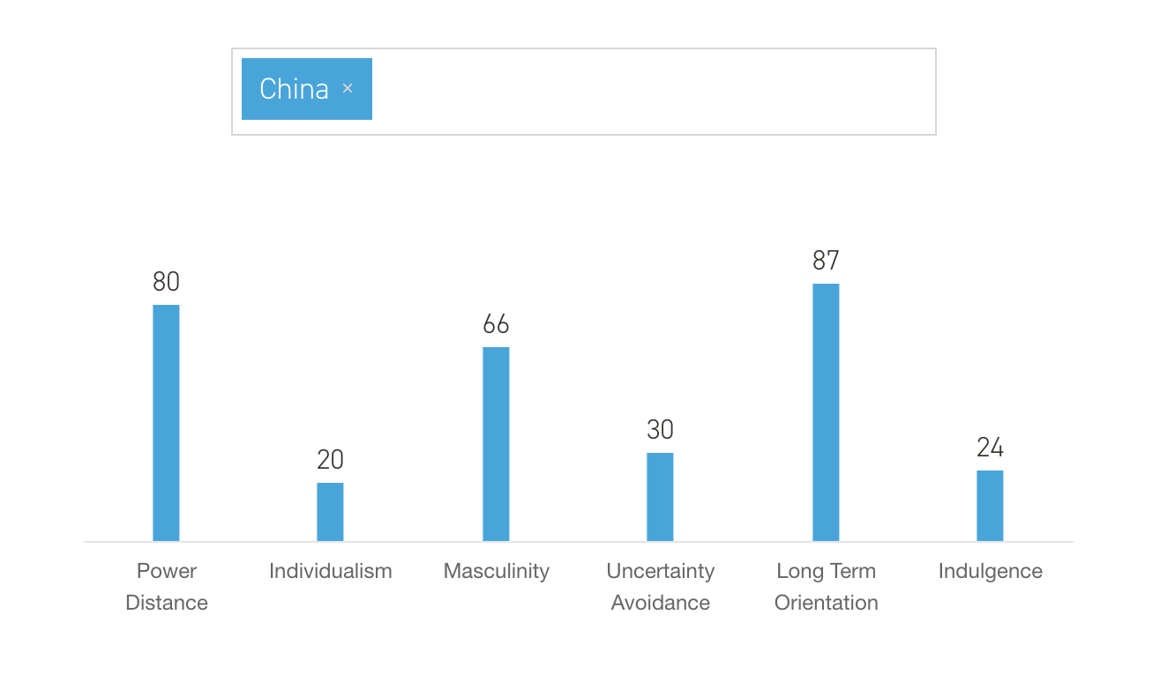
Figure 1(Source: Penn State, 2023)

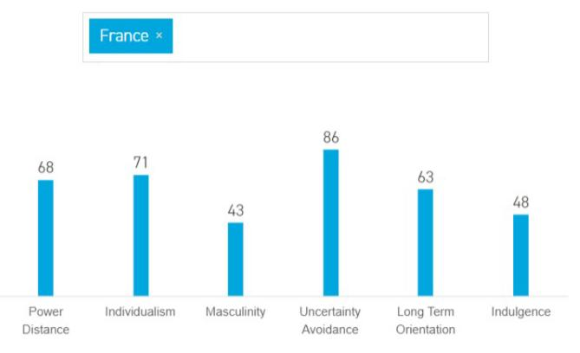
Figure 2(Source: Penn State, 2023)

Modifications in the Hotel’s Functions and Departments
Various hotel departments and functions in the French hotel need to modify their service delivery in order to meet the specific cultural norms and requirements of Chinese guests-
- Reception: The reception staff ought to be prepared to welcome Chinese visitors with a warm and deferential disposition, tending to them utilizing proper titles and honorifics. For smooth communication, it is essential to have Chinese-speaking staff or access to translation services.
- Drinks and Meals: Restaurants and room service should offer a variety of Chinese dishes to suit a variety of dietary needs and preferences. Chinese diners may enjoy their dining experience more if chopsticks are provided in addition to other utensils and Chinese tea is offered (Song et al, 2019).
- Concierge: The attendant group ought to know about Chinese far-reaching developments, celebrations, and attractions that may bear some significance to visitors. They can recommend tours that are friendly to the Chinese, local Chinese restaurants, and transportation services.
- Marketing and communication: Lodgings ought to consider deciphering their sites and limited-time materials into Chinese to connect with expected Chinese visitors. A presence on Chinese social media platforms and Chinese-language online booking options are also crucial.

Recommendations for Staff
Here are a few suggestions:
- Cultural Sensitivity Training: Train the staff of the hotel in cultural sensitivity, with a particular emphasis on Chinese culture, customs, and manners. Understanding the concept of "face" in Chinese culture and greetings are examples of topics that could be covered in this training. To provide a successful service to Chinese guests, the staff should be educated about their values and traditions.
- Fundamental Mandarin Language Abilities: Provide resources for language instruction or encourage staff members to acquire basic Mandarin language skills (Oliveira et al, 2022). Indeed, even a couple of key expressions or good tidings in Mandarin can go far in laying out compatibility and causing Chinese visitors to feel proud. Language proficiency can demonstrate the hotel's commitment to meeting the needs of Chinese guests and facilitate smoother communication.

Conclusion
Cultural sensitivity and flexibility assume a huge part in the hospitality business, especially while serving visitors from different social foundations. The cultural distinctions between France and China, as featured through Hofstede's cultural aspects, highlight the significance of understanding and tending to the interesting necessities of Chinese visitors. French hotel staff can improve cross-cultural communication, tailor experiences, and avoid potential misunderstandings and service failures by implementing the recommendations in this report. Eventually, these endeavors add to a more comprehensive and outstanding friendliness experience for Chinese visitors, laying out the inn as a favored objective and advancing positive visitor relations.

References
- Demossier, M., 2018. Wine drinking culture in France: a national myth or a modern passion?. University of Wales Press.
- Drott, E., 2021. Music and the elusive revolution: Cultural politics and political culture in France, 2010–2021 (Vol. 22). Univ of California Press.
- Fan, Y., 2020. A classification of Chinese culture. Cross Cultural Management: An International Journal, 7(2), pp.3-10.
- Hur, W.M., Kang, S. and Kim, M., 2019. The moderating role of Hofstede’s cultural dimensions in the customer-brand relationship in China. Cross Cultural Management, 22(3), pp.487-508.
- Oliveira, A.S., Renda, A.I., Correia, M.B. and Antonio, N., 2022. Hotel customer segmentation and sentiment analysis through online reviews: an analysis of selected European markets. Tourism & Management Studies, 18(1), pp.29-40.
- Song, H., Zhang-Zhang, Y., Tian, M., Rohlfer, S. and Sharkasi, N., 2019. Culture and regional innovation performance: an exploration in China. Chinese Management Studies, 13(2), pp.397-420.

