Cai Perry (2304939)
University of Wales Trinity Saint David
Abstract
This document contains both task 1, which is research on data security and compliance, and task 2 which is a case scenario where I will use newfound knowledge from my research and class activities to provide solutions for a tech company.
Data security and compliance
Computing Report

Contents
Task 1 – Data Security and Compliance Research 2
Abstract 2
Introduction 2
Security Frameworks 3
NIST Cybersecurity Framework 3
CIS Controls 5
Security Technologies 6
Firewalls 7
Intrusion detection systems (IDS) 8
Multi-Factor Authentication (MFA) 8
Task 2 – CyStesSolution Case Study 9
Defining the Objective 9
Policies and Procedures 9
Compliance (Laws and Ethics) 10
Risk Management 10
Contingency Planning 11
Protection Mechanisms 12
Seven Layers of Cybersecurity 13
Conclusion 14
Bibliography 15

Table of figures
Figure 1 - Cyber-attacks on businesses graph [2] 3
Figure 2 - NIST Cybersecurity Framework Core [5] 4
Figure 3 - NIST Implementation Tiers [6] 5
Figure 4 - The CIS Controls [11] 6
Figure 5 - Palo Alto's Network Firewall Diagram [15] 8
Figure 6 - Palo Alto's HBF Diagram [15] 8
Figure 7 - Risk Assessment Matrix [24] 12
Figure 8 -Seven Layers of Cybersecurity [29] 14

Task 1 – Data Security and Compliance Research

Abstract
In task 1 of this report, I will be displaying my understanding of data security and compliance by conducting research and providing a detailed written report in the following two topics which I have chosen from the list given in the assignment brief:
- Security frameworks
- Security technologies
This research paper will contain relative graphs charts and figures to give a visual representation of the data being discussed and will also be a review of why it is an absolute necessity that modern organisations must keep a certain level of data security. All sources will be listed at the bottom of this report.

Introduction
It is no secret that data security in the modern world is a necessity. In more recent times, data attacks have been more and more prevalent on businesses and organisations around the world. These attacks are devastating to business as malicious attackers purposely intrude into company’s databanks to steal employee’s information or infrastructure information from the business, if successful, this can lead to profit loss for the business, or huge data leaks such as the infamous Facebook data leak that affected approximately 533 million users worldwide, costing the business up to 5 billion dollars in damages and fines [1].
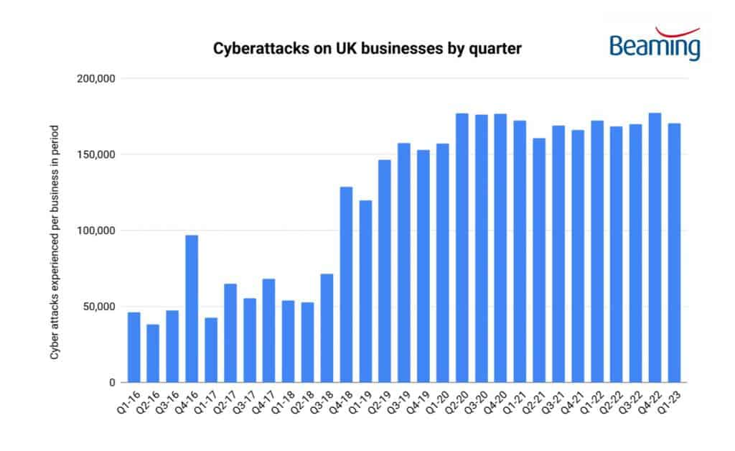
Figure 1 - Cyber-attacks on businesses graph [2]
The graph shown above provided by Beaming, details the number of cyber-attacks on UK businesses throughout the quarterly years of 2016 to the first quarter of 2023. In this graph, you can clearly see that there is a drastic increase of cyber-attacks in 2019 and 2020 some quarters even reaching over 150,000 incidents recorded, in fact, these attacks were so common that Beaming say that on average, UK businesses were experiencing an attack every minute in the first three months on 2023 [2]. These attacks are only predicted to increase furthermore in the future.
However, there are methods that businesses employ so they can deter these attacks and keep their data and profits safe. In the next few chapters I will be discussing how businesses can stay proactive and avoid malicious attacks.

Security Frameworks
Security frameworks are structured sets of rules, guidelines and best practices designed for businesses to implement to aid in data protection and manage the risks. Some key characteristics of security frameworks include risk management focus, as most frameworks focus on identifying and mitigating rising vulnerabilities to a business. Flexibility is often another as many different types of business will adapt a single framework, therefore, it needs to be flexible to accommodate the needs of all sizes and types of businesses and organisations. They also help with legal governance, helping businesses stay within the legal guidelines of the standard of security, helping in the avoidance of fines and reports, that could be as devastating to a business as a data breach.

NIST Cybersecurity Framework
One noticeable security framework is the NIST Cybersecurity Framework. This is provided by the national institute of standards and technology [3] and is one of the most popular and widely adopted security framework. This is because of the focus on ‘risk-based approach’ [3] instead of a one size fits all approach. The model focuses on the identification, assessment and then mitigation of rising problems, meaning that a business can allocate resources based on a specific security issue rather than having a ‘blanket solution’ of just using equal resources on everything, subsequently wasting resources [4].
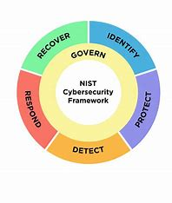
Figure 2 - NIST Cybersecurity Framework Core [5]
The image above shows the NIST CFS. These are the core functions within the NIST cybersecurity framework, and they are named after a verb which directly summarises what they cover [5]. Identify covers the understanding of rising threats and organisations security risks. Protect teaches how to properly implement correct safety measures. Detect focuses on the development and implementation of activities in relation to a cybersecurity event. Respond is the action taken to contain and the problem and mitigate the impact of a cybersecurity event and recovery is the development and implementation of new plans to restore anything that was damaged by an attack, and to further protect from another attack in the future. The way that govern acts is a little different to the rest of the functions. It acts as the overarching function that needs to be implemented alongside each of the other functions in order to achieve the best outcome [5]. It is the newest addition to the functions with earlier renditions of the NIST framework not explicitly labelling it as one of the core functions, but now it is seen as a necessary part of the core functions, as it is used in every other function.
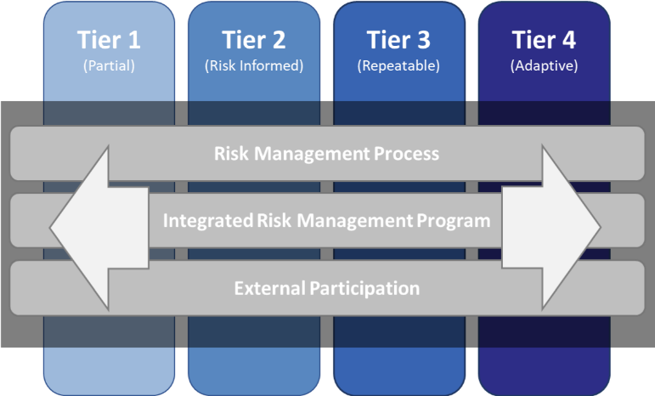
Figure 3 - NIST Implementation Tiers [6]
The official NIST CSF [5] also mentions of implementation tiers. These are the levels that reflect how the business exhibits the defined characteristics of the previously mentioned features. The tiers range from 1 (partial) which shows the business has a limited awareness. Tier 2 (risk informed) practices aren’t being fully integrated but shows more awareness than tier 1. Tier 3 (Repeatable) well established and consistent use of cybersecurity practices and tier 4 (Adaptive) which is proactive use of cybersecurity practices, ensuring the organisation is learning and constantly strengthening their defences based on previous threats [6]. However, the tiers shouldn’t replace an organisations risk management methodology rather to complement it, for example, organisations should determine their designated tier and then use the progression system to communicate an organisation wide approach to the minimalization of the security risks. Progression through the tiers is encouraged, but only when risks are greater, or when a cost analysis dictates that there is a cost-effective reduction of negative cybersecurity risks [5].

CIS Controls
The CIS controls [7] is another well-known Framework produced by the centre of internet security. These are a set of practices that are designed at its core to help businesses of any size add more rigor and defence to the most common and impactful cybersecurity threats. As of the latest version of the CIS controls, they have been categorised into 18 key controls with each control representing a specific cybersecurity control focus area. These 18 categories are then further categorised into three defining categories, controls 1 to 6 are called the basic controls, foundational controls range from 7-16 and the controls from 17-18 are the organisational controls. It is to be noted that some of the organisation of the controls can sometimes differ on what source is looked at, but the Centre for Internet Security [7] states that there are in fact 18 critical controls that their framework provides.
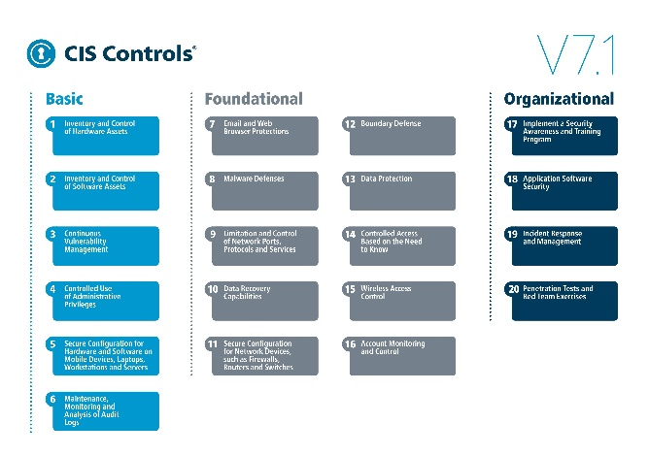
Figure 4 - The CIS Controls [11]
The basic controls are controls 1-6, and these are appropriately named, as CIS views the process of implementing a CSF as cumbersome, so to combat this, the first six controls are to be implemented one after the other, in order, as they build on each other [9]. Researchers at CSI [9] believe that even just the implementation of these first six controls will reduce the cybersecurity risk by 85%. These controls focus on core ‘security hygiene’ as said by writers at CSI [9] and combats basic cyber threats such as malware, unauthorised attacks and weak configurations. The first motion of the basic controls involves making sure that the whole organisations have a solid understanding of what exactly makes up the foundation of data security. Another key understanding of these first controls is proper vulnerability management. CIS urges organisations to continuously scan and assess vulnerabilities in the system, this way nothing is ignored for a long period of time and reduces the risk of an attack. The basic controls also mention control of administrative roles, as these are what have access to the most sensitive information within the company. Finally, the basic controls guide businesses in organising their configurations and provide a solid digital security baseline that any company should be able to follow.
The next set of controls are the foundational controls, these are where a majority of the 18 are set. These foundational controls range from 7-16, and compared to the basic controls, these are more focused on the improvement of organisational security and defence and tend to be more complicated than the first 6 [10]. One of the main focuses of the foundational group is the monitoring and analysis of activities preformed within the organisations IT systems. This includes the audit of audio logs, allowing companies to gather information early, letting them be proactive before an attack. These controls also emphasize protecting communications and ports. An example of this would be securing email and website access to prevent company personnel from falling for scams like phishing. Data protection is also another main focus of the foundational controls, CIS wants to push the point that data needs to be backed up properly, so that in the event of an attack, it can be properly recovered, minimising the damage. Lastly, the foundational controls close out by strengthening network infrastructure. This is done by the implementation of firewalls and routers, disallowing attackers to gain entry through any weak points.
Finally, group 3, the organisational controls focus on implementing security through processes and human factors, with a major aspect being training and awareness. Making sure that all employees are understanding of cyber security and the weaknesses within the companies, where employees are able to correctly respond to scams and other common attack tactics. Additionally, these controls guide the organisation into managing and controlling user accounts and ensuring that proper access control is in place, making sure employee accounts are monitored and are only being used for the correct purposes. Wireless access points are also mentioned int these controls as they are often overlooked but can still be exploited if not managed correctly. Finally, the organisational controls are a great closing point for the CIS controls, focusing on the human element in digital security, as this tends to be the most vulnerable, so by focusing in these areas it allows for long term resilience from cyber threats.

Security Technologies
Security Technologies are essential tools that any organization should employ to aid improve their data security. These technologies safeguard systems, data and whole networks. There are multiple different technologies an organisation can employ to help secure their data, many of which aiding in different ways and covering different aspects of data security [12], some of the most common include firewalls, anti-virus, encryption and intrusion detection systems. Inclusion of multiple of these listed, can create what’s known as a ‘layered security model’ [13]. This is where organisations make it as hard as possible for unauthorised persons to gain access into their system, by using multiple levels of data security [13]. For example, if a hacker were to get past a company’s outermost firewall, their data would still be protected by other security measures they have in place. This is a much safer way to protect data than having a single measure of defence in the way. The next three security measures are what I believe every organisation should have in place to protect their data, and should be the first safety measures before they employ other more advanced security technologies.

Firewalls
A firewall is a security system that can either be installed on a network or a personal device which manages incoming and outgoing network traffic that has been based on predetermined security rules. Its main purpose is to act as a barrier between a trusted internal network, such as a local network, and an untrusted external network, this usually being the internet [14]. Programmers a Palo Alto [15] say that the two most common firewalls deployed by businesses are the Network firewall and Host-based firewall.
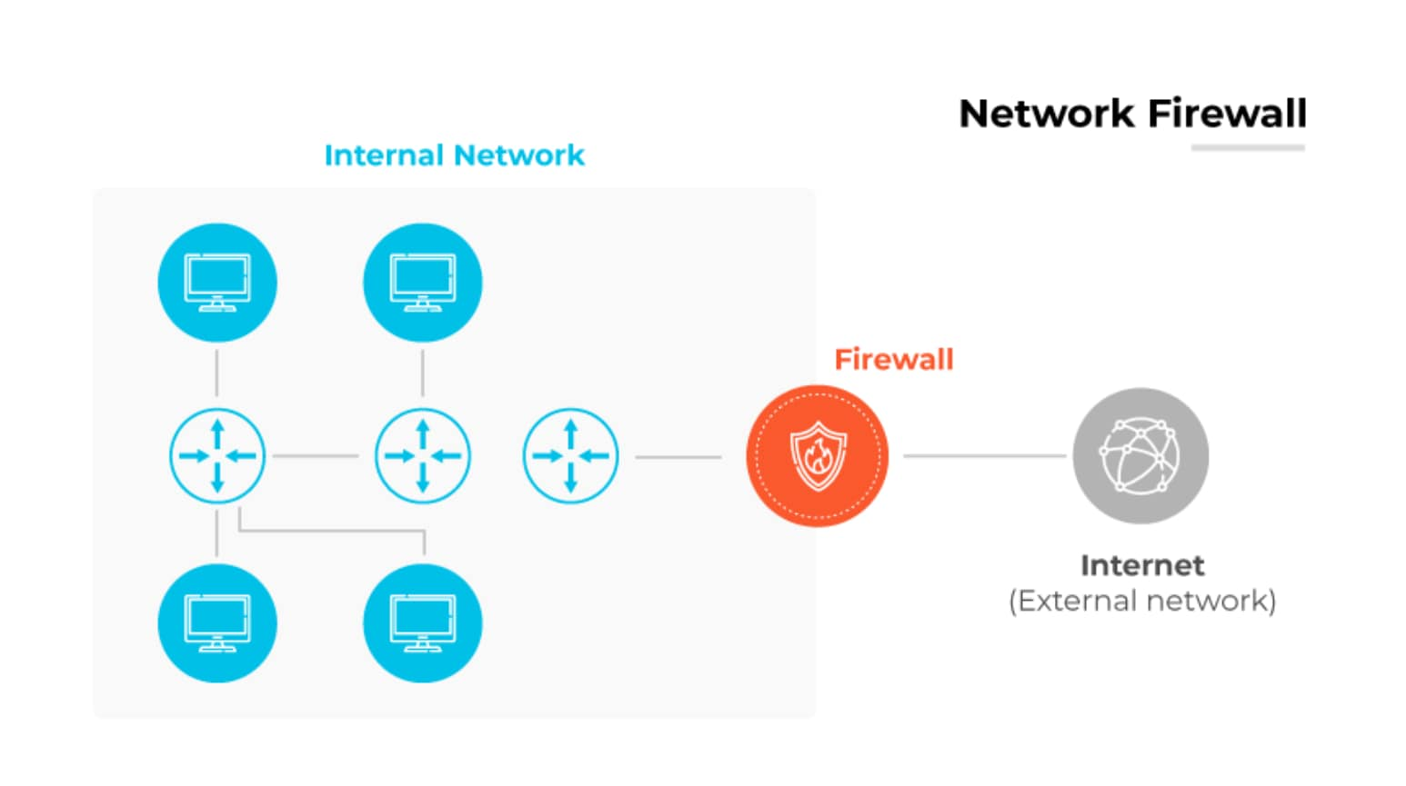
Figure 5 - Palo Alto's Network Firewall Diagram [15]
In the diagram above provided by Palo Alto [15], it quite simply displays where a network firewall gets installed. Here you can see that it sits between the trusted and untrusted network where it will monitor the data traffic coming in and out of the network. It will have established rules given to it, and from there it will compare factors such as destination IP addresses, port numbers and protocol to these established rules and will subsequently block anything it deems as dangerous or a threat.
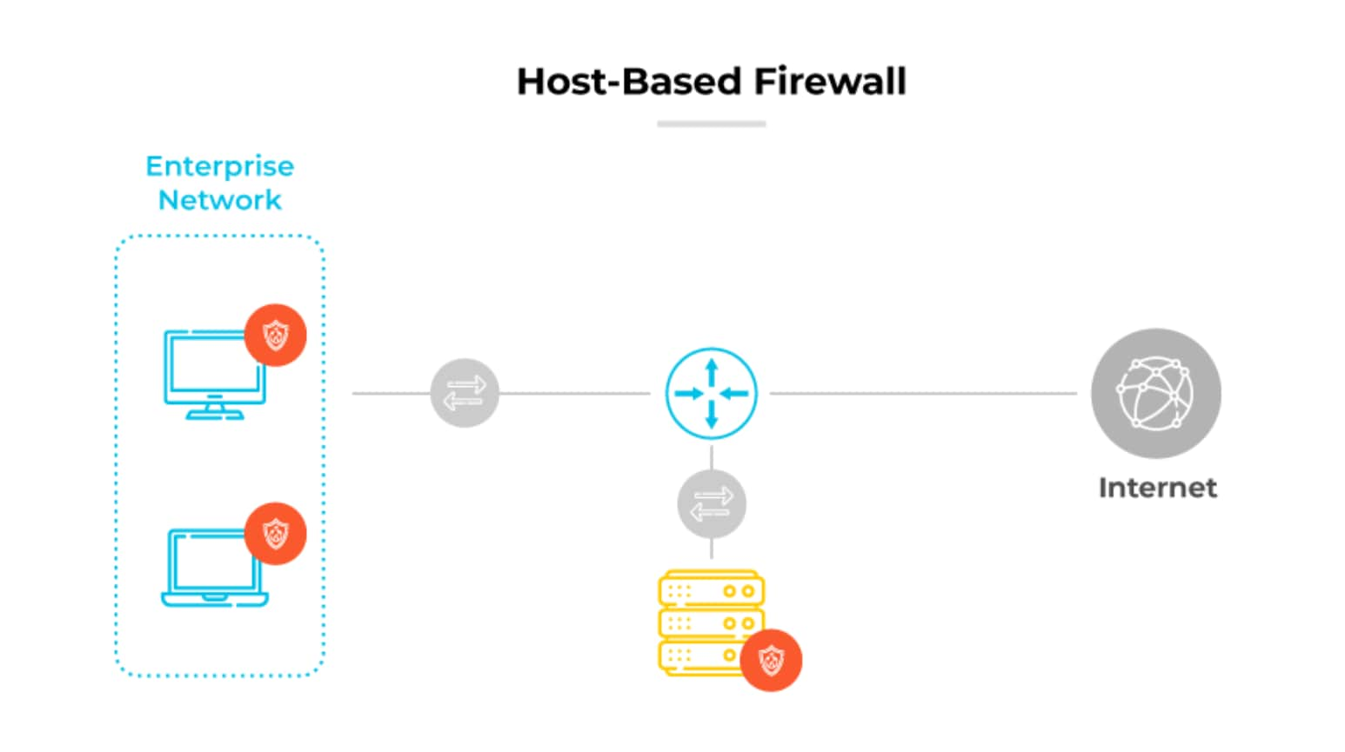
Figure 6 - Palo Alto's HBF Diagram [15]
This is a diagram depicting a host-based firewall, this differs to a network firewall in the way they are installed. Host-based firewalls will be installed on a singular device on a network, rather than the network itself. These firewalls are effective, as when they are installed, they protect the data at the device level, meaning that if the outer network was to be breached, the computers and devices would remain safe.

Intrusion detection systems (IDS)
An intrusion detection system is a tool which scans and detects malicious activity in a network [16]. This is different from the firewall however, because its purpose is to only detect suspicious activity, whist firewalls will actively block anything that is deemed suspicious. The two processes can be described as reactive and proactive, where firewalls will take a proactive approach, blocking out any malicious activity before it has chance to act on the network, whilst an IDS will take a reactive approach, alerting the user when it has found something suspicious.
An IDS can be installed onto hardware connected to a network this will then monitor the network traffic, for any suspicious activity or anything against security rule violations. IDS’s are an effective way to automate the network threat detection within an organisation as they can alert administrators of suspicious activity or send any alerts to a centralised security tool [16]. However effective IDS are at detecting unauthorised activity, they are unable to stop any activity which is why they are often incorporated into intrusion prevention systems (IPS) which will be able to automatically be able to prevent those threats that have been detected.

Multi-Factor Authentication (MFA)
Multi-Factor authentication is also more widely known as two factor authentication (2FA). This is the process of having two different instances of authentication before being granted access into an account or system. The primary goal of this is to add another layer of protection, as one of the most common ways someone can access an account is through physical password theft, for example, if someone were to write down their password because they kept forgetting it, anyone can access their accounts.
Examples of MFA include a one-time password, this is even implemented within the school’s network, where as any student logs into Moodle, a one time password will be sent to your email on your phone, and you will have to input the generated number into your phone to enter. This is one of the most important and first steps an organisation should take as physical password theft is common in the workplace, and a study taken by Keeper Security in 2021 shows that 57% of workplace employees write their passwords down on sticky notes [17].

Task 2 – CyStesSolution Case Study

Defining the Objective
This Information security unit would be ineffective if at first the key mission and objectives weren’t first discussed so that the ISU can align with exactly what the organisation wants. In the scenario, CSS is described to be a cyber threat intelligence and consultancy service, so after analysing the company’s product and needs, I believe that the main two focus areas of the ISU should be both internal security procedures, and on customer services. This is the most effective focus of the Information security unit because it allows CSS’s security posture to remain strong, but it will also guide clients to have a proactive mindset in cyber threat identification and nullification. There are multiple fields and tools that can be discussed in order to reach this goal. These could include the organisation of the security model, Policies and compliance, Laws and ethics, risk management and contingency planning to name a few.

Policies and Procedures
Policies and Procedures play a crucial role in the foundation of any ISU. They act as guidelines from which issues and problems should be addressed [18]. These are usually set by top level leadership within the organization such as the chief operating officer. Whilst policies and procedures are vital in keeping the company in check within their own security vision, they must not contradict with the law, as that is also another feature in the ISU which I will discuss later.
The procedures are where security frameworks can be implemented. One of the most popular being the NIST security framework, as previously mentioned under security frameworks. To implement this, CSS Lead IT Teams can visit the NIST website [3] to see the core resources of the framework. What’s so good about the NIST framework in particular is the approach it takes to security, allows It to fit any business no matter the size or growth rate, this is why I think this is the best option for CSS.
Because of the constant change of the law, and constant development of now guidelines and technology, it is common that company policy will change often, this means that in order to maintain viability these policies must be managed properly and that the employees of the company know the new policies. Having a policy manager, who keeps track of the distribution and uphold of the existing and newer polices will heavily benefit this company. One tool that is widely used includes automated policy management software. This allows documents to be stored and reviewed in a central cloud and ensures no employee will miss an update [19].

Compliance (Laws and Ethics)
Whilst the company’s policy and procedures dictate how a company should act within their own vision, the law is what they need to be doing, otherwise a company will risk legal trouble further leading to fines, or if the infringements are severe enough, possible prison time for those who’s responsibility it is to maintain the company’s legal compliance.
Because CSS use the online methods to provide their service for customers, they have to follow data regulation protection laws (GDPR) [20]. These laws govern how the company handles customer data and how it is transferred. Customers also have rights to know what is happening to their personal data when given, and all companies involved with it. The computer misuse act of 1990 [21] is another law that must be followed which criminalises the unauthorised access of computers, data theft and cyberattacks. There are many laws that the CSS must follow in order to stay compliant, a good way to integrate this into the system would be again to have proper management to survey the company’s actions. The application of a third-party audit company would also help stay within the confines of the law, as they will independently survey the organisation and will provide a report on any areas they deem close to infringement and areas to improve on.
The difference between laws and ethics are that laws are something in which must be adhered to by the company, whilst ethics are more about moral principles, and they go beyond compliance and focus on doing what’s right. When dealing with customers and solutions, it is important that the company be transparent with the use of their data, and that they have the customers full consent for it to be used. This not only complies with the GDPR laws, but makes the customer feel reassured that their data isn’t being misused. As ethics aren’t as easy to be followed because some they aren’t exactly fully required, some professional organizations have made their own code of ethics that can be followed. The most known one would be the ACM code of conduct [22], ACM is the oldest computing society and requires members to act out their duties in a manner that reflects an ethical computing professional.

Risk Management
The first step to risk management is the identification of a risk. These could be any cyber threats, data breaches or any operational risks. After the risk has been identified, it must be assed. This is a process where the severity of the risk is analysed and the impact it will have. This is an important step because this is where the company will allocate resources and prioritise areas which are more high risk than others [23].

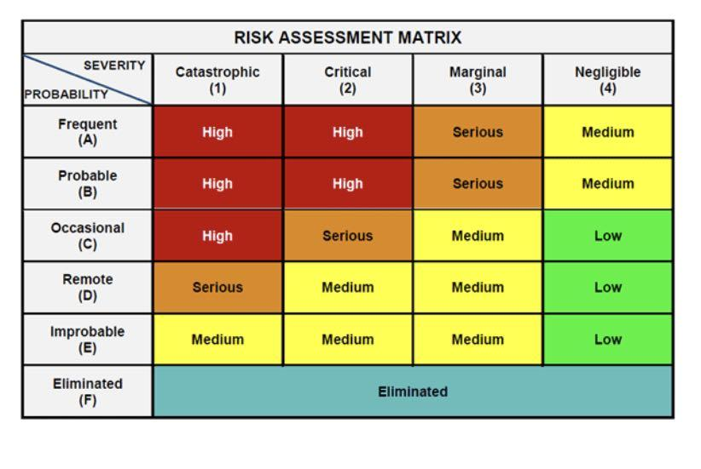
Figure 7 - Risk Assessment Matrix [24]
This is a risk assessment matrix; this is a tool used to evaluate the prioritisation of risks within an organisation. It combines the severity and probability of risks and depending on what category on the matrix they fall in, decides if immediate action should be taken. It is a good visualization to help allocate the organisations resources towards different risks. The risk matrix isn’t a guaranteed success tool however, as it can sometimes lead to inaccurate assessments if the categories aren’t specific enough to compare. It shouldn’t be used as the basis to prioritize risks, rather a tool that helps aid already established and growing issues within the organisation.
The final step after identifying and then assessing the risk would be to conduct risk control. This is the process were thought out methods are taken to upper management to be reviewed before implementation. These methods will then be assessed when they are being implemented to further review their effectiveness in the future. Finally, the full process of individual risk control would be extensively documented so that there is a strong control strategy in place eliminating any residual risk.

Contingency Planning
Contingency planning is the planning that will help any business get back on track after an event or disruption. CSS management roles such as the Chief Information Officer and Business continuity/ disaster recovery manager will often be the people responsible for designing and implementing these technical procedures [25].
A contingency plan is a much-required step in risk management as it provides the business much needed stability in the recovery process, and it provides foundation to work off in a higher-pressure environment. There are many different steps that make up a contingency plan, with many providers having their own guidelines, but because the ISU should be tailored to internal security, CSS’s plan should focus on areas such as data protection having data caches that have stored backup data to ensure nothing has been lost in an attack and to make sure that they are all encrypted with strong data encryption. It is also important that the service isn’t disrupted, or at minimum recovered as soon as possible. Preforming regular disaster recovery tests on the system to be assured that they can be restored in a good time.
Much of CSS’s value comes from the service they provide with security consultancy, so in their contingency plan in is imperative that client services are held to the same importance as their own, and that client service continuity be upheld. In the event of an attack, clientele should be immediately notified through a dedicated mobile hotline or email service, this would be managed by the customer service department within the company, to handle any further questions pr complaints that customers have. The use of multiple cloud services will also minimise downtime after an attack.
Focusing the contingency plan on both of these areas should guarantee the minimisation of downtime for both the company’s servers and the service they provide, maintaining good customer reputation and security within their organisation.

Protection Mechanisms
Having protection mechanisms in place is critical to any business’s security. They act as the backbone of any standard security model. Protection methods include cybersecurity areas such as the implementation of firewalls and antivirus checker. These are effective methods to prevent unauthorized access of data. With the use of tools that were described in Part 1’s Security Technologies CSS can create a strong digital environment, that guarantees proactive action on threats and keeps data safe.
Firewalls are a great tool to employ, as they are effective at monitoring and keeping unwanted data out of a network as they operate on pre-determined parameters that are set by CSS, this way, they can set the information they don’t want to come into their networks. Intrusion prevention system is also another effective digital protection mechanism [26]. This hardware has evolved from intrusion detection systems and has the capability to not only detect malicious content, but also block it, whereas an IDS can only alert security teams of any malicious presence.
Whilst the implementation of digital security methods such as firewalls and antivirus create a strong online security presence, it is also important for a security company such as CSS to have the correct physical security in place too. This starts with the correct education training of all employees. Phishing is a common scam that uses emails, or messages to trick employees into reaving their sensitive data to hackers [27]. This will usually effect businesses the most, as hackers pretend to be higher management, often asking for data reports or a link which leads to a website that installs ransomware onto a PC [27]. This scam should be carried out in dummy tests by the IT department, to make sure that the other employees know what too look for when sent a fake email or message, and if they don’t carry out the expected response, no data is lost or damaged and they can be submitted into a re-education course. Refresher courses should also be often carried out every quarter, or as often as they need to so that all employees are kept up to date about new emerging technologies or digital threats.

Seven Layers of Cybersecurity
The seven layers of cybersecurity is a conceptual model that would be a good visual tool for the entire implementation of CSS’s ISU. The model ensures what’s known as a multi- layered security model [28]. Where it encompasses every aspect of security within a business and are structured starting at the physical (human) layer up to the data security layer.
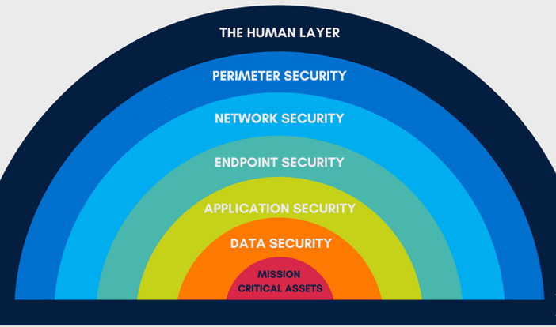
Figure 8 -Seven Layers of Cybersecurity [29]
The physical layer covers all things human, this includes security controls designed to protect hardware such as servers and workstations from theft. Good practice of physical security involves biometric locks, such as fingerprint recognition on doors, hardware encryptions to protect devices, and CCTV to monitor any physical threats.
Perimeter security involves the boundary between the internal network and the outside, usually the rest of the internet. This is the layer where firewalls are implemented, as they monitor the traffic that comes in and out of a local network from the outside. DDoS protection can also be implemented at this layer, to prevent any denial-of-service attacks.
Layer 3 is the network security, this is securing the infrastructure of the network through the use of security technologies such as IPS’s, and VPN’s for secure remote access to servers.
Endpoint security protects individual machines such as laptops and smartphones that are connected to the network. Prevention methods such as antivirus are effective at preventing malicious content on personal machines. Having good access control policies in place to limit what users can do on the network also help uphold endpoint security.
Application security covers security at the software level, these are the applications that are used throughout the business, making sure these are secure can prevent data that is being transferred through applications will not be at risk.
Data security ensures the confidentiality, integrity and availability of data that is in storage and transfer, this layer is crucial for CSS. They must make sure that data is encrypted in transfer, and proper disaster recovery plans are in place.
Finally, the mission critical assets layer covers all of the important information that if compromised can seriously cripple the business [30]. In CSS’s case, this data would go beyond simple customer data and extends to business transaction data including the customers monetary information, for example, credit card details if they were on a payment solutions plan with the company, or utilising one of their paid services.

Conclusion
The ISU covers every basis that CSS needs in order to create a secure environment for their staff and data. From describing the structure of the organization to different data security practises that describe different ways to secure the most vital information the company needs to thrive. Incorporating the use of expert frameworks, such as the previously mentioned NIST Framework will provide a third party insight into data security.
Even though the full integration on a new ISU will be a lengthy process, following the ISU is critical to success, and includes such activities such as proper staff training and how management and IT experts within the company can uphold these practices. The ISU not only aligns with the companies best interests by upgrading the internal digital security, but by also having focus on the customer service side of the organisation will boost the company image with already existing clientele and possible new clients. Clients will also feel reassured as the ISU details how to remain transparent with clients in the event of an attack, but also in general with ethical codes of data handing.
With the implementation of this ISU could mark a new milestone for this company, as it enables them to offer more secure, law compliant service that will no doubt in the future boost customer rating and employee morale. The focus on data protection and business continuity provides immediate value to the customers, but allows the company to keep a competitive edge in the fast evolving environment of cybersecurity solutions.

Bibliography
[1] A. Senaite, “The 20 biggest data breaches in history | Norvan,” nordvpn.com, Jun. 28, 2024. (accessed Nov. 26, 2024) https://nordvpn.com/blog/biggest-data-breaches/
[2] R. White, “Q1 2023 Cyber Threat Report,” Beaming, Apr. 13, 2023. (accessed Nov. 26, 2024) https://www.beaming.co.uk/cyber-reports/q1-2023-cyber-threat-report/
[3] NIST, “Cybersecurity Framework,” National Institute of Standards and Technology, 2024. (accessed Nov. 26, 2024) https://www.nist.gov/cyberframework
[4] “Cybersecurity Framework FAQS Framework Basics,” NIST, Sep. 2015, (accessed Nov. 26, 2024) Available: https://www.nist.gov/cyberframework/cybersecurity-framework-faqs-framework-basics
[5] National Institute of Standards and Technology, “The NIST Cybersecurity Framework (CSF) 2.0,” The NIST Cybersecurity Framework (CSF) 2.0, vol. 2.0, no. 29, Feb. 2024, (accessed Nov. 26, 2024) doi: https://doi.org/10.6028/nist.cswp.29.
[6] NIST, “Cybersecurity Framework 1.1 Components,” NIST, Feb. 2018, (accessed Nov. 26, 2024) Available: https://www.nist.gov/cyberframework/cybersecurity-framework-components
[7] Center for Internet Security, “CIS Critical Security Controls,” CIS, 2023. (accessed Nov. 27, 2024) https://www.cisecurity.org/controls
[8] A. Marget, “CIS Controls: What They Are and How They Are Used,” Unitrends, Jun. 14, 2022. (accessed Nov. 27, 2024) https://www.unitrends.com/blog/cis-controls
[9] N. Riley, “Practice Cyber Hygiene with 6 Basic CIS Controls,” CSI, Aug. 06, 2020. (accessed Nov. 27, 2024) https://www.csiweb.com/what-to-know/content-hub/blog/6-basic-cis-controls/
[10] “Breaking Down CIS Foundational Controls,” www.cimcor.com. (accessed Nov. 27, 2024) https://www.cimcor.com/blog/cis-foundational-controls
[11] “The 7 CIS controls you should implement first,” CSO Online. (accessed Nov. 27, 2024) https://www.csoonline.com/article/567737/the-5-cis-controls-you-should-implement-first.html
[12] K. Johnson, “Top 7 types of data security technology,” SearchSecurity, 2022. (accessed Nov. 27, 2024) https://www.techtarget.com/searchsecurity/feature/Top-7-types-of-data-security-technology
[13] “What is Layered Security?,” Ericom Software. (accessed Nov. 27, 2024) https://www.ericom.com/glossary/what-is-layered-security/
[14] Fortinet, “What is a firewall?,” Fortinet, 2023. (accessed Nov. 27, 2024) https://www.fortinet.com/resources/cyberglossary/firewall
[15] Paloalto Networks, “Types of Firewalls Defined and Explained,” Palo Alto Networks. (accessed Nov. 27, 2024) https://www.paloaltonetworks.com/cyberpedia/types-of-firewalls
[16] IBM, “What is an intrusion detection system (IDS)?,” www.ibm.com, 2023. (accessed Nov. 27, 2024) https://www.ibm.com/topics/intrusion-detection-system
[17] J. Chang, “55 Important Password Statistics You Should Know: 2021 Breaches & Reuse Data,” Financesonline.com, Apr. 28, 2021 (accessed Nov. 27, 2024). https://financesonline.com/password-statistics/
[18] “ISO/IEC 20000-1 | ISO Specialists |,” IMSM GB, Aug. 15, 2024. https://www.imsm.com/gb/iso-20000/ (accessed Nov. 28, 2024).
[19] “What is policy management? (And why it’s important),” Indeed Career Guide, 2024. https://uk.indeed.com/career-advice/career-development/what-is-policy-management (accessed Nov. 28, 2024).
[20] UK Government, “Data Protection Act,” GOV.UK, 2018. https://www.gov.uk/data-protection (accessed Nov. 28, 2024).
[21] “Computer Misuse Act 1990,” Legislation.gov.uk, 1990. https://www.legislation.gov.uk/ukpga/1990/18/contents (accessed Nov. 28, 2024).
[22] ACM, “ACM Code of Ethics and Professional Conduct,” Association for Computing Machinery, Jun. 22, 2018. https://www.acm.org/code-of-ethics (accessed Nov. 28, 2024).
[23] “Risk Management in DFID.” Available: https://assets.publishing.service.gov.uk/government/uploads/system/uploads/attachment_data/file/253815/risk-management-guidance.pdf (accessed Nov. 29, 2024).
[24] F. Usmani, “Risk Assessment Matrix: Definition, Examples, and Templates |,” PM Study Circle, Mar. 24, 2022. https://pmstudycircle.com/risk-assessment-matrix/ (accessed Nov. 29, 2024).
[25] I. T. L. Computer Security Division, “CSRC Topic: contingency planning | CSRC,” CSRC | NIST, Jun. 08, 2016. https://csrc.nist.gov/Topics/Security-and-Privacy/security-programs-and-operations/contingency-planning (accessed Nov. 29, 2024).
[26] IBM, “What is an intrusion prevention system (IPS)? | IBM,” www.ibm.com, 2023. https://www.ibm.com/topics/intrusion-prevention-system (accessed Nov. 29, 2024).
[27] M. Kosinski, “What is phishing?,” IBM, May 17, 2024. https://www.ibm.com/topics/phishing (accessed Nov. 30, 2024).
[28] “What is Multi-Layered Security? | Druva,” www.druva.com. https://www.druva.com/glossary/multi-layered-security (accessed Nov. 30, 2024).
[29] M. Mayo, “The 7 Layers of Cybersecurity,” DiamondIT, May 12, 2022. https://www.diamondit.pro/7-layers-of-cybersecurity/(accessed Nov. 30, 2024).
[30] “7 Layers of Cybersecurity Explained: A Complete Guide,” AxiomQ, Nov. 2024. https://axiomq.com/blog/7-layers-of-cybersecurity-explained-a-complete-guide/ (accessed Nov. 30, 2024).

