

Postgraduate/Distance Learning
Assignment coversheet & feedback form

THIS SHEET MUST BE THE FIRST PAGE OF THE ASSIGNMENT YOU ARE SUBMITTING (DO NOT SEND AS A SEPARATE FILE)

For completion by the student:
Student Name: DAISY PLUMMER

Student University Email: 2406954@student.uwtsd.ac.uk
Module code: HPCA7015  Module title: Foundations in Cultural Astronomy and Astrology | Student ID number:  2406954 |  |  | Educational support needs:  No
Assignment title: Essay based on a Sky Journal
Assignment due date: 28th November 2024
Word Count: 2098 including title excluding footnotes, bibliography and text in Fig. 1.
This assignment is for the 1st 2nd 3rd 4th 5th 6th module of the degree
I confirm that this is my original work and that I have adhered to the University policy on plagiarism.
Signed: Daisy Plummer
Email submission:if you are submitting this form via email, please tick this box 
(as a substitute for your signature) to confirm that you agree to the above declaration.
Assignment Mark
1st Marker’s Provisional mark
2nd Marker’s/Moderator’s provisional mark
External Examiner’s mark (if relevant)
Final Mark

NB. All marks are provisional until confirmed by the Final Examination Board.

For completion by Marker 1 :
Comments:

Marker’s signature: |  |  | Date:
For completion by Marker 2/Moderator:

Comments:

Marker’s Signature: |  | Date:
External Examiner’s comments (if relevant)

External Examiner’s Signature: |  | Date:

Essay based on a Sky Journal

‘Be clearly aware of the stars and infinity on high. Then life seems almost enchanted after all.’ Discuss this statement from Vincent Van Gogh as it relates to your sky journal observations.
This essay analyses a sky journal that I kept from 11th October 2024 to 11th November 2024 and considers my observations of the sky at sunrise in relation to the above quote from Vincent van Gogh. I studied the morning sky from an upstairs window in my home that faces due East. In analysing my observations three themes became apparent; firstly, 'The Sky' as a living entity imbued with personality and emotions; secondly, 'The Sun' as a symbol of life and hope and the absence of the sun as the opposite and thirdly, the importance of active choice in the experience of enchantment.
The approach I initially intended to take within the sky journal was one of logic and analysis. I planned to observe sunrise and document the sun's journey southwards towards its winter solstice point, using the lattice frame of the windows. I carefully noted the sunrise times for Oxfordshire.

'11th October 2024. Sunrise 7.23. I think about the grid lines of the window frame and decide to measure where I stand so that I can take a photo a day and watch the Sun move south towards the winter solstice. I place my feet against the edges of the banisters at the top of the stairs and take a photo of the Sun through the windows. I notice that it is sitting in the cross hairs of the window's bars.'

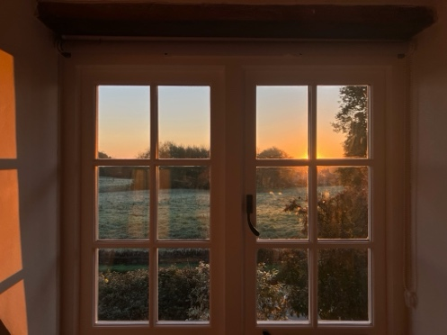

However, in analysing my observations there is a speedy switch in approach from logic and analysis to impression and emotion. On 13th October I wrote 'The Sky is getting dressed up to welcome The Sun with streaks of peach, orange and gold mixing with pinks and blues. I am excited for the day.' On 20th October I wrote 'There is no sign of The Sun this morning and the sky seems upset about it! It looks bruised and brooding. It is making me feel sad,' whilst on 24th October I recorded that I announced over breakfast 'oh I must go and take a photo of my sky' prompting my daughter to ask, 'Is the sky your friend?' The sky journal entries depict the sky becoming ensouled in an animist fashion identified by anthropologist Edward B. Tylor (1832-1917). As Tylor wrote ''the laws of the universe are not limited with the direct observation of our senses,' so my sky journal entries moved beyond direct observation and took on a doctrine of soul and spirit. I perceived the sky as imbued with emotion and this influenced my own emotion; I was upholding Lucien Lévy-Bruhl's (1857-1939) 'law of participation;' the sky was both itself and something other than itself and I had developed a mystic connection with it. I realised that in keeping a sky journal I had embarked upon a relationship with the sky and the appearance or not of the sun at sunrise influenced my thoughts and feelings in a way that went beyond rational logic.
The appearance, or not, of the sun was the key influence in reading positivity or negativity into the sky's mood and maintained the focus on sunrise set at the start of the project. My journal entries depict the appearance of the sun as symbolising positivity and hope. On 17th October I wrote 'The sun appears and the sky glows orangey red full of promise for a golden day. The sky feels filled with hope.' On 22nd October my journal entry says 'I watch the sun rise and the sky is bursting with white light. I feel hopeful and excited for the day.' I experienced the visible presence of the sun as reassuring and positive. It reminded me of the comforting 'it's all right' of The Beatles song 'Here Comes The Sun.' The lack of sun at sunrise was just as strongly felt and produced the opposite emotions of hopelessness and sadness. On 28th October I wrote, 'There are low, big, and black angry clouds this morning - thick like a blanket... The lack of Sun makes me feel depressed and as if this day is destined to be a bad one,' and on 30th October I asked 'What is a sunrise with no sun? It's a false start, its sucks all the get up and go out of the day.' Of course, October and November in the Northern hemisphere are times of reduced sunshine hours both in length of day and meteorological conditions and the psychological effects of less sunlight are acknowledged by the mainstream medical community. The poet Lloyd Schwartz (1941 -) beautifully describes the morale boost that The Sun can prompt at this time of year in 'Leaves':

'You'll be driving along depressed when suddenly
a cloud will move and the sun will muscle through
and ignite the hills. It may not last. Probably
won't last. But for a moment the whole world
comes to. Wakes up. Proves it lives. It lives.'

However, in November the United Kingdom was plunged into an 'anticylonic gloom,' described by BBC weather as:

'when high pressure traps an area of moisture close to the surface of the Earth. The moisture forms low cloud, mist and fog, which then cannot lift and clear as the winds are so light and the sunshine at this time of year is so weak'

This resulted in no visible sun at sunrise for the remainder of my sky journaling. [Fig. 1] This also coincided with the sudden death of my father on 2nd November. Nevertheless, I continued to experience the sky as living and the lack of sun as participating in the circumstances of my life and my emotions, writing on 3rd November 2024 'Daddy is gone and so there is no sun,' and on 5th November 'The sky is dark purple, grey blue. It feels like the sky is crying with me. We feel hopeless.' The lack of sun did not result in a lack of participation; the participatory relationship continued, and I experienced the sky as grieving with me.
The sky remained ensouled whether the sun appeared at sunrise or not but the presence of the sun, or lack of, is what contributed to the mood of the sky. However, the 'gloom' of the sky was no mere lack of sun, but the thick mist and fog trapped by the high pressure of the weather system. This created an additional sense of limitation, restriction, and helplessness. My journal entries show that the sky felt suffocating and as though it were 'closing in' and 'crushing down on me.' On Friday 8th November I wrote ' The sky is so uniformly grey that it is very unsettling; you can't see far and there is no colour or texture to observe. It is not enchanting at all.' Nicholas Campion says that enchantment 'in conventional usage is synonymous with being bewitched - to be under a spell which has been uttered or chanted' and that 'it may also be synonymous with wonder.' Whilst the sky remained enchanted for me in that it was still magically imbued with emotion, I felt no awe or wonder when looking at it. Helen de Cruz describes awe and wonder as 'epistemic emotions; emotions that motivate us to explore our environment and learn more about it.' She links awe with vastness and wonder with the glimpse of the unknown and when I observed the sky as limited and unpromising, my experiences of wonder and awe were limited. Daniel Silva Luna and Jesse Bering argue that awe, like all other emotions, is an abstract concept and a learned reaction according to a person's cultural laws, saying that people's 'experiences of awe reflect the knowledge they have acquired through life and the situations they find themselves in.' De Cruz acknowledges that 'a sense of despair and powerlessness' can damage our ability to experience awe and wonder. She claims that experiencing awe and wonder involves the choice to do so. 'We can choose to see things with firstness.' That is 'seeing the familiar as wondrous or strange, as if we were encountering it for the first time.' A salient observation of this phenomenological project was that when the sun was visible at sunrise, I threw the window open. I experienced the window as a limiting and restrictive obstacle. '11th October. I am so excited that I fling the windows open to take more photos.' '23rd October. I open the window to be closer to the sun, to feel the air and bathe in the sky.'

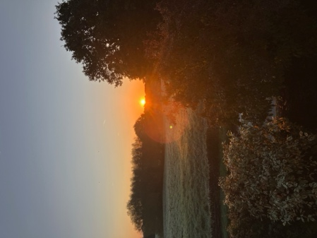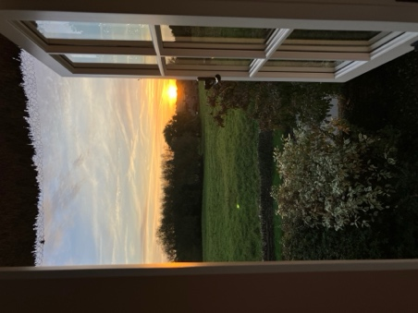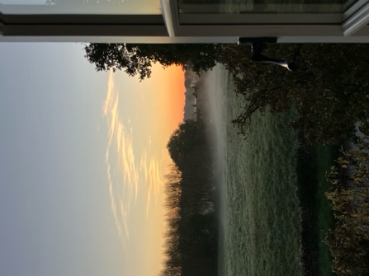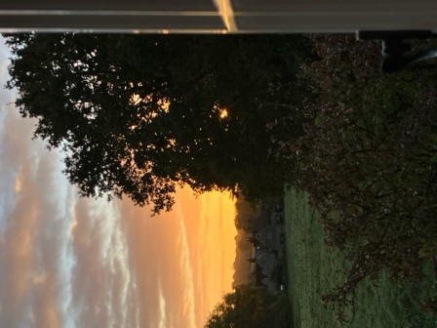

11th October 2024 13th October 2024 24th October 2024 27th October 2024

The window restricted an experience of the vastness of the sky; it was a literal obstacle to observing the infinity of the sky in a similar way to the gloom of the high-pressure weather system. The lattice frame of the window was inextricably linked to the original rational approach that I had intended to take within the sky journal and so suggested the calculation and intellectualisation that sociologist Max Weber (1864-1920) felt fed 'the disenchanting of the world.' However, Campion has challenged Weber's view that 'enchantment is necessarily inhibited by rationalisation and technology,' citing as an example the awe it is possible to feel when looking through a telescope. De Cruz agrees with both points of view saying, 'modernity offers new opportunities for awe and wonder' as well as noting that 'we have become increasingly alienated from the natural world, a major source of awe and wonder.' Analysis of my sky journal suggests that emotional limitations might disenchant and dispel awe as much as rationality and technology are sometimes able to and De Cruz's proposal of choice being a key component in the experience of awe and wonder explains this. In looking through a telescope we are choosing to participate with the Universe and awe is a likely reaction, albeit a culturally primed one, according to Silva Luna and Bering. Grief hampered my ability to choose awe, and limited enchantment, despite the continuation of a participatory relationship with an animated sky.
To conclude in analysing the observations in my sky journal I agree with van Gogh's statement ‘Be clearly aware of the stars and infinity on high. Then life seems almost enchanted after all.’ However, being 'clearly aware' involves not only entering a participatory relationship with the stars, but also actively choosing to seek out 'infinity on high,' even on those occasions when the stars may not be visible, both literally and metaphorically. If we choose not to do so then the possibility of experiencing the enchantment of life is restricted, for enchantment, awe and wonder are emotions that we can opt in or out of.

Fig. 1 - The anticyclonic gloom over November's sunrises.

01.11 03.11
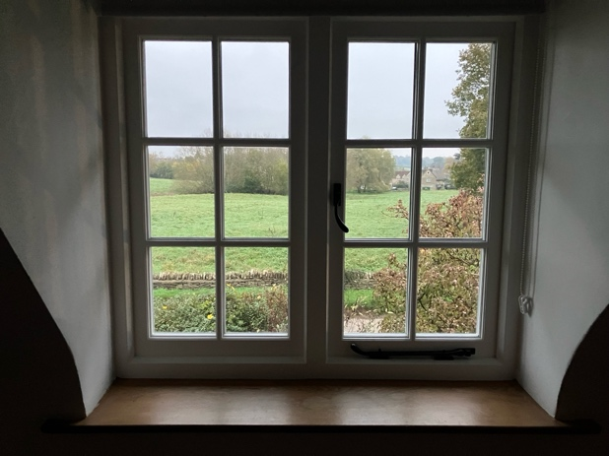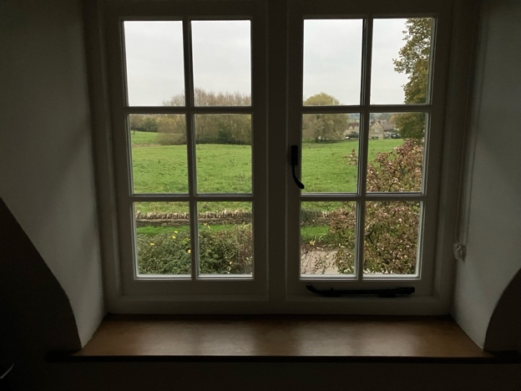
05.11 06.11
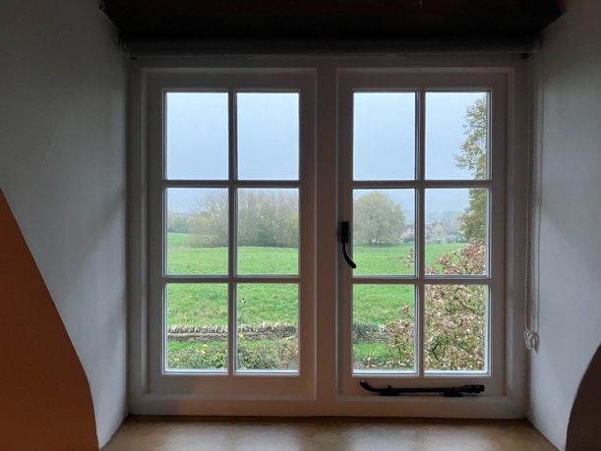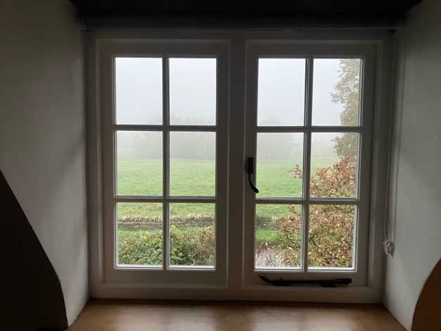
07.11 08.11
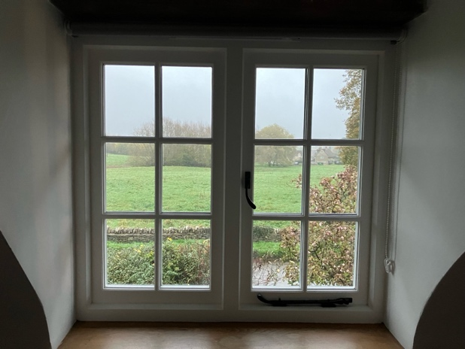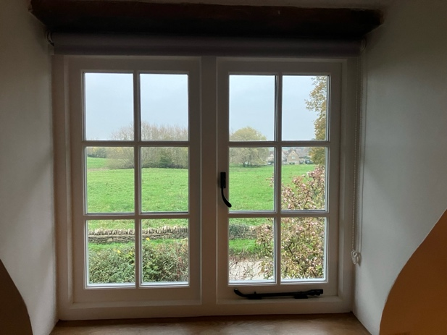
09.11 10.11
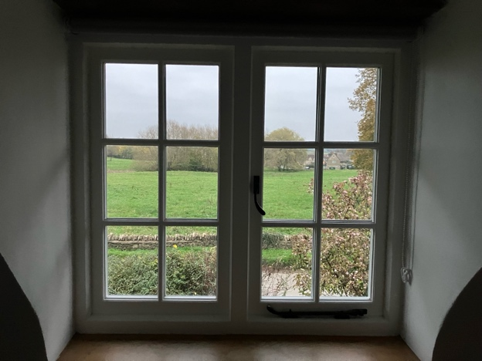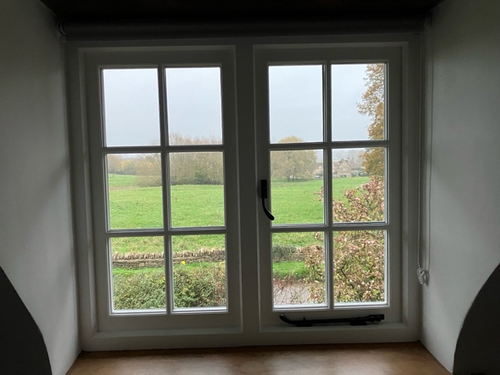

Bibliography

BBC, BBC Weather 2024, <https://www.bbc.co.uk/weather/articles/c36pxjx855go> [accessed 19.11.2024]

Campion, Nicholas, Enchantment and the Awe of the Heavens, THE INSPIRATION OF ASTRONOMICAL PHENOMENA VI Conference Series, 2011

De Cruz, Helen Wonderstruck How Wonder & Awe Shape the Way We Think, (Princetown University Press, Princetown and Oxford, 2024)

Harrison, George, The Beatles, Here Comes The Sun, Abbey Road, 1969

Lévy-Bruhl, Lucien, How Natives Think (Princeton University Press, Princeton, 1985)

NHS, NHS Mental Health Conditions, 2022 <https://www.nhs.uk/mental- health/conditions/seasonal-affective-disorder-sad/overview/> Crown copyright. [accessed 18/11/24]

Schwartz, Lloyd, Leaves, From Goodnight, Gracie (The University of Chicago Press, 1992) , Poets.org https://poets.org/poem/leaves-0 [accessed 19.11.2024]

Silva Luna, Daniel and Bering, Jesse M. The construction of awe in scientific communication Public Understanding of Science, Vol. 30(1) (University of Otago, New Zealand, 2021)

Tylor, Edward Burnett Primitive Culture, 3 Vols., Vol. I, (John Murray, London, 1920 [1871])

van Gogh, Vincent The Letters of Vincent van Gogh, ed. Ronald de Leeuw, trans. Arnold Pomerans, (Penguin Classics, London, 1997)

Weber, Max Charisma and Disenchantment The Vocation Lectures, ed. Paul Reitter and Chad Wellmon, trans. Damion Searls, (New York Review Books, New York, 2020)

Vincent van Gogh, The Letters of Vincent van Gogh, ed. Ronald de Leeuw, trans. Arnold Pomerans, (Penguin Classics, London, 1997) p. 392
Edward Burnett Tylor, Primitive Culture, 3 Vols., Vol. I, (John Murray, London, 1920 [1871]) p.p. 23, 25
Edward Burnett Tylor, Primitive Culture, 3 Vols., Vol. I, (John Murray, London, 1920 [1871]) p.p. 23, 25
Lucien Lévy-Bruhl, How Natives Think (Princeton University Press, Princeton, 1985) Chapter 2 The Law of Participation, p. 76
George Harrison, The Beatles, Here Comes The Sun, Abbey Road, 1969
NHS, NHS Mental Health Conditions, 2022 <https://www.nhs.uk/mental-health/conditions/seasonal-affective-disorder-sad/overview/> Crown copyright. [accessed 18/11/24]
Lloyd Schwartz, Leaves From Goodnight, Gracie (The University of Chicago Press, 1992), Poets.org https://poets.org/poem/leaves-0 [accessed 19.11.2024]
BBC, BBC Weather 2024, <https://www.bbc.co.uk/weather/articles/c36pxjx855go> [accessed 19.11.2024]
Nicholas Campion, Enchantment and the Awe of the Heavens, THE INSPIRATION OF ASTRONOMICAL PHENOMENA VI Conference Series, 2011 p. 4
Helen De Cruz, Wonderstruck How Wonder & Awe Shape the Way We Think, (Princetown University Press, Princetown and Oxford, 2024) p 5
Daniel Silva Luna and Jesse M. Bering, The construction of awe in scientific communication Public Understanding of Science, Vol. 30(1) (University of Otago, New Zealand, 2021) p. 7
Helen De Cruz, Wonderstruck How Wonder & Awe Shape the Way We Think, (Princetown University Press, Princetown and Oxford, 2024) p 177
De Cruz, Wonderstruck p. 174
Ibid p. 19
Max Weber, Charisma and Disenchantment The Vocation Lectures, ed. Paul Reitter and Chad Wellmon, trans. Damion Searls, (New York Review Books, New York, 2020) p. 18
Nicholas Campion, Enchantment and the Awe of the Heavens, THE INSPIRATION OF ASTRONOMICAL PHENOMENA VI Conference Series, 2011 p. 4
Helen De Cruz, Wonderstruck How Wonder & Awe Shape the Way We Think, (Princetown University Press, Princetown and Oxford, 2024) p 176
Vincent van Gogh, The Letters of Vincent van Gogh, ed. Ronald de Leeuw, trans. Arnold Pomerans, (Penguin Classics, London, 1997) p. 392

