Title page


https://www.staffs.ac.uk/(09.04.22)

Student Name: Sefia Bibi
Student ID Number: 2014087
Programme: BSc Health and Social Care
Module: Children, Young People and Families
Module Code: BMHP5004
Lecturer: Dr Mohammad Hossain
Assignment Title: Essay

Page 1
TABLE OF CONTENT
Introduction……………….…….3
Main body…………..…4,5,6,7,8,9
ANALAYSIS FOR NHS……………10
CONCLUSION…….……………………11
REFERENCES………….……………..12

Page 2
INTRODUCTION
The questions that I have chosen are: Critically discuss the safeguarding concerns for children and families during the COVID-19 crisis and provide a brief overview of current challenges that children, young people and families are facing in the UK. In this essay, I will be talking about the Multidisciplinary team (NHS and the Social workers) During Covid-19 and the Lock-down, and the real-life scenario that happened. I am also going to talk about how to protect children and families that have been harmed by it. I am also going to discuss how this illness has affected families, children and elderly as well as the consequences it has had on people. I'll speak about the absence of money for the NHS and day care centres, as well as the consequences for children and families. I've also utilised an analysis tool that might be used by the NHS to determine what issues or variables have arisen that may be addressed.

Page 3
MAIN BODY
Critically discuss the safeguarding concerns for children and families during the COVID-19 crisis. Give examples?
The Covid-19 Pandemic, also known as coronavirus 2019, is a virus epidemic that is still spreading over the world. This virus was initially discovered in Wuhan, China, in December of 2019. This virus is a collection of viruses that have caused infection in mammals and birds. This virus caused respiratory tract infections in individuals, which ranged from minor to fatal. It was announced in January 2020 that the novel coronavirus had been identified in samples acquired from cases, and that preliminary research of virus genetic sequences suggested that this virus was the source of the outbreak. This virus is a highly contagious infection caused by the SARS-CoV-2 virus. People who have been infected with this virus have had a modest to high risk of respiratory illness, but the majority of them have recovered without the need for specific treatment, as there is vaccine available know to protect you from this infection and minimise the risk of getting the virus. Despite the fact that many people have become extremely ill and required medical attention. This disease has most likely affected the elderly and adults with underlying conditions such as heart disease, diabetes, chronic respiratory disease, and cancer. Anyone, at any age, can become ill with covid-19 and become extremely ill and a lot of people have died from the virus.
Whys to minimise the risk of infection
The greatest method to prevent or reduce the spread of this virus is to understand the virus and how it spreads. When an infected person coughs, sneezes, speaks, sings, or breathes, the virus can spread through their mouth or nose. With this virus, you can defend yourself from others by keeping a 1 metre space between you and them. You can also protect yourself against infection by wearing masks, cleaning your hands frequently, and applying alcohol-based rub gel more frequently. If feasible, meet people outside, open windows and doors to let fresh air in when meeting people inside, and don't touch your eyes, nose, or mouth if you haven't washed your hands. When you meet indoors or in a crowded environment, the chance of contracting coronavirus is very high.

Page 4

There are a few more things you can do to stop the infection from spreading.
- Try to spend as little time as possible in shared places with others.
- Informing others who wish to visit you that you have tested positive.
- Clean surfaces that you contact frequently, such as door handles and remote controls.
- You can also do later flow tests more often to reduce the risk of spreading the virus.
- There also vaccines available for people to have to reduce the risk of getting the virus.

https://www.who.int/(13.04.22)
Safeguarding concerns for families and children during Covid-19
As covid-19 has been and will continue to be a part of our lives, it has been a very stressful time for families and young children who are vulnerable, as social workers could not meet face to face and things were done over the phone, which meant that there was a risk of abuse, harm, and exploitation from a variety of sources. It is critical to protect families who have been under significant stress during Covid-19 by encouraging parents to continue to rely on and encourage their children's welfare, as some parents are already struggling and the risk of harm or neglect may increase as a result of not meeting their children's basic needs. During COVID-19, child safety and safeguarding were more crucial than they have ever been. With lockdown and social distance in place, it has been extremely difficult for individuals to maintain contact with children and their welfare. The multidisciplinary teams couldn’t visit or make contact with families or vulnerable children due to lock-down rules and how it affected the social constructions of families.

Page 5
During Covid-19, many families were put under extreme stress, suffering from isolation, economic difficulty, and a lack of employment, among other things. Domestic violence increased in lockdown, and the rate of mental illness climbed. According to official data, the number of serious events in pandemics involving children has increased dramatically. Child maltreatment had increased by 20%, and child death had increased by 19%, according to reports. Due to the closure of schools as a result of Covid-19, the covert atrocities have stayed secret. A lot of individuals had anxiety, depression due to not being able to go out because of lock-down. And, because they didn't have time for themselves or a break when their children were at home due to Covid-19 and lock-down, it wasn't convenient; it was simply too much for parents to manage.
There has also been evidence that the epidemic had a significant impact on children's and young people's mental health and well-being. When schools were closed, many students displayed depression and post-traumatic stress disorder symptoms, which were found to be significantly higher among kids and young people aged 7.5 to 12 years. When the pandemic hit, children with special educational needs (SEND) appeared to be suffering and having a significant impact on their mental health, as well as experiencing a great deal of anxiety.(gov.uk)
A real life scenario that happened during covid19 like the little poor child who was murdered by his step mother.
Arthur Labinjo-Hughes' situation was taken seriously because he was not protected due to a lock-down period. Arthur went from being a bright and happy little kid to a fragile and skinny boy who was scared of his own life in just 18 months. The schools had expressed their concerns about Arthur's behaviour to his father and mother, Joanne, and they stated that Arthur was growing preoccupied with death, murder, and guns, and that he was fixated on his father leaving his life. Arthur was also referred to a children and adolescent mental health specialist, who determined that he had no mental health problems.
Joanne Arthurs mother, who was worried and despondent because nothing was being done for her child, even after reporting Arthur to social services after seeing bruises on his back. Arthur was visited by social services, who stated that there were no safeguarding issues and that no further investigation was required. Many problems happened with others that were not resolved or noticed, such as schools being closed, preventing face-to-face contact with schools. Arthur's father did not send him to school when the schools reopened. So much happened to Arthur, but nothing was done; when Arthur arrived at the hospital, the doctors told said there was nothing they could do to save him, and he died in June 2020.
Page 6
Children and online learning, affected children
The corona-virus has had an impact on our lives; due to the lockdown, children were conducting online learning, which had an impact on their learning; many children struggled to learn on line.
- Having trouble concentrating on the internet
- Having an impact on their confidence
- Self-esteem from learning
- Ability to learn
- not growing in necessary communication skills
- lack of motivation
- the effects of not being able to interact with others
- Find it hard to understand the concepts taught
When the schools reopened, the children returned to school, but they were infected with the virus, which they brought home and passed on to their elderly family members. This was a very stressful time for families because if you didn't send your children to school, the education department would call you to ask why they weren't sent to school and when they did go to school, they would bring it home and pass it on.
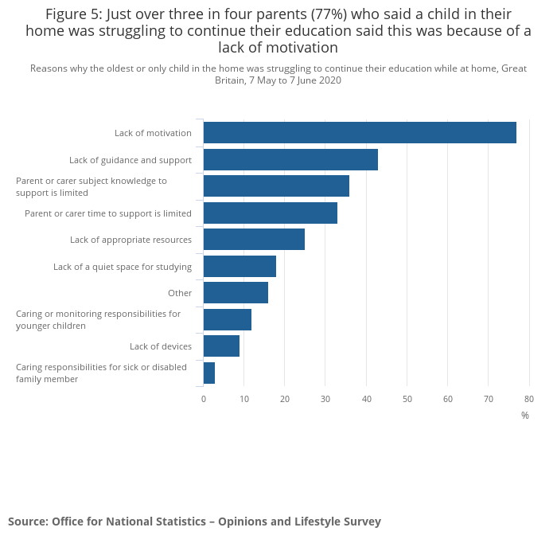
https://www.ons.gov.uk/(13.04.22)
Page 7
Provide a brief overview of current challenges that children, young people and families are facing in the UK?
There has been a lot of underfunding of centres for young children and families, and the bulk of the facilities have closed owing to budget constraints. These services are usually provided by local governments in order to get better results. It would provide a break for families who care for their children. These places where local for families to go and enjoy the facilities and get the help they need, which can include free parenting support. The goal of these centres was to improve children's and families' outcomes.

Due to a lack of financing, several local authorities are shutting or reducing the number of days that these centres are open; many of these centres were for people with learning disabilities. These centres were established to provide opportunities to people who rarely get out, meet new people, or simply have a social life. Individuals could participate in a variety of activities at the day centres. They offer community outings, life skills, and a lot of it is person-centred at the centres. Families with young children have been harmed as a result of the closure of several centres, and their needs have not been defined. Due to a lack of break or assistance, the parents are enduring isolation, poor mental health, and even violent home lives. By moving these challenges forward and creating companionship for parents and children, the centres supported these issues from professionals to peers.

Families with children with learning disabilities have also been impacted by the budget, as they are not receiving the necessary support for their children, which has a significant impact on both the parents and the children. Because there isn't enough money to hire carers to look after their child, this puts a lot of strain and duty on the parent to handle everything by them-selves.
Families are currently dealing with a slew of issues.
Bills are incredibly costly.

Page 8
Another example of budget (NHS)
The NHS's staffing shortage has a significant impact on patients and employees, resulting in high levels of stress. Staff members' health and capacity to function effectively are both impacted by high levels of stress. Patients aren't getting the care they require, which leads to mistakes owing to a lack of staff, working overtime, heavy workloads, and skipping breaks. There is also a significant financing issue with the NHS. This has a significant impact on the tasks that must be completed. This involves a lack of equipment, a staffing shortfall, and inadequate training. Because there isn't enough money to keep the right number of people on the job every day, there are mistakes in the care that is offered to families and children. Nurses, midwives, GPs, hospital doctors, and mental health workers are in short supply, putting the NHS at risk. This problem has persisted for a long time due to a lack of financing, and it has yet to be resolved. Complex problems frequently necessitate extra time. The National Health Service (NHS) is a government-run organisation that offers free healthcare to everyone British citizens.
Due to a shortage of staff, the NHS is under even more strain than before. Staff are dealing with increased workloads, excessive expectations, being overworked, and being under a lot of stress as a result of Covid-19.
Some example and problems NHS facing
- The wait for an appointment is significant, and you will have to wait a long time to be seen.
- Whereas the United Kingdom spends less on health care, the use of private organisations has expanded.
- The population is a big role in the NHS cash being spent on other providers.
- The costs of caring for the elderly are substantially higher
- Construction projects are falling behind schedule due to a lack of funds.
- Because fewer Elderly people are receiving free care from local councillors toward their care costs, this puts pressure on Health care and is under increasing strain
- Due to a shortage of funds, many elderly persons are left without care.

Page 9
Analysis for NHS
In my perspective, the research that I conducted by researching online, Training is an important component that should be taken carefully because a lack of training is producing a lot of errors and mishaps in the NHS. Another major issue affecting employees is a lack of funding, which is causing them to work longer hours owing to a shortage of personnel. There is insufficient equipment due to a lack of money, which is generating challenges for the personnel because the patients are not receiving the kind of treatment that they require. I've also recommended that the NHS look into hiring more people and training them.
With the current state of health care, they could consider bringing back retired employees at no additional expense, or providing them with training because they are already qualified. Another option is to hire additional employees, as this is having a significant impact on both employees and patients. Nurses are under a lot of pressure to perform their work because certain employees are trained to execute specific jobs. They could also use the Pestle Analysis cheat sheet, which gives a framework of micro environmental variables. This tool allows businesses to get a sense of what factors may have an impact on their operations. (Perera, R., 2017)
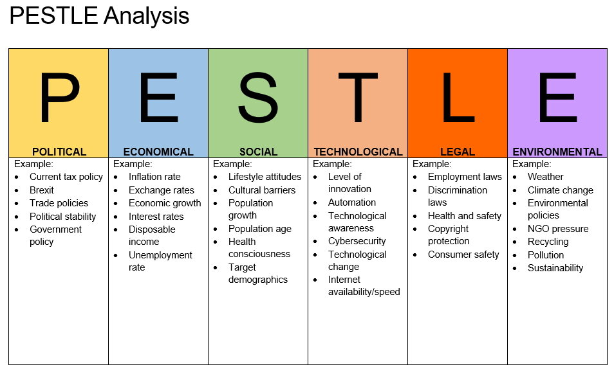
https://www.impact-innovation.co.uk/(14.04.22)

Page 10
CONCLUSION
To keep track of each department's financial needs, the management must communicate with the workforce. They should be aware of what needs are essential and where cuts can be made if necessary. The NHS workforce is growing, but not quickly enough to keep up with the high volume of calls. This means that immediate efforts must be taken to ensure that the NHS has enough nurses to deliver high-quality treatment to its patients. They should call back the retired employees because there would be no further expense. Local councillors could revive some of the day centres; they might use smaller buildings to save money, and rename them something like the hub to give parents and children a break from home. This would suffice for their requirements.
As a result of covid-19 There have been numerous cases for mental health, or children who have been mistreated by their parents, to ensure that they have a regular meeting to discuss their requirements or care, or if they are unable to meet at home, to meet with them in a cafe or suitable place. This would give a chance for individuals to speak about this problems they are facing.

Page 11
REFERENCES
Cowie, H. and Myers, C.A., 2021. The impact of the COVID‐19 pandemic on the mental health and well‐being of children and young people.
Dayan, M., Ward, D., Gardner, T. and Kelly, E., 2018. How good is the NHS?. King's Fund.
https://www.gov.uk
https://www.nhs.uk/conditions/coronavirus-covid-19/how-to-avoid-catching-and-spreading-coronavirus-covid-19/
https://www.ons.gov.uk/
https://www.staffs.ac.uk/course/working-with-children-young-people-families-ba
https://www.theguardian.com/society/2021/dec/03/how-much-did-lockdown-help-arthur-labinjo-hughes-killers-escape-notice
Johnson, J., 2018. Mental healthcare staff well‐being and burnout: A narrative review of trends, causes, implications, and recommendations for future interventions. International journal of mental health nursing
Parish, C., 2011. Funding cuts threaten to damage social care provision. Learning Disability Practice (through 2013).
Peeri, N.C., 2020. The SARS, MERS and novel coronavirus (COVID-19) epidemics, the newest and biggest global health threats: what lessons have we learned?
Perera, R., 2017. The PESTLE analysis. Nerdynaut.
Thomson, H., 2021. Children with long covid
Wu, Q. and Xu, Y., 2020. Parenting stress and risk of child maltreatment during the COVID-19 pandemic: A family stress theory-informed perspective. Developmental Child Welfare.

Page 12

