Building My Personal Brand for a Career in Midwifery

Student name: Daisy Darko
Student number: 2333091
Programme: BSc (Hons) Health and Social Care
Module: Changemakers: Building Your Personal Brand for Sustainable Employment
Module code: BMHP5015
Word count: 2,000 words
Submission date: 31st July 2026

Introduction
My chosen career goal is to become a registered midwife in the United Kingdom. I am interested in midwifery because it would allow me to support women, babies and families during pregnancy, labour, birth and the postnatal period. This can be an important and emotional stage of life, so midwives need compassion, clear communication, professional judgement and the ability to remain calm under pressure. This degree is helping me understand person-centred care, safeguarding, equality, communication and the wider social factors that affect health. However, I understand that this degree alone will not qualify me to practise as a midwife. After completing, I will need to successfully complete a Nursing and Midwifery Council-approved pre-registration midwifery program and apply to join the NMC register. This portfolio reflects on activities completed during the module, including self-determination, emotional intelligence, transferable skills, networking, professional communication, personal branding, resilience, technology, and mentoring. The activities have helped me recognise my strengths, identify areas for development and create a realistic plan for progressing towards a career in midwifery.

1. Self-Determination, Autonomy and Career Goals
Here, I explored the meanings of self-determination, autonomy and career goals. Self-determination means being able to make choices, set goals and take responsibility for my future. Autonomy means having control over decisions that affect my life. These ideas are relevant to my own career planning, but they are also important in maternity care. Women and families should be given clear information and supported to take part in decisions about their care. Respecting autonomy does not mean leaving people without professional guidance. It means listening to their concerns, explaining their choices in an understandable way and respecting informed decisions wherever possible. This connects with person-centered care and the responsibility to treat people with dignity. The Week 1 activity helped me clarify that my long-term aim is to become a midwife. Midwives support women and babies before, during and after birth. I am interested in this career because I want women to feel safe, listened to and respected during pregnancy and childbirth. I am also interested in maternal mental health, patient safety, breastfeeding, health education, and reducing inequalities in access to maternity care. Roy (2008) links ambition with personal and professional progress. My ambition is therefore not only to gain employment but also to become a safe, compassionate, and dependable midwife. Barriers include the competitive nature of midwifery applications, financial pressure, family responsibilities, and lack of confidence during interviews. I will respond to these barriers by researching approved programs, gaining maternity-related experience, preparing carefully for interviews, and seeking advice from careers staff and practicing midwives.
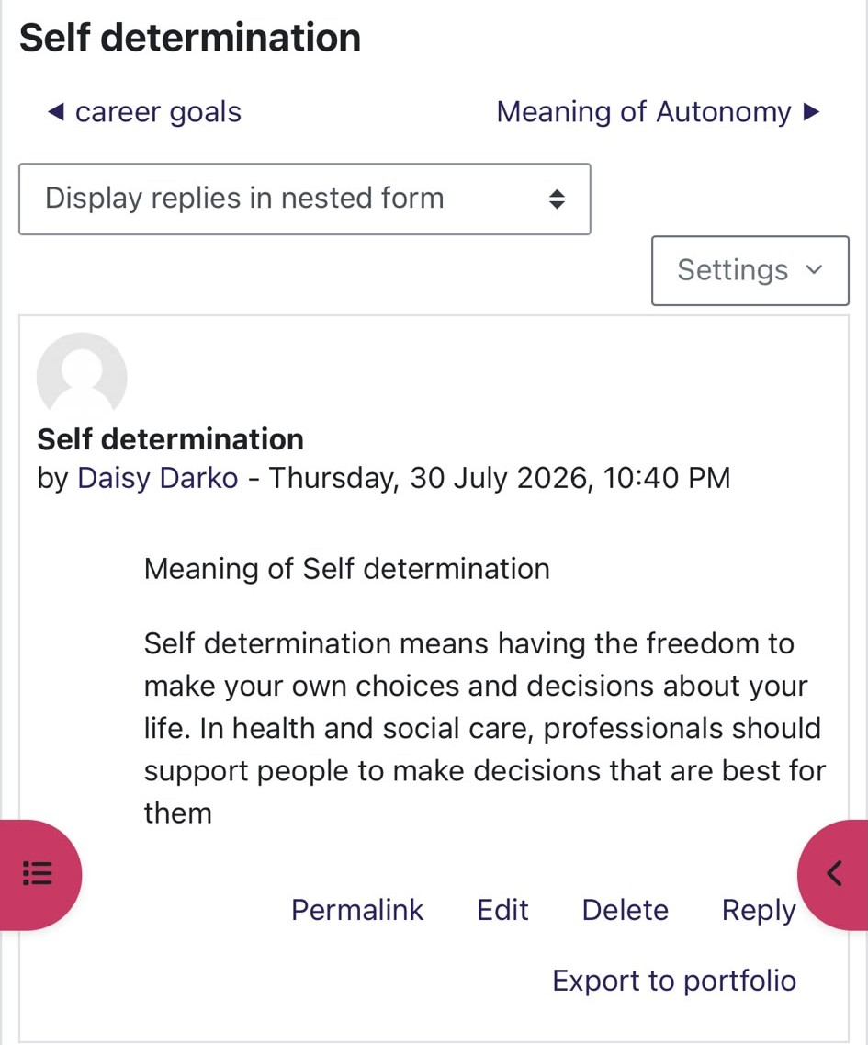 | 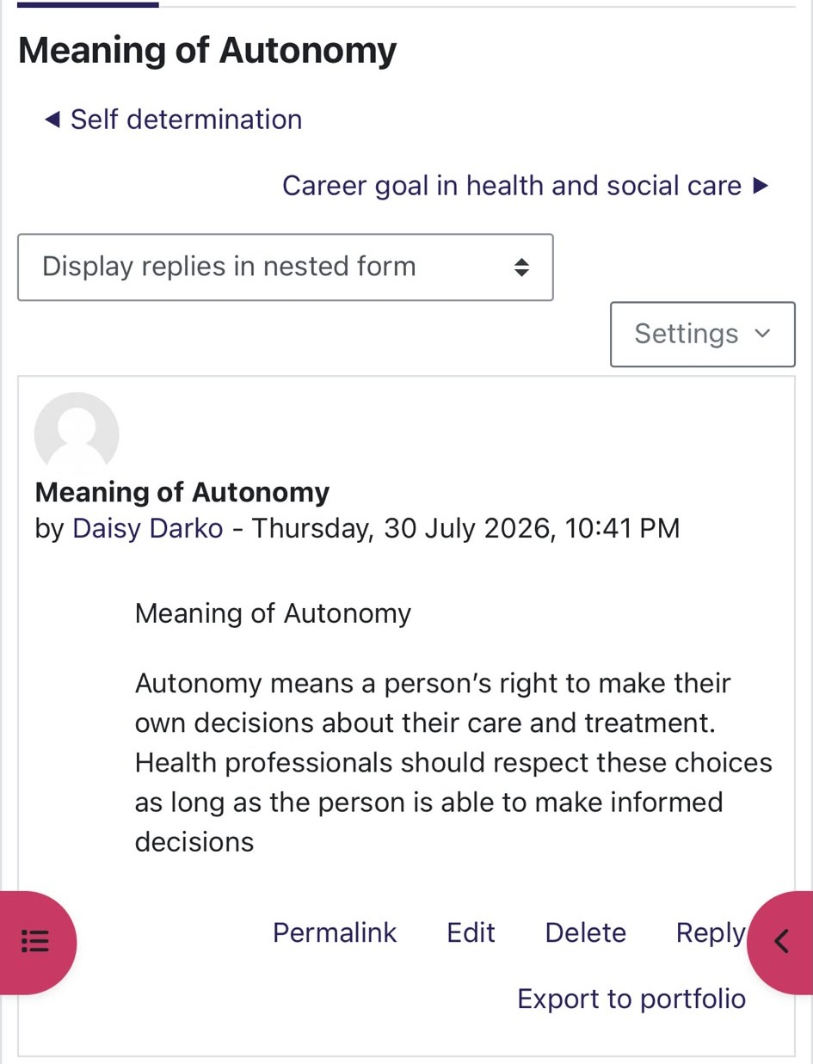
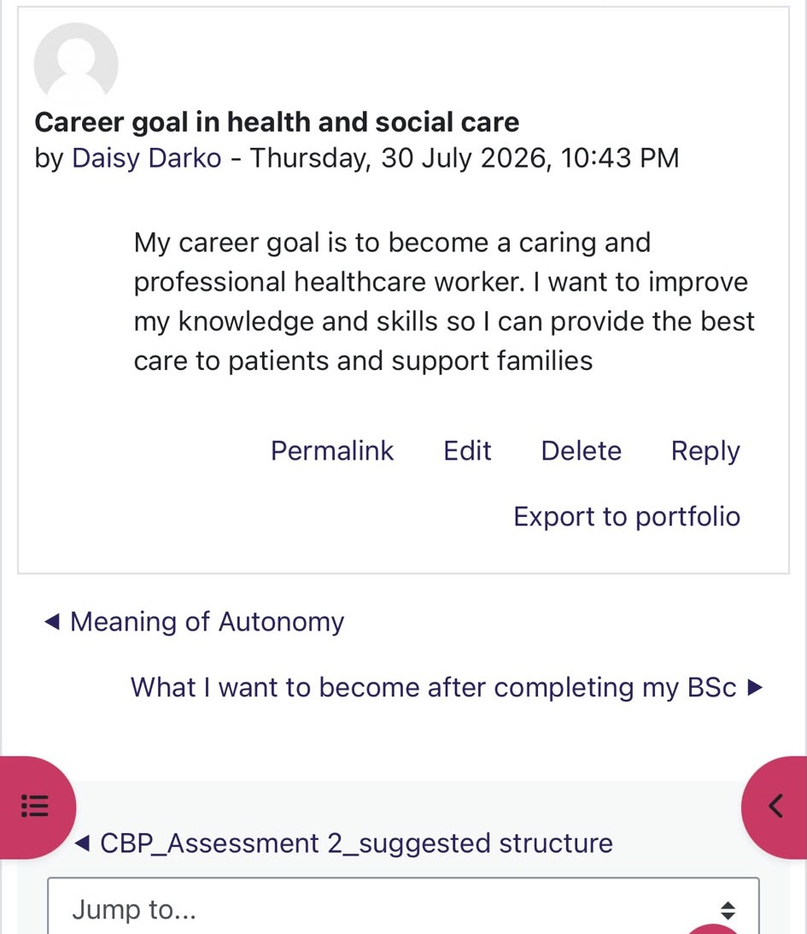 | 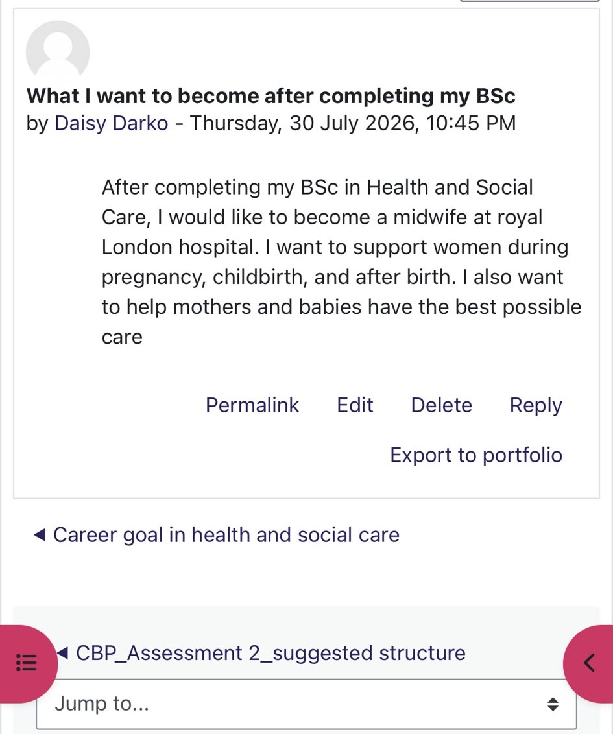
Week 1 Moodle activity on self-determination, autonomy and career planning.

2. Emotional Intelligence, Transferable Skills, and Career Planning
I focused on emotional intelligence, soft skills, career planning and boundaryless careers. This is important because service users may be anxious, upset, confused or angry. A worker must listen carefully and respond peacefully rather than taking difficult behaviour personally. Salovey, Caruso and Mayer (2004) explain that emotional intelligence supports the understanding and management of emotions. Empathy and listening are strengths I have because I try to understand other people before responding. However, I need more confidence when dealing with conflict, giving feedback or speaking in unfamiliar professional situations. I also learned the difference between soft and hard skills. Soft skills include communication, teamwork, patience, empathy, organisation, and problem-solving. Hard skills are more specific and may include medication procedures, safeguarding, care planning, and the use of electronic care records. Communication and organisation developed through university study, family responsibilities or other employment may also be useful in a care setting. I learned that I should explain what I have learned from earlier experiences rather than focusing only on experience I do not yet have and continue learning and adapt my CV to each role.
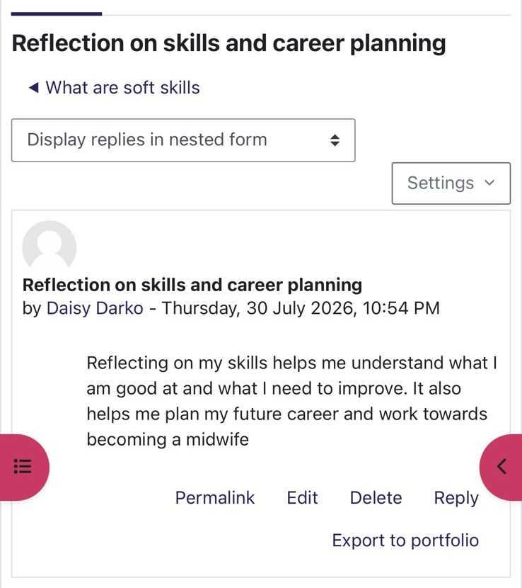 | 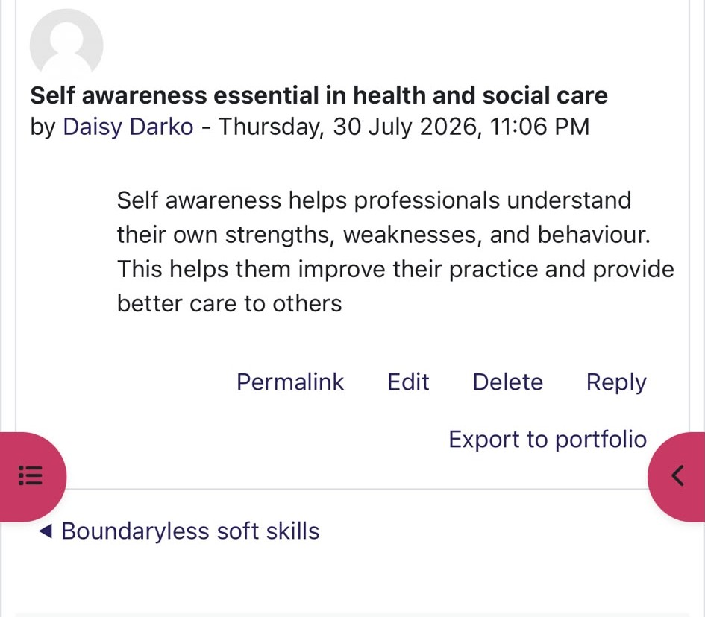
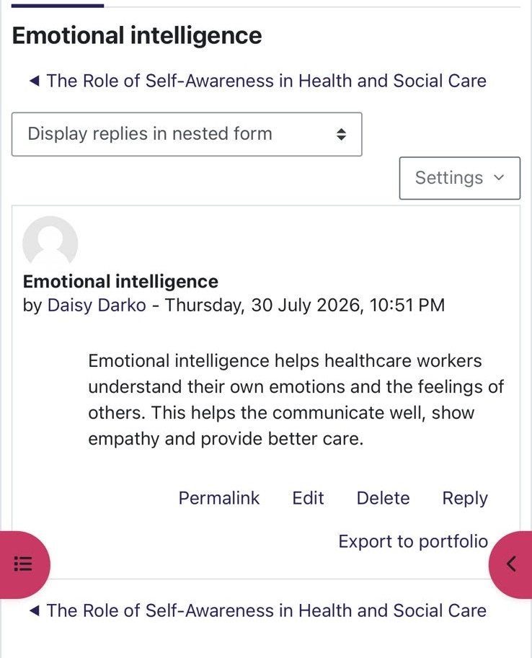 | 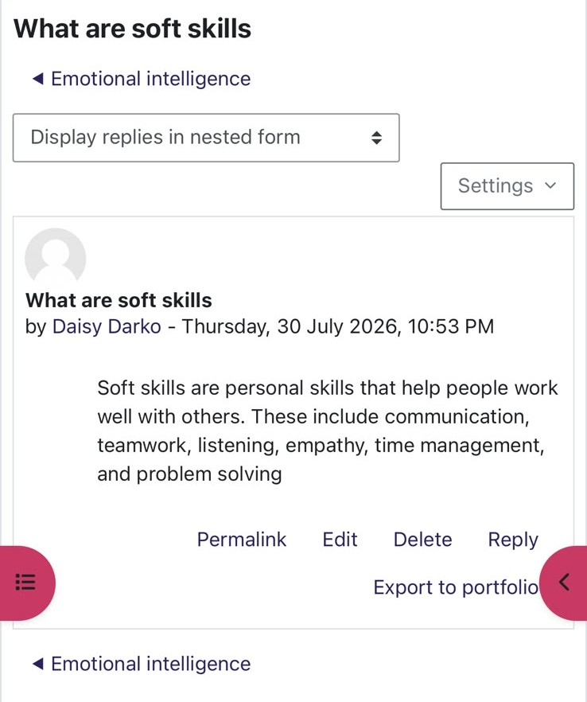
Week 2 activity on emotional intelligence and transferable skills.

3. Networking and Professional Communication
During Weeks 3 and 4, I learned about networking, professional communication, organisational structures, and persuasion. One activity involved creating a networking map for research on breastfeeding. This activity is connected to my career goal because breastfeeding education and support are important parts of maternity care. A network for breastfeeding research could include mothers, midwives, health visitors, GPs, maternity support workers, infant-feeding specialists, community organisations, charities, and university researchers. Each person or organisation may contribute different knowledge. Mothers can describe their individual experiences, while professionals can provide clinical, social, and practical perspectives.
The activity showed me that maternity care depends on cooperation between different people and services. Gibson, Hardy and Buckley (2014) explain that networking can support learning, professional development, and access to career opportunities. My current network includes lecturers, classmates, family members, and employers. However, I need to develop stronger connections with registered midwives, maternity support workers, breastfeeding specialists, and university admissions teams. Professional communication is also necessary when developing these relationships. I use email, Microsoft Teams, Google Meet and LinkedIn. I should introduce myself clearly, use respectful language, check my spelling and grammar, and respond within a reasonable time. I must also protect confidential information and avoid discussing personal details about anyone receiving care. Week 4 introduced bureaucracy and hierarchy. In maternity services, policies, records, and reporting systems can support safety and accountability. A hierarchy can make responsibilities clear, but staff at every level should feel able to raise concerns when care may be unsafe. The NMC Code requires registered midwives to prioritise people, practice effectively, preserve safety and promote professionalism and trust.
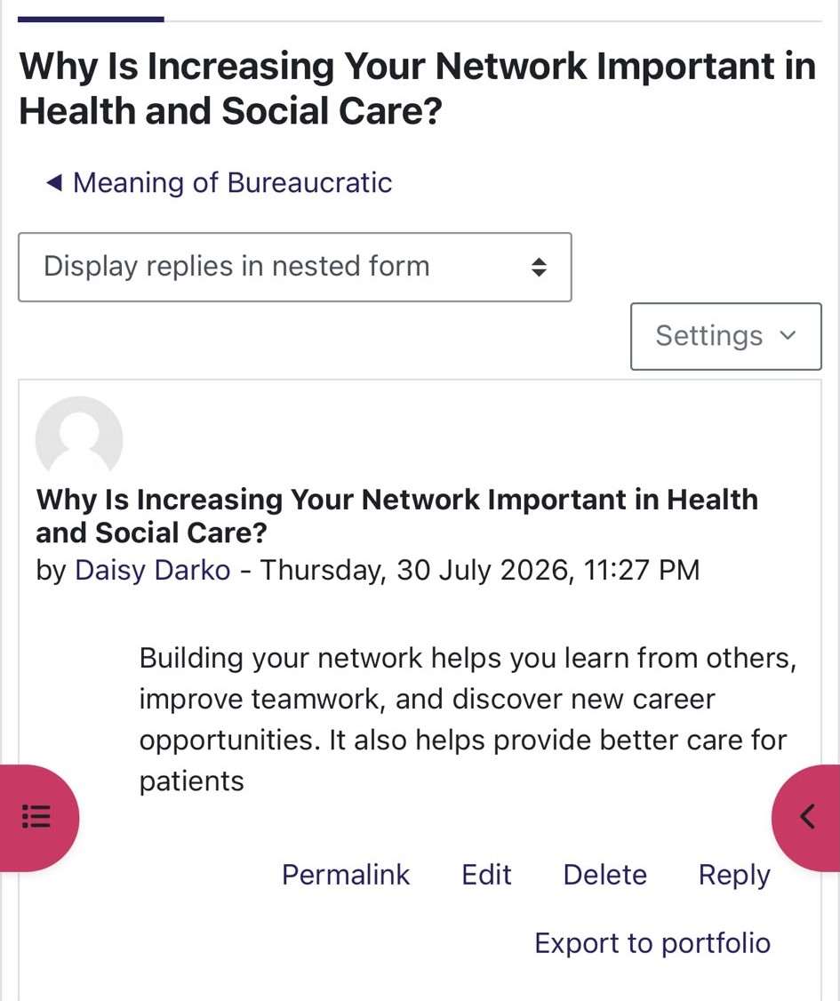 | 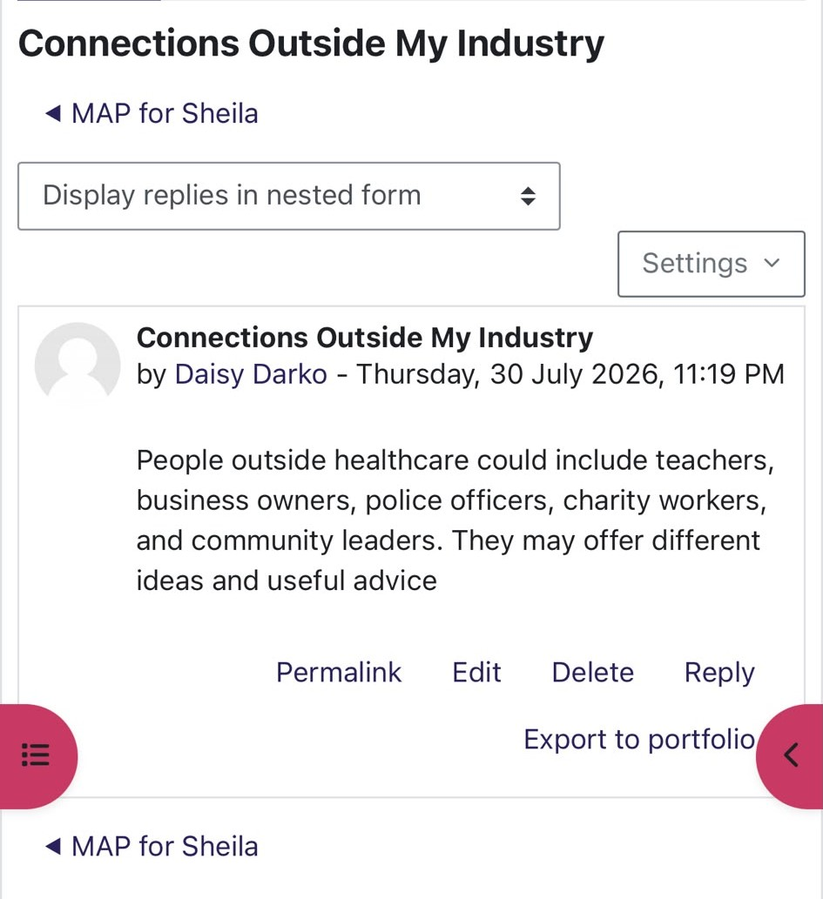
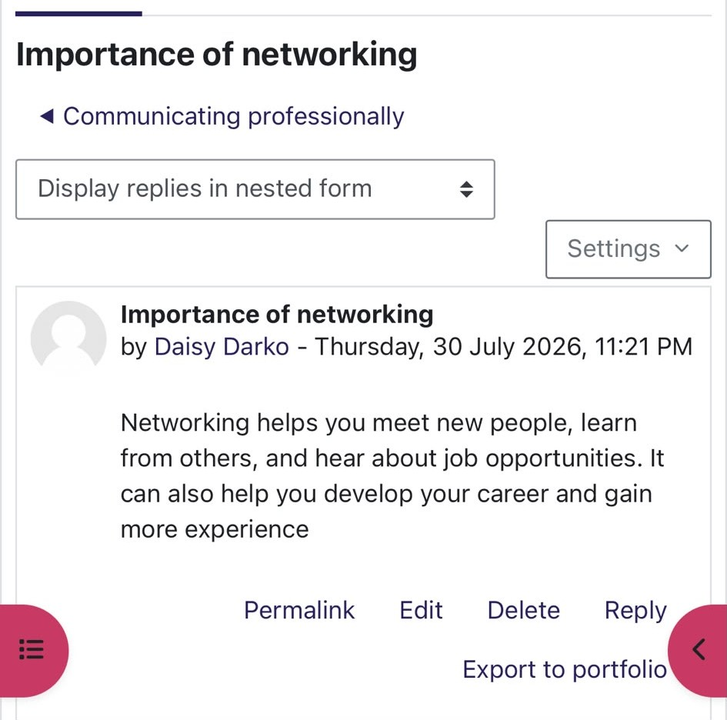 | 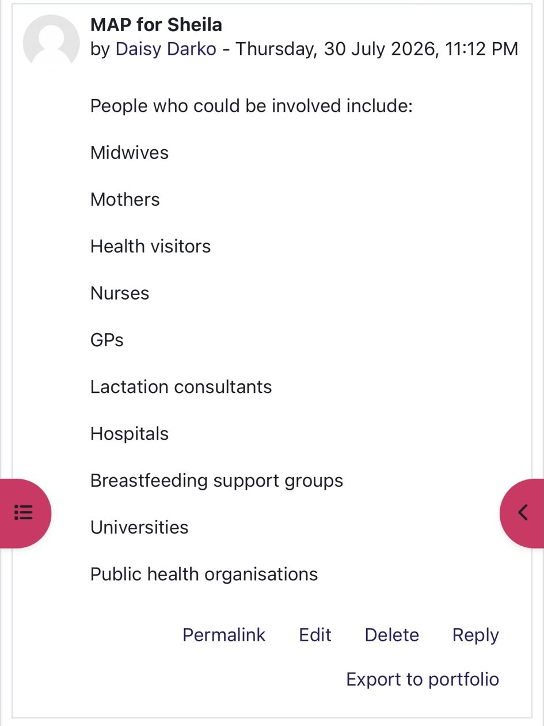
Networking and professional communication activity from Weeks 3 and 4.

4. Personal Brand, Online Presence and Career Opportunities
I focused on career opportunities, personal branding, professional online presence, blogging and person-centered care. The activity helped me connect my skills and interests with midwifery. My strengths include empathy, communication, teamwork, organisation, and problem-solving. My interests include women’s health, breastfeeding, mental health, patient safety, and health education.
My personal-brand statement is:
“I am an aspiring midwife who uses empathy, clear communication and a commitment to safe, person-centered care to support women, babies and families”.
I previously thought that personal branding meant promoting myself. I now understand that it is the impression created by my behaviour, communication, experience and values. My personal brand must be honest and supported by evidence. For example, if I describe myself as compassionate, I should be able to explain a situation in which I listened carefully, respected someone’s choices or provided support. I should use a professional email address, keep my LinkedIn information exact and avoid posting material that could appear disrespectful or damage trust.
Confidentiality is particularly important in healthcare and responsibilities apply when using social media and other online platforms. Blogging can support reflection, knowledge sharing, and public education. A maternity-related blog could provide general information about preparing for birth, emotional wellbeing, or available support services. Nardi et al., (2004) explain that blogs allow people to share information and experiences.
Person-centered care is central to midwifery, as recognizing that each woman has her own culture, beliefs, family situation, health needs, and preferences. In midwifery, listening to women, involving them in planning, and considering their emotional and social needs alongside their physical health (Entwistle, Cribb and Owens, 2018).
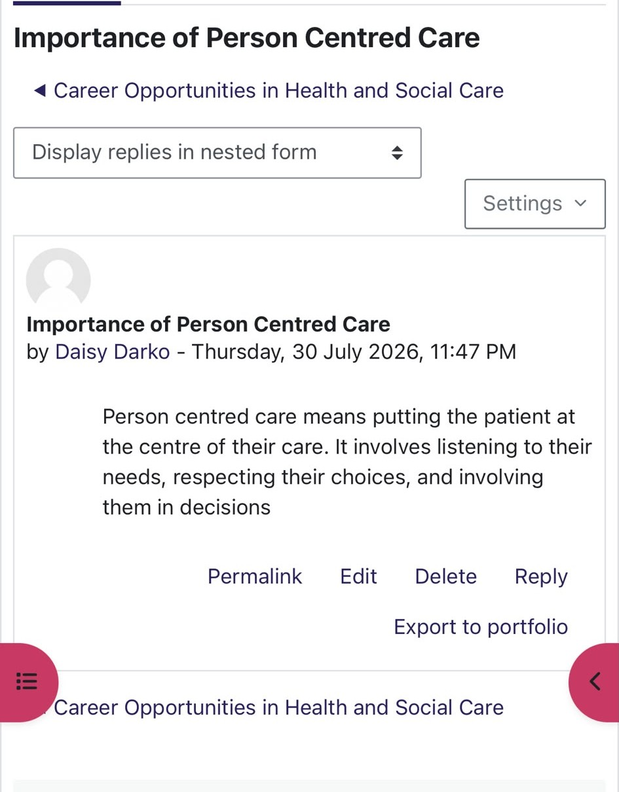 | 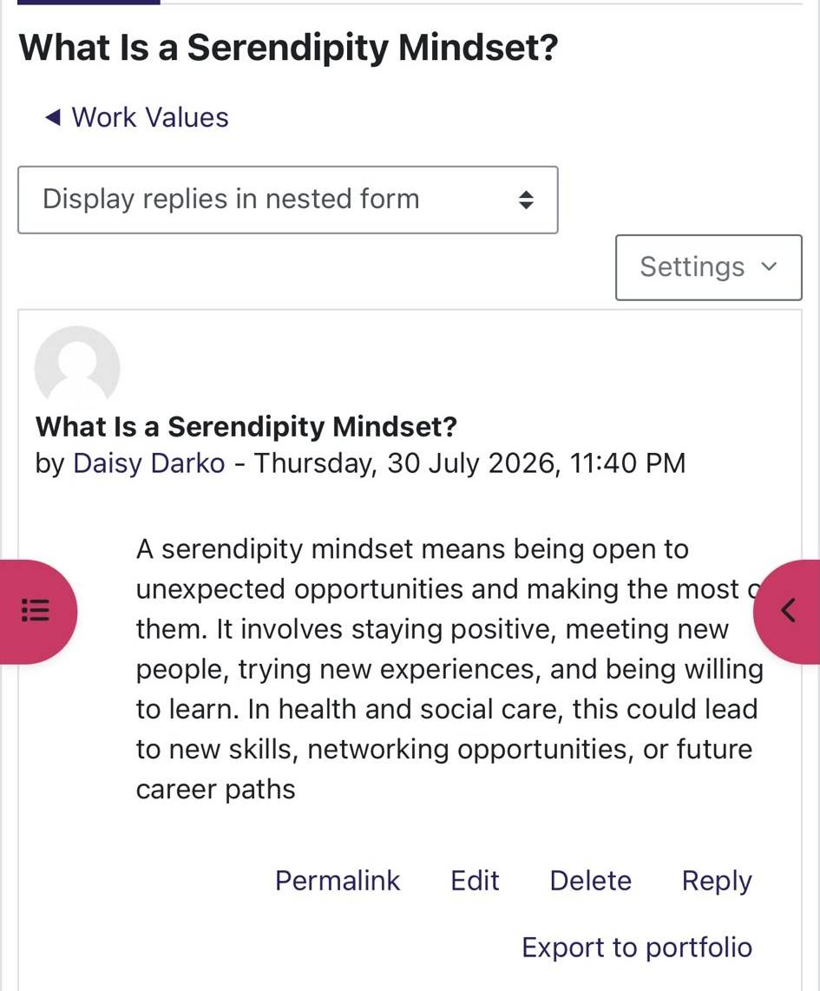
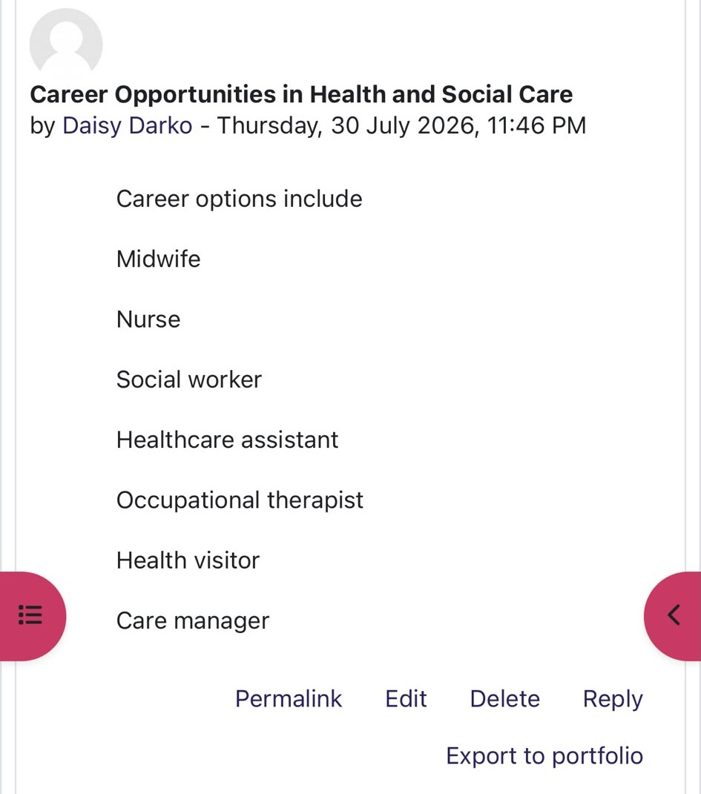 | 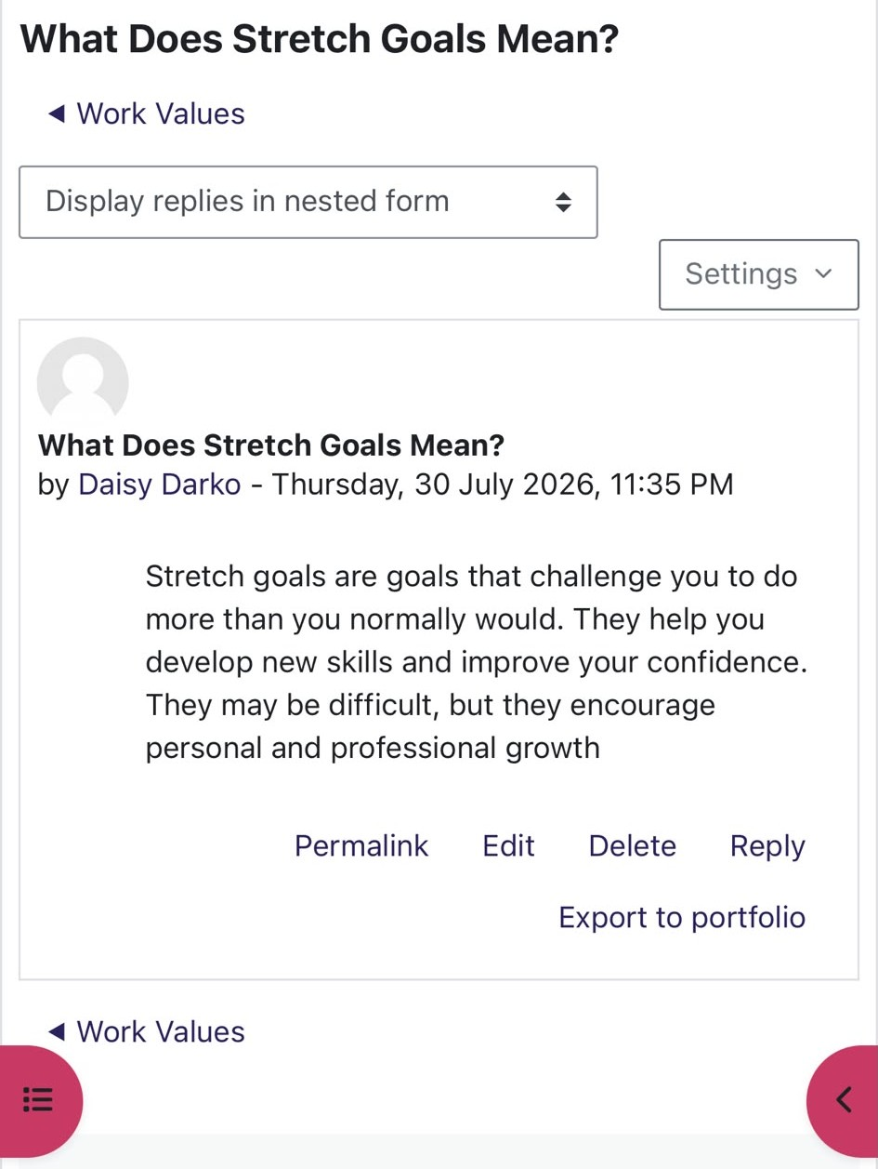
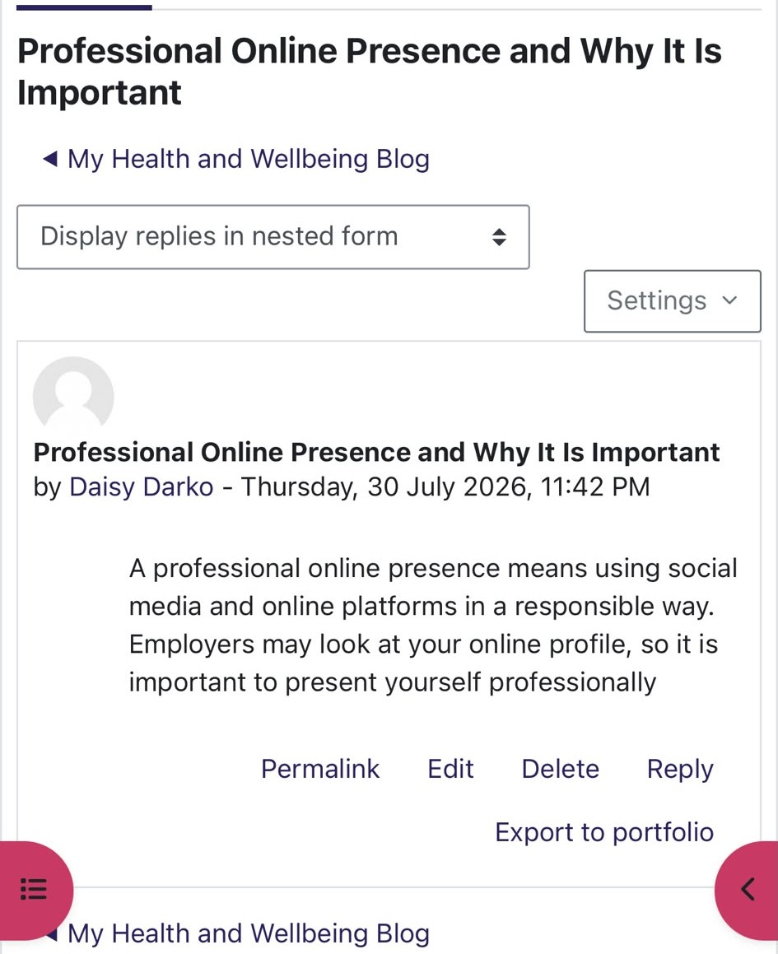 | 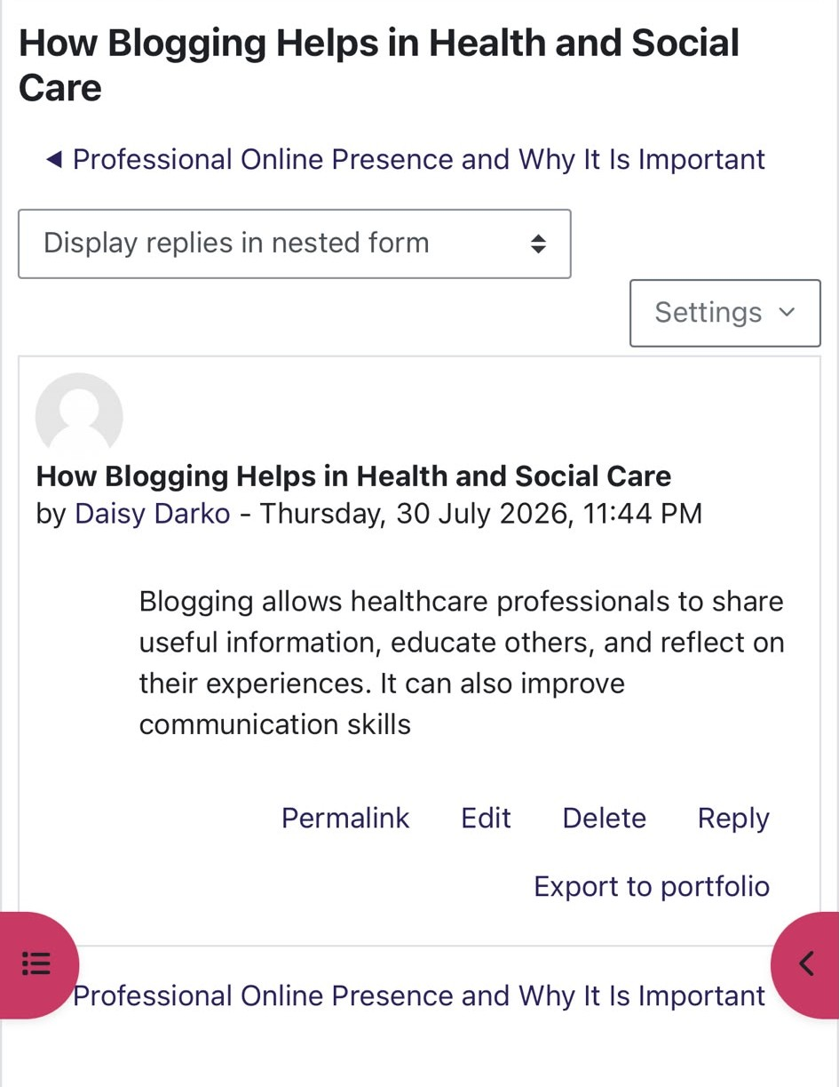
Week 6 activity on career opportunities and professional identity.

5. Resilience, Limiting Beliefs, Technology and Mentoring
The Week 7 activity helped me identify beliefs that may reduce my confidence. One belief was, “I am not smart enough.” I challenged this by reminding myself that I do not need to know everything immediately. Midwifery training will be demanding, but my knowledge and confidence can develop through study, practical experience, and feedback. I also identified the belief that other people’s needs are more important than mine. Caring for other people is important, but ignoring my own wellbeing could lead to stress or burnout. Midwifery can involve emotional situations, long working hours, and responsibility for the safety of women and babies. Looking after my own physical and emotional wellbeing will help me provide safer and more compassionate care.

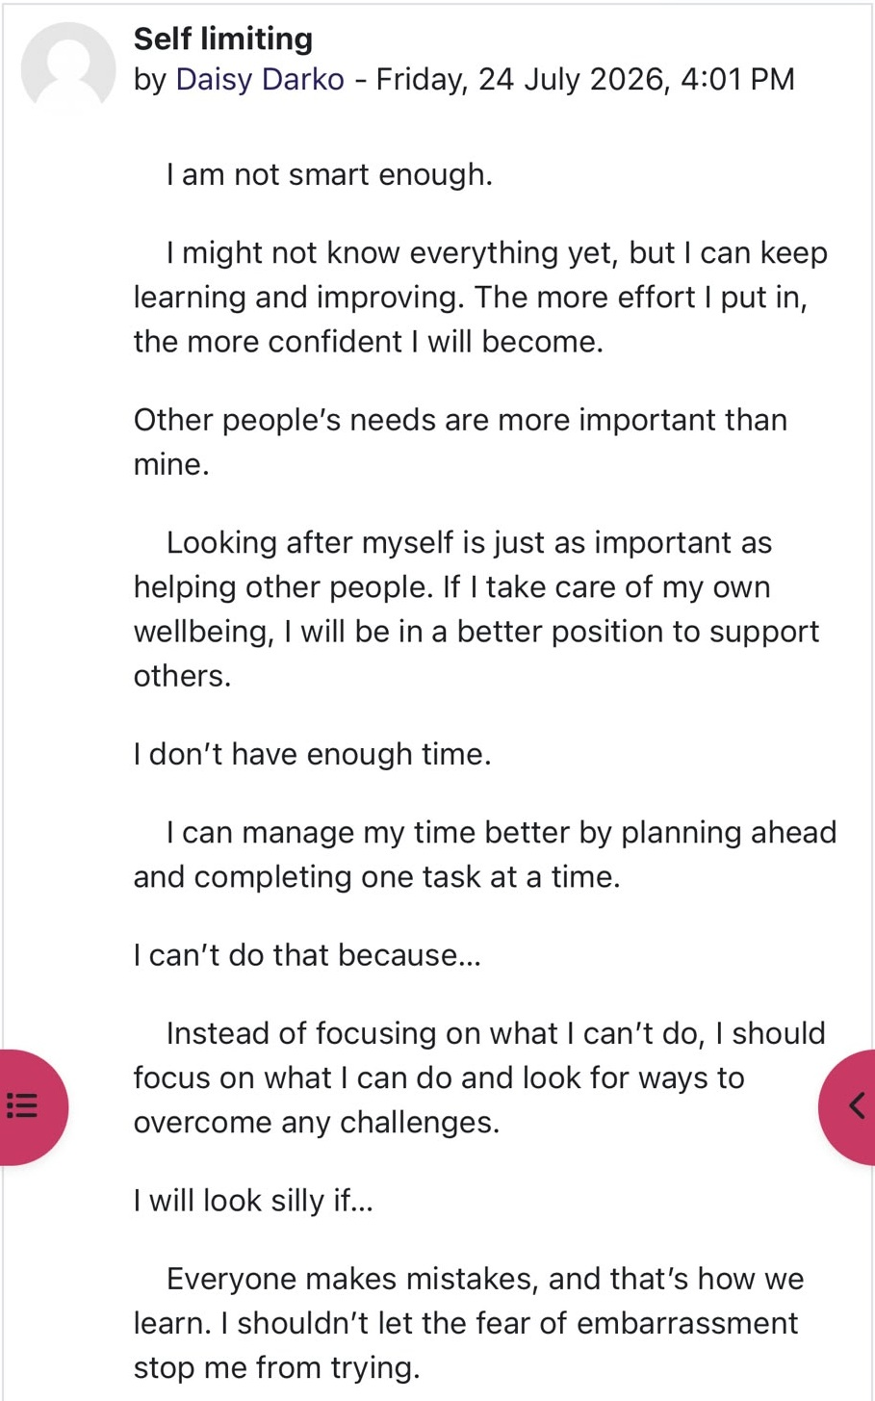
My Week 7 Moodle reflection on recognising and challenging self-limiting beliefs.
Another limiting belief was that I do not have enough time. I can challenge this by planning ahead, dividing large tasks into smaller stages and completing one task at a time. I also worry that I may look silly when I make a mistake. However, fear of embarrassment should not stop me from asking questions or requesting support. Meadows (2015) suggests that limiting beliefs may prevent people from taking useful action. I will challenge these beliefs by recording my achievements, seeking feedback, and focusing on improvement rather than perfection. Technology is increasingly important in maternity care. Midwives may use electronic health records, digital monitoring systems, online learning platforms, video consultations, and professional communication systems. Sheikh et al. (2021) identify challenges such as limited staff training, systems that do not communicate effectively with one another and concerns about personal data. I need to develop confidence in using digital systems while remembering that technology should support rather than replace compassionate face-to-face care. Midwives must continue listening to women and responding to their individual needs.
My mentor is Mrs Sharron Owusu, an NHS midwife. I value her practical knowledge, encouragement, calm communication and honest advice about applications, placements and maternity practice. Her example shows me that professionalism includes kindness, responsibility, lifelong learning and the confidence to ask for help. I will use mentoring conversations to review my progress and make my career plan more realistic.
6. Professional Development Action Plan
My first plan is to understand the correct route into midwifery. After completing my BSc (Hons) Health and Social Care, I will identify NMC-approved pre-registration midwifery programmes and compare their entry requirements. I will contact university admissions teams to ask how my degree and previous qualifications will be considered. This will help me identify whether I meet the entry requirements or need to complete any additional qualifications. My second priority is to gain relevant experience. I will apply for maternity support, and hospital volunteering roles at Royal London Hospital to help me understand maternity services and provide evidence of my commitment to midwifery.
I will update my CV and personal statement with support from the university careers service. To improve my communication and confidence, I will practice interview questions, take part in presentations and request feedback. I will also expand my network by reaching out and speaking with at least two registered midwives and attending midwifery careers events. Finally, I will keep a monthly reflective record of my achievements, setbacks, and lessons. I will review this development plan every three months and make changes when necessary.

Conclusion
This portfolio has shown me that employability involves more than completing my current degree. The Moodle activities showed that communication, emotional intelligence, networking, resilience, digital skills, and professional behaviour will be important in my future career. My understanding of personal branding has changed because I now see it as the impression created by my actions and values rather than simply promoting myself. Networking and mentoring can provide guidance, while reflection can help me learn from mistakes and continue developing.

Reference List
Roy, S.K., 2008. Identifying the dimensions of attractiveness of an employer brand in the Indian context. South Asian Journal of Management, 15(4), pp.110-130.
Sheikh, A., Anderson, M., Albala, S., Casadei, B., Franklin, B.D., Richards, M., Taylor, D., Tibble, H. and Mossialos, E., 2021. Health information technology and digital innovation for national learning health and care systems. The Lancet Digital Health, 3(6), pp.e383-e396.
Maddux, J.E., 2016. Self-efficacy. In Interpersonal and intrapersonal expectancies (pp. 41-46). Routledge.
Salovey, P., Caruso, D. and Mayer, J.D., 2004. Emotional intelligence in practice. Positive psychology in practice, pp.447-463.
Gibson, C., H. Hardy III, J. and Ronald Buckley, M. (2014). Understanding the role of networking in organizations. Career Development International, 19(2), pp.146-161.
Nardi, B.A., Schiano, D.J., Gumbrecht, M. and Swartz, L., 2004. Why we blog. Communications of the ACM, 47(12), pp.41-46.
Entwistle, V.A., Cribb, A. and Owens, J., 2018. Why health and social care support for people with long-term conditions should be oriented towards enabling them to live well. Health care analysis, 26(1), pp.48-65.
Meadows, M., 2015. Confidence: How to overcome your limiting beliefs and achieve your goals. Meadows Publishing.

