Benjamin John (1707698)

Business Research Project Proposal

A Critical Evaluation of the Impact online shopping has had on Swansea City Centre Retailers.

Benjamin John (1707698)
Contents
1. Introduction 2
1.1 Rationale 2
1.2 Background 2
1.3 Aim and Objectives 4
2. Research Design 5
2.1 Research Methodology 5
2.2 Research Philosophy 6
2.3 Research Approaches 6
2.4 Quantitative Research 7
2.5 Sample 7
2.6 Data Collection 7
2.7 Data Analysis 8
3.Limitations and Ethical Considerations 8
3.1 Ethical Considerations 8
3.2 Time Limitations 8
4. Resources 9
4.1 Resources 9
5. References 9
6. Appendix 13

Introduction

1.1 Rationale
Soaring business rates, online stores and the weakening consumer demand for physical retail stores are beginning to present challenging conditions for city-centre retailers (Hope, 2019). In 2019 alone, 12 chain retailers were forced to close their doors in Swansea City Centre due to the rise in costs and the lack of consumer interest (BBC, 2019).
The widespread availability of the internet and the convenience of online shopping has contributed to the change in consumer behaviours regarding the way that consumers purchase goods. According to the Office for National Statistics, in 2017, online sales in the UK increased by 15.9% compared to the previous year (Office for National Statistics, 2018). By the year 2028, it has been predicted that at least half of retail sales within the UK will be from online retailers (Guardian, 2019), this is a growing problem for retailers which are located in Swansea City Centre as they face a painful readjustment if they are to stay open amid the inevitable growth of online retailers.
The business research project will evaluate how changes within consumer behaviour, the rising business costs, the lack of available city centre parking and the increase in out of town shopping centres have all impacted the way that consumers now choose to shop in Swansea. The project will analyse all of these different factors to understand whether or not the internet and the rise in online retailers is the main factor for the subsequent decline in the high street in Swansea City Centre.

1.2 Background
Online retailers are becoming ever more popular while Highstreet stores are struggling. The topic has been looked at in-depth by a number of researchers who have looked to explore the various amounts of issues that online retailers have caused for high street stores as well as looking at the perceptions held by consumers and the changes in consumer behaviours.
As well as the spike in the number of online retailers many other factors must be taken into consideration when looking to fully understand the decline in the Highstreet in Swansea.
One of the factors that has had an impact on the Highstreet in Swansea is the change in consumer behaviour. Consumer behaviour is considered as the activities that people undertake when obtaining, consuming and disposing of different products and services (Blackwell, Miniard and Engel, 2001).
The Engel-Kollet-Blackwell model is a model that has been created to help users to understand and learn about the concept of consumer behaviour. The model helps users to see different components of decision making and the relationship and interaction between them. The model describes consumer behaviour as a decision process, and it identifies five key activities that occur as part of the decision-making process. The five stages are problem recognition, need recognition, information search, evaluation of alternatives and choice (Engel, Kollat and Blackwell, 1978).
A study that was conducted by Jones and Livingstone (2017) found that the UK has the greatest proportion of online retail sales in Europe. This indicates that consumers in the UK are more likely to shop online before visiting the local high streets, therefore, drawing the sales away from the Highstreet retailers.
Consumers are now looking for convenience when it comes to shopping. A study by Jiang, Yang and Jun (2013) found that the convenience of online shopping is a key factor in why consumers now chose to shop online. The study found that as consumers now allocate less of their time to shopping and more time to other endeavours, their desire for shopping convenience has risen and therefore their wish to shop online has also increased. The same study also found that the time, effort and costs associated with visiting physical stores in the Highstreet all play a role in the way that the consumer measures convenience so, therefore, the online method is seen as the most convenient by the consumer.
A study by Beauchamp and Ponder (2010) examines the key differences between in-store shopping and online shopping for the consumer. The differences are based on the following four factors, access, search, transaction and convenience. The study finds that compared to conventional in-store shopping, consumers perceive online shopping to be more convenient for the purpose of access and search convenience. This means that consumers find searching for products and gaining access to the specific products that they want easier when using online retailers as appose to visiting the local Highstreet.
As well as the convenience of online shopping, another factor that has impacted the Highstreet is out of town shopping centres. In the same study by Jones and Livingstone (2017), it was found that shoppers in the United Kingdom are more likely to shop at out of town shopping centres before visiting the Highstreet due to the convenience that out of town retail parks have for the consumers. Benefits such as free parking and a range of well-known Highstreet retailers located within the same space make retail parks a more desirable option for consumers who still wish to shop in-store (Anderson, 2015).

1.3 Aim and Objectives
Research Aim
This project aims to critically evaluate how the rise in the amount on online retailers has changed consumer behaviour which has impacted retailers located within Swansea City Centre.
Research Objectives
The research objectives are as follows:
- To conduct primary research through the use of questionnaires in order to be able to better understand how consumer behaviour has changed regarding shopping habits.

- To conduct secondary research using government data to understand how retailers have been impacted by the rise in the number of online retailers.

- To make recommendations going forward that will allow retailers to move forward with their business and adapt to the ever-changing circumstances and consumer behaviours.

2. Research Design

2.1 Research Methodology
The concept of research defined by (Kumar, 2008) is “an intensive and purposeful search for knowledge and understating of social and physical phenomena”. As a result of performing intensive and purposeful research, a deeper knowledge and understanding of a subject is made available.
In order to conduct successful research, Saunders, Lewis and Thornhill, (2019) developed a model that outlines the steps required when conducting any research. The model they developed is called the ‘Research Onion’. The model consists of six different layers, at least one step from each of the layers must be used when conducting research to ensure the success of the research.
The six layers of the research onion represent Philosophies, Approaches, Strategies, Choices, Horizons and Techniques Saunders et al (2019). Figure 1 demonstrates the pathway that will be used to conduct the research for the project.
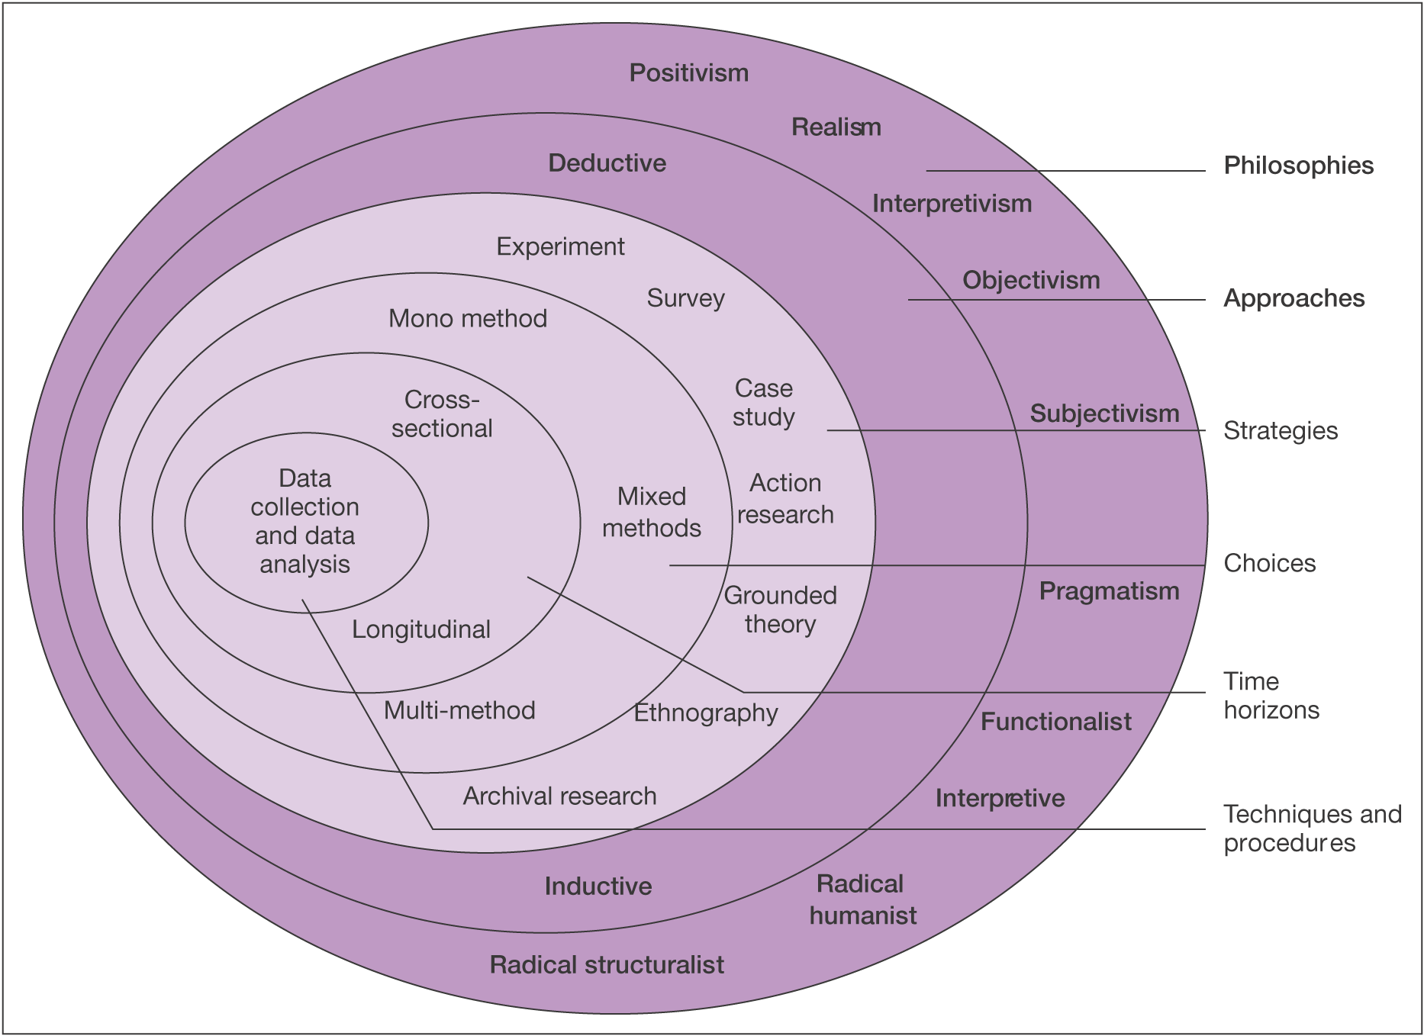

Figure 1. The Research Onion (Saunders et al, 2019).

2.2 Research Philosophy
The philosophical approach that will be used for the research will be the positivism approach. According to (Grey, 2019) positivism is the natural and human sciences which share common methodological and logical principles when dealing with facts and not with values. As the aim of the research is to test what is impacting the highstreets by using research, this philosophy is necessary. This philosophy will allow for data held to be analysed and compared in order to gain a piece of deeper knowledge into the potential causes of the decline in the Highstreet.

2.3 Research Approaches
The research approach that will be used for the research will be the deductive approach. The deductive approach is seen more as a scientific approach to research as a theory is rigorously tested against propositions (Saunders et.al, 2019). The deductive approach is the most appropriate approach to use for this research as it allows for the hypothesis to be tested against existing theory (Wilson, 2010). Using the deductive approach along with the positivism philosophy is the most suitable approach for the project as it will allow for the hypothesis that has been set out to be tested following the research.

2.4 Quantitative Research
Quantitative research seeks to generate knowledge and create an understanding based on the information that has been gathered to observe different occurrences that affect individuals (Allen, 2017). The data provided from the questionnaire research will be using the quantitative method as it allows for the data to be analysed and understood in a way that is helpful for the research (Nardi, 2016).

2.5 Sample
The sample of research collected will be a convenience sample. A convenience sample is a type of nonprobability sample that allows for participants to be chosen simply because they are convenient sources for data collection (Lavrakas, 2008). A convenience sample allows for factors such as accessibility and geographic proximity to be considered when choosing the research participants (Etikan, 2016). As the research question is based on Swansea City Centre, the research questionnaire will be aimed at those who currently live or have lived in the Swansea Area.

2.6 Data Collection
The primary data collection method that will be used in order to collect a data sample for the research will be a questionnaire. Questionnaires will be created using google forms and will then be distributed through social media channels in order to successfully gain a substantial response from a wide range of participants.
According to (Kotler, Armstrong and Harris, 2020) the use of questionnaires is the favoured research method among researchers as they are a very flexible method for asking a range of open and closed-ended questions. The mixture of both open and closed questions allows for the participants to express their opinions in more detail on certain questions while limiting the possible responses from other questions. This allows the participants' responses from some of the questions to be turned into statistical data that can assist in the research.
In order to gather a substantial response, social media channels will be used to distribute the questionnaire. The advantages of using social media channels to gather a substantial number of participants are that the participants are able to keep their anonymity throughout the process of the research and a wider audience can be accessed more efficiently (Wright, 2017).

2.7 Data Analysis
Appropriate statistical tests will be conducted with the data set that has been collected from the primary research method. Online tools will be used to analyse the data to ensure that the most significant findings have been outlined.

3.Limitations and Ethical Considerations

3.1 Ethical Considerations
When conducting research, ethical considerations and limitations must be taken into account. The ethical considerations and limitations are set out by guidelines which are intended to ensure that the participants who have taken part in the research are protected from any potential risks that may arise as a result of their participation in the research (Krishnaswamy, Sivakumar and Mathirajan, 2009). The research will be conducted with those only over the age of 18 and the nature of the questions are unlikely to cause any psychological harm to participants.
All data that is submitted by participants will be stored in a safe and secure way at all times to ensure that any information collected is only available for those whom it is intended.

3.2 Time Limitations
As there is a limited time frame for the completion of the project it is vital that tasks are completed on time and in a timely manner. To appropriately plan the project the use of a Gantt chart is required. Gantt charts are a powerful and effective visual tool that can be used for the strategic planning and scheduling of projects (Kumar, 2005). The Gantt chart created will clearly provide key dates and time scales to ensure that the project is completed in the time frame available.
*Please see figure G1 in the appendix*

4. Resources
4.1 Resources
Strategical planning and research play a vital role in the success of any business research project (Steiner, 1979). In order to complete this research project a number of different resources are going to be used in order to gain an understanding for the aim and objectives that have been decided upon. The resource that will aid in the project the most will be the university library and online library. The university library will be a useful resource as it will provide books and articles from credible sources that will cover the topic in detail. Another resource that will be used during the project will be the internet. The internet has a wide range of sources that can be used to gather information quickly to aid the project. The internet will be a helpful aid when completing secondary research using the Swansea government website in order to find out key facts and figures to support the project, however, the disadvantage of the internet is that many of the sources can be unreliable and non-credible. Rice et al (2017) states that although there are plenty of benefits to using the internet for secondary research it does have some drawbacks that suggest that the method should only be used with caution. In order to have the most credible sources from the internet, google scholar will be used when researching books or articles on the internet.

5. References

Allen, M., (2017). Quantitative Research. In: The Sage Encyclopedia of Communication Research Methods. Sage.

Anderson, E., 2015. High Street Suffers as More People Favour Out-Of-Town Locations. [online] The Telegraph. Available at: <https://www.telegraph.co.uk/finance/newsbysector/retailandconsumer/11409692/High-Street-suffers-as-more-people-favour-out-of-town-locations.html> [Accessed 21 March 2020].

BBC, (2019). Retail: Chain Shop Closures Outweigh New Stores Opening. [online] Available at: https://www.bbc.co.uk/news/uk-wales-49648242 [Accessed 4 February 2020].

Beauchamp, M and Ponder, N. (2010), “Perceptions of Retail Convenience for in-store and Online Shoppers”, The Marketing Management Journal, Vol. 20(1), pp. 49-65.

Blackwell, R., Miniard, P. and Engel, J., (2001). Consumer Behaviour. 9th ed. Ft. Worth: Harcourt College Publishers.

Engel, J. F, Kollat, D., and Blackwell, R. (1978) Consumer Behaviour. Dryden Press, NY.

Etikan, I., 2016. Comparison of Convenience Sampling and Purposive Sampling. American Journal of Theoretical and Applied Statistics, [online] 5(1), p.2. Available at: <https://www.researchgate.net/publication/304339244_Comparison_of_Convenience_Sampling_and_Purposive_Sampling> [Accessed 14 March 2020].

Gray, D., 2019. Doing Research in The Business World. 2nd ed. London: Sage, pp.24-25.
Guardian, (2019). Half of UK Retail Sales Will be Online Within 10 Years, Report Predicts. [online] Available at: https://www.theguardian.com/business/2019/jul/09/half-of-uk-retail-sales-will-be-online-within-10-years-report-predicts [Accessed 4 February 2020].

Hope, J., 2019. Innovation on the high street. Property Journal. pp. 30-31

Jiang, L., Yang, Z. and Jun, M., 2013. Measuring consumer perceptions of online shopping convenience. Journal of Service Management, 24(2), pp.191-214.

Jones, C. and Livingstone, N., 2017. The ‘online high street’ or the high street online? The implications for the urban retail hierarchy. The International Review of Retail, Distribution and Consumer Research, [online] 28(1), pp.47-63. Available at: <https://www.tandfonline.com/doi/full/10.1080/09593969.2017.1393441?scroll=top&needAccess=true> [Accessed 21 March 2020].

Kotler, P., Armstrong, G. and Harris, L. (2020). Principles of Marketing. 8th ed. Hoboken: Pearson, p.123.

Krishnaswamy, K., Sivakumar, A. and Mathirajan. (2009). Management Research Methodology: Integration of Principles, Methods and Techniques. 3rd ed. Delhi: Pearson Education, p.563.

Kumar, C. (2008). Research Methodology. 1st ed. New Delhi: APH PUBLISHING, pp.1-4.

Kumar, P., (2005). Effective Use of Gantt Chart for Managing Large Scale Projects. [online]. 47(7). Available at: https://search.proquest.com/docview/220442584/fulltext/B4D436C0EFAF41C8PQ/1?accountid=130472> [Accessed 9 March 2020].

Lavrakas, P., (2008). Convenience Sampling. In: Encyclopedia of Survey Research Methods. Sage.

Nardi, P., 2016. Doing Survey Research. 3rd ed. New York: Paradigm Publishers, pp.18-19.

Office for National Statistics, (2018). Comparing “bricks and mortar” store sales with online retail sales: August 2018. [online] Available at: https://www.ons.gov.uk/businessindustryandtrade/retailindustry/articles/comparingbricksandmortarstoresalestoonlineretailsales/august2018 [Accessed 25 February 2020].

Rice, S., Winter, S., Doherty, S. and Milner, M., 2017. Advantages and Disadvantages of Using Internet-Based Survey Methods in Aviation-Related Research. Journal of Aviation Technology and Engineering, [online] 7(1). Available at: https://docs.lib.purdue.edu/cgi/viewcontent.cgi?article=1160&context=jate [Access 9 March 2020].

Saunders, M., Lewis, P. and Thornhill, A. (2019). Research Methods for Business Students. 8th ed. London: Pearson Education.

Steiner, G. (1979). Strategic Planning, What Every Manager Must Know. New York: The Free Press.

Wilson, J., (2010). Essentials of Business Research: A Guide to Doing Your Research Project. Sage Publications, p.7.

Wright, K. (2017). Researching Internet-Based Populations: Advantages and Disadvantages of Online Survey Research, Online Questionnaire Authoring Software Packages, and Web Survey Services. Journal of Computer-Mediated Communication, [online] 10(3). Available at: https://academic.oup.com/jcmc/article/10/3/JCMC1034/4614509 [Accessed 1 Mar. 2020

6. Appendix

Figure G1 – Gantt chart



Figure G2 – Engel-Kollat-Blackwell Model (1978)


