Module title: Personal Resourcing and Development
Module Code: BMIH5005
Research Project Proposal
“Is the external challenge good or bad? Analysis of the impact of external environment on employee recruitment and retention: A case study of Marriot Hotel”
Lecture’s Name: Helen Lee
Student Name: Constantin Macaran
Student ID: 2008329

Table of Contents
Introduction and Background 3
Discussion/Literature 5
Evaluation and Conclusion 9
References 12

Introduction and Background
The study aims to highlight different types of external factors and their significant impact on the matter of employee retention and recruitment. Marriot is one of the largest global lodging companies in the UK. The hotel recruit skilled staff from all over the country to provide better services to customers. However, because of a few external factors such as AI, retirement tide and more, questions have arised regarding the staff recruitment process. The study will discuss those matters and help to determine whether challenges that came from external factors are good or bad for the company, and their impact on other factors.

Background
Marriott Hotels are well known for their global services which help to generate an attractive amount of revenue. The revenue of the company dropped in the year 2020 due to the sudden outburst of COVID-19 (Marriott Bonvoy, 2023). However, due to its high quality services and skilled labour force, the company was able to dominate against its competitors. The revenue of the company ranks ahead of the other large hotel chains, such as MGM Resorts International, Hilton, and Caesars Entertainment.
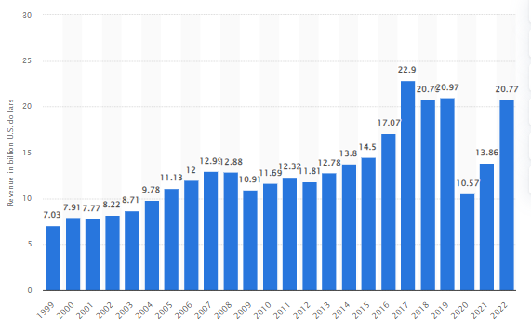
Figure 1: Worldwide revenue of Marriot
(Source: Statista, 2023)
The above graph is a visual representation of the worldwide revenue of the hotel which increases over time. As per the statistical information, the worldwide revenue accounted for around 22.77 billion British pounds in 2022 (Statista, 2023). The hotel has been counted among the top five global leading brands. According to information from the market, when it comes to property matters Marriot International Inc. has been accounted for because of the half a thousand hotels it runs worldwide in the year 2021. Even the company holds the best brand value in the market with increases in the value of market share.

On the other hand, a company should use a significant strategy while recruiting employees and staff in the hotel industry. During the selection process, many candidates did not rercieve a proper backround check. This can create issues for the busineess as due to a lack of information about staff, serious risks for the business can arise if candidates have any kind of criminal record (Bilan et al., 2020). On the other hand, another significant reason for employee turnover is the pay sucks and toxic environment which is common in hotel industries. Those are a few issues that affected business and needed to be improved for future benefits.

Discussion/Literature
SWOT analysis
Strengths | Weaknesses
- The company have a solid reputation in the market  - High brand value and employee retention rate is 35%  - The worldwide revenue of the brand is around 22.77 billion (Statista, 2023).  - Operating income reported around 3.46 billion in 2022 | - Unclearing proposition of selling  - The cost of set up is extremely high  - Essential facilities are poor and lack the availability of in-room technologies  - The highly competitive market in a global hotel chain
Opportunities | Threats
- Companies have chances to customise their services  - The hotel industry has a chance to develop its economy  - Service expansion of the company can help attract consumers | - Loitering, vandalism, and theft are common threats that hotels faced  - The Global pandemic and the company may lose 92% of its profits and customers (FOXBusiness, 2020)  - Losses control over the supply chain which affected the business  - Negative marketing and rapid changes in lawsuits
Table 1: SWOT analysis of the hotel
(Source: Created by the learner)

The above table helps to highlight different types of opportunities and threats that the company faces due to different factors. The company is in the top 35% compared to other same-sized companies and it can retain quality employees (Marriott Bonvoy, 2023). Due to the impact of COVID, it heavily destroyed the entire UK hotel chains and declined all bookings of consumers. Additionally, because of flight cancelations, customers withdrew their bookings, which then heavily impacted the profitability ratio of the hotel. According to business news information, the company lost over 92% of its annual profits as well as the number of consumers declining due to the impact of COVID-19 (FOXBusiness, 2020). On the other hand, negative marketing as well as continuous changes in lawsuits in the UK affected businesses and their policies, which to some extent contributed towards lack of recrutment and retention rate.

PESTLE analysis
Political Factors
A business needs to have stability in the political condition which helps to increase business possibilities during expansion. The British Monarchy, which is also known as the constitutional monarchy, Is a political system which functions as the head of the state is vested in the hereditary (The British Monarchy). The government is accountable to the Parliament as the bulk of executives' powers, determining policies for nations and overseas. Despite this, the effects of Brexit negatively impacted the entire hotel industry in the UK. It was found that service levels may be in declin because hotels are struggling with a shortage of staff that can meet all demands across hotel departments. Furthermore, the rate of occupancy also continues to decline as many travellers are cancelling visits in Britain. Around 42% of citizens believed that Brexit created a negative impact on hotel businesses (Statista, 2023). Additionnally, due to a shortage of migrant workers, the hotel industry find it difficult to recruit staff to fill positions, making it more difficult to serve people or visitors.

Economic Factors
The economic factors are another significant matter and the main source of a hotel's success and continuing growth process. During the COVID-19 pandemic, the annual revenue of the company fell dramatically based on all regions in the year 2020 due to high restrictions on travelling. COVID-19 affected the UK hotel industry which caused a decline in sales, which then negatively impacted its profitability. The occupancy rate of the UK failed by around 21% which caused a fall in RevPar by 27.7% (Statista, 2020). The expenditure on hotels as well as restaurants by UK households significantly declined by the year 2020 because of the worldwide spread of COVID-19.
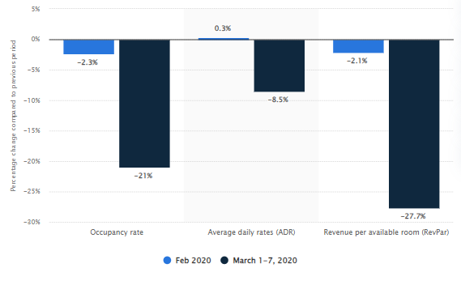
Figure 2: Performances of the hotel industry
(Source: Statista, 2020)
The above diagram is a visual representation of the performances of the hotel industry in London, UK. A business needs to have strong support from the economy to increase business capabilities. Not only that, this particular industry plays a pivotal role in the country's economy. As per the information from the government in 2019, output of the economy of the hospitality industry was 59.3 billion British pounds, which was around 3% of the UK economic output (Parliament.uk, 2021). During this situation, the rate of employee turnover increases, which in turn creates additional expenses with recruitment, development, selection, and training (Ramlall, 2004).

Social Factors
Social factors also play a pivotal role in the business of a hotel, as more client revenue increases service provisions for hotels, thus increasing facilities and qualoty of service/amenities. Whilst the literacy rate in the UK is around 99% (Gov.uk, 2023), it is important for Marriott Hotels to consider the cultural differences (in literacy rates, customs and more) when promoting their services to the general public. It can be suggested that this would impact the business positively, which is required for better effectiveness and initial business growth. Overcoming cultural diffrernces through staff trainign would catapult the business ahead of its competitors (Gamio, 1991). Additionally, having different religions and cultural backgrounds people make the workplace more diversified and it also helps to attract more people from different religions and cultures (Ntounis et al., 2022). The company needs to hire employees from different zones and provide initial training, an acknowledgement in the workplace, appropriate mission and vision, and values that help to bring more positive opportunities for business. However, employee retention can also lead workers to become overtired, as it is one of the significant factors which affect the retention of employees in the industry of hospitality.
Technological Factors
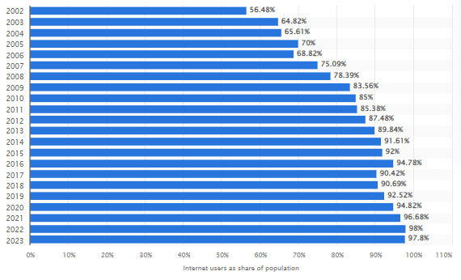
Figure 3: Number of Internet users in the UK
(Source: 2023)
The increased numbers of users of the Internet the can become an advantage for businesses of hotel industries. It can be stated that with the help of the Internet, it become easier for companies to reach customers in different areas across the world. The rate of Internet users is around 98% in the UK which also increases over time (Statista, 2023). Therefore, the company needs to use this as an opportunity to develop the business. Not only that, it also positively impacted the company in different ways. Through the use of the Internet, it becomes easier to get the attention of customers and it is easier to recruit eligible candidates. Advertising through social media platforms also helps employees get to know about job opportunities so that it becomes easier for the management to recruit candied from different areas.

Legal Factors
The hotel industry needs to maintain legal factors to avoid disruptions. The hotel industry within the UK is required to follow "The National Minimum Wages Act 1998" to maintain its reputation in the market and positively impact the business (Bargain et al., 2019). Marriot is one of the largest hotel firms in the UK, which currently faces mass employee turnover in business because of COVID-19. In addition to this, to attract and hire more employees in business, it is necessary to offer appropriate rates of wages which are around £10.42 for people above age 23 and over £10.18 for 21-22 years (Gov.UK, 2023). Eventually, if the company can maintain that ratio it will help to connect more people with the business.

Environmental factors
The major environmental areas that impacted the hotel industry negatively are energy, waste, and water. Not only that, if the country’s weather is not stable and changing rapidly, tourists might lose interest in visiting which would negatively affect the economic structure of the hotels (Khandaker et al., 2020). The hospitality industry often pressurises natural resources. Maintenance of environmental act in business is important so that unwanted issues are not created and the business runs smoothly.

Evaluation and Conclusion

Evaluation
It can be recommended that the company that it needs to evaluate its procedures of recruitment as well as retention for business growth by considering other external issues. It might be helpful for the company to offer an increase in wages in exchange for the hard work that employees do for the company, as well as to incentivise further prospective employees (Berggren,1999). This would help in retaining at least 40% of employees, as well as motivating and attracting a further 73% of potential employees within the population that are well suited for jobs within the hotel (Marriott Bonvoy, 2023). It is also essential and recommended for large hotel chains like The Marriott to teach employees skills related to job roles. On the other hand, the company can use social media platforms, advertisements, and different TV channels for hiring employees from different diverse backgrounds. Furthermore, a company can use models such as The ”P”s which are performance, purpose, and process as the improvement process of recruitment (Münstermann, 2010). Engaging employees with business can increase productivity power. Additionally, having satisfaction in a job reduces the number of resignations which also increases the profitability ratio (Batt, 2011).

The labour market is one of the most essential parts of the hotel industry as it controls the supply as well as the demand of labour which is an external factor. The external factors of a company can be broadly categorised as the technological, political, social cultural, and legal environment (He et al., 2021). That is why all of those factors have both positive as well as negative impacts on staff retention and the recruitment process. It is recommended that the company should address significant issues that come with those external factors to avoid any types of critical circumstances. Not only that, the company should provide a positive working culture as well as flexibility so that employees can share their thoughts without any hesitation, in turn promoting motivation and positive attitudes within the workplace.

Conclusion
It can be concluded from the analysis that a company like Marriott should consider different types of external as well as internal factors which might impact the company’s revenue, success and profitability. Job satisfaction and factors of engagement are the main factors of employee retention matter. Utilisation of different matters in business is necessary for initial growth. This therefore helps in understanding how the company can improve its process and bring changes that connect employees and increase productivity power. Additionally, with the help of SWOT and PESTLE analysis, all essential matter has been highlighted for better understanding for better effectiveness.

References
Bargain, O., Doorley, K. and Van Kerm, P., 2019. Minimum wages and the gender gap in pay: new evidence from the United Kingdom and Ireland. Review of Income and Wealth, 65(3), pp.514-539.
Berggren, E.G., 1999. Using money to attract, develop, and retain staff. Consulting to Management, 10(4), p.47.
Batt, R. and Colvin, A.J., 2011. An employment systems approach to turnover: Human resources practices, quits, dismissals, and performance. Academy of management Journal, 54(4), pp.695-717.
Bilan, Y., Mishchuk, H., Roshchyk, I. and Joshi, O., 2020. Hiring and retaining skilled employees in SMEs: problems in human resource practices and links with organizational success. Business: Theory and Practice, 21(2), pp.780-791.
FOXBusiness, 2020. Marriott profit plunges 92% as coronavirus zaps travel. [Online] Available at: <https://www.foxbusiness.com/markets/marriott-coronavirus-earnings-q1-2020> [Accessed 6 Oct. 2023].
Gamio, M.O. and Sneed, J., 1991. Cross-cultural training practices and needs in the hotel industry. Hospitality Research Journal, 15(3), pp.13-26.
Gov.UK, 2023. National Minimum Wage Act 1998. [Online] Available at: <https://www.legislation.gov.uk/ukpga/1998/39/contents> [Accessed 6 Oct. 2023].
Gov.uk, 2023. Recognising the power of literacy when designing services - Defra digital, data and technology. [Online] Available at: <https://defradigital.gov.uk/2022/09/21/recognising-the-power-of-literacy-when-designing-services/> [Accessed 6 Oct. 2023].
He, J., Mao, Y., Morrison, A.M. and Coca-Stefaniak, J.A., 2021. On being warm and friendly: the effect of socially responsible human resource management on employee fears of the threats of COVID-19. International Journal of Contemporary Hospitality Management, 33(1), pp.346-366.
Khandaker, G.M., Zuber, V., Rees, J.M., Carvalho, L., Mason, A.M., Foley, C.N., Gkatzionis, A., Jones, P.B. and Burgess, S., 2020. Shared mechanisms between coronary heart disease and depression: findings from a large UK general population-based cohort. Molecular psychiatry, 25(7), pp.1477-1486.
Marriott Bonvoy, 2023. Hotels & Resorts | Book your Hotel directly with Marriott Bonvoy. [Online] Available at: <https://www.marriott.com/en-gb/default.mi> [Accessed 6 Oct. 2023].
Münstermann, B., Eckhardt, A. and Weitzel, T., 2010. The performance impact of business process standardization: An empirical evaluation of the recruitment process. Business Process Management Journal, 16(1), pp.29-56.
Ntounis, N., Parker, C., Skinner, H., Steadman, C. and Warnaby, G., 2022. Tourism and Hospitality industry resilience during the Covid-19 pandemic: Evidence from England. Current Issues in Tourism, 25(1), pp.46-59.
Parliament.uk, 2021. Hospitality industry in the UK: pre-pandemic [Online] Available at: <https://commonslibrary.parliament.uk/research-briefings/cbp-9111/#:~:text=Hospitality%20industry%20in%20the%20UK%3A%20pre%2Dpandemic,in%20each%20country%20and%20region.> [Accessed 6 Oct. 2023].
Ramlall, S., 2004. A review of employee motivation theories and their implications for employee retention within organizations. Journal of American academy of business, 5(1/2), pp.52-63.
Statista, 2023. Brexit: impact on the UK tourism industry 2016-2017 survey. [Online] Available at: <https://www.statista.com/statistics/631483/brexit-impact-united-kingdom-uk-tourism-industry/> [Accessed 6 Oct. 2023].
Statista, 2023. COVID-19 impact on London hotel performance 2020. [Online] Available at: <https://www.statista.com/statistics/1105288/covid-19-impact-on-london-hotel-performance/> [Accessed 6 Oct. 2023].
Statista, 2023. Internet penetration in the UK 1990-2018. [Online] Available at: <https://www.statista.com/statistics/1124328/internet-penetration-uk/> [Accessed 6 Oct. 2023].
Statista, 2023. Revenue of Marriott International worldwide from 1999 to 2022 [Online] Available at: <https://www.statista.com/statistics/266279/revenue-of-the-marriott-international-inc-hotel-chain/> [Accessed 6 Oct. 2023].
UK Parliament, 2022. The British Monarchy Home page. [Online] Available at: <https://www.parliament.uk/. [Accessed 6 Oct. 2023].

