Computer Architecture and Operating Systems
Assessment 2-Report


Student Name: Sadaf Yusufzai
Student ID: 2513631
Module Code: ACCA4022_LON
Lecturer: Kwame Assa Agyei

Table of Contents
Introduction 2
Task 1. Key functions of general Operating Systems 3
Task 2. Use of Windows OS CLI commands 4
Task 3. Use of Linux OS CLI commands 11
Task 4. Use of Windows OS scripts 18
Task 5. Use of Linux OS scripts 20
Conclusion 23
References 24
Appendix 25

Introduction
In this report, I will explore the key functions of operating systems and how they are used to manage system resources. I will focus on both Windows and Linux environments, as these are widely used in different computing contexts. To support this, I will carry out practical tasks using command line interfaces to manage files, monitor processes, and test network connections. I will also create simple scripts to show how routine tasks can be automated. Overall, this report will demonstrate my understanding of operating systems through both practical work and explanation.

Task 1. Key functions of general Operating Systems
Operating systems are a key part of any computer system, as they manage hardware resources and allow users to interact with the system. Common operating systems such as Microsoft Windows and Linux provide a range of features that help the system run efficiently and securely. In this section, I will explain some of the main functions of operating systems and how they can be monitored or managed.
One of the main functions is process management. This involves controlling programs while they are running and making sure the system can handle multiple tasks at the same time. In Windows, I used Task Manager to view active processes and observe how system resources were being used. In Linux, I used commands such as ps and top to display running processes and monitor activity. This helped me understand how the system manages different tasks at once [1].
Memory management is another important function. The operating system controls how memory is allocated to different processes and ensures that they do not interfere with each other. In Windows, I viewed memory usage through the Performance tab in Task Manager. In Linux, the top command also displayed memory information in real time. This helped me understand how the system maintains performance by managing memory effectively [2].
File system management is also essential. The operating system organises files and directories so that data can be stored and accessed easily. In Windows, this is done through File Explorer, while in Linux I used commands such as ls and cd to navigate between directories. This allowed me to see how files are structured and how they can be accessed when needed [3].
Security and user management are also key functions. The operating system controls access to files and system resources by managing user accounts and permissions. In Windows, this is handled through system settings, while in Linux I used the whoami command to identify the current user. This showed how the system ensures that only authorised users can access certain parts of the system [1].
Another important function is device management. The operating system communicates with hardware devices such as keyboards, printers, and storage devices. It uses drivers to ensure these devices work correctly. In Windows, devices can be managed through Device Manager, while Linux handles this through system
level controls. This ensures that hardware components function properly with the system.
In conclusion, operating systems perform several important functions, including managing processes, memory, files, users, and devices. These functions work together to ensure that the system runs smoothly and provides a stable environment for users and applications.

Task 2. Use of Windows OS CLI commands
In this task, I used a range of Windows command-line tools to carry out different system operations. These commands allowed me to manage files and directories, monitor system processes, check network connectivity, and view user information. Using the command line interface helped me understand how tasks can be performed without relying on a graphical interface.
To begin, I opened the Command Prompt using the Windows search function, which allowed me to access the command line environment (Figure 1 and Figure 2). I then used the dir command to display the contents of my main user directory (Figure 3). This showed all the folders and files stored on the system.
For file and directory management, I used a sequence of commands to create and organise files. I used the mkdir command to create a new folder, followed by the cd command to move into that folder (Figures 4 and 5). After that, I used the echo command to create a text file and write content into it (Figure 6). To confirm that the file had been created successfully, I used the dir command again, which displayed the file within the folder (Figure 7).
For process management, I used the tasklist command to display all running processes on the system (Figure 8). This produced a list of active applications along with their process IDs and memory usage, helping me understand how the system manages multiple tasks at the same time.
For network monitoring, I used the ipconfig command to view network configuration details (Figure 9). This showed information such as the IP address and network connection status. I also used the ping command to test network connectivity (Figure 10). This confirmed that the system was able to communicate with an external server.
Finally, I used the whoami command to identify the current user logged into the system (Figure 11). This displayed the username, confirming the account being used to perform the tasks.
Overall, these commands helped me understand how the Windows command-line interface can be used to manage different aspects of a system in a simple and efficient way [4].

File and Directory Management
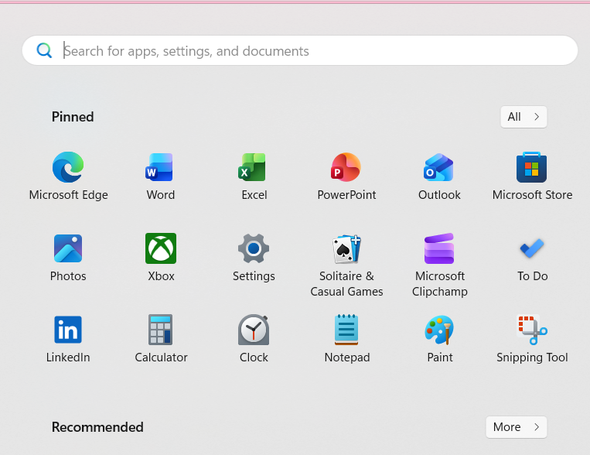
Figure 1: Opening Windows search function.

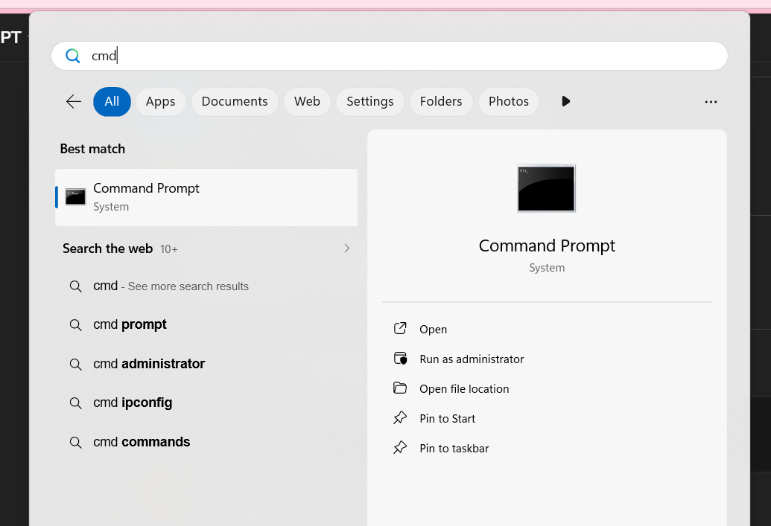

Figure 2: Command Prompt interface ready for command input

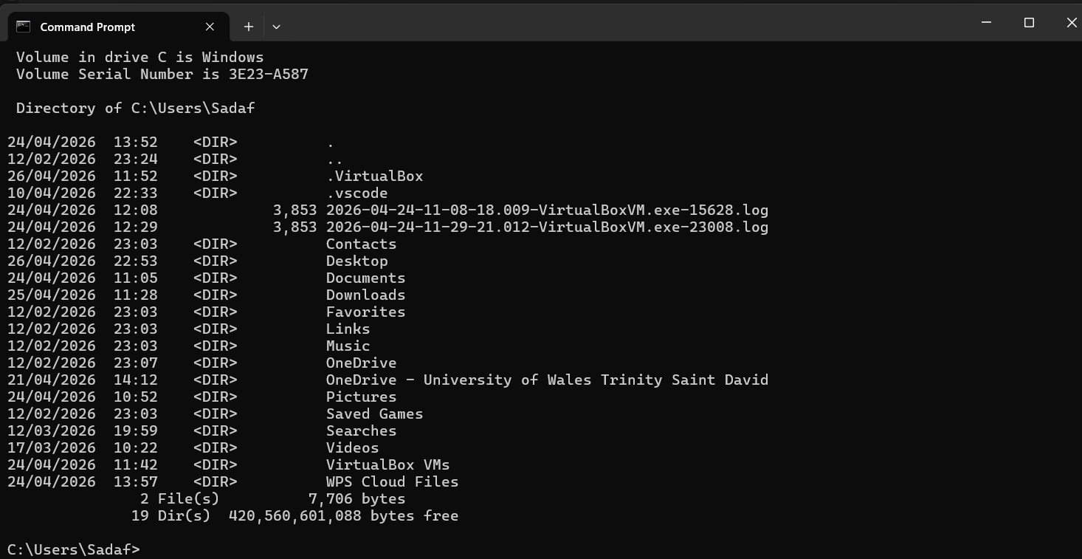
Figure 3: Displaying the contents of the directory using the dir command

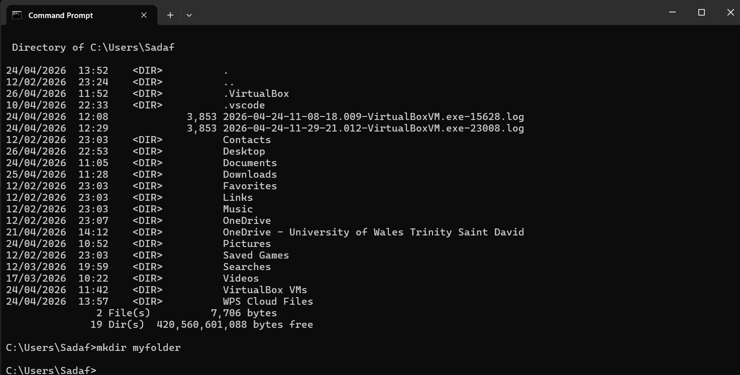
Figure 4: Creating a new directory using the mkdir command

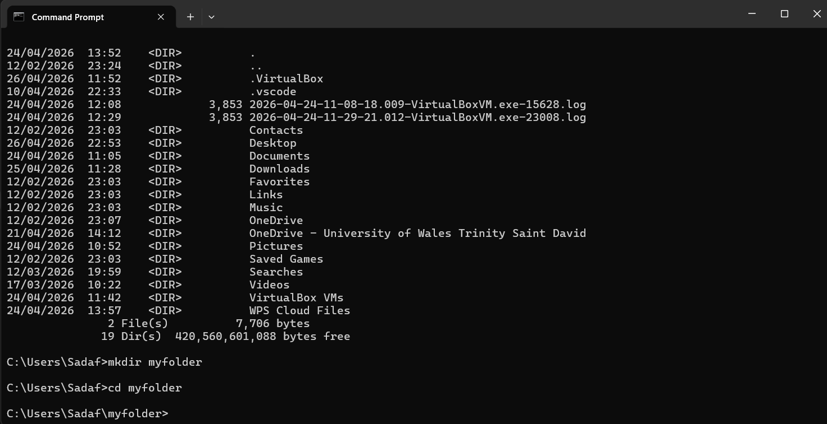
Figure 5: Navigating between directories using the cd command

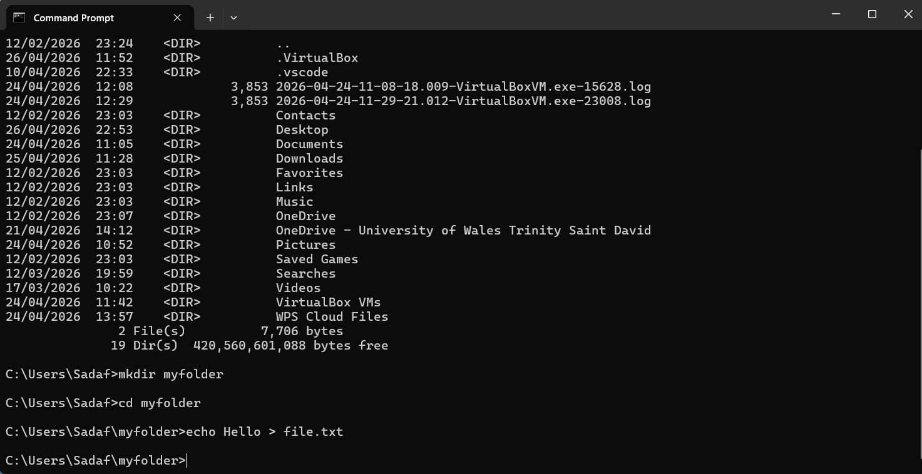
Figure 6; creating a file using the echo command

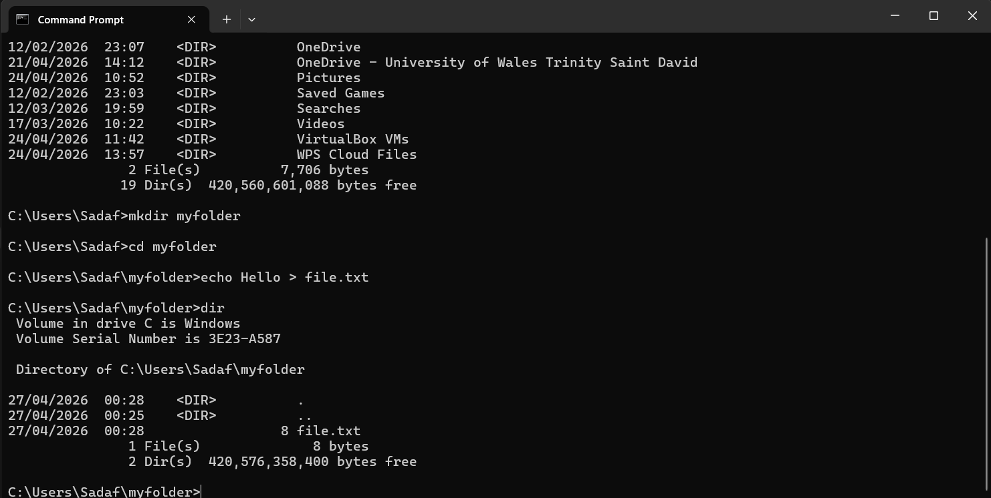
Figure 7; Verifying file creation using the dir command

Process Management

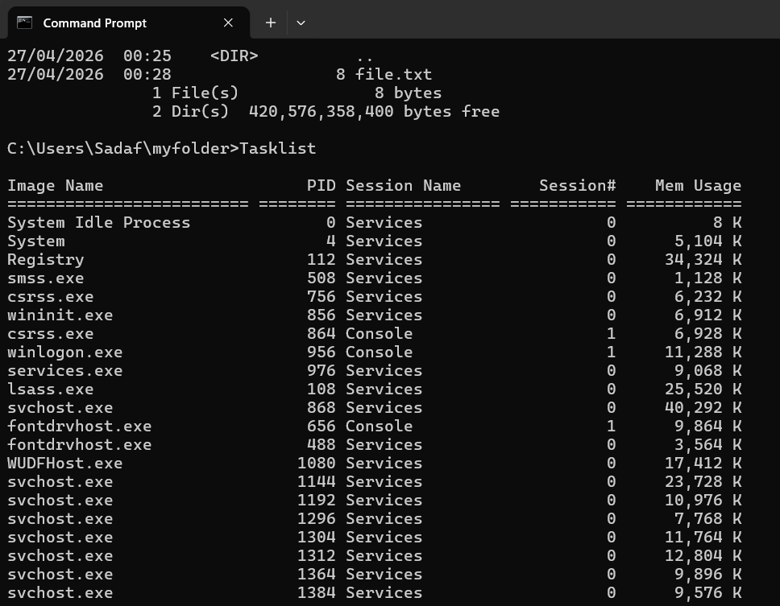
Figure 8: Displaying running processes using the tasklist command

Network Monitoring

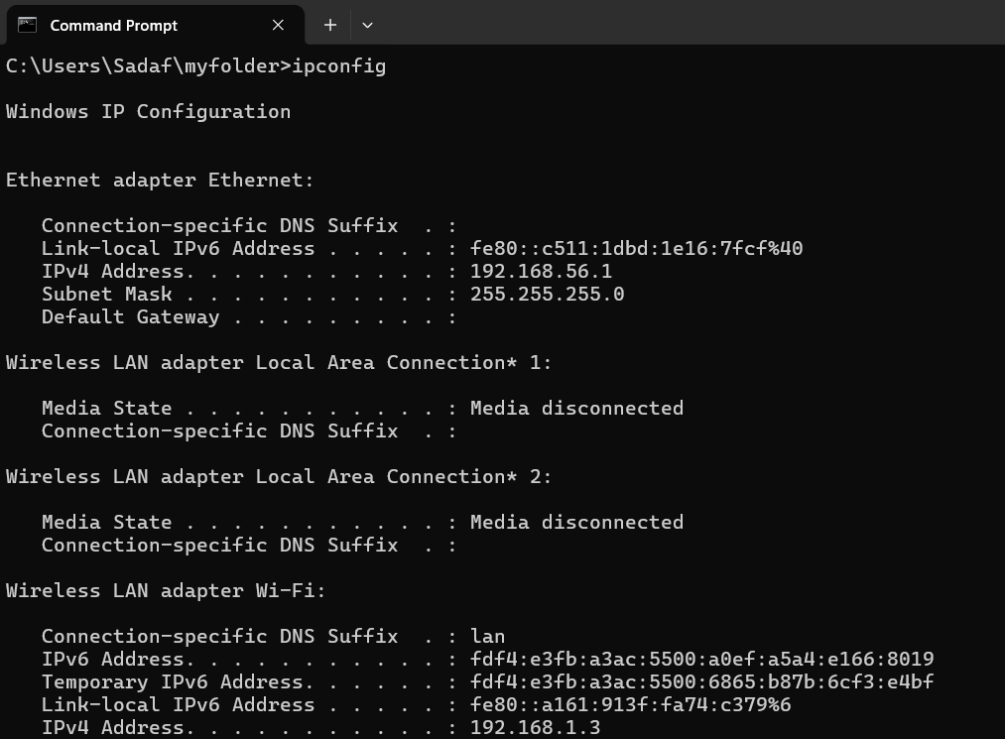
Figure 9; Viewing network configuration using the ipconfig command

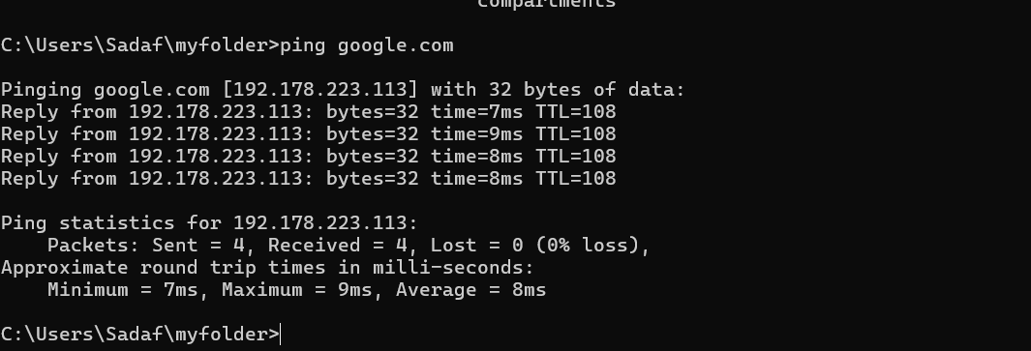
Figure 10: Testing network connectivity using the ping command

User Management

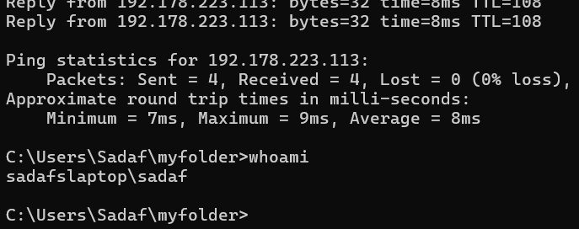

Figure 11: Identifying the current user using the whoami command

Task 3. Use of Linux OS CLI commands

In this task, I used a range of Linux command-line commands to carry out different system operations. This helped me see how tasks can be done directly in the terminal without needing to use a graphical interface.
To start with, I worked on file and directory management. I created a new folder using the mkdir command and moved into it using cd. I then used the pwd command to check my current location in the system. After setting up my workspace, I created a text file using the echo command and added my personal details. I used the cat command to display the contents of the file, which confirmed that the information had been saved correctly. I also used ls -l to view detailed information about the file, including its size and permissions. To show further file management, I copied the file using the cp command and checked that the copy had been created using ls.
I then moved on to process management. I used the ps aux command to display running processes on the system, which showed details such as process IDs and system usage. The top command was then used to monitor system activity in real time, allowing me to observe how CPU and memory were being used.
For network monitoring, I used the ping command to test connectivity to an external server. The results showed successful replies, confirming that the system was connected to the network [5]. I also used the ip addr command to view network configuration details, including IP addresses and network interfaces.
For user management, I used the whoami command to check the current user logged into the system. Finally, I used the crontab -l command to view scheduled tasks. The output showed that no tasks were set, but it demonstrated how tasks can be managed through the command line.
Overall, these commands helped me understand how Linux systems can be controlled efficiently using the command line [6]– [7]

File and Directory Management
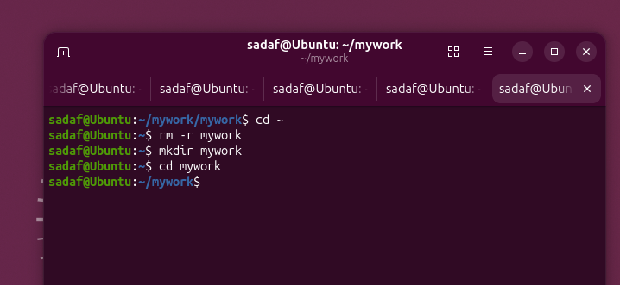

Figure 12: Creating and navigating into a directory using the mkdir and cd commands

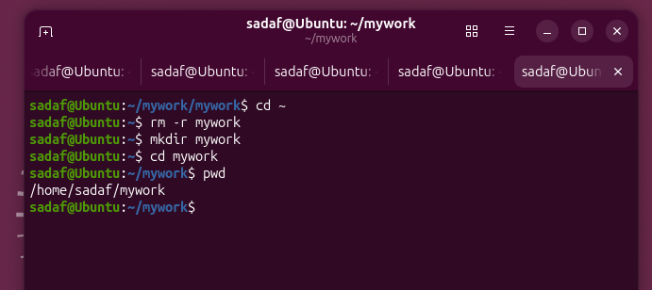

Figure 13; Displaying the current working directory using the pwd command

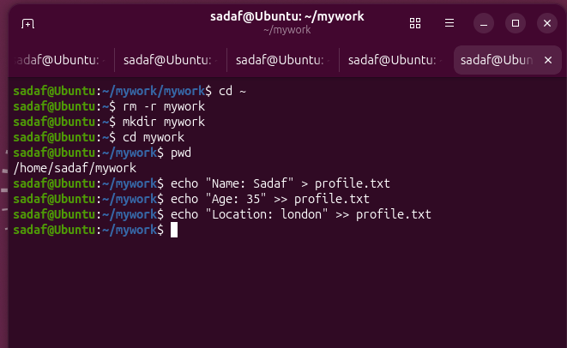

Figure 14: Creating a file and adding personal details using the echo command

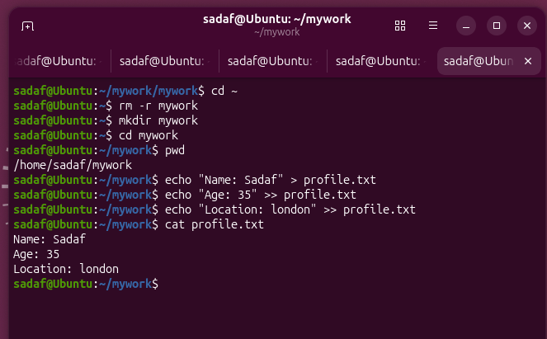

Figure 15: Displaying file contents using the cat command

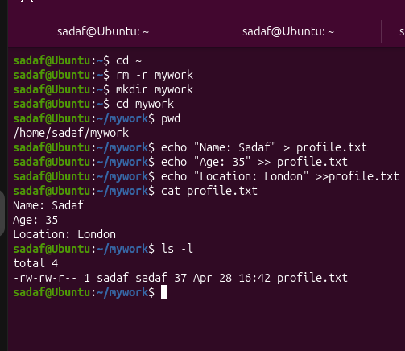

Figure 16: Listing files with detailed information using the ls -l command

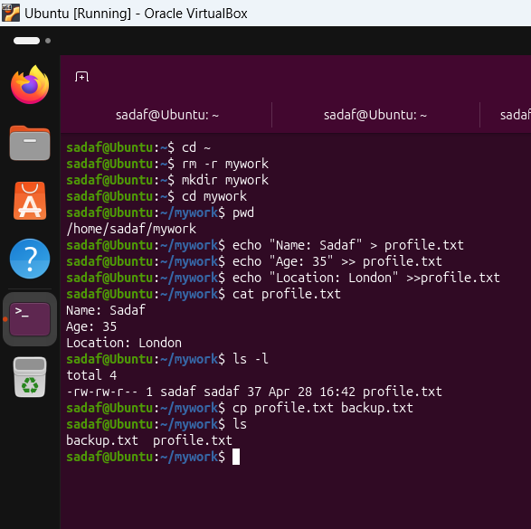

Figure 17: copying files using cp command and verifying its creation using the ls command

Process Management

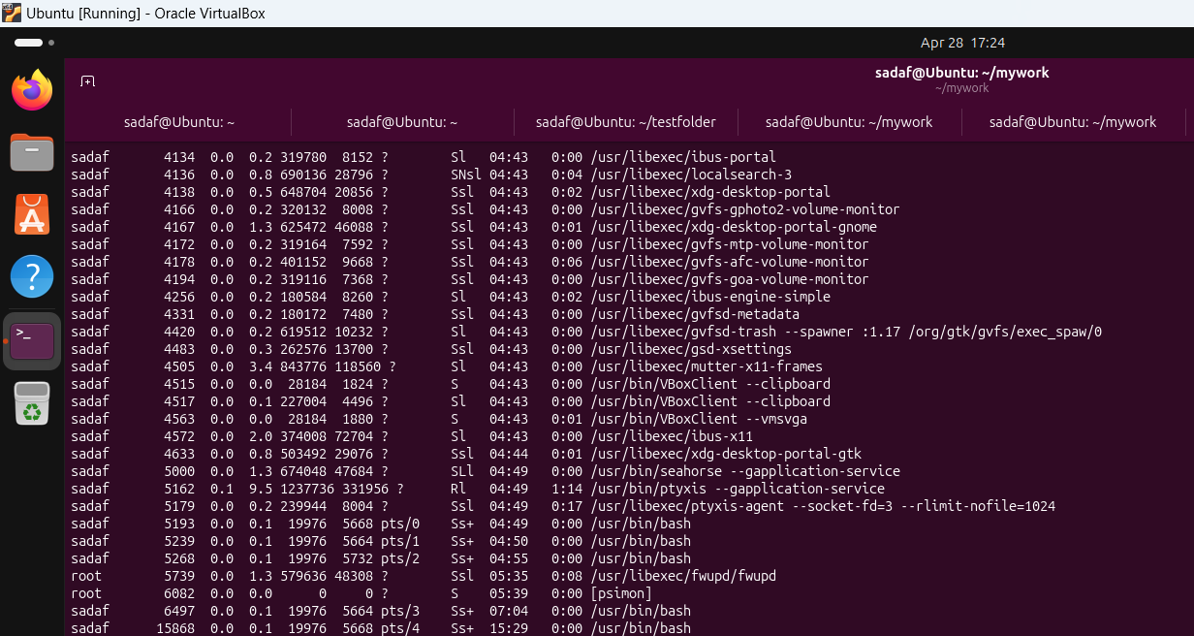
Figure 18: Displaying running processes using the ps aux command

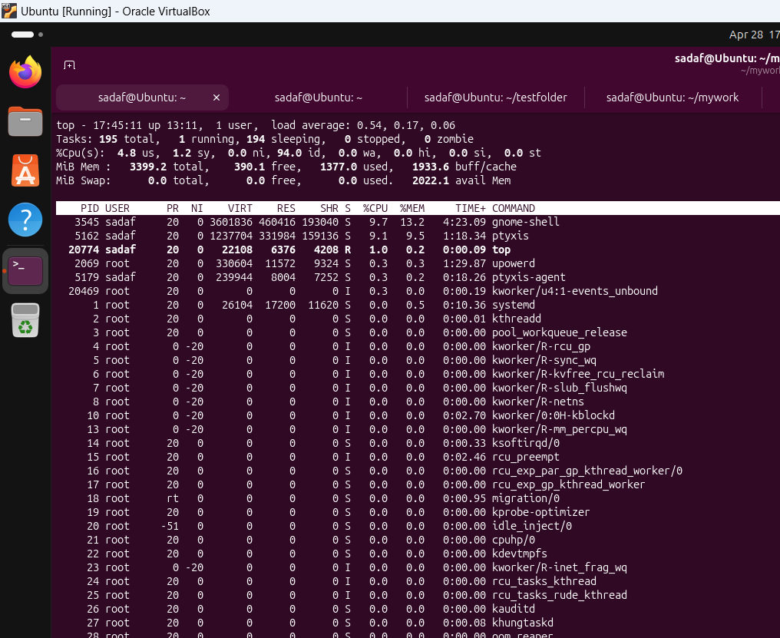
Figure 19: Monitoring system performance in real time using the top command
Network Monitoring

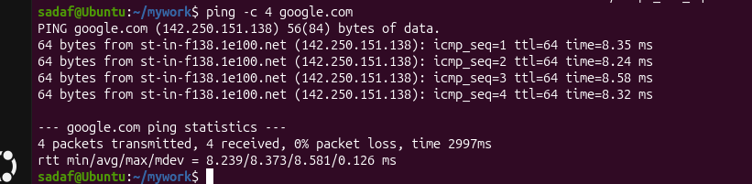
Figure 20: Testing network connectivity using the ping command

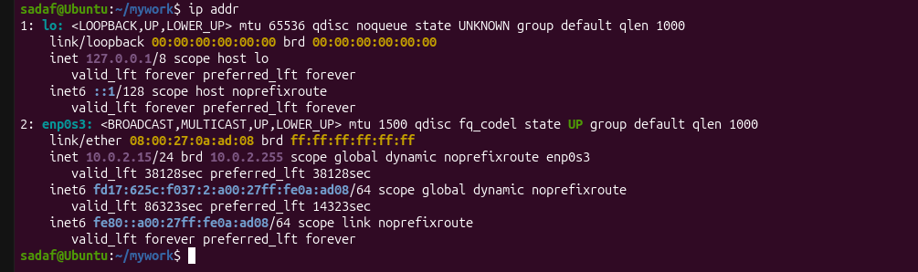
Figure 21: Viewing network configuration using the ip addr command

User Management
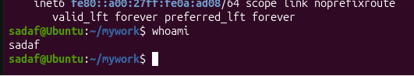

Figure 22; Identifying the current user using the whoami command

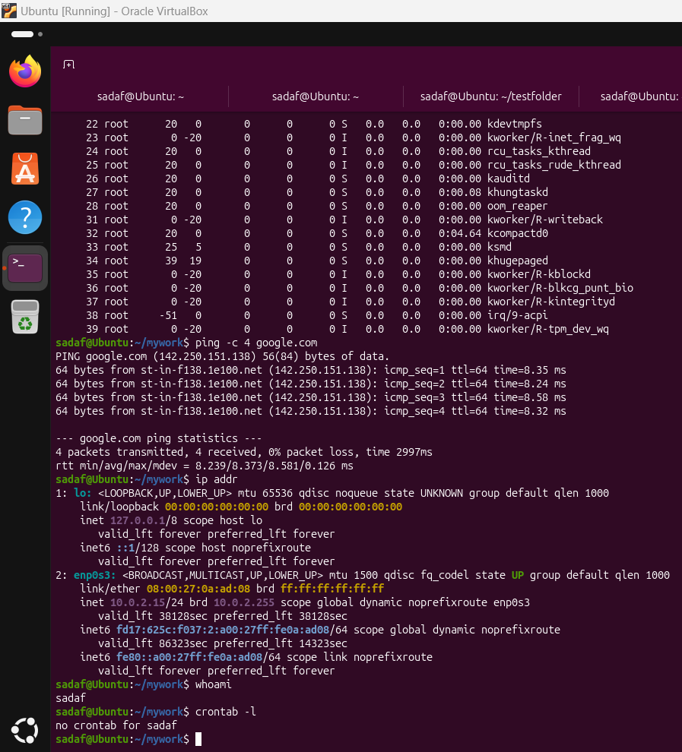

Figure 23: Viewing scheduled tasks using the crontab -l command

Task 4. Use of Windows OS scripts

In this task, I created two simple Batch scripts to show how Windows command-line automation works. The first script was a calculator that asked the user to enter two numbers and then added them together. This helped me understand how variables, user input and basic calculations can be used within a script. The second script checked if a folder already existed. If it did, a message was displayed, and if it didn’t, a new folder was created. This showed how conditional statements can be used to control what happens in different situations. Overall, both scripts showed how Batch files can be used to automate simple tasks instead of doing them manually.

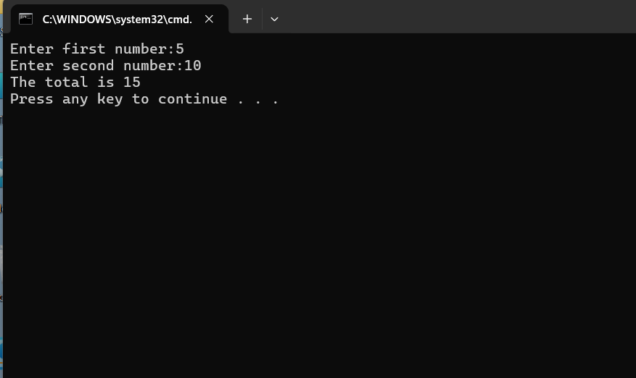
Figure 24: Executing a Batch script to perform a mathematical operations using user input

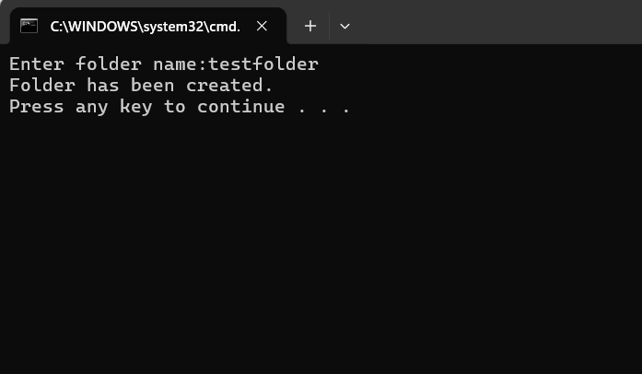
Figure 25: Executing a Batch script to check and create a directory using conditional statements

Task 5. Use of Linux OS scripts
In this task, I created two simple Bash scripts to demonstrate how automation works in the Linux environment. The first script asked the user to enter their name and age, then displayed the information back in the terminal. This helped me understand how variables and user input can be used within a script. The second script asked the user to enter a number and then used a loop to generate a multiplication output. This showed how loops can be used to repeat commands and perform calculations automatically. Overall, this task helped me understand how Bash scripting can be used to automate simple tasks and make working in the terminal more efficient.

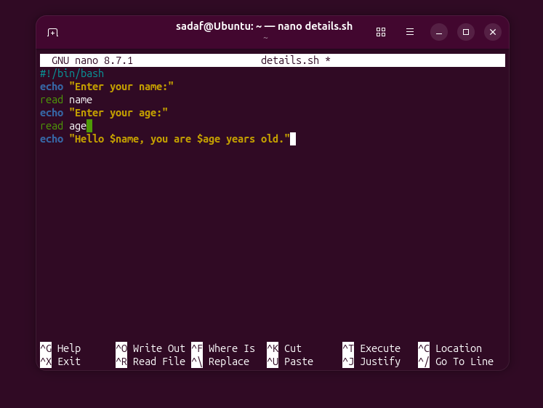
Figure 26: Writing a Bash script using nano editor

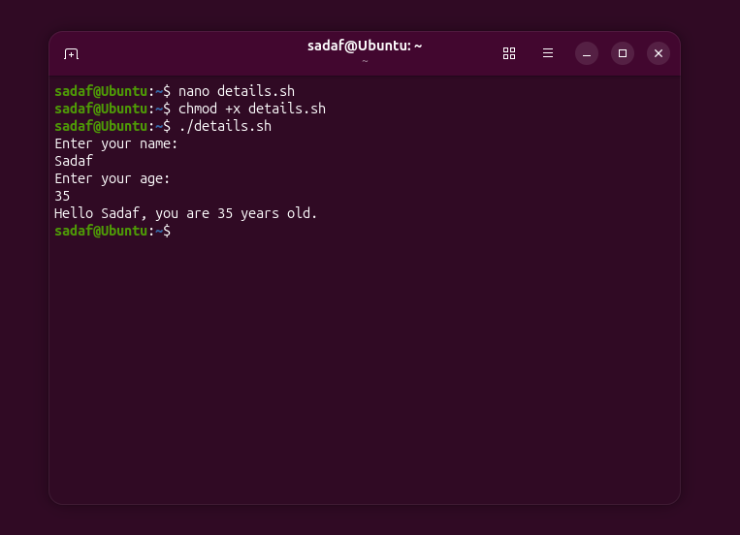
Figure 27: Executing a Bash script using user input and variables

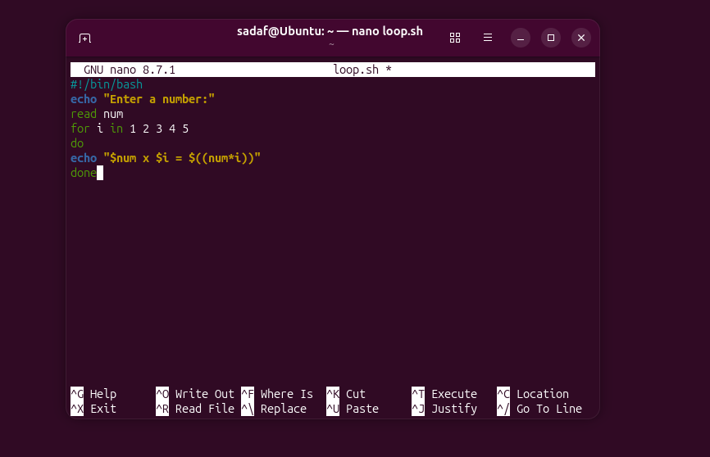
Figure 28: Writing a Bash script using a loop and arithmetic operations in nano editor

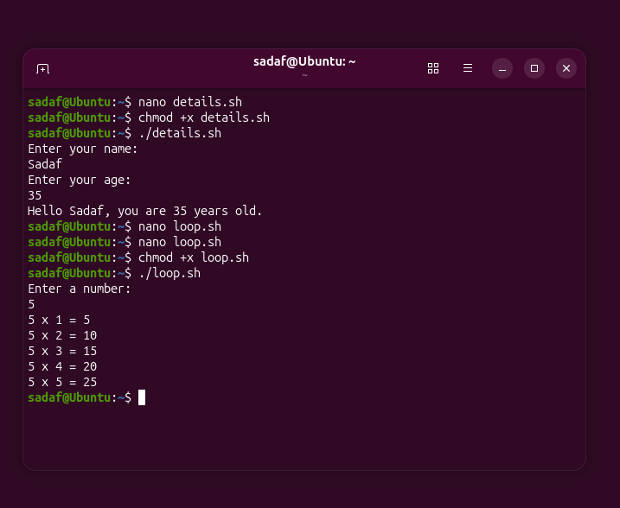
Figure 29: Executing a Bash script to generate multiplication results using a loop

Conclusion
In conclusion, this assignment helped me develop a better understanding of both Windows and Linux command-line environments. Through Task 2 and Task 3, I was able to practise using different commands to manage files, monitor systems and test network connections. Task 4 and Task 5 allowed me to explore scripting, where I created simple Batch and Bash scripts to automate tasks such as calculations, file management and looping operations. This showed how repetitive tasks can be simplified using scripts. Overall, the assignment improved my confidence in using command-line tools and helped me understand how automation can make system operations more efficient.

References

[1] | T. L. Foundation, “Introduction to Linux,” [Online]. Available: https://www.linuxfoundation.org.. [Accessed 20 04 2026].
[2] | Microsoft, “Windows Operating System Overview,” [Online]. Available: https://www.microsoft.com. [Accessed 20 04 2026].
[3] | A. Silberschatz, P. B. Galvin and G. Gagne, Operating System Concepts, Hoboken, NJ: Wiley, 2018.
[4] | Microsoft, “Windows Command-Line Reference,” [Online]. Available: https://learn.microsoft.com/. [Accessed 20 04 2026].
[5] | T. L. Foundation, “Linux Command Line Basics,” [Online]. Available: https://www.linuxfoundation.org/. [Accessed 20 04 2026].
[6] | C. Ltd., “Ubuntu Command Line Documentation,” [Online]. Available: https://ubuntu.com. [Accessed 20 04 2026].
[7] | W3Schools, “Bash Tutorial,” [Online]. Available: https://www.w3schools.com/bash. [Accessed 20 04 2026].

Appendix

Appendix A: Windows Batch Scripts
@echo off
set /p num1=Enter first number:
set /p num2=Enter second number:
set /a total=%num1%+%num2%
echo The total is %total%
pause

@echo off
set /p folder=Enter folder name:
if exist %folder% (
echo Folder already exists.
) else (
mkdir %folder%
echo Folder has been created.
)
pause

Appendix B: Linux Bash Scripts
#!/bin/bash
echo "Enter your name:"
read name
echo "Enter your age:"
read age
echo "Hello $name, you are $age years old."

#!/bin/bash
echo "Enter a number:"
read num
for i in 1 2 3 4 5
do
echo "$num x $i = $((num*i))"
done

