
Data analysis
M7X01702

January 9, 2018
University of wales trinity saint david
Irfan Onur P147861



Abstract

This report is conducted to show understanding and skills within data analysis due to that factor this assignment is broken up into two different parts. The first part of this report is strictly based on research within data analysis which helps aid the author on understanding what they will be doing and also the reader. The second part of this report shows practical work on data analysis where the author is given an X amount of data which the author was to locate the significant difference.

Introduction

This document was produced to show evidence and understanding in data analysis and statistical mathematics. The author was given two sets of mathematical numbers to identify the significant statistics difference between the two sets of data, other indications the authors was meant to locate and report in an ethical manor were the appropriate measures of centre and distribution, calculations of the statistical significance.
The given data was tested and documented in this report using different terms of testing to check the integrity of the result and test. The author had ensured that a correct hypothesis had been set as a target before understanding what types of test will need to be completed. Once an appropriate hypothesis had been set the author had ensured that a deep and brief understanding had been completed in the mathematical understanding of statistics to locate appropriate tests for the given data sets. The author will need to also show a deep understanding of cognitive principles involved in presenting statistics efficiently also in detecting problems with visualizations.

The t Test

One of used hypothesis was based on the t test, the t test can be used for several purposes such as independent samples critical value, $t:t_{crit}$ , directional vs. non-directional test but an t test is only two calculate the means of two sets of data[1], [2][3]. The benefit of an t test allows the users to compare the means of two different samples and is also commonly used within statistical tests to differ a statically significance degree. When an t test is used only the given value will be a single obtained value which is defined as $t_{obt}$. Some of the disadvantages of the t Test is that it can only allow the author of the test to only analyse two sets of data and nothing more or there can be an anonymous amount of type 1 error.

Examples of given t test values.

  - $t_{obt}$ = value of $t$ attained from given data by the user
  - $n_{1},n_{2}$ = given number of items in samples 1 and 2
  - ${SD}_{1}^{2}, {SD}_{2}^{2}$ =approximations of the variances of the two populations
  - ${\overline{X}}_{1},{\overline{X}}_{2}$ = value of the two samples

Frequency distribution

The known understanding of frequency distribution is to allow data to be set in a fashionable manor for users or viewers to understand the data in the simplest way possible.[4], [5] If a user wants to provide simplicity for better understanding they can create a graph, list or table for a better display of a set amount of numerical data, the user could also create a tally chart to help aid the viewer in understanding the data set. Tables are used to help aid the user in understanding the distribution of values.

Descriptive statistics

The use of descriptive statistics within an X amount of data set is to provide the user with summarised descriptions of the collected data, either by numerical output, tables or graphs[6]–[8]. This is to help aid the user with a more descriptive idea of the quantitative data result. Descriptive statistics are known to be used for sample testing unlike inferential statistics which are commonly used to help understand and learn the statistics of the outcome, but descriptive statistics are known to also be used to show a brief sample of the final outcome.

Measures of central tendency

A measure of central tendency is a single value that describes the way in which a group of data average or typical score cluster around a central value. Central tendency is beneficial when in comparison to individual scores with a group or external standard. In other definitions the use of measures of central tendency is a term used to describe the centre of a data set[9], [10]. There stand three key procedures of central tendency: mean, median, and the mode. The meaning of the mean is the most often use type of measure to check for the central tendency when is calculated by adding all the data and diving it by the amount of data given. The median is when all the given data is set in an order of manner from smallest data given to the largest data given then the median is detected by identifying the middle number. The final key element of measures of central tendency is the mode which is used to the find the most frequently occurring data given in a set of data.

Inferential statistics

The mean of inferential statistics is used to help produce predictions of large data clusters in comparison to analysis of small data clusters. The use of inferential statistics is to allow more specific outcomes as some time data sets could be enormous the user may break the data up into smaller data groups to help understand the given data[3], [8], [11].

Correlations

When undertaking research of correlations of statistics there are four key elements that are taken into consideration which are correlation coefficient, Pearson product-moment correlation coefficients, spearman rank correlation and Interpreting Correlation Coefficients[12]–[14].
The definition of a correlation coefficient measures the strength of r in a scatterplot if the means is stronger or weaker in the linear relationship this can be from -1.0 and +1.0. This method is useful to understand if there are abnormal data within their test to understand the significant difference.
The use of Pearson product-moment correlation coefficients is the most common measurement method, with designation of$r_{xy}$. The indicated variables are used to indicate the given results within in the linear relationship between two quantitative variables. The variables and two formals given below is to help calculate Pearson $r_{xy}$, between the variables X and Y.
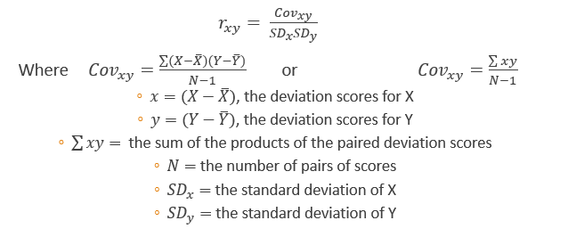
Figure 1 - correlations formula
Interpreting correlation coefficients is used to determine the strength of the linear relationship, the relationship of r is always between -0 and -1, and so the tester will need to use the following fields to determine the strength of the relationship within the scatter plot. Example is given below to help understand the result to compare against statistical significant difference.
- Exactly +1, This definition is used to translate a prefect uphill
- +0.70, This states that the linear relationship is classed strong uphill
- +0.50, Strength is classed as moderate uphill
- +0.30, Classed as a weak uphill strength
- 0, No existing linear relationship
- -0.30, States that is a weak downhill relationship
- -0.50, States that it is a moderate downhill relationship
- -0.70, Strength is classed to be strong downhill
- Exactly -1, shows the understanding of and excellent downhill relationship

Spearman rank correlation also can be known as Spearman’s rho and which could also be used within monotonically related data. One of key benefits found within spearman rank correlation is that when a variable decides to increase the other variables tend to increase together, although this doesn’t define within a linear manner, this method can also be used for $r_{s}$ranked data but which then the following formula will need to be implied.

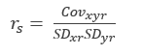
Figure 2 - Correlations formula 2

Linear regression

The basic use of linear regression is to identify a single independent variable which is used to predict the values of a dependent variable within a set of data this is to help have a better understanding of the predication of statistical answer[15]–[17]. In multiple linear regression more than one independent variables are supposed to be used to predict the value of a dependent variable. The significant difference that can be located between the two is the number of independent variables. A linear regression is only appropriate to be used when the key variable Y has a linear regression to its own independent when the alternative variable is X. in statistics the use of predications is carefully planned and used to help aid the predictions there are formals used when using these formals, the user of the test can ensure if the outcome of the predictions is low or high and with the use of scatter plots linear regression the user will be able to identify chance or how close by independent and dependent variables.

Analysis of variance (ANOVA)

An analysis of variance (ANOVA) test is commonly used when there are more than two sets of data. This is to ensure less type 1 errors due to the reason if the t method is used to there will be some complications which will result an increase of type 1 errors. ANOVA population is calculated using the method below, N-1 is known to be the degrees of freedom. It is shown by research that using the ANOVA calculation by hand can be extinct to many mistakes and is preferred by many author and testers to use additional tools such as Microsoft Office Excel[18]–[20]. Benefits of the ANOVA test are that the output data result will indicate to the user the following fields: Count, Sum, Average (mean), Variance (standard deviation squared), SS (the sum of squares between groups and within groups), df (the degrees of freedom between groups and within groups), MS (the mean square value between groups and within groups), F,F crit (the equivalent of$t_{obt}$ and $t_{crit}$ in the $t$ Test, P-value (the probability that the variation is due to chance).

Nonparametric tests

The common purpose of the use of nonparametric tests is that it allows the user to handle data that doesn’t have a usual distribution (also known as distribution-free)[21], [22]. Some testers use this method of testing to when given data will not meet the criteria of the parametric test. To allow users to perform nonparametric test the user must be able utilise a chi-square testing, yate’s correction for continuity, mann-whitney U test.

Practical development and skills

The author was required to test two sets of data which are made from mathematical numbers to analyse the hypothesis of statistical significance. The two sets of data were given to the author to obtain a result then to gather understanding of the given result and also examine the difference between younger and mature students on perceived university experience satisfaction.

t-Testing

The trial of the study was conducted by obtaining ten students from each field (i.e. mature and young students) this is to test the given hypothesis of university experience. The given fields were based around a specific age group as the younger students were aged between 17 to 20 years old, and the mature students were aged between 45 to 62 years old. Alternative information that was required to be obtained by the given data was to produce alternative accurate assumptions of the given hypothesis.
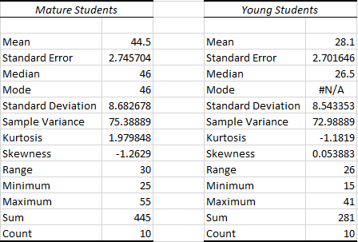
Figure 3 - obtained results 1
The given figure above (figure 3) shows the given data to the author the author has used this information to obtain additional information. The additional information the author had tried to information from the set of data is called descriptive statistics and measure of central tendency. This sort of information is useful to help understand the median, the mode and the mean, which will help aid the author in understanding what sort of t-testing method will be required.

The following field helps understand the university satisfaction experience for younger and mature students using the t-testing formula method. The author checks the $t_{stat}$value in comparison to the $t_{obt}$, this is to help aid the author in understanding an acceptation or rejection.
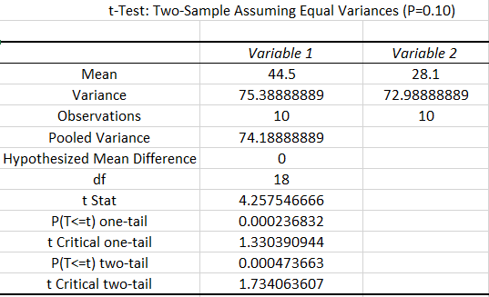
Figure 4 - t-Testing-sample assuming equal Variance (P=0.10)

Figure 4 shows evidence of the output for the t-test the given P value for figure 4 is P0.10. From the given output result the author understands that the null hypothesis will therefore be to reject as the $t_{obt}$ = 4.257 and the $t_{crit}$ = 1.734, therefore the given analysis can be rejected as the null hypothesis show that the students of either group was not satisfied.
The author also tries comparing the results for $t_{crit}$ one-tail value which is also the exact amount so therefore the result cannot be assessed again for an accept or reject.

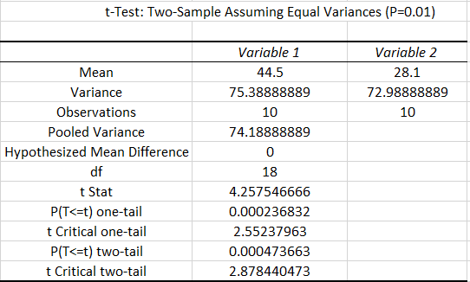
Figure 5 - t-Testing-sample assuming equal Variance (P=0.01)
Figure 5, shows the final given output result for the t-Testing value of the equal variance of P=0.01, the $t_{obt}$ value is 2.878 as same as the obtained result therefore the final decision will be reject as the neither group satisfactory level is not enough.

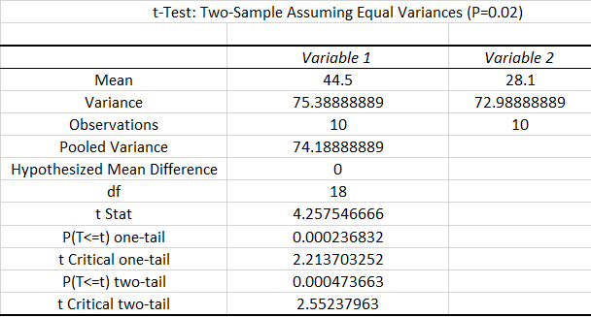
Figure 6 - t-Testing-sample assuming equal Variance (P=0.02)
Figure 6, shows the final test that was conducted using the t-Testing using the equal variance value P=0.02 the observed results shown are for ${ t}_{obt}$ =4.257 and ${ t}_{crit}$=2.55, which therefore is also a reject for satisfactory level. Figure 6 also shows the understanding that the university satisfaction level is equal therefore could not provide an accurate prediction on what group enjoys there time.
Figures 4, 5 and 6 show that the given $t_{obt}$ and the conducted ${ t}_{crit}$ is at different values that all null hypothesis has to be rejected. Due to the author obtaining an accurate null hypothesis with same exact results for each test the author compares the results with additional information such as the measure of central tendency, descriptive statistics to understand if younger or mature students was more satisfied with their experience.
The alternative hypothesis then helps the author understands a clearer understanding in which student group enjoys the university experience, with the aid of the obtained results the author understands that mature students enjoyed the university satisfaction at a slightly higher level.

Correlations and outliers

Figure 7 - t-testing chart output
Figure 7 shown above provides evidence of t-testing correlation. This aids the author on understanding in any abnormal data. The correlation chart provides a straight line any abnormal data will not be inconsistent with the line as shown on the figure (7) above. The given abnormal data on figure 7 shows that there is an outliers within the data set.

Figure 7 shows that there is four given out layers within the correlation of the chart this generally does not mean that the data output will have a high amount of difference. The outliers could have been more concerning if there was more data but due to the amount of data given the outliers do not really affect the final outcome of the given results.

Alternative Factors

Factors that could have affected the given results. The results given can be affected if there were more amounts of data was used to show an more brief understanding but key facts that might of affected the outcome of the results can be such as:
- Students have previous experience
- Students have already seen alternative studies similar or same as the satisfaction day
- Some pupils could of medically been unfit
- Some of the pupils might have been restricted to participate with some activity
- Some students might have been under educated to understand what’s going on

Conclusion

Once several hypothesis were tested the author had concluded several results from the given sets of data. To the completion of this report the author had obtained several understanding within statistics which can help aid in many various fields and objects to have a better understanding of predicting data. The author was obligated to find alternative hypothesis other than the given null hypothesis as all tested t-Tests had shown the same results. Due to help of alternative hypothesis the author had obtained the evidence that mature students had a better satisfactory level compared to the younger students. The author had provided alternative factors that might have had affected the results due to the factor that there was not a significant difference within the data set and that there was not a lot of data provided to the author which also meant that the given information was not enough to be explained in-depth.
The author suggest that in overall the report was at 100% and that if more data was provided it would of help understand more information regarding the result. Future recommendations will be to obtain more data sets to help use ANOVA test which can help understand more data groups and more in-depth data analysis tests.

Table of Figures
Figure 1 - correlations formula 5
Figure 2 - Correlations formula 2 6
Figure 3 - obtained results 1 8
Figure 4 - t-Testing-sample assuming equal Variance (P=0.10) 8
Figure 5 - t-Testing-sample assuming equal Variance (P=0.01) 9
Figure 6 - t-Testing-sample assuming equal Variance (P=0.02) 9
Figure 7 - t-testing chart output 10

Reference’s:
[1] Nick Allum, Paired Samples T-test and the Eurobarometer (63.1, Jan?Feb 2005): 2015.
[2] Mark Harmon, t-Tests in Excel - The Excel Statistical Master. .
[3] M. Abuhami, “L7 - Research Methods & Data Analysis (M7X01702/M7X00730).” [Online]. Available: https://moodle.uwtsd.ac.uk/course/view.php?id=2823.
[4] Data Analysis Manual for Coconut Researchers - Bioversity Technical Bulletin No. 14. .
[5] L. W. Frederick Gravetter, Essentials of Statistics for the Behavioral Science. 2007.
[6] M. O. Lacort, Descriptive and Inferential Statistics - Summaries of theory and Exercises solved. 2014.
[7] D. K. Malcolm O. Asadoorian, Essentials of Inferential Statistics. 2005.
[8] D. G. M. Herman J. Loether, Descriptive and Inferential Statistics: An Introduction. .
[9] F. F. Gorow, Statistical Measures: A Programmed Text : Central Tendency, Dispersion, Correlation. 1962.
[10] P. H. F. W. Herbert Weisberg, Central Tendency and Variability, Issue 83 Central Tendency and Variability, Herbert F. Weisberg Volume 83 of Quantitative Applications in t Quantitative Applications in the Social Sciences, ISSN 0149-192X Volume 83 of Sage University papers: series 7. 1992.
[11] J. H. K. Ph.D, Statistics for the Terrified. 2010.
[12] T. J. Archdeacon, Correlation and Regression Analysis: A Historian’s Guide. .
[13] A. K. Sharma, Text Book Of Correlations And Regression. 2005.
[14] R. J. Wherry, Contributions to Correlational Analysis. 2014.
[15] X. Yan, Linear Regression Analysis: Theory and Computing. .
[16] G. G. V. Douglas C. Montgomery, Elizabeth A. Peck, Introduction to Linear Regression Analysis. 2015.
[17] A. J. L. George A. F. Seber, Linear Regression Analysis. 2012.
[18] E. R. Girden, ANOVA: Repeated Measures, Issue 84. 1992.
[19] M. S. Paolella, Linear Models and Time-Series Analysis: Regression, ANOVA,. 2018.
[20] R. R. Maxwell Roberts, A Student’s Guide to Analysis of Variance. 2014.
[21] M. Neuhauser, Nonparametric Statistical Tests: A Computational Approach. 2011.
[22] M. S. N. Vilijandas Bagdonavicius, Julius Kruopis, Nonparametric Tests for Complete Data. 2013.

