Choose an intervention that supports the learning and development of a pupil / group of pupils. Reflect critically on its potential for ensuring pupil progression and the possible challenges that may arise.

Target 1 | Continue to strengthen your critical analysis by engaging more deeply with conflicting perspectives and theoretical debates related to your topic.
Target 2 | Try to make consistent and explicit links between the literature and your research experiences and findings.
Target 3 | Careful proofreading is needed to eliminate spelling/punctuation errors.

Introduction
This assignment will closely examine the learning and development of one individual pupil. It will discuss and consider implications and barriers that could be preventing the pupil from developing. In addition, the assignment will carefully investigate the impact of what pupil voice has on the individual. I will be identifying and evaluating efficient methods and techniques to satisfy the pupils needs. To following Bera 2018 guidelines (BERA , 2018) of confidentiality, I will be using a pseudonym for the pupil I have chosen to write my assignment on. The pupil in this assignment will be referred to as ‘Emily’. I will be investigating into the developmental needs of Emily and what intervention will best aid her needs. Emily is an 8 Year old girl and is a Year 3 pupil. Emily is a young girl who is struggling with emotional and social difficulties. This has started to heighten since her parents recently split up (Appendix One). I believe that many interventions will support and assist Emily’s development needs. To aid Emily’s development and well- being, the intervention that I have decided to recommend for Emily is an ‘ELSA intervention’. ELSA interventions have been created to support children emotional and wellbeing needs (ELSA Network, 2020). Emotional literacy support assistance is trained to aid pupils with their personal barriers to learning. I have chosen this intervention because it will provide Emily with the necessary support and advice that will best cater for Emily’s emotional and social difficulties (Twinkl , No date ). Furthermore, within this assignment, I will further my research and understanding of what an ELSA intervention is and will discuss the strengths and limitations of the impact that an ELSA intervention will have an Emily.

Main body
Progression is at the heart of the Curriculum for Wales. Pupil and learning progression is embed throughout the new curriculum (Welsh Government , 2021). It suggests that progression occurs when there is ‘any movement along a learning path. These learning paths are referred to as Progression frameworks which are then broken down into descriptions of learning (Progression steps). Within the new curriculum the descriptions of learning are to be used as a guide for teachers and to direct them to where they need to go next within their planning and teaching. They should not be directly evaluating against them. Progression steps are referred to as references points for the pace of progression, which is to aid teachers and members of staffs understanding of how children should be progressing ( International Educational Assessment Network , 2020). Progression steps are not little tests or a single assessment task and just because they have achieved one on the progression steps one, it does not mean they have fully met the progression. However, not all children progress in the same way or show it in the same way as other pupils. Every child progresses in their own way and different times, each child is on their own learning journey. Every child’s learning journey will be different. Especially the children who struggle and encounter learning barriers (Welsh Government , 2021). Not every child will get to the point where you want them to be, but as long as they have reached their personal full potential.
Furthermore, progression also happens when the learner is activating their skills and knowledge they have previously learnt by implement it into more challenging tasks ( International Educational Assessment Network , 2020). The term ‘progression’ is where a child starts to confidently understand their learning and know how they can move forward and achieve their improvements in order to develop further (Donaldson, 2015). Assessment for learning (AfL) is a very useful form of assessment to monitor pupil progression. AfL enables teachers to understand where the children are currently at and what they need to do to progress further (Black & Wiliam , 1998). Assessment for Learning is embedded throughout the new curriculum in Wales and is highlight its importance by being one of the twelve pedagogical principles (Welsh Governmnet , 2023). The twelve pedagogical principles are very important for enabling pupils to reach their full potential (Welsh Government , 2024).

Having previously mentioned, after observing and gaining a better understand of the needs and difficulties Emily is experiencing, the Class teacher has decided to refer her to an ELSA, where they can complete and aid Emily within small intervention sessions. An ELSA is there to guide and support children to achieve their full potential. This could be emotionally, socially or academically (ELSA Network, 2020). ELSAs have been designed to be children’s emotional available adult. They are individuals who children can trust and feel able to discuss what might be on their mind or bothering them. They are there to comfort them. ELSA are there to reassure pupils that their voice and opinion matter. By Emily interacting with the ELSA within the school, might encourage her to form a strong relationship with her. The ELSA will be someone that Emily might feel she can go to discuss things that she feels she cannot with anyone else. By Emily potentially forming a bond with the ELSA, it might aid her willing to leave her mother in the mornings. Having studied the work of John Bowlby, he might indicate that Emily has insecure attachment (Simply Psychology , 2024). Observing Emily’s behaviour, it potentially implies that she is anxious, ambivalent. As we are aware Emily’s parents have recently split up, we are unaware of the circumstances and how long this has been brewing for. From Emily’s behaviour she seems to display that she is struggling with the situation emotionally and socially. She could potentially be getting less attention and home and starting to feel lonely as she has no other sibling to talk to about her feelings. Her mother might have too much on her mind which is causing her to act unpredictably. Emily might be frightened about her relationship with her mother which resulted in Emily being very attached to her. This could be the reason as to why Emily does not like coming to school and will not leave her mother in the mornings. Potentially, Emily might feel that if she leaves her mother, she might not come back, like what happened with her father. By Emily building a connection with the ELSA, it may aid her attachment issue. Emily will know that she always has someone to go to talk to. Emily might see the ELSA as a mother figure and someone who provides them with safety (Purcell & Kelly, 2023) within the school and reassure her that she is not allow. In addition, they are also there to aid young children in recognizing their emotional and well-being needs. They will then work alongside the individual to find and trail copying strategies for their specific needs. However, they are not there to fix all problems, they can only provide advice and ways to try and deal with difficult situations (ELSA Support, 2024). An ELSA is there to be children’s emotionally available adult and an individual that a children can trust and feel able to discuss what might be on their mind or bothering them. Most ELSA interventions will last between half and a full term. Emily will engage with this intervention for one full term with a trained Emotional Literacy Support Assistant (ELSA) within the school. In this period, Emily will take part in proactive activities and find her own copying methods to help her manage her emotional, social and well-being difficulties. From this intervention Emily will be working on learning to understand and become more self-aware of her own emotions and thoughts. Alongside this, she will also be working towards increasing her school attendance. At the end of this intervention period, the goal is for Emily to start willingly come to school without any battles and getting upset when she leaves her mother.

Furthermore, an ELSA intervention is planned to deliver group and individual support, I think it might be helpful for Emily to receive both group and individual support. In one to one sessions Emily may feel she can open up to the ELSA and build/form a strong relationship between her and the ELSA. Whereas, the group sessions might impact and aid Emily’s social interactions and for her to understand how to form friendships with other children. ELSA’s are trained to support pupils with a variety of different emotional and well-being needs such as loss and bereavement, social skills, friendship issues, anxiety, worries, bullying and managing strong feelings (ELSA Support, 2024). This intervention is confidential; however, it is indicated that to follow good practise, the school should inform parents if their child is being provided with any extra/ additional support for any needs (ELSA Network, 2017). In this case, Emily’s parents will be informed and given information to explain the role of an ELSA and what support Emily will be provided with. Emily’s parents will be invited to a meeting to discuss any worries they might have and to discuss any strategies or activities that the ELSA has been implementing in different sessions. By doing this will help to encourage the parents to work alongside the school in enabling that Emilys emotional and well-being needs are being supported appropriately.

ELSA interventions are an important aspect of the ‘whole school approach’ to addressing the requirements of children and young adults emotional and well-being difficulties (Welsh Government , 2021). This framework indicates that everybody is responsible for ensuring that pupils meet their full potential and are supported fully with their mental health needs. Furthermore, the framework suggests that an individual’s emotional and well-being needs can be influenced by the environment and interaction they have received. Having read this, it could imply that Emily’s emotional well-being has been affected by her parents splitting up. She might of potentially been living in a quarrelsome environment which has influenced her recent behaviour (appendix one). In addition, according to Bronfenbrenner, he suggests that children’s development is impacted by their environment around them and who they interact with. His research implies that each individual has five systems around them (Appendix Two). These systems represent the different environments and interaction an individual gets. He proposed that the layer closest to the individual (her parents) will have greater impact on their behaviour and development (SimplyPsychology, 2024). According to Bronfenbrenner family have a significant impact to an individual. The change in Emily environment, and interaction could be the cause of her change in behaviour and cause emotional difficulties. Lately she has been struggling to interact with other children and seems to get upset over the smallest of things. Emily has also started to not like coming to school and each morning is a battle to get Emily through the school doors. Quite frequently Emily will not turn up to school, which her attendance is now starting to get increasingly concerning due to the amount of work and lessons she is missing.

To assist with Emily’s targets on becoming more self-aware of her emotions and thoughts within the ELSA intervention, the ELSA could carry out games that get Emily to think about how she is feeling. A game that might potentially benefit Emily is ‘bear cards’. The bear cards are designed to talk about different feelings. There are a variety of different activities you could do with these cards. One could be for an individual to pick out a card, then they need to think of a little story to describe what the bear might be feeling and why they might be feeling that certain way. Another activity could be for an individual to select a bear card that best describes how they are feeling now or potentially how they often feel. This activity might be a good game to use at the start of the block sessions, Emily might find it difficult to voice how she feels and would rather point. In further lessons, this might aid Emily’s confidence to discuss her emotions. These cards might work well in a group setting. Emily might benefit in participating in one group session with the bear cards. The outcome of this would be for Emily to realise that she is not alone and that others feel the same way as she does and that it is normal to feel this way. An activity that might possibly assist Emily’s emotional needs is ‘Puppet Play’ (Brookes Blog, 2021). The individual will choose a voice they would like their puppet to have and will then express their emotions and thoughts by pretending to be the puppet. Individuals who find it difficult to open up find this really helpful because they do not feel like it is them talking. Another activity that aid Emily to understand herself is an ‘All about me board game’ (ELSA Support, 2024). Emily enjoys Board games because it reminded her of when her parents were together, this might help Emily to remember the memories she had with her family and talk to the ELSA about them. This activity might also help her to understand different methods or activities that she can do when she is feeling low and upset which will aid her to get it off her mind. In addition, to aid Emily coming into school, a ‘worry monster’ (Oxfordshire County Council , 2021) might be quite useful. A worry monster is designed for individuals to write on a piece of paper any worries they might have on their mind. They are then encouraged to put the worry into the month of the worry monster and zip it up (the worry monster has eaten their worry away). This might help understand why Emily does not like coming to school, from this the ELSA and I can implement different activities in the invention sessions and within the classroom. Moreover, in ELSA sessions mindfulness activities (NHS, 2022) might support Emily’s needs. Emily shows her passion for drawing. To make Emily feel relax and calm, Arts and craft activities could be set up for her to use whilst she is having a chat with the ELSA. This may increase the potentially of Emily opening more because she is doing something that she enjoys. This may also build on the relationship between her and the ELSA because she may feel that the ELSA understands her as she is doing something she enjoys. This could give Emily the opportunity to talk about her father, which she may not be able to discuss or mention at home. It will allow Emily to may draw pictures of her father and her together. This will aid Emily’s thoughts and lifting the weight that she might be holding on her shoulder. Hopefully in these sessions Emily has built trust between her and the ELSA. Emily will then understand that the ELSA is available at any point and is someone that she can go to and discuss her thoughts and not be judged. Also, through mindfulness, Emily may prefer to draw pictures to describe how she is feeling that day rather than voice it.

Once Emily has started to understand her own emotions and thoughts, then she might start to adapt her understanding of others. The ELSA will then implement social activities that involve understanding other feelings and how to be a good friend to others. Emily has trouble with sharing with other children (appendix One), this could be because she is an only child and is not used to sharing her toys at home. To help support help to understand that sharing and taking in turns is important, the ELSA could implement board games that require Emily to practise these skills. Another nice activity to encourage Emily to interact with others could be a puzzle (Brookes Blog, 2018), where she has to work with others to complete the puzzle. It has been highlighted that Emily’s behaviour has recently become aggressive towards other children within the classroom. According to Bandura he indicates that this behaviour might have been influenced from Emily watching and observing others. In Banduras’ research study, he experimented whether social influences impacted the learning and behaviour of individuals (Everywhere Pschology , 2012). In this experiment he split it up into different groups. One of these groups watched a model aggressively hit the bobo doll by using aggressive toys. The other group watched a model carrying out normal activities such as colouring. There was no aggressive behaviour involved. These children then got taken to a room containing fun and exciting toys. Once the children were engaged and playing with the toys they were removed and taken to another room. This got the children frustrated. The room they got removed from contained aggressive and non-aggressive toys. From this research, it was implied that children who witnessed the aggression at the start of the experiment copied and implement their frustration through aggressive behaviour towards the doll (Practical Psychology , 2021). Having researched into Bandura’s experiment it could imply that Emilys aggressive behaviour towards her peers is potentially impacted by social influences. Emily might have witnessed and observed her parents arguing and using aggressive behaviour towards each other. This could of caused her to copy the behaviour she has been exposed to not understanding that it is no acceptable. She may believe it is normal behaviour. However, on the other hand Maslow argues that there are five stages of needs that impact an individual’s behaviour. He argues that first a human needs physiological needs, this is where we need to eat, drink, sleep and breathe. He then goes on to proclaim that once these needs are met, we then are motivated to the next need which is safety, we look for a safe place or shelter to protect us from any danger. Furthermore, once are needs have been satisfied, we are motivated to love and belonging. This is where we want to be close to our family and friends and belong to a group. Next we start to want esteem, we build self confidence and wish for respect from others. Only if all these needs are met can we reach the final stage where we can relax and do want we desire (Sprouts, 2017) (Sprouts, 2017). Maslow might suggest that Emily might not be able to currently reach the final stage. At stage one Emily physiological needs might not be met, due to Emily’s parents splitting up this might have caused the family income to decrease which could potentially result in there not being enough food in the house or even the right type of food. It might force the family to have to eat convenient and unhealthy foods. This could mean that Emily is not getting enough nutrients and vitamins within her diet. Aswell as this, Emily could be feeling very anxious and upset about her family situation, this could impact her sleeping if she has too much on her mind. She might not be having enough sleep. In addition to this, Emily may also not feel as though she has a safe shelter or space to stay to keep her from danger. This could be because she is worried that she might become homeless if money is an issue with the family income being reduced to one income. Having said that, Emily may currently not be feeling loved or looked after. Due to the situation within Emily’s family, she may have been potentially left to fend for herself and get on with things whilst her parents were constantly arguing. From this, it might have impacted decreased Emily’s self-confidence and esteem. Within Emily’s ELSA interventions, the ELSA could allocate one session to behaviour management and work with Emily to discuss why she might be feeling this emotion and what strategies best suit her to aid her when she feels this aggression and frustration. Possibly breathing strategies might benefit Emily. The ELSA could also use the ‘all about me board game’ (ELSA Support, 2024) to help increase and build up Emily’s self-confidence and esteem.

Additionally, due to the amount of funding in the school Emily might not be provided with an appropriate amount of time in one session. One session normally would last between ten to fifteen minutes, altogether Emily will then only receive roughly ninety minutes of intervention and support over the whole term (ELSA Support, 2024). Personally, I do not think this will be enough time for Emily to achieve the outcomes that are wanted of her. To aid the support Emily receive, her classroom teacher could work alongside the ELSA interventions to deliver activities and support which will build on assisting Emily’s needs in the classroom. Emily could be given Jobs to complete in the morning. Emily enjoys helping the class teacher, to aid her attendance, she could be given Jobs to complete in the morning once she has come in to school. These jobs could include handing out books, worksheets or going on a message. Emily seems to enjoy gardening, the class teacher could give Emily the responsibility to water a plant each morning, this might help keep her mind also off getting upset and encourage her to see a purpose to come to school. Another activity that we can complete within the classroom to support Emily’s social and emotional needs could be circle time. There are many different activities that can aid Emily within a circle time that focus on emotions and feelings. It has also been highlighted that Emily only likes to sit in one chair within the classroom (Appendix One), to prevent Emily getting annoyed and frustrated hen other pupils sit in that chair, the class teacher could create a seating plan. This might then also impact Emily wanting to come into school because she knows she will be able to sit in the chair she likes. Furthermore, to encourage Emily to interact with other children the class teacher could plan and create activities that requires different children to work together. Furthermore, it has been implied that children with emotional difficulties learn best in calm environment (Child Mind Institue , 2024). It is also said that pupils with emotional difficulties rely on positive feedback to aid their self-esteem. Having read this article, the class teacher could potentially try and avoid as much disruption and off task situations. By the teacher setting a calm and peaceful classroom environment might aid Emily in being less aggressive and willing to come to school. Having said that, to aid a calm classroom environment, the class teacher could encourage Emily use the strategies she has learnt in her ELSA sessions on how to self-regulate (Child Mind Institue , 2024) when she encounters difficult situations.

The majority of ELSA’s are teaching assistance within the school. Whilst observing in my PTE2, I concluded that the ELSA was struggling to find enough time to carry out their ELSA sessions. The ELSA was allocating one morning a week to deliver their sessions. However, this did not seem to be an appropriate amount of time. Especially for the number of children that needed to receive the additional support. According to the latest Estyn report, they recommend that members of staff that are delivery extra support sessions need to be given enough time (Estyn , 2023). By them having the correct amount of time will help to ensure that pupils are receive the full support they are entitled to.

Conclusion
After Emily has completed and attend all the ELSA interventions provided for her, she will be reviewed, and it will be decided whether she has achieved her outcomes from the interventions and consider the impact the intervention had on Emily’s emotional difficulties. After the review, if Emily is still experiencing high emotional and social difficulties then a potential referral back on to the ELSA programme might be needed. However, ELSA interventions are mainly ‘short term focused interventions’ (ELSA Support, 2024) to provide support over a small period. In addition, I conclude that the ELSA intervention will have a significant impact on Emily’s emotional difficulties. I believe that by the end of the course Emily will have either of reach her outcomes or on the way. As previously mentioned, I still think it will be crucial for Emily’s class teacher to work alongside the ELSA and provide extra support within the classroom. Her teacher should also ensure that she implements strategies and techniques advised by the ELSA. Furthermore, the class teacher should also work closely with the ELSA to monitor Emily’s progression to ensure that she can provide Emily with the best possible support within the classroom. Overall, I think that the ELSA intervention will be very beneficial and will allow Emily to have a safe space, environment and individual to voice her emotions, feelings, and thoughts to.

References
International Educational Assessment Network , 2020. Rethinking Learner Progression for the Future , Ontario: International Educational Assessment Network .
BERA. (2018) Ethical guidelines for educational research. 4th ed. London: British Educational Research Association (BERA).
Black , P. and Wiliam, D. (1998) Inside the Black box. 1st ed. North America : GL Assessment .
Brookes Blog. (2018) '11 Ways to Encourage Friendship Skills and Social Play', Brookes Blog [Blog] 4 September. Available at: https://blog.brookespublishing.com/11-ways-to-encourage-friendship-skills-and-social-play/
(Accessed: 27th March 2024).
Brookes Blog. (2021) '10 Activities for Teaching Young Children About Emotions', Brookes Blog [Blog] 26 January. Available at: https://blog.brookespublishing.com/10-activities-for-teaching-young-children-about-emotions/#:~:text=Puppet%20play%20is%20a%20good,from%20scary%20or%20upsetting%20issues.
(Accessed: 27th March 2024).
Child Mind Institue. (2024) How Can We Help Kids With Self-Regulation?.
Available at: https://childmind.org/article/can-help-kids-self-regulation/#:~:text=You%20can%20help%20your%20child,handle%20challenges%20on%20their%20own.
(Accessed: 28th March 2024).
Donaldson, P. G. (2015) Successful Futures.
Available at: https://www.gov.wales/sites/default/files/publications/2018-03/successful-futures.pdf
(Accessed: 28th March 2024).
ELSA Network. (2017) Code of Practise.
Available at: https://www.elsanetwork.org/about/code-of-practice/
(Accessed: 27th March 2024).
ELSA Network. (2020) Search Results for: what is an elsa intervention.
Available at: https://www.elsanetwork.org/?s=what+is+an+elsa+intervention+
(Accessed: 18th March 2024).
ELSA Support. (2024) All About Me Game.
Available at: https://www.elsa-support.co.uk/all-about-me-game/
(Accessed: 27th March 2024).
ELSA Support. (2024) What is ELSA Intervention?.
Available at: https://www.elsa-support.co.uk/what-is-elsa-intervention/
(Accessed: 18th March 2024).
Estyn. (2023) The new Additional Learning Needs system, Cardiff: Estyn.
Everywhere Pschology. (2012) Bandura's Bobo Doll Experiment. [YouTube]
Available at: https://www.youtube.com/watch?v=dmBqwWlJg8U
(Accessed: 19th March 2024).
NHS. (2022) Mindfulness.
Available at: https://www.nhs.uk/mental-health/self-help/tips-and-support/mindfulness/
(Accessed: 27th March 2024).
Oxfordshire County Council. (2021) Worry monsters to help Oxfordshire children cope with stress and anxiety.
Available at: https://news.oxfordshire.gov.uk/worry-monsters/#:~:text=The%20monsters%20aren't%20really,it%20to%20their%20worry%20monster.
(Accessed: 27th March 2024).
Practical Psychology. (2021) The Bobo Doll Experiment - Albert Bandura on Social Learning. [YouTube]
Available at: https://www.youtube.com/watch?v=6lYsmt9qUVI
(Accessed: 19th March 2024).

Purcell, R. & Kelly, C. (2023). ‘A systematic literature review to explore pupils’ perspectives on key outcomes of the Emotional Literacy Support Assistant (ELSA) intervention’, Educational Psychology in Practice, 12(4), p. 13. Available at: https://doi.org/10.1080/02667363.2023.2185208
(Accessed: 28th March 2024)

Simply Psychology. (2024) Attachment Theory In Psychology.
Available at: https://www.simplypsychology.org/attachment.html
(Accessed: 27th March 2024).
SimplyPsychology. (2024) Bronfenbrenner’s Ecological Systems Theory.
Available at: https://www.simplypsychology.org/bronfenbrenner.html
(Accessed: 19th March 2024).
Sprouts. (2017) Maslow's Hierarchy of Needs. [Youtube]
Available at: https://www.youtube.com/watch?v=O-4ithG_07Q
(Accessed: 19th March 2024).
Twinkl. (No date) What is ELSA?.
Available at: https://www.twinkl.co.uk/teaching-wiki/elsa
(Accessed: 28th March 2024).
Welsh Government. (2021) Framework on embedding a whole-school approach to emotional and mental well-being.
Available at: to meeting the emotional and mental wellbeing needs of children and young people.
(Accessed: 27th March 2024).
Welsh Government. (2021) The Curriculum for Wales – Progression Code.
Available at: https://www.gov.wales/sites/default/files/publications/2021-11/curriculum-for-wales-progression-code.pdf
(Accessed: 18th March 2024).
Welsh Government . ( Supporting learner progression: assessment guidance.
Available at: https://hwb.gov.wales/curriculum-for-wales/assessment-arrangements/supporting-learner-progression-assessment-guidance
(Accessed: 28th Marh 2024).
Welsh Governmnet. (2023) Pedagogy.
Available at: https://hwb.gov.wales/curriculum-for-wales/designing-your-curriculum/pedagogy
(Accessed: 28th March 2024).

Appendix

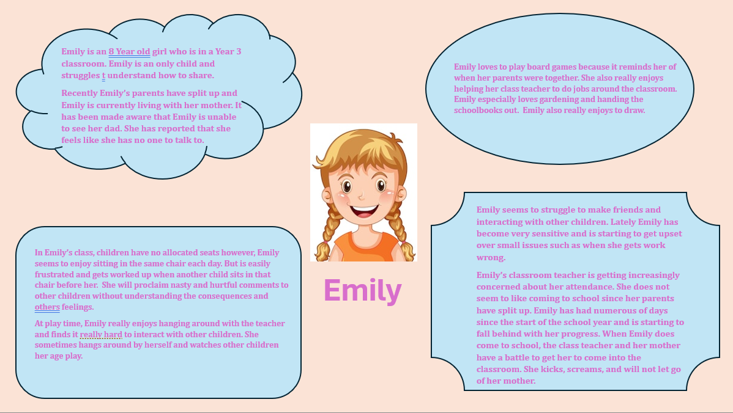
Appendix One

Appendix Two
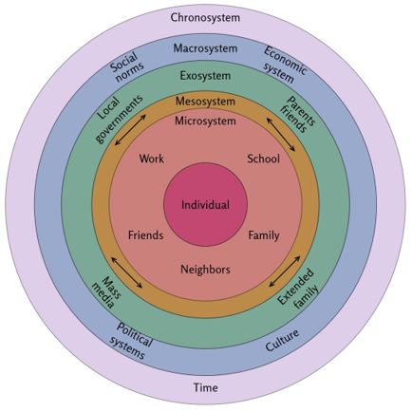
https://www.simplypsychology.org/bronfenbrenner.html

Appendix Three
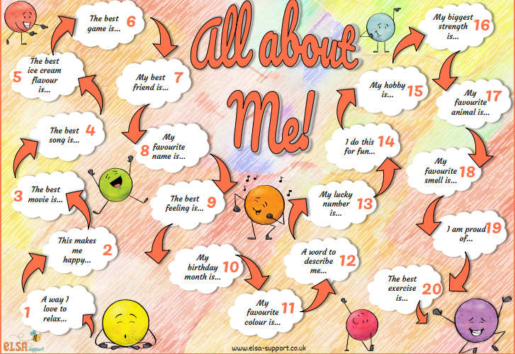

https://www.elsa-support.co.uk/all-about-me-game/

