M&S history
Since its founding in 1884, Marks and Spencer has expanded from a penny bazaar to become one of the UK's major food merchants as well as the country's largest apparel vendor. Here is a visual timeline of the British organisation.
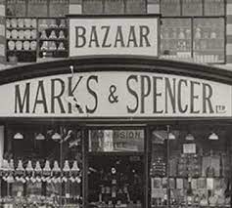

Michael Marks, a Polish immigrant who started the business as a solitary market stand in Leeds in 1884, is pictured above on the left. Ten years later, Thomas Spencer joined him, and the business was known as Marks and Spencer.

Segmentation, Targeting and Positioning (STP) framework becomes important uncontemporary marketing and communication as it aims at enhancing sales performance based on a customer-centric approach instead of a product-oriented marketing strategy. In other words, STP analysis helps business leaders to improve brand acceptance among target customers by increasing product specifications.

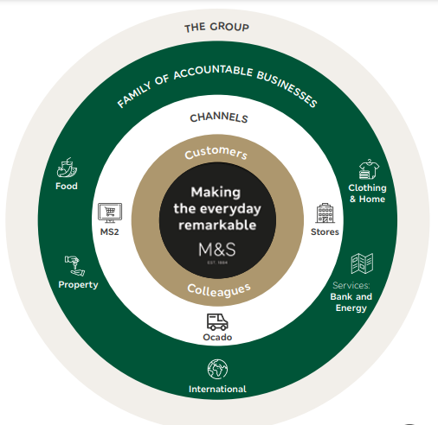

Figure 1: Business Model of M&S
(Source: Corporate.marksandspencer.com, 2023)

In this regard, the contemporary marketing approach of Marks & Spencer (M&S) becomes noteworthy. M&S appears to be one of the leading brands within the UK retail chain that has manifested its ability in a wide range of retailing operations including food, luxury goods, household articles, cosmetics, clothing and grocery items.

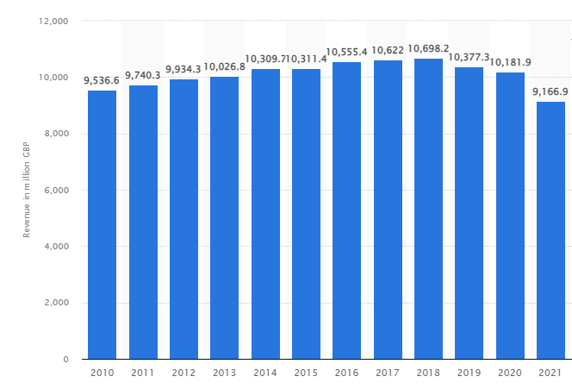
Figure 2: Decline in Revenue of M&S
(Source: Statista.com, 2023)
The brand mainly runs its business operations following the traditional retail operation. As a result, the organisation operates 1,035 departmental stores in the UK and 452 other stores across the globe (Statista.com, 2023). However, despite vast operations, M&S has failed to achieve financial stability as its revenue has decreased by 900 million GBP during the Covid-19 period (Statista.com, 2023). Accordingly, this blog will analyse the current marketing mix and segmentation strategy of M&S to develop a suitable recommendation for further enhancement.
Segmentation, Targeting and Positioning Strategy of M&S
- Demographic Segmentation  - Psychographic Segmentation  - Behavioural Segmentation | - Differentiated Targeting  - Targeting Multiple segments  - Both male and female  - Children, Teenagers and Young Adults  - Belonging to the middle and upper-middle class of the society | - Product Quality based Positioning  - High Quality  - Moderate Price

Table 1: STP Analysis of M&S (Created by Author)

Segmentation (S)
The segmentation process appears to play a fundamental role in market segmentation strategy as it makes the marketing communication more relevant, focused and personalised by identifying the most potential segment of customers. According to Owusu and Agyemang (2021), the four pillars of market segmentation include Geographic Segmentation, Demographic Segmentation, Psychographic Segmentation, and Behavioural Segmentation. However, in the case of Marks & Spencer, geographic segmentation becomes less important as the brand operates over 452 different locations all across the globe outside the UK (Statista.com, 2023). On the contrary, the organisation appears to focus more on segmenting its consumer market based on its Psychographic, Demographic and Behavioural segmentation.
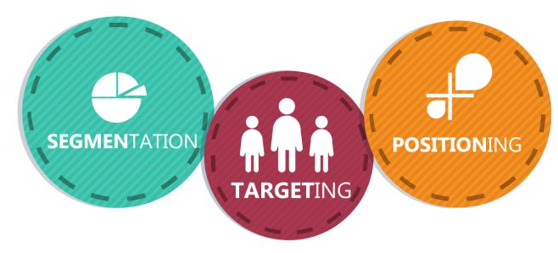
Figure 3: STP Analysis Framework
(Source: Owusu and Agyemang, 2021)

As per Kotler and Armstrong (2010), demographic segmentation includes sub-variables such as age, gender, family and income status and psychographic segmentation focus on sub-variables including lifestyle, social class and personal characteristics of the consumers. Similarly, behavioural segmentation focuses on the knowledge, attitude and response of customers to a specific product. M&S has launched their latest “Voice of the Customer programme” supported by the “Net Promoter Scores (NPS) Framework” to analyse the behaviour of the customers and their psychographic intent behind purchasing, (Corporate.marksandspencer.com, 2023). This strategy of segmentation has helped M&S to gain a deeper insight into what is bought by the customers and analyse their buying behaviour.

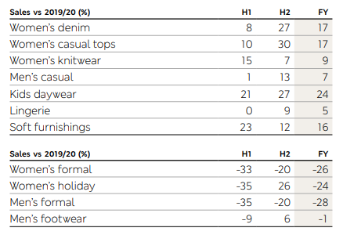
Figure 4: Analysis of Customer Purchasing Behaviour by Categories in M&S using Customer Data Engine
(Source: Corporate.marksandspencer.com, 2023)
In addition, the NPS framework has also helped M&S to segment its consumer market by analysing what they bought, from where they bought and the mode of purchase. On the other hand, the brand has also analysed the psychographic intent of the brand following the Customer Rating of their products following the Vangarde Trading Model. According to Samans and Nelson (2022), the Vangarde Trading Model has enabled M&S to establish a simple and flexible trading system by offering multiple products in respect of consumer buying behaviour and their demands. On the other hand, M&S also utilises their “Customer Data Platform” and “Customer Data Engine" to analyse the demographic variables of its consumer market (Corporate.marksandspencer.com, 2023). In this respect, the brand focuses on subcategories such as gender, age and financial position to analyse their availability on different selling channels and their choice of personalisation in M&S products.
Targeting (T)
Targeting appears to be another crucial factor in the STP framework as it helps to integrate the organisational objectives with structural factors. As per the findings of Kotler and Armstrong (2010), targeting the consumers based on segmentation strategies help in differentiating various segments and claiming a stronger position within the market based on increased personalisation in offers. In the case of M&S, the organisation has focused on targeting several consumer segments and designing specific offers for each of these segments. According to Olson (2021), the “Differentiated Theory of Targeting” addresses several consumer segments with personalised offers and approaches. It allows for an increase in total sales across the marketing segments. For instance, M&S has targeted both female and male customers belonging to the middle and upper-middle sections of society by introducing menswear and womenswear in clothing (Corporate.marksandspencer.com, 2023).

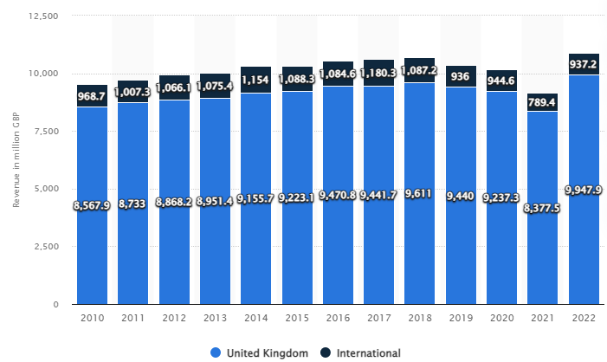
Figure 5: Increase in Regional Sales and Revenue in M&S with New Product Launch
(Source: Statista.com, 2023)
In addition, M&S has targeted both family persons as well as single customers. The targeted consumer segment of M&S has included children, teenagers and young adults. In this respect, the brand has designed and launched a new range of clothing addressing the age-specific trends in the market and gender-specific demands (Bbc.com, 2021). The launch of new products by M&S following differentiated targeting of potential customers helped to boost its sales. For instance, the revenue of M&S has increased from 8,377 million GBP in 2021 to 9,947 million GBP in 2022 (Statista.com, 2023). Thus, it can be stated that the application of differentiated targeting in M&S has helped to boost the sales and revenue of the brand.

Positioning (P)
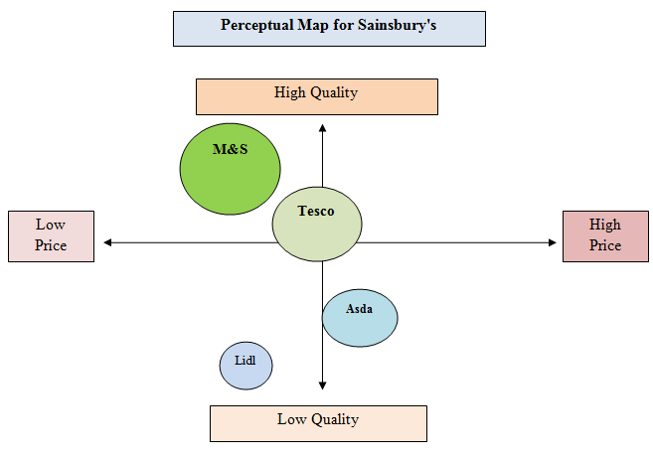
Figure 6: Perceptual Positioning of M&S in the UK Retail Chain
(Created by Author)
Positioning of a brand within the target market appears to be another crucial step for gaining a competitive advantage in the market and gaining stability. As per the observations of Kotler and Armstrong (2010), the positioning of a brand helps in increasing the value of the brand to target customers. In M&S, Product Quality has formed the basis of their positioning in the competitive environment. M&S offers sustainably sourced food products with exceptional quality measured through five quality components including protein, ambient, deli and dairy and in-store bakery (Corporate.marksandspencer.com, 2023). On the other hand, M&S maintains the quality of their clothing products with an elegant and subtle design, simplified range and sustainable prices. Accordingly, M&S can be positioned as a brand with High Quality and Moderate Pricing in the UK retail market.

Advantages and Disadvantages of the current Segmentation process in M&S
The current strategy of segmentation, targeting and positioning has brought both advantages and disadvantages to M&S. For instance, the traditional aspects of retail business and lack of differentiation in product categories have brought disadvantages by reducing the financial performance of the organisation. The lack of simplification in the product range due to ineffective behavioural segmentation has also decreased the sales of M&S between 2018 and 2019 by 16% (Corporate.marksandspencer.com, 2023). Thus, ineffective behavioural segmentation in M&S has reduced both its financial performance and acceptance among the potential consumer segments.
On the contrary, Behavioural and Psychographic segmentation in relation to demographic segmentation has helped M&S to analyse how consumer demands and responses vary as per their gender, age and financial income. Accordingly, with the help of Customer Data Engine, M&S has brought diversity to its clothing products range including men's wear, women's wear, kids' wear and lingerie and added specifications to the design (Corporate.marksandspencer.com, 2023). In addition, launching 1350 new products following differentiated targeting has helped the organisation to boost its sales. As a result, the sales of clothing and home products have increased by 40% within the UK (Corporate.marksandspencer.com, 2023). The psychographic intent of M&S customers exhibited a demand for purchasing simple yet elegant clothes. In this respect, relaunching the clothes range with 20% simplified products has increased overall sales of clothing on the international platform by 3.8% (Corporate.marksandspencer.com, 2023). Thus, designing affordable products with quality and added specifications as per consumer requirements based on behavioural and psychographic segmentation and differentiated targeting has helped M&S to increase overall sales performance.

The current Marketing Mix strategy of M&S- 4P Marketing Mix
Marketing Mix appears to be equally important as that of segmentation in gaining competitive advantage as it helps in setting a marketing plan and establishing effective communication with target customers. As per the opinion of Kotler and Armstrong (2010), Marketing mix refers to a set of tactical and controllable marketing tools that helps to regulate the response of the target market against a specific product. In M&S, the four pillars of the 4P Marketing Mix have included Product, Price, Place and Promotion.
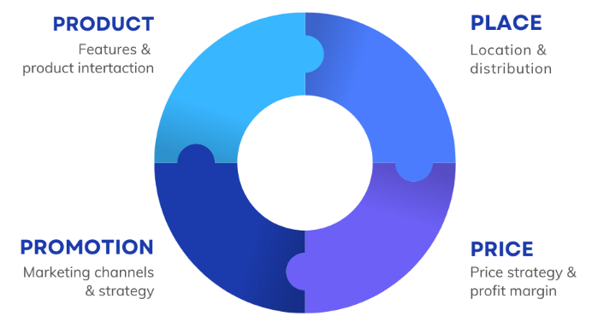

Figure 7: 4P Marketing Mix
(Source: Christen, 2022)

Product
The Product appears to form the first pillar of the 4P Marketing Mix which helps to include variety in service offerings and attract new consumers. M&S operates with a vast range of Products including food, clothing, home accessories and appliances, cosmetics and beauty as well. However, the organisation aims at focusing on its quality to differentiate its retail product from major competitors such as Tesco, Asda and Lidl to gain a competitive advantage in the market. In this regard, M&S has followed both “Quality Perception” and “Value for Moneyperception” so that quality products can be offered to target customers.
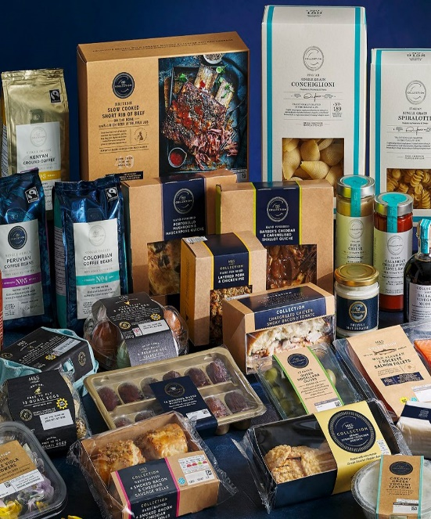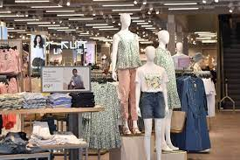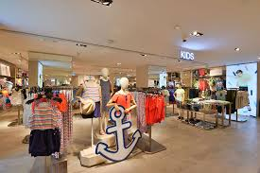

Place
The place of business operation plays another significant role in the 4P Marketing Mix as it helps in increasing the availability of the products. M&S has extended its business operations over more than 62 countries, including Ireland, Australia, India, Germany, South Korea, Poland, Qatar, Romania and Japan (Corporate.marksandspencer.com, 2023). In this regard, the company has adopted both offline and online channels to access their places of distribution to these national and international markets. Accordingly, M&S has offered their products and services through both departmental stores and online channels such as the company app and its websites following a selective strategy of distribution.
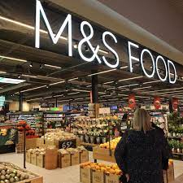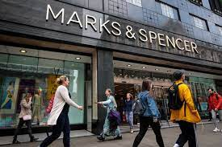

Price
The pricing strategy becomes significant in 4P Marketing Mix as it helps to symbolise the value of a product to the consumers and makes the business venture profitable. M&S has attempted to maintain both affordability and sustainability in their price considering the quality of products. According to the findings of Christen (2022), the strategy to adjust the product price based on its value and quality is considered Value-based pricing. Hence, it can be stated that M&S is inspired by value-based pricing to make its products affordable.

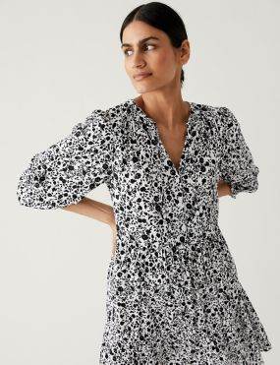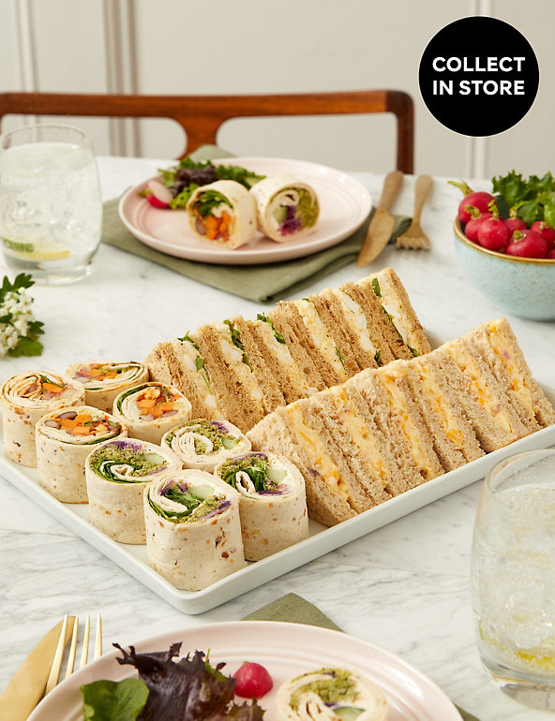

M&S COLLECTION Vegetarian Sandwich & Wrap Selection (20 Pieces)

Printed Tie Neck Mini Tiered Dress Price £15.00
£39.50

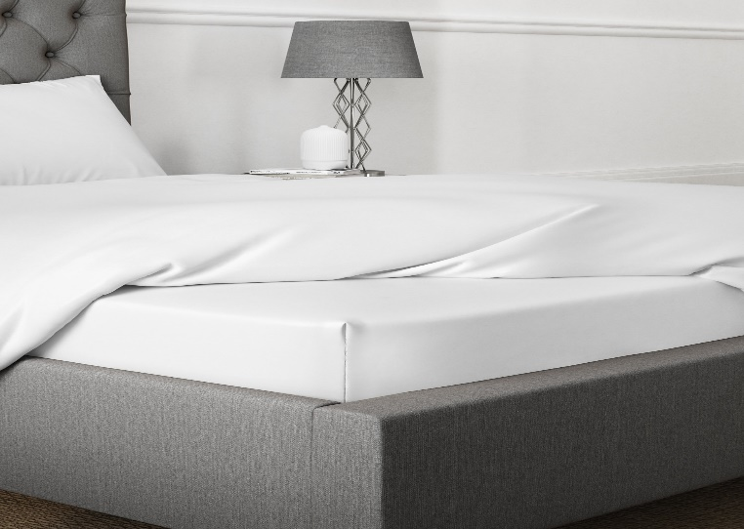

Coral Meadow Egyptian Cotton 400 Thread Count Deep Fitted Sheet
£40.00 £25.00 – £39.50

Promotion
Promotional Activities become essential in the 4P marketing Mix as it helps to set direct communication between the brand and its target customers. M&S has adopted both Online and traditional promotion for their products. In this respect, M&S has adopted an omnichannel marketing strategy combining personalised websites, social media platforms, company apps and traditional channels such as hoardings, advertisements on print media and Google ad-words (Corporate.marksandspencer.com, 2023). Thus, it can be stated that the omnichannel promotional activity has helped M&S to increase their area of operation.
Social media links:
https://www.instagram.com/marksandspencer/?hl=uk
https://www.facebook.com/MarksandSpencer/
https://www.youtube.com/channel/UCi86xSII1cJOOwOtiefntRw
Other offerts:
https://www.marksandspencer.com/c/offers#intid=gnav_Offers

Reference List
Bbc.com (2021), M&S tries to boost sales with new clothing range, https://www.bbc.com/news/av/business-22546823
Christen, T., Hess, M., Grichnik, D. and Wincent, J., (2022). Value-based pricing in digital platforms: A machine learning approach to signalling beyond core product attributes in cross-platform settings. Journal of Business Research, 152, pp.82-92.
Corporate.marksandspencer.com (2023), Annual Report 2022, Available at: https://corporate.marksandspencer.com/sites/marksandspencer/files/marks-spencer/m-and-s_ar22_full-ar.pdf [Accessed on: 28th March 2023]
Corporate.marksandspencer.com (2023), Financial Statement 2022, Available at: https://corporate.marksandspencer.com/sites/marksandspencer/files/marks-spencer/m-and-s_ar22_financial-statements.pdf [Accessed on: 28th March 2023]
Corporate.marksandspencer.com (2023), Strategic Report 2022, Available at: https://corporate.marksandspencer.com/sites/marksandspencer/files/marks-spencer/m-and-s_ar22_strategic-report.pdf [Accessed on: 28th March 2023]
Kotler, P. and Armstrong, G.M., (2010). Principles of marketing. Pearson Education India.
Olson, E.M., Olson, K.M., Czaplewski, A.J. and Key, T.M., (2021). Business strategy and the management of digital marketing. Business horizons, 64(2), pp.285-293.
Owusu, A. and Agyemang, G., (2021). Impact of Market Segmentation Strategies on Customer Loyalty: The Mediating Role of Positioning Effectiveness of Interior Design Industries within the Kumasi Metropolis. European Business & Management, 7(1), pp.1-14.
Ozdenerol, E. and Seboly, J., (2022). The Effects of Lifestyle on COVID-19 Vaccine Hesitancy in the United States: An Analysis of Market Segmentation. International Journal of Environmental Research and Public Health, 19(13), p.7732.
Samans, R. and Nelson, J., (2022). Corporate strategy and implementation. In Sustainable Enterprise Value Creation: Implementing Stakeholder Capitalism through Full ESG Integration (pp. 141-186). Cham: Springer International Publishing.
Statista.com (2023), Marks & Spencer brand awareness, usage, popularity, loyalty, and buzz among grocery store customers in the UK in 2022, Available at: https://www.statista.com/forecasts/1335793/marks-and-spencer-grocery-stores-brand-profile-in-the-uk [Accessed on: 28th March 2023]
Statista.com (2023), Marks and Spencer - Statistics & Facts, Available at: https://www.statista.com/topics/3707/marks-and-spencer/ [Accessed on: 28th March 2023]
Statista.com (2023), Revenue of Marks & Spencer from 2010 to 2022, by region, Available at: https://www.statista.com/statistics/413332/group-revenue-marks-and-spencer-united-kingdom-uk-international/ [Accessed on: 28th March 2023]
Statista.com (2023), Revenue of Marks & Spencer worldwide from financial year 2010 to 2022, Available at: https://www.statista.com/statistics/413349/group-revenue-marks-and-spencer-mands/ [Accessed on: 28th March 2023]

