Student name: Roxana Ciocoiu
Student number:1814110
Project Management
Module number LCBB5005
Lecturer name: Nandish Patel

Table of Content

Contents
Contents 2
INTRODUCTION 3
Main Body 3
Project Management Plan 3
Project Execution Challenges 15
CONCLUSION 15
REFERENCES 15

INTRODUCTION
Project management is the process of planning, organising and managing resources to bring about the completion of project goals plus objectives (Akkermans and et. al., 2020). The main challenge that is undertaken by the project manager is to achieve the project goals and objectives while minimising the constraints. It is the application of knowledge, skills, tools and techniques to project activities so as to meet the expectations of stakeholders. It involves the development of project management plan which specify several aspects such as requirement of resources, accomplishment of project, preparation of budgets, duration of project and so on.

Main Body

Project Management Plan
The project management plan is a written document that define the method of carrying out the project within a limited duration of time as proper planning need to be done regarding the scope, cost, goal and timeline of a project (Bjorvatn and Wald, 2018). The project manager emphasises on tracking the overall activities and engaging the stakeholders so that better decision could be taken. The significant aspect of project is to complete a specific task in a proper manner as it follows a proper sequence of activities which determine the overall accuracy and efficiency of a project. In addition to this, the event which is considered here is to construct a building so that better image would be reflected and provide a greater prosperity of success in future. This would enhance the company to crea te a vast expansion and generate greater revenue so it plans to shift its employees and staff in a workplace and also it provides an enormous opportunity to generate multiple streams of revenues by emphasising on modernisation and diversification. There are different aspects or elements of project management plan which are elucidated below:
Stakeholder analysis:
This analysis assists in determining the interest of individual towards the project which involve division of work on the basis of their level of interest and also, they address conflicts by listening their issues so that they could ensure transparency and smooth operations of a firm (Chawla and et. al., 2018). Gaining an insight support from stakeholders and external users would help in determining the availability of resources and also aids in improving the quality of project by discussing them with relevant fact and figures as it helps in successful completion of project in a respective time period.
High power plus high interest: These are most precious stakeholders who are given an utmost priority as they take active part in core activities of an organisation. The reason that they develop more interest is that they put their maximum efforts in fulfillment of task. The categories involve in this are the owners, senior executives, managers and managing directors.
Low power but high interest: It is necessary that stakeholders has to keep themselves updated so as to make ensure that there is not arrival of issues or any sort of problems to them. Stakeholders covered in this category are suppliers as well as subordinates.
High power but low interest: The stakeholders tends to generate maximum output while making their customers satisfied but excessive use of same message and communication with them would develop low interest among them. Example of such stakeholder category are investors, customers as well as trade associations.
Low power plus low interest: In this, people are not much bothered about their work and lacks clarity in communication as the information are passed to them on periodically. the examples are many such as security guard, sweepers, and so on.
Communication plan
Hence, it can be determined that the engagement of stakeholders in decision making would take place from time to time in order to make ensure that they are assured about the completion of the project (Farashah, Thomas and Blomquist, 2019). A basis communication plan is presented as follows:
Stakeholder Name | Engagement | Channel | Frequency
Owners, Managing director, Senior authority | Manage Closely | E mails, personal meetings | On a regular basis
Buyers, Sponsors | To make them feel satisfied | E mails, telephonically | Once in a month
Suppliers as well as subordinates | To keep them updated | Video conferencing, regular meetings | On a weekly basis
Sweepers plus Guard | Less Effort (Control) | Newsletters | Once in two months.

SMART Objectives
The vital purpose of performing this project is to build a new building within set duration so that it employees could perform the task in a well defined manner and thus provide better prospects of future (Kerzner, 2019). This improves the overall performance of staff and develop a competitive spirit among them which in turn generates greater productivity. The major SMART objectives are presented as follows:
- To ensure that the project is completed on time within six months as per planned budget that is of £50,000 in order to promote a vast growth of a business prospects.
This project is very crucial as it would assist the firm as well as employees to carry their activities in a coordinated manner which promotes efficiency plus harmonious environment in a workplace. Furthermore, the emphasise is that staff would work with zeal and determination so as to bring positive consequences and thus bring unity of command.
Work Breakdown Structure
It is defined as the process of breaking down of work into small task which cover the overall scope of a project. In other words, it is defined as deliverable orientation of project activities which is measurable or any tangible outcome that must be produced to complete the overall task in a predetermined manner (Layton and Ostermiller, 2017). This work breakdown structure help in developing controlling and assignment of responsibilities among the team members in accordance of planned budgeted. The main reason of developing this structure is that it minimises the chances of overlapping plus duplication of activities which form a proper hierarchical structure on a workplace. Another significant rationale of using this is that it provides an assurance that all the elements related to work are included in the work output. The initial step of creation of WBS is to make an appropriate planning that reflect the way in which work has to be performed that is broken into small manageable elements as this help in proper identification of activities (Lee and et. al., 2018). In this, the role of project manager is to monitor the overall activities so that work would be completed with efficiency and thus result in positive consequences. Also, this reduce the overall burden and help in completion of even complicated task in a short period of time. The work breakdown structure consist of three stages that is initiation, planning and proper execution and monitoring.
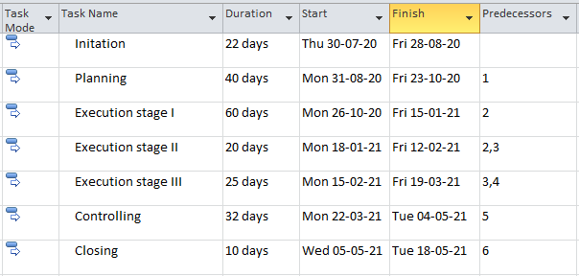

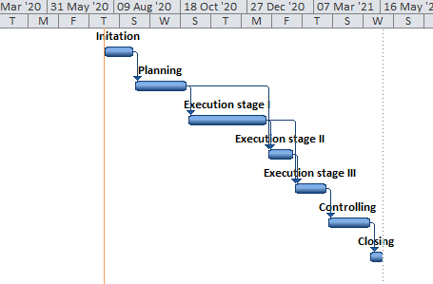
Activity list:
The various activities are undertaken while constructing a building as it is elaborated in a following manner:
Initiation stage
- Preparing an estimated roughwork: This is most crucial stage in which the project manager tends to ascertain the all paperwork which is required for this project such as drawings, specifications of machinery and equipment, lining up construction contractors and so on and the most important the approval from clients is necessary so that work could be started as early as possible.
Planning stage
- Roofing: This is most significant stage in which the overall roofing of building is made as labours has to be careful in this stage and take proper measurements and scale as this depict the proper systematic working of operations.
- Plastering: This determine the greatest strength as sufficient time is to be given so that plaster could be dry as it determines the overall effectiveness and aids in maintaining proper structure of building. This wall is properly covered with plaster which provide it with hard surface.
- Structure or layout: The planning related to structure is formed which depict the physical appearance of a building.
- Electric and plumber work: Once a proper layout is formed, electric work as well as plumbering is done as proper fitting is done.
- Others: In this, doors and windows are properly framed which create an lasting appearance and create a overall furnishing of the work. Also, tiles are affixed in kitchen where staff could have their refreshments.
Execution as well as monitoring
- Miscellaneous activities: After a proper set up of furniture and other equipment’s, there are various activities which are taken place in this aspect such as water proof of terrace, wall ceiling and so on in a building.
Risk management
It is better understood as the process of determining as well as identification of risk and monitoring and combatting the threats on the basis of capital plus earnings (Lock, 2020). For this, the project manager would prepare a risk management plan risk so that it could identify the risk earlier and then take necessary precautions accordingly which increase the confidence level of business to manage and handle such risk more appropriately.
Risk Plan
In this, the manager would make an efficient planning by identification and determination of risk which has a direct impact on the project work. With the help of this approach, this assist in removing all sort of risk and thus could focus on their goals which create a safe environment in a workplace (McKevitt, Carbery and Lyons, 2017). In case if the risk is identified by the project manager in an advance, then they could save time and money. The main role of project manager is to assess the level of risk while managing construction activities and then it would develop an appropriate strategy accordingly by analysing all factors into consideration. They would make ensure that the work is done with utmost care by making optimum utilisation of resources which thus saves time.
Risk Register
Sr no. | Risk | Likelihood | Impact | Owner | Mitigation | Contingency | Weighting score (pre action) | Weighting score (post action)
1 | Shortage of funds | High | High | Owner | There are several ways of eliminating the risk but at the same time it require the formation of a proper planning. One most effective way is that the project manager should make proper usage of resources such as manpower, materials and money. | The project manager need to formulate a best course of action among the several alternatives available so that they could take decision more effectively plus efficiently. | 7 out of 10 | 8 out of 10
2 | Limited time period | Medium | High | Project Manager | It would allocate the time in a very proper manner so that they could generate maximum level of output. | Making a proper schedule could help the company to manage time efficiently. | 7 out of 10 | 8 out of 10
3 | Attractive and talented workforce | Low | Medium | Project Manager | The manager could recruit efficient and trained staff so that they would save time and cost in rendering training to them. This improve their knowledge level and maximise the overall efficiency. | By hiring the most potential staff would assist the company in rendering an effective growth of a company and aids in improving their knowledge base as they would meet the expectations of clients in a best possible manner. | 8 out of 10 | 9 out of 10

Activity Scheduling
The activities which are undertaken while conducting this project is ascertained below:
- Document formalities
- Construction of walls
- Roofing
- Plastering
- Plumber
- Other related work
Gantt chart
A Gantt chart is a vertical graph as it is propounded by Henry Gantt in year 1919 which show a relation between the time taken for completion of a project. It illustrates the activities which are taken place as a proper schedule is prepared which help in making proper division of work in accordance of allocation of time (Owusu, Chan and Shan, 2019). In relation to this, it provides the necessary information regarding the time duration of starting and finishing of task. This aids in proper planning and assessing the availability of resources by managing and monitoring activities in an efficient manner so that there is no sort of confusion and misunderstanding among them. It involves the procedure of sequence of activities which is to be followed so that there is no delay in working procedure as otherwise it hampers the overall performance and thus affect the functioning of a company.
Critical path
Critical path method involves a series of activities which depict that minimum time is to be taken for completing the operations of a business. Critical path method could be applied specially in case of research and development as it helps in identification of different project activities and time duration while performing these activities (Silvius and et. al., 2017). One of the greatest benefits of using such method is that it avoids the wastage of time, energy and money on irrelevant matters and render a standard method for communication of project plan, schedule as well as cost. It establishes a relationship between time plus cost and cost is directly proportionate to time as it mainly designed for repetition of task. It is considered as a useful technique which is designed for making planning related to project.
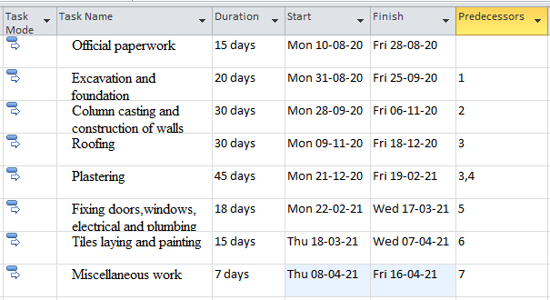
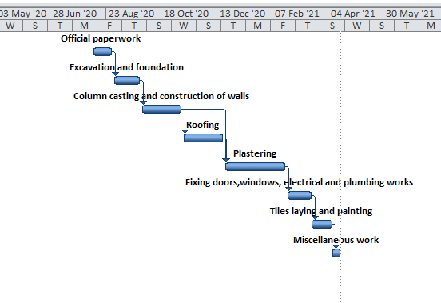

Budget modelling
Budget discuss the estimated expenditure which is incurred while undertaking a task for a particular period of time. The budget is prepared for a year as several activity has to be taken place in a proper manner as it involves several expenses which is to be incurred such as registration fee, notary fee and other necessary expenditure are declared independently and also miscellaneous expense is kept aside. Th first and foremast activity which is performed by project manager is to make proper judgement about funds and using it judiciously in order to facilitate smooth conduct of activities. In case of arise of any deviations, the project manager would take immediate corrective actions so as to avoid any kind of uncertainties in future.
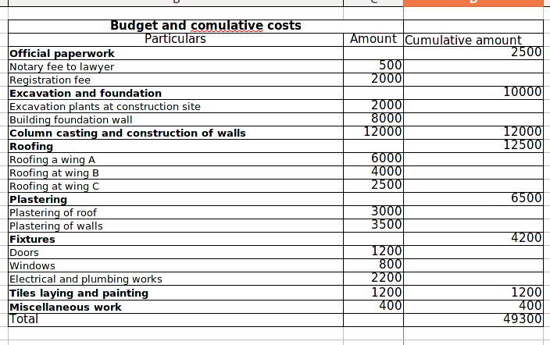
Cash Flow Statement
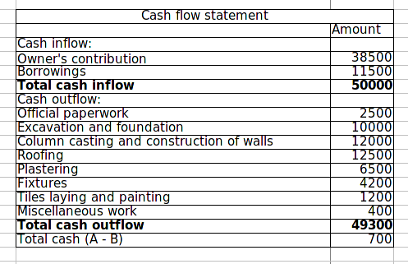
This financial aspect is prepared which depict the inflow as well as outflow of cash over a certain period of time. It aids in identification of resources and determine the overall disbursement of cash by finance manager in order to maintain efficiency (Turner, 2017). Also, the firm emphasise on managing the capital in a proper manner and it aids in understanding the requirement of cash so that work could be performed accordingly. It results in outflow of cash due to expense incurred in several activities such as plastering, roofing, tile laying and other miscellaneous work.

Project Execution Challenges

While implementation and executing the project, there are several challenges that are being faced by project manager which possess a little bit difficulty in completing the project work. For instance, shortage of funds would hamper the performance as it led to delay in activities which affect the overall working procedure. It is necessary that the team members must be efficient and hard working as they must have advanced knowledge level so that they could bring desirable outcomes. In a workplace, conflict is inevitable so the project manager must handle this aspect very calmly so that it could take a right decision very precisely which ensure a successful completion of a project within a set time frame.

CONCLUSION
From the above information, it can be comprehended that the objectives specified in project management are clear as project must be undertaken in such a manner which require efforts and systematic planning which involve time, scope and budget while completion of a project. It is necessary for project manager to determine the cost money and resources required in it and work breakdown structure is analysed which determine the division of task into complex units and also Gannt chart is also discussed in this report.

REFERENCES
Books and Journals

Akkermans and et. al., 2020. Crafting project managers’ careers: Integrating the fields of careers and project management. Project management journal. 51(2). pp.135-153.
Bjorvatn, T. and Wald, A., 2018. Project complexity and team-level absorptive capacity as drivers of project management performance. International Journal of Project Management. 36(6). pp.876-888.
Chawla, V. and et. al., 2018. The sustainable project management: A review and future possibilities. Journal of Project Management, 3(3), pp.157-170.
Farashah, A.D., Thomas, J. and Blomquist, T., 2019. Exploring the value of project management certification in selection and recruiting. International Journal of Project Management. 37(1). pp.14-26.
Kerzner, H., 2019. Using the project management maturity model: strategic planning for project management. John Wiley & Sons.
Layton, M. C. and Ostermiller, S. J., 2017. Agile project management for dummies. John Wiley & Sons.
Lee, C.Y. And et. al., 2018. Critical review of social network analysis applications in complex project management. Journal of Management in Engineering. 34(2). p.04017061.
Lock, D., 2020. Project management. Routledge.
McKevitt, D., Carbery, R. and Lyons, A., 2017. A profession but not a career? Work identity and career satisfaction in project management. International Journal of Project Management, 35(8), pp.1673-1682.
Owusu, E. K., Chan, A. P. and Shan, M., 2019. Causal factors of corruption in construction project management: An overview. Science and engineering ethics, 25(1), pp.1-31.
Silvius, A. G. and et. al., 2017. Considering sustainability in project management decision making; An investigation using Q-methodology. International Journal of Project Management, 35(6), pp.1133-1150
Turner, J.R. ed., 2017. Contracting for project management. Taylor & Francis.

