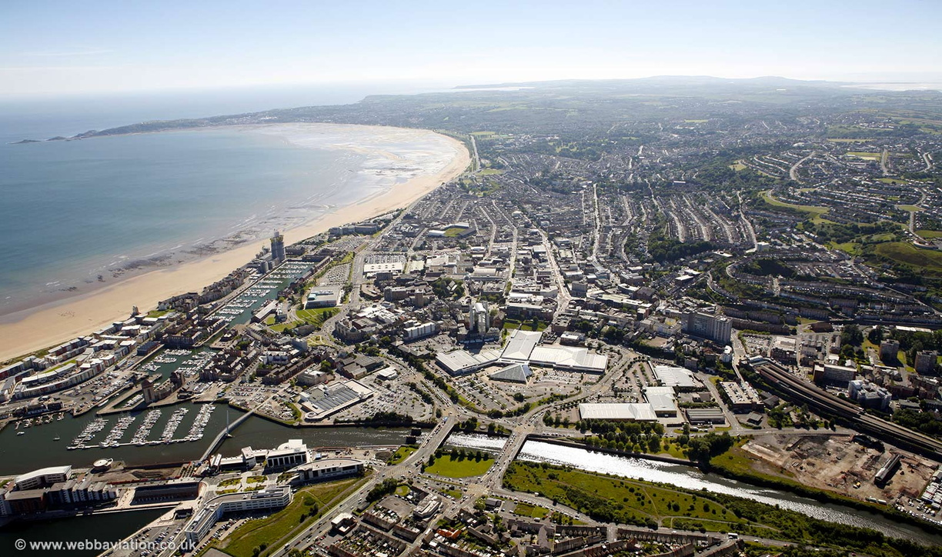  Construction Technology 2  MEDIUM TO HIGH RISE HOTEL PROPOSAL | Joanna Weedon 2414801  ACBA5019

Table of Contents
FIGURE LIST 2
GLOSSARY OF TERMS 3
INTRODUCTION 5
SITE ANALYSIS AND GROUND CONDITIONS 5
Maritime Climate 6
Ground makeup 6
Mining 7
FOUNDATION DESIGN 8
Table 1: Piling Quality Control Requirements (BS EN 1536:2015) 9
STRUCTURAL FRAME SYSTEM 10
Table 2: Structural System Comparative Analysis for Steel v. Concrete 10
Weight and Foundation Benefits 13
Construction Speed and Hospital Proximity 13
Fire Safety Performance 13
Coastal Environment Protection 14
Sustainability Considerations 14
Limitations 14
BUILDING ENVELOPE DESIGN 15
Table 3 : External Wall Build-up 15
Table 4: Window Performance 18
Table 5: Roof System Build-up 18
PREFABRICATION VS ON-SITE CONSTRUCTIOM 20
Traditional On-Site Construction 20
Maximum Prefabrication 21
Hybrid Prefabrication (chosen) 21
Justification for Hybrid Prefabrication 21
SUSTAINABILITY CONSIDERATIONS 22
Enhancing Thermal Performance 22
Sustainable Materials 22
Local Sourcing 23
CONCLUSION 23
REFERENCES 25

FIGURE LIST
Figure 1 – Proposed Site Location - DigiMap Discovery Service (no date). https://digimap.edina.ac.uk/roam/map/os.
Figure 2 - Atmospheric corrosion categories - C1-C5M & CX corrosion Classes - Northpoint Ltd - Technical support (2025). https://northpoint.ltd.uk/anti-corrosion-coatings/c1-c5m-corrosion-classes/.
Figure 3 – Abandoned Mine Catalogue - Authority, C. (no date) Mining Remediation Authority Map Viewer. https://datamine-cauk.hub.arcgis.com/.
Figure 4 – Bored Pile Method - Bored piles | Keller UK (2024). https://www.keller.co.uk/expertise/techniques/bored-piles.
Figure 5 – Steel Frame and Concrete Core - steel frame-reinforced concrete core tube structural system. (no date).
Figure 6 – Cross Section of Rainscreen - Sculptform (2026) 'How to build a rainscreen | Sculptform,' How to build a rainscreen, 9 January. https://sculptform.com/en-gb/blogs/how-to-build-a-rainscreen/ (Accessed: January 11, 2026).
Figure 7 - EDPM Flat Roof Section - EPDM Flat roof System - Inspection Gallery - InterNACHI® (no date). https://www.nachi.org/gallery/flat/epdm-flat-roof-system.
Figure 1 - James Hardie - Assessing impacts along their value chain James Hardie (no date) Building Resilience Sustainability Report | Fiscal Year 2025.

GLOSSARY OF TERMS
A2-s1,d0 – A fire rating indicating limited combustibility, low smoke production and no flaming droplets.
Approved Document B – UK Building Regulations guidance relating to fire safety and fire resistance.
Approved Document F – UK Building Regulations guidance relating to ventilation requirements.
Approved Document L – UK Building Regulations guidance covering energy efficiency and thermal performance.
Breather membrane – A water-resistant but vapour-permeable layer that protects the wall build-up from moisture.
BS EN 1536 – A British Standard setting out requirements for the construction and testing of bored pile foundations.
BS EN 1991-1-4 – The Eurocode standard used to determine wind loading on buildings, including coastal sites.
BS EN ISO 12944 – A standard used to classify corrosion environments and specify protective coatings for steel.
Cavity barriers – Fire-stopping components installed within cavities to limit fire and smoke spread.
Coastal exposure – Environmental conditions involving wind-driven rain and salt-laden air, which accelerate material deterioration.
Euroclass fire rating – A European classification system used to describe a material’s reaction to fire.
Fibre cement – A composite material made from cement, sand and cellulose fibres, commonly used for external façades.
PIR insulation – A rigid insulation material with high thermal efficiency, commonly used in external walls and roofs.
R-value – A measure of how well a material resists heat transfer. Higher values indicate better insulation.
Thermal conductivity – A property describing how easily heat passes through a material.
U-value – The rate at which heat is lost through a building element, measured in W/m²K. Lower values indicate better performance.
Ventilated cavity – An air gap behind cladding that allows water to drain and moisture to evaporate.

INTRODUCTION
The following report presents suitable construction technologies for the proposed medium-to-high rise hotel situated adjacent to Swansea Sea front. Outlining the appropriate foundations and structural frames, building envelope design including the methodology best suited for the ground, coastal exposure and close proximity to the urban environment.
Due to the challenges this site presents, it will require careful design consideration. The coastal exposure, which consist of high wind loads, elevated rainfall averaging annually around 1334 mm and salt – laden air accelerating material degradation. Desktop ground investigations show us that we have weak superficial deposits compromising of beach sands, mudstone and siltstone. Historic coal activity in the area requires deeper foundation solutions by passing potential compromised strata.
Systematically each design aspect will be considered with structural strength, stability, fire safety, aesthetics and environmental impact and sustainability with reference to current British Standards and Building Regulations.

SITE ANALYSIS AND GROUND CONDITIONS
The approx. 6.4 acre site is located south of the A4067 and east of Sketty Lane and around 150m from the coast. The surrounding lands comprise of athletic facilities, Singleton Park, Swansea University, Singleton Hospital, and residential buildings. Due to the proximity of Singleton Hospital, we will need to consider low noise construction methods and careful traffic management to eliminate any disruptions.
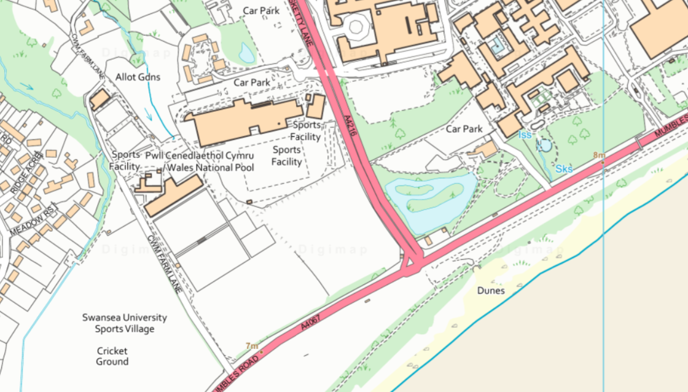

Figure 2 – Proposed Site Location (DigiMap Discovery Service, no date)

Maritime Climate
Swansea maritime climate produces annually around 1333mm of rainfall (Met Office, 2023) and prevailing winds from the south which will carry salt spray inland. We will need to take into consideration the wind forces on the building and follow BS EN 1991-1-4 when designing the structure and external details to withstand the pressures (BSI, 2005). Following EN ISO 12944, we would classify the area as Exposure category C5-I this would require metal components to have protective coating and design the build to resist salt and weathering as much as possible (BSI, 2017).
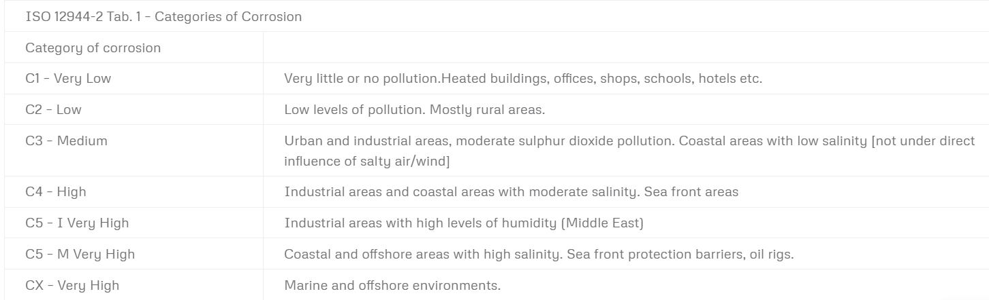
Figure 3 - Atmospheric corrosion categories. (C1-C5M & CX corrosion Classes - Northpoint Ltd - Technical support, 2025)

Ground makeup
As found in the British geological survey viewer, the ground comprises of mudstone, siltstone and sandstone (British Geological Survey, 2023). Although sandstone can provide bearing capacity for some builds because of its strength and durability, mudstone and siltstone are weaker, and when exposed to water lose strength, therefore, making this a weak layer of composites to build on.
The British Geological viewer also identifies beach superficial deposits. These consist of sand and gravel overlaying the bedrock. Whilst both materials can perform well together in building materials when dense, the loose and inconsistent nature in the soil can lead to settlement under structural loading, due to the deposits being non-cohesive and highly permeable.
Supporting borehole data exists nearby (BH 1A at Sketty Lane Pool extending to 5.10m depth (Bgs, no date)), however site-specific ground surveys will need to be carried out to assess load bearing capacity’s at the depths required for this project.

Mining
Due to our findings in the Geological viewer and the commonly associated materials with historic coal extraction, a further investigation was undertaken to see historic mining records via the Mining Remediation Authority Map Viewer. As shown in Figure 3, the records highlight the presence of abandoned mine catalogue areas within and surrounding the site, shown in green. This identification highlights potential risks such as underground voids, shallow workings and areas of weakened grounds.
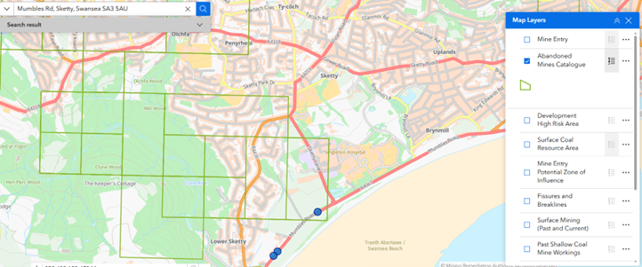
Figure 4 – Abandoned Mine Catalogue (Authority, no date)

FOUNDATION DESIGN
Due to our findings with the desktop geological survey, we know that the ground near the surface is weak and unreliable. When considering the type of foundation, we need a design that will allow us to go to a more competent strata layer for load bearing. Therefore, we would recommend pile foundations. Based on the British Geological Survey, sandstone bedrock is expected to be around 12-15 metres depth. To assure adequate bearing capacity, we would penetrate the foundations at least 3 meters into the sandstone.

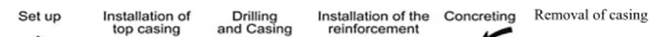
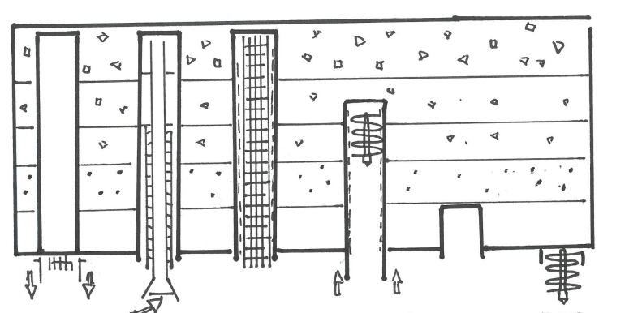
There are several piling methods, however, taking everything into consideration we would suggest cased rotary bored piles. This technique has a temporary steel casing maintaining ground stability when coring into the ground, therefore removing the probability of the loose deposits collapsing and filling the hole. When the drill hits suitable strata all loose material will be removed and a steel reinforcement cage is lowered into the hole (Tomlinson and Woodward, 2014).
Figure 5 - Bored Pile Method (Bored piles | Keller UK, 2024)
Using a tremie pipe, concrete is pumped in from the bottom upwards, ensuring that the material fills without any air pockets or contamination from groundwater. When the concrete has cured enough to handle ground pressure, the outer casing can be removed.
There are several advantages to why rotary piling foundations are suitable for this site. Due to the proximity to the urban environment, hospital, residential areas, this technique produces very little noise and vibration (CIRIA, 2017). Not only does the temporary steel casing prevent weak soil collapsing back into the hole, but it will also prevent water filling the borehole, which we would expect to see being a coastal location. Most importantly this method bypasses the weak strata of made-up ground by creating a suitable load bearing foundation on competent sandstone. These piles will extend below potential historic mine workings, providing added protection against subsidence from historic coal extraction.
When selecting the type of concrete used for the foundations we need to take into consideration the environment as different elements can interfere with different materials. As sulfites naturally occur in coastal groundwater due to seawater infiltration and we may see even higher levels of contamination from the historic coal mining in Swansea Bay, we need to looking at incorporating 25-30% ground granulated blast-furnace slag or known as GGBS. This additional material creates a denser concrete making it less permeable, therefore physically blocking sulfate penetration and secondly making the cement chemistry less reactive when encountering sulfates (BRE, 2019). Cement that hasn’t had the corporation on GGBS in a coastal area would react with the sulfates causing, cracking, expansion and structural deterioration. A concrete that typically includes this composition would be C32/40 concrete, known for its strength mix (BS 8500:2015).

Table 1: Piling Quality Control Requirements (BS EN 1536:2015)
Requirement | The Standard/Specification | Purpose
Execution Standards | BS EN 1536:2015 (Execution of Specialist Geotechnical work -augured or bored piles) | Specific criteria for the drilling of bores, what the casing use should be, where the concrete should be placed and provision of measures to ensure that bore strength and durability are within the design parameters.
Preparing the Bore | As per BS EN 1536:2015 requirements | The base foundation must be clear of debris and in contact with geology consistent with load bearing properties required for the loadings.
Temporary Casing | As per BS EN 1536:2015 requirements | Used during the construction process this casing ensures that the stability of the bore is protected if there are weak layers of geological material. Further it restricts groundwater adulteration that might impact fresh concrete during the install.
Pile Integrity Testing | Low-strain ultrasonic testing methods conforming to BS EN 1536:2015 | This testing is used to establish whether there are defects such as necking, voids, soft toes or soil inclusions within the shaft.
Load Testing | Testing regime per BS EN 1536:2015 (minimum requirements to be confirmed by geotechnical engineer) | Validates the design parameters and confirmation that the pile(s) reach the necessary bearing tolerances required.
Concrete Specification | Specification C32/40 grade with 25-30% GGBS, maximum 0.50 w/c ratio, tremie placement | Fulfils the necessary robustness, sulfate-resistance (ACEC class AC-2), and resilience for the 60+ year design life in potentially corrosive coastal groundwater

STRUCTURAL FRAME SYSTEM
The proposed site has three substantial constraints when deciding the structural frame, ground conditions, urban environment and coastal proximity. This means we want to look at a system that minimizes foundation demands, escalated construction time to reduce disruption and long-term durability.

Table 2: Structural System Comparative Analysis for Steel v. Concrete
Criterion | Full Concrete Frame | Full Steel Frame | Hybrid System (Selected)
Structural Weight and Foundation | - Heavy  - Myriad piles required – estimated 150-180 piles required  - High loads on weak ground (BH 1A) | - Lightest Material – estimated to be 60% of Concrete Weight  - Minimal foundation demands  - Approximately 80-100 piles required | - 30-40% lighter than concrete  - Moderate pile requirements (100-120 piles)  - Reduces foundation loads whilst avoiding full steel issues (Steel Construction Institute, 2018)
Construction Programme | - 24-30  - 7 days per floor  - Weather-dependent  - Operational disruption for hospital | - 16-18 weeks  - 1-2 floors per week install  - Offsite factory fabrication – rapid assembly | - 16-20 weeks  - 1-2 floors per week  - Saving of 3-4 months over concrete route  - Reduction in operational disruption for the hospital
Coastal Corrosion Resistance | - Material has exemplary fundamental durability  - Concrete naturally resistant to salt  - Minimal maintenance | - Needs extensive protection from harsh coastal environment  - ALL elements need marine-grade treatment  - Protection adds 15-20% to the cost | - Precise targeted protection  - Core inherently durable  - Perimeter steel needing Category C5-M protection
Fire Safety Provision | - High safety factor  - 300mm concrete provides 120+ minutes without additional protection. | - Low safety factor  - ALL steel elements require intumescent coating providing extensive fire protection. | - Respectable safety factor  - Concrete Core provides 120 mins inherent resistance  - Perimeter steel requires 90 min coating (Approved Document B).
Lateral Wind Stability | - Concrete provides good stability resulting from a rigid frame.  - Heavy structural mass provides natural lateral resistance | - Requires diagonal bracing OR moment connections  - Bracing can interferes with layouts.  - The addition of Moment Frames add £340k-880k | - Excellent. 10m x 12m core provides all lateral resistance  - Simple pin connections for steel frame  - No additional bracing required
Thermal Mass and Energy Performance | - High thermal mass throughout  - Moderates temperature swings  - Reduces peak heating/cooling loads. | - Very low thermal mass  - Rapid responses to temperature fluctuations  - May require higher peak loads therefore larger HVAC needed | - Moderate thermal mass from core  - Provides some temperature moderation whilst minimising weight
Acoustic Performance | - Excellent  - Heavy concrete floors (300-350mm) provide superior sound reduction  - Exceeds Part E | - Poor  - Lightweight structure Requires additional treatments to meet Part E  - Added cost to the structure | - Good  - Composite floors (130mm) achieve 53-55 dB  - Exceeds Approved Document E for hotels.
Hotel Spatial Flexibility | - Moderate  - Column spacing limited to 6-8 meters  - Columns may interfere with layouts. | - Moderate  - Bracing every 15-20 meters restricts layouts  - Steel frame expensive in isolation | - Excellent  - 7.5m x 9m grid provides column-free rooms  - Long spans prevent conflicts for layout
Material Availability and Lead Times | - Readily available  - Short lead times (1-2 weeks from order)  - Multiple local suppliers  - Minimal procurement risk | - Lead times (12-16 weeks fabrication)  - Requires specialist fabricators  - Medium risk for supply | - Moderate lead times  - Concrete local  - Steel from South Wales (12-16 weeks)
Overall Suitability for This Site | - Poor  - Heavy structural element increases the piling and foundation costs  - Slow construction extends disruption to the hospital | - Moderate  - Lightweight good for ground but corrosion costs offset savings  - Stability risks | - Excellent. Balances all design requirements  - 30-40% lighter  - fast construction, economical protection, no bracing on steel  - Acoustic performance high

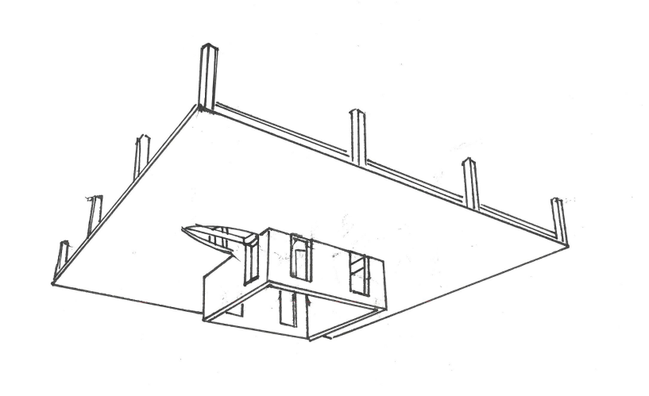
Choosing a hybrid system combining a central reinforced concrete core with steel frame addresses the constraints at the proposed development.
Reinforced Concrete Core Tube
Steel Beam-Concrete wall joint
Steel Frame
Slab
Figure 6 - Steel Frame and Concrete Core Example (steel frame-reinforced concrete core tube structural system., no date

Weight and Foundation Benefits
The integration of using a mix of concrete and steel structure creates a system that is 30-40% lighter rather than use of a full concrete frame. Weight reduction is needed when taking into consideration the weak ground conditions identified in the geological survey and boreholes. Due to the frame being lighter, less foundation piles are needed. This reduces not only the cost of ground works but also decreases the risk associated with building on weak strata.

Construction Speed and Hospital Proximity
The proposed site is situated near Singleton Hospital as well as university grounds, housing estates and athletic facilities. Using a hybrid approach can achieve accelerated performance rather than traditional concrete construction timings. This method not only reduces on site costs but also minimizes crucial impacts to the environment adjacent to the development (BCSA, 2023).

Fire Safety Performance
The concrete core naturally provides 120 minutes of fire resistance, therefore critical areas such as fire compartments like stair casing won’t need additional protection. The steel frame will require an intumescent coating to achieve 90 minutes of fire protection, which aligns with Building Regulations Approved Document B (HM Government, 2019)

Coastal Environment Protection
All steel components will need marine-grade corrosion protection for coastal exposure as explained in the maritime climate section. Areas where we have smaller steel elements will be hot-dip galvanized with an 85-micron zinc coating, while larger fabrication will have coat paint systems achieving 200-300 microns thickness. Adding protection to the steel will provide long- term durability in this coastal environment.

Sustainability Considerations
Structural steel made in the UK contains 95% recycled material and can be recycled at end of life. The concrete used will include GGBS as a cement replacement (BCSA, 2023). This will reduce the embodied carbon compared to ordinary concrete. As we have selected a hybrid structure using steel, this reduces the need for larger foundations meaning less concrete is needed, further reducing the project’s carbon footprint. Specifying local steel procurement (within 50 miles) reduces transport emissions whilst supporting regional supply chains (WRAP, 2019).

Limitations
Whilst the hybrid structure is the best suited for this specific project there are some limitations that follow. The hybrid structure will require specialist steel erectors and suitable ground space for crane access, which will need careful coordination given the proximity to buildings around the site. Initially the costs may be greater than traditional concrete construction, however these additional costs are likely to be offset these by the reduction in piles/foundations and the accelerated programme due to the steel fabrication methods. Therefore, there will be shorter construction period.

BUILDING ENVELOPE DESIGN
When designing the building envelope, it needs to respond to the site’s climate, prioritising fire safety, thermal efficiency and durability. Instead of a traditional masonry cavity that would increase weight loads on the structure and be affected by coastal conditions, a lightweight ventilated rainscreen façade has been picked. This specification will be lighter, better moisture managed and provide longer longevity to the corrosive environment.

Table 3 : External Wall Build-up
Layer | What It Is | Why We Need It
Outer Panels | Hardie Plank fiber-cement panels or planks – made up from cement, sand, cellulose fibers – comes in a wide range of colours Aluminum standing seam - vertical dark grey accents. | Creates contemporary coastal aesthetic fitting into the surrounding environment. Unlike timber cladding the material won’t rot. Low maintenance due to cladding not needing to be treated, painting every 15 years. Non-combustible A2-s1,d0, therefore meeting the Building Safety Act 2022(HM Government, 2022)
Support Brackets | Marine-grade aluminum brackets every 600mm fixed through insulation to blockwork | Fixing the cladding to the building envelope. Category C5-M corrosion resistance per BS EN ISO 12944
Ventilated Cavity | 50mm air gap behind outer panels | Two-stage defense: outer panels shed rain, cavity drains any penetration to trays at each floor. Air circulation enables drying. Prevents moisture reaching insulation.
Insulation | 100mm PIR insulation boards | U-value sits at 0.18 W/m²K better than building regulation requirements of 0.26. Therefore reducing heating costs in the long term.
Breather Membrane | Vapor permeable, water-resistant layer | Secondary water barrier. Allows outward moisture diffusion.
Inner Leaf | 100mm lightweight concrete blockwork built off the composite floor slabs | Structural support. Airtightness. Acoustic mass. Integrates with the hybrid frame.
Internal Finish | 13mm plasterboard | Inner face finish
Fixings | Grade 316 stainless steel | Reduces coastal erosion.
Fire Safety | Mineral wool cavity barriers at each floor. 600mm spandrel separation between floor windows. | Prevents vertical fire/smoke spread. Complies with Approved Document B.
Cross section of Rainscreen
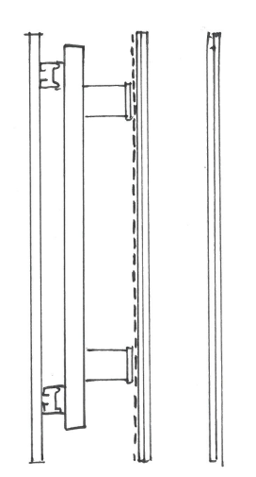
Membrane

Rigid air barrier

Back Drainage

Drainage Cavity

Hardie Plank Cladding

Plasterboard

Stud

Insulation

Helping hand bracket

Figure 7 - Cross section of Rainscreen (Sculptform, 2026)

Table 4: Window Performance
Feature | Specification | Performance Achieved
Thermal Efficiency | Double-glazed window with argon gas and low e coating. | Lower U-value sitting around 1.1 W/m²K achieving less heat loss.
Acoustic Control | Argon-filled cavity | The argon gilled cavity reduces sound, created from inside the hotel and external factors.
Frame Performance | Marine grade aluminum alloy with plastic thermal break | Thermal break stops 60-70% of heat escaping through frame.
Corrosion Resistance | Ironmongery - Grade 316 stainless steel | Won’t corrode from environment factors
Natural Ventilation | 30-40% of window opens. 100mm safety restrictors fitted | Meets Part F.- Ventilation. Natural ventilation will also reduce air conditioning needs. With safety restrictors installed to prevent falls
Wind Resistance | Toughened glass for windows | Complies with BS EN 1991-1-4 coastal wind loading. Toughened glass stronger than normal glass.

Table 5: Roof System Build-up
Layer | What It Is | Purpose/Performance
Surface Protection | Raised walkway on adjustable plastic pedestals for In Use (Facilities) with mansafe systems | Safe access to rooftop plant without damaging rubber membrane and providing fall-arrest system for workers
Waterproofing | - EPDM rubber membrane mechanically fastened/fixed with screws/plates | - 60+ year design life  - UV resistant  - Weather resistance -40°C to +120°C  - Superior wind uplift resistance vs ballasted  - Able to repair sections if needed. (SPRA, 2020)
Insulation | - PIR foam in two staggered layers (joints offset) | - Staggered joints eliminate thermal bridges
Vapor Control | - Self-adhered vapor barrier bonded to deck | - Reduces internal moisture  - Prevents internal moisture traveling into insulation causing condensation damage
Drainage System | - Drainage outfalls installed and sized per BS EN 12056-3 for rainfall  - Emergency overflows positioned 50mm higher than primary. | - Adequate capacity in line with design  - Backup drainage if primary outlets blocked.
Structural Deck | - Composite floor slab from hybrid frame – metal deck and concrete | - Supports roof loadings
EDPM Flat Roof System
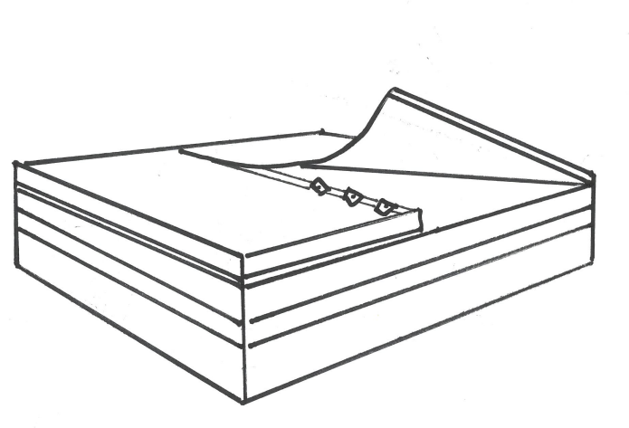
Adhesive

Vapor Control

Structural Decking/Substrate
EPDM Membrane

Anchor Points

Insulation

Figure 8 - EDPM Cross Roof Section (EPDM Flat roof System - Inspection Gallery - InterNACHI®, no date)

PREFABRICATION VS ON-SITE CONSTRUCTIOM
When specify products/methods for this project, we want to look at Time, Cost and Quality and having to decide if traditional onsite construction, prefabricate methods or hybrid prefabrication achieve all three the best.

Traditional On-Site Construction
Comprising a concrete frame built onsite using formwork, bathrooms installed with sequential trades and then the façade materials fixed from scaffolded platforms. The route is extremely versatile and does provide the least cost in terms of upfront materials. The downside is that concrete needs a 7-day cure window between floors (Concrete Society, 2019), the bathroom instal requires 400-500 worker days (Lawson et al. 2012) resulting in an overall programme of 24-26 months and at risk with hostile weather events which appear to be increasingly prevalent particularly in coastal regions.

Maximum Prefabrication
Use of room modules fabricated off site and fitted into position using cranes. These segments would comprise structure, services, finishes and furniture. In the United Kingdom circa 65% of steel-framed developments now include façade prefabrication (BCSA, 2023) which shows that the practice is widely endorsed. Whilst the programme is significantly shorter than traditional on-site construction the cost uplift is in the region of 25-30%. Extensive use of cranage would be needed and as the site in Swansea is spatially constrained the cranes would be difficult to accommodate.

Hybrid Prefabrication (chosen)
The building frame comprises prefabricated structural steel with installation of bathroom pods that have been manufactured off site. The façade panels would be partially prefabricated. Retention of traditional methods will be used wherever prefabrication provides little benefit. The steel frame is made using CNC equipment resulting in ±2mm tolerances (Steel Construction Institute, 2018) and will be erected at 1-2 floors per week - 40-50% faster than concrete (BCSA, 2023). The bathroom pods are delivered 85-90% complete - reducing the worker days from 400-500 days to 7-10 days install (Lawson et al., 2012). The partially constructed façade panels allow for a time reduction of 30-35% against the traditional method of installing by hand from scaffolding platforms.

Justification for Hybrid Prefabrication
This hybrid method lowers the costs by 45-50% using the prefabrication, compresses the programme to 18-20 months saving 4 to 6 months on a traditional method of build and allowing the Client to benefit from earlier revenue generation. It is the case that prefabricated units do characteristically cost 10-20% more than on-site labour and materials but the offset to these costs arises by a reduction in scaffold hire, curtailed supervision, lower site welfare, and general preliminary costs. It has become a recognised method of construction. Premier Inns now use bathroom pods in 90% of their new hotel builds (Whitbread, 2020). The environmental benefits are unambiguous. 20-30% of the construction waste is reduced through factory efficiencies (WRAP, 2018). This hybrid construction approach delivers speed, excellent quality, and reduced costs as well as minimizing the disruption to the nearby hospital and residential units by a smaller labour force, fewer site deliveries, and a shorter construction window.

SUSTAINABILITY CONSIDERATIONS
Specifications mentioned in this report targets BREEAM ‘Very Good’. This route has been chosen due to the development being a hotel, and the need for the build to make financial sense with reasonable ROI. Expensive upgrades that would qualify for BREEAM ‘Excellent’ would take a lot longer to pay back (BRE, 2021).

Enhancing Thermal Performance
One of the easiest ways to make the building more sustainable is improving the thermal performance. The walls, roof and windows specifications chosen in this document exceed Building Regulations requirements by 30-40% (HM Government, 2021). As these elements have better thermal performance, we do see an uplift in costs from around £15-20 extra per SQM (Spon's, 2024), however heating costs would be reduced around 20%, therefore, the upfront costs will be paid over 8-10 years, and the building will see a financial benefit after and preventing CO2 being released (CIBSE, 2015).

Sustainable Materials
Throughout this report I have properties materials with high recycled content where possible.
- Uk structural steel – contains 95% recycled material and can be recycled again when the building is demolished (BCSA, 2023).
- Concrete mix – Includes 30-40% GGBS which cuts carbon emissions by 25-30%
- James Hardie Material - Lowest CO₂ emissions* amongst A2-rated non-combustible facades. Materials absorb CO2 during use. Fully recyclable.
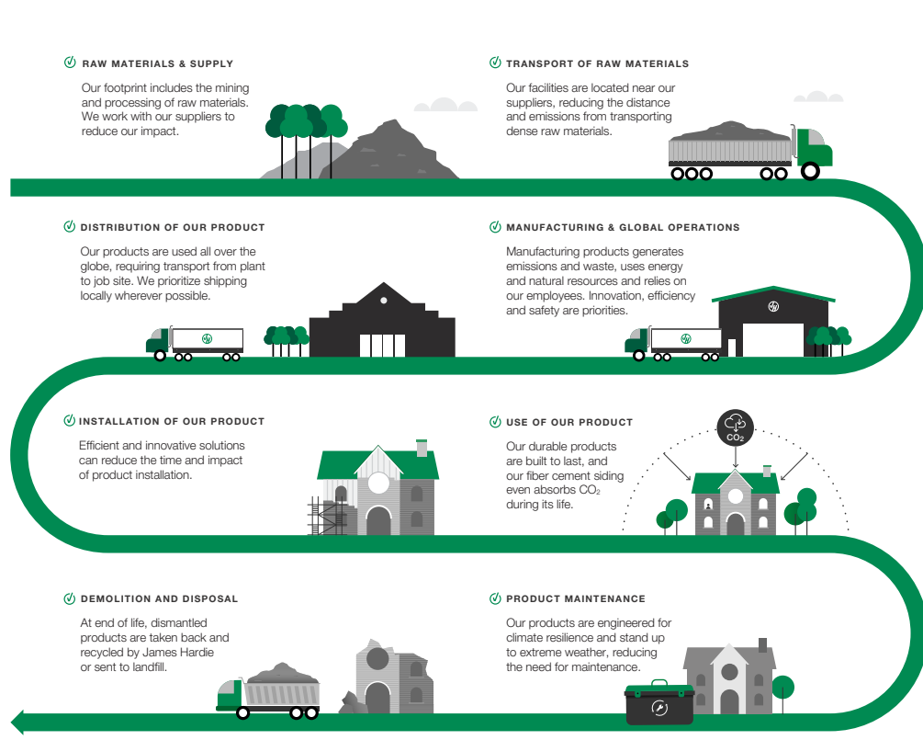

Figure 9 - James Hardie - Assessing impacts along their value chain (James Hardie, no date)

Local Sourcing
- Structural steel – This can be procured from fabricators in Cardiff, Newport or Port Talbot, which are all within 45 miles. This significantly reduces transportation CO2 compared to procuring steel from national suppliers located further away.
- Aggregates – These can be procured from Tarmac Glyntaff and Hason Penderyn quarries, which are both within 35 miles, again reducing transportation CO2.

The suitability approach shows you can have a good environment performance without compromising on costs. By focusing on better insulation, recycled materials and local sourcing, the design tackles the main environmental impacts whilst still making commercial sense through lower running costs and reasonable payback periods.

CONCLUSION
To conclude this report has outlined key elements for a medium-rise hotel proposal in a challenging costal site in Swansea. Considerations have been given to multiple constraints such as weak strata, historic mining, coastal exposure and proximity to the urban environment. The selection of rotary bored piles extending to sandstone bearing strata address the ground conditions, whilst also surpassing the historic mining dangers. The added defense to the foundation style is the addition of GGBS in the concrete, which provides both the sulfate resistance required for the groundwater conditions and reduced embodied carbon, supporting sustainability objectives.
The hybrid structural systems combining a central reinforced concrete core with a perimeter steel frame provides lateral stability, fire resistance, accelerated programme and weight reduction which reduces foundation needs. The specification of marine-grade protective coatings and high recycled content materials demonstrates consideration of both durability and sustainability throughout the structural design.
Detailing the building envelope with rainscreen cladding using fiber -cement Hardie Plank achieves thermal performance whilst also providing non-combustible materials which have been essential for post-Grenfell fire safety compliance. The Specification of all the materials for Category C5-M marine exposure classification ensures durability in the salt laden coastal environment with minimal maintenance requirements compared to other products over the building's design life.
The prefabrication of the steel frame and bathroom pods delivers not only controlled quality checks through factory-based testing but compresses the programme whilst reducing construction waste.
BREEAM’S sustainability strategy targeting ‘Very Good’ certification, focuses practical cost-effective measures whilst balancing environmental performance, demonstration clear economic justification.
Overall, this approach combines strength, sustainability, and cost-effectiveness, creating a hotel design that is safe, durable, and suitable for its coastal location.

REFERENCES
Bgs (no date) GeoIndex - British Geological Survey. https://mapapps2.bgs.ac.uk/geoindex/home.html?_ga=2.142945205.108690770.1731939977-1995514978.1731939977.
British Constructional Steelwork Association (BCSA) (2023) Sustainability Charter: The sustainable steel construction commitment. London: British Constructional Steelwork Association. Available at: https://www.steelconstruction.info/Sustainability_charter (Accessed: 11 January 2026).
British Geological Survey (BGS) (2023) Geology of Britain Viewer. Nottingham: British Geological Survey. Available at: https://www.bgs.ac.uk/map-viewers/geoindex-onshore/ (Accessed: 11 January 2026).
British Standards Institution (BSI) (2005) BS EN 1991-1-4:2005+A1:2010 Eurocode 1: Actions on structures. General actions. Wind actions. London: BSI Standards Limited.
British Standards Institution (BSI) (2015) BS EN 1536:2015 Execution of special geotechnical works. Bored piles. London: BSI Standards Limited.
British Standards Institution (BSI) (2017) BS EN ISO 12944:2017 Paints and varnishes. Corrosion protection of steel structures by protective paint systems. London: BSI Standards Limited.
BS EN 1536:2015 (2015) Execution of special geotechnical works. Bored piles. British
Building Research Establishment (BRE) (2019) The Green Guide to Specification: an environmental profiling system for building materials and components. 4th edn. Watford: BRE Global Ltd.
Building Research Establishment (BRE) (2021) BREEAM UK New Construction 2018: Technical Manual SD5078. Version 6.0. Watford: BRE Global Ltd.
Chartered Institution of Building Services Engineers (CIBSE) (2015) CIBSE Guide A: Environmental Design. 8th edn. London: Chartered Institution of Building Services Engineers.
Coal Authority (2023) Mining Remediation Authority Interactive Map Viewer. Mansfield: Coal Authority. Available at: https://mapapps2.bgs.ac.uk/coalauthority/home.html
Construction Industry Research and Information Association (CIRIA) (2017) Noise and Vibration from Piling Operations. CIRIA Report C700. London: CIRIA.
Department for Transport (DfT) (2020) Local Transport Note 1/20: Cycle Infrastructure Design (LTN 1/20). London: Department for Transport. Available at: https://www.gov.uk/government/publications/cycle-infrastructure-design-ltn-120 (Accessed: 11 January 2026).
HM Government (2019) The Building Regulations 2010: Approved Document B (Fire Safety). Volume 2: Buildings other than dwellinghouses. 2019 edition incorporating 2020 amendments. London: NBS.
HM Government (2021) The Building Regulations 2010: Approved Document L2A (Conservation of fuel and power in new buildings other than dwellings). 2021 edition incorporating 2021 amendments for the Future Homes Standard. London: NBS.
Lawson, R.M., Ogden, R.G. and Bergin, R. (2012) 'Application of modular construction in high-rise buildings', Journal of Architectural Engineering, 18(2), pp. 148-154. doi: 10.1061/(ASCE)AE.1943-5568.0000057.
Met Office (2023) UK Climate Averages: Swansea. Exeter: Met Office. Available at: https://www.metoffice.gov.uk/research/climate/maps-and-data/uk-climate-averages
Sculptform (2026) 'How to build a rainscreen', Sculptform Technical Library. Melbourne: Sculptform. Available at: https://www.sculptform.com.au/how-to-build-a-rainscreen
Steel Construction Institute (SCI) (2018) Steel Building Design: Introduction to the Eurocodes. SCI Publication P361. 2nd edn. Ascot: Steel Construction Institute.
Tomlinson, M. and Woodward, J. (2014) Pile Design and Construction Practice. 6th edn. Boca Raton, FL: CRC Press.
Waste and Resources Action Programme (WRAP) (2018) Waste Reduction Potential of Offsite Construction: A review of the evidence. Banbury: WRAP. Available at: https://www.wrap.org.uk
Waste and Resources Action Programme (WRAP) (2019) Embodied Carbon Database. Banbury: WRAP. Available at: https://wrap.org.uk/resources/tool/embodied-carbon-database
Water UK (2019) Water Efficiency in New Homes: A Guide for Planners and Developers. London: Water UK. Available at: https://www.water.org.uk/policy/water-resources/water-efficiency
Whitbread PLC (2020) Premier Inn: Sustainable Development Report 2019-2020. Dunstable: Whitbread PLC. Available at: https://www.whitbread.co.uk/sustainability

