Planning and Delivering an International Event at Marina Bay Sands, Singapore

Student: Silviu Cilica
Student Id: 2225055
Module: International Meetings Management BMIH6007
Lecture: Chris Wilkin

Acknowledgement
The ideas in my report came from original study and analysis that I did on my own. The report only has my study work in it, along with academic journals, business reports, and textbooks. No generative AI tool was used to complete this assignment. For better language and grammatical accuracy, I used Grammarly (https://www.grammarly.com/) as a proofreading tool.

Assignment 1: An Inclusive Culinary Experience at Marina Bay Sands, Singapore
Slide 1:
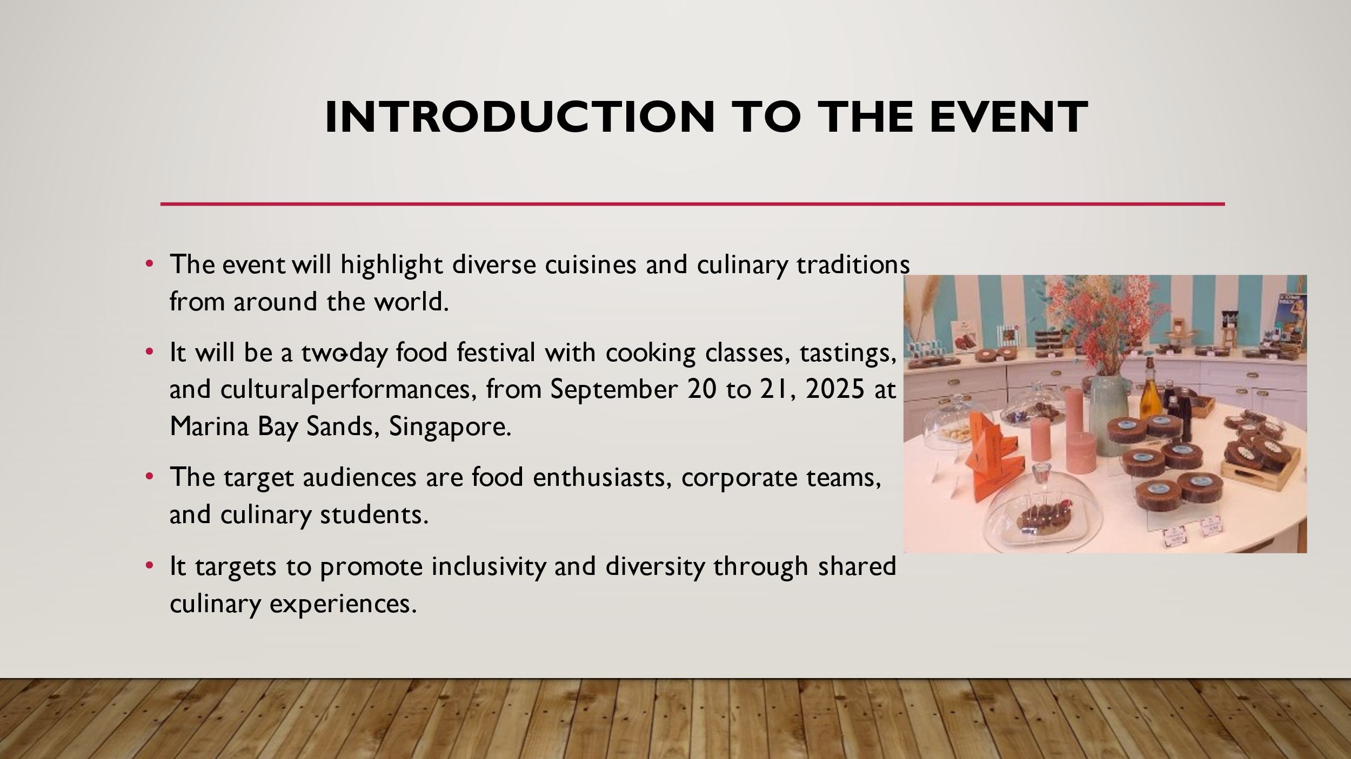
Slide 2:
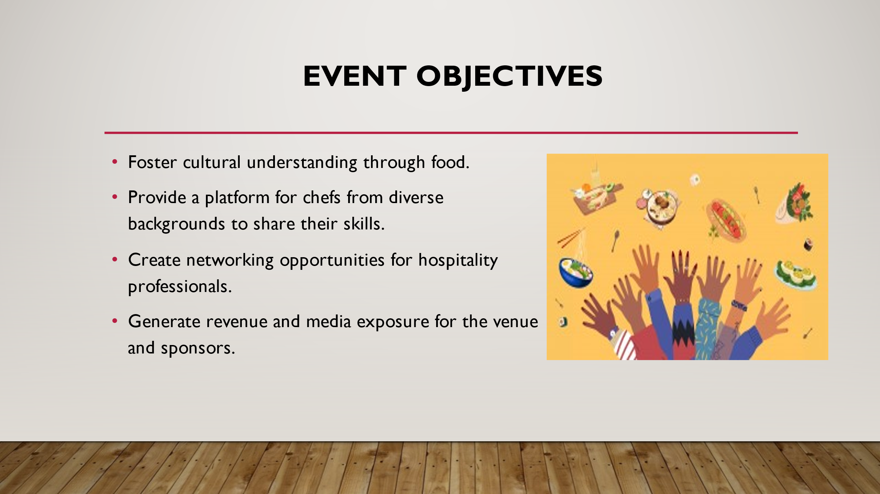
Slide 3
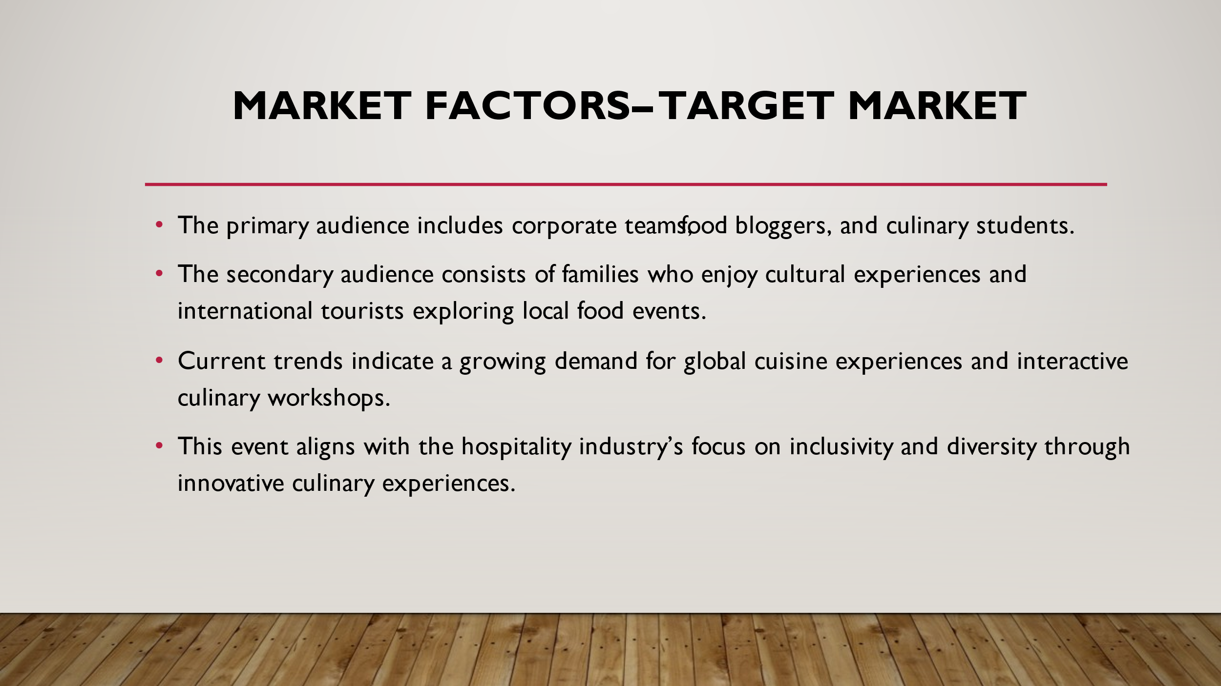

Slide 4:
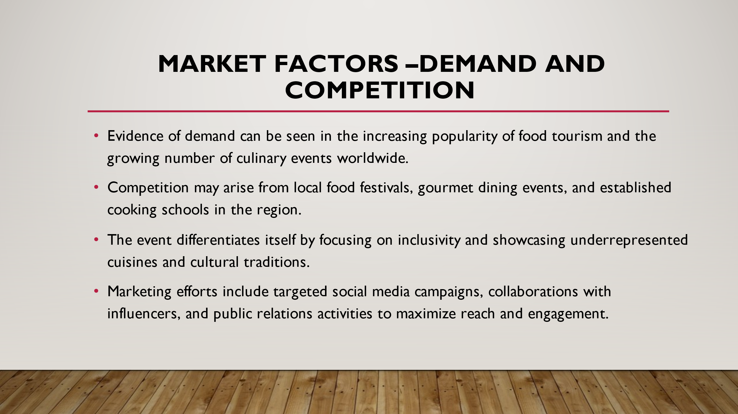
Slide 5:
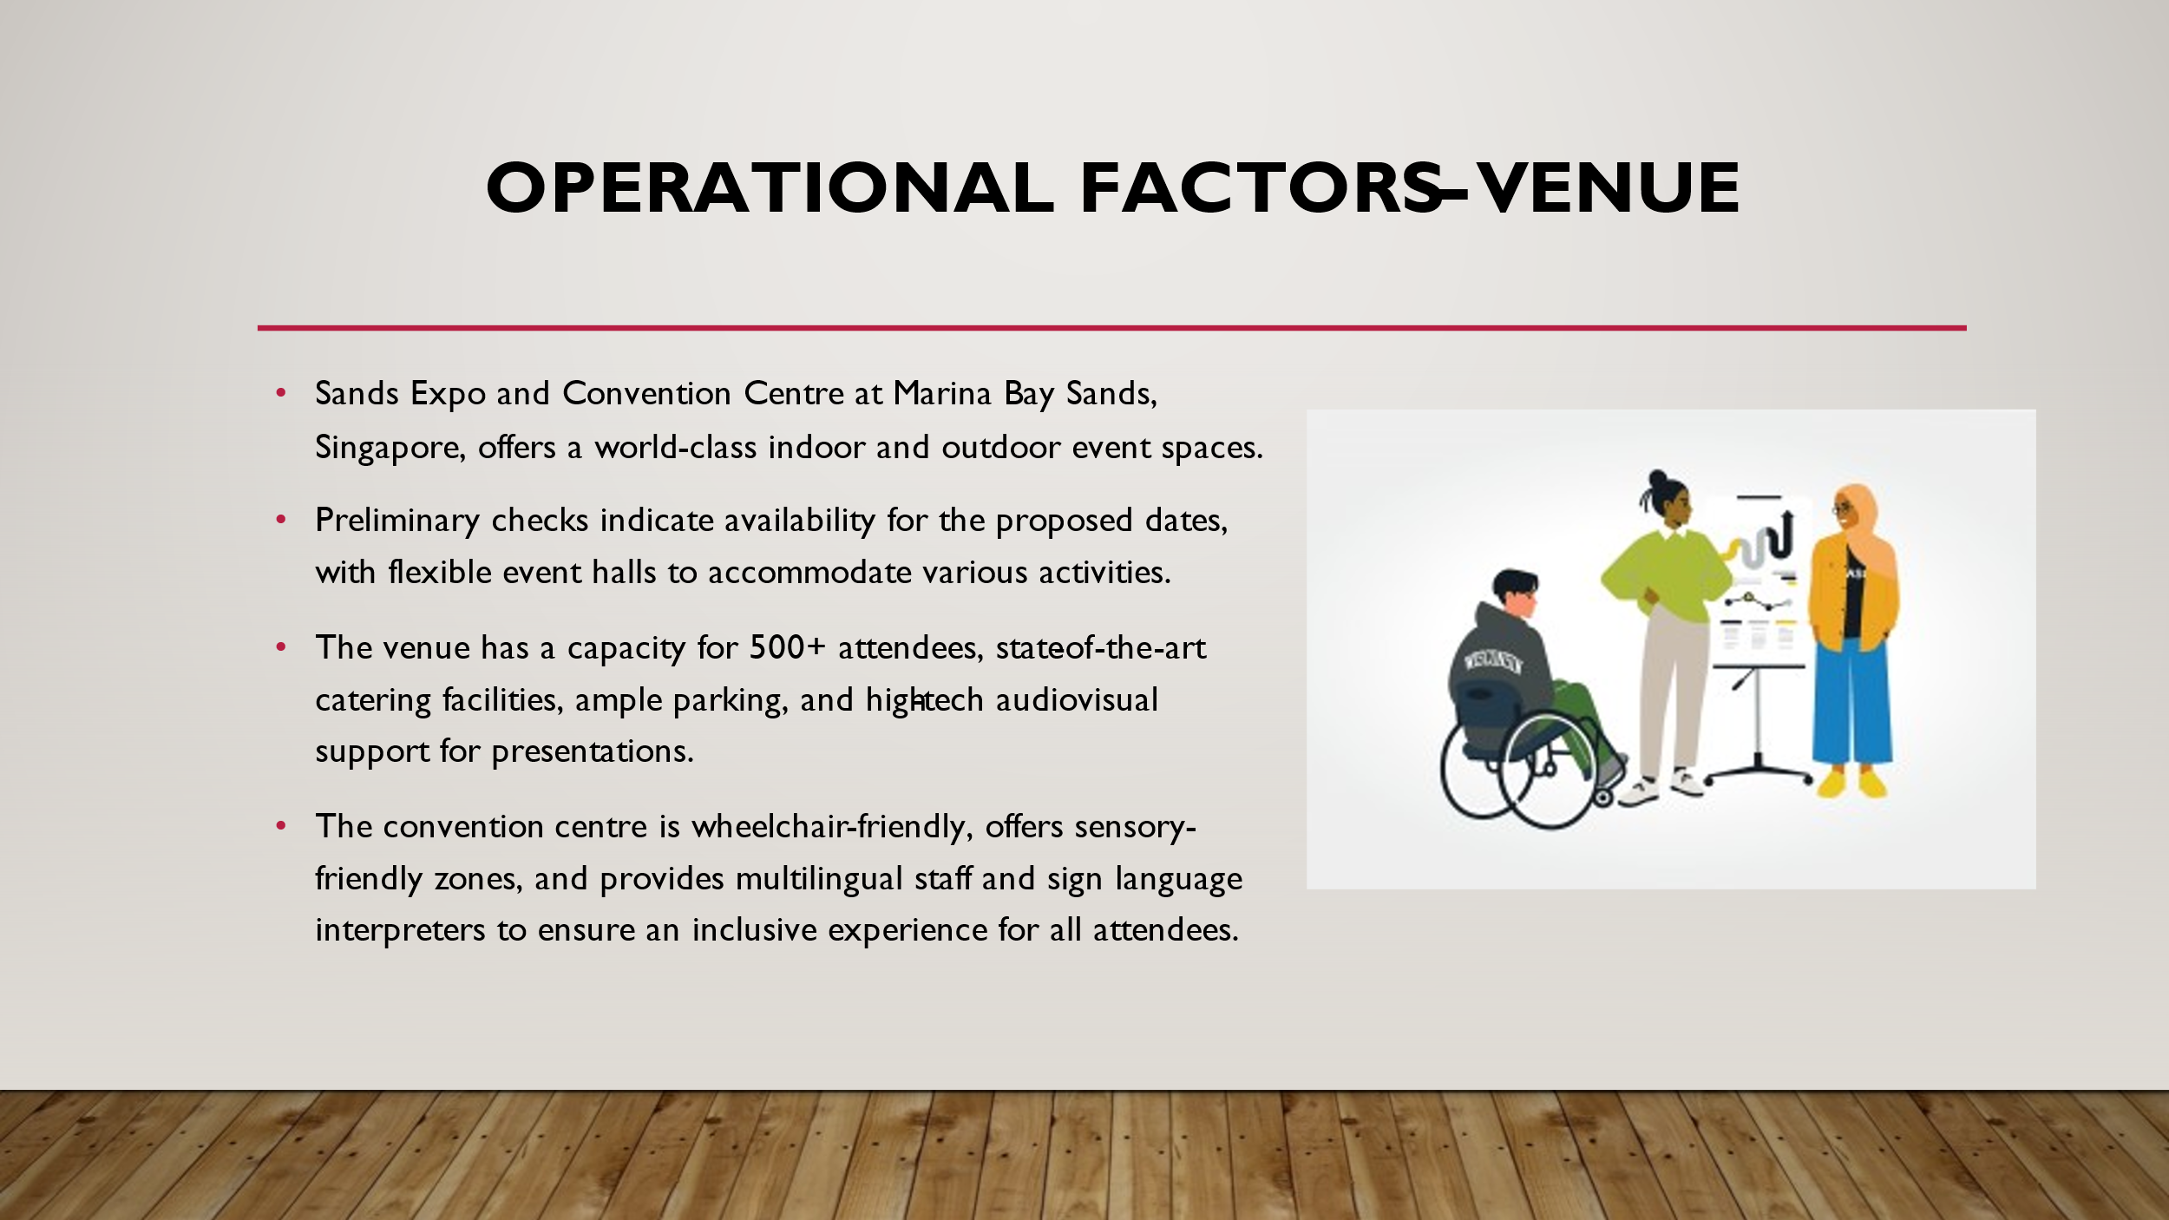
Slide 6:
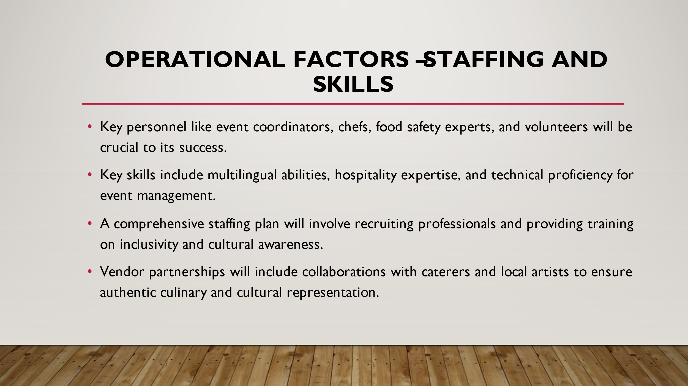
Slide 7:
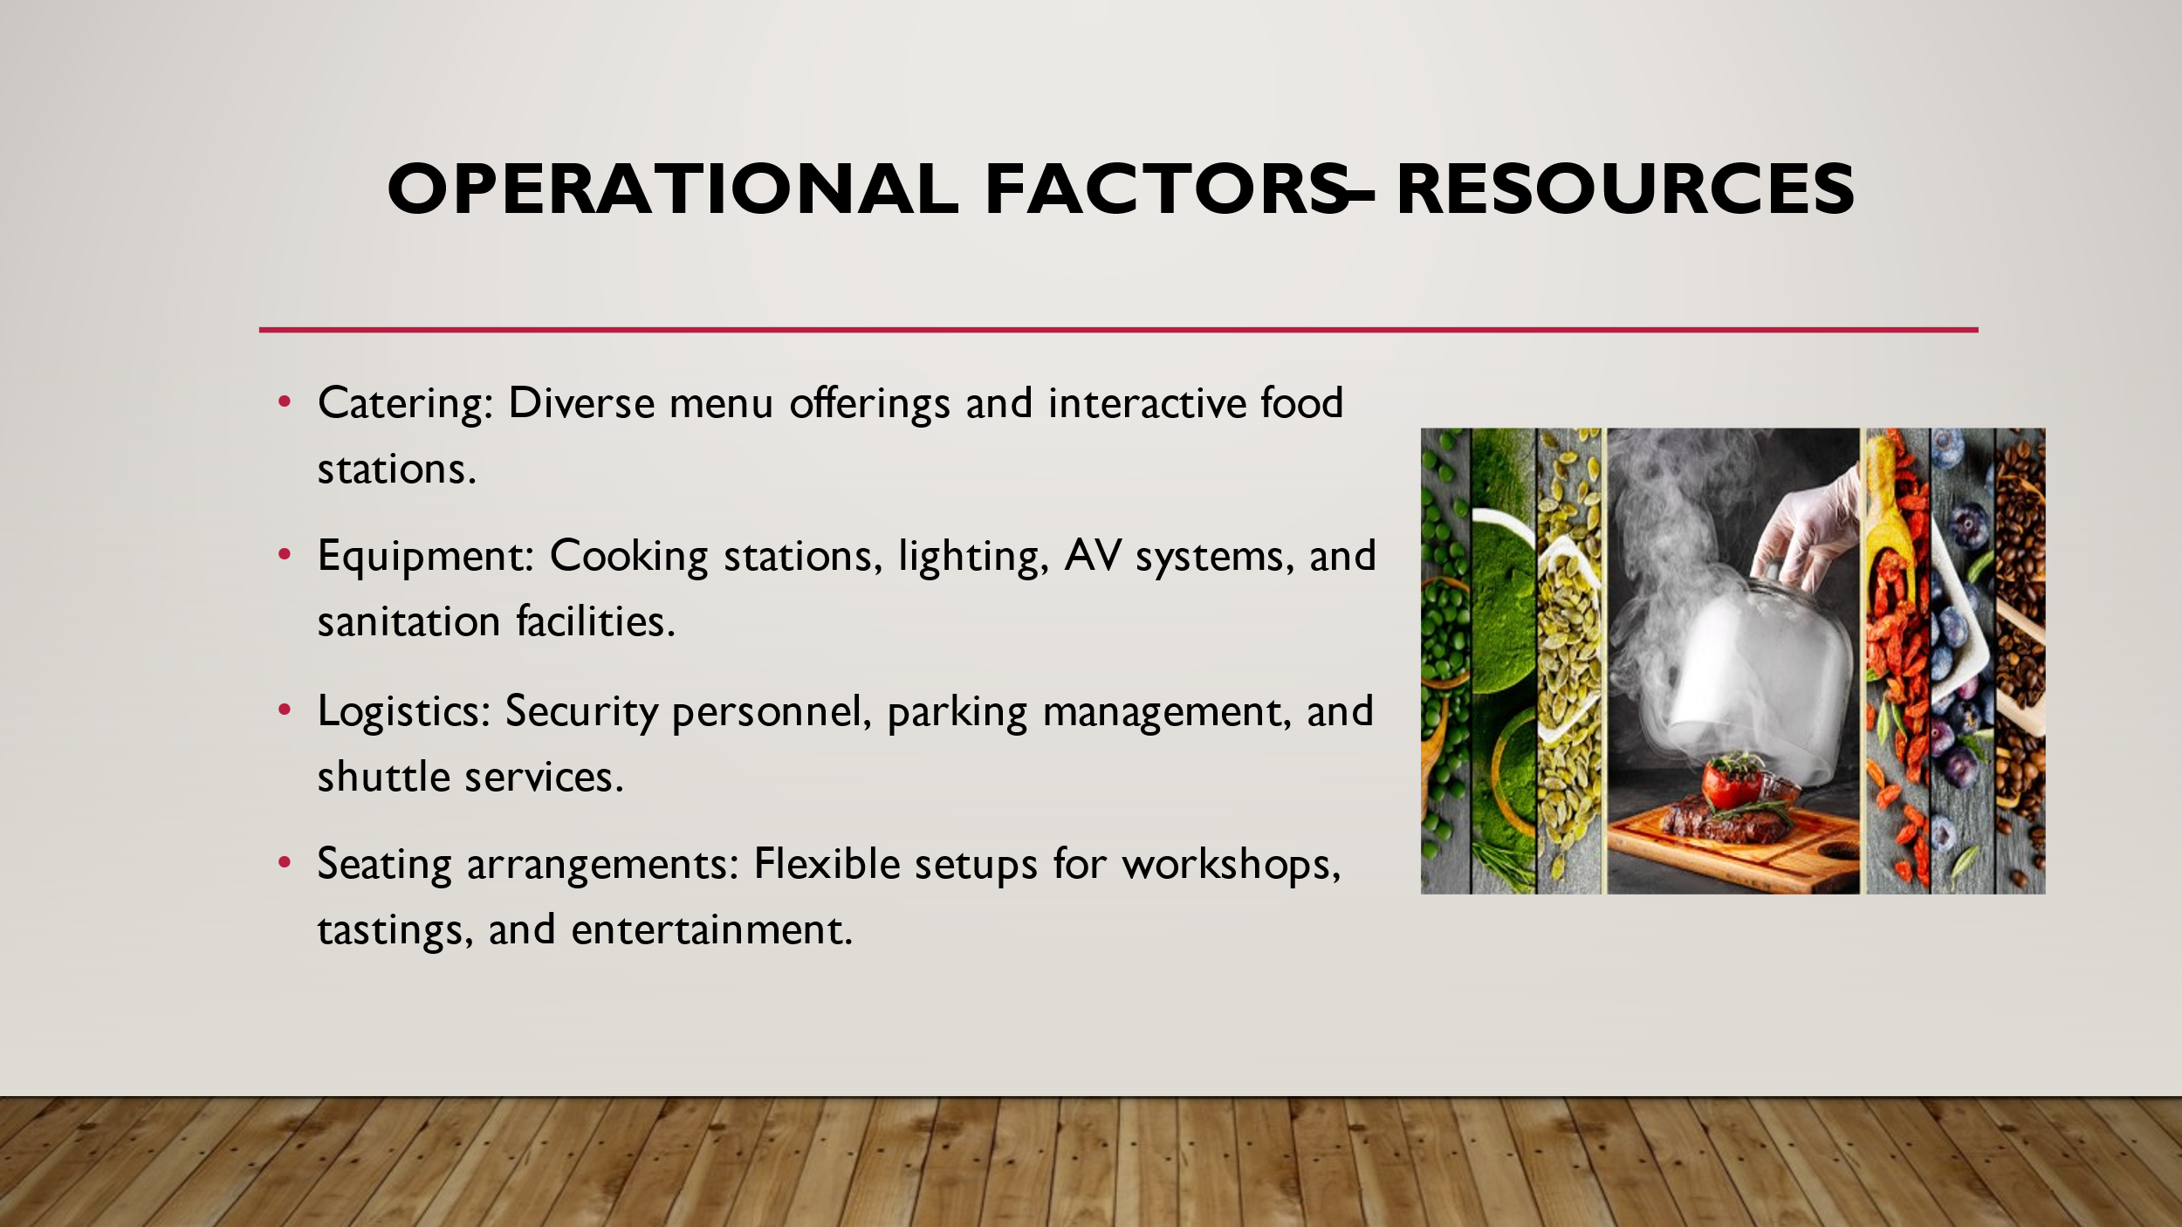
Slide 8:
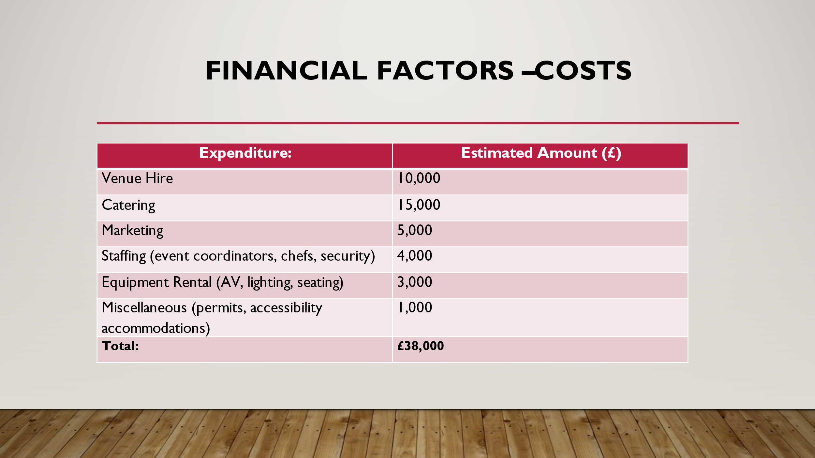
Slide 9:
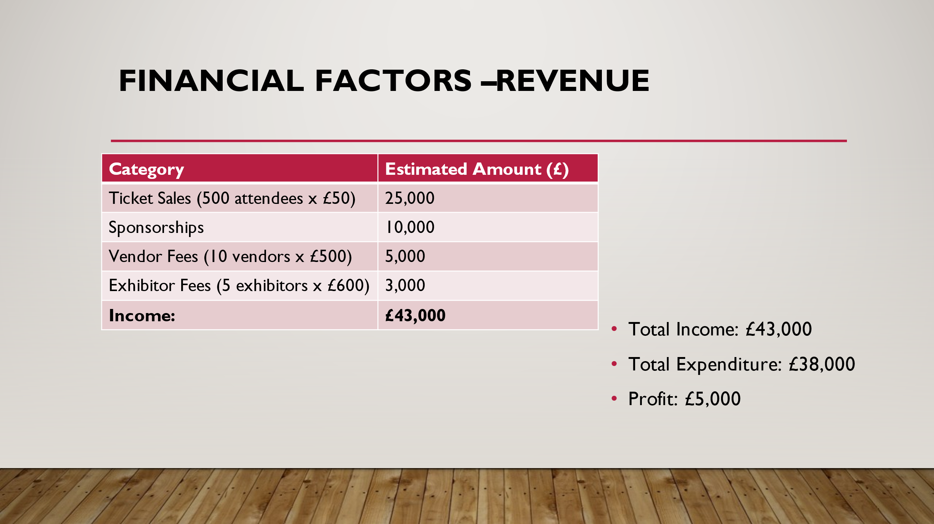
Slide 10:
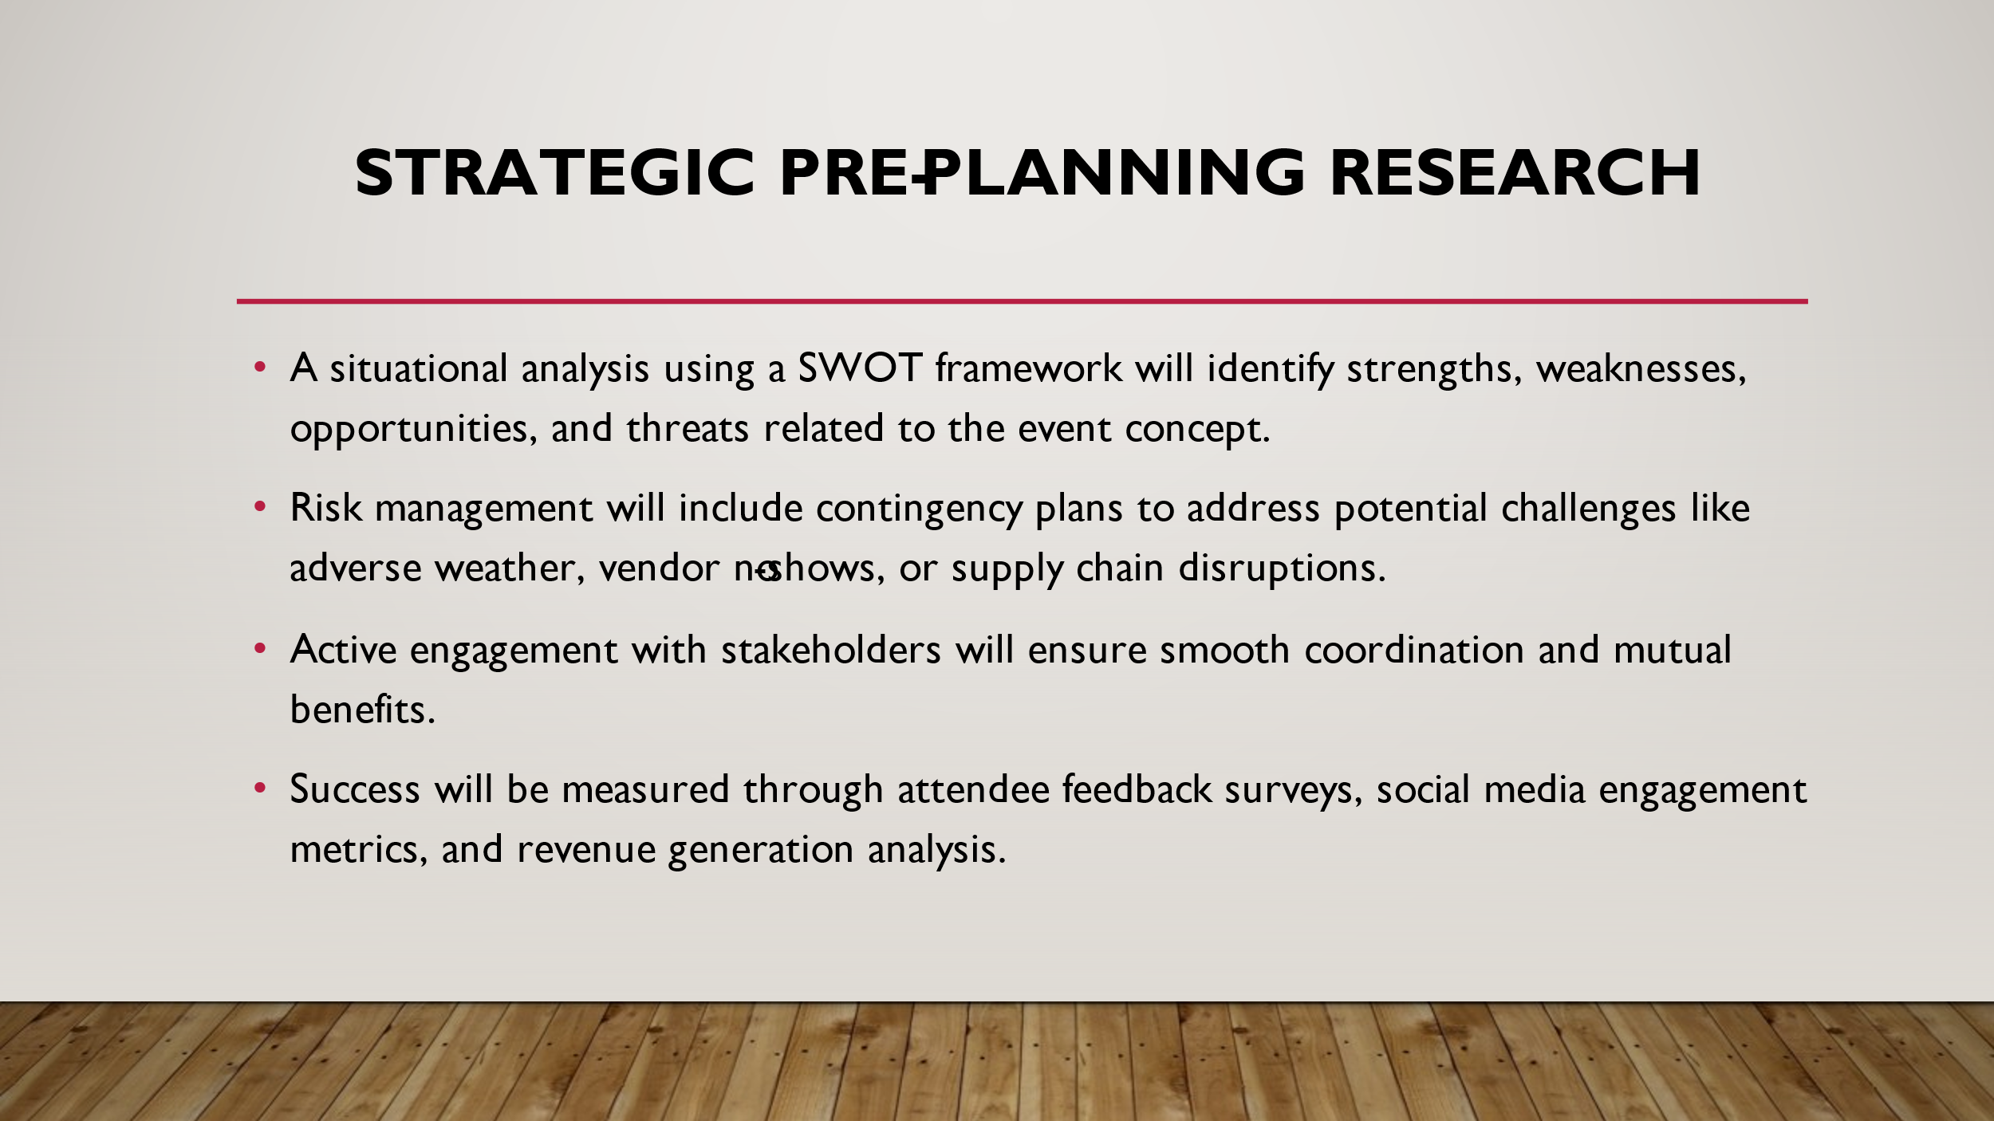
Slide References
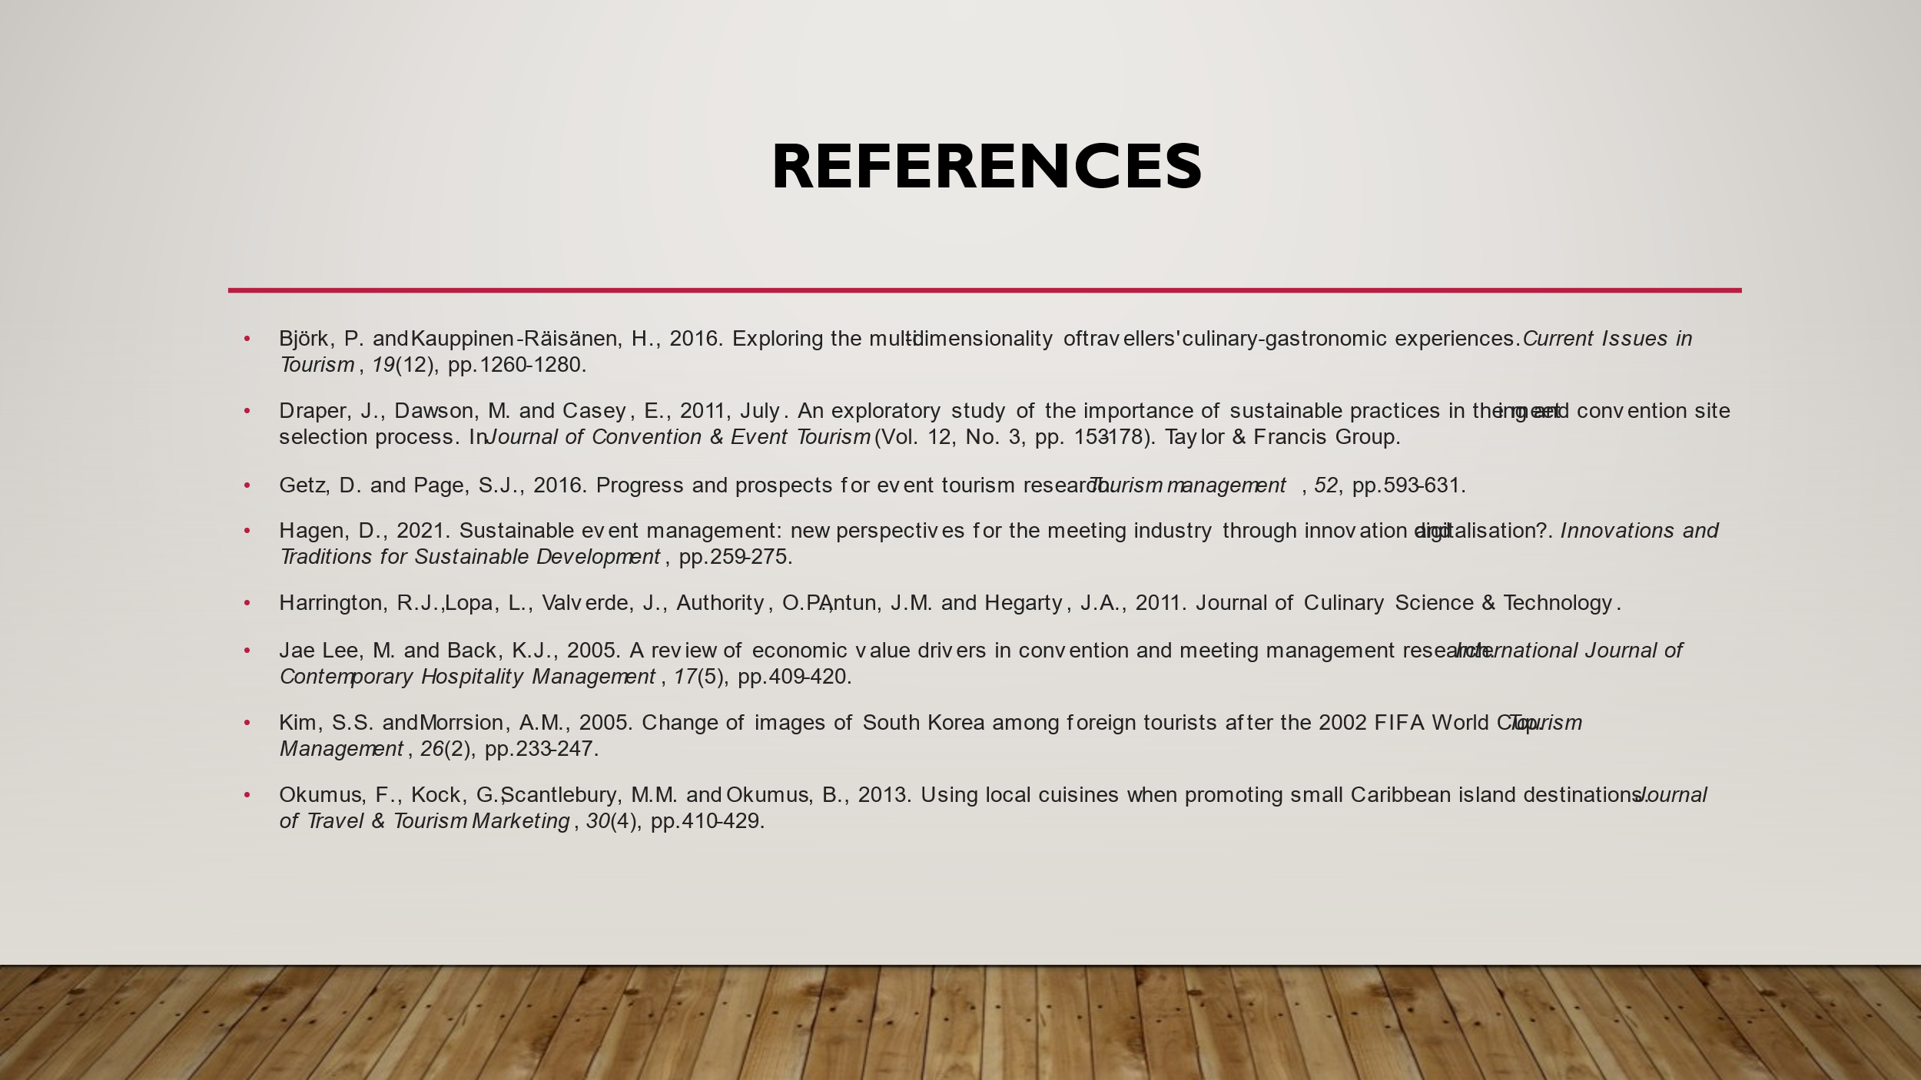
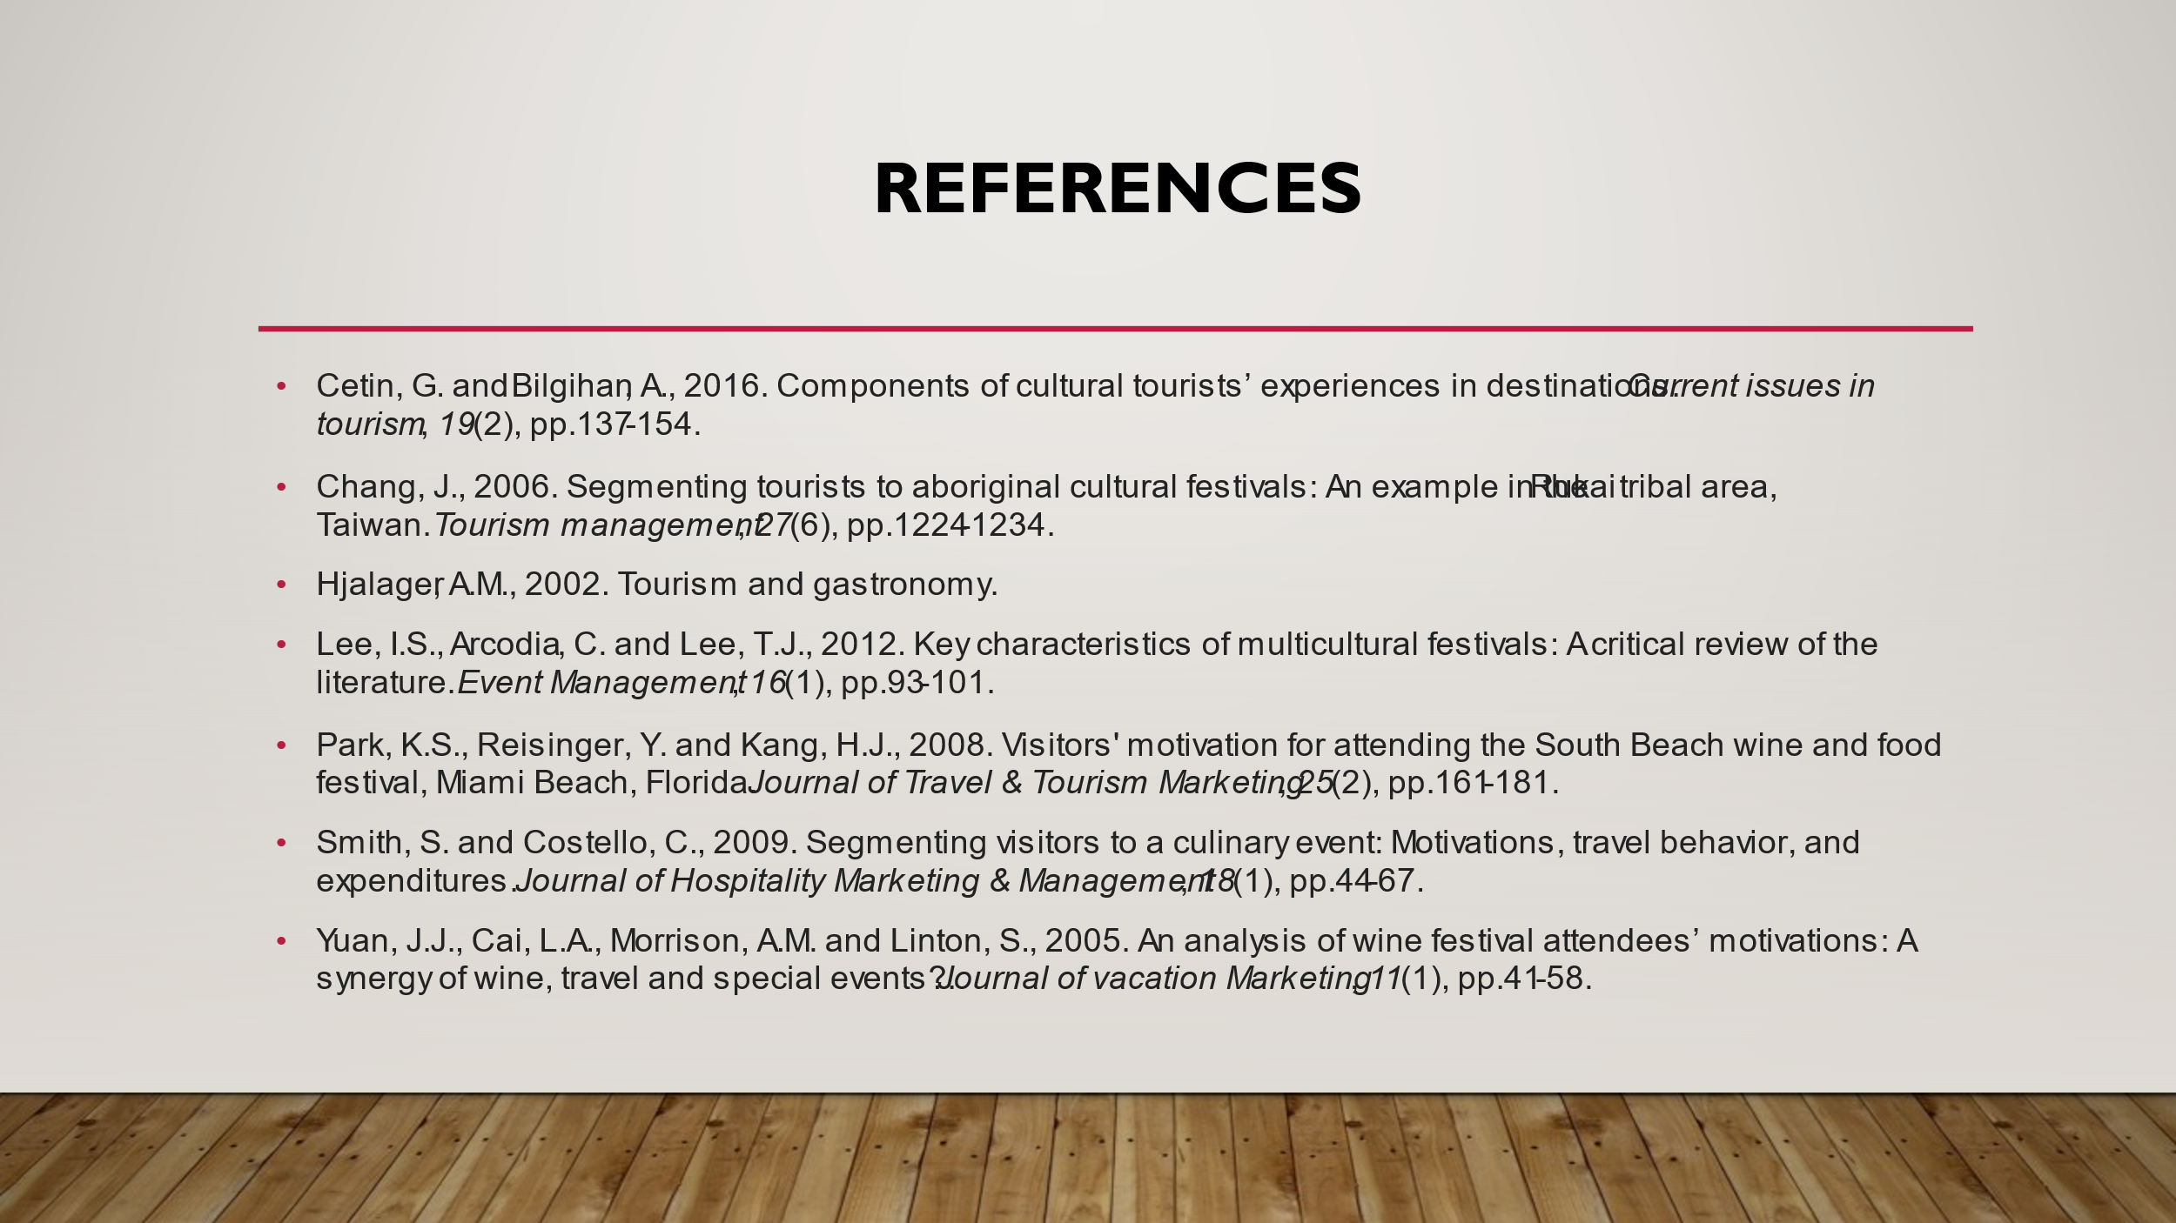
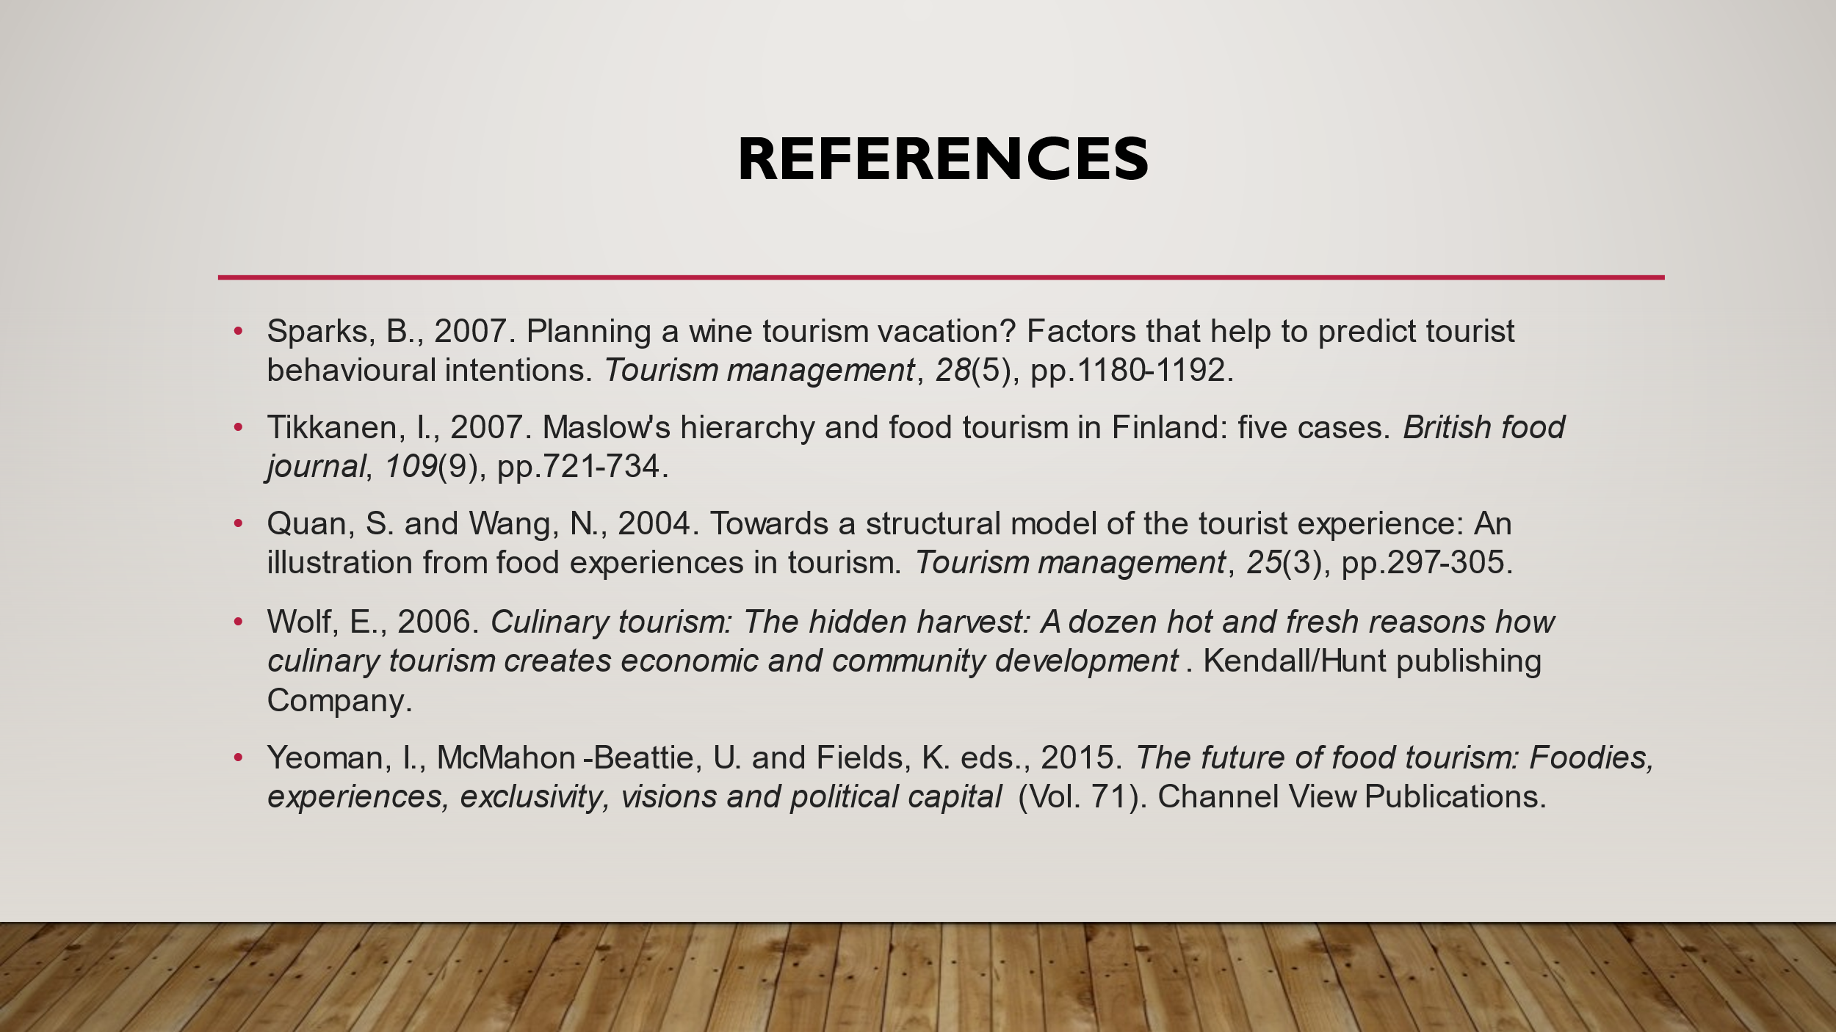

Assignment 2
Planning and Delivering an International Event at Marina Bay Sands, Singapore
The proposed event focuses on the theme of inclusive culinary experiences. It will be planned as a two-day food festival from September 20–21, 2025, to celebrate diversity through culinary traditions and global cuisines. The proposed venue is the Sands Expo & Convention Centre in Singapore. The event will feature cultural performances, cooking workshops and tasting sessions to offer the participants an immersive experience. It takes an initiative to promote inclusivity by highlighting underrepresented cuisines and creating an environment for cultural exchange. These selected themes of inclusive culinary experiences were chosen to address the growing demand for diverse culinary events representing a broader range of traditions and cultures. Food is a crucial aspect of society as it acts as a medium that promotes connections and understanding. This event aims at bridging cultural gaps while celebrating the richness of global cuisines.
Inclusivity stands out as a core value of the event, including efforts to ensure accessibility for all attendees and representation of minority culinary traditions. Further, the event will target at least 500 attendees from across the globe. The Sands Expo and Convention Centre at Marina Bay Sands promotes accessibility, supports catering facilities and provides ample parking. Also, the venue's wheel-chair-friendly infrastructure and proximity to public transportation were among the primary considerations as they offer ideal suitability to a diverse audience. This report focuses on strategic planning and delivery considerations, building on the earlier feasibility analysis. It outlines the necessary steps to ensure the event's success and long-term impact.
The Event Cycle
The event cycle is a structured framework outlining the key stages in planning, executing, and evaluating events. This cycle ensures systematic organisation and successful delivery of an event. The Goldblatt Event Management Cycle is used for this event, and it includes four stages: initiation, planning, implementation, and evaluation. These stages are crucial in offering a strategic approach to managing events effectively and aligning objectives with the intended outcomes.
- Initiation: This stage involves a clear definition of the purpose and objectives of the event (Goldblatt, 2000). The initiation stage for the inclusive culinary experience event consists of determining the theme of cultural inclusivity, setting SMART objectives, and assessing feasibility. Market research, planning of the preliminary budget, and stakeholder engagement are necessary at this stage to establish a strong foundation.
- Planning: This stage mainly focuses on logistics and resource allocation for the event (Goldblatt, 2000). Fundamental elements at this stage include securing the venue, scheduling activities, recruiting diverse chefs and performers, and developing a marketing strategy. Other critical elements addressed in the stage include risk assessment, vendor contracts and ensuring inclusivity measures are met before the event.
- Implementation: This stage is associated with executing the planned activities and ascertaining effective coordination of workshops, performances and tasting sessions (Goldblatt, 2000). Also, this stage is related to real-life problem-solving and ensuring effective communication among staff.
- Evaluation: This is the last stage of the event cycle, measuring the event's success through metrics like social media engagement, attendee feedback, and financial performance (Goldblatt, 2000). The information obtained in this phase is usually crucial for improvements in the future to ensure continued impact and relevance.
Event Concept
The "Inclusive Culinary Experiences" event is an innovative initiative to celebrate global diversity through food, offering attendees a rich tapestry of culinary and cultural encounters. Over two days, participants will be immersed in a carefully curated program emphasising learning, participation, and artistic appreciation. The event blends hands-on activities, educational panels, and social engagement to ensure attendees understand the connections between food, culture, and inclusivity (Allen et al., 2012). Every detail, from the event layout to the menu options, is thoughtfully planned to align with the theme of inclusivity and cater to a diverse audience.
Day 1: Culinary Exploration and Cultural Showcases
The first day commences with interactive cooking classes, allowing chefs from different cultural backgrounds to interact with participants and teach them how to prepare their iconic dishes. The audience will be allowed to participate in preparing various cuisines and learning the dishes' history and preparations. The chefs will share stories relating to the cultural significance of their dishes, bridging the gap between cultural traditions and culinary practices. These sessions are crucial in promoting engagement and understanding, enabling the attendees to connect with the stories behind the food. The afternoon schedule will be shifted to celebrations through cultural performances, including musical presentations, traditional dances, and storytelling sessions. The performance highlights culinary customs' history and significance within a cultural context. Also, they offer a multidimensional experience of the culture. For example, a specific traditional dance can be accompanied by explanations about the preparations of traditional dishes. This approach helps to establish a vivid connection between the art form and its gastronomic roots. Additionally, the food stalls showcasing cuisines from different parts of the world will be set up around the venue, offering attendees the chance to sample everything from other parts of the world. Since the event targets inclusivity, vendors must be carefully selected to represent all dietary preferences and restrictions like halal, vegan, and kosher options.
Day 2: Thoughtful Dialogues and Festive Farewell
After an eventful day 1, the second day will focus on reflection and dialogue to offer feedback and farewell. Morning hours should be designated for panel discussions with chefs, food historians, and community leaders, exploring various themes, including the impact of globalisation on traditional cuisines and leveraging culinary practices to promote inclusivity. Such discussions motivate audience participation, especially if live Q&A sessions are incorporated to encourage deeper engagement. The afternoon will be designated for tasting sessions to allow attendees to meet the chefs, sample their creations and hear firsthand about the significance of their dishes. These sessions are intended to deepen the participants' appreciation of underrepresented cuisines while showcasing the commonalities that unite global food traditions.
The event will climax with a gala dinner, representing a grand celebration of unity through food. The menu for dinner will be made up of a creative mix of dishes, bringing out a blend of culinary traditions to symbolise cultural harmony. The dinner will be made up of speeches from the event organisers and chefs to celebrate the achievement of the event's goal of promoting diversity. Various inclusivity measures, including sensory-friendly zones, multilingual staff, and accessibility for persons with disability, are crucial in ensuring inclusivity throughout the event. All attendees will be motivated to participate in the event, thus promoting a welcoming approach. These approaches will make the event memorable and transformative, promoting cross-cultural connection and understanding.
Aim and Objectives of the Event
The underlying aim of the event is to promote culinary inclusivity by celebrating diverse cuisines and traditions, fostering understanding and appreciation among attendees from varied cultural and professional backgrounds. This aim aligns with the event's mission of creating a platform that brings people together through shared culinary experiences, highlighting the unifying power of food. The event is guided by a series of SMART (Specific, Measurable, Achievable, Relevant, and Time-bound) objectives designed to ensure the event's success and sustainability to achieve this aim.
- To attract at least 500 attendees, including corporate teams, culinary students, families, and international tourists.
This objective ensures a diverse and inclusive audience representing various demographics and professional interests. The target of 500 attendees is both measurable and achievable, considering the broad appeal of the event and its carefully curated programming. Strategic marketing initiatives will be employed, such as social media campaigns, collaborations with influencers in the culinary and travel sectors, and partnerships with educational institutions and corporate organisations. These efforts aim to generate interest and drive ticket sales while emphasising the inclusive nature of the event. Singapore is a global tourist hub, and the venue's accessibility at the Marina Bay Sands further supports this objective, making it convenient for attendees to participate.
- It will feature chefs and vendors representing at least 10 underrepresented cuisines, ensuring inclusivity in culinary representation.
This objective highlights the event's commitment to diversity and its focus on amplifying often overlooked voices and cuisines. The selection of chefs and vendors will be guided by rigorous research to identify underrepresented cuisines, ensuring the inclusion of various cultural perspectives. Invitations will be extended to chefs specialising in Indigenous, African, and Middle Eastern cuisines. Vendor selection will also prioritise inclusivity, focusing on small businesses and community-based food entrepreneurs. This approach ensures attendees gain exposure to a rich fabric of culinary traditions while supporting underrepresented groups in the food industry.
- To achieve a minimum 90% satisfaction rate among attendees based on post-event feedback surveys.
Ensuring a positive attendee experience is critical to the event's success and sustainability. This objective is measurable through post-event surveys that assess satisfaction with various aspects, such as programming quality, accessibility, and overall organisation. The event will prioritise seamless execution, from providing precise schedules to ensuring ample facilities and accommodations. Multilingual staff, sensory-friendly zones, and dietary-inclusive food options will cater to diverse needs, enhancing the experience for all participants. Real-time feedback mechanisms during the event, such as suggestion boxes or quick surveys, will allow for immediate adjustments to address concerns.
The event should target aligning these SMART objectives to create a strategic planning and delivery framework. Each objective is tailored to specific aspects of the event, from audience engagement to culinary representation and attendee satisfaction. Together, they ensure that the event celebrates diversity and is a model for inclusive and effective event management.
Event Management
Effective event management is crucial to the event's success, requiring a combination of operational, planning, and marketing activities (Bladen et al., 2022). These components work together to ensure seamless execution, while risk management and contingency planning provide a safety net to address unforeseen challenges.
Operational Activities
Operational activities include the logistical groundwork required to execute the event. The proposed venue is Marina Bay Sands, Singapore City, Singapore. This location was chosen because of its renowned culture and cuisine. Singapore has diverse food scenes reflecting Chinese, Malay, Indian, and Peranakan influences. This multicultural food landscape aligns perfectly with the theme of Inclusive Culinary Experiences, making it an ideal destination for the event. The Sands Expo & Convention Centre at Marina Bay Sands provides a premier venue with cutting-edge facilities, flexible spaces, and dedicated areas for cooking demonstrations and discussions.
Venue setup is a primary focus, ensuring the indoor and outdoor spaces at Marina Bay Sands are well-equipped for cooking demonstrations, cultural performances, and panel discussions. Accessibility features, such as wheelchair-friendly areas and sensory-friendly zones, must be installed before the event. Catering teams must be briefed on providing inclusive food options, considering diverse dietary needs such as vegan, halal, and gluten-free preferences. Staff training is another critical operational activity (Bladen et al., 2022). The event will involve multilingual staff, hospitality professionals, and technical teams proficient in managing live demonstrations, event equipment, and crowd control. Training will emphasise cultural sensitivity, inclusivity awareness, and first aid to handle emergencies. Resource allocation will be planned effectively to avoid last-minute issues.
Planning Activities
Planning is the backbone of the event, ensuring every detail is accounted for well in advance (Bowdin et al., 2023). A detailed schedule will be developed to outline activities for both event days, including cooking classes, cultural performances, panel discussions, and the closing gala. This schedule will be shared with stakeholders, including chefs, vendors, sponsors, and staff, ensuring alignment and preparedness among all stakeholders. Stakeholder engagement is integral to planning. Regular communication with chefs and vendors will ensure their requirements are met, while sponsors will be updated on event progress to maintain their confidence and support (Bladen et al., 2022). Contracts and agreements with vendors and service providers will be finalised to mitigate potential delays or misunderstandings. Additionally, permits and licenses for food handling and large gatherings will be secured during the planning phase.
Marketing Activities
Marketing activities will focus on generating awareness and driving attendance. Social media campaigns will leverage platforms such as Instagram, Facebook, and TikTok, showcasing event highlights, chef profiles, and behind-the-scenes content to build anticipation. Partnerships with influencers in the culinary and travel sectors will amplify the event's reach, targeting key demographics such as food enthusiasts and international tourists. Email outreach will target local businesses, educational institutions, and corporate teams, offering group discounts to encourage participation (Bowdin et al., 2023). PR coverage in regional and global media will enhance visibility, emphasising the event's unique theme of inclusivity and diversity.
Risk Management and Contingency Planning
Risk management is critical to navigating potential challenges. Identified risks include weather disruptions, supply chain issues, and no-show participants (Cohen and Cohen, 2019). Contingency plans are crucial to risk mitigation, such as securing backup indoor venues and alternative vendors. Insurance coverage will protect against financial losses stemming from cancellations or liabilities. Health and safety are also paramount, with measures including on-site medical staff, crowd management protocols, and compliance with food safety regulations (Bowdin et al., 2023). Emergency response plans will be established, with staff trained to handle evacuations or medical incidents.
Event Budget
The event will require a well-structured budget to ensure a successful execution and ascertain financial feasibility while delivering a high-quality experience.
Income Sources
The event's income will primarily derive from ticket sales, sponsorships, and vendor fees. Ticket sales are projected at £20 per attendee, with an estimated attendance of 500 people, generating £10,000. Sponsorships from local businesses, food brands, and cultural organisations are expected to contribute £15,000, while vendor fees for food stalls and promotional booths are projected to bring in an additional £8,000. The total estimated income stands at £33,000.
Expenditure Breakdown
The primary expenditures include venue hire (£10,000), catering (£15,000), staffing (£4,000), marketing (£5,000), equipment rental (£3,000), and miscellaneous ((£3,000), to cover costs like permits and accessibility accommodations. Venue costs are justified by the selection of Marina Bay Sands, a world-class venue in Singapore, a global culinary hub and a major tourist destination, and has strong policies supporting diversity. Catering expenses reflect the inclusive menu options catering to diverse dietary preferences.
Expenditure: | Estimated Amount (£)
Venue Hire | 10,000
Catering | 15,000
Marketing | 5,000
Staffing (event coordinators, chefs, security) | 4,000
Equipment Rental (AV, lighting, seating) | 3,000
Miscellaneous (permits, accessibility accommodations) | 1,000
Total: | £38,000
Funding and Revenue Strategies
Strategic partnerships with sponsors and vendors are crucial to optimise revenue. Marketing efforts will prioritise digital campaigns to drive ticket sales, emphasising the event's unique theme and inclusivity. Investments in accessibility, such as wheelchair-friendly spaces and sign language interpreters, are essential to align with the event's objectives and ensure an inclusive environment for all attendees. Below are the projected revenue streams:
Category | Estimated Amount (£)
Ticket Sales (500 attendees x £50) | 25,000
Sponsorships | 10,000
Vendor Fees (10 vendors x £500) | 5,000
Exhibitor Fees (5 exhibitors x £600) | 3,000
Income: | £43,000

Industry Trends, Issues, and Impacts
The event industry is evolving, with several key trends influencing strategic planning. One of the most prominent trends is sustainability, with increasing pressure on event organisers to reduce their environmental impact (Laing, 2018). This includes minimising waste, using sustainable materials, and promoting eco-friendly practices. The "Inclusive Culinary Experiences" event can address this trend by sourcing local, sustainable ingredients and reducing single-use plastics through eco-conscious vendor partnerships (Green and Dougherty, 2008).
Another trend is the growing demand for hybrid event formats. As more events integrate in-person and virtual components, providing accessibility for a wider audience becomes essential (Mair and Jago, 2010). While this may not be central to the event concept, providing virtual workshops or cooking demonstrations could attract a global audience, promoting inclusivity beyond geographical limits. There is also an increasing demand for diverse cultural experiences, especially in the food industry. Attendees are seeking opportunities to explore and celebrate global culinary traditions. This aligns well with the event's theme and will appeal to the growing number of people interested in cultural and culinary diversity.
However, these trends also present challenges. Rising costs may strain the event's budget, particularly in venue hire, catering, and sustainable materials (Cohen and Cohen, 2019). Furthermore, cultural sensitivity is critical when showcasing diverse cuisines. Ensuring that the representations of various cultures are respectful and accurate is vital. These factors must be carefully considered during the strategic planning phase to ensure the event is both inclusive and financially viable.
Situational and Cultural Considerations
A PESTEL analysis helps understand the situational and cultural factors influencing the event. This analysis explores Political, Economic, Social, Technological, Environmental, and Legal factors that may impact the event.
- Political and Legal considerations are crucial, particularly when organising large-scale public events. Compliance with local regulations, including health and safety standards, permits, and licensing, is essential (Getz and Page, 2019). The event must follow all public event regulations, such as food safety, COVID-19 protocols, and accessibility laws. This is especially important when showcasing diverse cuisines to avoid legal issues related to food handling and vendor operations.
- Economic factors, including budget constraints, are always a concern. These factors influence both the costs associated with organising the event and the potential spending power of attendees. With rising event production costs, including venue rental, catering, and staffing, balancing these with anticipated income from ticket sales, sponsorships, and vendor fees is crucial for profitability. Understanding the economic environment allows for effective budget management and resource allocation.
Cultural considerations are vital for creating an inclusive and respectful environment. The event's theme revolves around celebrating diverse culinary traditions, so it's critical to represent each culture authentically and respectfully. Cultural sensitivity is necessary when selecting cuisines and engaging with chefs from various backgrounds (Getz and Page, 2019). Misrepresentation or cultural appropriation can lead to backlash and damage the event's reputation. Ensuring proper consultation with cultural experts and communities helps maintain a positive and inclusive atmosphere, which is essential for the success and credibility of the event.
Conclusion
The strategic planning and delivery of the "Inclusive Culinary Experiences" event are integral to ensuring its success. The organising team must follow a detailed event cycle and focus on operational, planning, and marketing activities to promote culinary inclusivity. Choosing a global culinary and tourist hub like Singapore, thoughtful venue selection like Marina Bay Sands, staffing requirements, and risk management strategies support a seamless event execution. The budget breakdown, transparent funding sources, and revenue strategies further solidify the event's financial viability. This event's focus on inclusivity, through the celebration of diverse cuisines, offers an opportunity to highlight cultural representation and respect within the culinary and hospitality sectors. Also, featuring underrepresented cuisines and creating a platform for chefs from various backgrounds will enable the event to provide unique culinary experiences and foster a sense of belonging and appreciation for diverse traditions. Strategically, this event aligns with current industry trends of sustainability, cultural diversity, and hybrid formats. It addresses key challenges such as cultural sensitivity and rising costs by incorporating effective planning, stakeholder engagement, and innovation. The "Inclusive Culinary Experiences" event sets a standard for inclusivity in the hospitality sector, contributing to a more diverse, accessible, and culturally enriched culinary landscape.

References
Allen, J., O'Toole, W., Harris, R. and McDonnell, I., 2012. Festival and special event management, Google eBook. John Wiley & Sons.
Bladen, C., Kennell, J., Abson, E. and Wilde, N., 2022. Events management: An introduction. Routledge.
Bowdin, G.A., Allen, J., Harris, R., Jago, L., O'Toole, W. and McDonnell, I., 2023. Events management. Routledge.
Cohen, S.A. and Cohen, E., 2019. New directions in the sociology of tourism. Current Issues in Tourism, 22(2), pp.153-172.
Getz, D. and Page, S.J., 2019. Event studies: Theory, research and policy for planned events. Routledge.
Green, G.P. and Dougherty, M.L., 2008. Localising linkages for food and tourism: Culinary tourism as a community development strategy. Community Development, 39(3), pp.148-158.
Goldblatt, J., 2000. A future for event management: The analysis of major trends impacting the emerging profession. Events Beyond, pp.2-9.
Laing, J., 2018. Festival and event tourism research: Current and future perspectives. Tourism management perspectives, 25, pp.165-168.
Mair, J. and Jago, L., 2010. The development of a conceptual model of greening in the business events tourism sector. Journal of Sustainable Tourism, 18(1), pp.77-94.

