COMMUNITY ENGAGEMENT
LCBB4011

IONUT HRISCA
STUDENT ID: 2243953
Table of Contents
Introduction 3
Element 1: Community Outreach 3
Element 2: Stakeholder Mapping Exercise 5
Element 3. Community Engagement Plan 7
Element 4. Practical Discussion 12
Conclusion 15
References 16

Introduction
Stakeholder interaction in community enhancement is critical in promoting society’s coherence, inclusiveness and prosperity (Baba, Mohammad and Young, 2021). The present discussion is primarily based on the case of the Romanian Community in Canterbury, which is stated to be a non-profit and non-politival social group. Romanian Community in Canterbury is open to all Romanian members regardless of their ages, genders, professional backgrounds and ethnicities. town in respect of its culture, social structure, and economy. As for the mix of people, many of Canterbury’s population have different ethnicities, ages and income levels, which is why community work to help the consumers who are Canterbury inhabitants is rather important. Its technique of stakeholder identification, engagement, elaboration of stakeholder maps and engagement plans show that the more the stakeholders are involved from all the sectors, the better it is for the town. If the executed strengths and the threats are, Canterbury can foster community cohesion, promote the local economy, and embrace multiculturalism. This not only identifies how these engagement efforts are theore­tically grounded but also demonstrates the author's own experience in the community to authenticate the paradigm shift of the stakeholder engagement processes at work.

Element 1: Community Outreach
The Romanian Community in Canterbury – RCC which is more formally known in Romania as Comunitatea Românilor din Canterbury, Kent is a very vibrant although associate member of EMIC (EMIC, 2024). Founded in October 2014, RCC was formerly called the Romanian Social Club Canterbury the board members are volunteers of different professions who arrived in Canterbury in the 1990s, 2000s and 2010s. It is a non-profit and non-political organisation where all Romanian residents of any gender, age, ethnicity and occupation are welcome. Thus, the group’s objectives adopted at the meeting are the social integration of the Romanian brand of individuals into British society and establishing cultural interchange between the Romanian community and other ethnic groups in the area. Under the auspices of EMIC and with its help and support, RCC has been able to arrange several social and cultural events from Romania and for the Romanian community in particular and for the local people as a whole.
Social factors: Canterbury is an ancient city located in the South Eastern part of England and boasts of a number of social structures owing to its historical background and the changing worldview. Besides, Canterbury is in many ways a medieval city and is first of all a place of pilgrimage, with a focus on the Canterbury Cathedral. Estrin attributes the strong culture of the city to the inhabitants of the city being many locals, students from the universities and visitors from other countries. Some of the key attractions include presence of several universities including the University of Kent and Canterbury Christ Church University which give the neighborhood a young vibrant look. Also Canterbury as a city is known globally and has been recognized as a UNESCO World Heritage site; this acts as a pulling factor globally hence impacting on the economy and social relations. Healthy living in the community has become possible due to natural surroundings and seaside destinations. The local authority of OHID helped to support health facilities with transparency.

Economic factors: Canterbury in Kent is an economically heterogeneous city that has much to gain from history, education and tourism. Being one of the UNESCO world heritage sites, the city hosts millions of tourists every year contributing largely in hospitality industry as well as trading and tourism activities of the state (Gill, Moore and Winder, 2022). The presence of University of Kent as well as the Canterbury Christ Church University also helped in growing the economy of the region through provision of employment and through growth and development policies and researches. Nevertheless, Canterbury has various economic problems. Since tourism is very central to the operation of the city, it becomes very sensitive to changes in the numbers of tourists due to factors such as a global pandemic. This makes the tourism sector as a whole have a seasonal economy, and that is making business establish in that sector to have their income fluctuate within a particular period.
Moreover, it has the problem of maintaining the historic character of the city while providing facilities and businesses required by the contemporary globe the conflict between the restoration of older buildings and structures or constructing new buildings to meet the needs of the global market. Hence, Canterbury in Kent being a buoyant touristic destination, it caters for approximately 7.8 million visitors in 2019 (Hersey, 2022). The results further show that The number of tourism jobs across the district was 5.9% increased between 2017 to 2019. While it had risen by only 5.9% between 2017 and 2019, to 10,707 and constituted 15% of Canterbury’s total employment last year (Hersey, 2022).

Cultural factors: The diversity and equality in the Romanian Community in Canterbury increased cultural inclusiveness. The unique and innovative culture within the Romanian Community in Canterbury enhanced the scope of maintaining diversity and inclusion. Ethnicities in the Romanian Community in Canterbury have created scope to support collaborative practices to maintain an open-minded and adaptive approach. By considering the ethnicities and cultures, community development in the Canterbury area has become possible. Policies to support cultural ethnicity and diversity also increased awareness within the population about the strategies to empower cultural multiplicity. The Romanian Community in Canterbury also indulged in accepting the global culture to remain active and updated. However, changing culture over time increased the need for acceptance towards sustainability and equality in the community.

Element 2: Stakeholder Mapping Exercise
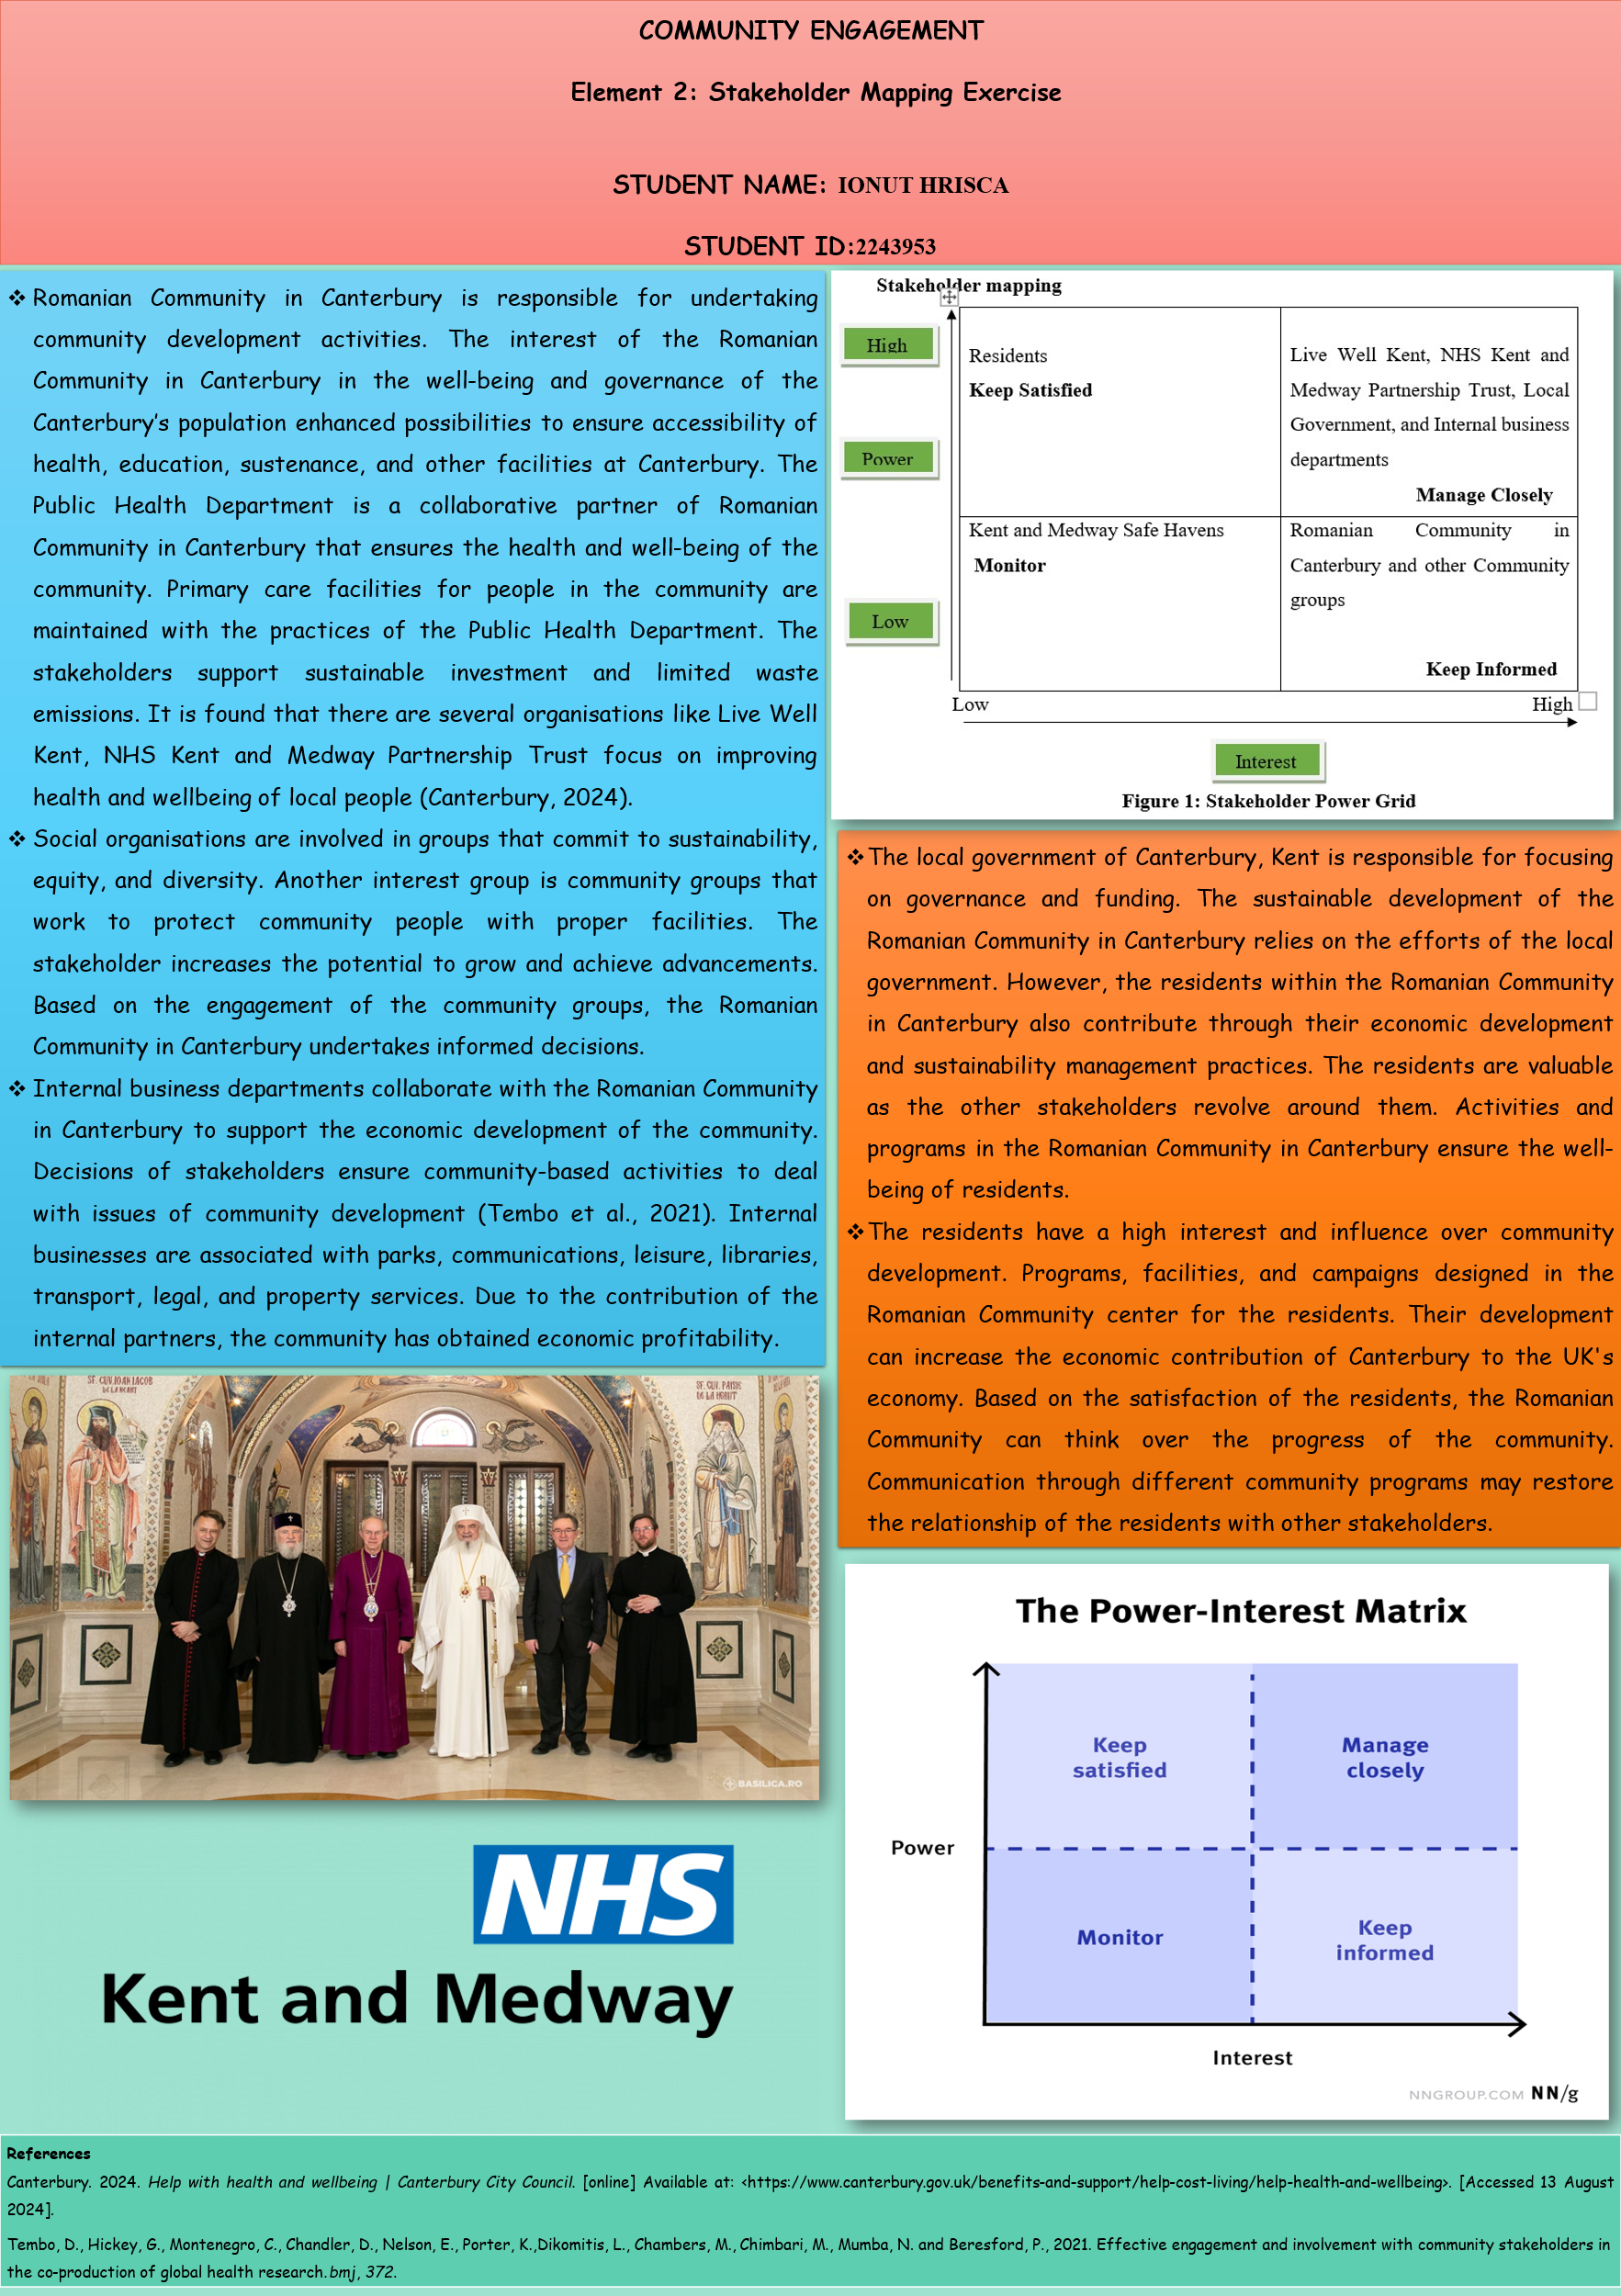
Romanian Community in Canterbury is responsible for undertaking community development activities. The interest of the Romanian Community in Canterbury in the well-being and governance of the Canterbury’s population enhanced possibilities to ensure accessibility of health, education, sustenance, and other facilities at Canterbury. The Public Health Department is a collaborative partner of Romanian Community in Canterbury that ensures the health and well-being of the community. Primary care facilities for people in the community are maintained with the practices of the Public Health Department. The stakeholders support sustainable investment and limited waste emissions. It is found that there are several organisations like Live Well Kent, NHS Kent and Medway Partnership Trust focus on improving health and wellbeing of local people (Canterbury, 2024).
Social organisations are involved in groups that commit to sustainability, equity, and diversity. Another interest group is community groups that work to protect community people with proper facilities. The stakeholder increases the potential to grow and achieve advancements. Based on the engagement of the community groups, the Romanian Community in Canterbury undertakes informed decisions.
Internal business departments collaborate with the Romanian Community in Canterbury to support the economic development of the community. Decisions of stakeholders ensure community-based activities to deal with issues of community development (Tembo et al., 2021). Internal businesses are associated with parks, communications, leisure, libraries, transport, legal, and property services. Due to the contribution of the internal partners, the community has obtained economic profitability.
The local government of Canterbury, Kent is responsible for focusing on governance and funding. The sustainable development of the Romanian Community in Canterbury relies on the efforts of the local government. However, the residents within the Romanian Community in Canterbury also contribute through their economic development and sustainability management practices. The residents are valuable as the other stakeholders revolve around them. Activities and programs in the Romanian Community in Canterbury ensure the well-being of residents.

Stakeholder mapping
High  Residents  Keep Satisfied  Power | Live Well Kent, NHS Kent and Medway Partnership Trust, Local Government, and Internal business departments  Manage Closely
Kent and Medway Safe Havens  Monitor  Low | Romanian Community in Canterbury and other Community groups  Keep Informed
Low High
Interest
Figure 1: Stakeholder Power Grid
Source: (Developed by the author)
The residents have a high interest and influence over community development. Programs, facilities, and campaigns designed in the Romanian Community center for the residents. Their development can increase the economic contribution of Canterbury to the UK's economy. Based on the satisfaction of the residents, the Romanian Community can think over the progress of the community. Communication through different community programs may restore the relationship of the residents with other stakeholders.

Element 3. Community Engagement Plan
Introduction to Community Engagement Plan
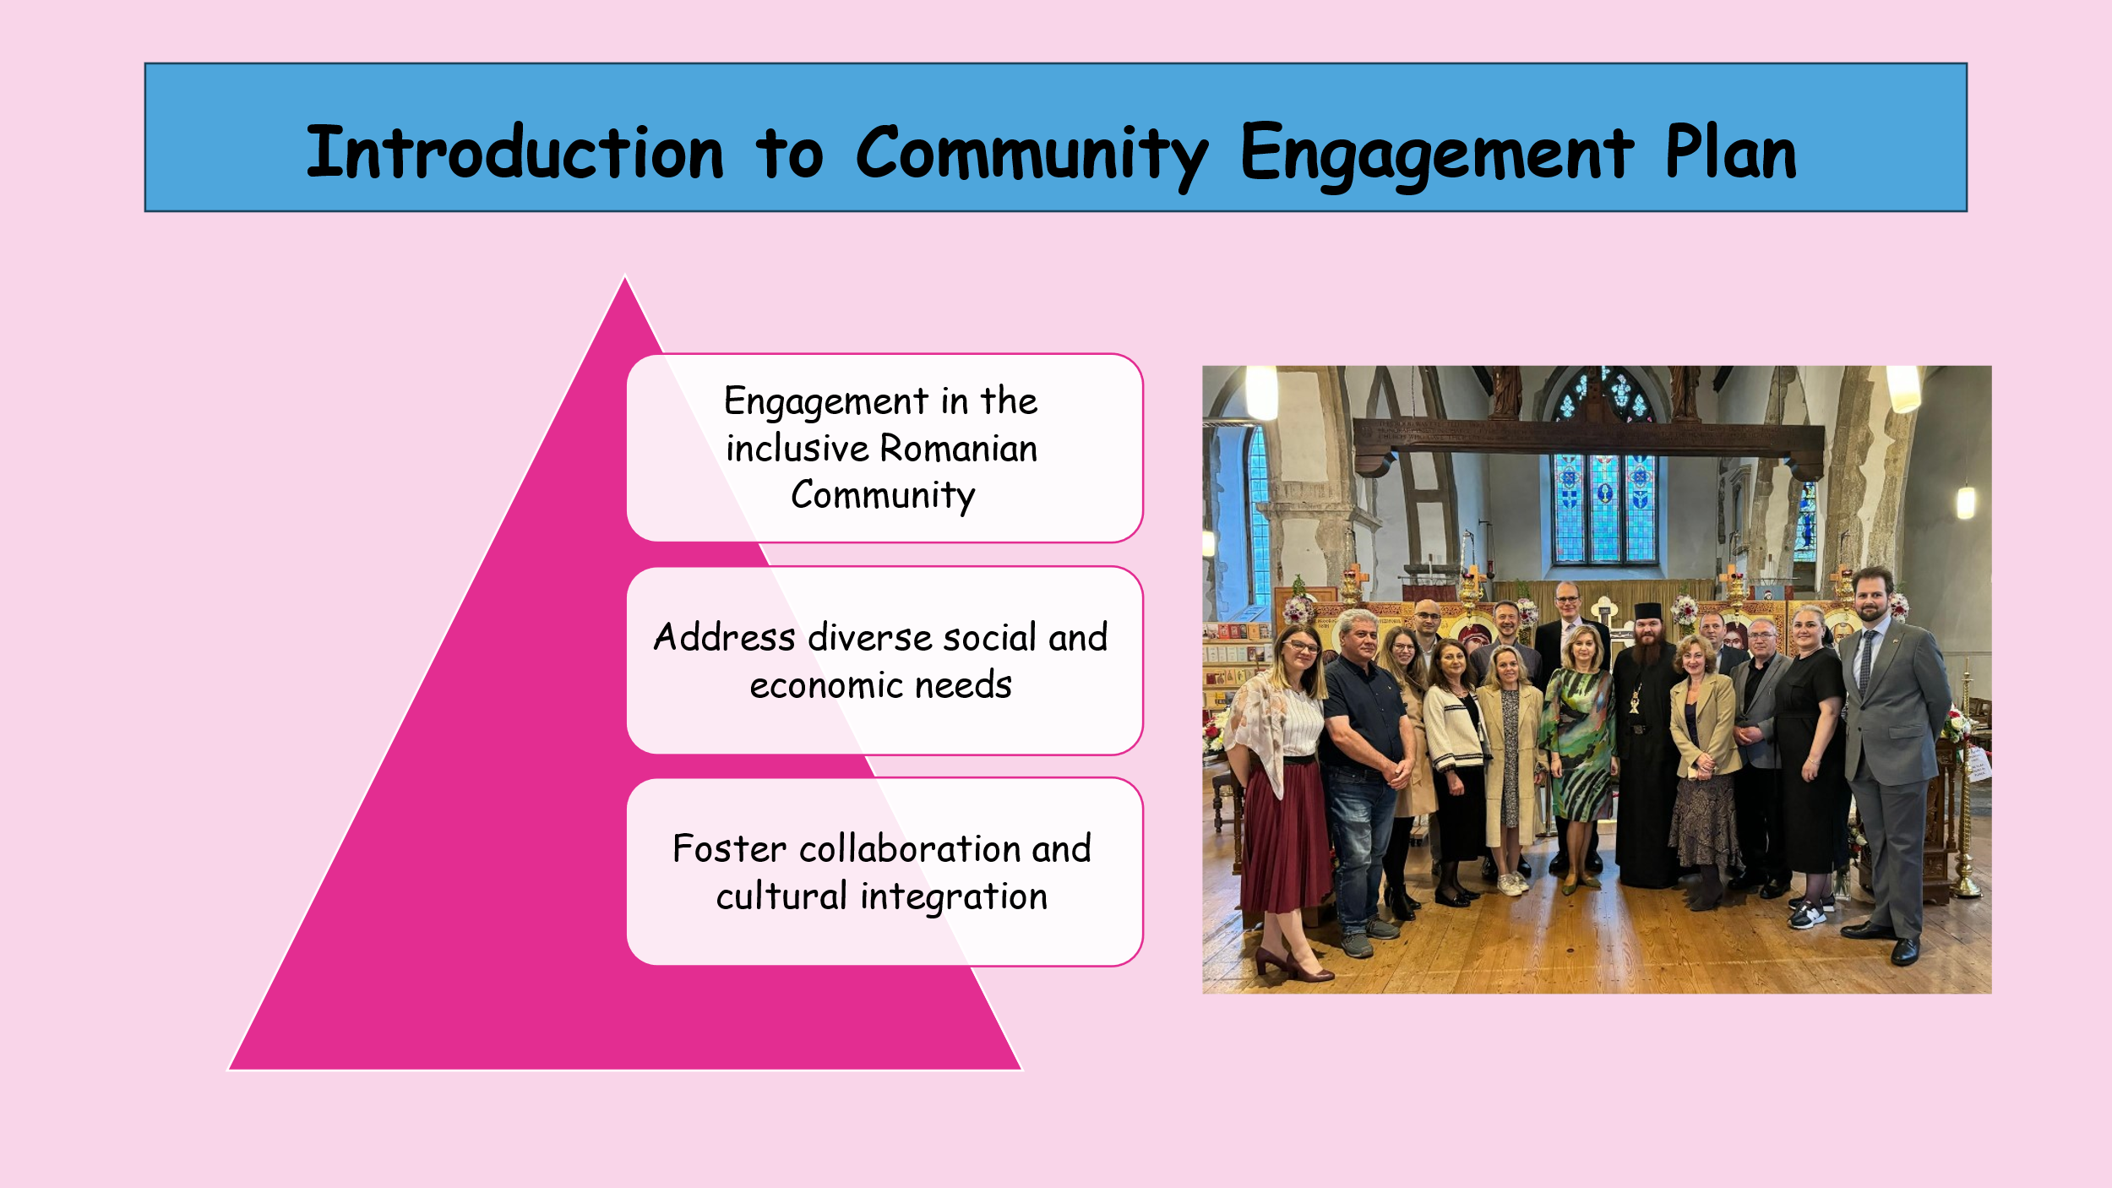
- Engagement in the inclusive Romanian Community
- Address diverse social and economic needs
- Foster collaboration and cultural integration
The Romanian Community engagement plan presented is to foster a united society that fully encompasses everybody. With a focus on the social, economic and cultural requirements of the members of the population, it aims to improve the standard of living of the people of the region. The approach incorporates a multi-stakeholder strategy in which culture is infused, and people's welfare is promoted.

Goals and Objectives
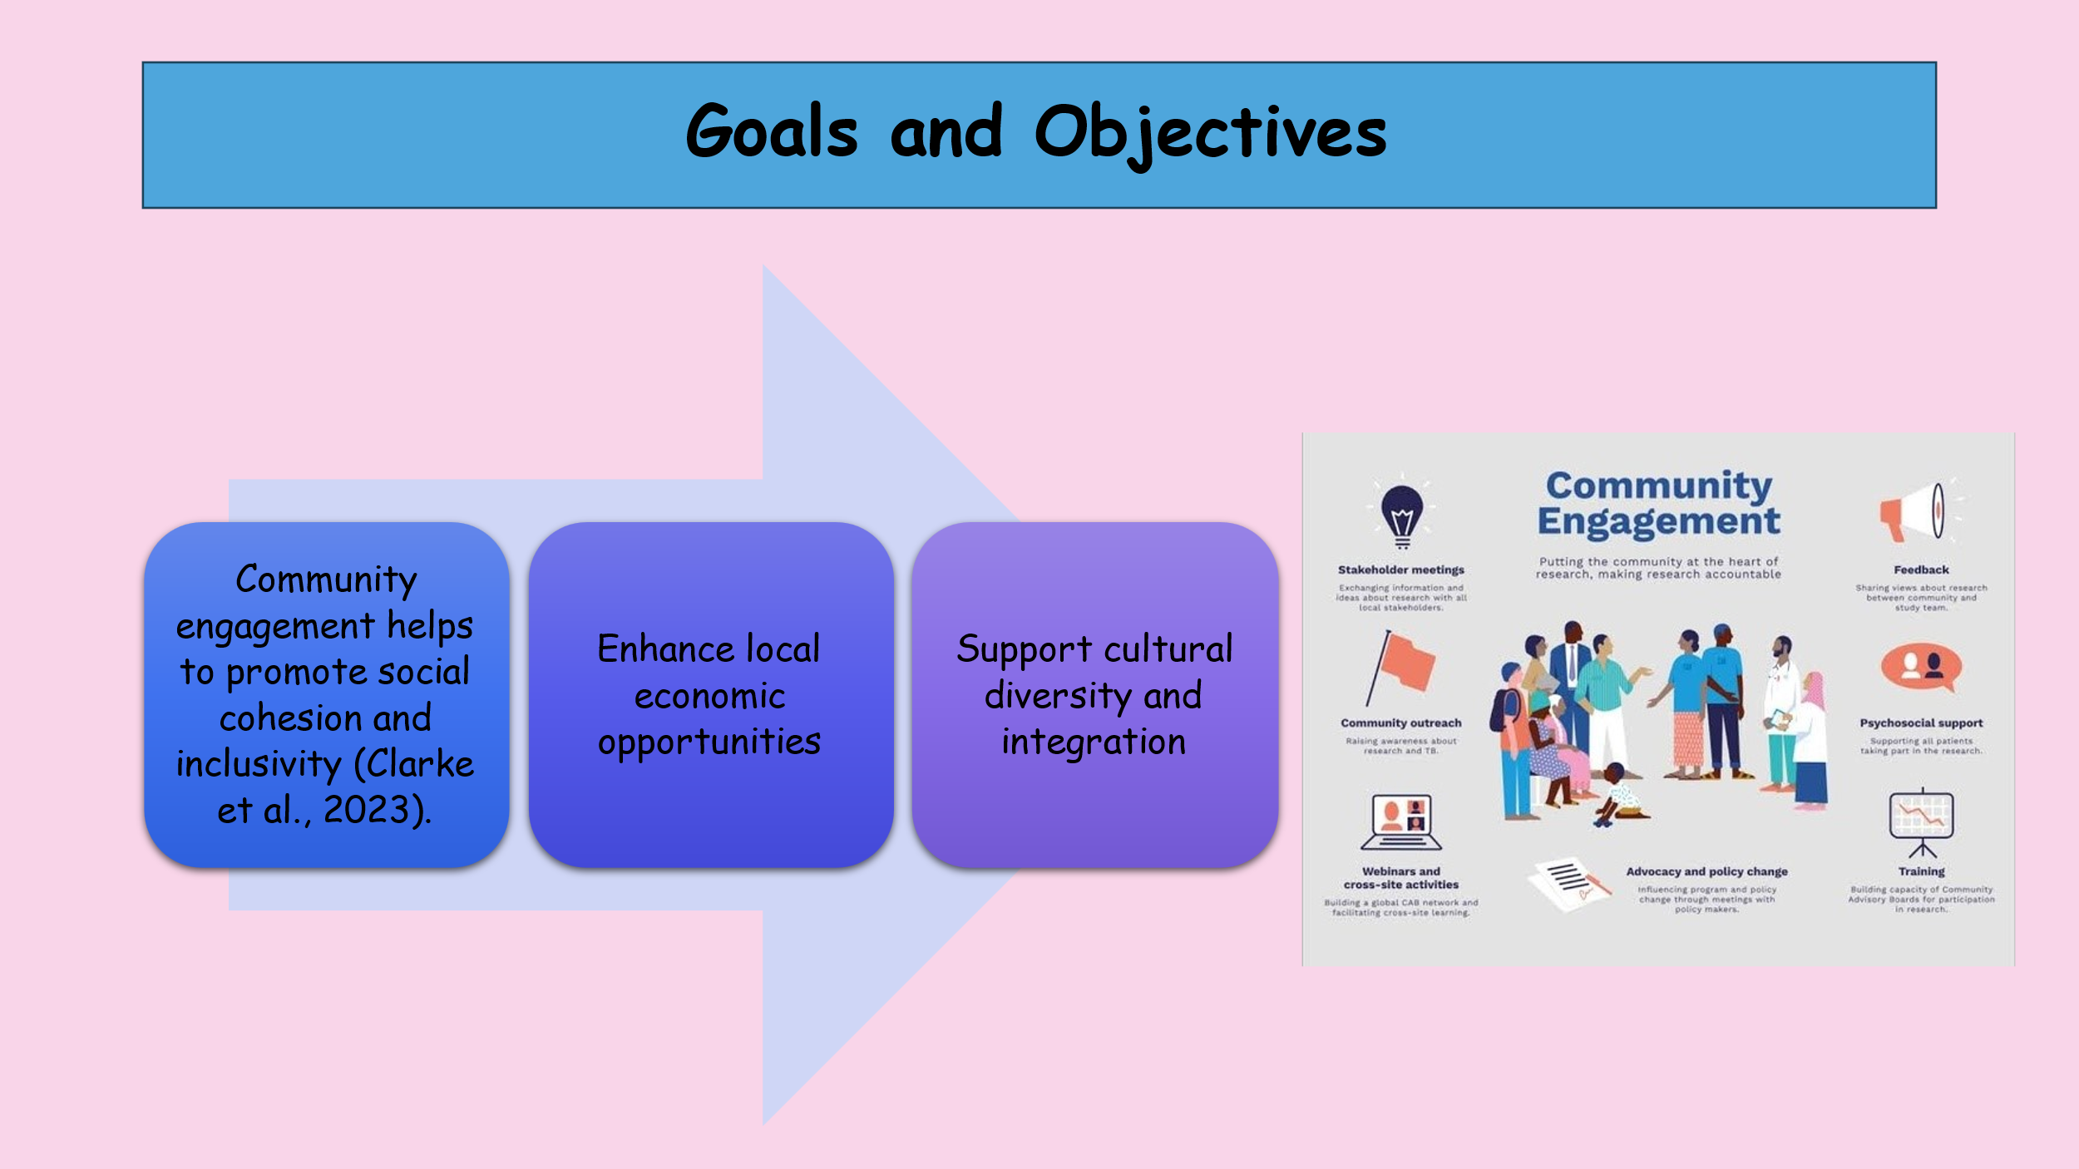
- Community engagement helps to promote social cohesion and inclusivity (Clarke et al., 2023).
- Enhance local economic opportunities
- Support cultural diversity and integration
The primary aims and objectives of engagement within this plan are to foster social integration as well as cultural diversity within the community, argue for the development and improvement of business and employment in the local area, and call for the acceptance of multicultural populations. These objectives are aimed at bringing about added interaction and general cohesiveness in the community and promoting the welfare of all the people within the society.

Principles and Standards
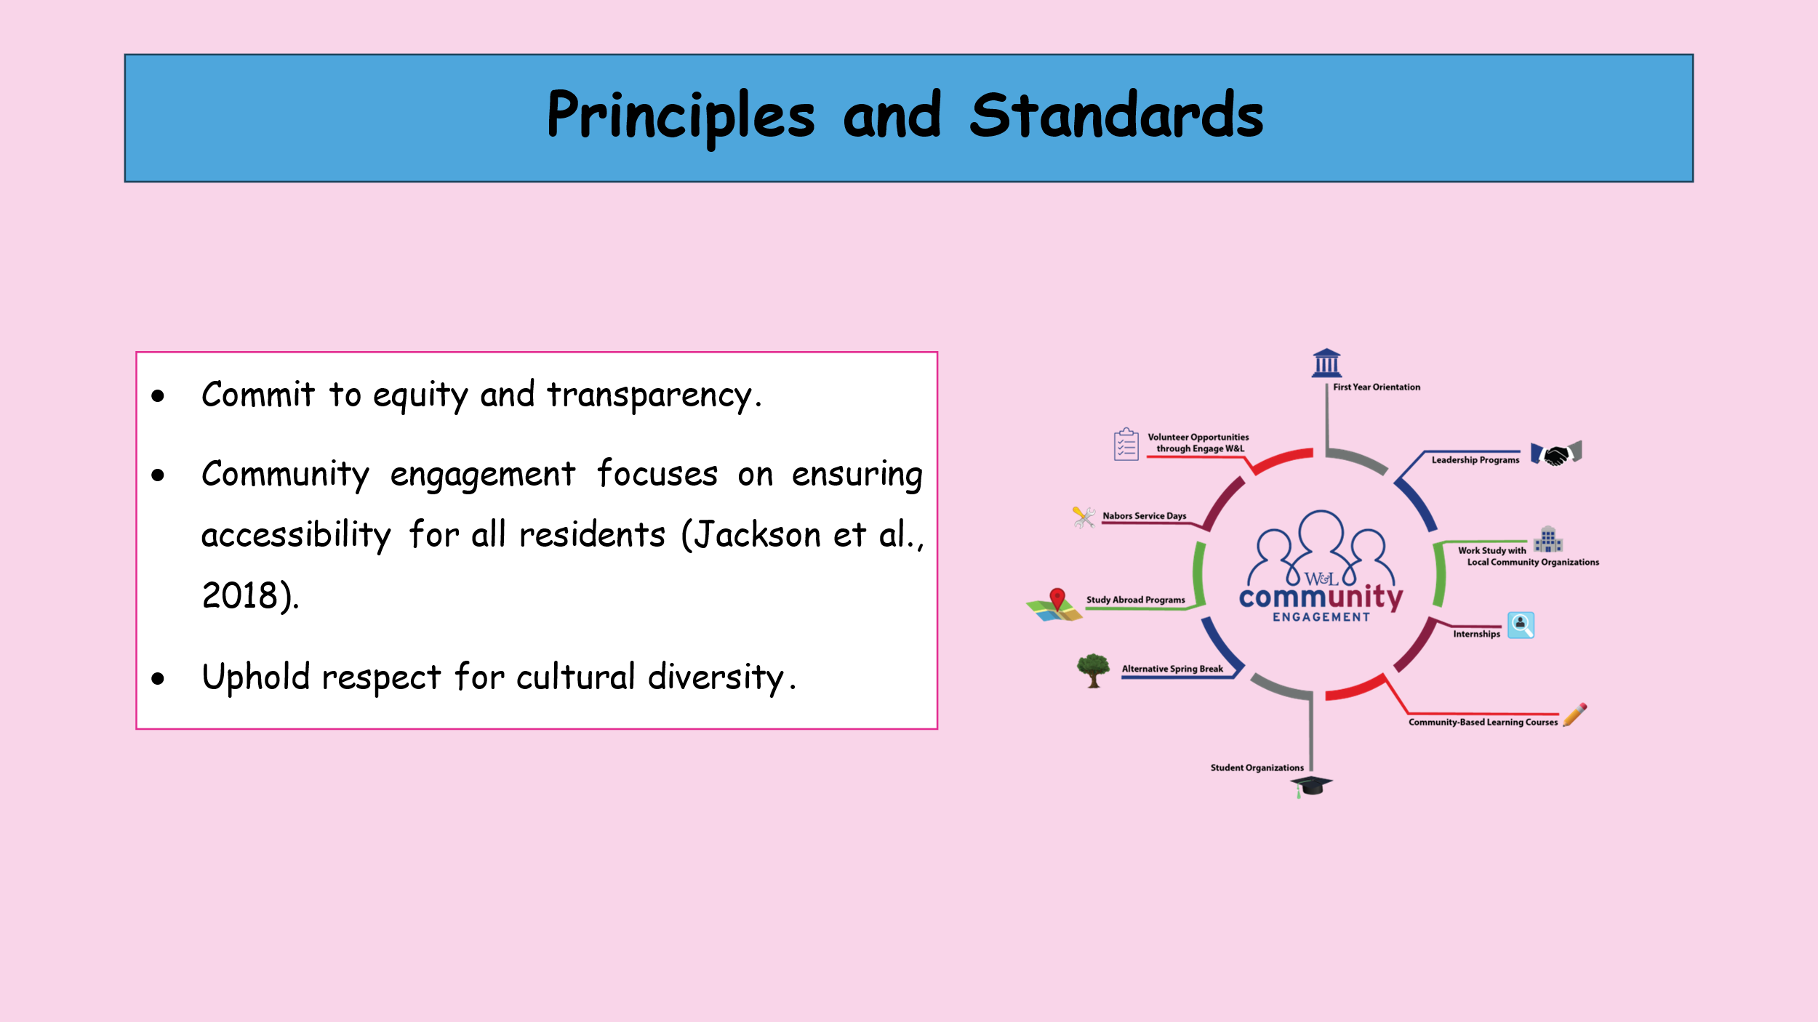
- Commit to equity and transparency.
- Community engagement focuses on ensuring accessibility for all residents (Jackson et al., 2018).
- Uphold respect for cultural diversity.
The plan has its basis rooted firmly in equity and the manner in which transactions shall be conducted with proper regard to cultural differences. The plan focuses on empowering the residents by providing them with Equal Opportunity so as to eliminate or at least minimise social inequality. These standards are deemed instrumental in the execution of the plan and progression towards the desired goals.

Strategies for Community Engagement
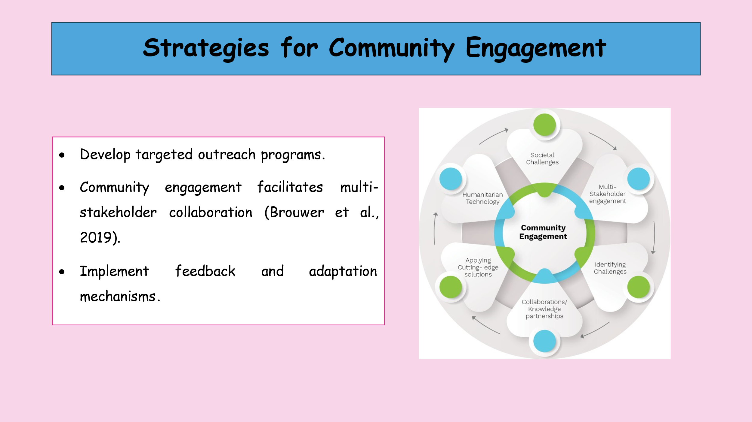
- Develop targeted outreach programs.
- Community engagement facilitates multi-stakeholder collaboration (Brouwer et al., 2019).
- Implement feedback and adaptation mechanisms.
The best practice when it comes to engaging the communities entails devising specific approaches that can be used in reaching out to the minority groups, coming up with organisational structures that bring together the stakeholders and incorporating feedback into future revisions of the plan. These strategies are, therefore, geared more towards being adaptive to the community's needs.

Potential Collaborations
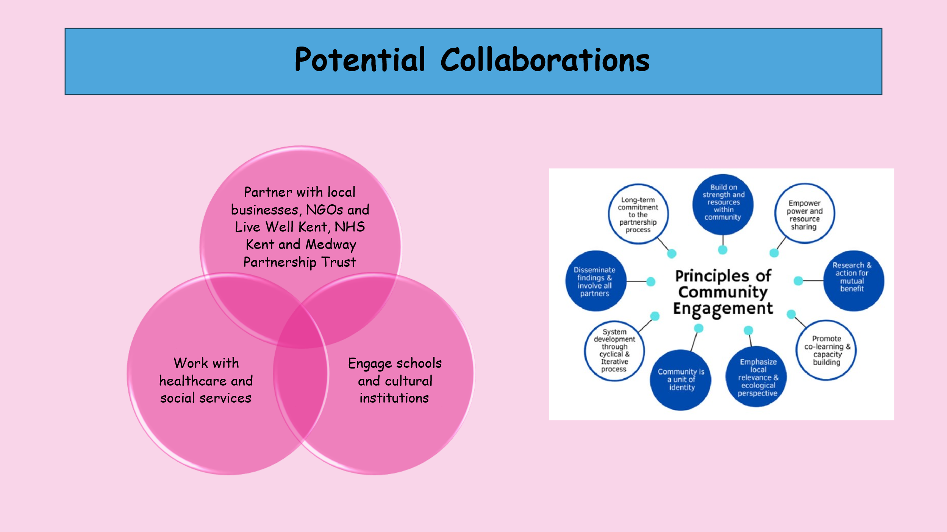
- Partner with local businesses, NGOs and Live Well Kent, NHS Kent and Medway Partnership Trust
- Engage schools and cultural institutions
- Work with healthcare and social services
The potential partnerships consist of the main components of the engagement plan. They include the identification of local businesses, NGOs and Live Well Kent, NHS Kent and Medway Partnership Trust that can embrace the project, schools and cultural centres as potential participants of social activities, and integration into the existing systems and institutions related to healthcare and social service. These collaborations will also apply a broad approach to the development of the community.

Inclusivity and Diversity Considerations
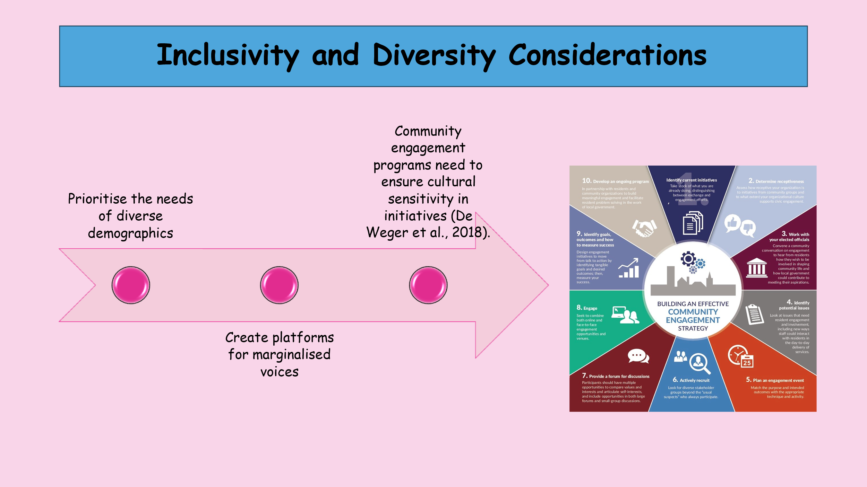
- Prioritise the needs of diverse demographics
- Create platforms for marginalised voices
- Community engagement programs need to ensure cultural sensitivity in initiatives (De Weger et al., 2018).
Thus, inclusiveness and diversity are the cornerstones of this engagement plan. That is why the commitment to addressing the concerns of various groups, including the establishment of groups for minorities and focusing on minorities in all activities, is what the plan set up to develop a community where everyone feels welcome.

Element 4. Practical Discussion
Understanding Canterbury’s Community Dynamics
Canterbury’s people uniquely combines the matter of gender and sexuality with relatively many representatives of the queer community. Diversity has been confirmed and appreciated by local authorities as well as state institutions. The main population of the town is a mix of diverse groups. Schools in Canterbury, Kent, which are within the Romanian Community in Canterbury, have provided better prospects within the students' arena, especially for those who have relocated. The health-oriented lifestyle of the community, coupled with the availability of natural resources and location along the coast, is backed by the local authority's open health-supporting endeavours. Health health-oriented community helps in enhancing the healthcare accessibility for people crucially (Fashahmi, Heidarabadi and Asfajir, 2022). In Canterbury, Kent the Public Health Department gives out vouchers for the free professional care of the aged population to ensure equal treatment to all citizens. Besides physical health outcomes, these community engagement health initiatives have played a positive role in strengthening emotional health and identity in the community.
A strong economy brings employment opportunities, which leads to the eradication of unemployment and stabilises an individual's financial status (Paul et al., 2018). Thus, stability is not only for the fulfilment of necessity but also contributes to mental and physical well-being, reducing the level of stress hormones and providing individuals with hope for the future. Also, with economic growth, the income per capita is fixed, and this will enhance the quality of life, hence, access to health care, education, and some of the vital needs in life. The last issue relates to the disparities of wealth among the population; equitable economic growth means that the opportunities for the progress achieved must be shared among the populace. Economically developed communities can spend more than less developed on infrastructure development and provision of public services in addition to enhancing their social well-being (Gardoni and Murphy, 2020). On the other hand, recession can lead to unemployment, limitation of services and social problems, meaning that the economy and prosperity of a nation have a complicated correlation. Hence, Supporting economic vitality is critical in the improvement of quality of life and provision of a favourable population environment.
Thus, culturally, Romanian Community in Canterbury is a rich and diverse mosaic of people's equality as inclusiveness is valued in the community. Multicultural presence has been integrated within the context of the town owing to the novelty and progressive culture of the area, thus allowing for the accommodation of diverse ethnical and cultural varieties. The rules adopted with references to cultural diversity have raised awareness of the population and given them the ability to accept plurality. Nevertheless, the emerging cultural changes have forced the casino to pay even more attention to the sustainability and equality of the community members.
The Romanian Community in Canterbury is a major player in the overall contribution to the development of the town's community. The Romanian Community in Canterbury’s concern for the welfare and policy of the population of Canterbury has led to obtaining better health, education, and sustenance. Another important stakeholder is the Live Well Kent, which is associated with Romanian Community in Canterbury to address the primary care facilities in the community and also to maintain the health interventional program.
Moreover, the NHS Kent and Medway Partnership Trust, an interest group for the voluntary citizen fundraising service, signed an intent to support sustainability, equity, and diversity in the community. Self-organisation by the population is also important, overseeing the quality of necessary facilities and services of residence, and affecting the Romanian Community in Canterbury’s decisions. The internal business departments of NHS Kent and Medway Partnership Trust work in cooperation with the communities, dealing with economic development in the communities. These relationships have promoted economic profitability through communal objectives for the main park, communication, leisure, library, transport, legal and property (Tembo et al., 2021). The local government of Canterbury, Kent is involved in management and sponsorship since they endeavor to local development initiatives of the society. Nevertheless, the special and most highly valuable client group to which all stakeholders' activities and programs are aimed are the residents.
The purpose of Romanian Community in Canterbury engagement plan is to encourage togetherness and solidity as key aspects of society to reduce social, economic, and cultural dilemmas among the masses. The plan’s main objectives include increasing the quality of life for all inhabitants through the development of social inclusion, the local economy, and addressing issues of cultural integration. The engagement plan's main aims and initial goals are to reduce racism and inequalities in the community, to increase the standard of living in the local economy, and to celebrate cultural diversity and encourage integration. These goals are necessary for helping to foster interconnectivity and liveliness in the neighbourhoods occupied by the inhabitants. It is in this context that social integration and cultural diversity are embraced through a plan crafted to enhance interaction and cohesiveness, thus, the welfare of the society members. The plan is based on the equity and the fair distribution of people, incorporating other residents in the accessibility of resources and opportunities. Another requirement is to respect cultural differences: the plan aims to assist residents in attaining equality. These standards are important so as to achieve the set plan and to get closer to the intended goals.
As a result, the community engagement framework involves the following activities: designing outreach programs for under-represented groups, stakeholder coordination, and implementing feedback to reflect on the plan. All of these strategies are based on change, which means that the engagement plan can be modified as the community requirements grow and become more according to the program's key objectives. Community engagement needs cooperation with local firms, NGOs, schools, and cultural establishments (Shiel et al., 2016). These will assist in collaboration with other stakeholders to fully maximise resource endowment and experience to support the roles of community development. In addition, collaboration with health care and social services can also become crucial for the treatment of the population’s health (Hilts et al., 2021). The basic requirements that should be fulfilled for the construction of a tolerant community include the acknowledgement of the need for support for different groups, the establishment of persecuted groups' voices and the inclusion of the understanding of cultural differences into all the processes. That the plan maps the ways and strategies for dealing with the various groups of people, or minorities is the other way the implementation of the plan will lead to better togetherness.

Conclusion
In conclusion, Romanian Community in Canterbury implies a profound and vital engagement plan, which allows for providing specific populations' needs for each community. This way the plan adheres to the principles of rational choice theory and embraces the values of social integration concerned with increasing the flow of people's well-being across different cultural groups. There is a conscious focus on equity, transparency, and cultural competence, which is one of the plan's main assets. These principles make sure that Canterbury’s demographic groups are respected in the engagement efforts that are being made. In addition, the use of economic aspects within the strategy guarantees that the use of optimally contributes to long-term changes in the standards of living. Thus, this approach is aimed at establishing connections within the community and guaranteeing that the population's conditions are improving through both social and economic directions. It can be assumed that the successful execution of this plan will lead to the further development of Romanian Community in Canterbury and the closer connections between people, thus enhancing the quality of their lives.

References
Baba, S., Mohammad, S. and Young, C., 2021. Managing project sustainability in the extractive industries: Towards a reciprocity framework for community engagement. International Journal of Project Management, 39(8), pp.887-901.
Brouwer, H., Woodhill, J., Hemmati, M., Verhoosel, K. and Van Vugt, S., 2019. The MSP guide: How to design and facilitate multi-stakeholder partnerships. Practical Action Publishing.
Canterbury. 2024. Help with health and wellbeing | Canterbury City Council. [online] Available at: <https://www.canterbury.gov.uk/benefits-and-support/help-cost-living/help-health-and-wellbeing>. [Accessed 13 August 2024].
Clarke, M., Cadaval, S., Wallace, C., Anderson, E., Egerer, M., Dinkins, L. and Platero, R., 2023. Factors that enhance or hinder social cohesion in urban greenspaces: A literature review. Urban Forestry & Urban Greening, 84, p.127936.
De Weger, E., Van Vooren, N., Luijkx, K.G., Baan, C.A. and Drewes, H.W., 2018. Achieving successful community engagement: a rapid realist review. BMC health services research, 18, pp.1-18.
EMIC. 2024. Romanian – Ethnic Minorities in Canterbury – EMIC. [online] Available at: <https://emic.org.uk/emic-family/romanians/#:~:text=Romanian%20Community%20in%20Canterbury&text=It%20is%20a%20non%2Dprofit,all%20ethnicities%20and%20professional%20backgrounds.>. [Accessed 13 August 2024].
Fashahmi, M.R.Z., Heidarabadi, A. and Asfajir, A.A.A., 2022. The Nexus between Health-Oriented Lifestyle, Social Inequality, Access to Health Services, and Dimensions of Social Health among Sari Citizens. Journal of Positive School Psychology, pp.9571-9584.
Gardoni, P. and Murphy, C., 2020. Society-based design: promoting societal well-being by designing sustainable and resilient infrastructure. Sustainable and Resilient Infrastructure, 5(1-2), pp.4-19.
Gill, D.W., Moore, C. and Winder, J., 2022. Historic Kent: The Value of the County's Heritage Sector.
Hersey, D., 2022. Tourists vital to district’s prosperity, report reveals - Canterbury Newsroom. [online] Canterbury Newsroom. Available at: <https://news.canterbury.gov.uk/news/tourists-vital-to-districts-prosperity-report-reveals/>. [Accessed 13 August 2024].
Hilts, K.E., Yeager, V.A., Gibson, P.J., Halverson, P.K., Blackburn, J. and Menachemi, N., 2021. Hospital partnerships for population health: a systematic review of the literature. Journal of Healthcare Management, 66(3), pp.170-198.
Jackson, K.T., Burgess, S., Toms, F. and Cuthbertson, E.L., 2018. Community engagement: Using feedback loops to empower residents and influence systemic change in culturally diverse communities. Global Journal of Community Psychology Practice, 9(2).
Paul, M., Darity, W., Hamilton, D. and Zaw, K., 2018. A path to ending poverty by way of ending unemployment: A federal job guarantee. RSF: The Russell Sage Foundation Journal of the Social Sciences, 4(3), pp.44-63.
Shiel, C., Leal Filho, W., do Paço, A. and Brandli, L., 2016. Evaluating the engagement of universities in capacity building for sustainable development in local communities. Evaluation and program planning, 54, pp.123-134.
Tembo, D., Hickey, G., Montenegro, C., Chandler, D., Nelson, E., Porter, K., Dikomitis, L., Chambers, M., Chimbari, M., Mumba, N. and Beresford, P., 2021. Effective engagement and involvement with community stakeholders in the co-production of global health research. bmj, 372.

