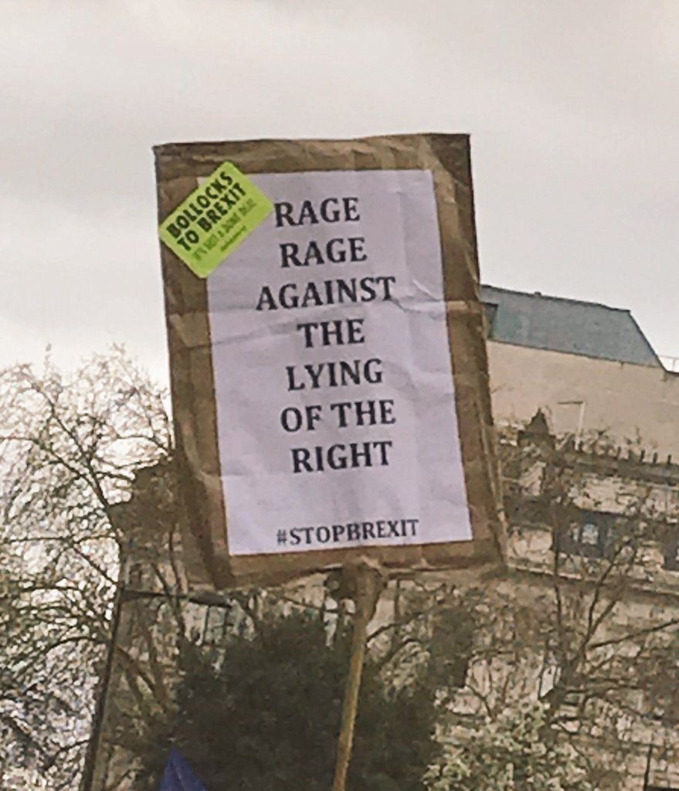

My initial inspiration for this poster comes from this placard that someone had shared on social media. I am yet, (like many) to hear a good argument for Brexit or how it will improve our lives yet I am also aware that the EU also has a lot do to help people such as the migrants risking their lives and very often drowning at sea, as shown below…



I have incorporated this image into another on the poster.
I have also incorporated the rage against the lying of the right text subconsciously into the far-right tabloid background using a similar red font.

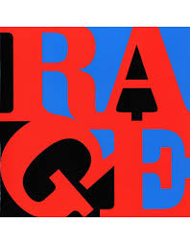
In relation to Brexit and the fair right influence on the referendum, I am heavily of the belief that Nick Griffin’s platform on Question time in the autumn of 2009 began a disturbing path to where we are now. This was highlighted by an Independent newspaper article written by Steve Richards on Thursday the 22nd of October 2009 where his final words were “The BNP is useless, but it does not deserve a helping hand”.
Griffin had consistently made comments denying the severity of the holocaust previous to his one-off Question time special and was also laughed at by the audience when he stated that the Ku Klux Klan’s David Duke was a non-violent figure.
It is an interesting argument though that society believes in freedom of speech yet is outraged when that speech includes holocaust denial!


Given that Rage against the machine have reformed and will be performing next year I also wanted to highlight the far right’s grip on countries such as Chile and Brazil amongst others.
The quote in the Chilean image which stated “if we don’t fuck shit up, We don’t exist to them” comes from the same titled article on the Newframe website.



