Supply Chain Strategy in Engineering Manufacturing

Name: Xun Cheng
Student Number: 2206582

Contents
1. Introduction 1
2. Literature Review 3
2.1 Supply Chain 3
2.2 Supply Chain Management Strategies 3
2.3 An innovative perspective on supply chain management 5
3. Methods 8
3.1 Questionnaires and interviews 9
3.2 Porter's value chain model 10
3.3 Porter's Five Forces Analysis 11
3.4 SWOT analysis 12
3.5 PEST analysis 13
4. Results 15
5. Evaluation 16
References 18
Appendix 21

1. Introduction
With the pace and speed of change in today's globalized market economy, business leaders need to use more innovative strategies to help them transform their businesses and maintain a competitive edge. Companies need to use innovative strategies to stay ahead of the commercial competition (Ramadan, 2019).The engineering manufacturing business is in a perpetual state of change due to technological breakthroughs, globalisation, and shifting consumer needs. This change has made efficient supply chain strategies essential for firms to maintain market competitiveness. Engineering manufacturers' supply chain strategies have a direct impact on their productivity, cost-effectiveness, and overall profitability. In particular, technological innovation and increasing globalisation are posing serious challenges to many companies. The development and upgrading of supply chain systems is the most important part of these businesses, especially for engineering and manufacturing companies, which are able to deliver their goods and services to customers quickly and efficiently, which is a huge challenge in today's fast-moving business.

The majority of engineering and manufacturing firms are sponsored by Amazon.com and can supply things quickly. As a result of faster delivery, customers are more satisfied with their orders and their willingness to buy is increasing, with orders travelling quickly and being delivered in just a few hours through innovative supply chain systems. As customer satisfaction with orders continues to increase, more engineering and manufacturing companies are paying more attention to supply chain management. The main objective of manufacturing companies is to be able to meet the expectations of their customers to the greatest extent possible. This paper will analyse the supply chain management perspective and explore the matching of inventory and customer demand in the supply chain, to explore the state, challenges, and trends of engineering manufacturing supply chain management. To get insight into how supply chain tactics in the engineering manufacturing business operate in reality, we will design a questionnaire and collect data from various manufacturing companies. The research findings will provide manufacturing companies with recommendations for effective supply chain strategies to adapt to the altering global competitive landscape.

For this study I will select Chinese manufacturing companies, about 50 or so. This study project seeks to investigate the existing state, difficulties, and future trends of engineering manufacturing supply chain strategy. By the construction of a questionnaire, we will collect data from various manufacturers to obtain insight into how engineering manufacturing supply chain plans are actually implemented. The findings will give manufacturing organisations with advise on successful supply chain strategies to adapt to the ever-changing global competitive climate. The study was conducted through questionnaires and interviews and subjected to SWOT analysis, PEST analysis, Porter's Five Forces analysis, and the Porter's Five Forces model in order to provide manufacturing companies with useful supply chain strategy advice for coping with the changing competitive environment in the global market. It examines solutions to these problems in an effort to increase business competitiveness and supply chain efficiency.

2. Literature Review
There will be a review of the literature that has already been written on the topics related to the proposed study, split down into the relevant subsections.

2.1 Supply Chain
Peter Drucker's "economic chain" created the concept of a supply chain, which was then followed by Michael Porter's "value chain" and then the "supply chain" concept. The current "supply chain" was formed gradually as a result of the research of academics from numerous countries, but its definition is contested amongst specialists. Unfortunately, the definition of "supply chain" has not yet been unified due to the diverse ideas and perspectives of numerous scholars.

According to Houlihan (1985), who coined the phrase, a supply chain is a system composed of suppliers, manufacturers, distributors, retailers, and ultimate customers in which material flows from suppliers to final customers and information flows in both directions. According to Christopher (2000), the supply chain is a network structure of organisations consisting of all parties involved in enterprises that use various upstream and downstream links, processes, and activities to provide value in the form of goods and services to the end user. supply chain performance can include two different types of solutions, such as IT solutions and non-IT solutions (Steeno, 2010).

2.2 Supply Chain Management Strategies
Leaders of engineering and manufacturing companies need to continuously build innovative thinking strategies in the development of their companies, which will enhance their competitive advantage and profitability (K, 2016). Supply chain management is a strategy that is often used by business leaders in engineering and manufacturing companies to reduce production costs and increase profitability quickly. SCM has a specialised process integration phase, such as the further transformation of raw materials into products and the final delivery of services and products to customers through this process (Baudin & Netland, 2022). In addition to this, SCM can play an important role in engineering manufacturing companies by using innovative concepts for the rapid penetration of functional silos to make the supply chain management of the entire engineering enterprise better. The main objective of the SCM strategy is to contribute to the growth and flexibility of the engineering manufacturing company and to minimise production costs (Maticevic et al., 2011). SCM strategies can quickly explore innovative solutions in engineering manufacturing companies that can link supply chain and profitability to maximise the value of both. A review of previous literature shows that some companies in the engineering manufacturing industry are able to look at supply chain strategy from a corporate social responsibility perspective, for example, researchers in some companies are able to develop more optimal supply chain systems for companies during project development and management, and good supply chain systems need to include three main elements, including economic, social and environmental ( Maticevic et al., 2011). In the process of quantifying the supply chain for engineering manufacturing companies, sustainability is also a major concern. David et al. were able to provide an excellent supply chain system for companies in engineering manufacturing companies by using a model to calculate the main impacts of the supply chain on the sustainability of the company's projects, and finally by comparing the results generated by these impacts, Pawn Red identified the most appropriate supply chain system (Kolmykova, 2015). In the direction of supply chain sustainability for engineering and manufacturing companies, some engineering managers are gradually expanding the scope of supply chain activities, particularly in terms of customer delivery, with the whole delivery process covering the life cycle stages of the company, for example, from raw materials in the engineering and manufacturing company to the recycling stage of the company. A review of research shows that more managers are choosing to use a mix of objectives when managing their supply chain activities (Yuan et al., 2020). This model allows for the rapid pursuit of optimal management of the supply chain of an engineering manufacturing company, helping the company to achieve its ultimate goal of achieving rapid growth in profits and maximising the social benefits of the company. Previous literature reviews have described specific tests of engineering manufacturing companies, and the evidence produced suggests that the use of mixed integer models as a decision making tool by engineering manufacturing company leaders can accurately assess the extent to which supply chain management can assist in the sustainable transformation of engineering manufacturing companies. Sustainability objectives in engineering manufacturing require some adjustment, particularly in terms of maintaining trade-offs between the sustainability pillars in engineering manufacturing. In terms of sustainability in engineering manufacturing, sustainability in manufacturing is determined by the activities of the supply chain system, for example, the leaders in the company choose to optimise manufacturing as a key pillar in supply chain management (Sambasivan et al., 2009).

2.3 An innovative perspective on supply chain management
SCM strategies in engineering manufacturing can be observed through different perspectives, and some researchers have been able to discuss and evaluate the partnership between innovative SCM strategies and the firm's supply chain, suggesting that SCM strategies can optimise supply chain systems through improvements in firm efficiency and firm profitability (Sriyogi, 2016). Researchers related to engineering and manufacturing companies have used SCM and supply chain technologies to promote more business managers to focus on other key aspects of project management, including IT technology in companies, and IT technology in manufacturing companies to optimise the supply chain and optimise the information and knowledge that is lacking in companies. A review of the previous literature review reveals the shift in information technology in supply chain management in engineering manufacturing companies and the shift in information technology to solve supply chain problems in companies (Islam & Anis, 2018). The most important aspect of the engineering manufacturing industry is the IT information technology in the company, which enables the enquiry of customer orders and deliveries, reducing and avoiding errors in the operational processes of the company. A review of the literature shows that an important technology in supply chain management is frequently used in engineering manufacturing companies, such as RFID technology, which allows the use of different components to identify and capture important data that occurs in engineering manufacturing, including tags and readers in the engineering manufacturing process, and databases (Baudin & Netland, 2022 ). Musa and Dabo reviewed 1000 journals and articles published between 2000 and 2015 that provide evidence that items produced in engineering manufacturing companies are labelled and provide evidence that supply chain managers in companies managers are able to optimise and perform different forms of supply chains through RFID technology (Yuan et al., 2020). In previous literature reviews, researchers have grouped the impact of RIFD technology on supply chains in companies in a logical way and have summarised the conclusions of different combinations of articles by grouping them. The articles that are mainly relevant to the topic are listed, including articles within the scope of warehouse management and articles within the scope of supply chain management. Both types of articles can be studied using RFID technology, including those that identify the best storage methods and improve the speed and accuracy of inbound and outbound operations (Dan Wang et al.). Supply chain managers in engineering manufacturing companies will strategise on the results of this research to create a new business environment for engineering manufacturing companies through RFID technology. In addition, many other researchers have also conducted systematic tracking of supply chain management in engineering manufacturing companies, such as the use of RFID chips and smart tags in the supply chain, which can quickly determine the location of products in the supply chain and know every detail of the manufacturing company's production and delivery process (Hong et al., 2019). The supply chain manager in the company can quickly access real-time supply chain data, such as the location and quantity of products in the supply chain during the project management process, which can be transmitted to the company's product database through the supply chain management system in a timely manner. It can be seen that the different types of innovative technologies that branch out from the supply chain management can effectively track the content of the supply chain of the company, and for improving the efficiency of the supply chain of the company, the management of the company should be able to control and adjust the technology to ensure that the database can be easily accessed and queried to achieve the tracking technology of the supply chain management in engineering and manufacturing companies (Rostamkhani & Ramayah, 2022). Ramayah, 2022).

3. Methods
This research uses a qualitative research approach to analyse supply chain management in engineering manufacturing companies to further assess the process of supply chain management in matching inventory and customer demand strategies in engineering manufacturing companies through the exploration of supply chain management. The use of qualitative research in this paper enhances the breadth and authenticity of the study. Qualitative research allows the researcher to be more interested in the process under study and with interest, the researcher is able to communicate with each other and the research sample to gather the views and experiences of the sample participants on this research question. Qualitative research methods can help the researcher to analyse and compare the ideas and decisions of the participants and obtain a more appropriate strategy to evaluate this study (Borucka & Mazurkiewicz, 2022). Qualitative research can be more appropriate for the research work in this paper, as it can collect appropriate data from the participants, for example, how supply chain managers in engineering manufacturing companies use strategies when developing projects in their companies. In addition to this, the data collected through qualitative analysis can shed light on the research questions, for example, qualitative research can shed light on the barriers that exist in the engineering manufacturing industry. The quantitative research approach prefers to analyse the hypotheses and analysis of data through more specific data than the qualitative research approach, analysing the relationships that exist between the two variables. Quantitative research allows for the formulation of hypotheses for the study, data collection and finally the determination of the data collected to verify the relationship between the data and the hypothesis. Reviewing previous literature reviews, researchers also choose to use a combination of qualitative and quantitative analysis, with the hybrid research approach being able to combine the rigour and activity in the research hypothesis. In this research paper, the use of quantitative research was not chosen as the primary research approach; this research paper will use a qualitative research approach to explore the main questions of the study and assess the strategies used and challenges encountered by supply chain managers in the engineering manufacturing industry in relation to the growth of the business. Therefore, a mixture of quantitative and qualitative analysis has not been chosen for this research, which is a method of analysis that is less relevant to the subject matter of the study than a single qualitative study.

3.1 Questionnaires and interviews
A case study orientation is a relatively standard research approach that explores the entire process of research and is integrated into the world of display. In a case study, the researcher needs to observe the entire research process and analyse the research through the data provided by the participants. For example, in an article study where interviews are used for data collection, a single study may include a very large amount of data, and the source of many data may be from just one case study. A single qualitative study is more appropriate for this article's research as it explores the use and planning of strategies by supply chain managers in engineering manufacturing companies. No ethnographic or phenomenological questions are designed in the research for this paper, data information is one of the factors that is focused on in the research for this paper, and participants are selected for interviews and questionnaires in order to ensure saturation of data in the research.

For this study I will select Chinese manufacturing companies, about 50 or so. The goal of the questionnaire is to collect data on the supply chain management practises employed by engineering manufacturing enterprises. The questionnaire will be distributed to an industrial sample, and the obtained data will be analysed using statistical methods. In order to gain a deeper understanding of the supply chain strategies of a select number of engineering manufacturing companies, interviews will be conducted there. In semi-structured interviews, key stakeholders such as supply chain managers, production managers, and logistics managers will participate.

Data will be collected using qualitative research methods, starting with a questionnaire that will be administered to a randomly selected sample, listing the appropriate research questions and research objectives, and compiling the data from the participants' responses. Interviews can be conducted either online or offline, The use of questionnaires and interviews to collect data in this study will enhance the usefulness and authenticity of the study and make it more meaningful. The questionnaire has been placed in the appendix.

3.2 Porter's value chain model
Porter's value chain model can be used as an important basis for competitive strategy in engineering manufacturing companies. The various elements of Porter's value chain enable companies to maintain a competitive advantage in business competition, and engineering manufacturing companies manage their supply chains in a business environment mainly due to different components (Peter, 2009). The model of Porter's value chain describes how value is added to a company's numerous links, from the acquisition of raw materials to the delivery of the final product or service. The methodology can aid firms in identifying the crucial areas in their internal business processes and optimising those points to boost productivity and save costs. When considering supply chain strategy, Porter's value chain model can aid firms in identifying the essential links and activities in their supply chain and maximising the value of these activities, The success of a company's supply chain depends heavily on its sourcing efforts. By determining the appropriate sourcing channels and delivery techniques, businesses can obtain better sourcing prices and faster delivery times, thereby increasing supply chain efficiency and decreasing expenses. To establish a seamless manufacturing process, a corporation may need to coordinate its production activities with its suppliers and consumers. Companies can reduce expenses and improve the dependability and resiliency of their supply chains by maximising manufacturing efficiency using modern technologies and techniques. Logistics involves transporting goods or services from the provider to the client. By optimising their logistics procedures, businesses may increase delivery speed and accuracy while simultaneously boosting customer happiness and loyalty. After-sales support should be included in a company's supply chain because it can boost customer loyalty and satisfaction. Businesses can increase customer satisfaction and loyalty by building an efficient after-sales service system that enables them to provide enhanced customer assistance and solutions, as seen in Figure 1 (Wang et al., 2022).

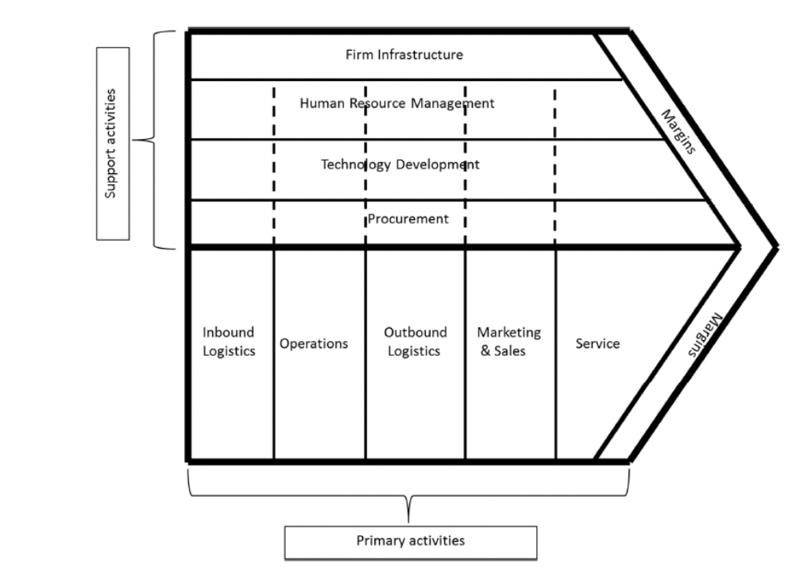
Figure 1 Resource by; (Wang et al., 2022).

3.3 Porter's Five Forces Analysis
The Five Forces Analysis model, developed by Michael Porter[1], has a significant impact on how competitive strategies are developed in an industry. It states that there are five fundamental competing forces at play in a market, in addition to the original competitors. The status and combined strength of these five core competencies define the level of industry competition, which in turn affects the level of industry profit potential and the flow of capital into the industry, which in turn affects the company's ability to maintain high returns. These forces include the ability of customers to negotiate, the ability of potential competitors to enter the market, the ability of substitutes to replace the original product, and the ability of suppliers to negotiate. The five forces include the negotiating strength of customers and suppliers, the ability of potential competitors to enter the market, the availability of substitutes, and the level of industry competition at present.

The Porter's Five Forces model can aid organisations in better creating and implementing their supply chain strategy by supporting them in identifying the supply chain's primary players and their impact on the business. A firm's competitors in the supply chain, for example, could exert pressure on it by delivering goods or services of a greater quality, at a lower price, or more rapidly. Potential competitors could enter the company's market, threatening its supply chain. Substitutes may affect a company's supply chain, for instance by reducing demand if they are more economical or available. Suppliers may have an impact on a company's supply chain; for example, if their prices or delivery capabilities change, this may affect the company's capacity to generate and deliver. A company's supply chain may be affected by its consumers. For instance, if customers want higher quality or faster delivery, this may have an effect on the organization's production and supply chain operations.

3.4 SWOT analysis
Using the SWOT analysis framework, analyses are conducted on a corporation to determine both its internal prospects and threats, as well as its internal strengths and weaknesses. By assessing these factors, a firm can develop a strategy and gain a deeper understanding of the resources and operating environment in which it operates. When considering supply chain strategy, a SWOT analysis can aid a business in identifying the essential elements of its internal and external surroundings, enabling it to develop an acceptable supply chain plan. For example:
- Internal advantages: Businesses can benefit from a robust supply chain network, efficient production procedures, and high-quality products. Using these advantages allows organisations to reduce expenses and improve supply chain efficiency, hence enhancing their market competitiveness.
- Internal disadvantages: Issues such as outdated technology and a dearth of management knowledge could be detrimental to businesses. The effectiveness and quality of the supply chain can be improved, and organisations can make better use of their own resources, if certain disadvantages are identified and solutions are developed to overcome them.
- External opportunities: Emerging markets, market expansion, industry changes, and new technologies provide business opportunities. By recognising these opportunities and acting strategically in accordance with them, businesses can expand their market share and improve the effectiveness and quality of their supply chains.
- External threats: Emerging competitors, fluctuating government laws, and escalating raw material prices are all potential threats to firms. By recognising these risks and taking necessary action, businesses may protect their market share, reduce costs, and improve supply chain efficiency.

3.5 PEST analysis
PEST analysis, where P stands for Political, E for Economic, S for Social, and T for Technological factors, refers to the examination of a company's macroenvironment. Each of these factors has a substantial impact on the growth and success of a company. PEST analysis is a tool that can help firms develop and manage their supply chain strategies by detecting key external trends and impacts.
- Political factors: Changes to government laws and regulations may have an effect on the supply chain of a corporation. Examples include trade pacts, tariff regulations, and regulatory compliance.
- Economic factors: A corporation's supply chain strategy may be affected by changes in the economic situation. Examples include price rises, exchange rate fluctuations, and economic recessions.
- Social factors: Social trends and cultural shifts can also have an effect on a company's supply chain. Examples include the growing interest in sustainability and environmental protection, as well as the desire for quality and transparency among customers.
- Technical factors: Technological advances may have an effect on a corporation's supply chain. For instance, IoT technology improvements may affect how firms network and manage their supply chains.

4. Results
Using descriptive statistics to analyse the data received from the questionnaires, a summary of the supply chain strategies utilised by engineering manufacturing companies will be presented. The interview data will be subjected to thematic analysis to identify themes and patterns of significance.

I will choose Chinese manufacturing companies for this study. The proposed research will throw significant insight on the supply chain policies utilised by engineering manufacturing companies. The study will assist in identifying the characteristics that influence the selection of supply chain strategies and assessing the efficacy of present tactics. In order to boost engineering manufacturing organisations' productivity, cost effectiveness, and overall profitability, the findings will also provide suggestions for improving supply chain strategies. The survey provides an overview of the industries where the engineering and manufacturing industry's major players are focused, such as machine construction, electronics manufacture, etc. In order to analyse the requirements and challenges faced by firms of varying sizes in terms of supply chain strategy, we must first determine the sizes of the survey participants. Examining the key responsibilities of the supply chain management departments of various organisations in order to determine their priorities and areas of concentration. To analyse the impact of supply chain strategy on business competitiveness, it is vital to comprehend the industry's perspective on supply chain strategy's importance in engineering and manufacturing operations.

5. Evaluation
The research title chosen for this article is Supply Chain Strategy in Engineering Manufacturing and provides an overview of the research questions. The introductory section of the study describes the background to the study, the purpose of the study and the research questions in a sequential manner, which is in line with a normal research process. The background of the study provides an adequate introduction to the main directions of the study, the purpose of the study explains the main motivations and desired results of the study, and finally explains the research questions in turn as they unfold in the body of the study. The literature review section of the study describes the Porter's value chain model, supply chain management strategies and supply chain innovation perspectives in engineering manufacturing firms respectively. The descriptions in the literature review section are based on studies from similar articles, respectively explaining what the study was able to relate to the research questions, which are relevant to the data analysis and discussion later in the article. Secondly, the main form of research in this article is qualitative, which has some degree of limitation for the article. While qualitative research can be conducted using questionnaires and interviews to collect data, quantitative analysis and secondary data as a secondary method of data collection would have made the overall data collection more comprehensive. The data collected will be analysed and discussed as the qualitative research data collection is more detailed and in line with the research of this paper, the research proposal will be successful and the chosen research method will allow for the collection of high quality data. The research plan for this paper is already very clear and will yield better results during the subsequent body of research.

Final is the timescales for dissertation.

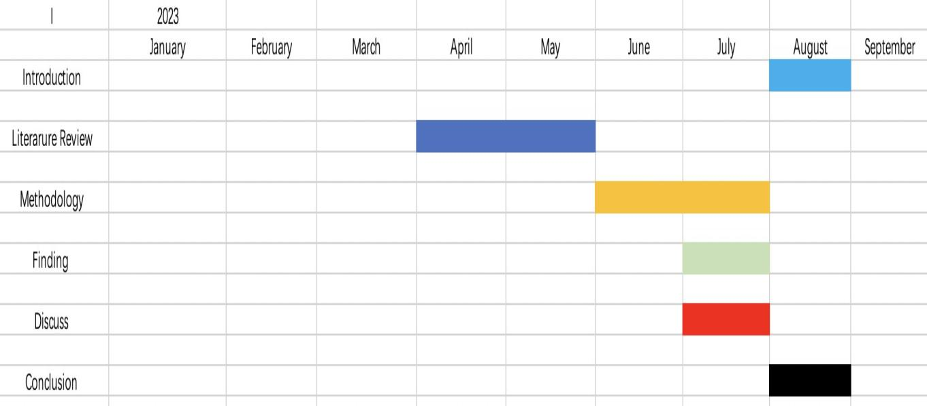

References
Arntzen, B.C., Brown, G.G., Harrison, T.P. and Trafton, L.L., 1995. Global supply chain management at Digital Equipment Corporation. Interfaces, 25(1), pp.69-93.
Amasaka, K., 2016. Evolution of Japanese automobile manufacturing strategy using New JIT: Developing QCD studies employing new SCM model. Journal of Applied Mechanical Engineering, 5(3), pp.1-14.
Baudin, M. and Netland, T., 2022. Introduction to Manufacturing: An Industrial Engineering and Management Perspective. Taylor & Francis
Borucka, A. and Mazurkiewicz, D., 2022. Production Process Stability: The Advantages of Going Beyond Qualitative Analysis. In Innovations in Industrial Engineering II (pp. 140-148). Cham: Springer International Publishing.
Christopher, M., 2000. The agile supply chain: competing in volatile markets. Industrial marketing management, 29(1), pp.37-44.
Hong, J., Liao, Y., Zhang, Y. and Yu, Z., 2019. The effect of supply chain quality management practices and capabilities on operational and innovation performance: Evidence from Chinese manufacturers. International Journal of Production Economics, 212, pp.227-235.
Houlihan, J.B., 1985. International supply chain management. International Journal of Physical Distribution & Materials Management, 15(1), pp.22-38.
Islam, R. and Anis, A., 2018. Prioritisation of Internal and External Barriers for Supply Chain Implementation in Manufacturing Companies: A Malaysian Perspective. In Multi-criteria methods and techniques applied to supply chain management (p. 35). IntechOpen.
Kolmykova, A., 2015. Supply Chain Integration: Entwicklung eines Integrators für die globale Supply Chain. Springer-Verlag.
Maticevic, G., Cicak, M. and Lovrić, T., 2011. RFID and supply chain management for manufacturing digital enterprise. In Supply Chain Management-New Perspectives. IntechOpen.
Porter, M.E., 1997. Competitive strategy. Measuring business excellence, 1(2), pp.12-17.
Peter, G.J., 2009, January. The effectiveness of mechanical and manufacturing engineering technology programs for full-time employed industry students. In ASME International Mechanical Engineering Congress and Exposition (Vol. 43802, pp. 257-262).
Ramadan, M., 2019, March. Industry 4.0: Development of smart sunroof ambient light manufacturing system for automotive industry. In 2019 Advances in Science and Engineering Technology International Conferences (ASET) (pp. 1-5). IEEE.
Rostamkhani, R. and Ramayah, T., 2022. The Perspective of Quality Engineering Techniques in Supply Chain Management Future. In A Quality Engineering Techniques Approach to Supply Chain Management (pp. 143-149). Singapore: Springer Nature Singapore.
Sriyogi, K., 2016. Sustainable Supply Chain Management Practices: An Environmental Perspective in Indian Manufacturing Companies. International Journal of Advanced Information Science and Technology (IJAIST) Vol, 46.
Sambasivan, M., Loke, S.P. and Abidin‐Mohamed, Z., 2009. Impact of knowledge management in supply chain management: a study in Malaysian manufacturing companies. Knowledge and Process Management, 16(3), pp.111-123.

Steeno, G.S., 2019. Experimental Design for Pharmaceutical Development. Chemical Engineering in the Pharmaceutical Industry: Active Pharmaceutical Ingredients, pp.881-907.
Wang, D., Tian, Y. and Hu, Y., 2004, October. Empirical study of supplier selection strategies across the supply chain management in manufacturing companies. In 2004 IEEE International Engineering Management Conference (IEEE Cat. No. 04CH37574) (Vol. 1, pp. 85-89). IEEE.
Wang, N., He, Q. and Jiang, B., 2022. An overview of enterprises’ green growth model and value chain reconstruction. Enterprises’ Green Growth Model and Value Chain Reconstruction: Theory and Method, pp.1-27.
Yuan, X., Chen, Y.W., Zhang, Q.B. and Ming, X.G., 2020, December. Internet-based Collaborative Design, Manufacturing, and Supply Chain for Manufacturing Companies. In 2020 IEEE International Conference on Industrial Engineering and Engineering Management (IEEM) (pp. 645-649). IEEE.

Appendix
Interview questionnaire
- What type of engineering and manufacturing business does your company work in?
a) Machinery manufacturing
b) Electronics manufacturing
c) Automotive manufacturing
d) Aerospace manufacturing
e) Other, please specify: ______

- What is the size of your company?
a) Under 50 people
b) 50-200 people
c) 200-500 people
d) 500-1000 people

e) Over 1000 people

- What are the main tasks of the supply chain management department in your company?
a) Supplier selection and evaluation
b) Material procurement
c) Inventory management

d) Logistics management
e) Other, please specify: ______

- How important do you consider supply chain strategy to be in the engineering manufacturing business?
a) Very important
b) Important
c) Moderately important

d) Not very important

e) Not important

- What are the main objectives of the supply chain strategy in your company?
a) Reduce costs
b) Improving production efficiency

c) Reduce lead times
d) To increase the sustainability and environmental friendliness of the supply chain
e) Other, please specify: ______

- What do you think is the biggest challenge facing the supply chain today?

a) Unstable suppliers
b) Fluctuating raw material prices

c) Rising logistics costs
d) Uncertainty in global markets
e) Other, please specify: ______

- Has your company adopted digital supply chain management tools?
a) Yes
b) No

- If your company has adopted a digital supply chain management tool, please list the features you find most valuable.

a) Supplier management
b) Demand forecasting
c) Inventory optimisation

d) Logistics tracking
e) Other, please specify: ______

- Which technologies do you think will play a key role in the future of the engineering and manufacturing supply chain?
a) Artificial intelligence

b) Internet of Things

c) Blockchain

d) 3D printing
e) Other, please specify: ______

- What challenges has your company encountered in supply chain management? How have they been addressed?

- Please provide your suggestions for improving supply chain strategies in the engineering manufacturing industry.

- What are your views on future trends in the engineering manufacturing supply chain?

