

Master of Business Administration

Human Capital Management (LCMB7023_LON)
Assessment 1 — Individual Report

Designing a Human Capital Architecture for Strategic Renewal:
A Strategic Human Capital Advisory Report for Helios Urban Mobility

Lecturers: Gladius Kulothungan & Eno Maycock
Student ID: 2538982
Submission Date: 17th July 2026
Word Count: 2,740 words

Table of Contents

1. Introduction 3
2. Socialisation, Identity and Business Activism 3
2.1 Traditional Onboarding versus Strategic Organisational Socialisation 3
2.2 A Structured Socialisation Framework for Helios Urban Mobility 5
2.3 Cultivating Organisational Identification, Ethical Professionalism, and the Business Activist Mindset 6
3. Job Design Strategy 7
3.1 An Innovative Job Design Strategy for Helios Urban Mobility 7
3.2 Job Crafting and the Skills-Based Internal Talent Marketplace 9
3.3 Stimulating Intrinsic Motivation and Supporting Innovation 10
4. Reflective Report 10
4.1 AI as a Decision-Support Tool Without Eroding Critical Human Judgement 10
4.2 Personal Capability Development Plan 11
5. Conclusion 12
References 13

Introduction
Helios Urban Mobility (HUM) is a European smart-transport start-up with 450 employees in London, Berlin and Singapore, innovating AI-powered electric mobility solutions and smart infrastructure analytics for cities. The organisation faces three related human capital issues after five years of explosive growth: the average time to ramp up a new hire is eight months; employee engagement is just 54% and a significant number of high-potential graduates are leaving. Symptoms suggest systemic weaknesses in the socialisation architecture, job design and career identity formation. This report from an external Strategic Human Capital Advisor covers three activities: Task A – Design an innovative job design system, Task B – Propose an innovative job design strategy and Task C – Reflect on the role of AI in HR decision making and include a personal capability development plan. Literature review in the field of organizational behavior, human resource management and strategic human capital theory is used in the analysis.

2. Socialisation, Identity and Business Activism

2.1 Traditional Onboarding versus Strategic Organisational Socialisation
Traditional onboarding is mostly paperwork and policy compliance – spending the first week with employees filling out paperwork, provisioning IT, and briefing on policies, etc. (Bauer, 2010). All such programmes cater for the primal logistical requirements but little to speed up the psychological journey from outsider to organisational citizen. Bauer et al. (2007) in their meta-analytic review confirm that information provision alone is not the only predictor of newcomer adjustment; rather, the quality of socialisation tactics, role clarity, self-efficacy and social acceptance are also important factors for the success of newcomers, which are not addressed by standard onboarding.
A more strategic lens is offered by the typology of socialisation tactics of Van Maanen and Schein (1979). They identify two different models: individualised (informal, random, disjunctive) and institutionalised (formal, sequential, serial). Structured, sequential and mentor supported experiences, represented by institutionalised tactics, are consistently correlated with decreased role ambiguity, increased organizational commitment and decreased intention to leave (Saks et al., 2007). Scaling is an issue critical for HUM, a company needed eight months to ramp up and has so far worked on a case by case basis, which implies an institutionalised process of socialisation is necessary.
Rousseau (1995) adds to this idea of psychological contract theory; whereby new employees have unspoken expectations of what they will receive from the organisation in return for their commitment. A psychological contract breach takes place when those expectations are not met during early experiences, a key precursor to disengagement and turnover (Robinson and Rousseau, 1994). The HUM engagement matrix indicates that 54% of the employees are not engaged in the process of recruitment during their socialisation, indicating that the promises of recruitment are not being fulfilled. The theory of identity construction (Ashforth and Mael, 1989) also suggests that newcomers are active participants in their role socialisation and shape their professional identity by seeking cues from the organisation; when it is not received they stay psychologically on the periphery. The differences between the two approaches are summarised in figure 1.
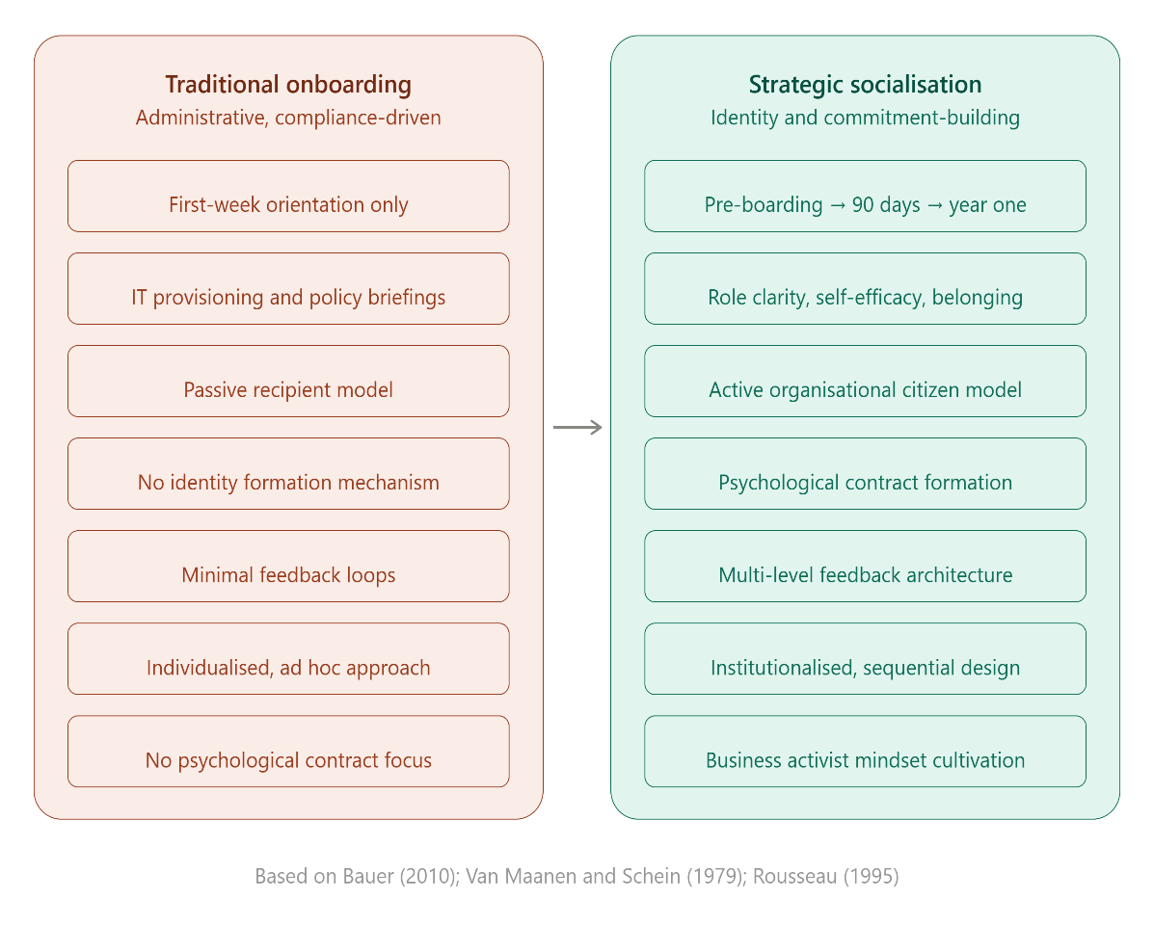
Figure 1: Traditional Onboarding vs Strategic Organisational Socialisation

2.2 A Structured Socialisation Framework for Helios Urban Mobility
Van Maanen and Schein (1979) have outlined the institutionalised tactics and Bauer (2010) provides evidence-based socialisation model for HUM, thus the following three phases proposal is given for HUM.
Phase 1 – Pre-boarding (Offer Acceptance to Day 1). New employees should be given a digital welcome package in advance of their start date, which will explain HUM's mission, values, and will introduce them to the team that will welcome them. It is important to have a designated ‘socialisation partner' one of the same function to answer questions and start building a relationship. This is the first step in fulfilling the psychological contract of Rousseau (1995) by establishing a positive expectation because the organisation has invested in the individual prior to the formal start of employment.
Phase 2: First 90 Days (Immersion and Role Clarity). First 90 Days (Immersion and Role Clarity) is Phase 2. A cross-functional sequence of mobility systems-based rotations through HUM's mobility systems and analytics client teams and city-government client teams should be structured and sequenced with weekly senior mentor check-ins. Based on the research from Bauer et al. (2007), four adjustment indicators should be focussed on: role clarity (setting milestones), self-efficacy (graded task difficulty), social acceptance (cohort based learning cross country of London, Berlin and Singapore), and organisational knowledge (structured exposure to the technology stack of HUM and client connections).
Phase 3: Year One (Embedding and Contribution). The final step moves the new recruits from supported learning to active participation in the business with quarterly development reviews, cross-functional innovation sprints and ‘reverse mentoring' in which new employees share their knowledge of new technology with senior managers. This corresponds with Ashforth and Mael's (1989) identity theory, which places newcomers as the focus of the contributions and not as the peripheral observer.
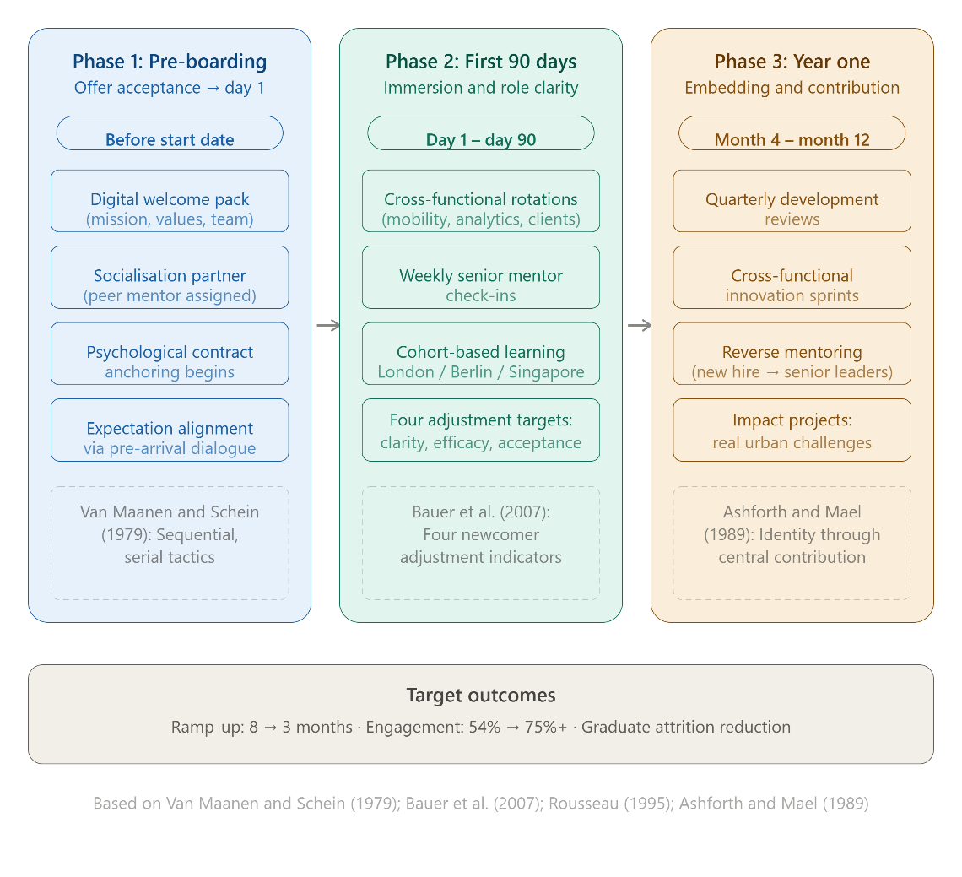
Figure 2: Three-Phase Socialisation Framework for Helios Urban Mobility

2.3 Cultivating Organisational Identification, Ethical Professionalism, and the Business Activist Mindset
Organisational identification becomes apparent when employees think that there are meaningful overlaps between their values and the organisation's (Ashforth and Mael, 1989). The socialisation framework is to explicitly tie daily activity with the overall urban impact for HUM via founder stories, client-site visits in the first 90 days, and mobility outcome visible displays (Weisman et al., 2023).
Ethical professionalism should not be merely a compliance issue. CIPD (2023) is clear that ethical practice is not just a matter of rules, it is a way of life. HUM to embed ethical decision making scenarios in socialisation workshops, introducing newcomers to challenges to privacy of data and fairness of algorithms that are inherent in AI-driven transport systems.
The business activist thought (Ulrich and Brockbank, 2005; Ulrich, 2024) requires professionals who are proactive in supporting solutions that are human-centred. Under a stakeholder capitalism approach (Freeman, 1984), HUM's staff should consider themselves as champions of sustainable mobility, working on behalf of people living in the city, city authorities and future generations as well as for the HUM business. The mindset is inculcated from the beginning in 'impact projects', in which new employees offer solutions to the challenges the city faces.

3. Job Design Strategy

3.1 An Innovative Job Design Strategy for Helios Urban Mobility
The difficulties HUM faces (low engagement, high dropout rate of graduates, and slow ramping up) are, at least in part, due to poor job design. Even well socialised employees will become disengaged over time without variety, autonomy and meaningful feedback in their roles (Hackman and Oldham, 1976). It is proposed that an integrated job design strategy, based on the Job Characteristics Model (JCM), the job crafting theory and an internal talent marketplace will be used (see Figure 3).
The JCM by Hackman and Oldham (1976; 1980) identified five job characteristics which create critical psychological states that result in intrinsic motivation: skill variety, task identity, task significance, autonomy, and feedback. In the case of a tech start-up developing AI-powered mobility solutions, roles can be created to be more cross-functional and less departmental, giving the job more variety. For instance, the data engineer shouldn't be limited to creating algorithms alone, but should be involved in client interactions, system deployments and the conclusions of those systems—seeing the whole picture of their contribution. This experience of task completion has not been achieved in organizations where staff members are working in matrix or project teams, doing small parts of a larger task. HUM's organizational structure should be based on small, independent teams of 5-8 people to own an entire client project from inception to completion, giving every individual member visibility of the complete value chain.
Task significance is a strong characteristic of tasks in the context of HUM and should not be taken for granted. Further reinforcement of meaningfulness would be achieved by regular 'impact briefings' in which client-city officials report on the impact of HUM's solutions in lowering emissions or increasing accessibility. The fourth dimension (autonomy) involves allowing pods a measure of autonomy in methodology, time, resources, and also a degree of strategic alignment, via quarterly objective-setting (Hackman and Oldham, 1980).
The fifth dimension of JCM, feedback, should be at two levels. Feedback must be written into operations, such as during agile sprint retrospectives and by making real-time client satisfaction dashboards accessible to the pod to give team members real-time information on how well their work is being done. Developmental feedback should take place in a structured way, with a regular quarterly conversation with a coach (not the line manager) to separate out performance appraisals from developmental feedback, which is backed up by Stone et al. (2024) on their study of feedback cultures in high-performance organizations. This two-channel approach is relevant especially to HUM's high potential graduates because are they leaving in larger numbers than is suggested by current feedback systems that show progress in their careers and that indicate that organisations are investing in their development.
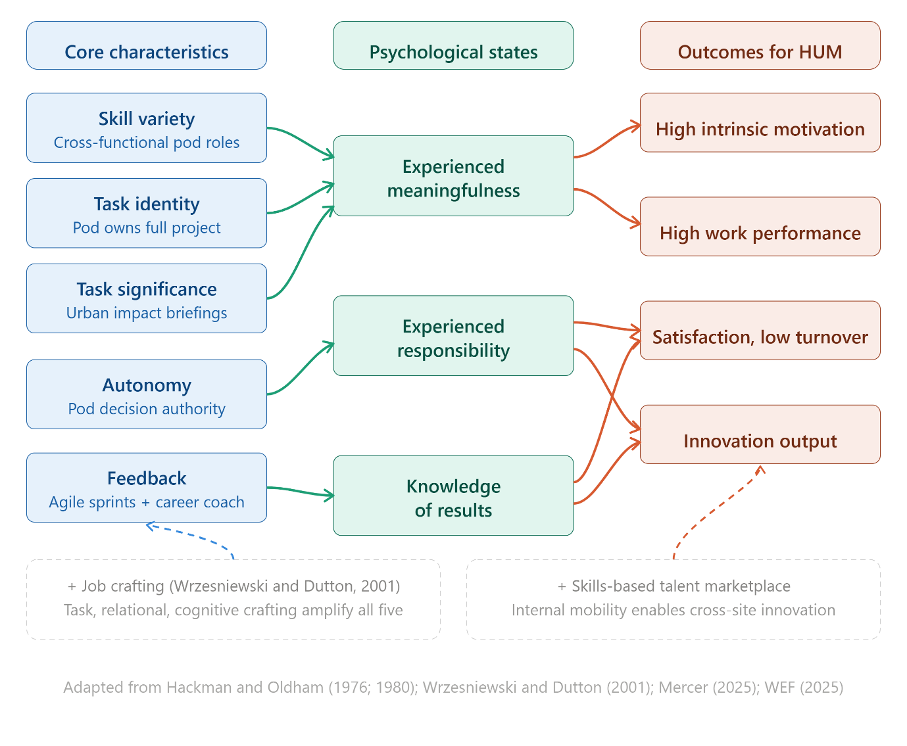
Figure 3: Job Characteristics Model Applied to Helios Urban Mobility

3.2 Job Crafting and the Skills-Based Internal Talent Marketplace
Job crafting theory (Wrzesniewski and Dutton, 2001) expands on the JCM by acknowledging that employees are not the passive recipients of job design, but are active contributors to shaping their own work. According to Wrzesniewski and Dutton’s (2001) framework there are three types of crafting: task crafting, which involves changing the scope or nature of tasks; relational crafting, which involves changing the quality or quantity of the relationships in the workplace; and cognitive crafting, which involves reframing the meaning of one's work. Job crafting can be formalised at HUM by implementing quarterly ‘craft reviews' where employees support one another, with the help of their career coach, to spot opportunities for adjusting task boundaries, look for new cross-functional relationships, or rethink the way they were thinking about their contribution, in relation to HUM's contribution to the urban impact mission. Tims and Bakker (2010) highlight that job crafting should focus on ‘seeking challenging job demands’ and not simply ‘reducing hindering demands’; both stretch assignments and inter-site collaboration should be promoted through the HUM's crafting programme.
Job crafting at scale is enabled through a skills-based internal talent marketplace. Instead of having fixed roles based on the grades, HUM should setup a digital platform, maybe using its own AI tools, that creates an employee skill/need match with project needs and development goals. Staff may volunteer for short term assignments, innovation projects and/or cross-site secondments based on skills they wish to acquire rather than those they already have. This is especially true of the graduate students at HUM, who have a higher attrition rate than other employees, which might be partially due to roles that are too specific. According to the World Economic Forum (2025), skills-based workforce planning is one of the five key enablers of organisational agility and Mercer's (2025) Skills Snapshot Survey shows that workers with internal mobility platforms are more engaged and less likely to intend to leave organisations. This also cuts the cost of recruitment and the dilution of culture for a 450-person company that is growing quickly by accessing the skills they already have, instead of bringing in new members for every skill set that is missing.

3.3 Stimulating Intrinsic Motivation and Supporting Innovation
The integrated approach focuses on what Hackman and Oldham (1976) call the three psychological states that lead to intrinsic motivation: experienced meaningfulness (which is established by the important role the task plays in the pod structure, its level of skill variety, and its level of task significance), experienced responsibility (which is created by pod-level autonomy and job crafting discretion), and knowledge of results (which is created by agile feedback loops and impact briefings). The facilitation of cross-pollination within the Talent marketplace can foster innovation, for example, an AI engineer from Berlin working with an urban planner from Singapore on a pilot project in London can lead to new solutions because of the variety of approaches. Wrzesniewski, Berg and Dutton (2010) believe that cognitive crafting, which involves redefining the meaning of one's work, allows for the unleashing of creativity in the thinking of employees when they perceive relationships between seemingly unrelated areas. This flexibility of thought is a strategic asset for a startup operating in the fields of technology, sustainability and public policy, rather than just a personal advantage.

4. Reflective Report

4.1 AI as a Decision-Support Tool Without Eroding Critical Human Judgement
There's a great deal potential to be harnessed in artificial intelligence for human capital management, including predictive analytics to plan a workforce, and natural language processing for screening applicants. But the danger of too much dependence is high. The research by Deloitte (2026) on AI and decision-making warns that organisations often mistake AI-driven recommendations for the truth, failing to recognize the biases in the data used to train the AI and the algorithms themselves. In my own practice, I would apply what might be called a ‘human-in-the-loop': AI tools should be used to surface patterns, flag anomalies, and provide options, but for decisions which impact on people's lives, livelihoods and wellbeing, it is paramount that it be left with human professionals who can provide contextual judgement, ethical reasoning and empathy. This is in line with CIPD's (2023) focus on ethical professionalism: Technology should be used to complement and never supplant the practitioner's ability to make ethical decisions. In practice, it involves learning how to critically evaluate the output from an AI, including what information it has been fed and what biases it might have absorbed, and when and how human input is required. For example, in the recruitment process, AI can effectively process applications against specific skills criteria, whereas the ability to contribute culturally, grow in the organisation and operate within a team is more complex and intangible, and thus would be difficult to define algorithmically (CIPD, 2023). Preserving this separation requires continuous learning, transparent decision-making processes and a culture that fosters the integration of human decision-making with machine intelligence.

4.2 Personal Capability Development Plan
In order to become more employable in the future, I have picked four priority areas that meet the changing needs of the human capital management profession (see Figure 4).
Data literacy is becoming an essential base skill, as individuals are able to understand and commission the right analysis with workforce data. Structured programme of studies in people analytics with an emphasis on converting data insights into strategic recommendations, while being mindful of the ethical implications of data-driven HR.
AI Augmentation in HR: By knowing the capabilities, limitations, and governance of AI tools, I will be empowered to make informed buying decisions and serve as a critical user of HR technology, with hands-on experience using AI-driven solutions for talent acquisition and learning and development.
The focus is on strategic influencing skills, as is emphasized by Ulrich & Brockbank (2005): The importance of the HR is not about administration but about adding value. Developing the skill of reconceptualising people issues in commercial terms, making evidence-based recommendations to senior management and engaging organisations' politics in an ethical manner is key to a credible advisory role. Having been in recruitment for the last few years gives me a grounding in stakeholder management and I want to build on that and become more competent in strategic communication at board level.
Awareness of global mobility: As the labour market becomes more interconnected, the regulatory, cultural and logistic aspects of the deployment of international mobility are of paramount importance. Cross-border skills mobility is one of the key characteristics of future labour markets, according to the World Economic Forum (2025). I hope to build up my knowledge in global mobility policy, immigration frameworks and culture to create a team of distributed staff — knowledge that is directly applicable to organisations such as HUM with a multi-jurisdictional scope.
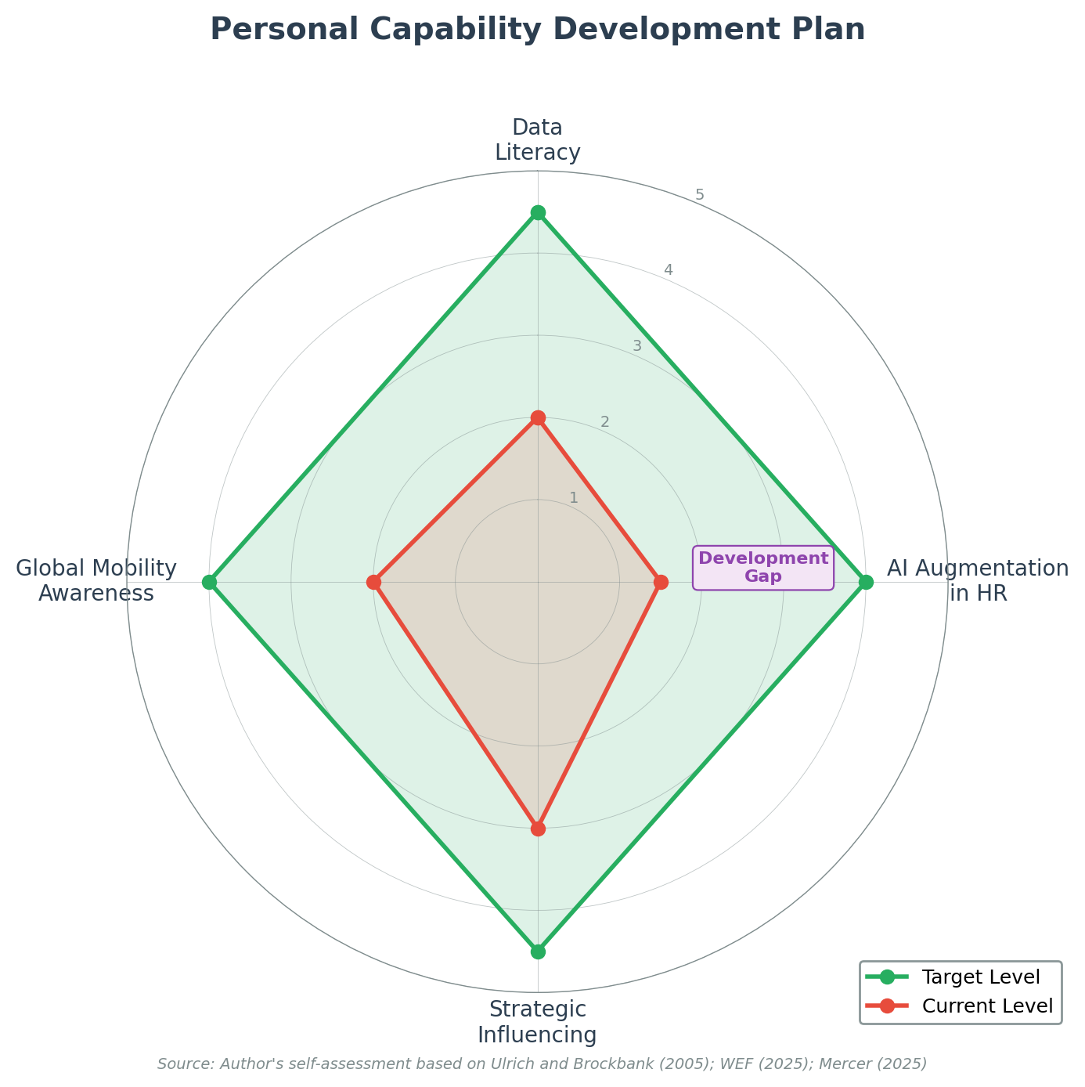
Figure 4: Personal Capability Development Plan — Current vs Target Levels

5. Conclusion
A human capital architecture has been proposed for Helios Urban Mobility that is integrated into its three challenges. A systematic socialisation process involves three stages, helping a newcomer to become an organisation citizen by satisfying psychological contracts and establishing identity from the first day. Intrinsic motivation is maintained and cross-functional innovation is facilitated by a complementary job design strategy that draws on the Job Characteristics Model and job crafting and an internal talent marketplace. The reflective exercise highlighted the need for critical human judgement alongside AI and building future-ready skills. These recommendations combine to put HUM on solid footing to build and sustain a competitive advantage through human capital.

References
Ashforth, B.E. and Mael, F. (1989) 'Social identity theory and the organization', Academy of Management Review, 14(1), pp. 20–39.
Bauer, T.N. (2010) Onboarding new employees: maximizing success. SHRM Foundation's Effective Practice Guidelines Series. Alexandria, VA: SHRM Foundation.
Bauer, T.N., Bodner, T., Erdogan, B., Truxillo, D.M. and Tucker, J.S. (2007) 'Newcomer adjustment during organizational socialization: a meta-analytic review of antecedents, outcomes, and methods', Journal of Applied Psychology, 92(3), pp. 707–721.
CIPD (2023) 'Ethical practice and the role of people professionals', Factsheet. London: Chartered Institute of Personnel and Development. Available at: https://www.cipd.org/en/knowledge/factsheets/ethics-role-hr-factsheet/ (Accessed: 28 June 2026).
Deloitte (2026) 'AI and the future of human decision-making', Deloitte Insights, 3 March. Available at: https://www.deloitte.com/us/en/insights/topics/talent/human-capital-trends/2026/decision-making-with-ai.html (Accessed: 5 July 2026).
Freeman, R.E. (1984) Strategic management: a stakeholder approach. Boston: Pitman.
Hackman, J.R. and Oldham, G.R. (1976) 'Motivation through the design of work: test of a theory', Organizational Behavior and Human Performance, 16(2), pp. 250–279.
Hackman, J.R. and Oldham, G.R. (1980) Work redesign. Reading, MA: Addison-Wesley.
Mercer (2025) 2024–2025 skills snapshot survey. New York: Mercer. Available at: https://www.mercer.com/en-ie/insights/talent-and-transformation/skill-based-talent-management/rebuilding-reward-and-career-frameworks-based-on-skills/ (Accessed: 2 July 2026).
Robinson, S.L. and Rousseau, D.M. (1994) 'Violating the psychological contract: not the exception but the norm', Journal of Organizational Behavior, 15(3), pp. 245–259.
Rousseau, D.M. (1995) Psychological contracts in organizations: understanding written and unwritten agreements. Thousand Oaks, CA: Sage.
Saks, A.M., Uggerslev, K.L. and Fassina, N.E. (2007) 'Socialization tactics and newcomer adjustment: a meta-analytic review and test of a model', Journal of Vocational Behavior, 70(3), pp. 413–446.
Stone, R.J., Cox, A., Gavin, M. and Carpini, J. (2024) Human resource management. Hoboken, NJ: John Wiley & Sons.
Tims, M. and Bakker, A.B. (2010) 'Job crafting: towards a new model of individual job redesign', SA Journal of Industrial Psychology, 36(2), pp. 1–9.
Ulrich, D. (2024) 'Update on HR business partner model: continuing evolution and relevance', LinkedIn, 9 July. Available at: https://www.linkedin.com/pulse/update-hr-business-partner-model-continuing-evolution-dave-ulrich-vqwoc/ (Accessed: 8 July 2026).
Ulrich, D. and Brockbank, W. (2005) The HR value proposition. Boston, MA: Harvard Business School Press.
Van Maanen, J. and Schein, E.H. (1979) 'Toward a theory of organizational socialization', in Staw, B.M. (ed.) Research in organizational behavior. Vol. 1. Greenwich, CT: JAI Press, pp. 209–264.
Weisman, H., Wu, C.-H., Yoshikawa, K. and Lee, H.-J. (2023) 'Antecedents of organizational identification: a review and agenda for future research', Journal of Management, 49(6), pp. 2030–2063.
World Economic Forum (2025) Future of jobs report 2025. Geneva: World Economic Forum. Available at: https://www.weforum.org/publications/the-future-of-jobs-report-2025/ (Accessed: 1 July 2026).
Wrzesniewski, A. and Dutton, J.E. (2001) 'Crafting a job: revisioning employees as active crafters of their work', Academy of Management Review, 26(2), pp. 179–201.
Wrzesniewski, A., Berg, J.M. and Dutton, J.E. (2010) 'Managing yourself: turn the job you have into the job you want', Harvard Business Review, 88(6), pp. 114–117.

