DANIEL LUPU
Student Nr: 1915933
The Global Business Environment A2
Hyundai
Syed Jaffery

Table of Contents
Introduction 3
Critical Analysis of the changes in the company during COVID 3
PESTEL Analysis 3
Political factors 3
Economic factors 4
Social factors 4
Technological factors 4
Environmental factors 5
Legal factors 5
Application of Porter’s Five Forces 6
Extent to changes are suitable 7
Recommendations 8
Conclusion 9
References 10

Introduction
In current situation of pandemic the businesses have faced different issues and it has impacted the working practices. As same the changes in the automobile sector are also being witnessed due to covid-19. For dealing with challenges the companies like Hyundai have focused on proper evaluation of different forces. According to forces understanding the changes are being implemented by entity. Sustainability of business is also being improved by having efforts in terms of transformation.
Present study covers information respecting changes made by Hyundai during Covid for better operations and production of electric cars. How market for electric cars has been changed is evaluated in the report. Factors that have promoted change inoperations and working style of Hyundai Electric Car Unit are also being discussed in the study.

Critical Analysis of the changes in the company during COVID
Automobile sector is referred as one of most transforming industry because continuous changes in the product line and technology have been made. As same, growth aspects are being changed regularly. Specifically in situation of covid-19 the sales and production rate of the Hyundai Electric Car Unit has been affected negatively. It was because allocation of resources has been impacted during covid situation. The global automobile industry is facing a slowdown due to the lockdown in several countries (Pani,et al. 2020). Operational and sales processes are being changed in critical manner to have better dealing with the pandemic situation. However, perception of customers in market has been changed during the covid situation because a person gets more concerned respecting environment. Using electric cars the people are trying to make sure that pollution related issues can be resolved and in future issue of virus infection on health can be controlled. However, there are different external factors that have changed so understanding respecting the same is necessary to consider.

PESTEL Analysis
Hyundai electric cars production is being affected due to pestle factors as covid situation has impacted the factors. Policies and perception based aspects are being changed that has affected development.

Political factors
Political situation in many nations are not stable and it affects the development of automobile sector. Also, continuous changes in the policies are being implemented that also forces Hyundai to bring changes in the operations (Kanda and Kivimaa, 2020). For example, after covid situation governments are focused towards promotion of electric cars that means Hyundai can take benefits of the same. Many nations are offering subsidies on the electric cars so such political aspects allow firm to have success.

Economic factors
Covid-19 situation has impacted the economic situation that has influenced the income level and other measures. It is a reason that investment on premium goods and automobiles has decreased in last few months. Sales of premium cars in terms of pricing have decreased that means the Hyundai also needs to cut down the prices of electric cars. It might not allow firm to attain high profits from sales but as per economic situation during covid and post pandemic such changes are necessary (Gillingham, et al. 2020).

Social factors
Social perception during pandemic has affected and the crisis situations have discouraged people from travelling and visiting the public places. It is a reason that people are not travelling lot to different places so sales of automobiles has decreased. People feel scared to visit car showrooms due to risk of covid-19 and it has impacted the sales. However, perception has turned towards use of electric vehicles that can benefit Hyundai in terms of electric car sales.

Technological factors
Use of technology is increasing day by day to deal with the covid situation. It is a reason that many AR based car showrooms are being introduced so that sales can be balanced in crises situation. Hyundai is currently not having focus on AR showrooms of electric cars but they need to investment on the same to deal with situation. However, Hyundai is concerned towards use of digital platforms for advertising and interacting with customers. Hyundai has also introduced air purifiers as part of car interior (Xu, et al. 2020).

Figure 1: Hyundai Car Air Purifier
(Source: Hyundai, 2020)

Environmental factors
Environmental factors are also favoring electric cars production because demand of less pollution vehicles and safe cars is increasing. It is a reason that recently company has announced they are working on UV light dashboards so that disinfect related measures can be taken into account (Lorio, 2020). UV light sterilization technology on vehicles is being tried to install and they soon will be introducing new car considering trends. They are working to create safe environment for its customers and offer better experience (Free and Hecimovic, 2020).

Legal factors
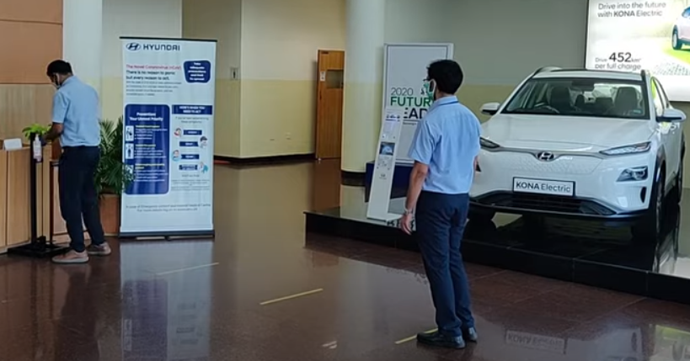
Figure 2: Social distancing and sanitize use at Hyundai Electric Car Unit
(Source: Daniels, 2020)
Legal policies are also being followed by Hyundai and recently they have made many changes in the policies. Wearing mask, sanitization and other covid legal guides are being followed by Hyundai at its electric car units during production and sales. Follow of guidelines and other measures is being considered accurately by the entity in order to have maintained legal aspects (Khan,et al. 2020).
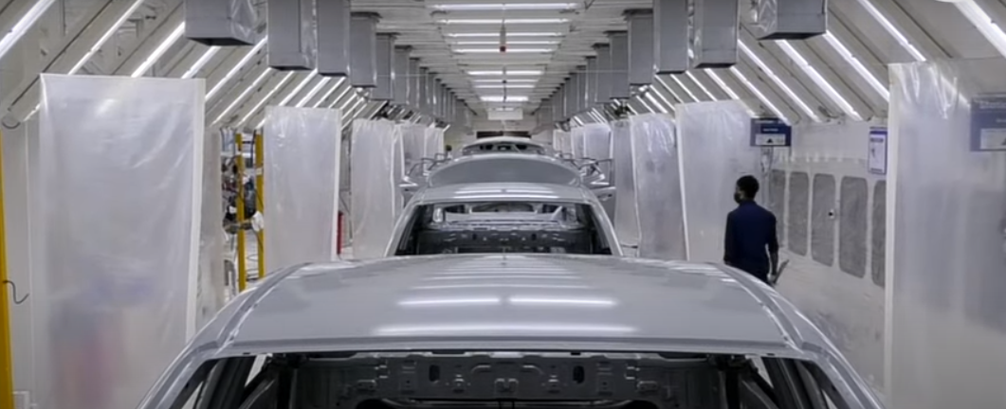
Figure 3: Social distance curtain use at production plant
(Source: Daniels, 2020)

Application of Porter’s Five Forces
Consideration of porter five forces is being taken into account by the management of Hyundai in order to have application of changes as per forces. It is necessary to have evaluation of forces to implement changes and ensure respecting growth.
Rivalry among existing firms
Hyundai electric cars are currently having high competition in the market. Even after the situation of covid as per market trends the more players are entering in the electric car industry. It might impact the working conditions of business and affect the long term development in negative manner. During time of pandemic the competitive aspects are being affected on rivals so Hyundai need to improve the customer experience (Baldwin and Tomiura, 2020).
Bargaining power of Hyundai electric car suppliers
Hyundai electric cars suppliers are having high bargaining power because they are very limited in the sector in current situation. In international market the les businesses are dealing in electric cars suppliers market so it create issue for company in pandemic situation. Export based issues are increased in covid-19 situation due to less support from suppliers.
Bargaining power of buyers
It is also recorded at high scale and company need to bring changes as per needs of customers. It is also a reason that Hyundai is continuously looking for changes in features of electric cars to have success. Air purifier and UV light dashboards are two major changes are being considered as major concern for Hyundai in covid situation. Such changes are according to need of the buyers to have growth in market (Kang, et al. 2020).
Threat of new entrants
In electric car market the existing competition is low but it is increasing because many other car players are looking forward to switch to electric cars. It is easy for existing automobile companies to enter in electric car market because they have easy access to resources. In pandemic situation the new entrants are not taking much risk so for short term the company can take advantage of same.
Threat of substitute
Threat of substitute is low because electric cars are considered as more safe and efficient medium of transportation then others and currently there no such substitute product that can affect electric car market (Belhadi,et al. 2020). Covid situation has increased opportunity for Hyundai and threat of substitute is really low in current market.

Extent to changes are suitable
According to analysis, Hyundai is looking forward to boost the electric cars production so that competitive edge in market can be gained. However, changes are being implemented in terms of production process and sales routine and covid-19 situation has become a critical issue for entity. Demand of cars in the market has also been decreased because f less travelling trends in pandemic situation. Also, income level of many people has been affected that also decreases the demand and opportunities for Hyundai.
Measures that are followed at production and sales unites are also affecting the current pricing strategy of company. Social distancing and use of mask are two major guides that are followed by Hyundai at different stages of operations. It impacts the expense and increases the financial issues for company (Lorio, 2020). Sales of the electric cars are considered as premium sales and pricing strategy is also followed accordingly but covid-19 situation has affected the pricing factors. It forces to bring cut down in the prices and company may need to shift to competitive pricing from premium pricing.
Cost of electric car production is high and following price skimming factors is not suitable for company but it is necessary to change pricing for sustainable development. Expenses are also being increased in pandemic situation such as social distancing cuts number of employees at single unit, sanitization of units, temperature check, etc have increased the cost and it has impacted the overall feasibility of business in terms of financial performance.
During the covid the sales of company was not increasing because customers were not visiting to showrooms. However, it was necessary for Hyundai to maintain the engagement with customers and present firm as socially active. In respect to the same, Hyundai has initiated different CSR activities to deal with issues. Many donations and other aspects are being considered by entity to have growth (Kanda and Kivimaa, 2020).
Transformations like social distancing and focus on disinfection activities has forced company to bring solutions for society. In respect to same, UV protection technology initiation program has been considered by Hyundai to deal with issue. More investment in the electric cars has been made by Hyundai so that support to environmental conditions can be offered (Daniels, 2020). According to changes in the market conditions the company is having efforts to bring changes in the working protocols. Cost of training has been increased within Hyundai because during covid situation the overall process gets modified.
Cost related issues are being increased because many additional arrangements and research based investment was required to deal with issue. It has increased the finical burden on the Hyundai and impacted the revenue in pandemic times. It can also be said that changes have also incur the extra cost of training and development including the expenses in the high standard medical and sanitization facilities that will increase the financial burden. Also, it was a situation when the business is not able to generate the revenues in the pandemic times.The greatest drawback for Hyundai in operating the business operations is to provide remote working for the employees. As a result, it had to cut down the personnel availability due to the business disruptions in the pandemic. Such step had caused the hotel great loss in terms of compromising on the committee staff because the nature of work does not make way for remote working (Gillingham, et al. 2020). However, by having adequate support of technology and other tools has facilitated in accomplishing objectives. If such measures are not being considered by Hyundai then production of electric cars might be affected for long term period.

Recommendations
- It is recommended to the Hyundai that use of digital technology needs to be used more in the operations so that contact les working and production can be prompted. Self-check kiosks can also be introduced at the workplace so that support to operations can be provided in context to dealing with issue.
- It is suggested that Hyundai need to focus on the end of showrooms strategy so that better support to distribution channel can be offered. It means application of AR based showrooms and digital selling using live streaming so that risk of physical contact can be resolved. Considering the same accurately the business firm can easily attain better opportunity respecting diverse measures.
- It is recommended that redesign of the production plant and other units can be taken into account so that operational changes can be managed accurately.

Conclusion
As per study, covid-19 situation has impacted the overall outcome and created risk in terms of financial development. Expense based risk has been increased and it has forced entity to bring changes and ensure respecting long term development. By having technological and operational changes the issues are being managed by entity.

References
Baldwin, R. and Tomiura, E., 2020. Thinking ahead about the trade impact of COVID-19. Economics in the Time of COVID-19, 59.
Belhadi, A., Kamble, S., Jabbour, C.J.C., Gunasekaran, A., Ndubisi, N.O. and Venkatesh, M., 2020. Manufacturing and service supply chain resilience to the COVID-19 outbreak: Lessons learned from the automobile and airline industries. Technological Forecasting and Social Change, p.120447.
Daniels, P., 2020. Hyundai India manufacturing cars with precautionary measures.[Online].<Available through: https://www.rushlane.com/hyundai-india-manufacturing-cars-video-12362816.html>. Accessed on: [8th January, 2020].
Free, C. and Hecimovic, A., 2020. Global supply chains after COVID-19: the end of the road for neoliberal globalisation?. Accounting, Auditing & Accountability Journal.
Gillingham, K.T., Knittel, C.R., Li, J., Ovaere, M. and Reguant, M., 2020.The Short-run and Long-run Effects of Covid-19 on Energy and the Environment. Joule, 4(7), pp.1337-1341.
Kanda, W. and Kivimaa, P., 2020. What opportunities could the COVID-19 outbreak offer for sustainability transitions research on electricity and mobility?. Energy Research & Social Science, 68, p.101666.
Kang, M., Choi, Y., Kim, J., Lee, K.O., Lee, S., Park, I.K., Park, J. and Seo, I., 2020. COVID-19 impact on city and region: what’s next after lockdown?. International Journal of Urban Sciences, 24(3), pp.297-315.
Khan, S.A.R., Jabbour, C.J.C., Mardani, A. and Wong, C.Y., 2020. Supply Chain and Technology Innovation during COVID-19 Outbreak.
Lorio, J., 2020. Hyundai wants to use UV light to disinfect automobile interiors.[Online].<Available through: https://www.autoblog.com/2020/05/13/hyundai-using-uv-light-against-viruses/>. Accessed on: [8th January, 2020].
Pani, A., Mishra, S., Golias, M. and Figliozzi, M., 2020.Evaluating public acceptance of autonomous delivery robots during COVID-19 pandemic. Transportation Research Part D: Transport and Environment, 89, p.102600.
Xu, Z., Elomri, A., Kerbache, L. and El Omri, A., 2020. Impacts of COVID-19 on global supply chains: facts and perspectives. IEEE Engineering Management Review, 48(3), pp.153-166.
Hyundai, 2020.Hyundai Models.[Online].<Available through: https://www.hyundai.com/in/en/find-a-car/venue/interior>. Accessed on: [8th January, 2020].

