LCLM5006 Developing Emotional Intelligence Skills
Name: Catalin Alexandru Boghiu
Student Id:2333790
Table of Contents
Introduction 3
Task 1 – Emotional Intelligence in the Workplace 3
Introduction to Emotional Intelligence in Organisations 3
Comparative Analysis of Emotional Intelligence Models 4
Emotional Intelligence and Workplace Performance 5
Emotional Intelligence in Collaboration and Teamwork 7
Critical Evaluation of Emotional Intelligence 8
Task 2 – Multigenerational Workforce 9
Generational Profiles in the Workplace 9
Impact of Generational Differences on Workplace Effectiveness 10
Emotional Intelligence and Mindfulness in Managing Generational Diversity 11
Conclusion and Recommendations 12
References 14

Figure 1: Goleman’s Emotional Intelligence Model 4
Figure 2: Emotional Intelligence in Workplace 7
Figure 3: Generational Workplace 10

Table 1: Comparison of Major Emotional Intelligence Models 5
Table 2: Generational Comparison in the Workplace 11

Introduction
Emotional Intelligence (EI) is defined as the capacity to sense, think and to control the feelings as explained by Goleman using the self-awareness, self-regulation, motivation, empathy and social skills (Antonopoulou, 2024). Other models are the ability-based framework of Mayer and Salovey, which also identifies cognitive and behavioural aspects of emotional competence, and the emotional-social intelligence model of Bar-On. According to Kabat-Zinn, mindfulness entails paying a present-mindfulness and non-judging attention, which aids in control of emotions at work. The modern organisations are confronting more issues like the working environment is getting hybrid, the level of employee stress is growing, and there is multigenerational working environment diversity. According to Deloitte reports, more than 80% of employees face risk factors of burnout, while World Economic Forum included emotions skills in the top ten workforce competencies in the future. The present report critically reviews EI and mindfulness within organisations to aid top-level management in their decision-making procedures concerning leadership and workforce development.

Task 1 – Emotional Intelligence in the Workplace

Introduction to Emotional Intelligence in Organisations
Emotional Intelligence (EI) can be described as a skill to be in a position to identify, manage and harness emotions in a positive way both to oneself and to others. According to Goleman, there are five competencies that are described as the core competencies: self-awareness, self-regulation, motivation, empathy, social skill, which are combined and have impact on workplace behaviour and performance as a leader (Goleman, 2009). EI is being considered as central predictor of the performance, teamwork and wellbeing of an employee in the modern organisations.
Other conceptualisations give alternative views. According to the ability model by Mayer and Salovey, EI is a cognitive capacity that entails emotional perception, comprehension, and management. The model by Bar-On extends EI to emotional-social intelligence that includes the flexibility, ability to cope with stress, and interpersonal functioning. These varying arguments underscore the fact that there is still a debate on whether EI is a cognitive ability that can be measured, or whether it is a behavioural competency, or as a trait construct based on personality.
EI has become a strategic component in contemporary work environments that are characterised by a hybrid workplace, stress integrated work settings, and a multi-generational workforce. Its applicability is also supported by the reports of Deloitte who state that more than 80% of workers are exposed to the risk factors of burnout, and emotional skills are the list of the ten most desired workforce capabilities provided by the World Economic Forum. This illustrates the increasingly important role of EI in organisations in promoting productivity and effectiveness in leadership.

Comparative Analysis of Emotional Intelligence Models
Goleman’s Mixed Model
This model by Goleman is the commonest one that is used in the organisational practice because it is directly applied to performance management as well as leadership. It also focuses on the behavioural competencies like emotional awareness, empathy and social skills that are critical when managing teams and shaping organisational culture. Its greatest strength is that it is practically applicable especially in the areas of leadership, coaching and improving performance.
Nonetheless, it has been greatly criticised that the model is not precise enough. The critics claim that it crosses the line with personality traits and behavioural competencies, and does not constitute a specific kind of intelligence. Consequently, its scientific validity is not credible although it is popular in the management practice.
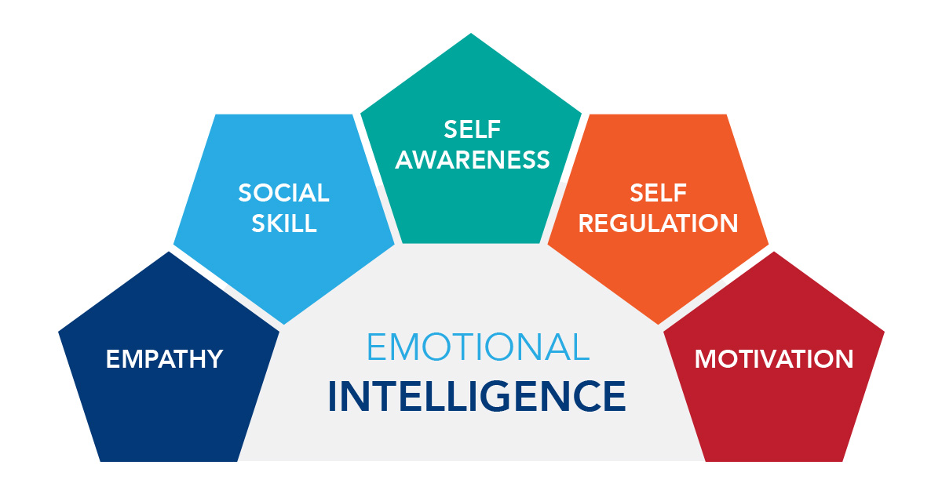
Figure 1: Goleman’s Emotional Intelligence Model
Source: (Uluç, 2023)
Mayer Salovey Ability Model
The conceptualisation of the ability-based model defines the EI as a type of intelligence that is comparable to cognitive ability that deals with four major processes; emotional perception, facilitation, understanding, and regulation (Ramdas, 2024). This model is scientifically more rigorous and it has a close association with psychometric testing methods.
Its main advantage is that it is more appropriate in terms of academic research due to its theoretical elegance and empirical foundation. Nevertheless, it lacks uses in organisational settings because of challenges in the measurement of emotional ability consistency in actual work scenarios. This makes it less useful in the development of leadership and recruitment.
Bar-On Emotional-Social Intelligence Model
The model used by Bar-On is more comprehensive as it incorporates emotional and social skills like stress tolerance, flexibility and interpersonal skills. It offers a comprehensive perspective of emotional operating within workplaces, and it is applicable to appreciate the wellbeing and resilience of employees (Zain, Rajput and Ali, 2025).
The model has however been criticised to have conceptual overlaps with personality psychology thus casts doubt on construct validity. Its theoretical precision is limited by the fact that it includes personality-like traits and is hard to differentiate.
Table 1: Comparison of Major Emotional Intelligence Models
Model | Focus | Strength | Limitation
Goleman's Emotional Intelligence Framework) | Emotional competencies | Practical and leadership-focused | Limited scientific validity
Mayer and Salovey's Ability Model | Emotional abilities | Strong theoretical foundation | Less practical in organisations
Bar-On Emotional-Social Intelligence Model | Emotional-social skills | Comprehensive approach | Overlaps with personality traits

Critical Comparison
Comparative analysis of EI models finds that there exists a basic controversy of EI as a mental ability or behavioural competency. The model created by Goleman is winning the popular choice in organisations because it is more easily accessible, whereas Mayer and Salovey offer better scientific validity. Bar-On presents a more integrative yet less specific way.
According to Harvard Business Review reports, about 90% of high performers have high emotional intelligence, which both confirms the practical applicability of EI (Krasimira Yancheva, 2025). Nonetheless, this relationship does not imply causation meaning that EI must be deemed carefully as a predictor of performance.

Emotional Intelligence and Workplace Performance
Communication Effectiveness
EI improves communication a lot through its capacity to advance emotional awareness and decoding interpretation of verbal and non-verbal messages. Emotionally intelligent employees can prevent the emergence of misunderstandings and keep the interaction clearer in a hybrid-working environment where digital communication is prevailing. Of special concern is the fact that due to low face-to-face engagement, there are higher chances of misinterpretation and disengagement.
Leadership Effectiveness
Emotional intelligence closely correlates with quality leadership performance. Gallup reports that high-EI leaders help to enhance the level of employee engagement by 20-30% (Gallup Inc, 2021). This can be credited to enhanced empathy, inspiration and relational trust among the leaders and employees. Nevertheless, with all the improvement in leadership, EI cannot substitute the technical competence and the skill in strategic decision, which are still vital to organisational success.
Conflict Management
EI is important in the management of workplace conflict as it allows one to exercise emotional control and perspective taking. Workers of higher EI have more chances of getting into a positive conversation as opposed to defensive or violent reactions. This makes attaining consensus in any conflict a lot easier and tension in the workplace diminished, enhancing team unity and productivity.
Decision-Making
Emotional regulation aids in better decision-making in the face of pressure due to a decreased level of responding impulsively and increasing the judgments made rationally. Nevertheless, the overuse of emotional awareness could bring in the element of prejudice in making decisions especially when it comes to those situations where objectivity is essential. This underscores the necessity of emotional and rational thinking in decision making in organisations.
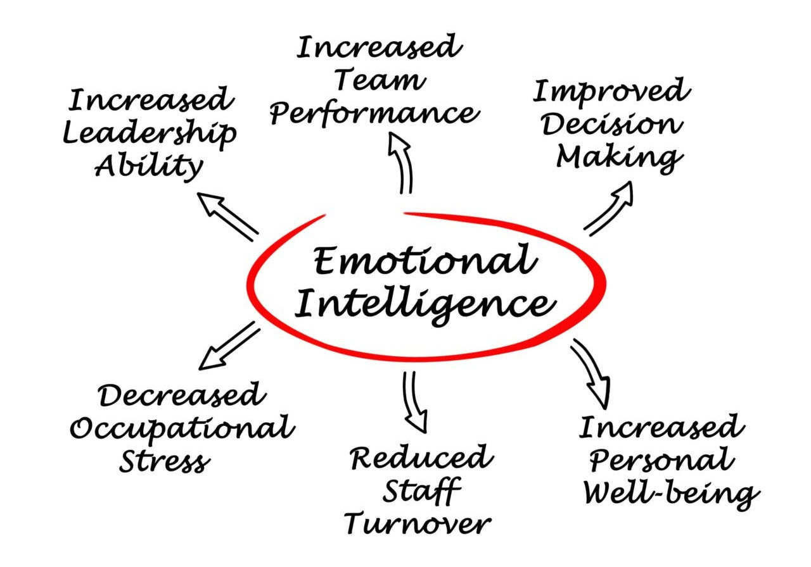
Figure 2: Emotional Intelligence in Workplace
Source: (Randall, 2021)
Critical Perspective
Even though it has its positive aspects, Emotional Intelligence cannot be considered as all positive. The overdependence of emotional intelligence can make organisations underestimate technical skills and logic. Moreover, biases could occur with emotional decisions thus lowering objectivity in leadership decisions. Thus, Emotional Intelligence needs to be incorporated with cognitive intelligence and technical proficiency to have performance balanced in the organisations.

Emotional Intelligence in Collaboration and Teamwork
Emotional intelligence is crucial to the development of effective collaboration within the team, and especially it impacts trust, psychological safety, and emotional regulation. Psychological safety is another concept introduced by Edmondson as the environment where a person is not afraid to share ideas and take interpersonal risks and is sure that they will not be negatively impacted (Edmondson, 2019). EI is part of this environment as it fosters empathy, active listening, and emotional awareness.
The Project Aristotle conducted by Google offers a solid empirical data in favour of the value of EI in the context of teamwork. The research also concluded that high-performing teams depended most on psychological safety, which was more important than technical skills and individual intelligence. This serves to show that relational and emotional aspects of organisations are very important in organisational success.
EI also enhances trust among groups because it promotes respect and emotional stability. High emotional intelligence teams are more collaborative, engage well, and resolve conflicts effectively. Regulating emotions will help keep conflicts task-oriented, not personal relationships, which leads to enhanced effectiveness in the long term of a team.
Nevertheless, teamwork EI is very context sensitive. Emotional expression and understanding are affected by cultural differences so that what is construed as emotionally intelligent behaviour in one culture might not be construed in the same way in another culture (Mortillaro and Schlegel, 2023). As an illustration, a culture might consider direct emotional expression important, whereas in other cultures it is unacceptable. This underscores the role of cultural awareness in combination with emotional intelligence in the international organisations.

Critical Evaluation of Emotional Intelligence
Irrespective of its popularity, Emotional Intelligence is a controversial phenomenon in the field of organisational psychology. The major drawback is the incoherence of measurement models where various models have varying definitions and assessment instruments. This minimises reliability and comparability between studies.
Another limitation is the cultural biases because most of EI framework is created in a western setting. This restricts their use in different work environments around the world where there are very few similarities in emotional norms of expression. Due to this, EI cannot be universally definite and appreciated in terms of different cultures.
In addition to this, EI makes ethical issues surrounding leadership. The emotional awareness that highly emotionally intelligent leaders could be using may raise a question of the ethical leadership practices and imbalance of power by influencing or manipulating employee behaviour.
Lastly, there is still debate on whether Emotional Intelligence or the IQ is higher. Although EI improves interpersonal effectiveness and leadership, IQ is required in the process of analytical thinking and solving technical problems. Hence, EI cannot be deemed as being superior to cognitive intelligence but as a complement.

Overall, Emotional Intelligence can play a critical role in employee performance, leadership, and teamwork in the workplace. Nonetheless, its shortfalls such as inconsistencies in measurements, cultural inclination and ethical issues point to balanced usage. To have the best results in organisational performance, organisations need to combine EI, cognitive and technical competencies.

Task 2 – Multigenerational Workforce

Generational Profiles in the Workplace
Generation X
Generation X (born around 1965-1980) is generally defined as either independent, self-reliant and being pragmatic towards work. Workers in this generation tend to focus on work-life balance and enjoy stability in organisational set ups (Huyler et al., 2024). They tend to lean towards practical results-oriented leadership due to experience in pre-digital and transitional working environments. This helps in making them flexible, but can favour systems that are structured and have set courses in making decisions.
Millennials (Generation Y)
Millennials (born around 1981-1996) are well-known purposeful and team players. They put a lot of emphasis on meaningful work, feedback and alignment of organisational culture. This generation is likely to be more inclined towards participative leadership orientations and appreciate individual and professional growth opportunities (Mann et al., 2026). The digital transformation and global accessibility have a powerful influence on their attitude towards work and position them at ease in collaborative and highly dynamic settings.
Generation Z
The cohort that is the most digitally native is Generation Z (born around 1997 and onwards). They are distinguished by a high technological fluency, rapid communication tastes and high expectations of leeway in work arrangements. This population focuses a lot on wellbeing, inclusiveness, and swift career advancement. McKinsey estimates the increasing influence of Generation Z on the organisational environment to the size of about 27% of the global workforce by 2025 (Mahapatra, Bhullar and Gupta, 2022).
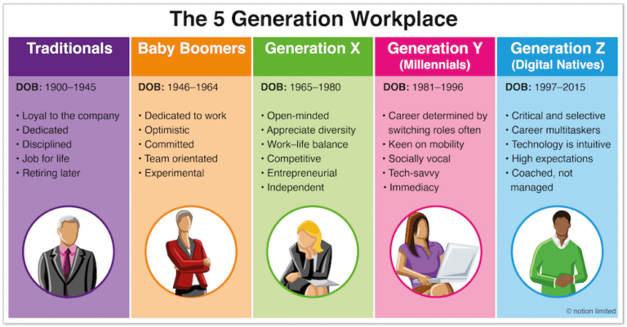
Figure 3: Generational Workplace
Source: (Robinson, 2023)
Critical Perspective on Generational Categorisation
Although generational frameworks offer valuable analytical understanding, the frameworks may simplify complicated human behaviour. There is often more individual variations in each cohort than generalisation by generation. Thus, organisations should not be strictly categorised but should be people-centred, flexible in management methods.

Impact of Generational Differences on Workplace Effectiveness
Communication Styles
Communication preference is among the most dramatic differences in generational groups. Most Generation X members prefer official lines of communication like email and organized meetings. Millennials like mutually supportive and feedback-derived communication approaches and frequently use digital mediums. Generation Z exhibits a communication style that uses instant messaging and fast, informal communication.
Multigenerational teams may pose communicational challenges due to such differences (Kinger and Kumar, 2023). As an example, slower email communication can be seen as ineffective among younger workers and instant messaging style seen as too informal among older workers. These differences may cause misunderstanding and low-level collaboration, without proper management.
Motivation and Work Values
There are also a great deal of motivational drivers that differ across generations. Generation X is much more focused on job security, financial stability, and independence. Purpose, organisational values, and growth opportunities make the millennials more motivated. Generation Z, on the other hand, is more focused on flexibility, wellbeing, and expedited career progression.
These variations affect the levels of engagement and retention in organisations. Therefore, managers should ensure that they implement elastic motivational structures that take into consideration different expectations instead of the approach of uniform one.
Technological Adaptation
Another few important differentiators include technological flexibility. Gen Z as the most digitally fluent generation can quickly adopt the new technologies. The millennials are also highly digitally competent given that they have witnessed the emergence of digital transformation in their working life. Being flexible, Generation X might need more support and systematic instruction to use new technologies (Agata Koksanowicz et al., 2025).
Such disparity may affect productivity and workflow integration within organisations that rely heavily on digital system operations.
Table 2: Generational Comparison in the Workplace
Generation | Preferred Communication | Primary Motivation
Generation X | Email and formal meetings | Job security and stability
Millennials (Gen Y) | Regular feedback and collaboration | Career development and meaningful work
Generation Z | Instant messaging and digital communication | Flexibility and rapid career growth

Critical Evaluation
Whilst the generational differences may offer informative advice, when taken strictly, they pose a risk of strengthening stereotypes. Several factors determine workplace behaviour such as personality, experience and organisational culture. This means that although generational analysis can prove helpful in terms of trend comprehension, it cannot be substituted with individual level analysis in the practice of management.

Emotional Intelligence and Mindfulness in Managing Generational Diversity
Role of Emotional Intelligence
EI is also fundamental in handling a multi-generational workforce because it will help managers to comprehend and address various employee needs appropriately. This is facilitated by High Emotional Intelligence, which encourages conflict mediation by assisting leaders to identify when they become emotionally aroused, and respond to miscommunication in a constructive manner. It also promotes inclusive leadership, through encouraging empathetic, active listening, and flexibility in various intergenerational expectations.
Emotionally intelligent leadership enables organisations to enhance communications, alleviate tension at work, and boost the work in various teams.
Role of Mindfulness
Mindfulness is a complement to emotional intelligence as it enhances attention management and emotional regulation (Popescu, 2025). Mindfulness in workplaces aids employees to be focused, less reactive and handle stress effectively. Especially, it should be considered in multigenerational teams where the presence of dissimilar expectations can cause tension.
According to the American Psychological Association, mindfulness practices can be used to alleviate stress levels in the workplace to an extent of 28%, and because of this fact, mindfulness uplifts the wellbeing of employees and organisational strength.
Critical Evaluation of EI and Mindfulness
Although they have advantages, there are limitations to Emotional Intelligence and mindfulness. The ability of EI based intervention to be effective differs with individual personality traits, organisation culture, and style of leadership. On the same note, mindfulness practice may not be applicable universally and in all cultural and workplace settings.
Moreover, EI should be trained and committed to by the organisation over time and its influence may not be direct. Therefore, EI and mindfulness as methods of managing generational diversity are useful, and need to be used as an addition to larger organisational development plans but not as solutions.

Conclusion and Recommendations
Summary of Findings
This report has critically analysed how Emotional Intelligence (EI) and mindfulness play a role in the modern organisations. The discussion shows that EI is an important factor that can boost leadership performance, communication skill, and teamwork by providing individuals with the ability to control their emotions, show empathy, and enhance interpersonal decision-making. Through the critique of the well-known models, such as the mixed model offered by Goleman, the ability model developed by Mayer and Salovey, and the emotional-social intelligence model proposed by Bar-On, it is possible to outline the strengths and weaknesses of EI in the workplace, both in theory and in practice. Further, the report has established that the generational diversity in the workforce presents opportunities and challenges. Although the differences of Generation X, Millennials, and Generation Z may contribute to the increased levels of innovation and flexibility, they may cause barriers to communication and conflict when not addressed properly. In addition, mindfulness also enhances emotional regulation, less stress, and better conditions by promoting greater organisational resiliency through employee wellbeing.
Recommendations to Senior Management Team
It is suggested that organisations should have in place well-articulated Emotional Intelligence training programmes to increase leadership capacity and interpersonal effectiveness at all levels within the organisation. Moreover, the leadership development programs rooted in mindfulness are to be proposed to enhance emotion regulation, stability, and attitude towards stressful situations. The process of recruitment and talent management should have an inclusive policy to acknowledge the differences in generational diversity and not make assumptions based on stereotyping so that the talent can be absorbed efficiently and fairly. Moreover, organisations are encouraged to foster a culture of psychological safety through fostering communication, trust as well as mutual respect among teams. Such interventions will facilitate a better level of engagement among employees, less conflict at workplace and better general organisational performance due to more adaptive and emotionally intelligent leadership practices.

References
Agata Koksanowicz, Justyna Milewska, Chmiel, S., Glica, P. and Kochańska, J. (2025). Generational Differences and the Implementation of Modern Management Methods in Industry: Motivation, Approach to Change, Technology. Lecture notes in mechanical engineering, pp.423–435. doi: https://doi.org/10.1007/978-3-032-01517-4_31.
Antonopoulou, H. (2024). The Value of Emotional Intelligence: Self-Awareness, Self-Regulation, Motivation, and Empathy as Key Components. Technium Education and Humanities, [online] 8(1), pp.78–92. Available at: https://pdfs.semanticscholar.org/01fd/901d7b6a987dc06497bea64f3b506eb0d4ea.pdf.
Edmondson, A. (2019). The fearless organization : creating psychological safety in the workplace for learning, innovation, and growth. Hoboken, New Jersey John Wiley & Sons, Inc.
Gallup Inc (2021). Gallup’s Q12 Employee Engagement Survey - Gallup. [online] Gallup.com. Available at: https://www.gallup.com/workplace/356063/gallup-q12-employee-engagement-survey.aspx.
Goleman, D. (2009). Emotional Intelligence: Why It Can Matter More than IQ. 1st ed. London: Bloomsbury Publishing.
Huyler, D., Gomez, L., Rocco, T.S. and Plakhotnik, M.S. (2024). Leading Different Generational Cohorts in the Workplace: Focus on Situational and Inclusive Leadership. New Horizons in Adult Education and Human Resource Development, 37(1). doi: https://doi.org/10.1177/19394225241297230.
Kinger, N. and Kumar, S. (2023). Generational Differences In Work Values In The Workplace. Folia Oeconomica Stetinensia, 23(2), pp.204–221. doi: https://doi.org/10.2478/foli-2023-0027.
Krasimira Yancheva (2025). EMPATHY AND EMOTIONAL INTELLIGENCE AS PREDICTORS OF EVENT MANAGEMENT SUCCESS: A MIXED-METHODS STUDY. Psychological Research (in the Balkans), [online] 28(2), pp.119–138. Available at: https://www.ceeol.com/search/article-detail?id=1391099.
Mahapatra, G.P., Bhullar, N. and Gupta, P. (2022). Gen Z: An Emerging Phenomenon. NHRD Network Journal, [online] 15(2), pp.246–256. doi: https://doi.org/10.1177/26314541221077137.
Mann, S., Mann, S., Mistry, T. and Mahajan, Y. (2026). Cultures in Transition. Navigating the Hybrid Workforce, [online] pp.131–162. doi: https://doi.org/10.4018/979-8-2600-1313-7.ch005.
Mortillaro, M. and Schlegel, K. (2023). Embracing the Emotion in Emotional Intelligence Measurement: Insights from Emotion Theory and Research. Journal of Intelligence, [online] 11(11), pp.210–210. doi: https://doi.org/10.3390/jintelligence11110210.
Popescu, C.-D. (2025). THE ROLE OF MINDFULNESS IN DEVELOPING STUDENTS’ EMOTIONAL INTELLIGENCE. Journal of Romanian Literary Studies, [online] (40), pp.713–720. Available at: https://www.ceeol.com/search/article-detail?id=1331356.
Ramdas, M. (2024). Emotional Intelligence in Applied Settings: Approaches to Its Theoretical Model, Measurement, and Application. Frontiers Media SA.
Randall, K.-A. (2021). Emotional Intelligence Workplace. [online] Medium. Available at: https://medium.com/@kim_96989/emotional-intelligence-workplace-661509a8dedb.
Robinson, J. (2023). The Key to Managing a Multigenerational Workforce. [online] STAR® Manager. Available at: https://starmanager.global/the-key-to-managing-a-multigenerational-workforce/.
Uluç, Ö.S. (2023). A Milestone of Intelligent Development: Daniel Goleman’s Emotional Intelligence Theory - Experianta. [online] Experianta. Available at: https://experianta.com/directory/concepts/a-milestone-of-intelligent-development-daniel-golemans-emotional-intelligence-theory/.
Zain, Rajput, N.H. and Ali, S. (2025). Models of Emotional Intelligence: Implications for Higher Educational Institutions. Deleted Journal, [online] 14(1), pp.536–543. doi: https://doi.org/10.62345/jads.2025.14.1.42.

