introduction to physiology

Suma Begum 1808421

Lecturer- Mumtaz Goolam

  - BMHP5003_BIRM

Human Respiratory System
Pharynx also called the throat it is a canal like muscle which allows air that has been inhaled through the nasal cavity go down to the lungs.
Nasal cavity is the major path for air to enter the system.
Trachea also known as windpipe is a tube-like pipe made of cartilage rings, the main function is to supply clear airway for the air to enter and exit the lungs.

Nostril is the outer openings of the nose that goes into the nasal cavity.
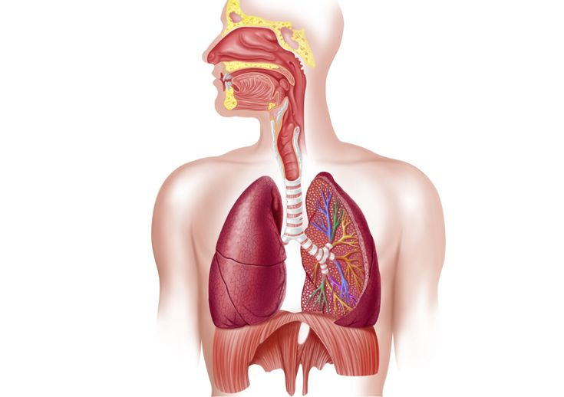
Right lung is in the upper lobe of the lung it is one of three lobes that complete the right lung, it is divided into three separate sectors called lobes. The lobes are formed out of sponge like tissue that is enclosed in by a membrane wall called pleura. Its function is to allow oxygen from the air to enter the bloodstream.
Diaphragm is a vital muscle in the respiratory system, it is located below the lungs. The diaphragm compresses to inflate the area in the lungs at the same time moving a little into the abdominal pouch, during this time the muscles also tighten causing the rib cage to move up and down.

Left main bronchus is narrower, smaller, and longer in length in comparison to the right bronchus, it splits onto two bronchi’s which act as a tube for air to move from the mouth and trachea down to the alveoli and then back out into the outer surroundings.

Left lung takes oxygen from air and passes to the blood.
Bronchioles are in the lower part of the respiratory system, the bronchial tubes which flow through to the lungs break up into smaller air tubes which are called bronchioles.

Right main bronchus function is making sure air enters the correct lung.
Larynx also called voice box its function is the gift of speech.
Oral cavity known as mouth inhales more air than nasal cavity and has no hair or filtering process.
Figure 1: Human Respiratory System. (HaikuDeck, 2015).

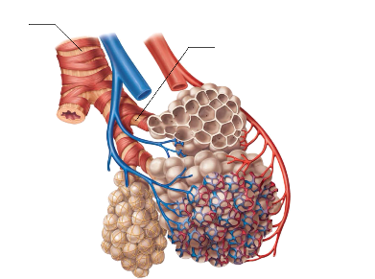
Alveoli are enclosed by a web of small blood vessels called capillaries this is where oxygen that has been breathed in from the air passes through into the blood. Upon absorbing the oxygen blood goes to the heart which then pumps it around to the cells of your tissues and organs. The cells use this oxygen and make carbon monoxide which goes into the blood, the blood then transfers the carbon monoxide back to the lungs where it is then discharged from the body when exhaled.

Figure 2: Alveoli. (Evolving Sciences, 2020).

Figure 3: Healthy lung vs Diseased Lung
Smoking cigarettes is the likeliest factor for lung cancer (Mckinley, 2013). Approximately 70% of lung cancer cases are within smokers (NHS, 2020).
Frequent exposure to Passive smoking can increase the risk of developing lung diseases (Lekeux, 1994).
A person who smokes 25 cigarettes per day is 25 times more likely to get lung cancer than a non-smoking person (Xing et al. 2017).

This image shows a smokers diseased lung which is due to smoking which then leads to being infected with lung cancer.

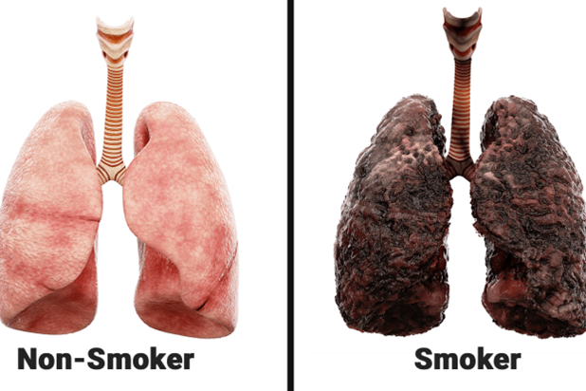
Smoking cannabis has also been found to be connected to lung cancer (Alberg, 2003). Many cannabis smokers blend cannabis with tobacco, despite smoking less tobacco than a regular smoker cannabis smokers inhale smoke more deeply and hold the smoke in the lungs for longer periods.
This is an image of healthy lungs.

Source from: (Healthline, 2020).

There are several respiratory diseases which affect humans every day, among many one of those is lung cancer (Waugh and Grant, 2018).
Cancerous mass building in the lung cells.

Lung cancer initially starts in the lungs cells and spreads fast (Sharma, 2006). However, it is not detected through an x ray and does not always have any symptoms.

Figure 4: (Alberg, 2003)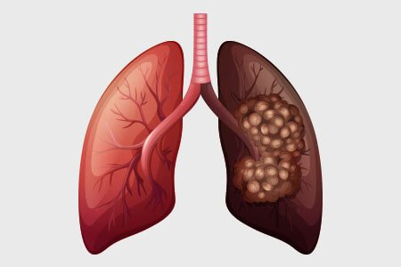
Lung cancer can affect the breathing process in three ways (Tucker, 2011).
In some cases, symptoms are coughing up blood, getting breathless after short activities, wheezing, chest or shoulder pain, hoarseness and losing weight unexpectedly (Peate, 2011). Furthermore, infections such as bronchitis or pneumonia which keep reoccurring.

Healthy Lung.
Once cancerous cells increase, they form new tumours which can spread into the airways and the chest walls (Berube, 2010).
Secondly when fluid may build up called pleural effusion in the outer lining of the lungs and chest wall (Ionescu, 2013).
When a tumour blocks the airway.
Reference
Alberg, A.J. and Samet, J.M., (2003). Epidemiology of lung cancer. Chest, 123(1), pp.21S-49S. [Accessed 15th October 2020]
BéruBé, K., Prytherch, Z., Job, C. and Hughes, T., (2010). Human primary bronchial lung cell constructs: the new respiratory models. Toxicology, 278(3), pp.311-318. [Accessed 11th October 2020]
Evolvingsciences.com. (2020). Evolving Sciences. [online] Available at: <https://www.evolvingsciences.com/> [Accessed 1st November 2020]
Haikudeck.com. (2020). Respiratory System. [online] Available at: <https://www.haikudeck.com/respiratory-system-uncategorised-presentation-w4vxwoipyl> [Accessed 4th November 2020]
Healthline. (2020). Chemotherapy Side Effects: 18 Ways Chemo Affects You. [online] Available at: <https://www.healthline.com/health/cancer/effects-on-body> [Accessed 8th October 2020]
Ionescu, C.M. (2013). The human respiratory system: an analysis of the interplay between anatomy, structure, breathing and fractal dynamics. Springer Science & Business Media. [Accessed 20 October 2020]
Lekeux, P. and Art, T., (1994). The respiratory system: anatomy, physiology, and adaptations to exercise and training. In The Athletic Horse: principles and practice of equine sports medicine (pp. 79-127). WB Saunders, Philadelphia. [Accessed 21st October 2020]
Mckinley, M, O’Louglin, V.& Bidle. T, (2013) Anatomy & Physiology : An integrative Approach. Maidenhead : McGraw Hill [ Accessed 17th October 2020]
nhs.uk. (2020). The NHS Website. [online] Available at: <https://www.nhs.uk/> [Accessed 30th October 2020]
Peate, I, and Nair, M. (2011) Fundamentals of Anatomy and Physiology for student Nurses. Chichester= Wiley Blackwell. [Accessed on 12th October 2020]
Sharma, G. and Goodwin, J., 2006. Effect of aging on respiratory system physiology and immunology. Clinical interventions in aging, 1(3), p.253. [Accessed 19th October 2020]
Tucker, L. (2011) An introductory Guide to Anatomy An introductory Guide to Anatomy and Physiology: (5th Edition). London = Ems Publishing. [Accessed on 17th October 2020]
Waugh, A. and Grant, A., (2018). Ross & Wilson Anatomy And Physiology in Health and illness: (12th Edition) London= Church Livingstone. [Accessed on 10th October 2020]
Xing, Y.F., Xu, Y.H., Shi, M.H. and Lian, Y.X., 2016. The impact of PM2. 5 on the human respiratory system. Journal of thoracic disease, 8(1), p.E69. [Accessed 19th October 2020]
Who.int. (2020). [online] Available at: <https://www.who.int/gard/publications/The_Global_Impact_of_Respiratory_Disease.pdf> [Accessed 12th October 2020]

