Germaine Engondo 1801242

The Global destination Tourism industy
Kath Flynn
Welcome to Hong Kong:
One of the hottest cities that you will be spoilt with some of the words most intense such as sightseeing, shopping, dining experience and Cultural attractions. This unique city is a moveable feast of skyline, Ancient tradition and outstanding food. The tantalising neighbourhood and unique Islands that make up Hong Kong are sincerely delight just waiting to be discovered. Hong Kong is one of heart-warming, peaceful, smooth and historic city that ‘’you may end up finding yourself swaying along on a historic double decker tram, cheering with the hordes at the city centre horse races, or simply gazing out at the glorious harbour’’ (Lonely planet ,2019). Hong Kong has one of unique and beautiful landscape; one side you’ll see skyscrapers, the other you’ll see mountains which is very popular for locals to go hiking. Most tourists are often surprised to find out that over 76% of Hong Kong is made up of mountains (Lonely Planet,2019).
Hong Kong has been part of china from July 1st, 1997 when the British handed it back to China (Tripsavvy, 2018). Hong Kong is located south east of China and has an area size of 426 square miles (1,104 square kilometres) with a population over 7.392 million.
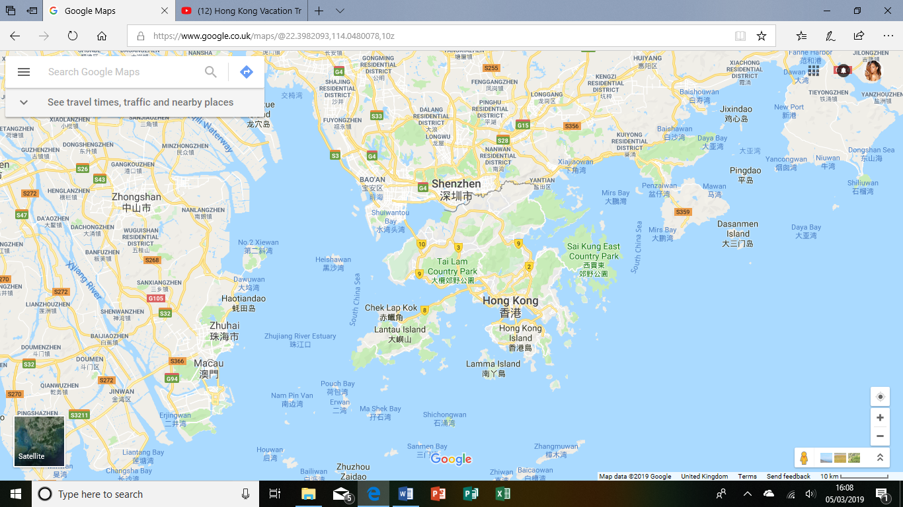
Source: www.google.co.uk/map
In Hong Kong most of the population speaks Cantonese and English remains an official language, since the city used to be colonised by the British. The population density of Hong Kong is at 6,690 persons per square kilometre, making Hong Kong one of the largest and most exciting place in the world. According to Gov.hk, (2015) during to 2010 and 2014, the number of the population has continued to increase each year at an average annual rate of 0.8% as this picture shows.
The Population of Hong Kong:
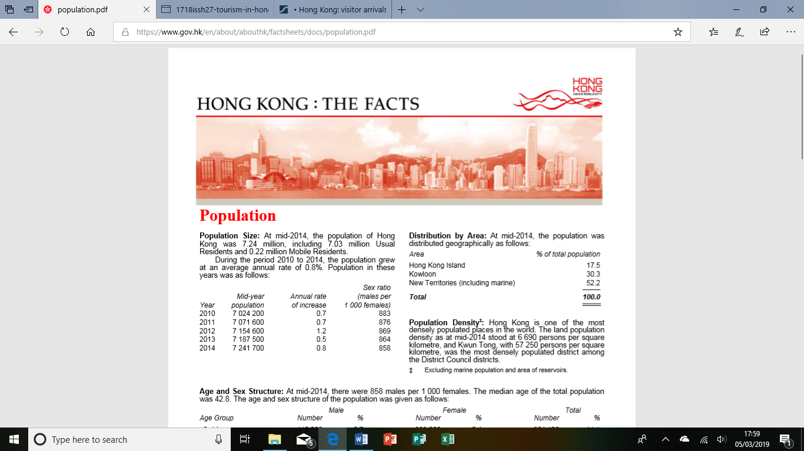

Source: www.gov.hk
The term Hong Kong is both administrative and geographical. For convenience, Hong Kong is made up of three main areas; The New Territories, Kowloon and Hong Kong Island. At the tip of Kowloon is Tsim Sha Tsui, Yau Ma Tei and Mong Kok. Kowloon is an area that is filled with unique neighbourhoods. Why not take a trip to Tsim Sha Tsui which overlooks Victoria Harbor, one of the busiest and most stunning ports in the world. The New Territories is a home to some of outstanding arts institutions, like the museum of art and the Hong Kong Cultural centre. From The new Territories why not take a trip to Hong Kong Island to explore the shopping malls and unique buildings, just by hoping aboard an historic Star ferry for the short crossing to Hong Kong Island (Hong Kong Traveller, 2019).
However, throughout the year Hong Kong has develop a very strong position in travel industry, from attracting many visitors from all over the world. In 2017 the number of visitor arrivals in Hong Kong was over 58.5million (Statista,2016), ‘’supported largely by the return of overnight visitor arrivals, which registered a 5% increase’’ (legco.gov.hk,2018).

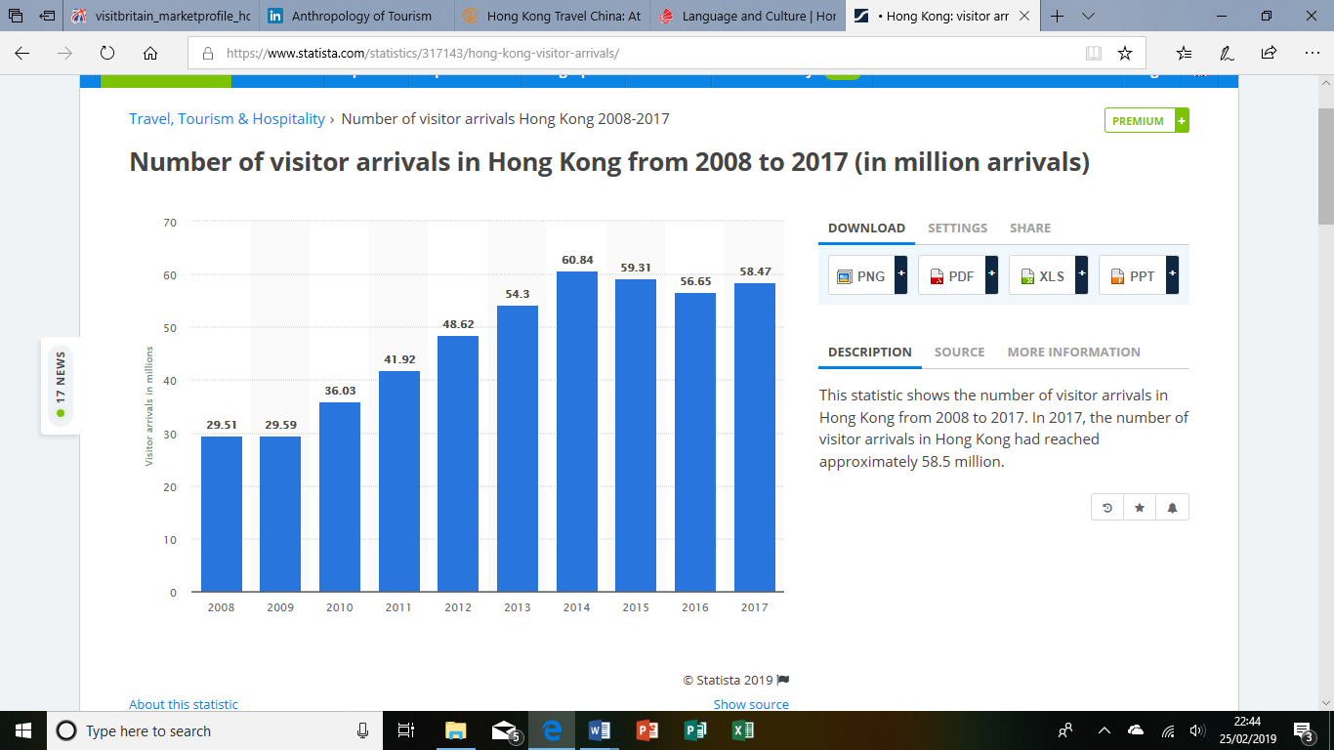
Source: www.statista.com
Linking this Statista to the Butler model system, which shows how a tourist area or tourist resort grows and develops over time (Geographyfiedword, 2018). Looking at the Statista you will be familiar how the number of tourists as develop from 2008 to 2015, because of the traditional activities and cultural attractions. Somehow, cultural and traditional attractions have gained popularity in Hong Kong, especially among tourists from UK and America. According to legco.gov.hk, (2018) over 19% of tourists in 2015 visited cultural attractions, while 9% of tourists was more interested in Hong Kong traditional activities. However, at some point the number of tourist arrivals in Hong Kong dropped in 2016 and 2017, because of the air travel become expenses to travel there and the weather wasn’t always brilliant, this led to the number of visitors to decrease. So, what could the city of Hong Kong did to attract more tourists, the city invested a huge amount of money in a range of different things, first thing that was done was to attract a lot of companies from all over the world and entrepreneurship with other countries, by doing this as help Hong Kong to attract over 300 million international companies from all over the world, making Hong Kong one of the most trade and investment city in the world.

Hong Kong for business:
If you’re coming to Hong Kong to start a business, then you have made the right choice. This unique city is one of the world’s most popular financial, Banking, and the third largest stock exchange city in the world, attracting many businesses from all over the globe. Hong Kong is a great place to start a business, because it is relatively easy, tax free and cost effective to start a business in Hong Kong. However, starting a business in Hong Kong also gives you a great gateway for establishing your business in Asian (Brandhk,2019).
A 2019 survey by Brandhk found that in 2012 to 2015 Hong Kong was voted to be one of the best business cities in the world for its economic freedom, cost effective, opportunity and ease of doing business.
Making money is everything, but these nowhere else in this world has the art of making money and the style of spending it like the city of Hong Kong does. For a small city inhabited by almost over 7.392 million of population, just like the sun, Hong Kong has continued to rise by holding a very strong position in international financial centre in the world. According to Insight guides Hong Kong (1980) Over 80% of the world’s top 100 banks are represented in Hong Kong, Making Hong Kong the thirteenth largest trading partner in the world.
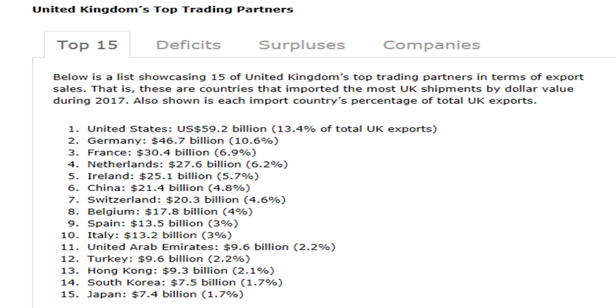
Source: www.worldstopexports.com
Hong Kong’s runway entrepreneurship with other countries has made it one of the world’s successful cities. According to Wong.W, (2017), so many overseas businesses often look up to Hong Kong as an ideal location to establish their company in order to gain a position in Asian markets. National of most developed counties do not need a visa to enter Hong Kong, that why most overseas countries such as the UK, America and Australia business visitors visits Hong Kong each year to develop new opportunities that may help their companies. Hong Kong might be a suitable destination for you, if you’re looking forward to starting a business; as the city of Hong Kong offers a great marketing access and growth opportunities.
However, not all visitors travel to Hong Kong to start a business. What does really attract them is culture, according to gov.hk (2018) around 76% of visitors say culture are the reason their visit Hong Kong, this shows that visitors are keenly taking part in culture and combining this with tourism by learning new things and meeting new people from different background. Hong Kong is the best cultural destination in the world as it is a multicultural city that is opened with a great natural unit harbor, this unique city it is a place where several cultures blend harmoniously. You may also find British culture everywhere in Hong Kong as a result of that Hong Kong used to be colonised by the British. Not to mention Hong Kong has some of the best museums like Museum of tea ware flagstaff house, Hong Kong museums of art, Hong Kong history museum, Hong Kong racing museum and many more. It’s would be amazing to visit one or two of those museums as it tells the story of Hong Kong and to have a better understanding of the city cultural. However, a visitor allows unlimited entry to four museums for free that is run by the Chinese council. Hong Kong is also known for being the background for modern movies and music that people from all over the world enjoy listening too. (lonelyplant.com,2019). With over 7.392 million of population and few languages spoken in the city, Hong Kong is also a place that welcomes and values other countries and cities culture as much as valuing they own culture.
According to Kotler.P, (2017) ‘’ the goal of every marketer is to create more value for customers’’. Therefore, in Hong Kong visitor attractions is very important, as the city maintains it ongoing popularity by having various of exciting thing to do and a huge range of things on offer in order to suit a wide range of people needs. Tourists can experience the city traditional festivals, such as Chinese New Year festival one of the world’s most popular festival of the year, a time that bring friends and relatives together to celebrate. There are plenty of things to see during the Chinese New Year festival, but the most highlight is the firework display, when the beautiful Victoria Harbour lights up like the milky way. It may be smell, but the city of Hong Kong always finds a way to entertain visitors from all over the world.
First time visitors will no doubt to be amazed by the things the city has on offer. To make it easier here’s a list of top attractions that is truly worth of visiting:
Hong Kong Disneyland:
Hong Kong Disneyland is a must visit, because of its special attractions and the unique family entertainment. Walking into it, you’re guaranteed to feel like you’ve stepped back in your childhood time, as you get a chance to meet all your childhood favourite Disney characters, such Mickey Mouse and other Disney characters. There is so much thing to do in the Disneyland, why not start a fantastic and magical journey by taking a walking tour of Tarzan’s Treehouse, where the story of the legend Tarzan is brought to life.
Victoria Peak:
Rising above the financial heart of Hong Kong Island, Victoria peak offers an outstanding view of the city and the mountains beside the countryside. At night Victoria peak glitters like the milky way, making it one of the most visited attractions in Hong Kong. Victoria peak has been the city’s most visited attractions since Hong Kong used to be colonised by the British, back then it was the fresh air that use to attracts visitors from around the world to come. But, nowadays the views of Victoria peak as become one the most attractions place in Hong Kong.
Madame Tussauds Hong Kong:
Madame Tussauds is a museum that is well known from all over the world for making famous people out of wax. Anna Maria was the founder of Madame Tussaud in 1761, she was an outstanding artist in France. The head office of the museum is in London. Because of it being so popular Madame Tussaud museum is now located in so many places and Hong Kong is one of them. This was the first Madame Tussauds museums that was opened in Asia and the museum has over 100 wax figures display of celebrities. Since this museum was opened in Asia, it has attracted many visitors from all over the world and of course Hong Kong to.
Shopping and eating:
Hong Kong is a city that is overflowing with plenty of retail and dining options to keep the tourists from coming back for more. As a multicultural city with many different cultures, this brings food from all over the world to the city. So, it is wonderland full of different types of foods to taste. Hong Kong is a great place for you to have a good dining experience, as the city offers different types of food options from different background, whether it’s Chinese food, Asian food, Western food and many more, you’re guaranteed to have a great food experience here.
Transportation:
The city of Hong Kong is worldwide famous for its safe, affordable and reliable public transport system that keeps the city moving at all time. Getting around Hong Kong is easy using various ways of transport systems that never rests, whether it’s by bus, train, ferry and taxi. To make traveling around Hong Kong easier and cheaper, you’ll need to get an Octopus card. Octopus card is an electronic card that can be used for public transportation which in Hong Kong is called the MTR, this is the most efficient cleanest convenient card ever to use around Hong Kong. Octopus card can be used for so many things such as traveling across Hong Kong or paying for your meal at any restaurant.
However, according to discoverhongkong, (2019) In the future the city of Hong Kong plans to bullet more speed high rail that going to connect with more cities in the mainland, making traveling easier for tourists to get around the city.
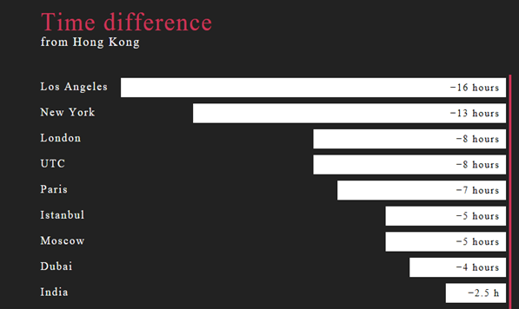
Time Zone:
According to Insight guises (1980) Hong Kong is always eight hours ahead of London and thirteen ahead of New York, as this picture shows.
Source: www.time.is/Hong_Kong

The Climate:
During to the seasons time Hong Kong has four distinct seasons: warm and humid, hot and rainy summer, pleasant and sunny autumn, cool and dry winter. Although, the best time for travelling to Hong Kong is between October or to early December time when the weather is warm.
However, Dry and cool winter usually comes in late December to early March time, so it is advisable to bring something warm to wear. This is also the best time to do shopping since most malls will be making sales promotions to sell out all the season clothes in much cheaper prices.
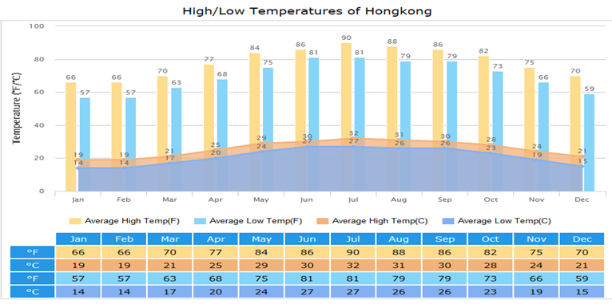
Source: www.travelchinaguide.com
As this picture shows all the temperature of each month and which month is the best for travelling to Hong Kong.
Choosing a Hotel:
Hong Kong has some of the best hotels in the world and the most expensive in the world. Therefore, according to Lonely planet (2019) hotels cost in Hong Kong could range less than 700HKD a day if you enjoy the guest house and a food store. Although If you don’t enjoy the guest house, visitors can always pay over 1700HKD a day for a boutique room and dinner in a top restaurant.
In conclusion, Hong Kong is one of the most densely populated places in the world, it is one of the most dramatic cityscapes cling to the hillside and the edges of its remarkable harbour. This unique city it is filled with unique neighbourhoods that resonate with Chinese and Ancient tradition. For tourists, Hong Kong offers some of the world’s most intense, such as attractions, restaurant and malls with the latest luxury in a cheaper price. It’s when you’re out here, you’ll truly appreciate just how beautiful and outstanding Hong Kong is. That in one of the world’s most financial hub city in Asia and one of the world’s hottest cities destinations can flourish, from a glittering view on top of Victoria peak shining bright just like the milky way and almost outshine the city itself, that’s pure Hong Kong.

References / Bibliography:
Tripsavvy, (2018),’ What Country is Hong Kong Actually In?’, [Online]. Available: https://www.tripsavvy.com/what-country-is-hong-kong-in-1535874, [ Accessed 2019, February 06]
Travel China guides, (1998-2019), ‘Hong Kong Travel Guide’, [Online]. Available: https://www.travelchinaguide.com/cityguides/hongkong/, [ Accessed 2019, February 06]
Lonely planet, (2019),’ Welcome to Hong Kong’, [Online]. Available: https://www.lonelyplanet.com/china/hong-kong [ Accessed 2019, February 06]
Gov.hk, (2015),’ HONG KONG: THE FACTS’, [Online]. Available: https://www.gov.hk/en/about/abouthk/factsheets/docs/population.pdf [ Accessed 2019, February 06]
Gov.hk, (2018),’ Tourism HONG KONG: THE FACTS’, [Online]. Available: https://www.gov.hk/en/about/abouthk/factsheets/docs/tourism.pdf[ Accessed 2019, February 06]
Hong Kong traveller, (2019)’, Hong Kong Area by Area’, [Online]. Available: https://www.hong-kong-traveller.com/hong-kong-by-area.html#hong Kong island [ Accessed 2019, February 07]
Jumpstartoffices, (2019) ‘, 5 Reasons Why You Should Be Doing Business in Hong Kong’, [Online]. Available: https://www.jumpstartoffices.com/en/5-reasons-why-you-should-be-doing-business-in-hong-kong/ [ Accessed 2019, February 10]
Brandhk, (2019); Hong Kong for Business; [Online]. Available: https://www.brandhk.gov.hk/html/en/AboutHongKong/HongKongForBusiness.html[ Accessed 2019, February 10]
Travelchinaguide, (2019),’ Hong Kong Weather’, [Online]. Available: https://www.travelchinaguide.com/climate/hongkong.htm [ Accessed 2019, February 11]
Theculturetrip, (2018),’ 20 Must-Visit Attractions in Hong Kong,’ [Online]. Available: https://theculturetrip.com/asia/hong-kong/articles/20-must-visit-attractions-in-hong-kong/ [ Accessed 2019, February 11]
Disneyland, (2005) ‘, Hong Kong Disneyland’, [Online]. Available: https://www.hongkongdisneyland.com/?located=true [ Accessed 2019, February 11]
Discoverhongkong, (2019),’ Top 10 Attractions’, [Online]. Available: http://www.discoverhongkong.com/eng/see-do/highlight-attractions/top-10/the-peak.jsp[ Accessed 2019, February 12]
Madametussauds, (2019),’ Madametussaudshongkong’, [Online]. Available: https://www.madametussauds.com/hong-kong/en/ [ Accessed 2019, February 12]
Discoverhongkong, (2019),’ Best of all it’s in Hong Kong,’ [Online]. Available: http://www.discoverhongkong.com/uk/plan-your-trip/traveller-info/transport/getting-around/index.jsp [ Accessed 2019, February 25]
Rutherford, S. & Bell, B. (1980), Insight guides Hong Kong, (1st Ed), London: Ltd
Travelchinaguide, (1998-2019),’ Hong Kong Dining’, [Online]. Available: https://www.travelchinaguide.com/cityguides/hongkong/dining.htm [ Accessed 2019, February 25]
Statista, (2016),’ Number of visitor arrivals in Hong Kong from 2008 to 2017 (in million arrivals),’ [Online]. Available: https://www.statista.com/statistics/317143/hong-kong-visitor-arrivals/[ Accessed 2019, February 27]
Legco.gov.hk, (2018)’, Tourism in Hong Kong’, [Online]. Available: https://www.legco.gov.hk/research-publications/english/1718issh27-tourism-in-hong-kong-20180604-e.pdf [ Accessed 2019, February 27]
Wong.W, (2017),’ The Benefits of Expanding into Hong Kong’, [Online]. Available: https://www.radiusworldwide.com/blog/2017/5/benefits-expanding-hong-kong [ Accessed 2019, February 28]
Geographyfieldwork, (2018) ‘, The Butler Model of tourist resort development’, [Online]. Available: https://geographyfieldwork.com/ButlerModel.htm[ Accessed 2019, March 5]
Kotler.P, (2017)’, Principles of Marketing, (7th Edition), Edinburgh gate: person education limited.

