Document of Intent

introduction
The work was to animate a short film in small groups，”K11’s Bizarre Adventure”， I had almost no experience working on group animation before that, but I had some experience making 3D models, so I felt like I was capable of holding some positions on the team.

A Supervisory Role:

A supervisory Role, I don't think I have enough time and ability to manage the progress and completion of other members' projects, because I have had the experience of failure, so I did not choose to participate in the work after discussing with the team leader, but if necessary I can also help to draw on some good ideas or give some feedback.

A Primary Role
In animation, I mainly play the role of prop maker, and before that I had some experience in prop making, such as Gameboy
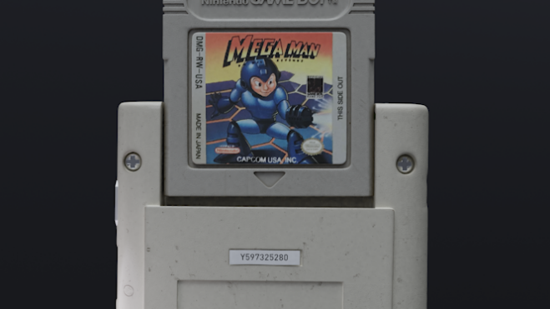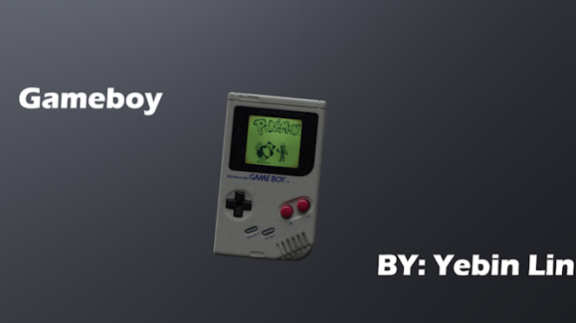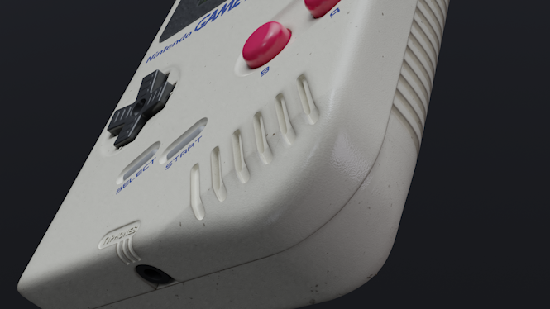
In the previous assignment, I completed the material and model production alone, which was a very interesting thing, so in this multiplayer project, I was mainly responsible for the prop making of the character pig and rabbit motorcycles, and I had not made motorcycles before, which was a very interesting challenge.
First of all, in the early project I set some goals, motorcycles are divided into many types, rally cars, motorcycles, unicycles, two-wheeled, etc., for the character image and its character personality, I discussed with the group leader what the motorcycle should look like, after communication, I also communicated with other team members to get opinions, after perfecting the production of models and textures, and again got the opinions to improve.
I think this is a good opportunity to improve myself, to try motorcycle making that I have not been exposed to, which requires some relevant mechanical knowledge, which will make me learn a lot and will be very helpful for my future career path.

A Secondary or Support Role:

In terms of secondary characters, I chose lights and renderings, which are the last step before the post-animation stage and require a lot of time to debug, which belongs to the work of increasing efficiency with more people, I joined the output pressure that can slow down some of the renderings, and can discuss and learn from the other members of the group, and our ultimate goal is to develop towards a complete, high-quality final effect.

A Standby Role:

In terms of alternate roles, I work as a post-production (subtitles, sound effects, editing, opening credits), most of my roles are biased towards pre-production, so I chose post-production when I was in the backup role, which allowed me to have a different experience in the project, allowed me to keep me happy, and when other members encountered difficulties, I could take over and complete tasks for them, and the work content could be done in pr and ae so I could learn more than 3D software.

