The Art of War (21-01-22)
This reference seems to come up all the time. It definitely looks relevant to strategy; but does it also have an ethical application?
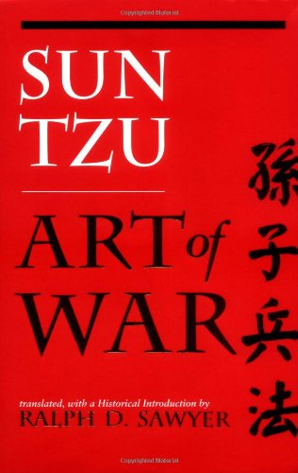

A book cover on Sun Tzu's Art of War. This is used by all business schools as a guide to developing strategy......some people, particularly feminist critics say that we should not be using military models and transferring them into business. Also that the modern world needs more peaceful, interactive and consensual approaches. Less agressive, masculine approaches? This sounds very Confucian....
Here is another reference to it in a free journal.
See De Cremer’s article. Like all academics he also boosts his own impact by quoting and referencing himself
https://worldfinancialreview.com/the-art-of-war-as-a-business-strategy/
Free journals…..academics or other writers who quote themselves…is this a refereed article????? All factors for you to think about when assessing the articles’ academic validity…
Here is a link to the Mckinsey journals on the military, a USA consultancy firm but well respected, however bias again? https://www.mckinsey.com/featured-insights/leadership-lessons-from-the-military

Look at another briefing document on this tile, where I draw parallels between business and military strategy. Business used to steal from the military, now it is more interactive with the modern military developing modern management concepts like “inclusive management”, social responsibility, ethical rules and how to avoid toxic leadership etc.

The Americans really do make a lot of Sun Tzu: https://joshuahoering.medium.com/the-influence-of-military-strategy-on-business-strategy-6d702ea9656a
And
http://www.strategiimanageriale.ro/papers/160132.pdf

Here is a professor with a nuanced view of the links between business and the military.
https://rogermartin.medium.com/business-strategy-and-or-military-strategy-271fff1319bd

From my other briefing document:
A consultancy blog:
https://www.thehrdirector.com/features/hr-in-business/the-similarities-between-business-strategy-and-military-strategy/
See Sun Tzu
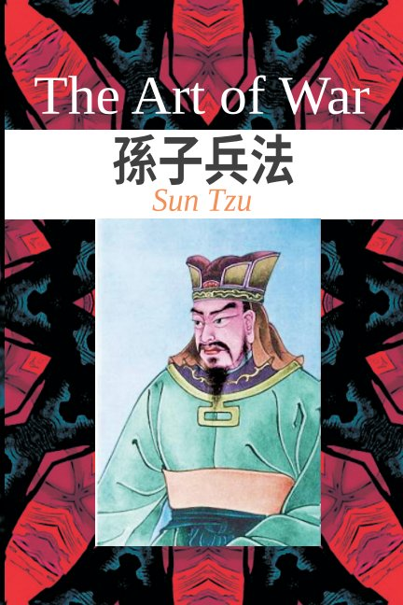
http://www.gutenberg.org/files/1946/1946-h/1946-h.htm
Everyone is copying Sun Tzu in business schools and management consultancies, but is it possible to apply the text out of context and to a totally different activity?
Just one example: https://tweakyourbiz.com/global/the-art-of-war

A feminist critique of the militarist approach:
A general critique, but does quote Foucault which should please Caroline: https://onlinelibrary.wiley.com/doi/abs/10.1111/j.1468-0432.2004.00232.x

https://www.tandfonline.com/doi/abs/10.1080/14616740500065170

https://journals.sagepub.com/doi/10.1177/0967010617742006

There are, of course critiques of the feminist critique. Mostly that it may not reflect women’s views in general and may focus on the negative experiences of women historically, which might not be so relevant to modern practices.

https://journals.iupui.edu/index.php/advancesinsocialwork/article/view/131/122

The military can be analysed from a business/management perspective. A governmental (public sector) organisation, but still needing to find resources, achieve objectives, manage reputation and stakeholders etc. Therefore it might be one of your specialist case studies.

Steve

